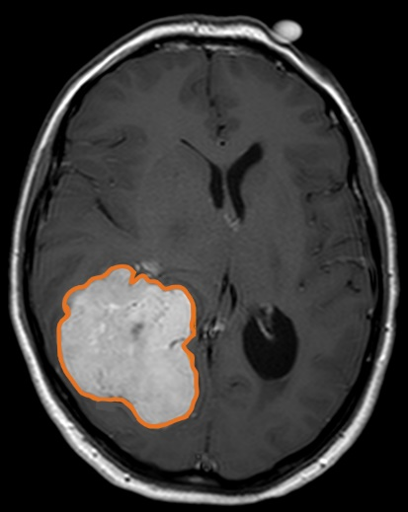
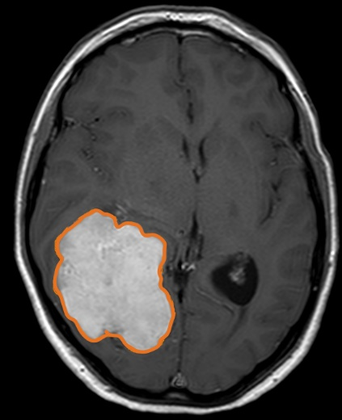
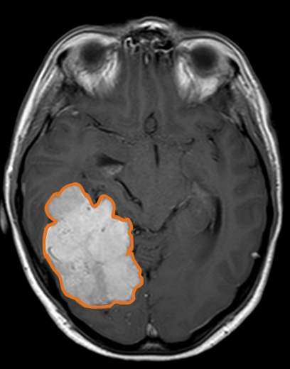
1
2
3

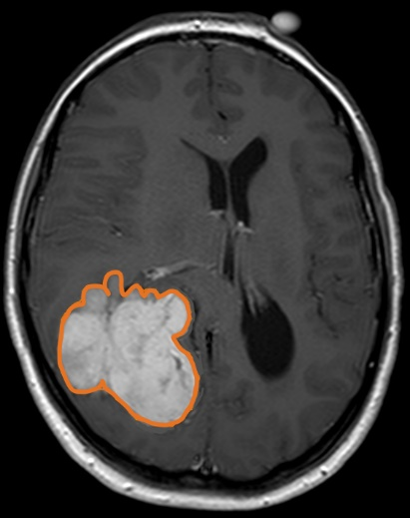
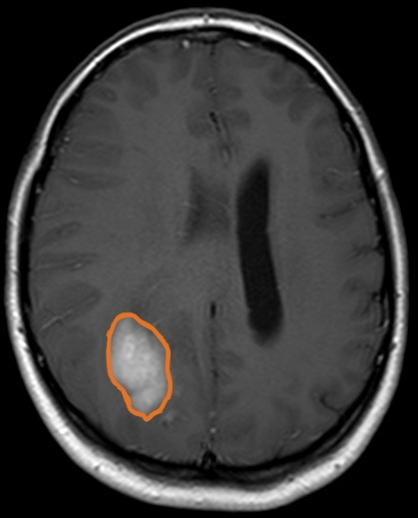
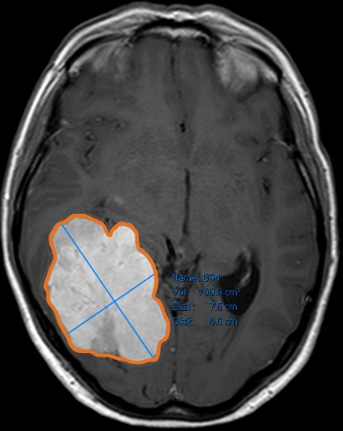
4
5
6

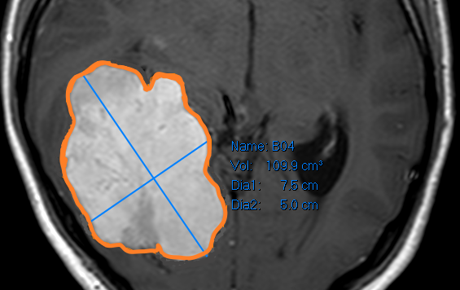

Supplemental Digital Content 1. Figure 1. Figure demonstrating the PACS semi-automated measuring tool for volumetric analysis (Images 1-6). Manual tracing is performed for each axial slice of tumour, and the volume calculated (larger tracing line used for illustrative purposes).
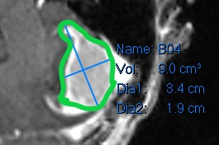
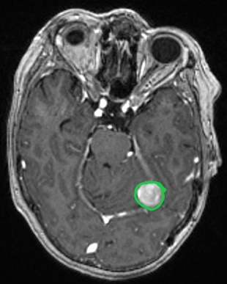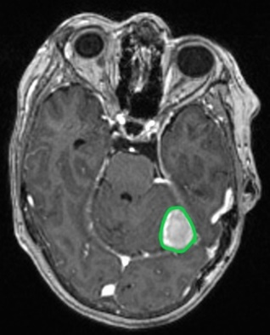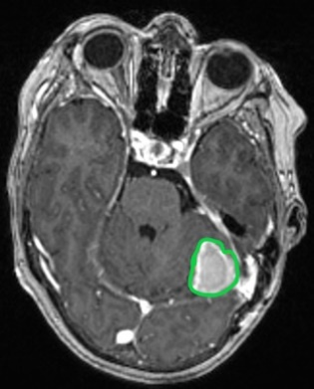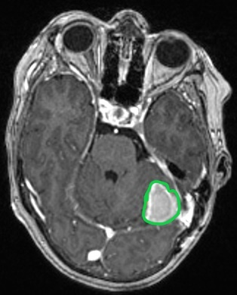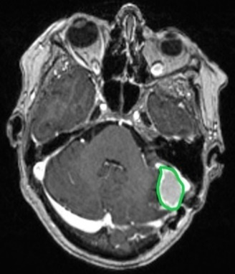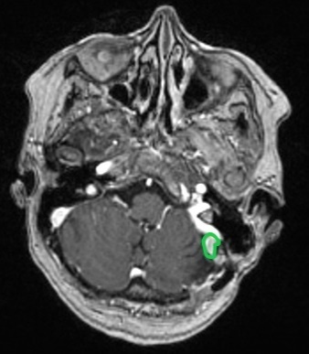
1
6
5
4
3
2
Supplemental Digital Content 1. Figure 2. Figure demonstrating the PACS semi-automated measuring tool for residual tumour volume measurement (Images 1-6). Manual tracing is performed for each axial slice of tumour, and the volume calculated (larger tracing line used for illustrative purposes).

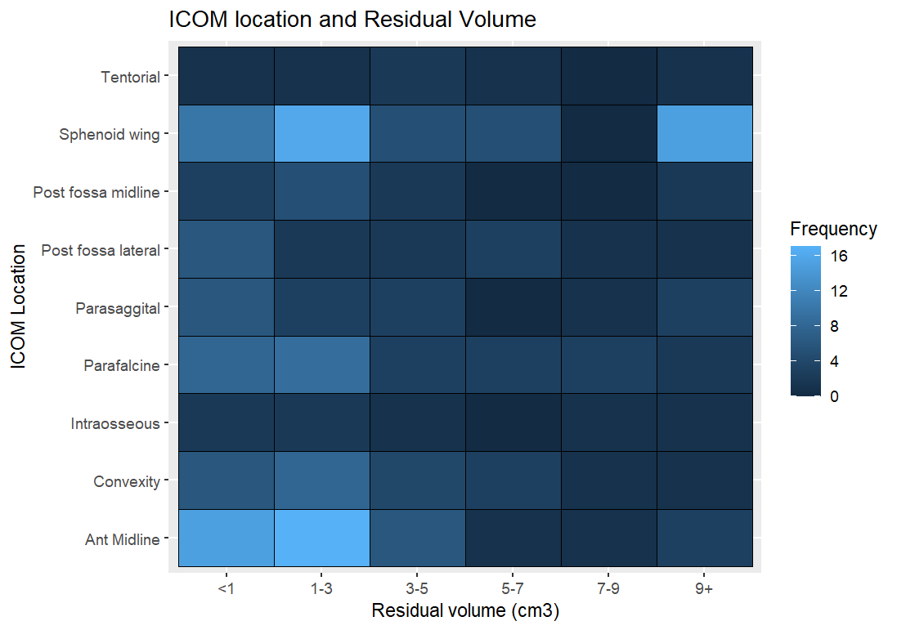

Supplemental Digital Content 1. Figure 3. Heatmap demonstrating ICOM location, and residual tumour volume, with density representing number of cases.

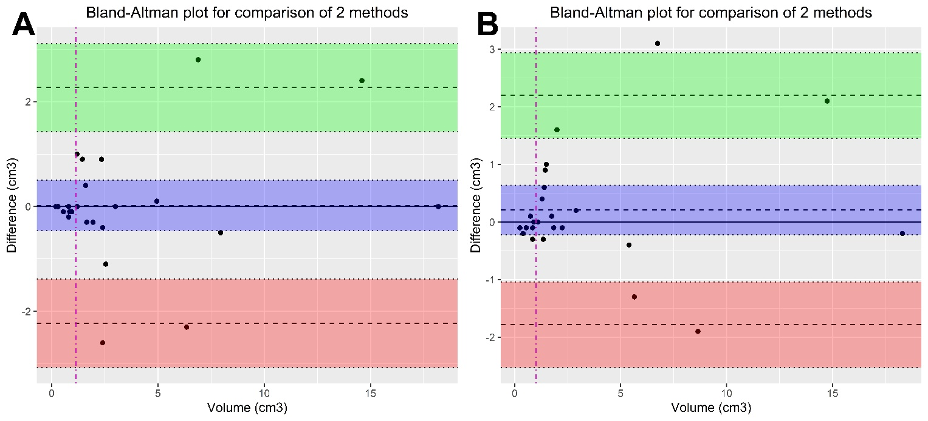

Supplemental Digital Content 1. Figure 4. Bland-Altman plot with mean residual volume intercept (1.15cm³) for interobserver variability (A) and intra-observer variability (B). All points are within the 95% CI indicating a good level of agreement.

Supplemental Digital Content 1. Figure 5. Schoenfeld residual plot for each of the covariates. The solid line is a smoothing spline fit to the plot, with the dashed lines representing a ± 2-standard-error band around the fit. None of the plots demonstrated a regular pattern with time, and tests were all not statistically significant.

Supplemental Digital Content 1. Figure 6. Volume-time growth plot demonstrating meningioma volumetric growth, stratified by those that received adjuvant fRT (black).

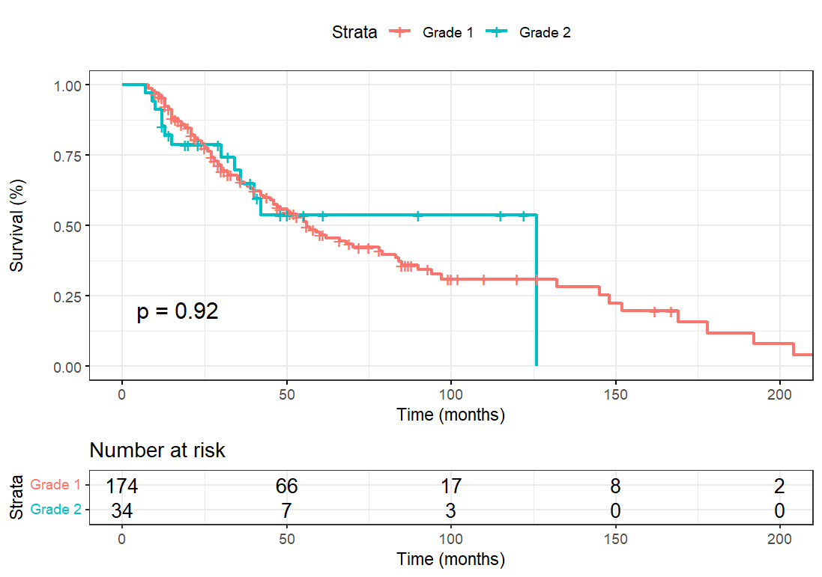
Supplemental Digital Content 1. Figure 7. Kaplan-Meier curve demonstrating progression-free survival (PFS) in the cohort, stratified by adjuvant fRT.

Supplemental Digital Content 1. Figure 8. Violin plot (with internal boxplot) of the overall R² values for meningioma that received early intervention (Fractionated radiotherapy, repeat surgery, stereotactic radiosurgery), stratified by type of growth curve model. The wider the sections for each ‘violin’, the more meningioma R² values are located around this. The exponential (red) and logistic models (blue) displayed the highest median R² values overall.

