Supplementary Figure legends
S Fig. 1 The a-Diversity between Females and Males in each week of NICU stay
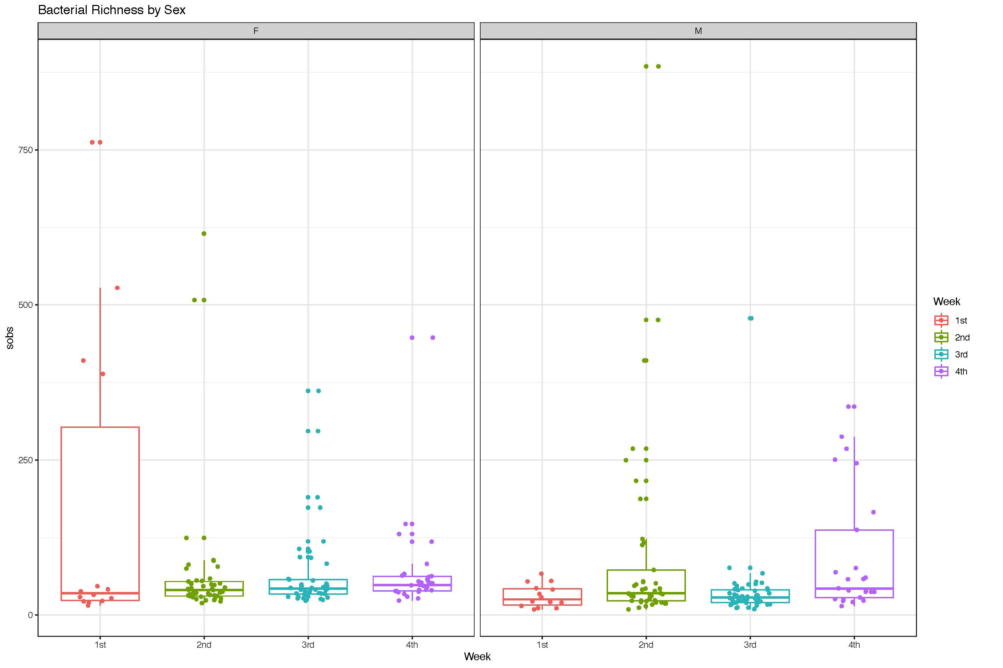
- Species of observations (Sobs) betwezen different weeks of female and male
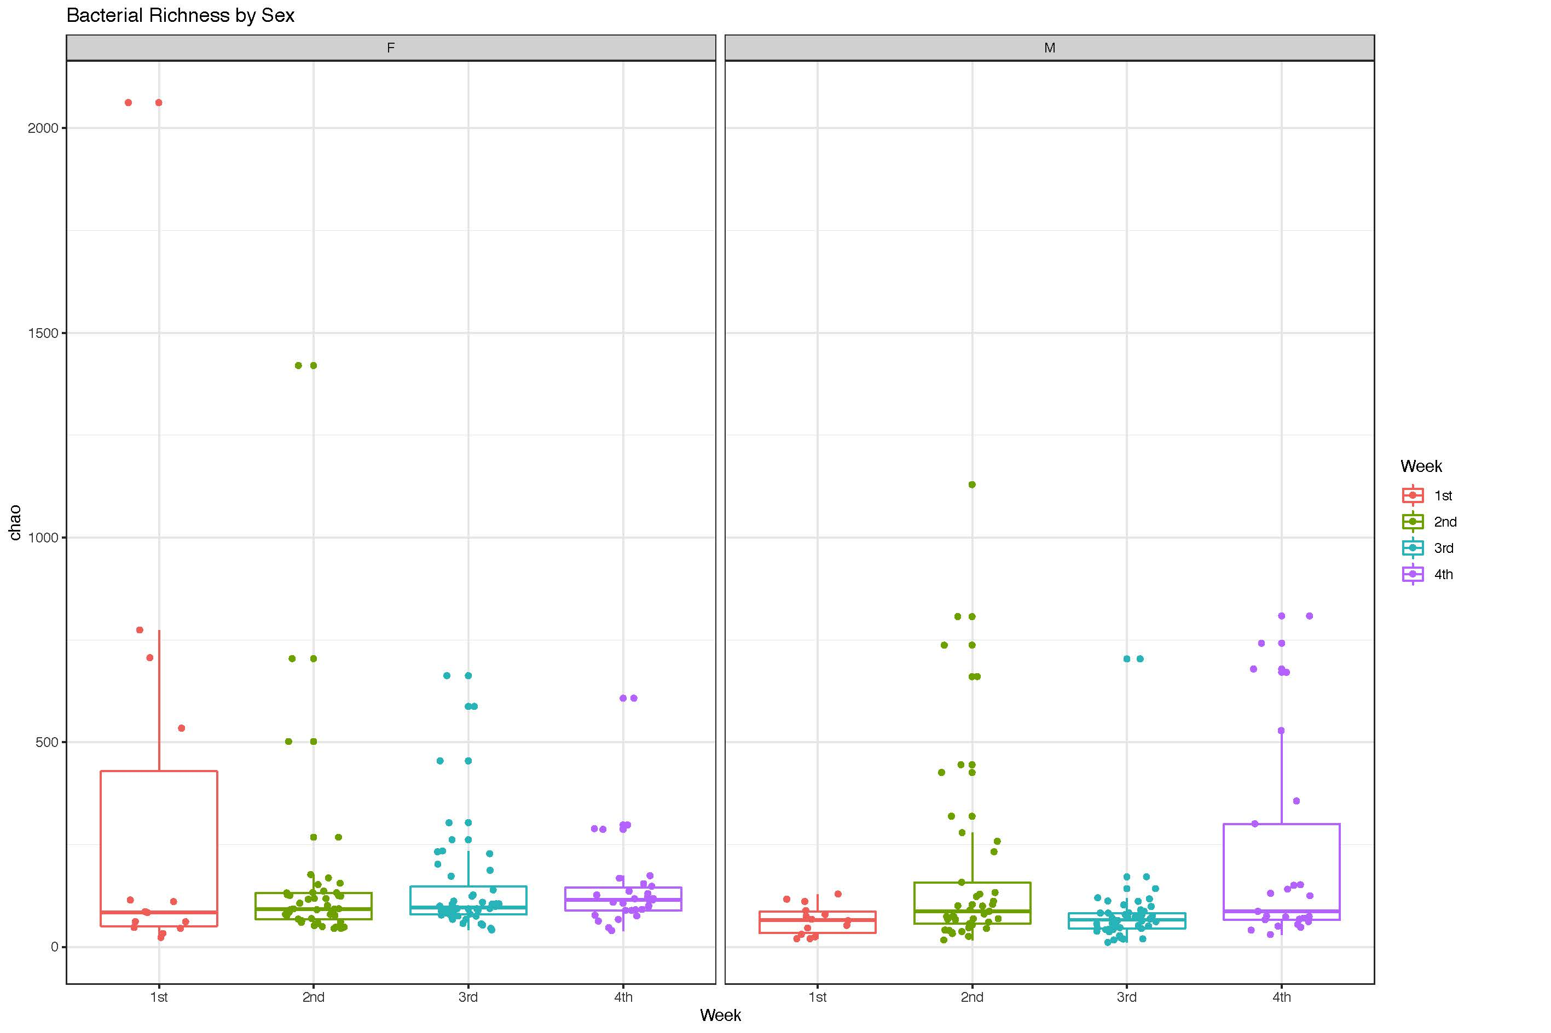
- Chao index between different weeks of female and male
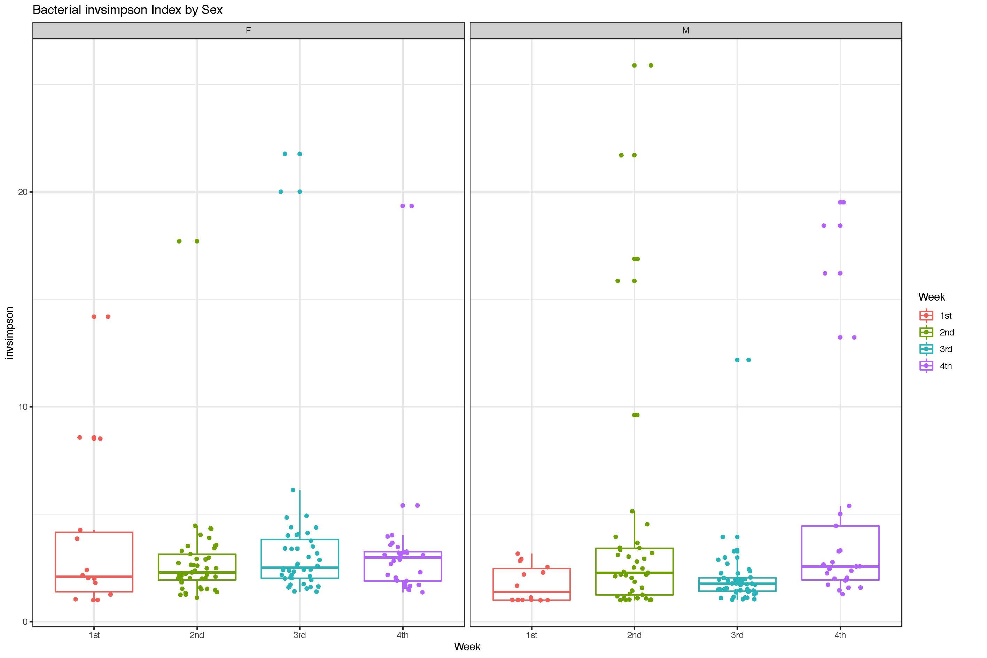
- Invsimpson index between different weeks of female and male
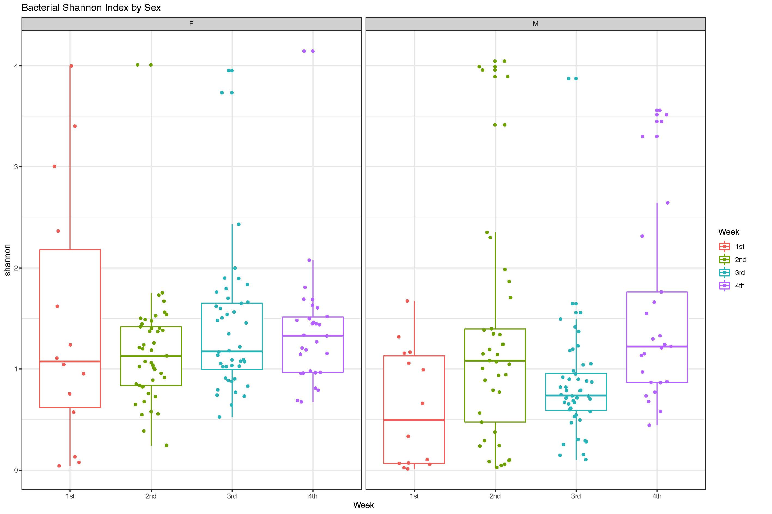
- Shannon index between different weeks of female and male
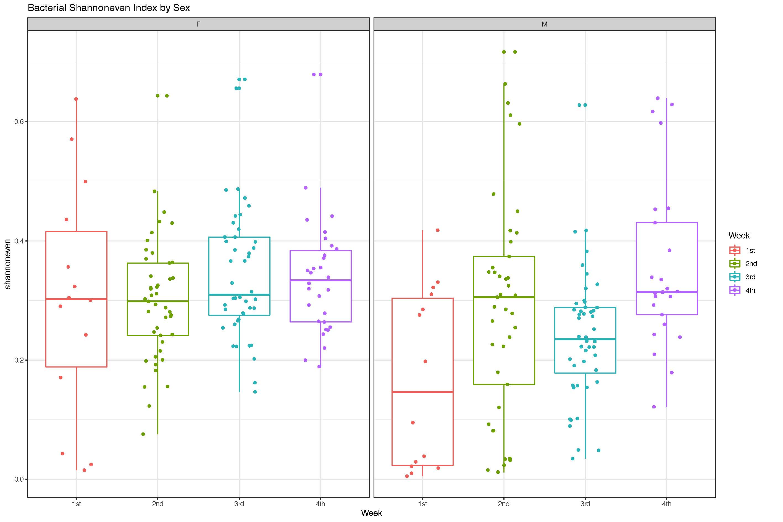
- Shannon-even index between different weeks of female and male

S Fig. 2 β-Diversity between Females and Males Over Time
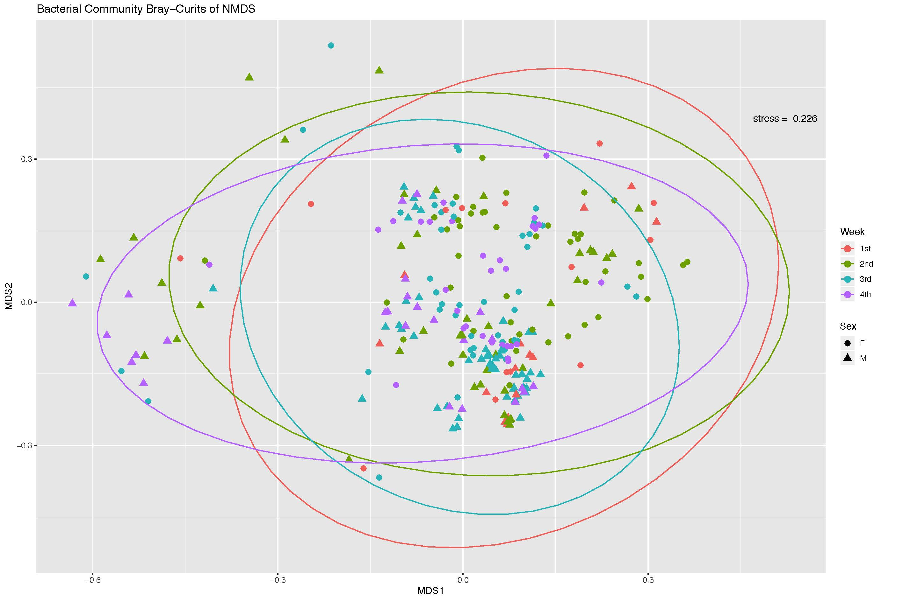
- Nonmetric multidimensional scaling (NMDS) plot of the Bray–Curtis dissimilarities between female and male samples
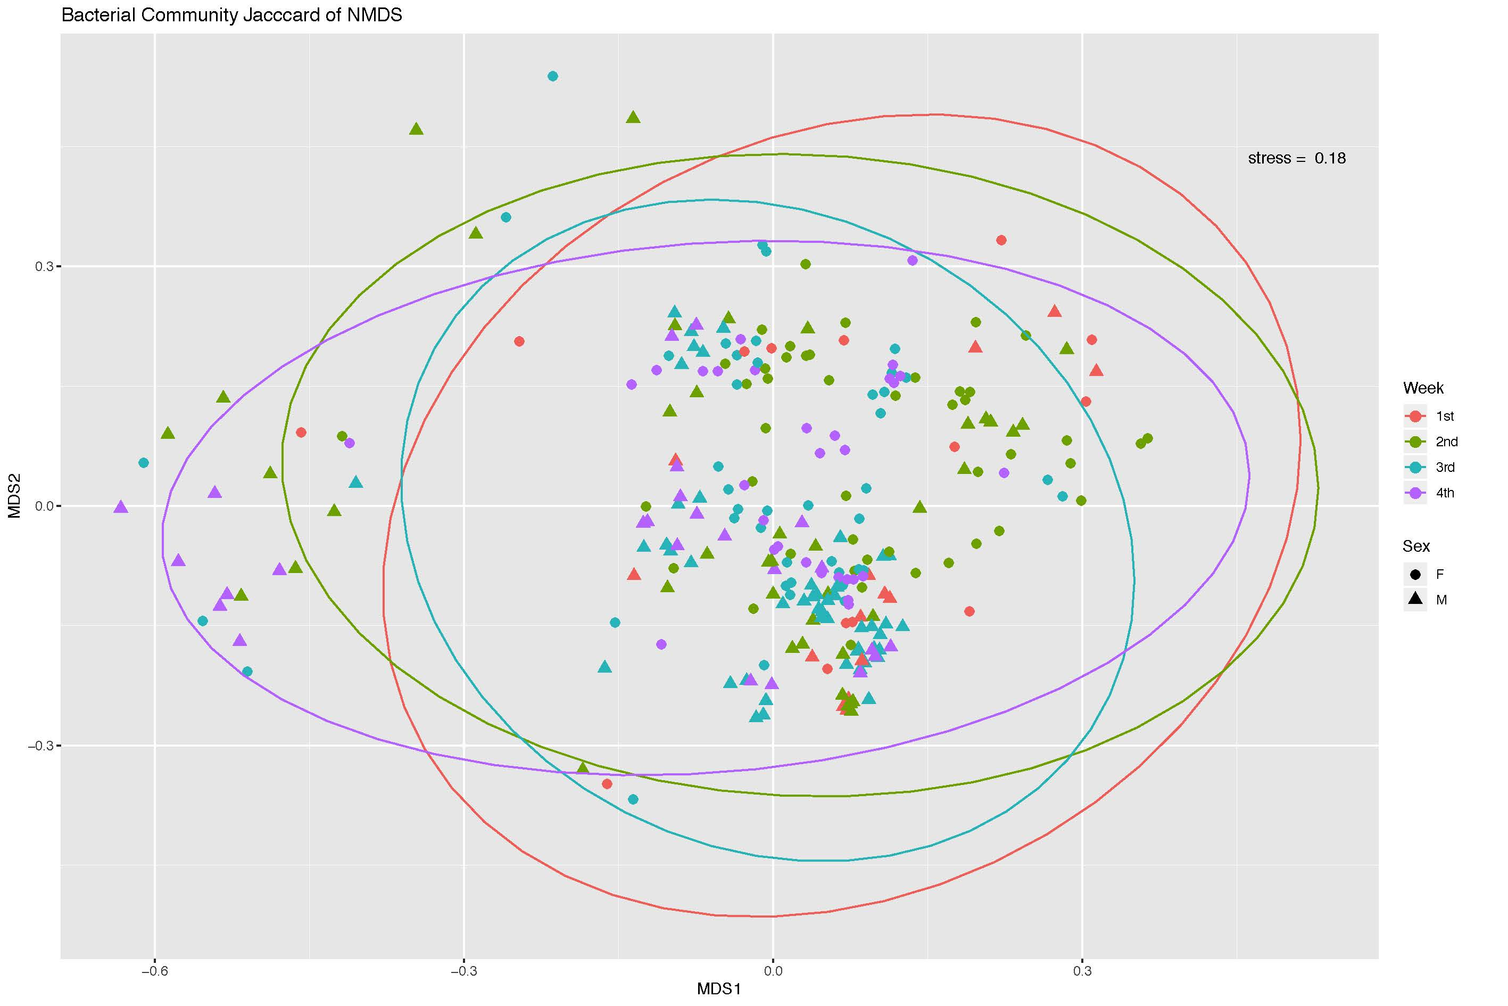
- Nonmetric multidimensional scaling (NMDS) plot of the Jaccard dissimilarities between female and male samples
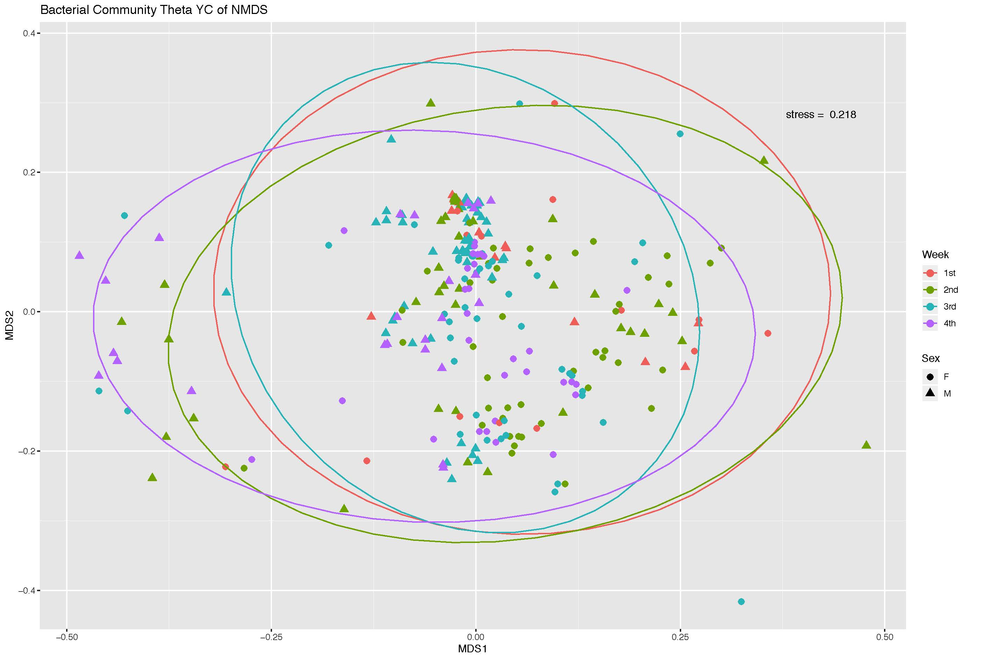
c. Nonmetric multidimensional scaling (NMDS) plot of the Theta YC dissimilarities between female and male samples

S Fig. 3 Weekly Compositional Difference of Gut Microbiota Among Females
The alpha value for the factorial Kruskal–Wallis test was set to 0.05 as well as for the pairwise Wilcoxon test, and the threshold on the logarithmic LDA score for discriminative features was set as 2.0.
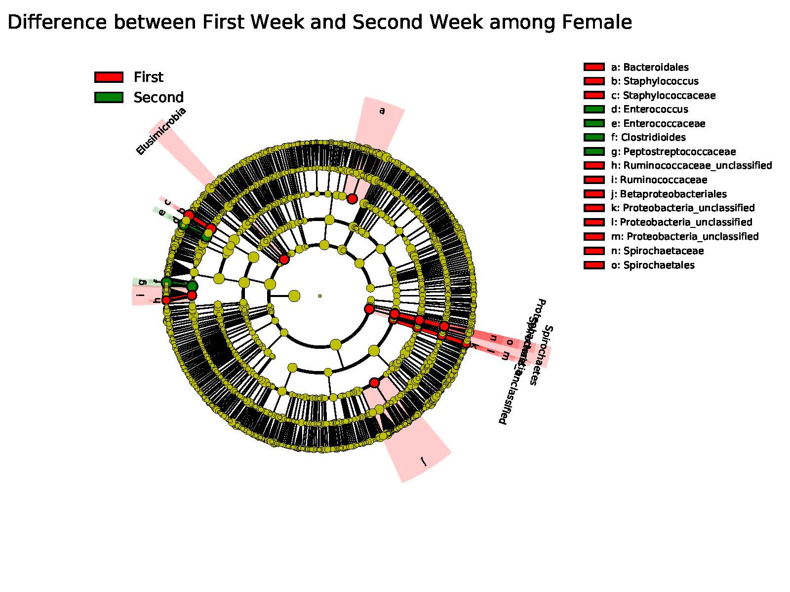
- The compositional difference of gut microbiota between 1st and 2nd week of NICU stay among females
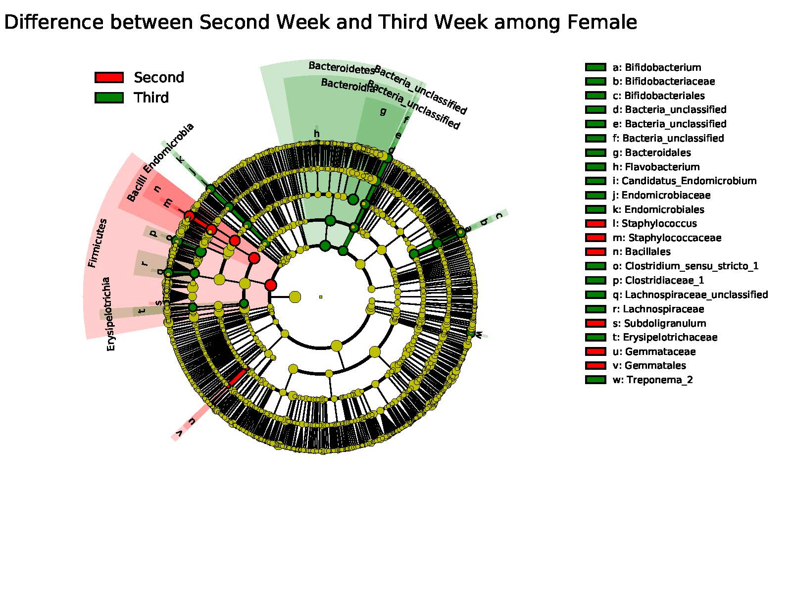
b. The compositional difference of gut microbiota between 2nd and 3rd week of NICU stay among females
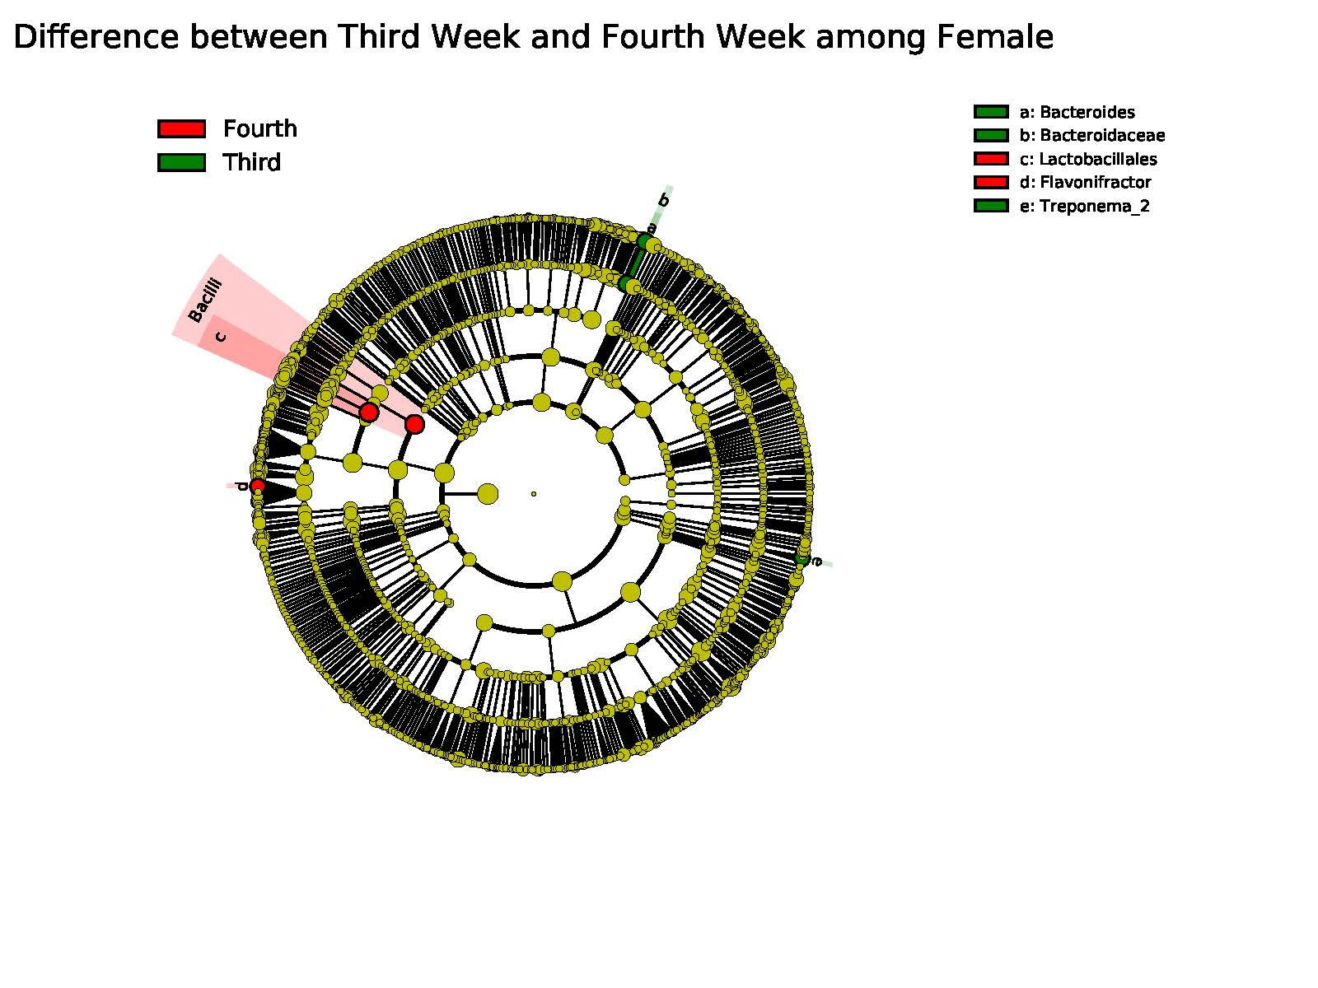
c. The compositional difference of gut microbiota between 3rd and 4th week of NICU stay among females

S Fig. 4 Weekly Compositional Difference of Gut Microbiota Among Males
The alpha value for the factorial Kruskal–Wallis test was set to 0.05 as well as for the pairwise Wilcoxon test, and the threshold on the logarithmic LDA score for discriminative features was set as 2.0.
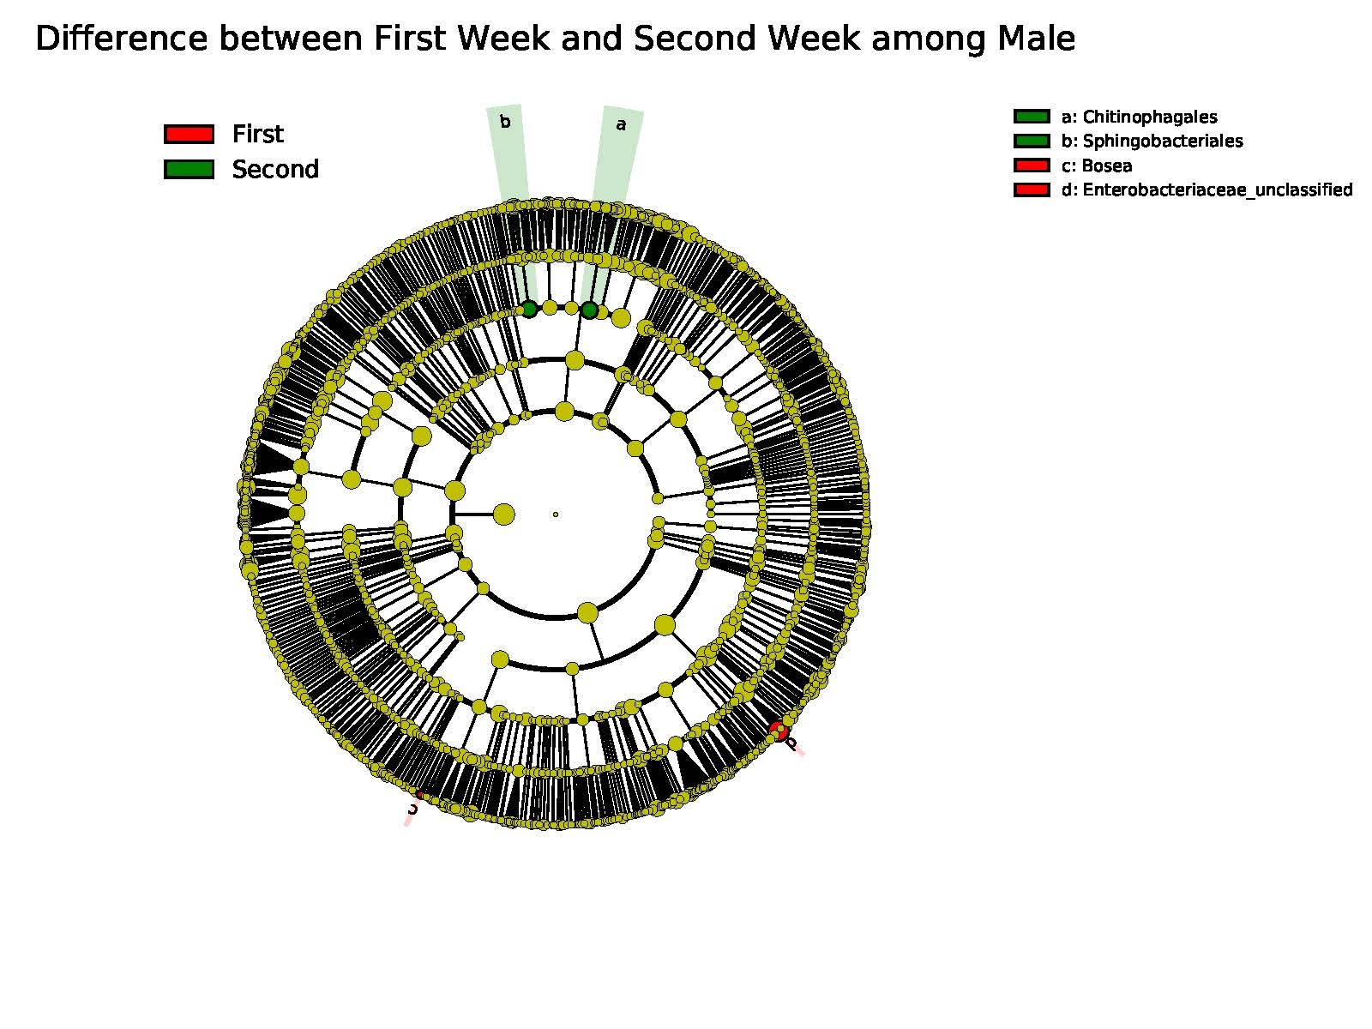
- The compositional difference of gut microbiota between 1st and 2nd week of NICU stay among males
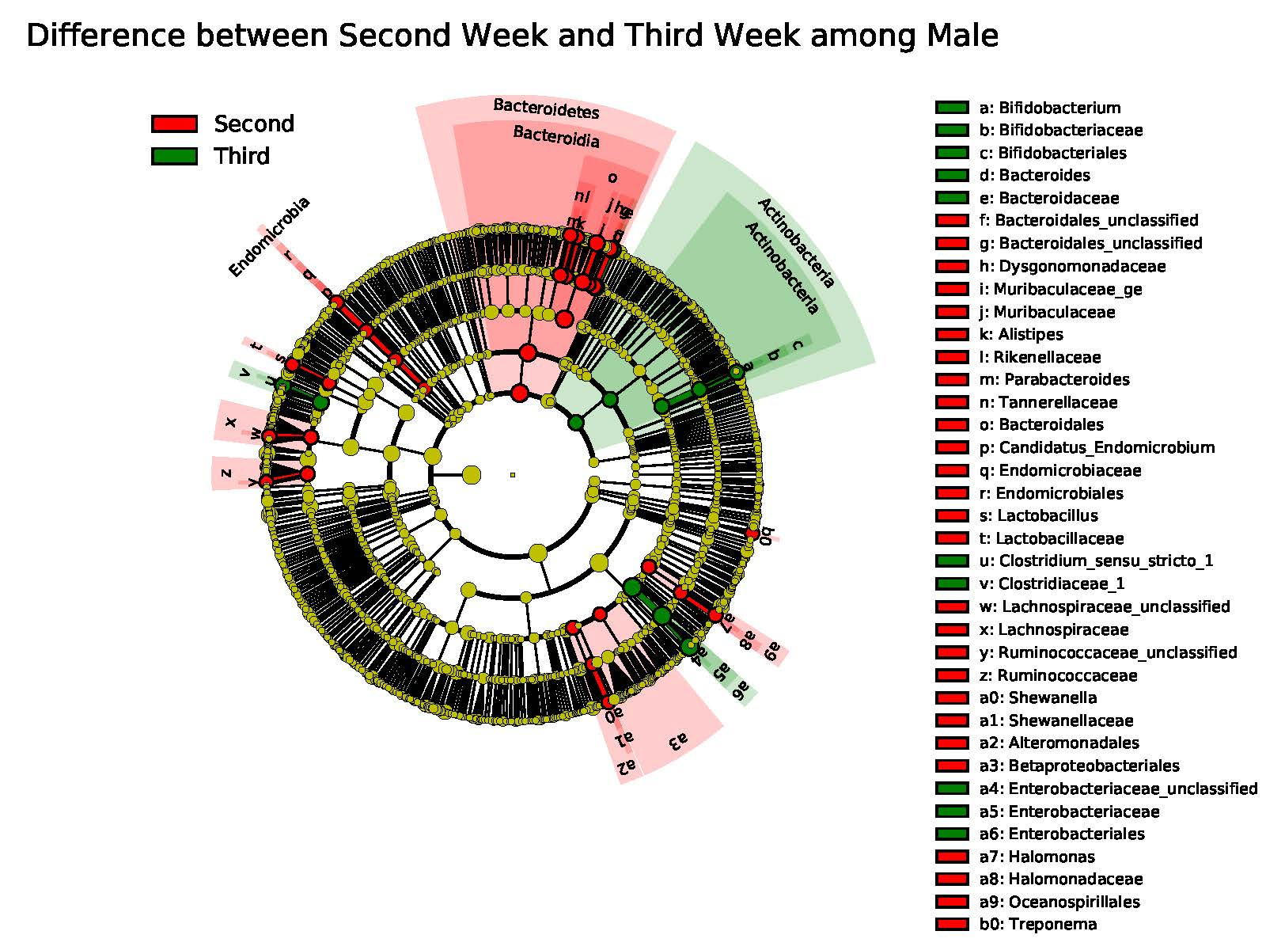
- The compositional difference of gut microbiota between 2nd and 3rd week of NICU stay among males
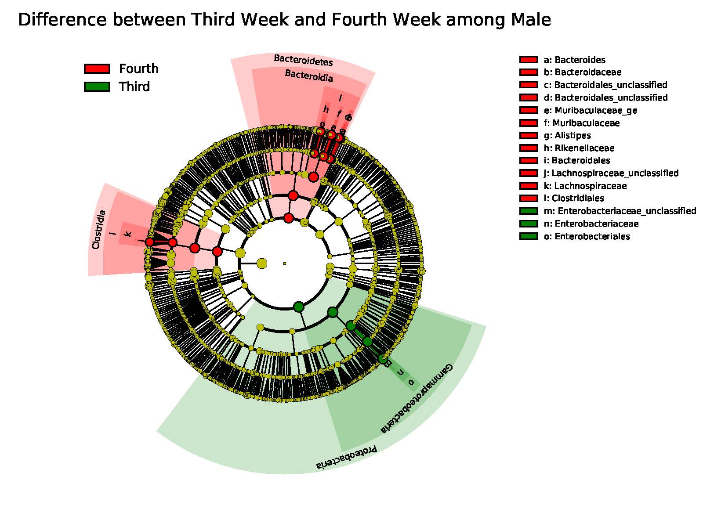
c. The compositional difference of gut microbiota between 3rd and 4th week of NICU stay among males

S Fig. 5 Different Metabolic Profiles of Gut Microbiota between Females and Males
Kruskal-Wallis test was used to compare the difference of the KEGG pathway (level 3). Benjamin-Hochberg procedure was used to decreases the false discovery rate for multiple test corrections. The p-value was set as 0.05.
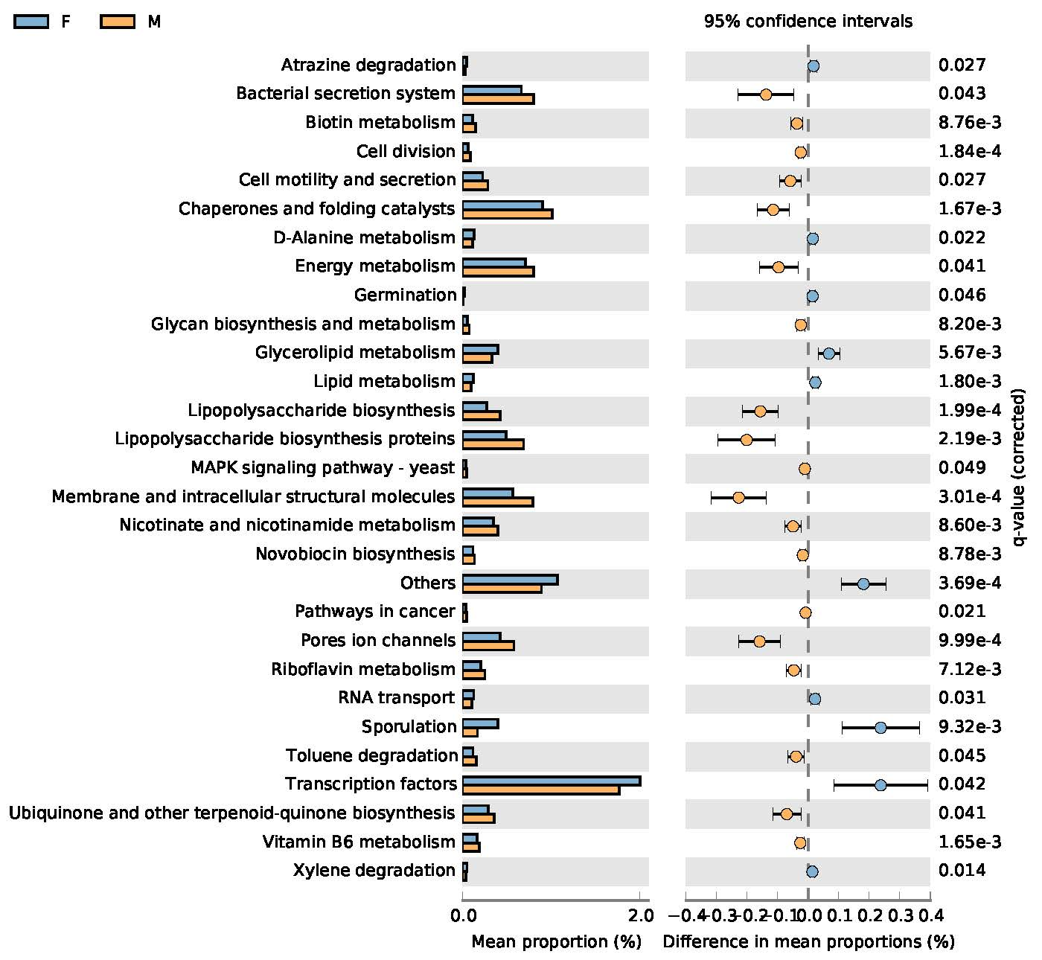
- KEGG pathway difference between Females and Males during the 2nd week of NICU stay
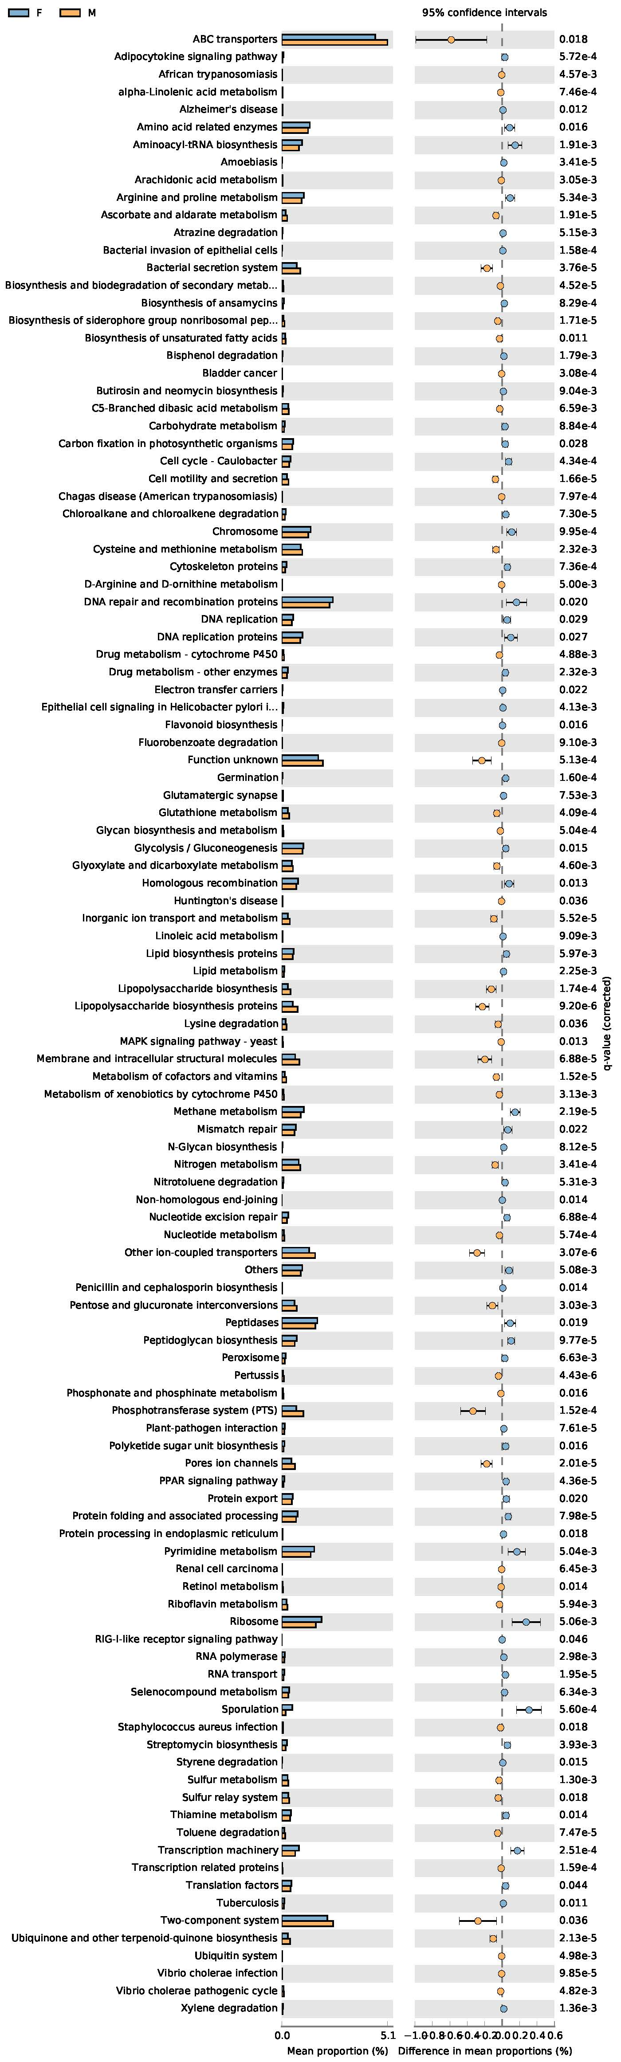
- KEGG pathway difference between Females and Males during the 3rd week of NICU stay
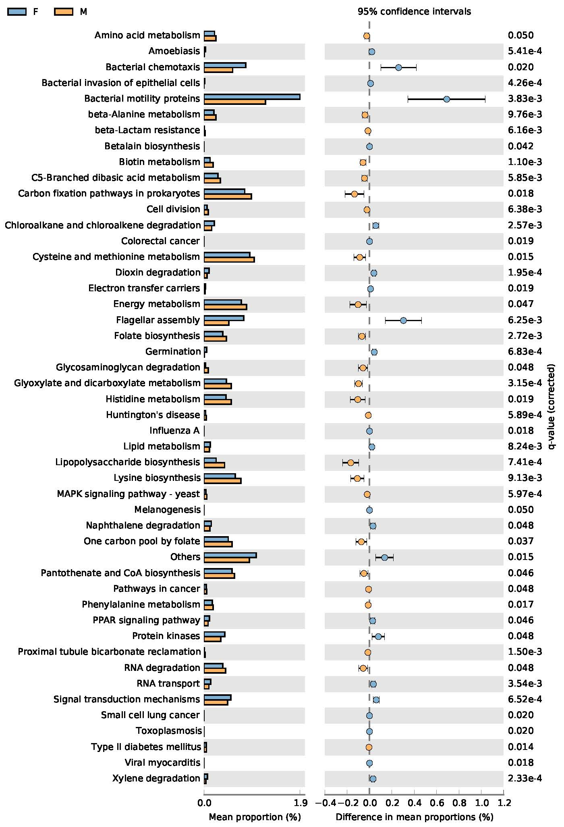
c. KEGG pathway difference between Females and Males during the 4th week of NICU stay

