SUPPLEMENTS
*gam.check() generates four plots:
<1> Quantile-quantile plots of residuals
<2> Histogram of residuals
<3> Residuals vs. linear predictor
<4> Observed vs. fitted values

The model diagnostics from gam.check(): Model 1, no covariates
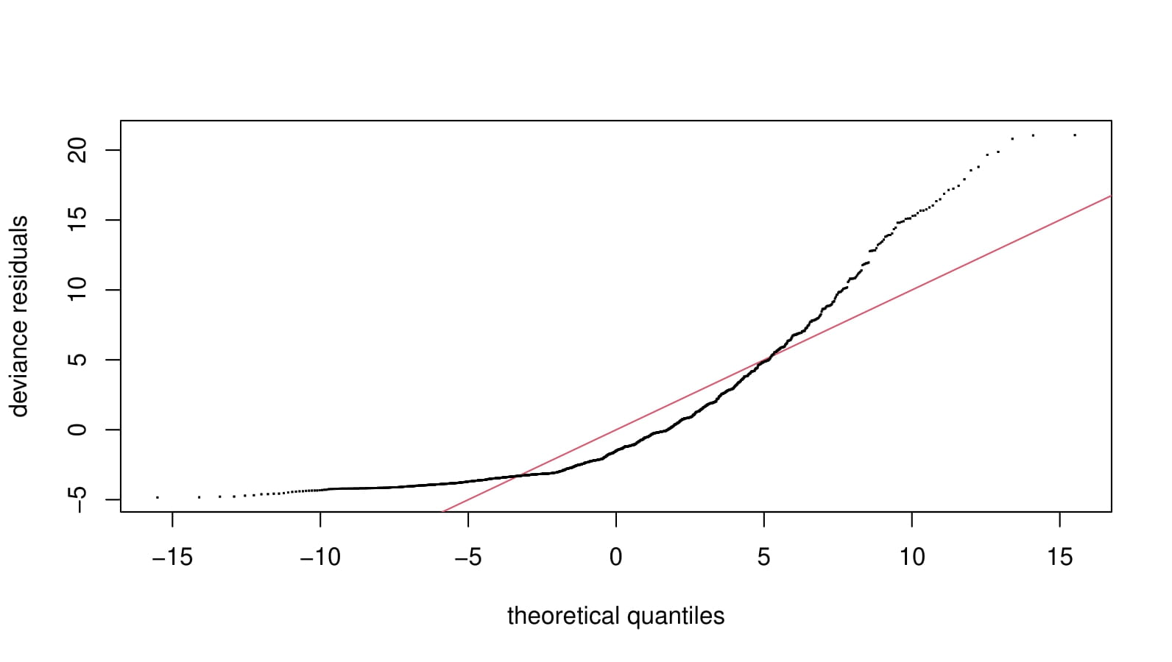  <1> | 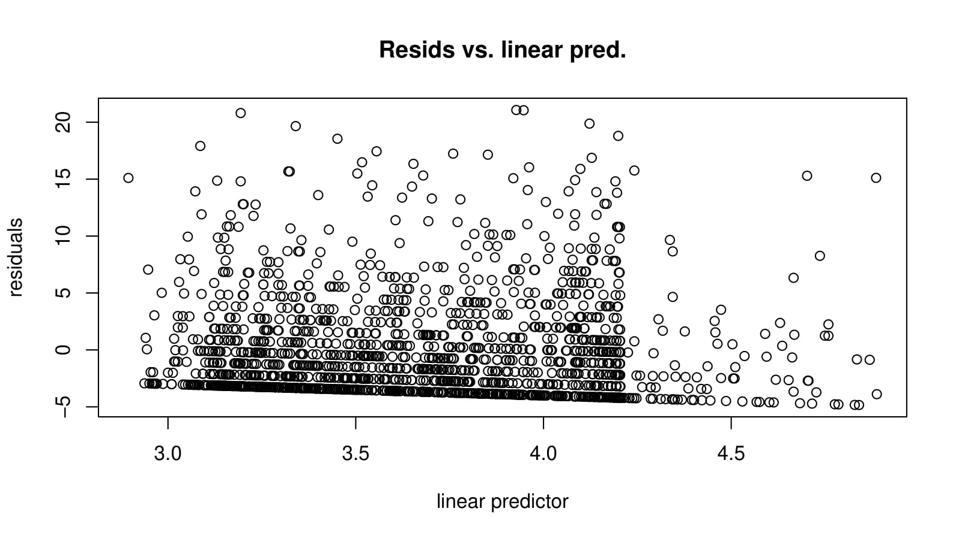  <3>
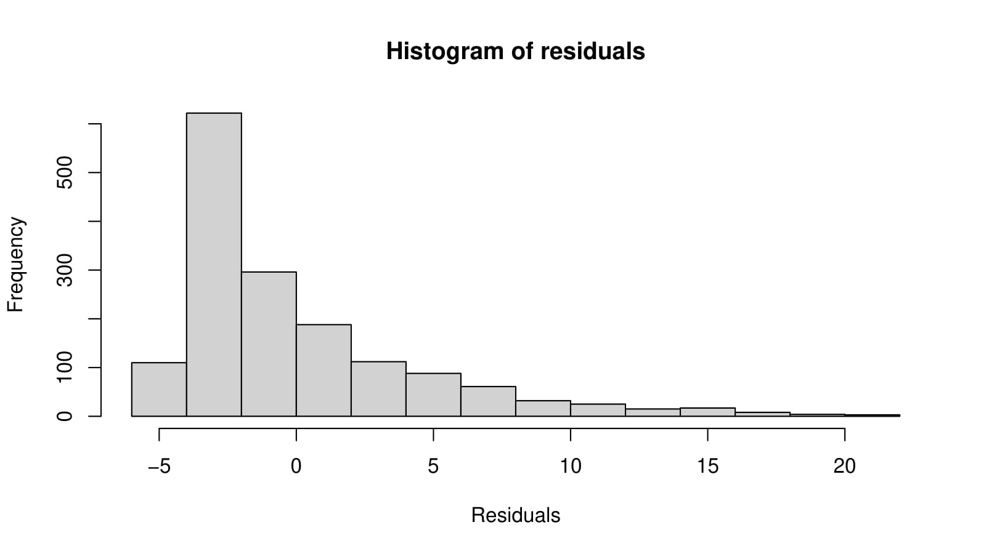  <2> | 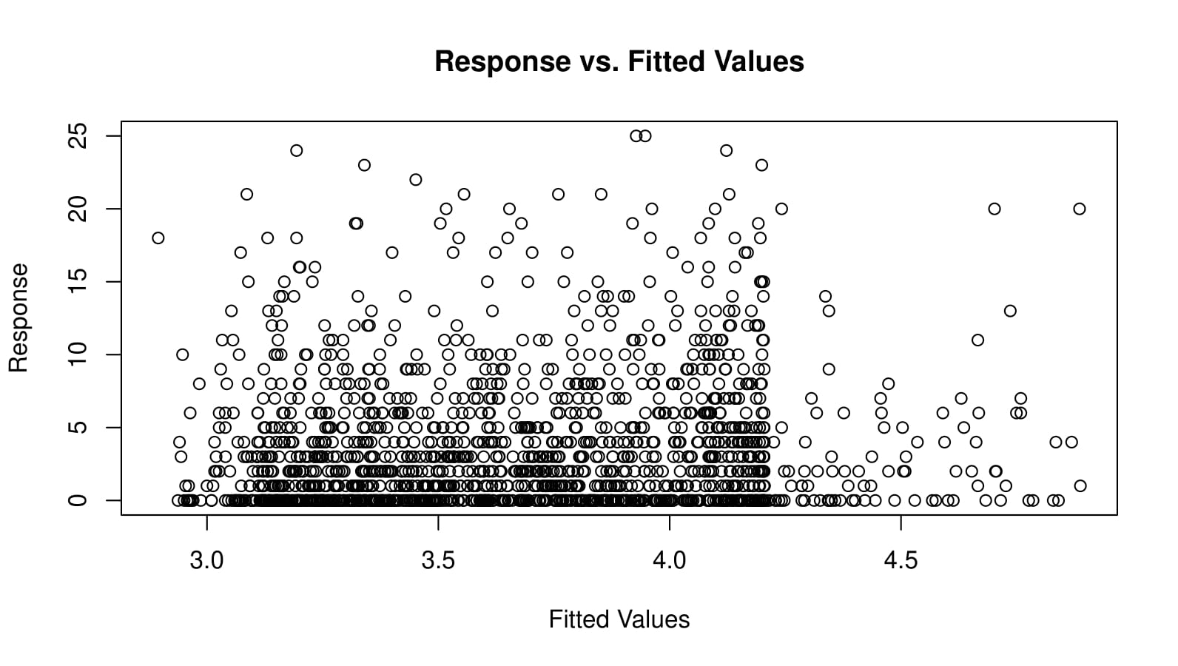  <4>
The model diagnostics from gam.check(): Model 2, adjusted for sociodemographic data
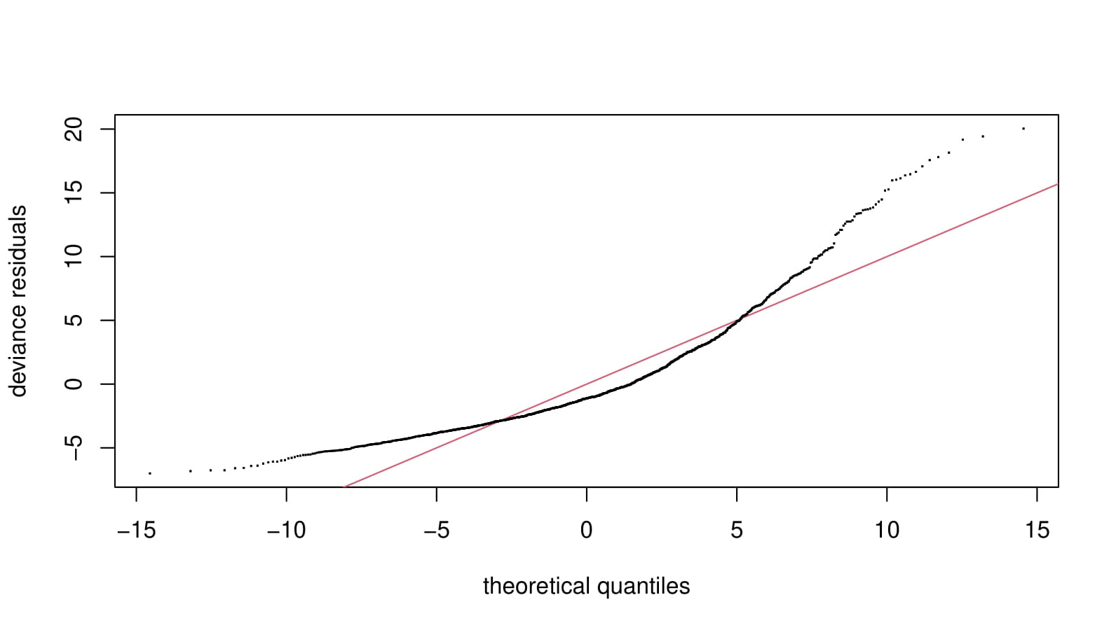  <1> | 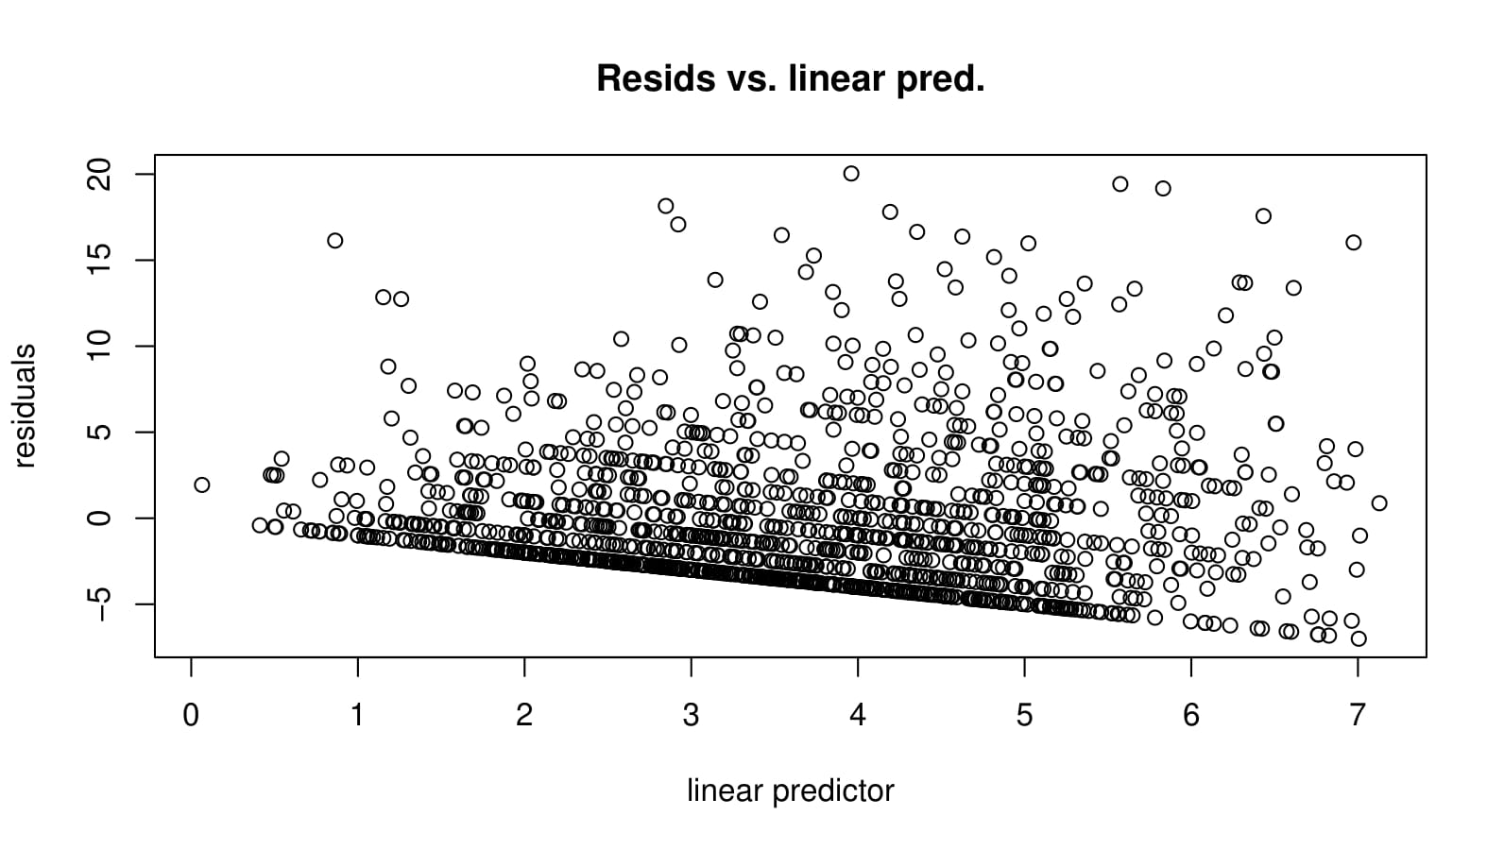  <3>
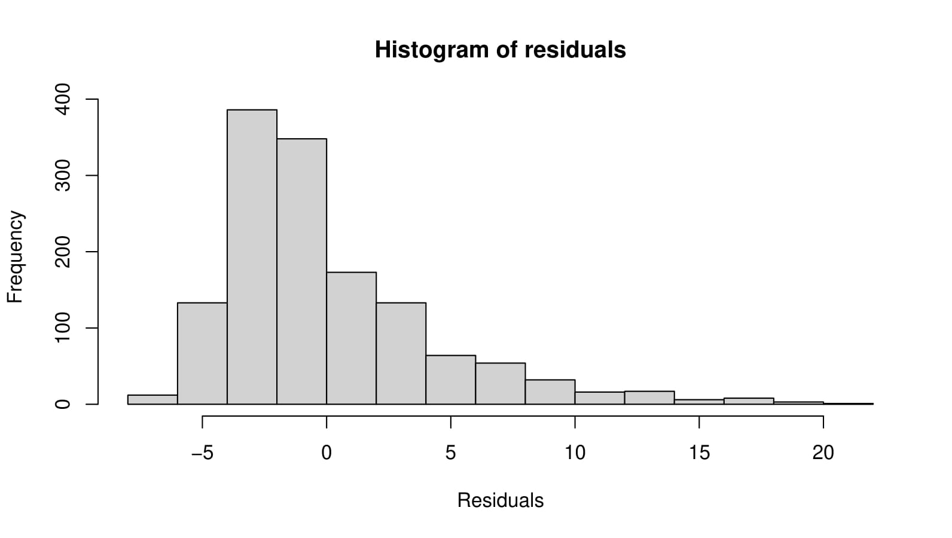  <2> | 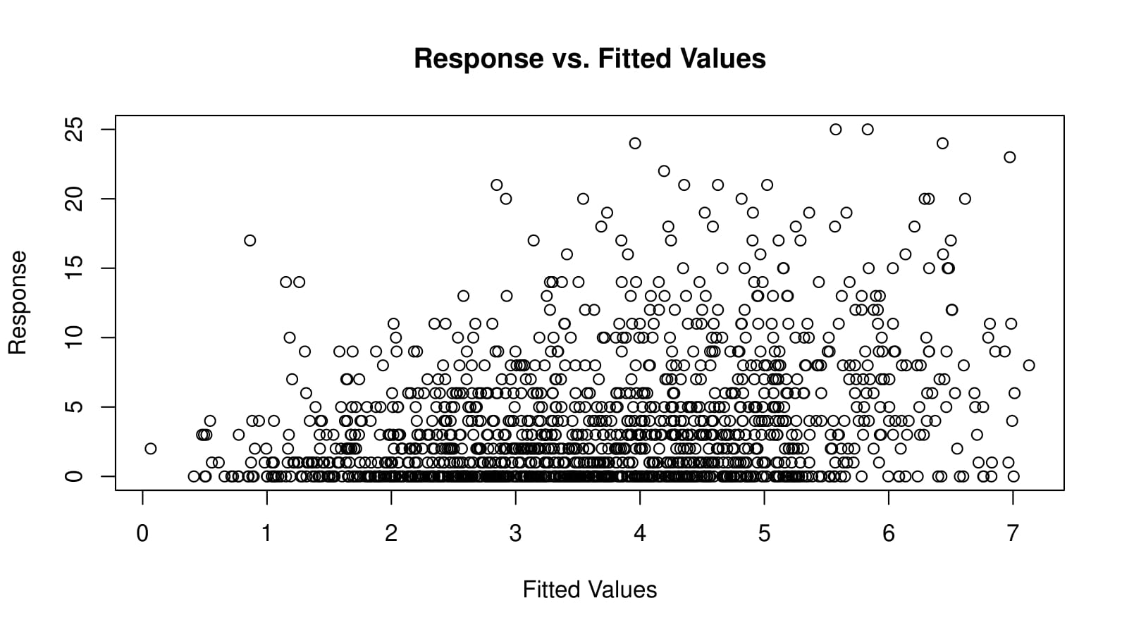  <4>

The model diagnostics from gam.check(): Model 3, Model 2 + lifestyle and clinical covariates
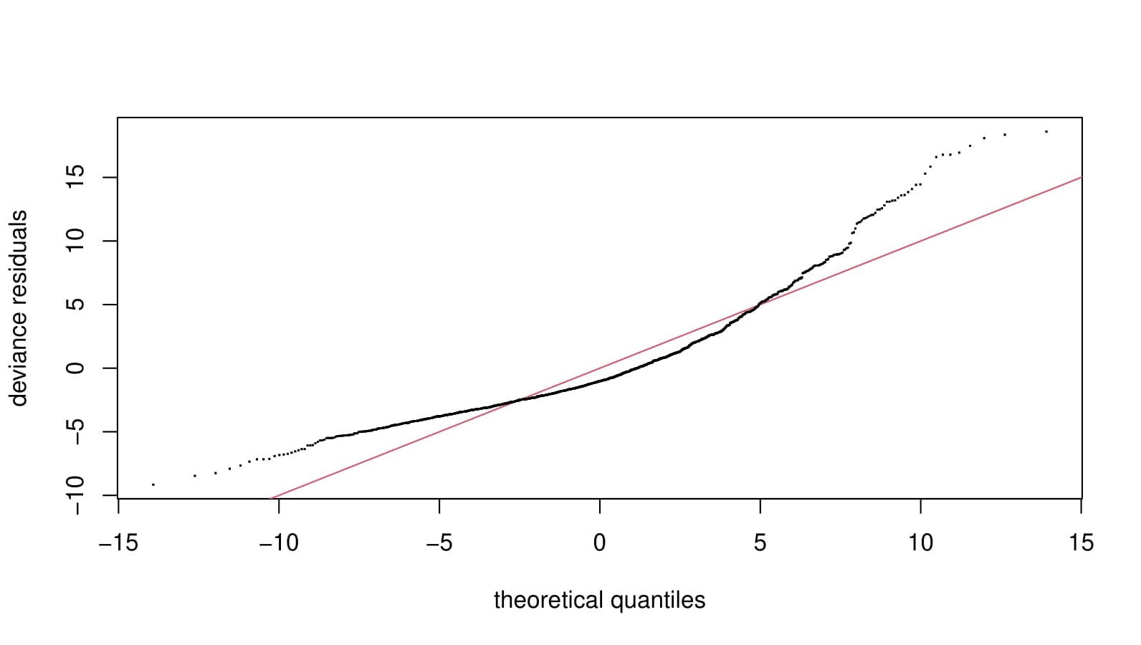  <1> | 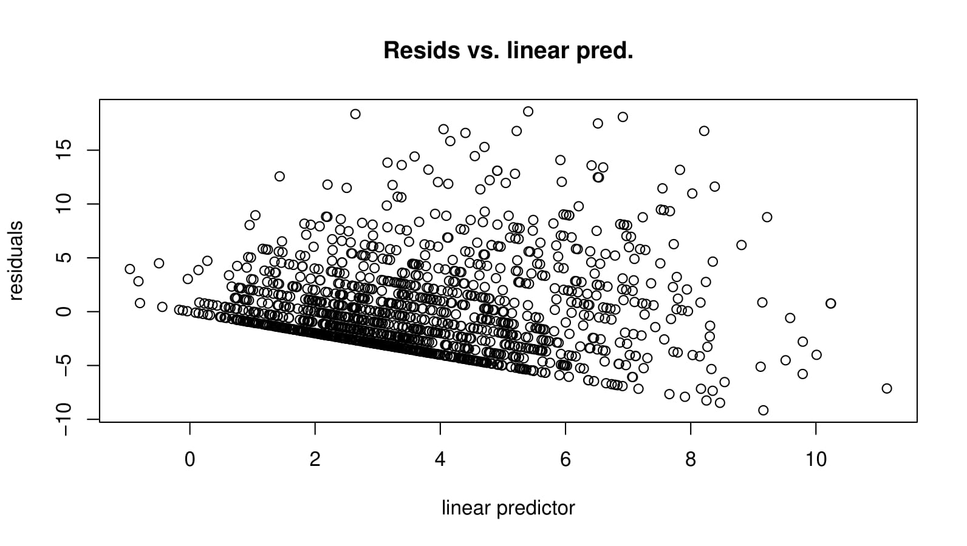  <3>
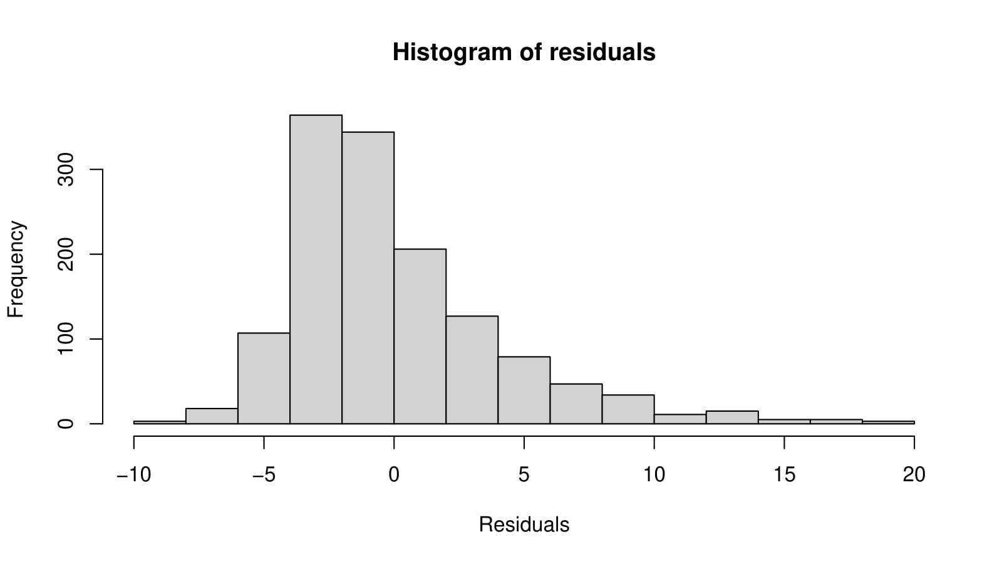  <2> | 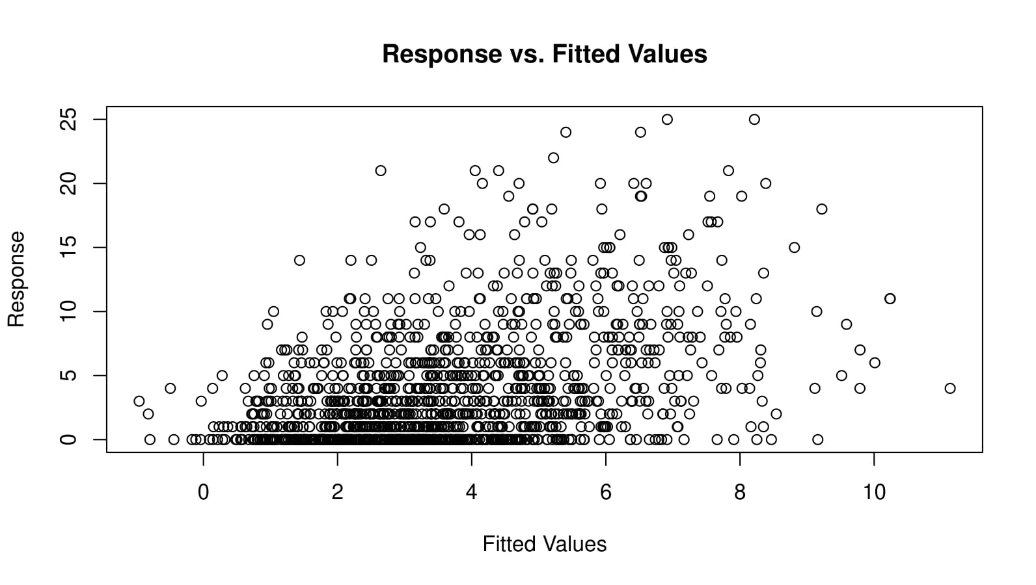  <4>

