figure e-2 Immunohistochemical Analysis of TAs

As a confirmation of IL-8 signaling and neutrophil recruitment/degranulation seen on pathway analysis, IHC analysis for IL-8 and neutrophils was performed. Analysis revealed IL-8 (pink color, first column) and CD15 (pink color, third column) antigen in a tonsil used as a positive control. Immunostaining of a GCA/VZV-positive TAs revealed IL-8 in the adventitia of the artery (pink color, first column, second row) and neutrophils in the same field of an adjacent slide (pink color, third column, second row). Immunostaining of a control/VZV-negative TA did not show IL-8 (first column, last row) or neutrophils (third column, last row). No staining was seen when primary antibodies were replaced with control mouse IgG1 antibody (second and fourth columns). Magnification 600X.

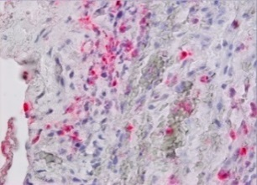
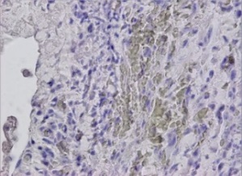
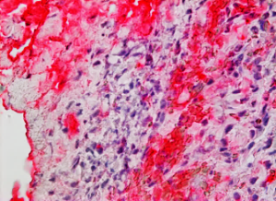
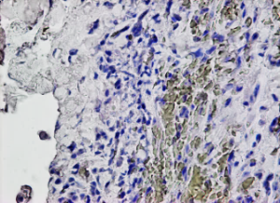
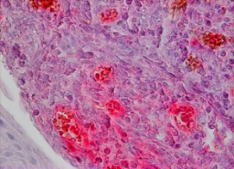
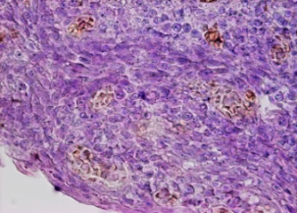
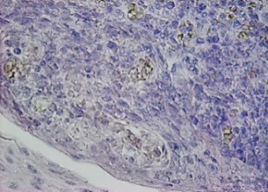
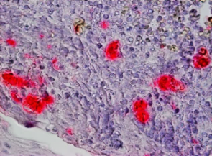
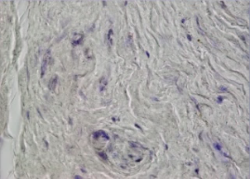
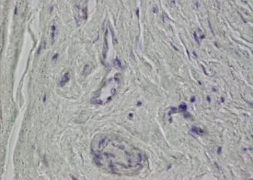
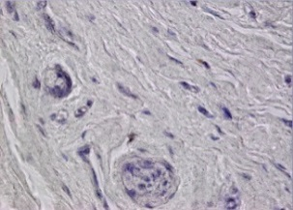
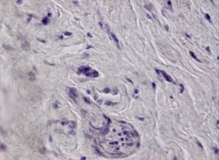
IL-8 mIgG1 CD15 mIgG1
Tonsil
GCA+
VZV+
Normal VZV-

