Supplemental Digital Content 1. Overview of entries and judge scores (on a 1-10 scale, 10 as best and 1 as worst).
Entry # | Brief description | Emotionª | Mean Preliminary Score | Mean Final Score | Youku views^{b}
1 | Two men meet, fall in love, and test for HIV together as part of a supportive environment | Positive | 5.92 | 6.08 | 57
2 | A man over-cooks an egg and over-fills a cup of juice: earlier testing is better | Positive | 5.92 | 5.92 | 975
3 | Compared to cancers and heart disease, HIV is increasingly treatable, necessitating early testing | Positive | 5.67 | 5.83 | 38
4 | A man is haunted by fear and anxiety after having unsafe sex, then gets testing | Negative | 5.00 | 5.00 | NA
5 | Overview of local services provided by the CBO, focusing on community links and support | Neutral | 4.5 | 4.33 | NA
6 | Erotic film showing two men having sensual sex together, then a message to promote testing | Positive | 3.58 | 3.75 | NA
7 | Cartoon with information about STDs and prevention | Negative | 2.33 | 2.33 | NA
ªFocus on positive attributes of testing coded as positive; focus on negative attributes of delayed testing coded as negative.
^{b}During the three month period from posting until January 29th, 2014.

Supplemental Digital Content 2. Finalists in the “Testing Saves Lives” Short Video Contest.

- Beijing Danlan Gongyi – Available on Youtube here and on Youku here.
- Chengdu Tongle – Available on Youtube here and on Youku here.
- Shanghai Xinsheng – Available on Youtube here and on Youku here.

Supplementary Digital Content 3. Prize structure for “Sex+Health” image contest.

Participation Prize Category | Who is eligible | Prize
Event Participation Incentives | All individuals who joined the final “Sex+Health” in-person event | - Vitamin cream, cupcakes, lemonade  - Raffle prizes: Polaroid camera, mobile power charger (2)
Individual Level Contest Incentives | Individuals determined to be in the top five positions according to judge voting | - 1st Place: Silver iPhone6 16g and certificate  - 2nd Place: Instax Polaroid Camera Package with decorating materials and certificate  - 3rd Place: Mobile Power Charger and certificate  - 4th Place: Mug from local coffee shop  - 5th Place: Mug from local coffee shop
Group Level Contest Incentives | Groups with the greatest number of total entries | - 1st place: Certificate  - 2nd place: Certificate
Crowd Favorite Incentive | Individual entry with the greatest number of votes online and in-person (combined) | - 1st place: Mug from local coffee shop

Supplemental Digital Content 4. Finalists in the “Sex+Health” Image Contest.
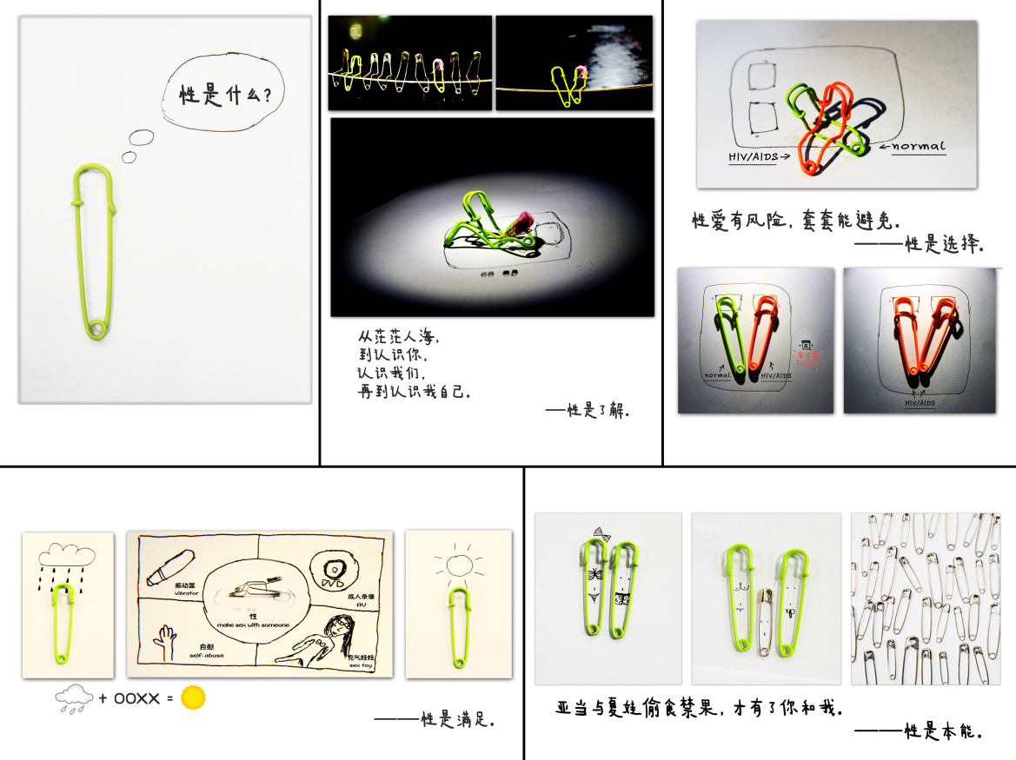

Supplement 4a. First place image. English captions from upper left to to upper right, then lower left to lower right: (Upper left panel) What is sex?; (Upper middle panel) In the crowded sea of people, We got to know each other, Then we knew ourselves, And finally I knew myself, Sex is understanding; (Upper right panel) Sex is risky, but condoms can avoid [the risk], Sex is a choice; (Lower left panel) Sex is satisfaction; (Lower right panel) Adam and Eve ate the forbidden fruit and only then came you and me. Sex is instinct.



Supplement 4b. Second place image.


Supplement 4c. Third place image.

