**Supplementary Materials**

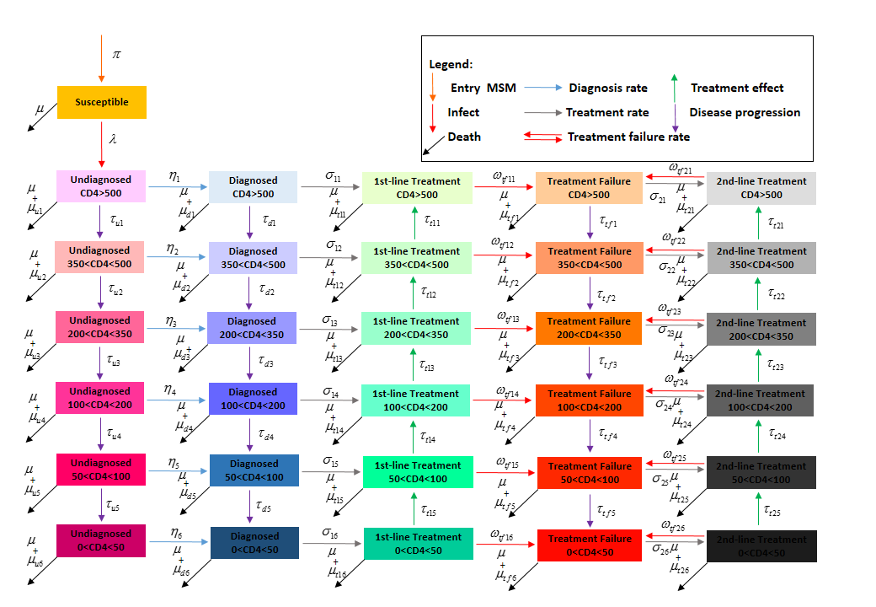Figure S1 HIV epidemic model of MSM population in China.

Note: there are six disease progression stages: (1) susceptible; (2) infected but undiagnosed; (3) diagnosed but untreated; (4) on 1st-line treatment; (5) treatment failure and (6) on 2nd-line treatment, where are all the people living with HIV except in the stage of susceptible which is the only susceptible population of all these stages, and people in the stages of undiagnosed, diagnosed and treatment failure are infectious, The numbers of susceptible MSM and infectious MSM would significantly affect the transmission process.

**Model formulas**

**Uninfected MSM**



**Infected and undiagnosed MSM**

 

**Infected and diagnosed MSM**



**MSM on 1st-line treatment**





**Treatment failure MSM**



**MSM on 2nd-line treatment**



Table S1 Demography and behavioristics parameters of MSM population in China.

|  |  |  |  |
| --- | --- | --- | --- |
| Parameters | Description | Values (min~max) | Source |
| *P* | Total number of MSM in 2000 | 7,500,000 (5,000,000~10,000,000) | 31s |
| *β* | Possibility of HIV transmission per homosexual behavior | 0.020  (0.001~0.030) | Model simulationa |
| *Np* | Numbers of homosexual partners (in the past 12 months) | 9.870  (7.400~12.340) | 32, 3s |
| *Na* | Numbers of homosexual behaviors with each partner (in the past 12 months) | 14.460  (8.440~25.680) | 32s |
| *ε* | Effectiveness of condom | 0.820  (0.690~0.950) | 34, 5s |
| *pc* | Condom use rate in last homosexual behavior | 0.616  (0.584~0.648) | 36s |
|  | Numbers of becoming MSM each year | 50,000  (35,000~70,000) | Experts estimationb |

Note: Numbers in brackets are the minimum and maximum of parameter values. a was the result of model simulation ; b was the result of experts estimation according to 1% growth rate annually in MSM population.

Table S2 Biological parameters of MSM population in China.

|  |  |  |  |  |
| --- | --- | --- | --- | --- |
| Parameter | | Viral load | Value | Source |
| The disease progression rate in infected and undiagnosed MSM | | | | |
|  | CD4>500 to 350-500 | | 0.245 (0.226~0.264) | a |
|  | CD4 350-500 to 200-350 | | 0.510 (0.470~0.553) | a37s |
|  | CD4 200-350 100-200 | | 0.600 (0.320~0.880) | 38-10s |
|  | CD4 100-200 50-100 | | 1.000 (0.530~1.470) | 38-10s |
|  | CD4 50-100 <50 | | 1.500 (0.800~2.200) | 33, 7, 10s |
| The disease progression rate in infected and diagnosed MSM | | | | |
|  | CD4>500 to 350-500 | | 0.245 (0.226~0.264) | a37s |
|  | CD4 350-500 to 200-350 | | 0.510 (0.470~0.553) | a37s |
|  | CD4 200-350 to 100-200 | | 0.600 (0.320~0.880) | 32, 9, 10s |
|  | CD4 100-200 to 50-100 | | 1.000 (0.530~1.470) | 32, 9, 10s |
|  | CD4 50-100 to <50 | | 1.500 (0.800~2.200) | 32, 4, 10s |
| The disease progression rate in MSM on 1st-treatment | | | | |
|  | CD4 350-500 to >500 | | 1.626 (1.227~2.041) | b11s |
|  | CD4 200-350 to 350-500 | | 0.800 (0.613~1.020) | b11s |
|  | CD4 100-200 to 200-350 | | 1.664 (1.248~2.080) | b11s |
|  | CD4 50-100 to 100-200 | | 2.027 (1.520~2.534) | b11s |
|  | CD4 <50 to 50-100 | | 3.660 (2.740~4.581) | b11s |
| The disease progression rate in treatment failure MSM | | | | |
|  | CD4>500 to 350-500 | | 0.091 (0.083~0.758) | 12s |
|  | CD4 350-500 to 200-350 | | 0.157 (0.125~2.083) | 12s |
|  | CD4 200-350 to 100-200 | | 0.600 (0.320-0.880) | 32, 9, 10s |
|  | CD4 100-200 to 50-100 | | 1.000 (0.530~1.470) | 32, 9, 10s |
|  | CD4 50-100 to <50 | | 1.500 (0.800~2.200) | 38-10s |
| The disease progression rate in MSM on 2nd-treatment | | | | |
|  | CD4 350-500 to >500 | | 1.626 (1.227~2.041) | b11s |
|  | CD4 200-350 to 350-500 | | 0.800 (0.613~1.020) | b11s |
|  | CD4 100-200 to 200-350 | | 1.664 (1.248~2.080) | b11s |
|  | CD4 50-100 to 100-200 | | 2.027 (1.520~2.534) | b11s |
|  | CD4 <50 to 50-100 | | 3.660 (2.740~4.581) | b11s |
| HIV testing rate | | | | |
|  | CD4>500 | | 0.005 (0.004~0.006) | Model simulationc |
|  | 350<CD4<500 | | 0.005 (0.004~0.006) | Model simulationc |
|  | 200<CD4<350 | | 0.020 (0.015~0.025) | Model simulationc |
|  | 100<CD4<200 | | 0.070 (0.053~0.088) | Model simulationc |
|  | 50<CD4<100 | | 0.200 (0.150~0.250) | Model simulationc |
|  | CD4<50 | | 0.200 (0.150~0.250) | Model simulationc |
| The 1st-treatment rate | | | | |
|  | CD4>500 | | 0.840 (0.630~1.050) | Model simulationd |
|  | 350<CD4<500 | | 0.850 (0.638~1.063) | Model simulationd |
|  | 200<CD4<350 | | 0.870 (0.653~1.088) | Model simulationd |
|  | 100<CD4<200 | | 0.890 (0.668~1.113) | Model simulationd |
|  | 50<CD4<100 | | 0.920 (0.690~1.150) | Model simulationd |
|  | CD4<50 | | 0.950 (0.713~1.188) | Model simulationd |
| The 2nd-treatment rate | | | | |
|  | CD4>500 | | 0.050 (0.038~0.063) | Model simulationd |
|  | 350<CD4<500 | | 0.051 (0.038~0.064) | Model simulationd |
|  | 200<CD4<350 | | 0.052 (0.039~0.065) | Model simulationd |
|  | 100<CD4<200 | | 0.053 (0.040~0.067) | Model simulationd |
|  | 50<CD4<100 | | 0.055 (0.041~0.069) | Model simulationd |
|  | CD4<50 | | 0.057 (0.043~0.071) | Model simulationd |
| The 1st-treatment failure rate | | | | |
|  | CD4>500 | | 0.043 (0.032~0.054) | 13s |
|  | 350<CD4<500 | | 0.043 (0.032~0.054) | 13s |
|  | 200<CD4<350 | | 0.043 (0.032~0.054) | 13s |
|  | 100<CD4<200 | | 0.043 (0.032~0.054) | 13s |
|  | 50<CD4<100 | | 0.043 (0.032~0.054) | 13s |
|  | CD4<50 | | 0.043 (0.032~0.054) | 13s |
| The 2nd-treatment failure rate | | | | |
|  | CD4>500 | | 0.231 (0.161~0.300) | 13s |
|  | 350<CD4<500 | | 0.231 (0.161~0.300) | 13s |
|  | 200<CD4<350 | | 0.231 (0.161~0.300) | 13s |
|  | 100<CD4<200 | | 0.231 (0.161~0.300) | 13s |
|  | 50<CD4<100 | | 0.231 (0.161~0.300) | 13s |
|  | CD4<50 | | 0.231 (0.161~0.300) | 13s |
| Death rate | | | | |
|  | Background death rate | | 0.007 (0.005~0.009) | 13s |
|  | Infected and undiagnosed: CD4>500 | | 0.050 (0.038~0.063) | Assumed to be 10% higher than rates in ‘infected and diagnosed’ individuals |
|  | Infected and undiagnosed: 350<CD4<500 | | 0.100 (0.075~0.125) |
|  | Infected and undiagnosed: 200<CD4<350 | | 0.500 (0.375~0.625) |
|  | Infected and undiagnosed: 100<CD4<200 | | 0.800 (0.600~1.000) |
|  | Infected and undiagnosed: 50<CD4<100 | | 0.800 (0.600~1.000) |
|  | Infected and undiagnosed: CD4<50 | | 0.900 (0.675~1.125) |
|  | Infected and diagnosed: CD4>500 | | 0.045 (0.034~0.056) | Expert estimate,  14, 15 |
|  | Infected and diagnosed: 350<CD4<500 | | 0.090 (0.068~0.113) |
|  | Infected and diagnosed: 200<CD4<350 | | 0.450 (0.338~0.563) |
|  | Infected and diagnosed: 100<CD4<200 | | 0.720 (0.540~0.900) |
|  | Infected and diagnosed: 50<CD4<100 | | 0.720 (0.540~0.900) |
|  | Infected and diagnosed: CD4<50 | | 0.810 (0.608~1.013) |
|  | On 1st-treatment: CD4>500 | | 0.017 (0.010~0.028) | 13s |
|  | On 1st-treatment: 350<CD4<500 | | 0.027 (0.015~0.048) | 13s |
|  | On 1st-treatment: 200<CD4<350 | | 0.011 (0.002~0.020) | 13s |
|  | On 1st-treatment: 100<CD4<200 | | 0.140 (0.105~0.175) | 13s |
|  | On 1st-treatment: 50<CD4<100 | | 0.110 (0.083~0.138) | 13s |
|  | On 1st-treatment: CD4<50 | | 0.195 (0.120~0.270) | 16, 17s |
|  | Treatment failure: CD4>500 | | 0.045 (0.034~0.056) | Assumed to be identical to the rate in ‘infected and diagnosed’ individuals |
|  | Treatment failure: 350<CD4<500 | | 0.090 (0.068~0.113) |
|  | Treatment failure: <CD4<350 | | 0.450 (0.338~0.563) |
|  | Treatment failure: <CD4<200 | | 0.720 (0.540~0.900) |
|  | Treatment failure: 50<CD4<100 | | 0.720 (0.540~0.900) |
|  | Treatment failure: <50 | | 0.810 (0.608~1.013) |
|  | On 2nd-treatment: CD4>500 | | 0.170 (0.102~0.281) | 18s |
|  | On 2nd-treatment: 350<CD4<500 | | 0.271 (0.154~0.477) | 18s |
|  | On 2nd-treatment: 200<CD4<350 | | 0.011 (0.002~0.020) | 12s |
|  | On 2nd-treatment: 100<CD4<200 | | 0.140 (0.105~0.175) | 16s |
|  | On 2nd-treatment: 50<CD4<100 | | 0.110 (0.083~0.138) | 16s |
|  | On 2nd-treatment: CD4<50 | | 0.195 (0.120~0.270) | 16, 17s |

Notes: Numbers in brackets are the maximum and minimum of the parameter values.

a was calculated by the average number of CD4 count annual descent in infection;

b was calculated by the average number of CD4 count annual rising in treatment;

c was the result of mathematical model simulation and was correspond with the number of new diagnosed MSM in China;

d the 1st-line and 2nd-line treatment rate were calculated by mathematical model simulation and were correspond with the number of MSM on treatment and the coverage rate of treatment after 2003 in China.

Table S3 Item costs for HIV testing and treatment per annum among MSM.

|  |  |  |  |  |
| --- | --- | --- | --- | --- |
| Indicators | Types | Estimated Cost ($) | Times  /year | Sources |
| HIV testing | Screening | 3.6 | 2 | 19s |
|  | Confirmation | 82.4 | -- | 19s |
| ART | 1st-line treatment | 473.0 | -- | a20s |
|  | 2nd-line treatment | 1488.0 | -- | a21s |
| Viral load testing |  | 102.7 | 1 | a22s |

Notes: the average cost per person-year =estimated value × times per year. (Unit: US$)

In the recent ten years (2005-2014), the yuan's exchange rate with the U. S. dollar is 6.89.

a the cost of 1st-line treatment, 2nd-treatment and viral load testing referenced the central subsidies special funding allocation table of HIV/AIDS prevention and control in Guangdong Province in 2012.

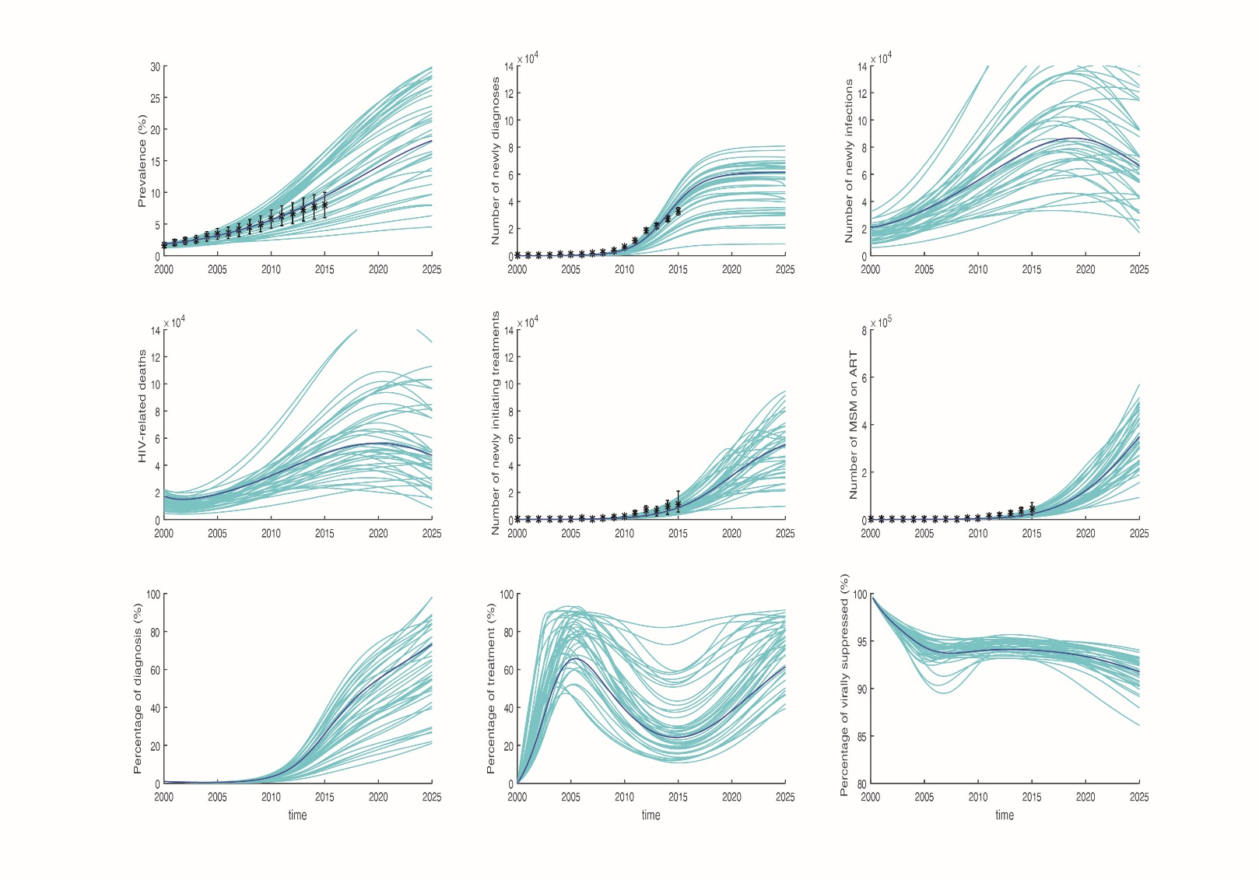

**Figure S2. Calibrated HIV epidemic curves forecast the trend of the epidemic in MSM in China, 2000 - 2025. Asterisk represents collected data; the cyan curves represents 50 simulations and the dark blue line is the median curve of the simulations.**

**References**

1. Chuanren W. The research status of men who have sex with men in China. *Practical Preventive Medicine.* 2009;16(3):985-986.

2. Zhang L, Chow EP, Wilson DP. Distributions and trends in sexual behaviors and HIV incidence among men who have sex with men in China. *BMC Public Health.* Jul 24 2012;12:546.

3. Zhang L, Fung Chow EP, Wilson DP. Men who have sex with men in China have relatively low numbers of sexual partners. *Infect Dis Rep.* Mar 08 2011;3(1):e10.

4. Weller SC. A meta-analysis of condom effectiveness in reducing sexually transmitted HIV. *Soc Sci Med.* Jun 1993;36(12):1635-1644.

5. Holmes KK, Levine R, Weaver M. Effectiveness of condoms in preventing sexually transmitted infections. *Bull World Health Organ.* Jun 2004;82(6):454-461.

6. Chow EP, Wilson DP, Zhang L. Patterns of condom use among men who have sex with men in China: a systematic review and meta-analysis. *AIDS Behav.* Apr 2012;16(3):653-663.

7. Mellors JW, Munoz A, Giorgi JV, et al. Plasma viral load and CD4+ lymphocytes as prognostic markers of HIV-1 infection. *Ann Intern Med.* Jun 15 1997;126(12):946-954.

8. May M, Wood R, Myer L, et al. CD4(+) T cell count decreases by ethnicity among untreated patients with HIV infection in South Africa and Switzerland. *J Infect Dis.* Dec 1 2009;200(11):1729-1735.

9. Mussini C, Cossarizza A, Sabin C, et al. Decline of CD4(+) T-cell count before start of therapy and immunological response to treatment in antiretroviral-naive individuals. *Aids.* May 15 2011;25(8):1041-1049.

10. Patrikar S, Basannar DR, Bhatti VK, Kotwal A, Gupta RM, Grewal RS. Rate of decline in CD4 count in HIV patients not on antiretroviral therapy. *Med J Armed Forces India.* Apr 2014;70(2):134-138.

11. Wang. M. The clinical research of highly active anti-retroviral therapy in people living with HIV/AIDS and the express of high mobility group box-1 protein. 2010.

12. Ledergerber B, Lundgren JD, Walker AS, et al. Predictors of trend in CD4-positive T-cell count and mortality among HIV-1-infected individuals with virological failure to all three antiretroviral-drug classes. *Lancet.* Jul 3-9 2004;364(9428):51-62.

13. Yufang Zheng LL, Renfang Zhang, Yinzhong Shen, Tangkai Qi, Jiangrong Wang, Hongzhou Lu. Analysis of the causes of switching first-line antiretroviral agents in treatment naive HIV/AIDS patients in Shanghai. *Chin J Infect Chemother.* 2012;12(1):5-9.

14. Ning C, Smith KM, McCann CD, et al. Outcome of Sentinel Hospital-based and CDC-based ART Service Delivery: A Prospective Open Cohort of People Living with HIV in China. *Scientific Reports.*

15. Chen M, Dou Z, Wang L, et al. Gender differences in outcomes of antiretroviral treatment among HIV-infected patients in China: a retrospective cohort study, 2010-2015. *J Acquir Immune Defic Syndr.* Jul 08 2017.

16. Barth RE, van der Meer JT, Hoepelman AI, et al. Effectiveness of highly active antiretroviral therapy administered by general practitioners in rural South Africa. *Eur J Clin Microbiol Infect Dis.* Oct 2008;27(10):977-984.

17. Zhao Y, Shi CX, McGoogan JM, Rou K, Zhang F, Wu Z. Methadone maintenance treatment and mortality in HIV-positive people who inject opioids in China. *Bull World Health Organ.* Feb 1 2013;91(2):93-101.

18. Masiira B, Baisley K, Mayanja BN, Kazooba P, Maher D, Kaleebu P. Mortality and its predictors among antiretroviral therapy naive HIV-infected individuals with CD4 cell count >/=350 cells/mm(3) compared to the general population: data from a population-based prospective HIV cohort in Uganda. *Glob Health Action.* 2014;7:21843.

19. Yue Yiji LJ, Zheng Yujian, Hu Xiaoyuan, Xie Huiling, Bai Simin. Cost-effectiveness analysis on the HIV voluntary counseling and testing in Xinjiang. *Journal of Xinjiang Medical University.* 2013;36(2):241-244.

20. Zhiwei G. Analysis of the direct medical cost of national free antiretroviral treatment for HIV/AIDS patients. *Chinese Peking Union Medical College.* 2008.

21. Ju Lahong ZG, Xu Peng, Xin Qianqian, Zeng Ji, Lv Fan. Unit cost of antiretroviral treatment of HIV/AIDS cases. *Chinese Journal of Public Health.* 2013;29(011):1580-1583.

22. Xiao Xin SQ, Liu Wei, Zang Ning, Bi Zhiyou, Zhou Ping, Liang Bingyu, Jiang Junjun, Shao Yiming, Liang Hao. The RT-PCR testing method for HIV-1 viral load. *Chinese Journal of public health.* 2011;27(3):273-274.