**Figure S1.** Forest plot of prevalence estimates obtained from samples of women of reproductive age of the general population, by sampling strategy

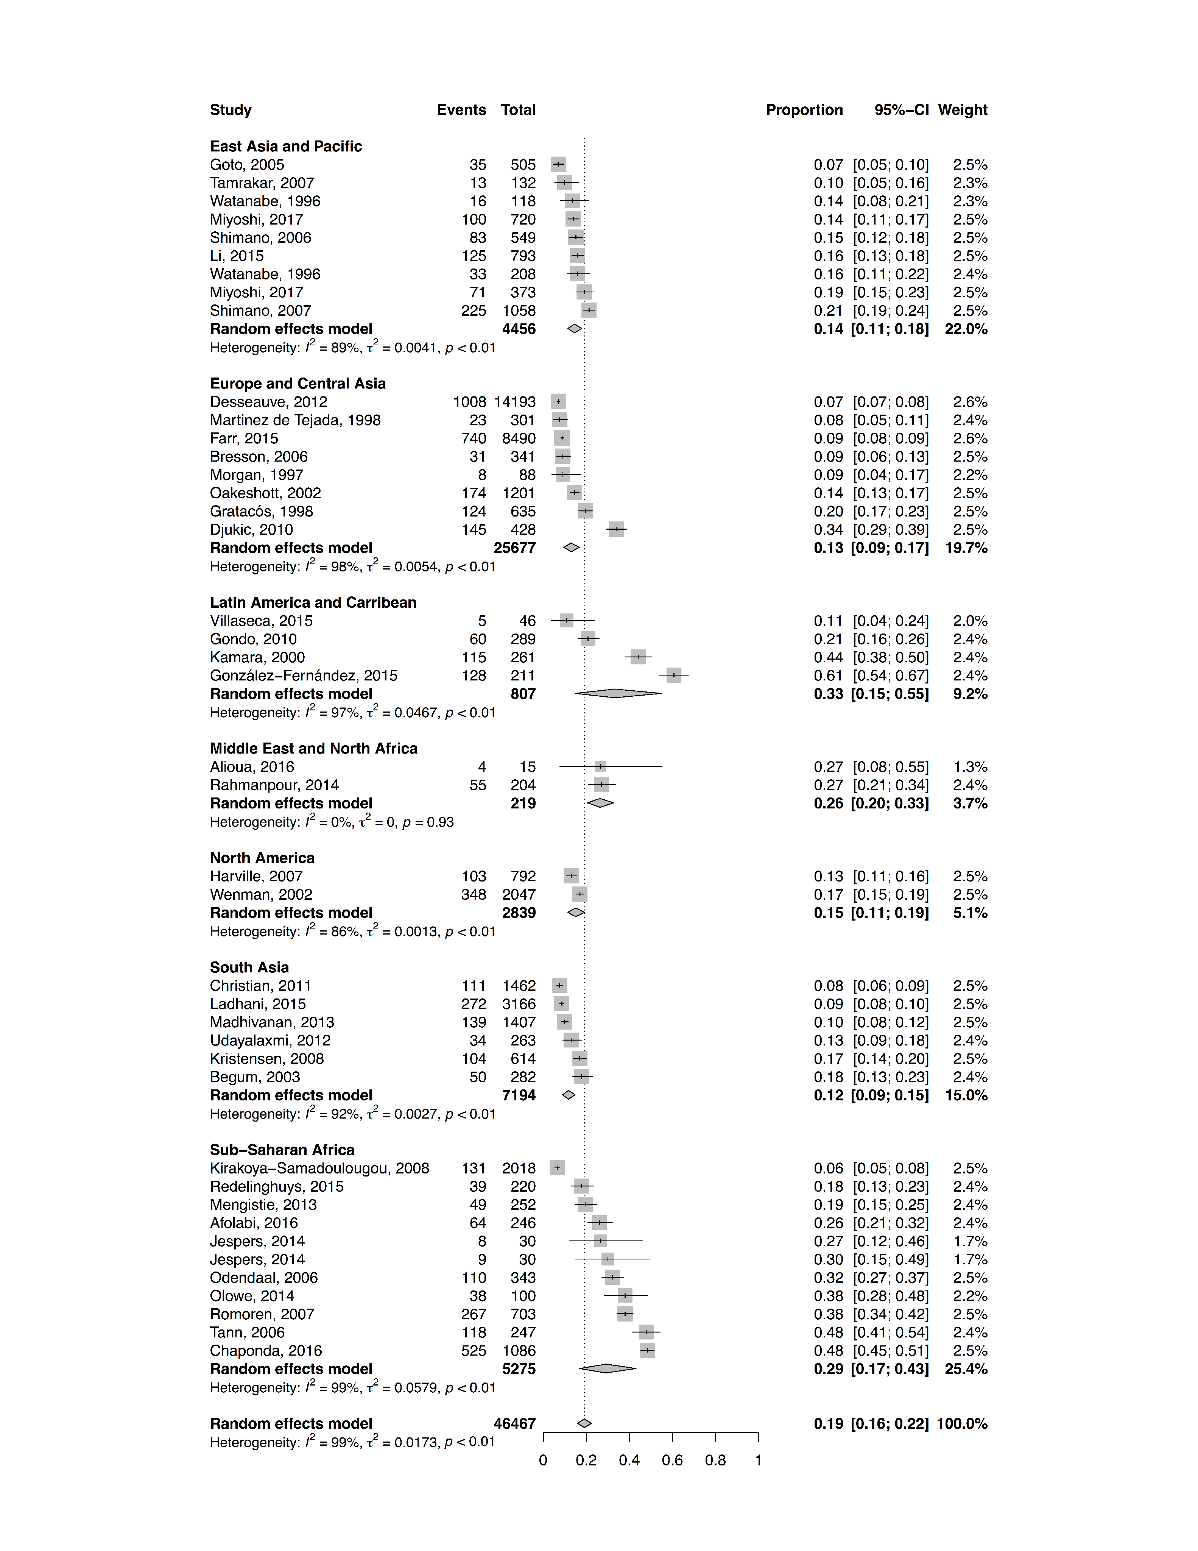**Figure S2.** Forest plot of prevalence estimates obtained from samples of pregnant women, by World Bank region