Technical Appendix – Population-Level Benefits of Extragenital Gonorrhea Screening among Men Who Have Sex with Men: An Exploratory Modeling Analysis

We built an agent-based model of HIV and gonorrhea transmission in R (Version 1.0.153) using the EpiModelHIV platform (Version 1.5.0-001). Men can be in main, casual, or instant (i.e. one-time) partnerships. EpiModelHIV estimates the network structure using separable temporal exponential family random graph models (STERGMs), and preserves the degree distribution of main/casual partnerships, the rate of instant partnerships by main/casual degree, risk quintiles of numbers of instant partnerships, race mixing, age mixing, and sexual role mixing. The network allows for births, deaths, and aging, and simulates HIV and gonorrhea transmission on top of this dynamic network. EpiModelHIV is described in extensive detail within the technical appendix of Jenness et al. 2018 (1). Our technical appendix focuses on the data sources and assumptions of new parameters added to EpiModelHIV for our model, along with further calibration details.

PARAMETERS

We used the same parameters as those detailed in another modeling paper using EpiModelHIV (1), except where described in Table S1. Data on pharyngeal and ororectal sex behaviors among men who have sex with men (MSM) were limited, and for many of the parameters we made assumptions given the best available data. Race-specific values were assumed to be the same unless detailed below. Table S1 includes only fixed parameters. Table S3 includes additional parameters that were calibrated.

Table S1.

Model Network Statistics and Fixed Parameters New or Modified from the Original EpiModelHIV

Name | Definition | Value | References
Main/casual degree distribution, any sex | Matrix of the fraction of men in the network (i.e. the degree distribution) with 0 or 1 main and 0, 1, or 2+ casual partners for any sex type (i.e. anal, orogenital, or ororectal sex). | Black:  0C 1C 2+C  0M 0.253 0.338 0.119  1M 0.165 0.092 0.033  White:  0C 1C 2+C  0M 0.218 0.327 0.169  1M 0.171 0.072 0.044 | The initial degree distribution was from two Atlanta MSM sexual network studies (1) that included only anal sex partnerships. To account for orogenital and ororectal sex partnerships as well, we adjusted the degree distribution following a literature review. Given a dearth of data on orogenital and ororectal sex partnerships, we made several assumptions to adjust the degree distribution:  - The proportion of men in main partnerships does not change (i.e. there are no main partnerships in which partners only have orogenital and/or ororectal sex).  - Some men in 0 main / 0 casual anal sex partnerships would be in orogenital and/or ororectal sex only partnerships. We assumed that twice as many men in casual partnerships were engaged in orogenital sex as anal sex, and that half of the men in 0 main / 0 casual anal sex partnerships were in orogenital and/or ororectal sex only partnerships (2). This 50% was redistributed evenly among the 0 main / 1 casual and 0 main / 2+ casual categories.  - Some men in 1 main anal sex partnership have additional orogenital and/or ororectal sex only partnerships, but this proportion is smaller than for men in 0 main anal sex partnerships. We therefore redistributed 20% of the men in this category (0.5 * (proportion of men in 1M OC / proportion of men in 0M OC)).
Instant partner rate: any sex | Average number of instant partnerships (i.e. anal, orogenital, and/or ororectal sex) per day, broken out by the number of main and casual partners. | Black:  0C 1C 2+C  0M 0.015603 0.019431 0.017228  1M 0.011868 0.011136 0.011136  White:  0C 1C 2+C  0M 0.012279 0.018026 0.019536  1M 0.012227 0.012512 0.012512 | We found no data on the breakdown of sex acts for instant encounters following a literature review, and did not have the original data behind the anal sex partnership quintiles (1). We assumed that the rates would increase by 50% with the addition of orogenital and ororectal sex.
Quintile distribution of instant partnership risk groups: any sex | Distribution of instant partnerships (i.e. anal, orogenital, and/or ororectal sex) rates split into quintiles to capture underlying high and low risk phenotypes that are fixed (these are in addition to the differences by relational status) per day. | Black:  0, 0.0021855, 0.008304, 0.015774, 0.045339  White:  0, 0.0006750, 0.007653, 0.014520, 0.049455
Sex role mixing: orogenital and ororectal sex | Proportion exclusively insertive, exclusively receptive, and versatile during orogenital or ororectal sex. | Black:  0, 0, 1  White:  0, 0, 1 | We followed the same approach used by a paper analyzing MSM sexual role preferences during orogenital sex using data from the 2002 cycle of the National Survey of Family Growth (NSFG) (3). The paper reviewed responses to questions about whether US 15-44 year-old non-Hispanic black and white men had ever performed or received orogenital sex on/from a male. We applied this approach to 2011-2015 NSFG data to obtain more recent estimates (4). The results yielded very high estimates of versatility for orogenital sex (<1.5% for each race and sexual role), but the level was assumed to hold for orogenital sex after reviewing other papers asking about more recent sex acts (5, 6). Given that the results were close to 100% versatility, we set this as the value. We found no data on explicit sexual role preferences for ororectal sex following a review, and assumed the same role mixing as for orogenital sex.
Sexual act probabilities: anal, orogenital and ororectal sex | Probability of engaging in a sex act during a given time period in a partnership after it has formed. | Anal sex:  1 (main), 0.36 (casual or instant)  Orogenital sex:  0.75 (all partnership types)  Ororectal sex:  0.24 (all partnership types) | We assumed that sex act probabilities do not vary across partnership types, with the exception that all main partnerships engage in anal sex. To find the remaining sex act probabilities, we reviewed a 2010 internet-based survey of 24,787 gay and bisexual men from the United States that recorded reported sexual behaviors during the most recent male-partnered sexual event (5). We averaged values for insertive and receptive roles and also across age groups since they were similar.
Scalars for base sex act rate: orogenital and ororectal sex | Scalar for the number of orogenital or ororectal sex acts per day – applied to the anal sex estimate. | Orogenital sex:  - (main), 1.22 (casual)  Ororectal sex:  0.30 (main or casual) | We followed the assumptions made in another site-specific gonorrhea modeling paper for orogenital sex (2):  - MSM in main partnerships have the same anal and orogenital sex act rates.  - 82.5% of MSM in casual partnerships engage in orogenital sex, with 1-10 acts per partnership. The average length of casual partnerships is 12-14 days, resulting in a maximum range of 0.07 (1/14) to 0.83 (10/12) orogenital sex acts per day and an average of 0.45. This compares to a maximum range of 0.07 (1/14) to 0.67 (8/12) acts per day and an average of 0.37 for anal sex. We divided 0.45 by 0.37 to obtain a scalar value of 1.22.  The paper did not provide act rate estimates for ororectal sex. The best estimate came from a sexual behavior survey (5) reporting that, across all races and partnership types, 36.38% of MSM had anal sex during last sex, 74.97% orogenital sex, and 23.6% ororectal sex. We made a rough assumption based on this data that the expected number of rimming acts per day was 0.30 times that of orogenital sex (23.60/74.97).
Condom use: anal sex | Probability of condom use in an anal sex partnership. | Black-black:  0.15 (main), 0.19 (casual), 0.19 (instant)  Black-white:  0.21 (main), 0.26 (casual), 0.27 (instant)  White-white:  0.34 (main), 0.42 (casual), 0.43 (instant) | We used race-specific values from another paper also using EpiModelHIV that calibrated these values within their 95% confidence intervals to reproduce observed racial disparities (1).
Scalar for condom use: orogenital and ororectal sex | Scalar for probability of condom use during orogenital or ororectal sex – applied to the anal sex condom use probabilities. | Orogenital sex:  0.37 (all partnership types)  Ororectal sex:  0 (all partnership types) | For the orogenital sex estimate, we restricted NSFG data (4) on condom use during last anal and last orogenital sex to black and white MSM, and then compared the values for anal (0.552) and orogenital (0.203) sex to arrive at an orogenital sex condom use scalar of 0.37 (0.203/0.552). We did not directly use the orogenital sex condom use value because the baseline values for anal sex condom use were substantially higher than those used by other models (1) (potentially due to the fact that NSFG does not break out data by partnership type (4)). We also looked at NHANES orogenital sex condom use responses, but the numbers for MSM were very small.  For ororectal sex, we conducted a review and found no data on barrier use and therefore assumed it to be unprotected.
Correlation coefficient for condoms: orogenital sex | Correlation coefficient for probability of always using condoms in both casual and instant orogenital sex. | 0.5 | We assumed the same value as for anal sex.
Gonorrhea symptoms: pharyngeal | Probability of any pharyngeal symptoms given a gonorrhea infection. | 0 | We found that numerous papers and models have assumed pharyngeal gonorrhea to be 100% or nearly 100% asymptomatic (2, 7-10). Given the vagueness and relative mildness of any potential symptoms, we assumed the value to be 0.
Gonorrhea transmission: rectal to pharyngeal | Probability of contracting pharyngeal gonorrhea per ororectal sex act with a rectal gonorrhea positive partner. | 0.05 | Fewer data are available for ororectal sex transmission probabilities compared to those for anal and orogenital sex. There is mixed evidence on whether ororectal sex is a risk factor for rectal or pharyngeal gonorrhea (11, 12). Gonorrhea has been isolated from saliva – which is commonly used as a lubricant in various types of sex acts (13) – but its role in infection remains unclear (11). We established a plausible range of 0-10% based on the available data, and fixed the values at the range midpoint (2, 11-14).
Gonorrhea transmission: pharyngeal to rectal | Probability of contracting rectal gonorrhea per ororectal sex act with a pharyngeal gonorrhea positive partner. | 0.05
Urogenital gonorrhea screening probability | Probability of an asymptomatic undiagnosed man being screened at the urogenital site each week. | 0.00978 | We extrapolated a value from another model’s national estimate of the annual MSM screening rate (15). This model estimated that approximately 40% of MSM would be screened at least once in a year. We transformed this value to a per-week probability using the formula P = 1 – (1-Y)^(1/52), where Y = the proportion screened at least once per year.
Rectal or pharyngeal gonorrhea screening probability | Probability of an asymptomatic undiagnosed man being screened at the urogenital site also being screened at the rectal or pharyngeal site – this is applied independently for each extragenital site. | 0.375 | Site-specific asymptomatic screening estimates, particularly for extragenital sites, were highly variable based on setting, patient, and geographic location (16-20). Almost all of the data we found were from STI clinics, and often focused on a subset of the MSM patient population (e.g., HIV-positive MSM, MSM who were screened at all three anatomic sites). Given this variability, we looked at the interquartile range for the proportion of men extragenitally tested across the studies, established an estimate of 25-50% for each site, and used the 37.5% midpoint.

CALIBRATION

Targets

The model was calibrated to 1) race- and site-specific gonorrhea prevalence and incidence data and 2) race-specific HIV prevalence data. All targets were derived from the Atlanta HIV and STI studies with the exception of pharyngeal gonorrhea (21, 22). We did not calibrate to a white urogenital gonorrhea prevalence target because its value was zero (22), and report the final burn-in value in Table S2. In addition, we assumed that the estimate for urogenital gonorrhea incidence was reflective of asymptomatic infections since study visits took place every 3-6 months, and symptomatically infected men (the most common scenario in the case of a urogenital infection) would be likely to seek care in between study visits. Also, the estimated duration of untreated urogenital gonorrhea ranges from approximately 6-12 months (1), so asymptomatic cases would likely be detected by a screening interval of 3-6 months before naturally recovering. These studies did not measure pharyngeal gonorrhea, and we conducted a literature review to determine target values. We found two studies providing pharyngeal gonorrhea incidence estimates (9, 12) and five providing prevalence estimates (2, 9, 12, 14, 19, 23). For pharyngeal gonorrhea incidence, we used an estimate from a 2001-2003 cohort of MSM in San Francisco, CA in which men were prospectively followed and tested at the pharynx every 6 months using NAATs, regardless of symptoms (9). This study was superior to the other study we found, which studied non-U.S. populations and indirectly estimated incidence using a combination of positivity data and duration estimates (12). However, the population was 71% white and only 6% black, so we assumed this to be an estimate for white MSM pharyngeal gonorrhea incidence and did not calibrate to a target for black MSM. Our prevalence estimate was also obtained from this population. We evaluated the suitability of using these estimates for pharyngeal gonorrhea along with the urogenital and rectal gonorrhea estimates from the Atlanta study (21, 22) by looking at the 95% confidence intervals. The intervals for white urogenital and rectal gonorrhea incidence and prevalence estimates from the California study (9) overlapped with those from the Atlanta study (21, 22), so we concluded that the difference between the estimates for these two populations was not necessarily statistically significant.

Approach

We initialized a population of 10,000 MSM, and seeded race-specific HIV and race- and site-specific gonorrhea at the target prevalence. We then used approximate Bayesian computation with sequential Monte Carlo sampling (ABC-SMC) (Lenormand method) via the EasyABC package (Version 1.5) to estimate values for parameters of interest. ABC-SMC sequentially estimates the posterior distribution by creating intermediate distributions that converge on the posterior distribution. This method is useful for models in which the likelihood is either impossible or computationally inefficient to evaluate, and instead replaces likelihood calculation with a comparison between the observed calibration targets and the simulated calibration output (24).

Estimated parameters included race-specific anal and orogenital sex act rate scalars, race-specific HIV and STI condom failure probabilities, untreated pharyngeal gonorrhea duration, and anal and orogenital sex transmission probabilities. Scalars were used for anal sex act rates given the impracticality of individually calibrating each of the race- and partnership-specific values, in addition to the other orogenital and ororectal sex parameters around which we had uncertainty. In the two Atlanta studies, black MSM had significantly lower risk behaviors compared to white MSM, but much higher HIV and gonorrhea prevalence and incidence (1), making it challenging to reproduce these observed racial disparities in the model. The reasons for this are complex and not completely understood (22, 25). However, by calibrating the act rate scalars and condom failure probabilities using priors based on 95% confidence intervals, we were able to reproduce the observed racial disparities while remaining within the bounds of the observed data.

Results

To arrive at our final burn-in model, we followed three steps: 1) choose the best calibration strategy, 2) select the best parameter set resulting from the calibration, and 3) pick the best simulation using the selected parameter set (i.e. the burn-in model). The model was calibrated over 50 years, with the targets compared to the simulated data from the last 10 years. Based on the specifications we gave the calibration algorithm, when the calibration completed, we had 40 accepted sets of the 15 estimated parameters. To decide on a calibration strategy, we first took the weighted means for each parameter across the sets and evaluated the results (Table S2, Initial Calibration Result). We assessed the success of our initial calibration by determining whether the model was able to generate simulated data within the 95% confidence intervals. In this initial calibration, we were unable to reproduce the incidence targets or the HIV prevalence target for black MSM, but by relatively small margins. We then sampled 200 times from the 40 accepted parameter sets with replacement, ran the model for 50 years using each sampled parameter set, and measured the Euclidean distance between the simulated data and the targets from the last 10 years. The parameter set resulting in the smallest distance between the data and targets was selected. Using this final parameter set (Table S3), we ran the model 32 times and selected the simulation resulting in, once again, the smallest distance to the targets and the most stable equilibrium. This simulation became our burn-in model (Table S2, Final Burn-In Value). We reproduced all of our targets with their 95% confidence intervals, excluding asymptomatic urogenital incidence for white MSM, rectal incidence for white MSM, rectal prevalence for black MSM, and pharyngeal prevalence for white MSM, which all deviated slightly from the targets.

Table S2.

Initial Calibration Results and Final Burn-In Values

Target | Point Estimate | 95% Confidence Interval | Initial Calibration Result | Final Burn-In Value | Source
Gonorrhea Incidence per 100 Person-Years
Urogenital – Black (Asymptomatic) | 2.2 | 0.9, 4.3 | 5.4 | 4.1 | (21)
Urogenital – White (Asymptomatic) | 0.2 | 0.0, 1.2 | 2.8 | 1.8
Rectal – Black | 9.4 | 6.3, 13.4 | 16.6 | 13.4
Rectal – White | 3.7 | 2.1, 6.1 | 8.9 | 6.4
Pharyngeal – Black | ^{b} | ^{b} | ^{b} | 20.0 | N/A
Pharyngeal – White | 11.7 | 8.8, 15.3 | 15.8 | 10.1 | (9)
Gonorrhea Prevalence
Urogenital – Black | 0.03 | 0.01, 0.04 | 0.04 | 0.03 | (22)
Urogenital – White | 0.00 | - | ª | 0.01
Rectal – Black | 0.11 | 0.07, 0.15 | 0.07 | 0.06
Rectal – White | 0.03 | 0.01, 0.09 | 0.04 | 0.03
Pharyngeal – Black | ^{b} | ^{b} | ^{b} | 0.07 | N/A
Pharyngeal – White | 0.06 | 0.05, 0.08 | 0.06 | 0.04 | (9)
HIV Incidence per 100 Person-Years
Black | 6.5 | 4.2, 9.7 | ª | 6.6 | (21)
White | 1.7 | 0.7, 3.3 | ª | 1.3
HIV Prevalence
Black | 0.43 | 0.39, 0.48 | 0.38 | 0.40 | (22)
White | 0.13 | 0.10, 0.17 | 0.12 | 0.11

ª We did not include this as a calibration target since the value was 0, and only report the final burn-in value.

^{b} Due to a lack of data, we did not have a calibration target for this and only reported the final burn-in value.

Table S3.

Calibrated Parameter Priors and Posteriors
Parameter | Definition | Posterior | Priors (Uniform) | References
Anal sex act rate scalars | Scalar for anal sex act rates in main and casual partnerships (instant rate is fixed at 1). | Black-black:  1.52  Black-white:  1.02  White-white:  0.91 | Black-black:  0.65 - 1.55  Black-white:  0.64 - 1.35  White-white:  0.70 - 1.10 | Priors were the values that would allow race-averaged partnerships to be calibrated within the full range of the 95% confidence interval for each partnership type (1). The values for main and casual partnerships were very similar and the same priors were used. We used the same priors for orogenital sex given a lack of data (orogenital sex was not included in the original studies and so 95% confidence intervals could not be obtained).
Orogenital sex act rate scalars | Scalar for orogenital sex act rates for main and casual partnerships (instant rate is fixed at 1). | Black-black:  1.13  Black-white:  0.69  White-white:  0.97 | Black-black:  0.65 - 1.55  Black-white:  0.64 - 1.35  White-white:  0.70 - 1.10
HIV condom failure probability | Probability of condom failure for MSM due to human errors for HIV, applied as a reduction in condom efficacy. | Black:  0.39  White:  0.30 | Black:  0.15 - 0.40  White:  0.15 - 0.40 | Priors are from a previous modeling study (1) and are based on estimates of condom efficacy and evidence that condom failure rates among black MSM can be 1-4 times higher than rates among white MSM (26).
Gonorrhea condom failure probability | Probability of condom failure for MSM due to human errors for gonorrhea, applied as a reduction in condom efficacy. | Black:  0.30  White:  0.27 | Black:  0.15 - 0.40  White:  0.15 - 0.40
Gonorrhea transmission: urogenital to rectal | Probability of contracting rectal gonorrhea per anal sex act with a urogenital gonorrhea positive partner. | 0.55 | 0.30 - 0.60 | A previous modeling study (1) conducted a literature review of transmission probabilities, finding a wide range of possible values with heterosexual transmission studies forming the basis of most estimates. They established priors using the middle 50% of estimates, and assumed greater risk for receptive versus insertive anal sex. Most other modeling studies also did this, extrapolating heterosexual transmission values to anal sex and assuming receptive anal sex to be riskier than insertive (2, 11, 14, 27).
Gonorrhea transmission: rectal to urogenital | Probability of contracting urogenital gonorrhea per anal sex act with a rectal gonorrhea positive partner. | 0.20 | 0.20 - 0.50
Gonorrhea transmission: urogenital to pharyngeal | Probability of contracting pharyngeal gonorrhea per orogenital sex act with urogenital gonorrhea positive partner. | 0.38 | 0.20 - 0.50 | A literature review found that several studies hypothesized this to be an important transmission route, though few data exist (2, 11, 12, 27). Model calibrations have yielded much higher urogenital to orogenital (0.40 – 0.63) transmission probabilities than orogenital to urogenital (0.008 – 0.08) (2, 14), and we followed this approach for our calibration.
Gonorrhea transmission: pharyngeal to urogenital | Probability of contracting urogenital gonorrhea per orogenital sex act with a pharyngeal gonorrhea positive partner. | 0.01 | 0.00 - 0.10
Untreated gonorrhea duration: pharyngeal | Average duration in days of untreated pharyngeal gonorrhea infection. | 182 | 100 - 245.83 | Untreated pharyngeal gonorrhea is believed to resolve faster than urogenital or rectal gonorrhea (28), but estimates vary widely. One modeling study (2) used a duration of infection of 84 days from a study of a MSM population undergoing routine screening in which 18 pharyngeal gonorrhea positive individuals were left untreated, asked to not have new sexual partners, and re-cultured every 2 weeks. Other model priors have ranged from 90-138 days (13, 14, 28). We set priors of 100 days up to the fixed duration of urogenital and rectal gonorrhea.

ANALYSIS

Calculations

Given the ability of gonorrhea to infect multiple anatomic sites within the same individual, we calculated gonorrhea outcomes at the level of the infection and the case. The calculation for each outcome is included below. A screen is defined as a test done at a single asymptomatic anatomic site on a patient.

- Site-specific prevalence = (number of infections at a specific site / number of individuals)
- Case prevalence = (number of individuals infected at any site / number of individuals)
- Site-specific infection incidence = (number of new infections at a specific site / number of individuals uninfected at that site)
- Case incidence = (number of new infections in completely uninfected individuals / number of completely uninfected people)
- Proportion of site-specific infections averted = ((cumulative site-specific infection incidence baseline - cumulative site-specific infection incidence scenario) / cumulative site-specific infection incidence baseline)
- Proportion of overall cases averted = ((cumulative case incidence baseline - cumulative case incidence scenario) / cumulative case infection incidence baseline)
- Number of screens needed to avert 1 infection = ((cumulative screens scenario - cumulative screens baseline) / (cumulative infection incidence baseline – cumulative infection incidence scenario))
- Number of screens needed to avert 1 case = ((cumulative screens scenario - cumulative screens baseline) / (cumulative case incidence baseline – cumulative case incidence scenario))

Select results

Race-stratified results for Figure 3 (proportion of baseline infections and cases averted at each site by screening scenario and level) from the manuscript are presented in Figure S-3A and S-3B.

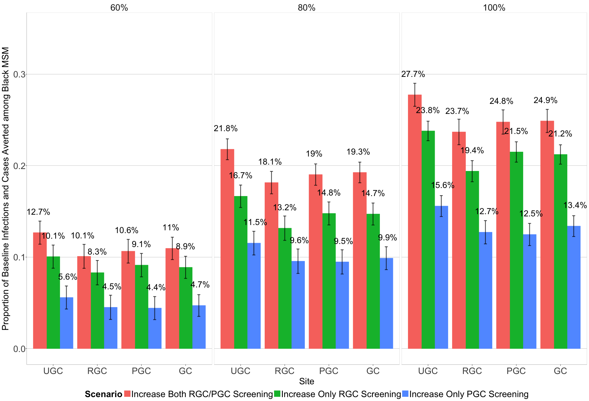
Figure S-3A.

Among black MSM, proportion of baseline site-specific infections (urogenital, rectal and pharyngeal labels) and overall cases (overall label) averted over 10 years (mean and 95% confidence intervals) as the extragenital screening probability among men being urogenitally screened was increased from 37.5% (baseline) to 60%, 80%, and 100%.

Figure S-3B.
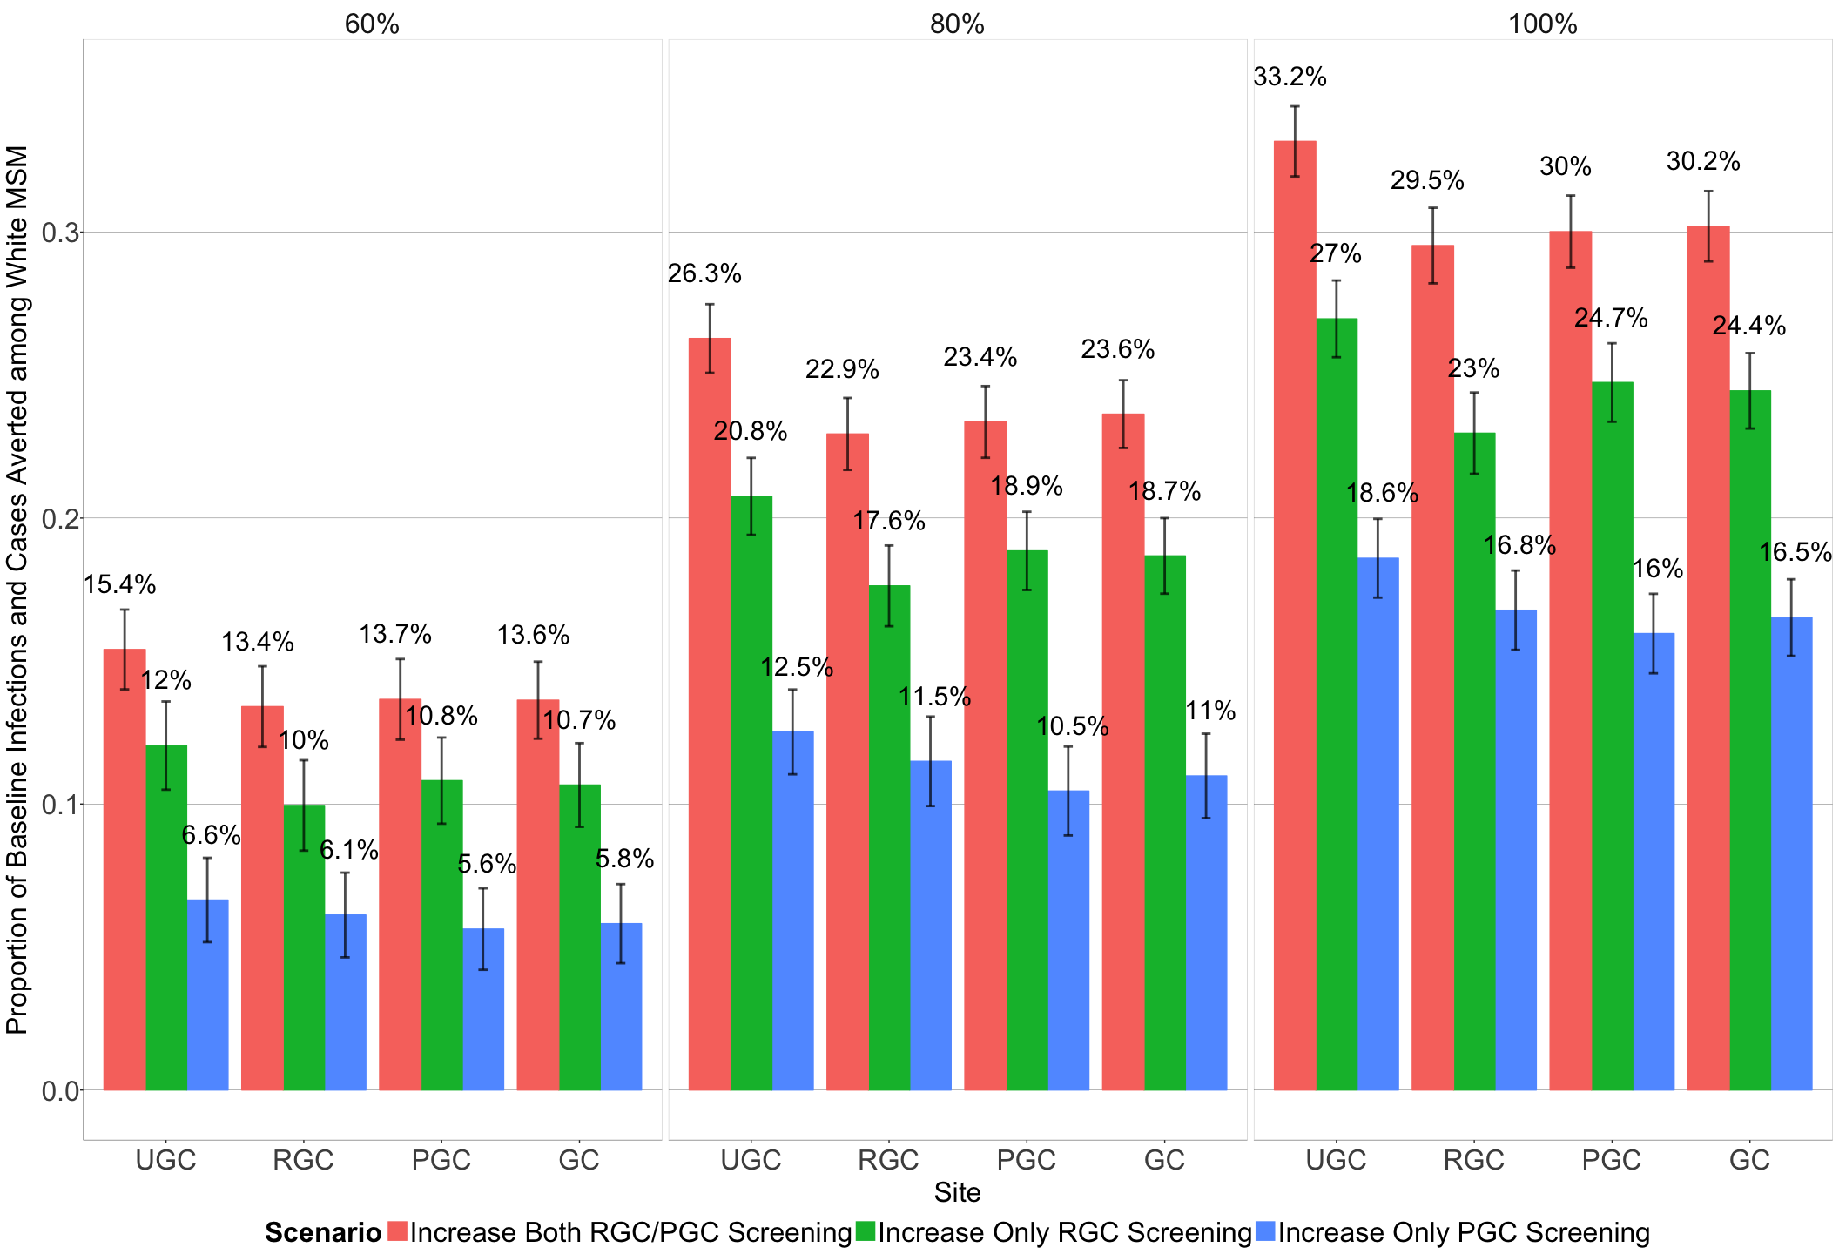

Among white MSM, proportion of baseline site-specific infections (urogenital, rectal and pharyngeal labels) and overall cases (overall label) averted over 10 years (mean and 95% confidence intervals) as the extragenital screening probability among men being urogenitally screened was increased from 37.5% (baseline) to 60%, 80%, and 100%.

REFERENCES

1. Jenness, S.M., K.M. Maloney, D.K. Smith, et al., Addressing Gaps in HIV Preexposure Prophylaxis Care to Reduce Racial Disparities in HIV Incidence in the United States. Am J Epidemiol, 2018.
2. Hui, B., C.K. Fairley, M. Chen, et al., Oral and anal sex are key to sustaining gonorrhoea at endemic levels in MSM populations: a mathematical model. Sex Transm Infect, 2015. 91(5): p. 365-9.
3. Jeffries, W.L.t., A comparative analysis of homosexual behaviors, sex role preferences, and anal sex proclivities in Latino and non-Latino men. Arch Sex Behav, 2009. 38(5): p. 765-78.
4. NCHS.
National Survey of Family Growth: 2011-2015 NSFG: Selected Data and Documentation. 2011-2015; Available from: https://www.cdc.gov/nchs/nsfg/nsfg_2011_2015_puf.htm.
5. Rosenberger, J.G., M. Reece, V. Schick, et al., Sexual behaviors and situational characteristics of most recent male-partnered sexual event among gay and bisexually identified men in the United States. J Sex Med, 2011. 8(11): p. 3040-50.
6. Stokes, J.P., P.A. Vanable, and D.J. McKirnan, Ethnic Differences in Sexual Behavior, Condom Use, and Psychosocial Variables among
Black and White Men Who Have Sex with Men. The Journal of Sex Research, 1996. 33(4): p. 373-381.
7. Beck, E.C., M. Birkett, B. Armbruster, et al., A Data-Driven Simulation of HIV Spread Among Young Men Who Have Sex With Men: Role of Age and Race Mixing and STIs. J Acquir Immune Defic Syndr, 2015. 70(2): p. 186-94.
8. Jebakumar, S.P., C. Storey, M. Lusher, et al., Value of screening for oro-pharyngeal Chlamydia trachomatis infection. J Clin Pathol, 1995. 48(7): p. 658-61.
9. Morris, S.R., J.D. Klausner, S.P. Buchbinder, et al., Prevalence and incidence of pharyngeal gonorrhea in a longitudinal sample of men who have sex with men: the EXPLORE study. Clin Infect Dis, 2006. 43(10): p. 1284-9.
10. Page-Shafer, K., A. Graves, C. Kent, et al., Increased sensitivity of DNA amplification testing for the detection of pharyngeal gonorrhea in men who have sex with men. Clin Infect Dis, 2002. 34(2): p. 173-6.
11. Bernstein, K.T., H. Chesson, R.D. Kirkcaldy, et al., Kiss and Tell: Limited Empirical Data on Oropharyngeal Neisseria gonorrhoeae Among Men Who Have Sex With Men and Implications for Modeling. Sex Transm Dis, 2017. 44(10): p. 596-598.
12. Fairley, C.K., J.S. Hocking, L. Zhang, et al., Frequent Transmission of Gonorrhea in Men Who Have Sex with Men. Emerg Infect Dis, 2017. 23(1): p. 102-104.
13. Chow, E.P., D. Lee, S.N. Tabrizi, et al., Detection of Neisseria gonorrhoeae in the pharynx and saliva: implications for gonorrhoea transmission. Sex Transm Infect, 2016. 92(5): p. 347-9.
14. Zhang, L., D.G. Regan, E.P.F. Chow, et al., Neisseria gonorrhoeae Transmission Among Men Who Have Sex With Men: An Anatomical Site-Specific Mathematical Model Evaluating the Potential Preventive Impact of Mouthwash. Sex Transm Dis, 2017. 44(10): p. 586-592.
15. Tuite, A.R., M.M. Ronn, E.E. Wolf, et al., Estimated Impact of Screening on Gonorrhea Epidemiology in the United States: Insights From a Mathematical Model. Sex Transm Dis, 2018. 45(11): p. 713-722.
16. Barbee, L.A., J.C. Dombrowski, R. Kerani, et al., Effect of nucleic acid amplification testing on detection of extragenital gonorrhea and chlamydial infections in men who have sex with men sexually transmitted disease clinic patients. Sex Transm Dis, 2014. 41(3): p. 168-72.
17. Barbee, L.A., S. Tat, S. Dhanireddy, et al., Implementation and Operational Research: Effectiveness and Patient Acceptability of a Sexually Transmitted Infection Self-Testing Program in an HIV Care Setting. J Acquir Immune Defic Syndr, 2016. 72(2): p. e26-31.
18. Patel, M.R., J.T. Brooks, Y. Tie, et al., Prevalence of Gonorrhea and Chlamydia Testing by Anatomical Site Among Men Who Have Sex With Men in HIV Medical Care, United States, 2013-2014. Sex Transm Dis, 2018. 45(1): p. 25-27.
19. Patton, M.E., S. Kidd, E. Llata, et al., Extragenital gonorrhea and chlamydia testing and infection among men who have sex with men--STD Surveillance Network, United States, 2010-2012. Clin Infect Dis, 2014. 58(11): p. 1564-70.
20. Scarborough, A.P., S. Slome, L.B. Hurley, et al., Improvement of Sexually Transmitted Disease Screening Among HIV-Infected Men Who Have Sex With Men Through Implementation of a Standardized Sexual Risk Assessment Tool. Sex Transm Dis, 2015. 42(10): p. 595-8.
21. Kelley, C.F., A.S. Vaughan, N. Luisi, et al., The Effect of High Rates of Bacterial Sexually Transmitted Infections on HIV Incidence in a Cohort of Black and White Men Who Have Sex with Men in Atlanta, Georgia. AIDS Res Hum Retroviruses, 2015. 31(6): p. 587-92.
22. Sullivan, P.S., J. Peterson, E.S. Rosenberg, et al., Understanding racial HIV/STI disparities in black and white men who have sex with men: a multilevel approach. PLoS One, 2014. 9(3): p. e90514.
23. Kent, C.K., J.K. Chaw, W. Wong, et al., Prevalence of rectal, urethral, and pharyngeal chlamydia and gonorrhea detected in 2 clinical settings among men who have sex with men: San Francisco, California, 2003. Clin Infect Dis, 2005. 41(1): p. 67-74.
24. Toni, T., D. Welch, N. Strelkowa, et al., Approximate Bayesian computation scheme for parameter inference and model selection in dynamical systems. J R Soc Interface, 2009. 6(31): p. 187-202.
25. Goodreau, S.M., E.S. Rosenberg, S.M. Jenness, et al., Sources of racial disparities in HIV prevalence in men who have sex with men in Atlanta, GA, USA: a modelling study. Lancet HIV, 2017. 4(7): p. e311-e320.
26. Kim, M., J. McKenney, C.M. Khosropour, et al., Factors Associated With Condom Breakage During Anal Intercourse: A Cross-Sectional Study of Men Who Have Sex With Men Recruited in an Online Survey. JMIR Public Health Surveill, 2016. 2(1): p. e7.
27. Whittles, L.K., X. Didelot, Y.H. Grad, et al., Testing for gonorrhoea should routinely include the pharynx. Lancet Infect Dis, 2018. 18(7): p. 716-717.
28. Chow, E.P., S. Camilleri, C. Ward, et al., Duration of gonorrhoea and chlamydia infection at the pharynx and rectum among men who have sex with men: a systematic review. Sex Health, 2016. 13(3): p. 199-204.

