Supplemental Materials:
Genomic analysis of the predominant strains and antimicrobial resistance determinants within 1479 Neisseria gonorrhoeae isolates from the U.S. Gonococcal Isolate Surveillance Project in 2018
Jennifer L Reimche, PhD^{1,2}*, Vasanta L Chivukula, PhD^{1,2}*, Matthew W Schmerer, PhD¹, Sandeep J Joseph, PhD, MPH¹, Cau D Pham, PhD¹, Karen Schlanger, PhD¹, Sancta B St Cyr, MD¹, Hillard S Weinstock, PhD¹, Brian H Raphael, PhD¹, Ellen N Kersh, PhD¹, Kim M Gernert, PhD^{1†}
Antimicrobial Resistant Neisseria gonorrhoeae Working Group
¹ Division of STD Prevention, National Center for HIV/AIDS, Viral Hepatitis, STD and TB Prevention, Centers for Disease Control and Prevention, Atlanta, GA USA.
² Oak Ridge Institute for Science and Education Research Participation and Fellowship Program, Oak Ridge, TN USA

*Jennifer L. Reimche and Vasanta Chivukula contributed equally to this paper.
†Corresponding author

Antimicrobial Resistant Neisseria gonorrhoeae Working Group: Sopheay Hun, MBA, Chi Hua, BS, Ryan Ruiz, MS (Antibiotic Resistance Laboratory Network [AR Lab Network], Washington State Department of Health, WA, USA); Olusegun O Soge, PhD (Department of Global Health and Medicine, University of Washington, Seattle, WA, USA); Catherine Dominguez, PhD, Jillian Loomis, BS, Ami Patel, PhD (AR Lab Network, Maryland Department of Health, MD, USA); Jenny Zhang, MD, Tamara Baldwin, BS, Chun Wang, MS, John Leavitt, PhD (AR Lab Network, Texas Department of State Health Services, TX, USA); Christina Moore, BS (AR Lab Network, Tennessee Department of Health, TN, USA); Christian Whelen, PhD, Pamela O’Brien, BS (Hawaii Department of Health State Laboratories Division, HI, USA); Alesia Harvey, BS and Emily Learner, PhD, MPH (Centers for Disease Control and Prevention, National Center for HIV/AIDS, Viral Hepatitis, STD and TB Prevention, Division of STD Prevention, Atlanta, GA USA).

Supplemental Materials
- Supplemental Figure 1. MLST distribution across sentinel sites based on 1479 GISP 1st 5 isolates from the US in 2018
- Supplemental Figure 2A. Distribution of NG-MAST of the 1st 5 isolates
- Supplemental Figure 2B. Distribution of NG-STAR of the 1st 5 isolates.
- Supplemental Figure 3. Maximum likelihood core-genome SNP phylogenetic alignment of 1479 GISP 1st 5 isolates from the U.S. in 2018.
- Supplemental Table 1A. Chi square for AZM with 23S
- Supplemental Table 1B. Chi square for CIP
- Supplemental Table 1C. Chi square for PEN
- Supplemental Table 1D. Chi square for TET
- Supplemental Table 1E. AZM with mosaic mtrR MIC ≥2.0 µg/mL
- Supplemental Table 1F. AZM with mosaic mtrR MIC ≥1.0 µg/mL
- Supplemental Table 1G. TET with PorB MIC ≥2.0 µg/mL
- Supplemental Table 1H. TET with PorB without isolates that have tetM plasmid (n = 1304) MIC ≥2.0 µg/mL
- Supplemental Table 2. Isolates carrying 23S rRNA C2611T variants in fewer than 4 copies
- Bioinformatic Methods
  - Supplemental Table 3: AMR Profiler Definition of Genomic and Protein Variants
  - Supplemental Table 4: Bioinformatics Methods and References.

- References
- Supplemental References.

Supplemental Figure 1. MLST distribution across sentinel sites based on 1479 GISP 1st 5 isolates from the US in 2018
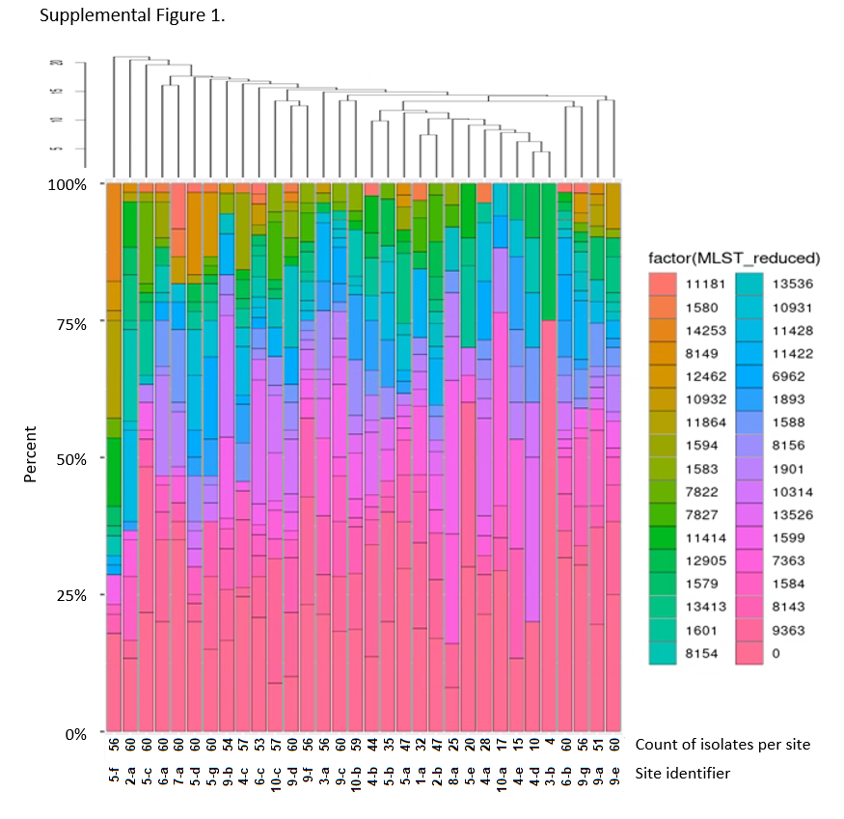

Supplemental Figure 1. MLST distribution across sentinel sites based on 1479 GISP 1st 5 isolates from the US in 2018.
Sites were first ordered based on hierarchical clustering of the overall distribution of MLSTs (n=143) per site.
A stacked histogram displays the distribution of the top 33 MLSTs per site. The color key is provided; the most prevalent MLST is ST9363 in pink, and the least prevalent is ST11181 in orange. The count of isolates per site is recorded by site identifier. Site identifier includes US HHS region (1 – 10, https://www.hhs.gov/about/agencies/iea/regional-offices/index.html ) and site number per region.

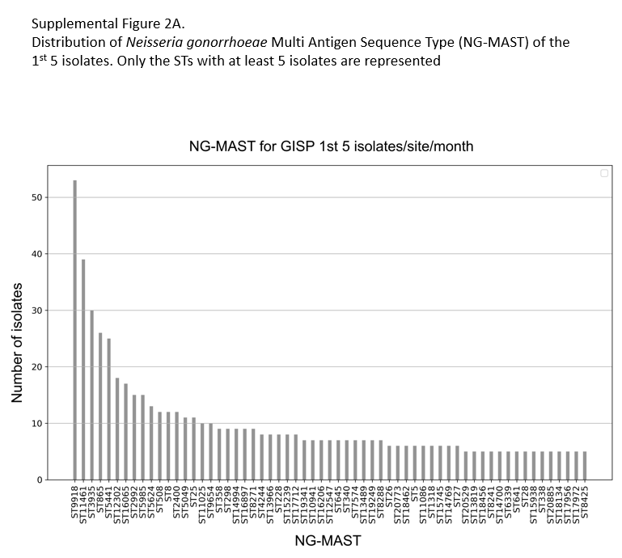

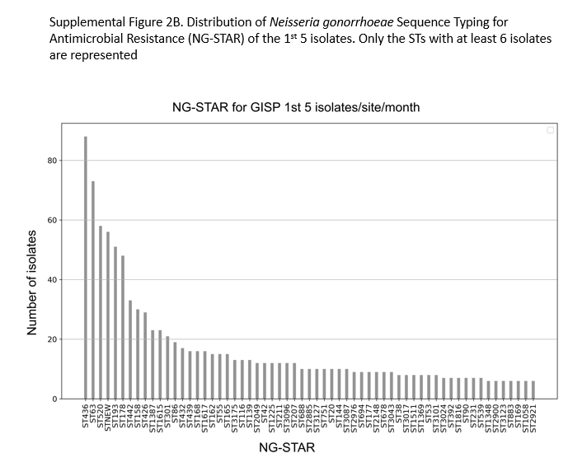
Supplemental Figure 2. The most common NG-MAST (at least 5 isolates/ST) and NG-STAR (at least 6 isolates/ST) are shown. The 1479 isolates were represented by 668 different NG-MAST and 306 different NG-STAR with 56 novel NG-STAR types.

Supplemental Figure 3. Maximum likelihood core-genome SNP phylogenetic alignment of 1479 GISP 1st 5 isolates from the U.S. in 2018. Maximum likelihood core-genome SNP analyses defined the 1479 isolates into two lineages, A and B, and into 23 clusters (“Cluster Number ”, left column) and color-defined in the left-most column. MLST STs are shown (with a color key to the right) and MLST STs (“MLST Labels” in center column). Isolate susceptibility profiles are shown for ciprofloxacin (CIP), penicillin (PEN), tetracycline (TET), azithromycin (AZM), cefixime (CFM) and ceftriaxone (CRO) and colored according to MIC (susceptible (gold),
elevated MIC (shades of purple). The variants are represented as wild-type (light orange) or mutant (light to dark purple).

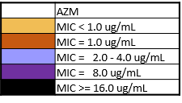
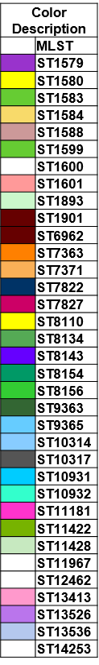
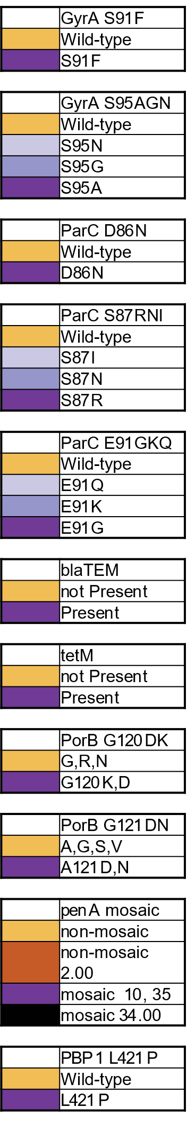
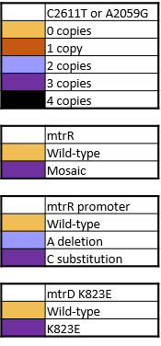
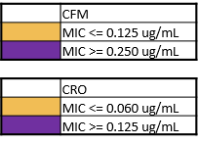
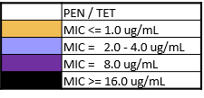
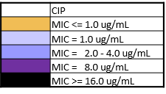
Supplemental Table 1A. Chi square for AZM and 23S rRNA

The chi-square for AZM, χ2(1, N=1479) = 298.4549, p < .01
1 is the degrees of freedom and N is the sample size. The susceptible variant for 23S rRNA at location 2611 is C and the AMR variant is T. Similarly, for 2059, the susceptible variant is A and the AMR variant is G. Elevated MIC for AZM is ≥ 2.0 µg/mL.

Allele | Elevated MIC | Susceptible | Marginal row totals
23S mutant  (C2611T or A2059G) | 18 | 5 | 24
23S Wild Type | 48 | 1408 | 1455
Marginal column totals | 66 | 1413 | 1479
Statistical Analysis
PPV | NPV | Sensitivity | Specificity
79.2 | 96.7 | 28.7 | 99.6

Supplemental Table 1B. Chi square for CIP and GyrA S91

The chi-square, χ2(1, N=1479) = 1289.36, p < .01.
The susceptible variant for GyrA position 91 is S; the AMR variant is F. CIP resistance is MIC ≥ 1.0 µg/mL.

Allele | Resistant | Susceptible | Marginal row totals
Mutant (GyrA S91F) | 475 | 31 | 506
Wild Type (GyrA S91) | 13 | 960 | 973
Marginal column totals | 488 | 991 | 1479
Statistical Analysis
PPV | NPV | Sensitivity | Specificity
93.87 | 98.66 | 97.34 | 96.87

Supplemental Table 1C. Chi square for PEN and blaTEM

The chi-square, χ2(1, N=1479) = 875.7199, p < .01
PEN resistance is MIC ≥ 2.0 µg/mL

Allele | Resistant | Susceptible | Marginal row totals
bla_{TEM} Present | 128 | 9 | 137
bla_{TEM} Absent | 62 | 1280 | 1342
Marginal column totals | 190 | 1289 | 1479
Statistical Analysis
PPV | NPV | Sensitivity | Specificity
93.43 | 95.38 | 67.37 | 99.3

Supplemental Table 1D. Chi square for TET and tetM.

The chi-square, χ2(1, N=1479) = 467.8454, p < .01.
TET resistance is MIC ≥ 2.0 µg/mL.

Allele | Resistant | Susceptible | Marginal row totals
tetM Present | 150 | 3 | 153
tetM Absent | 230 | 1096 | 1326
Marginal column totals | 380 | 1099 | 1479
Statistical Analysis
PPV | NPV | Sensitivity | Specificity
98.04 | 82.66 | 39.47 | 99.72

Supplemental Table 1E. Chi square for AZM vs mosaic mtrR

The chi-square, χ2(1, N=1479) = 465.295, p < .01
Elevated MIC to AZM is ≥ 2.0 µg/mL.

Allele | Elevated MIC | Susceptible | Marginal row totals
mosaic mtrR Present | 51 | 64 | 115
mosaic mtrR Absent | 15 | 1349 | 1364
Marginal column totals | 66 | 1413 | 1479
Statistical Analysis
PPV | NPV | Sensitivity | Specificity
44.35 | 98.9 | 92.4 | 88.2

Supplemental Table 1F. Chi square for AZM (MIC ≥1.0 µg/mL) vs mosaic mtrR

The chi-square, χ2(1, N=1479) = 795.746, p < .01

Allele | MIC ≥1.0 µg/mL | MIC <1.0 µg/mL | Marginal row totals
mosaic mtrR Present | 92 | 23 | 115
mosaic mtrR Absent | 37 | 1327 | 1364
Marginal column totals | 129 | 1350 | 1479
Statistical Analysis
PPV | NPV | Sensitivity | Specificity
80 | 97.3 | 71.3 | 98.3

Supplemental Table 1G. Chi square for TET^{R} and PorB G120 / G121 variants

The chi-square, χ2(1, N=1444) = 150.5726, p < .01.
TET resistance is MIC ≥ 2.0 µg/mL. Susceptible variants for PorB G120 included G or N; Susceptible variants for PorB G121 included G, A, S or V. AMR variants for PorB G120K or D, and G121D or N. Either a variant in PorB 120 or 121 were counted as mutants. Variants could not be determined for 35 isolates.

Allele | Resistant | Susceptible | Marginal row totals
Mutant  (PorB G120KD, G121DN) | 179 | 182 | 361
Wild Type (PorB G120N, G121ASV) | 186 | 897 | 1083
Marginal column totals | 365 | 1079 | 1444
Statistical Analysis
PPV | NPV | Sensitivity | Specificity
49.48 | 82.83 | 49.04 | 83.13

Supplemental Table 1H. Chi square for TET and PorB G120 / G121 variants in the absense of isolates carrying tetM.

The chi square, χ2(1, N=1304) = 283.9237, p < .01.
TET resistance is MIC ≥ 2.0 µg/mL. Variants could not be determined for 22 isolates and 153 isolates carried tetM plasmid.

Allele | Resistant | Susceptible | Marginal row totals
Mutant  (PorB G120KD, G121DN) | 162 | 182 | 344
Wild Type (PorB G120N, G121ASV) | 66 | 894 | 960
Marginal column totals | 228 | 1076 | 1304
Statistical Analysis
PPV | NPV | Sensitivity | Specificity
47.09 | 93.13 | 71.05 | 83.09

Supplemental Table 2.
Eight isolates carried 23S rRNA C2611T variants in fewer than 4 copies and resulted in AZM MIC ranging from 0.06 to 8.0 µg/mL

GCWGS_ID | AZM MIC | 23S-2611 base | 23S-2611 frequency | Count C2611T | MLST
GCWGS-3860 | 0.25 | T | 0.229 | 1 | 1901
GCWGS-4817 | 4 | T | 0.402 | 2 | 1901
GCWGS-2591 | 0.06 | T | 0.181 | 1 | 6962
GCWGS-4548 | 0.125 | T | 0.24 | 1 | 6962
GCWGS-2935 | 0.25 | T | 0.272 | 1 | 8156 | extension of clade ST1584.
GCWGS-3907 | 0.5 | T | 0.235 | 1 | 9363
GCWGS-5259 | 1 | T | 0.486 | 2 | 9363
GCWGS-8887 | 4 | T | 0.195 | 1 | 11422

Supplemental Table 3. AMR Profiler. Genomic and Protein Variants.
 | Accession Number: sequence identifier | Accession Number: sequence identifier
Genomic Variants | Nucleotide | Amino Acid
2611C>T | X67293.1: r.2599C>T
2059A>G | X67293.1: r.2047A>G
mtr promoter (mtrR and mtrCDE)
delA | NZ_CP012026.1: g.1110846del
A>C | NZ_CP012026.1: g.1110846A>C
mtrR -35A | NZ_CP012026.1: g.1110837G>A
mtrR premature stop * | NZ_CP012026.1: g. (1110901_?_1111533)del | (AKP10809.1) p.(1_?_210)del
Protein variants
MtrR Ala39Thr | NZ_CP012026.1: g.1111015G>A | (AKP10809.1) p.(Ala39Thr)
MtrR Gly45Asp | NZ_CP012026.1: g.1111034G>A | (AKP10809.1) p.(Gly45Asp)
MtrR His105Tyr | NZ_CP012026.1: g.1111213C>T | (AKP10809.1) p.(His105Tyr)
MtrD Ser821Ala | NZ_CP012026.1: g.1106940A>C | (AKP10807.1) p.(Ser821Ala)
MtrD Lys823Glu | NZ_CP012026.1: g.1106934T>C | (AKP10807.1) p.(Lys823Glu)
PorB Gly120Lys | NZ_CP012026.1:g.1598401GGC>AAG g.1598401GGC>AAG | (AKP11294.1) p.(Gly120Asp)
PorB Gly120Asp | NZ_CP012026.1: g.1598402G>A | (AKP11294.1) p.(Gly120Lys)
PorB Gly121Asp | NZ_CP012026.1: g.1598404GGC>GAC | (AKP11294.1) p.(Gly121Asp)
PorB Gly121Asn | NZ_CP012026.1: g.1598404GGC>AAC | (AKP11294.1) p.(Gly121Asn)
PBP1 Leu421Pro | NZ_CP012026.1: g.2080172T>C | (AKP11771.1) p.(Leu421Pro)
PBP2 Asp345 insertion | NZ_CP012026.1: g.1302135+TCG | (AKP10994.1) p.(Asp345ins)
PBP2 Ala501Thr | NZ_CP012026.1: g.1301669C>T | (AKP10994.1) p.(Ala501Thr)
PBP2 Ala501Val | NZ_CP012026.1: g.1301668G>A | (AKP10994.1) p.(Ala501Val)
GyrA Ser91Phe | NZ_CP012026.1: g.359891G>A | (AKP10068.1) p.(Ser91Phe)
GyrA Asp95Ala | NZ_CP012026.1: g.359879T>G | (AKP10068.1) p.(Asp95Ala)
GyrA Asp95Gly | NZ_CP012026.1: g.359879T>C | (AKP10068.1) p.(Asp95Gly)
GyrA Asp95Asn | NZ_CP012026.1: g.359880C>T | (AKP10068.1) p.(Asp95Asn)
ParC Asp86Asn | NZ_CP012026.1:g.993818G>A | (AKP10706.1) p.(Asp86Asn)
ParC Ser87Arg | NZ_CP012026.1: g.993821A>C | (AKP10706.1) p.(Ser87Arg)
ParC Ser87Asn | NZ_CP012026.1: g.993822G>A | (AKP10706.1) p.(Ser87Asn)
ParC Ser87Ile | NZ_CP012026.1: g.993822G>T | (AKP10706.1) p.(Ser87Ile)
ParC Ser88Pro | NZ_CP012026.1:g.993824T>C | (AKP10706.1) p.(Ser88Pro)
ParC Glu91Gly | NZ_CP012026.1:g.993834A>G | (AKP10706.1) p.(Glu91Gly)
ParC Glu91Lys | NZ_CP012026.1:g.993833G>A | (AKP10706.1) p.(Glu91Lys)
ParC Glu91Gln | NZ_CP012026.1:g.993833G>C | (AKP10706.1) p.(Glu91Gln)
RpsJ Val57Met V57M | NZ_CP012026.1:g.1616961C>T | (AKP11325.1) p.(Val57Met)
AcnB Gln57Lys | NZ_CP012026.1:g.964538C>A | (AKP10680.1) p.(Gln57Lys)
Genomic Mosaicity
mtrR mosaic† | KT954125.1: c.(1–797)
penA mosaic‡ | NZ_CP012026.1: c.(1301424-1303169)

* MtrR premature stop (AKP10809.1) p.(1_?_210)del : The complete nucleotide sequence mtrR was scanned for a stop codon or deletion in any position. If a stop codon or deletion was found in any position, it was assigned as a premature stop.
† mtrR mosaic KT954125.1: c.1–797 : The complete nucleotide sequence of gene mtrR was aligned to the reference to calculate percent similarity and determine mosaicity.
‡ penA mosaic NZ_CP012026.1: c.1301424-1303169 : The complete nucleotide sequence of gene penA was blasted against the PubMLST database penA locus (NEIS1753) to identify penA Type and NG STAR penA allele. https://pubmlst.org/neisseria/

Supplemental Table 4. Bioinformatic Methods and References.

Method | Reference
FastQC 0.10.1 | http://www.bioinformatics.babraham.ac.uk/projects/fastqc/
Kraken 0.10.5 | Wood et.al.¹
StringMLST 0.3.6 | Gupta et.al.²
Cutadapt 1.8.3 | Martin, Marcel³
SPAdes Genome Assembler 3.9.0 | Bankevich et.al.⁴
Quast 4.3 | Gurevich et.al⁵
AMR-Profiler and Typing Tool 2.8.3/2.9.2 | Thomas JC et.al ⁶
SNIPPY 3.1 | https://hpc.nih.gov/apps/snippy.html
bwa/0.7.12 samtools/1.3.1 freebayes/1.0.2 | Li et.al.⁷, Li et.al.⁸,Garrison et.al.⁹
NGMASTER 0.4 | Kwong at.al.¹⁰
NGSTAR | https://ngstar.canada.ca
ParSNP Harvest 1.2 | Treangen at.al.¹¹
Gubbins 2.3.1 | Croucher et.al.¹²
RaxML 8.2.9 GTRCAT substitution, 1000 bootstrap  GTRCAT substitution, 1000 bootstrap | Stamatakis¹³
FastBAPs | Tonkin-Hill et.al.¹⁴
ITOL | Letunic et.al.¹⁵

References

1. Wood DE, Salzberg SL. Kraken: Ultrafast metagenomic sequence classification using exact alignments. Genome Biol. 2014; 15:R46
2. Gupta A, Jordan IK, Rishishwar L. stringMLST: A fast k-mer based tool for multilocus sequence typing. Bioinformatics. 2017; 33(1): 119-121.
3. Martin M. Cutadapt removes adapter sequences from high-throughput sequencing reads. EMBnet.journal. 2011; 17(1): 10-12.
4. Bankevich A, Nurk S, Antipov D, et al. SPAdes: A new genome assembly algorithm and its applications to single-cell sequencing. J Comput Biol. 2012; 19(5): 455–477.
5. Gurevich A, Saveliev V, Vyahhi N, et al. QUAST: Quality assessment tool for genome assemblies. Bioinformatics. 2013; 29(8):1072-1075.
6. Thomas JC, Seby S, Abrams AJ, et al. Evidence of Recent Genomic Evolution in Gonococcal Strains with Decreased Susceptibility to Cephalosporins or Azithromycin in the United States, 2014-2016. J Infect Dis. 2019; 220(2): 294-305.
7. Li H, Durbin R. Fast and accurate short read alignment with Burrows-Wheeler transform. Bioinformatics.2009; 25(14):1754-1760.
8. Li H, Handsaker B, Wysoker A, et al. The Sequence Alignment/Map format and SAMtools. Bioinformatics. 2009; 25(16):2078-9.
9. Garrison E, Marth G. Haplotype-based variant detection from short-read sequencing -- Free bayes -- Variant Calling -- Variant Calling -- Longranger. arXiv Prepr arXiv12073907. 2012.
10. Kwong JC, Gonçalves da Silva A, Dyet K, et al. NGMASTER:in silico multi-antigen sequence typing for Neisseria gonorrhoeae. Microb Genom. 2016; 2(8): e000076.
11. Treangen TJ, Ondov BD, Koren S, et al. The harvest suite for rapid core-genome alignment and visualization of thousands of intraspecific microbial genomes. Genome Biol. 2014; 5(11):524-539.
12. Croucher NJ, Page AJ, Connor TR, et al. Rapid phylogenetic analysis of large samples of recombinant bacterial whole genome sequences using Gubbins. Nucleic Acids Res. 2015; 43(3):e15.
13. Stamatakis A. RAxML-VI-HPC: Maximum likelihood-based phylogenetic analyses with thousands of taxa and mixed models. Bioinformatics. 2006; 22(21): 2688-2690.
14. Tonkin-Hill G, Lees JA, Bentley SD, et al. Fast hierarchical Bayesian analysis of population structure. Nucleic Acids Res. 2019; 47(11): 5539-5549.
15. Letunic I, Bork P. Interactive Tree of Life (iTOL) v4: Recent updates and new developments. Nucleic Acids Res. 2019; 47(W1):W256-W259.

Supplementary references

31S. Korenromp EL, Rowley J, Alonso M, et al. Global burden of maternal and congenital syphilis and associated adverse birth outcomes—Estimates for 2016 and progress since 2012. Vellakkal S, ed. PLoS One. 2019;14(2):e0211720.
32S. Schmerer MW, Abrams AJ, Seby S, et al. Genomic characterization of Neisseria gonorrhoeae strains from 2016 U.S. sentinel surveillance displaying reduced susceptibility to azithromycin. Antimicrob Agents Chemother. 2020; 64(5): e02420-19
33S. Lindberg R, Fredlund H, Nicholas R, et al. Neisseria gonorrhoeae isolates with reduced susceptibility to cefixime and ceftriaxone: Association with genetic polymorphisms in penA, mtrR, porB1b, and ponA. Antimicrob Agents Chemother. 2007; 51(6):2117-2122.
34S. Phillips I. Beta-lactamase-producing, Penicillin-resistant Gonococcus. Lancet. 1976; 2(7987):656-657.
35S. Ashford WA, Golash RG, Hemming VG. Penicillinase-producing Neisseria gonorrhoeae. Lancet. 1976; 2(7987):657-658.
36S. Morse SA, Johnson SR, Biddle JW, et al. High-level tetracycline resistance in Neisseria gonorrhoeae is result of acquisition of streptococcal tetM determinant. Antimicrob Agents Chemother. 1986; 30(5):664-670.
37S. Unemo M, Nicholas RA. Emergence of multidrug-resistant, extensively drug-resistant and untreatable gonorrhea. Future Microbiol. 2012; 7(12):1401-1422.
38S. Marri PR, Paniscus M, Weyand NJ, et al. Genome sequencing reveals widespread virulence gene exchange among human Neisseria species. PLoS One. 2010; 5(7): e11835.
39S. Kirkcaldy RD, Harvey A, Papp JR, et al. Neisseria gonorrhoeae antimicrobial susceptibility surveillance - The Gonococcal Isolate Surveillance Project, 27 sites, United States, 2014. MMWR Surveill Summ. 2016; 65(7);1–19.
40S. GISP. Gonococcal Isolate Surveillance Project (GISP) Protocol. Gonococcal Isol Surveill Proj. 2016. https://www.cdc.gov/std/gisp/GISP-Protocol-May-2016.pdf
41S. Lyu M, Moseng MA, Reimche JL, et al. Cryo-EM structures of a gonococcal multidrug efflux pump illuminate a mechanism of drug recognition and resistance. mBio. 2020; 11(3): e00996-20.
42S. Lefebvre B, Martin I, Demczuk W, et al. Ceftriaxone-resistant Neisseria gonorrhoeae, Canada, 2017. Emerg Infect Dis. 2018; 24(2): 381-383.
43S. Tapsall J, Read P, Carmody C, et al. Two cases of failed ceftriaxone treatment in pharyngeal gonorrhoea verified by molecular microbiological methods. J Med Microbiol. 2009; 58(Pt 5):683-687.
44S. Ison CA, Hussey J, Sankar KN, et al. Gonorrhoea treatment failures to cefixime and azithromycin in England, 2010. Euro Surveill. 2011; 16(14):19833.
4S5. Unemo M, Golparian D, Syversen G, et al. Two cases of verified clinical failures using internationally recommended first-line cefixime for gonorrhoea treatment, Norway, 2010. Euro Surveill. 2010; 15(47):19721.
46S. Kenyon C, Manoharan-Basil SS, Van Dijck C. Gonococcal resistance can be viewed productively as part of a syndemic of antimicrobial resistance: an ecological analysis of 30 European countries. Antimicrob Resist Infect Control. 2020; 9: 97.
47S. Nguyen M, Wesley Long S, McDermott PF, et al. Using machine learning to predict antimicrobial MICs and associated genomic features for nontyphoidal Salmonella. J Clin Microbiol. 2019; 57(2): e01260-18.
48S. Kersh EN, & Workowski KA. (2020). Evidence Review for Centers for Disease Control and Prevention Guidance Development on Laboratory Testing to Detect Treponema pallidum Infection (Syphilis). Clinical Infectious Diseases. 2020; 71 (Supplement_1): S1-S3.
49S. Ribot EM, Freeman M, Hise KB, et al. PulseNet: entering the age of Next-generation sequencing. Food borne Pathog Dis. 2019; 16: 451-56.

