Effect of Screening and Treatment for Gonorrhea and Chlamydia on HIV Incidence among Men who Have Sex with Men in the United States: A Modeling Analysis

Jeb Jones, PhD¹, Adrien Le Guillou, MD, MPH¹, Tom Gift, PhD², Harrell Chesson, PhD², Kyle Bernstein, PhD ScM², Kevin Delaney, PhD², Cynthia Lyles, PhD², Andres Berruti, PhD², Patrick S. Sullivan, DVM, PhD¹, Samuel M. Jenness, PhD¹

¹Department of Epidemiology, Rollins School of Public Health, Emory University
²National Center for HIV, Viral Hepatitis, STD, and TB Prevention, Centers for Disease Control and Prevention

Supplemental Appendix

TABLE OF CONTENTS
1 INTRODUCTION 4
1.1 Model Framework 4
1.2 Model Software 4
1.3 Core Model Specifications 5
2 THE ARTnet STUDY 5
2.1 Study Design 5
2.2 Primary Measures 6
2.3 Statistical Analysis 6
3 NETWORKS OF SEXUAL PARTNERSHIPS 7
3.1 Conceptual Representation of Sexual Networks 7
3.2 Statistical Representation of Sexual Networks 13
4 BEHAVIOR WITHIN SEXUAL PARTNERSHIPS 15
4.1 Anal Intercourse Acts Per Partnership 15
4.2 Condom Use Per Act 18
4.4 Sexual Role 22
5 DEMOGRAPHY AND INITIAL CONDITIONS 22
5.1 Arrivals at Sexual Onset 23
5.2 Initialization of Attributes 23
5.3 Departures from the Network 24
5.4 Aging 25
6 INTRAHOST EPIDEMIOLOGY 25
7 CLINICAL EPIDEMIOLOGY 26
7.1 HIV Diagnostic Screening 26
7.2 Antiretroviral Therapy (ART) Initiation 29
7.3 ART Adherence and HIV Viral Load Suppression 31
7.4 AIDS Disease Progression and AIDS-Related Mortality 33
7.5 PrEP Initiation and Adherence 33
8 INTERHOST EPIDEMIOLOGY 33
8.1 HIV-Discordant Dyads 34
8.2 HIV Transmission Rates 34
9 STI TRANSMISSION 37
9.1 Overview of Model Structure 37
9.2 STI Co-Factor Effect on HIV Acquisition and Transmission Probability 38
9.3 Chlamydia Transmission Probability 38
9.4 Gonorrhea Transmission Probability 39
10 STI SYMPTOMS AND TREATMENT 39
10.1 Treatment 40
10.2 Chlamydia Symptoms 40
10.3 Gonorrhea Symptoms 41
11 STI RECOVERY 41
11.1 Duration of Chlamydia Infection 41
11.2 Duration of Gonorrhea Infection 42
12 STI SCREENING 42
12.1 STI Incidence Targets for Calibration 43
13 MODEL CALIBRATION 43
13.1 Calibration Methods 43
13.2 Calibration Steps 44
14 REFERENCES 45

1 INTRODUCTION
This supplementary technical appendix describes the mathematical model structure, parameterization, and statistical analysis of the accompanying paper in further detail.

1.1 Model Framework
The mathematical models for HIV transmission dynamics presented in this study are network-based transmission models in which uniquely identifiable sexual partnership dyads were simulated and tracked over time. This partnership structure is represented through the use of separable temporal exponential-family random graph models (STERGMs), described in Section 3. On top of this dynamic network simulation, the epidemic model represents demography (entries, exits, and aging), interhost epidemiology (disease transmission), intrahost epidemiology (disease progression), and clinical epidemiology (disease diagnosis and treatment and prevention interventions). Individual attributes related to these processes are stored and updated in discrete time over the course of each epidemic simulation.
The modeling methods presented here utilize and extend the EpiModel software platform to incorporate HIV-specific epidemiology and transmission dynamics. The HIV extensions for men who have sex with men (MSM) were originally developed by Goodreau et al. for use in prior modeling studies of MSM in the United States and South America,^{1–3} and subsequently used for a model for HIV preexposure prophylaxis (PrEP) among US MSM.^{4–7} The most recent innovation in our modeling platform has been to incorporate primary data from the ARTnet study of MSM in the United States directly into the workflow for parameterizing the network and behavioral components.⁸

1.2 Model Software
The models in this study were programmed in the R and C++ software languages using the EpiModel [http://epimodel.org/] software platform for epidemic modeling. EpiModel was developed by the authors for simulating complex network-based mathematical models of infectious diseases, with a primary focus on HIV and sexually transmitted infections (STIs).⁹ EpiModel depends on Statnet [http://statnet.org/], a suite of software in R for the representation, visualization, and statistical analysis of complex network data.¹⁰
EpiModel allows for a modular expansion of its built-in modeling tools to address novel research questions. We have developed a set of extension modules into a software package called EpiModelHIV. This software is available for download, along with the scripts used in the execution of these models. The tools and scripts to run these models are contained in two GitHub repositories:
- [http://github.com/statnet/EpiModelHIV] contains the general extension software package. Installing this using the instructions listed at the repository homepage will also load in EpiModel and the other dependencies. We use a branching repository architecture on Github; the branch of the repository associated with this research project is CombPrevNet.
- [http://github.com/EpiModel/PAFGuidelines] contains the scripts to execute the models and to run the statistical analyses provided in the manuscript.

1.3 Core Model Specifications
We started with a network size of 25,000 MSM aged 15 to 65 to represent the larger population of sexually active MSM in the Atlanta metropolitan area. The population size was allowed to increase and decrease with arrivals into the sexually active population at age 15 and departures related to mortality or aging out of the sexually active population at age 65. MSM were stratified by Black, Hispanic, and White/other (hereafter in the text, called White) race/ethnicity in proportions equivalent to Census-derived proportions. Further details on the demography (race and age) are provided in Section 5. We used a three-stage simulation framework, first calibrating the model to diagnosed HIV prevalence and HIV care continuum parameters for 120 years of burn-in time (Stage 1), then calibrating the model to current estimated levels of PrEP coverage for 5 years of burn-in time (Stage 2), and then simulating the reference and counterfactual intervention scenarios for 10 years (Stage 3). The time unit used throughout the simulations was one week. Unless otherwise noted, all rate-based parameters listed below are to be interpreted as the rate per week and all duration-based estimates are to be interpreted as the duration in weeks.

2 THE ARTnet STUDY
This model featured an innovative parameterization design in which primary individual-level and partnership-level data were used to fit statistical models for summary statistics that were then entered into the epidemic model. The primary data source for network structure and behavioral data was the ARTnet study, described below. Wherever possible, we used primary data from this study for model parameterization, and only relied on the secondary published literature for model parameters that could be generalized across target populations (e.g., HIV natural history or clinical response parameters).

2.1 Study Design
This analysis used data collected in the ARTnet study of MSM in the United States in 2017–2019.¹¹ MSM were recruited directly after participating in the American Men’s Internet Study (AMIS),¹² a parent web-based study about MSM sexual health that recruited through banner ads placed on websites or social network applications. At the completion of AMIS, MSM were asked to participate in ARTnet, which focused on sexual network features. ARTnet data collection occurred in two waves (following AMIS): July 2017 to February 2018 and September 2018 to January 2019.
Eligibility criteria for ARTnet were male sex at birth, current male cisgender identity, lifetime history of sexual activity with another man, and age between 15 and 65. Respondents were deduplicated within and across survey waves (based on IP and email addresses), resulting in a final sample of 4904 participants who reported on 16198 sexual partnerships. The Emory University Institutional Review Board approved the study.

2.2 Primary Measures
ARTnet participants were first asked about demographic and health-related information. Covariates used in this analysis included race, age, ZIP Code of residence, and current HIV status. ZIP Codes were transformed into Census regions/divisions and urbanicity levels by matching against county databases (using standardized methods for selecting county in the small number of cases when ZIP Codes crossed county lines). Participants reporting as never testing for HIV, having indeterminate test results, or never receiving test results were classified as having an unknown HIV status.
Participants were then asked detailed partner-specific questions for up to most recent 5 partners. The detailed partner-specific questions included attributes of the partner and details about the partnership itself. Partner attributes considered here included age, race/ethnicity, and HIV status. Participants were allowed to report any partner attribute as unknown. When partner age was unknown, age was imputed based on a response to a categorical question (e.g., 5–10 years younger/older, 2–5 years younger/older). Partnerships were classified into three types: main (respondent reported they considered this partner a “boyfriend, significant other, or life partner”), casual (someone they have had sex with more than once, but not a main partner), and one-time.¹³ For one-time partners, we asked for the date that sexual activity occurred. For persistent (main and casual) partnerships, we asked for the date of most recent sex, the date first sex (which could have been prior to the past year), and whether the partnership was ongoing (if the participant expected sexual activity would occur in the future). For each partnership, we asked whether (for one-time) or how frequently (for persistent) anal sex occurred.
Outcome measures include descriptive statistics for characteristics of participants and their reported partnerships, and the aggregate network statistics used to estimate the TERGMs underlying epidemic simulations on dynamic networks. The network statistics include ego degree, attribute mixing in partnerships, and the current length of ongoing partnerships, stratified by the attributes of persons and partnerships. Degree is a property of individuals, whereas mixing and length are properties of partnerships. Degree was defined as the ongoing number of persistent partners measured on the day of the survey (includes main and casual partnerships). Degree is not defined for one-time partnerships, so for these we instead calculated a weekly rate of new contacts by subtracting the total main and casual partners from the total past-year partners, and dividing by 52. Partnership length for ongoing main and casual partnerships was calculated by taking the difference between the survey date and the partnership start date. The mean length of ongoing partnerships is the network statistic needed for TERGM estimation; the logic and derivation are explained here.⁹ Mixing was measured by the relative frequency of partnerships that occurred within and between groups defined by race/ethnicity, and age.

2.3 Statistical Analysis
We fit a series of generalized linear models (GLMs) to estimate summary statistics for features of the sexual network structure and the behavior within partnerships. Specific GLM parameterizations are detailed below in the discussion of each set of model parameters. Common across all models was the general approach of including geography of residence as a main effect with two levels (Atlanta versus all other areas). This allowed for the model coefficients and predicted summary statistics to vary by geography while ensuring stability of outcomes under the assumption of conditional exchangeability.

3 NETWORKS OF SEXUAL PARTNERSHIPS
We modeled networks of three interacting types of sexual relations: main partnerships, casual (but persistent) partnerships, and one-time anal intercourse contacts. We first describe the methods conceptually, including the parameters used to guide the model and their derivation, and then present the formal statistical modeling methods. Consistent with our parameter derivations, all relationships are defined as those in which anal intercourse is expected to occur at least once.

3.1 Conceptual Representation of Sexual Networks
Our modeling methods aim to preserve certain features of the cross-sectional and dynamic network structure as observed in our primary data, while also allowing for mean relational durations to be targeted to those reported for different groups and relational types. Our methods do so within the context of changing population size (due to births, deaths, arrivals and departures from the population) and changing composition by attributes such as age. The broader motivation, methodological details, and link between models and primary data are described here.⁹
The network features that we aim to preserve are as follows:
- Persistent (Main and Casual) Partnerships
  - The mean degree (number of ongoing partners), stratified by main and casual partnership types, and the proportion of men with concurrency (2 or more ongoing partners) for each partnership type, at any time point.
  - Variations in the mean degree specific to each persistent partnership type by:
    - Race/ethnicity group (3 categories for Black, Hispanic, and White MSM).
    - Age group (5 categories for 15–24, 25–34, 35–44, 45–54, and 55–64).
    - Cross-type degree: Degree in the other persistent partnership type (e.g., mean degree of MSM for main partnerships given current casual degree of 0, 1, 2, 3).
  - Selection of partners within the same race/ethnicity group (mixing by race/ethnicity).
  - Selection of partners within the same age group (mixing by age).
  - Mean partnership durations, stratified by main and casual partnership types, and by mixing within age groups.
- One-Time Partnerships
  - The overall rate of having one-time anal intercourse partnerships per week.
  - Variations in this contact rate by:
    - Race/ethnicity group.
    - Age group.
    - Total persistent degree (sum of main and casual partnerships ongoing).
    - Risk level heterogeneity above variations by these three factors (mean partnership rates for five quintiles of MSM stratified by mean one-time rates).
  - Selection of partners within the same race/ethnicity group (mixing by race/ethnicity).
  - Selection of partners within the same age group (mixing by age).
- Common to Persistent and One-Time Partnership Types
  - Prohibitions against MSM with incompatible sexual positioning roles (e.g., no partnerships between exclusively receptive MSM).

3.1.1 Overall Mean Degree for Persistent Partnerships
Ongoing persistent partnerships (whether main or casual) were defined from the partnership-level ARTnet dataset as those in which sex had already occurred more than once, and in which the respondent anticipated having sex again. The momentary main or casual mean degree is then defined as the mean of the degree of all MSM for main or casual partnerships on the day of study. We estimated this with a Poisson model with main or casual degree as the outcome and a dummy variable for Atlanta residence as the predictor and then exponentiating the coefficients, resulting in an estimated mean main degree of 0.396 and a mean casual degree of 0.541.
In addition, we modeled the proportion of MSM with concurrency (degree of 2 or more) by partnership type. This was estimated with logistic regression models for binary outcomes with a dummy variable for Atlanta residence as the predictor. Taking the inverse of the logit of the coefficient yielded the predicted probabilities of 0.9% for main concurrency and 14.5% for casual concurrency.

3.1.2 Heterogeneity in Mean Degrees for Persistent Partnerships
We estimated the heterogeneity in main and casual mean degree by fitting three Poisson regression models. For race/ethnicity, we estimated the mean degree for each group within the target population by including dummy variables for city and race/ethnicity. For age, we modeled the non-linear relationship between age and mean degrees by including city, age group, and square root of age group to allow for a non-linear relationship between age and the outcome. For cross type degree, we modeled the mean degree for main partnerships as a function of degree of casual partnerships, and vice versa, again with city also as a predictor. For each of the 6 models (2 partnership types times three predictors of interest), we fit the statistical models and then exponentiated the coefficients to obtain the rates for each stratum. Those are shown in the Table below.

Supplemental Table 1. Heterogeneity in Mean Main and Casual Degree by Race/Ethnicity, Age Group, and Cross Type Degree of Ego (Respondent)
Predictor | Main Mean Degree | Casual Mean Degree
Race/Ethnicity
Black | 0.566 | 0.605
Hispanic | 0.470 | 0.513
White | 0.823 | 0.534
Age Group
15–24 | 0.795 | 0.297
25–34 | 0.697 | 0.479
35–44 | 0.577 | 0.615
45–54 | 0.448 | 0.701
55–64 | 0.326 | 0.742
Cross Type Degree
0 | 0.440 | 0.614
1 | 0.352 | 0.377
2 | 0.282 | 0.009
3 | 0.225 | —

3.1.3 Mixing by Race/Ethnicity and Age for Persistent Partnerships
Respondents reported on their perception of the race and ethnicity (Hispanic/non-Hispanic) for each partner. We categorized the respondents’ and partners’ races into three mutually exclusive groups: Black, Hispanic, and White. Using logistic regression models, we estimated the proportion of partnerships that were between MSM of the same race (within-group mixing) by evaluating relationship between the respondent group and partner group as a binary outcome (using geography of residence predictor as a main effect with two levels, Atlanta versus all other areas). The inverse logit of the coefficients is then interpreted as the predicted probability of a same-race/ethnicity partnership. The values were 76.5% for main partnerships and 63.3% for casual partnerships.
For mixing by age, we used a model parameterization for the 5-category age group that allowed for differences in the level of age mixing that could vary by age group (differential homophily). We fit a logistic regression model for partnerships, with being in a partnership of the same age group as the outcome and the age group of the respondent as the main predictor. With the inverse logit transformation, the probabilities of partnerships within the same age group, stratified by partnership type are shown in the table below.
Supplemental Table 2. Proportion of Main and Casual Partnerships within the Same Age Group, by Age of Ego (Respondent)
Age Group | Main Within Group | Casual Within Group
15–24 | 79.5% | 56.4%
25–34 | 69.7% | 43.8%
35–44 | 57.8% | 31.9%
45–54 | 44.8% | 22.1%
55–64 | 32.6% | 14.6%

3.1.4 Duration of Persistent Partnerships
We model partnership dissolution as a heterogenous, geometrically distributed process with unique parameters for each relational type. The geometric distribution for relational durations implies a “memoryless process,” which is a common assumption within ordinary differential equation modeling. Although this assumption implies that the rate of dissolution does not depend on the current age of the partnership, the overall exponential shape of the dissolution distribution matches reasonably well to empirical data on relational durations. The fit is improved considerably when the partnership types are stratified, as we do here, implying a mixture of geometric distributions. Once one-time contacts are removed, and longer-duration main partnerships are separated from shorter-term causal partnerships, the set of distributions fits the empirical data on partnership durations well.
The fit is improved further by stratifying based on the interaction between partnership type and age of the both members within the dyad. For this analysis, we explored how relationship duration varied by multiple demographic characteristics, and unsurprisingly age was most strongly associated with duration. For this model parameterization, we specifically elected to estimate and input based on matched age groups (that is, partnerships between two persons of the same age).
As detailed in previous work,^{1,9} for memoryless processes, the expected age of an extant (ongoing) relationship at any moment in time is an unbiased estimator of the expected uncensored duration of relationships, given the balancing effects of right-censoring and length bias for this distribution. Raw relational ages were calculated as the difference between first sex date and the study date for each dyad the ego reported sex with more than once in the interval. To derive our estimator of relational age, we take the median of the observed distribution and then calculate the mean for the geometric distributions associated with that median. To account for estimation within the Atlanta target population, we weighted this estimator by the inverse of the relative differences in Atlanta partnerships to non-Atlanta partnerships.
The resulting expected relational ages are summarized in the table below.

Supplemental Table 3. Duration of Main and Casual Partnerships by Dyadic Age Group of Ego (Respondent) and Alter (Partner)
Dyadic Age Group | Main Relational Age (Weeks) | Casual Relational Age (Weeks)
Both 15–24 | 71.2 | 50.5
Both 25–34 | 253.5 | 72.5
Both 35–44 | 523.3 | 112.1
Both 45–54 | 637.1 | 161.3
Both 55–64 | 903.1 | 147.4
Different Groups | 217.9 | 106.4

3.1.6 Overall Mean One-Time Contact Rate
In addition to persistent main and casual partnerships, we modeled one-time sexual contacts involving anal intercourse based on ARTnet reports on the number and variation in these types of relations. As noted above, degree is not defined for one-time contacts, so for these we instead calculated a weekly rate of new contacts by subtracting the total main and casual partners from the total past-year partners. We estimated the weekly rate by fitting a Poisson regression model with the count of one-time contacts as a function of city, exponentiating the coefficient to get the predicted count, and dividing by 52 to get the week rate. The overall mean one-time contact rate was 0.076 AI contacts per week.

3.1.7 Heterogeneity in One-Time Contact Rates
Heterogeneity in one-time contact rates was modeled with four Poisson regression models to estimate the rates as a function of race/ethnicity, age group, risk level strata, and total persistent (main plus casual) degree. Similar to the one-time rate, we fit these models with geography of residence as a main effect (which had two levels, Atlanta versus all other areas, with the former level used for predictions) and exponentiated the coefficients and then divided by 52 to get the group-specific rates. For age group, similar to the estimation of degree, we modeled this non-linearly by including age group and the square root of age group as the joint predictors (along with city). The results are shown in the table below.

Supplemental Table 4. Weekly One-Time Contact Rates by Race/Ethnicity, Age Group, Risk Level, and Total Persistent Degree of Ego (Respondent)
Predictor | Weekly Contact Rate
Race/Ethnicity
Black | 0.062
Hispanic | 0.071
White | 0.079
Age Group
15–24 | 0.048
25–34 | 0.075
35–44 | 0.089
45–54 | 0.093
55–64 | 0.087
Risk Level Quintile
1 | 0.000
2 | 0.000
3 | 0.012
4 | 0.043
5 | 0.326
Total Persistent Degree
0 | 0.049
1 | 0.057
2 | 0.121
3+ | 0.284

3.1.8 Mixing by Race/Ethnicity and Age for One-Time Contacts
We used a similar approach to within-group mixing by race/ethnicity and age group for one-time contacts to the one used for persistent contacts, with one difference that we did not model differential homophily by age group to improve model stability. Therefore, the overall proportion of one-time contacts that were within the same race/ethnic group was 67.6% and the proportion of one-time contacts that were within the same age group was 32.8%.

3.1.9 Mixing by Sexual Role Across All Partnership Types
We assign men a fixed sexual role preference (exclusively insertive, exclusively receptive, versatile). The model then includes an absolute prohibition, such that two exclusively insertive men cannot partner, nor can two exclusively receptive men. We estimated the proportion men were in each category (insertive, receptive, and versatile) by analyzing whether men had only insertive anal intercourse, only receptive anal intercourse, or both insertive and receptive anal intercourse (respectively) in their past five anal partnerships over the past year. These proportions were stratified (restricted) by geography of residence to the city of Atlanta. The proportions were: 18.5% exclusively insertive, 27.1% exclusively receptive, and 54.4% versatile.

3.2 Statistical Representation of Sexual Networks
Exponential-family random graph models (ERGMs) and their dynamic extension temporal ERGMs (TERGMs) provide a foundation for statistically principled simulation of local and global network structure given a set of target statistics from empirical data. Main and casual relationships were modeled using TERGMs,¹⁴ since they persist for multiple time steps. One-time contacts, on the other hand, were modeled using cross-sectional ERGMs.¹⁵ Formally, our statistical models for relational dynamics can be represented as five equations for the conditional log odds (logits) of relational formation and persistence at time t (for main and casual relationships) or for relational existence at time t (for one-time contacts):
$logit\left(P\left(Y_{ij,t}=1 | { Y}_{ij,t-1}=0\text{, }Y_{ij,t}^{C}\right)\right)\text{ = }{θ_{m}^{+}}^{'}∂\left(g_{m}^{+}\left(y\right)\right)$ Main partnership formation
$logit\left(P\left(Y_{ij,t}=1 | { Y}_{ij,t-1}=0\text{, }Y_{ij,t}^{C}\right)\right)\text{ = }{θ_{c}^{+}}^{'}∂\left(g_{c}^{+}\left(y\right)\right)$ Casual partnership formation
$logit\left(P\left(Y_{ij,t}=1 | { Y}_{ij,t-1}=1\text{, }Y_{ij,t}^{C}\right)\right)\text{ = }{θ_{m}^{-}}^{'}∂\left(g_{m}^{-}\left(y\right)\right)$ Main partnership persistence
$logit\left(P\left(Y_{ij,t}=1 | { Y}_{ij,t-1}=1\text{, }Y_{ij,t}^{C}\right)\right)\text{ = }{θ_{c}^{-}}^{'}∂\left(g_{c}^{-}\left(y\right)\right)$ Casual partnership persistence
$logit\left(P\left(Y_{ij,t}=1 | { Y}_{ij,t}^{C}\right)\right)\text{ = }{θ_{o}}^{'}∂\left(g_{o}\left(y\right)\right)$ One-time contact existence
where:
- $Y_{ij,t}$ = the relational status of persons i and j at time t (1 = in relationship/contact, 0 = not).
- $Y_{ij,t}^{C}$ = the network complement of i,j at time t, i.e. all relations in the network other than i,j.
- $g\left(y\right)$ = vector of network statistics in each model (the empirical statistics defined in the tables above).
- $∂\left(g\left(y\right)\right)$ = the change in $g\left(y\right)$ when Y_{ij} is toggled from 0 to 1 (for formation models) or 1 to 0 (for persistence models).
- $θ$ = vector of parameters in the model.
For $g\left(y\right)$ and $θ$, the superscript distinguishes the formation model (+), persistence model (-) and existence models (neither). The subscript indicates the main (m), casual (c) and one-time (o) models.
The recursive dependence among the relationships renders the model impossible to evaluate using standard techniques; we use a Markov Chain Monte Carlo (MCMC) approach in order to obtain the maximum likelihood estimates for the $θ$ vectors given the $g\left(y\right)$ vectors.
Our method of converting the statistics laid out in Section 3.1 into our fully specified network models consists of the following steps:
- Construct a cross-sectional network of 25,000 men with no relationships.
- Assign men demographics (race/ethnicity and age) based on Census data for Atlanta and assign men sexual roles based on frequencies listed above, as well as one-time risk quintiles (20% of the men in each race per quintile).
- Calculate the target statistics (i.e., the expected count of each statistic at any given moment in time) associated with the terms in the formation model (for the main and casual partnerships) and in the existence model (for one-time contacts).
- Assign each node a place-holder main and casual degree (number of on-going partnerships) that is consistent with the estimated distributions, and store these numbers as a nodal attribute. (Note: this does not actually require individuals to be paired up into the partnerships represented by those degrees).
- For the main and casual networks, use the mean relational durations by age group combination to calculate the parameters of the persistence model, using closed-form solutions, given that the models are dyadic-independent (each relationship’s persistence probability is independent of all others).
- For the main and casual networks, estimate the coefficients for the formation model that represent the maximum likelihood estimates for the expected cross-sectional network structure.
- For the one-time network, estimate the coefficients for the existence model that represent the maximum likelihood estimates for the expected cross-sectional network structure.
Steps 5–7 occur within the EpiModel software, and use the ERGM and STERGM methods therein. They are completed efficiently by the use of an approximation in Step 6.¹⁶ During the subsequent model simulation, we use the method of Krivitsky¹⁷ to adjust the coefficient for the edges term in each model at each time step, in order to preserve the same expected mean degree (relationships per person) over time in the face of changing network size and nodal composition. At all stages of the project, simulated partnership networks were checked to ensure that they indeed retained the expected cross-sectional structure and relational durations throughout the simulations.

4 BEHAVIOR WITHIN SEXUAL PARTNERSHIPS
In this study, we model three phenomena consecutively within relationships at each time step: the number of anal intercourse sex acts, condom use per sex act, and sexual role per sex act. We simulate these within all relationships regardless of HIV status (whether diagnosed or not).

4.1 Anal Intercourse Acts Per Partnership
The rate of anal intercourse is applicable to persistent (main and casual) partnerships in which there are repeated AI acts between the start and end of the partnership. We use ARTnet data on the overall rate and predictors of variation in rates unique to each partnership type. For one-time contacts, we assumed that the number of AI exposures was one by definition, although there could have been multiple AI acts within an exposure due to role versatility (see Section 4.4). The modeling of act rates here is based on the expectation that changes in coital frequency depend on race/ethnicity, age, diagnosed HIV status, and partnership type.

4.1.1 Measurement of Acts in ARTnet
We measured the number of acts within each reported partnership within the ARTnet study by asking participants about the frequency of AI acts. Study participants could report on the average number of acts within the partnership over the past year by week, month, year, or total partnership duration. We then scaled this into a total weekly act rate. The final ARTnet partnership-level dataset on 16198 partnerships includes this weekly rate as the outcome and predictors at the individual and dyadic level that we used for statistical modeling as described below.

4.1.2 Statistical Models of Act Rates
With this partnership-level dataset, we then modeled the count of acts per year per partnership based on the Poisson regression formula:
Y_{i} ~ β₀ + β₁X₁ + β₂X₁² + β₃X₂ + β₄X₃ + β₅X₁X₃ + β₆X₄ + β₇X₄² + β₈X₅ + β₉X₆
where:
Y_{i} = Log of the count of acts per year.
X₁ = Duration of partnership in weeks at the survey date.
X₂ = Racial/ethnic combination of the ego (respondent) and alter (partner), coded in 6 categories to capture within and across group mixing: Black-Black, Black-Hispanic/White, Hispanic-Black/White, Hispanic-Hispanic, White-Black/Hispanic, White-White.
X₃ = Partnership type (0 = main; 1 = casual).
X₄ = The combined age of ego and alter in years.
X₅ = The concordant diagnosed HIV-positive status of both ego and alter, compared to all other combinations of dyadic HIV status (1 = concordant positive; 0 = all other combinations of dyadic HIV status).
X₆ = Residence (1 = Atlanta metropolitan area; 0 = all other areas).
Note that we modeled the partnership duration and combined age of partners quadratically, and we modeled the interaction of partnership duration and partnership type. Terms within the prediction model were selection based on a combination of a priori theory and exploratory data analysis. The coefficients for the model, and their lower and upper 95% confidence intervals, are presented in the table below. Exponentiating any linear combination of coefficients will yield the yearly rates, which may be converted to weekly through division.
Supplemental Table 5. Statistical Model of Act Rates in Main and Casual Partnerships
Model Parameter | Estimate | Lower 95% CI | Upper 95% CI
β₀ (Intercept) | 4.9615 | 4.9208 | 5.002
β₁ (Duration) | -0.0013 | -0.0013 | -0.0012
β₂ (Duration²) | 6.3197E-07 | 6.0598E-07 | 6.5781E-07
β₃ (B-H/W Combo) | 0.5196 | 0.4888 | 0.5505
β₃ (H-B/W Combo) | 0.2178 | 0.1908 | 0.2449
β₃ (H-H Combo) | 0.1967 | 0.1687 | 0.2250
β₃ (W-B/H Combo) | 0.4758 | 0.4505 | 0.5013
β₃ (W-W Combo) | 0.1765 | 0.1516 | 0.2016
β₄ (Casual Type) | -1.0373 | -1.0458 | -1.0287
β₅ (Duration x Casual Type) | -0.0009 | -0.0010 | -0.0009
β₆ (Combined Age) | -0.0113 | -0.0122 | -0.0104
β₇ (Combined Age²) | 5.6269E-05 | 5.0154E-05 | 6.2374E-05
β₈ (HIV+ Concordant) | 0.3614 | 0.3452 | 0.3776
β₉ (Atlanta residence) | -0.0229 | -0.0396 | -0.0063
Abbreviations: CI, confidence interval; B-H/W, Black ego with either a Hispanic or White alter; H-B/W, Hispanic ego with either a Black or White alter; H-H, Hispanic ego with a Hispanic alter; W-B/H, White ego with either a Black or Hispanic alter; W-W, White ego with a White alter.

4.1.3 Predicted Rates in Epidemic Model
Predicted weekly rates of AI based on the combination of partnership and individual attributes is then obtained dynamically by predicting from the statistical model with inputs based on the current simulated population. EpiModel tracks the current age of partners, the duration of their partnership, their racial combination, and the partnership type. This set of predictors was input into a predict function in R to obtain the weekly mean rates in each strata. The size of the potential set of strata and corresponding predicted means is therefore nearly infinite based on all the potential combinations of input values.
In Supplemental Figure 1 below, we display some example weekly rates based on a subset of model inputs. This figure shows that rates decline in partnerships with a longer duration, that they are higher in partnerships in which both partners are younger, they are lower for casual partnerships (ptype = 2) compared to main partnerships, and that they are higher in White-White partnerships compared to Black-Black partnerships. The act rates generally ranged from 0.5 acts per week to 2 acts per week. Other predicted rates may be obtained by exponentiating the coefficients in the table above and dividing by 52 (to convert from yearly rates to weekly rates).
Based on these model predictions, which represent means for each linear combination, we then drew individual counts of acts per partnership per time step in EpiModel using the rpois function to draw randomly from the Poisson distribution with a vector of parameters, one value for each partnership.
Supplemental Figure 1. Predicted Weekly Act Rates from the Poisson Statistical Model, by Partnership Duration, Partnership Type (ptype: 1 = Main; 2 = Casual), Combined Partner Age (comb.age: 40 and 80 Years).
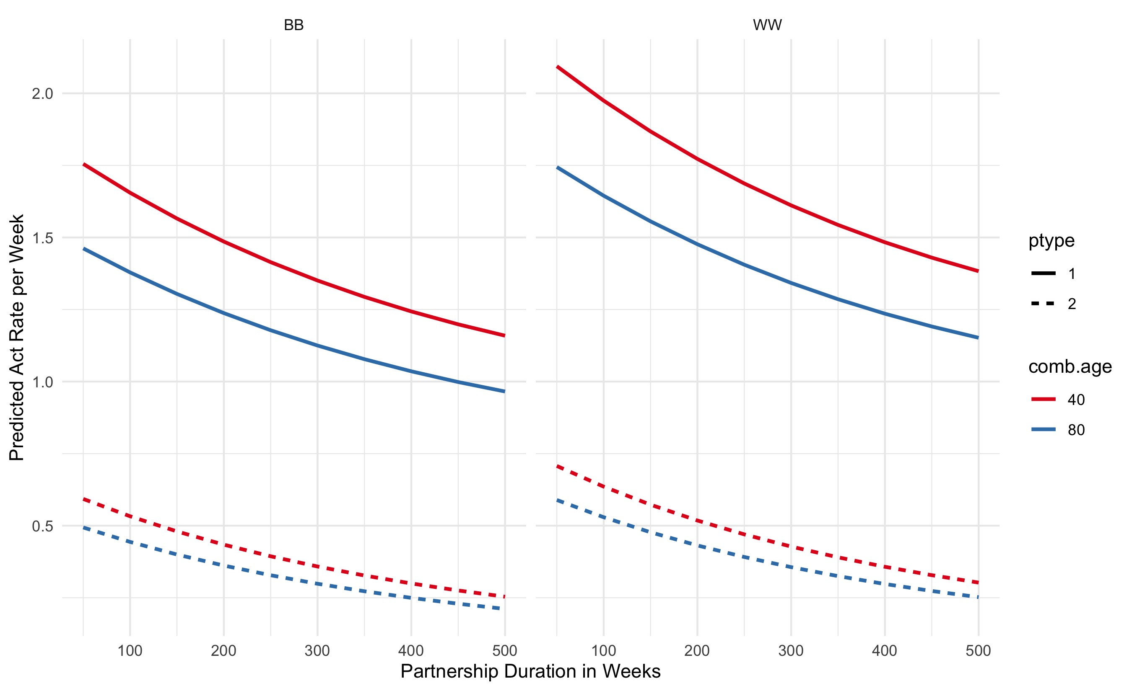

4.1.4 Cessation of Sexual Activity During Late-Stage AIDS
In addition to these data-driven statistical calculations, we assumed that MSM in late stages of AIDS (HIV viral load above 5.75), had no acts due to active disease that would limit their sexual activity. This reflected the mid-point between set-point viral load of chronic stage infection (4.5 log₁₀) and peak viral load (7.0 log₁₀, corresponding to the nadir of immunological function). We had no primary data in ARTnet on sexual partnerships in this late disease stage, but prior analysis and modeling studies support a large decline in sexual activity due to AIDS.¹⁸

4.2 Condom Use Per Act
We modeled condom use within all three partnership types (main, casual, and one-time contacts) based on ARTnet data on the frequency of condom use within reported partnerships. We followed the same general approach to measuring, fitting statistical models, and dynamically predicting condom use within EpiModel as we used for rates of AI. The modeling of condom here is based on the expectation that changes in condom use depend on race/ethnicity, age, diagnosed HIV status, current PrEP use, and partnership type.

4.2.1 Measurement of Condom Use in ARTnet
We measured condom use within partnerships in the ARTnet study by asking about the frequency of condom use (for persistent partnerships) or whether condom use occurred (for one-time partnerships) during anal intercourse. Study participants first reported on the number of AI acts that occurred in the time intervals described above, and then we followed-up with a question on the number of those total acts that involved condom use. We then transformed these subsetted counts into proportions of acts that were condom-protected. This resulted in a U-shaped distribution of proportions, with most persistent partnerships involving either always or never condom use. For this current study, we simplified the outcome variable to any condom use (yes, no) over the past year.

4.2.2 Statistical Models of Condom Use Probabilities
With the outcome described above, we used the partnership-level dataset to fit two logistic regression models for any condom use in the partnership, with one model for persistent (main and casual) and another model for one-time partnerships. The linear model formula for persistent partnerships was as follows:
Y_{i} ~ β₀ + β₁X₁ + β₂X₁² + β₃X₂ + β₄X₃ + β₅X₁X₃ + β₆X₄ + β₇X₄² + β₈X₅ + β₉X₆ + β₁₀X₇
where:
Y_{i} = Log odds of the probability of condom use per act.
X₁ = Duration of partnership in weeks at the survey date.
X₂ = Racial/ethnic combination of the ego (respondent) and alter (partner), coded in 6 categories to capture within and across group mixing: Black-Black, Black-Hispanic/White, Hispanic-Black/White, Hispanic-Hispanic, White-Black/Hispanic, White-White.
X₃ = Partnership type (0 = main; 1 = casual).
X₄ = The combined age of ego and alter in years.
X₅ = The concordant diagnosed HIV-positive status of both ego and alter, compared to all other combinations of dyadic HIV status (1 = concordant positive; 0 = all other combinations of dyadic HIV status).
X₆ = Current use of pre-exposure prophylaxis (PrEP) by the ego (respondent).
X₇ = Residence (1 = Atlanta metropolitan area; 0 = all other areas).
Note that we modeled the partnership duration and combined age of partners quadratically, and we modeled the interaction of partnership duration and partnership type. Terms within the prediction model were selected based on a combination of a priori theory and exploratory data analysis. The coefficients for the model, and their lower and upper 95% confidence intervals, are presented in the table below. Taking the inverse logit of the linear combination of coefficients will yield to the strata-specific predicted probabilities of condom use within the partnership.
Supplemental Table 6. Statistical Model of Per Act Condom Use Probability for Main and Casual Partnerships
Model Parameter | Estimate | Lower 95% CI | Upper 95% CI
β₀ (Intercept) | 2.008 | 1.3020 | 2.7144
β₁ (Duration) | -0.0031 | -0.0040 | -0.0023
β₂ (Duration²) | 1.2561E-06 | 5.8878E-07 | 1.8614E-06
β₃ (B-H/W Combo) | -0.3355 | -0.8549 | 0.1802
β₃ (H-B/W Combo) | -0.3692 | -0.7798 | 0.04214
β₃ (H-H Combo) | -0.3989 | -0.8314 | 0.0336
β₃ (W-B/H Combo) | -0.4402 | -0.8235 | -0.0557
β₃ (W-W Combo) | -0.5031 | -0.8738 | -0.1310
β₄ (Casual Type) | 0.5710 | 0.4084 | 0.7347
β₅ (Duration x Casual Type) | -0.0467 | -0.0638 | -0.0294
β₆ (Combined Age) | 0.0002 | 9.5502E-05 | 0.0003
β₇ (Combined Age²) | -1.6150 | -2.1624 | -1.1322
β₈ (HIV+ Concordant) | -0.5248 | -0.6790 | -0.3724
β₉ (PrEP Use) | 0.1701 | -0.1385 | 0.4743
β₁₀ (Atlanta residence) | 0.0012 | 0.0005 | 0.0019
Abbreviations: CI, confidence interval; B-H/W, Black ego with either a Hispanic or White alter; H-B/W, Hispanic ego with either a Black or White alter; H-H, Hispanic ego with a Hispanic alter; W-B/H, White ego with either a Black or Hispanic alter; W-W, White ego with a White alter; PrEP, preexposure prophylaxis.
For the logistic regression model of one-time partnerships, we used a similar logistic regression approach as for persistent partnerships but dropped the partnership duration and partnership type (since there was only one type for this model) predictor variables. The corresponding linear model formula for persistent partnerships was as follows:
Y_{i} ~ β₀ + β₁X₁ + β₂X₂ + β₃X₂² + β₄X₃ + β₅X₄ + β₆X₅
where:
Y_{i} = Log odds of the probability of condom use per one-time contact.
X₁ = Racial/ethnic combination of the ego (respondent) and alter (partner), coded in 6 categories to capture within and across group mixing: Black-Black, Black-Hispanic/White, Hispanic-Black/White, Hispanic-Hispanic, White-Black/Hispanic, White-White.
X₂ = The combined age of ego and alter in years.
X₃ = The concordant diagnosed HIV-positive status of both ego and alter, compared to all other combinations of dyadic HIV status (1 = concordant positive; 0 = all other combinations of dyadic HIV status).
X₄ = Current use of pre-exposure prophylaxis (PrEP) by the ego (respondent) (1 = yes; 0 = no)
X₅ = Residence (1 = Atlanta metropolitan area; 0 = all other areas).
The coefficients for the model, and their lower and upper 95% confidence intervals, are presented in the table below. Taking the inverse logit of the linear combination of coefficients will yield to the strata-specific predicted probabilities of condom use within the partnership.
Supplemental Table 7. Statistical Model of Per-Act Condom Use Probability for One-Time Sexual Contacts
Model Parameter | Estimate | Lower 95% CI | Upper 95% CI
β₀ (Intercept) | 2.4287 | 1.6597 | 3.2007
β₁ (B-H/W Combo) | 0.1526 | -0.3728 | 0.6785
β₁ (H-B/W Combo) | -0.1042 | -0.5311 | 0.3221
β₁ (H-H Combo) | -0.10538 | -0.5617 | 0.3506
β₁ (W-B/H Combo) | -0.1189 | -0.5205 | 0.2825
β₁ (W-W Combo) | -0.2507 | -0.6414 | 0.1396
β₂ (Combined Age) | -0.0542 | -0.0733 | -0.0351
β₂ (Combined Age²) | 0.0003 | 0.0001 | 0.0004
β₃ (HIV+ Concordant) | -1.8369 | -2.6547 | -1.1610
β₄ (PrEP Use) | -0.7133 | -0.8732 | -0.5553
β₅ (Atlanta residence) | 0.3102 | 0.0107 | 0.6095
Abbreviations: CI, confidence interval; B-H/W, Black ego with either a Hispanic or White alter; H-B/W, Hispanic ego with either a Black or White alter; H-H, Hispanic ego with a Hispanic alter; W-B/H, White ego with either a Black or Hispanic alter; W-W, White ego with a White alter; PrEP, preexposure prophylaxis.

4.2.3 Predicted Probabilities in Epidemic Model
Predicted probabilities of condom use conditional on an AI act were calculated based on the linear combination of partnership and individual attributes obtained dynamically by predicting from the statistical model with inputs based on the current simulated population. This set of predictors was input into a predict function in R to obtain the expected mean probabilities.
In Supplemental Figure 2 below, we display some example probabilities based on a subset of model inputs. This figure shows that condom use is lower in partnerships of a longer duration, higher in casual compared to main partnerships, higher when both partners are younger, and lower in partnerships in which the ego (respondent) reported currently using PrEP. Other predicted probabilities may be obtained from Supplemental Table 6 by taking the inverse logit of the linear combination of coefficients of interest.
Supplemental Figure 2. Predicted Probabilities of Condom Use Per AI Act in Persistent Partnerships from the Logistic Regression Model, by Partnership Duration, Partnership Type (ptype: 1 = Main; 2 = Casual), Combined Partner Age (comb.age: 40 or 80 years), and PrEP Use.
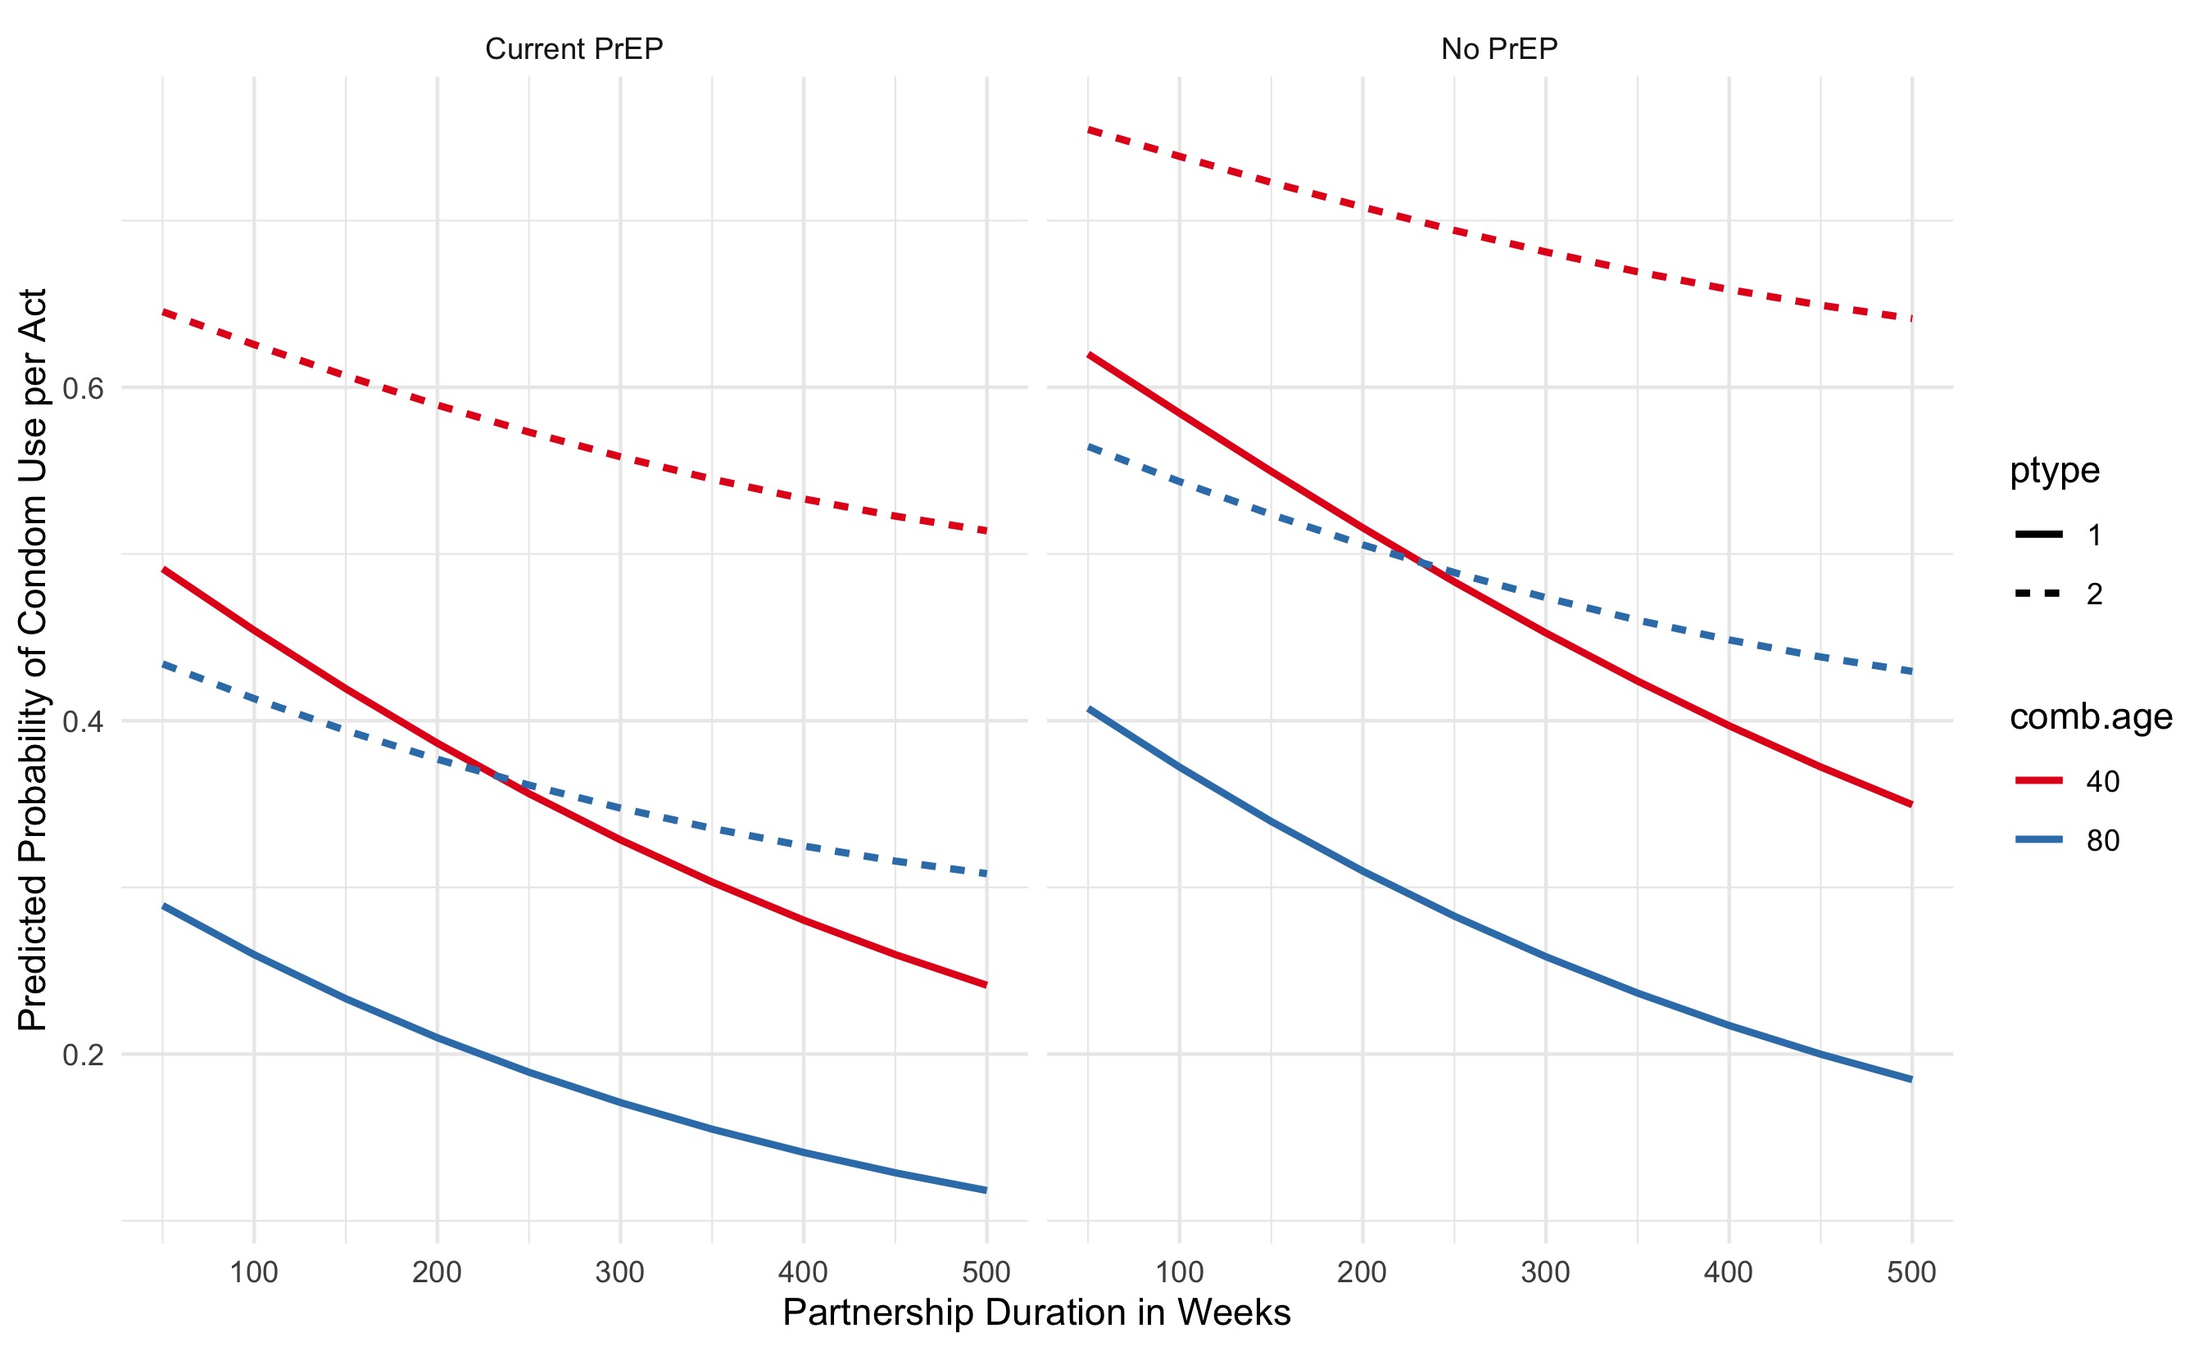
Supplemental Figure 3 shows the predicted probabilities for the second logistic model, for condom use within one-time AI contacts. Here we display variation in condom use by combined age of the partners, current PrEP use, and racial combination of the partners. As the figure shows, condom use is higher within partners of a lower combined age, higher in partnerships involving Black MSM (race.combo = 1 or 2), and lower among current PrEP users.
Based on these model predictions, which represent expected probabilities for each linear combination, we then drew individual probabilities of condom use per act in EpiModel using the rbinom function to draw randomly from the Bernoulli distribution with a vector of parameters, one value for each act. This generated a set of 0’s and 1’s for whether condom use occurred within the act as a function of the predictors in the statistical model.

4.4 Sexual Role
Supplemental Figure 3. Predicted Probabilities of Condom Use in One-Time AI Contacts from the Logistic Regression Model, by Combined Partner Age, Current PrEP Use, and Racial Combination of Partners (race.combo: 1 = Black ego-Black alter; 2 = Black ego-Hispanic or White alter; 3 = Hispanic ego-Black or White alter; 4 = Hispanic ego-Hispanic alter; 5 = White ego-Black or Hispanic alter; 6 = White ego-White alter.
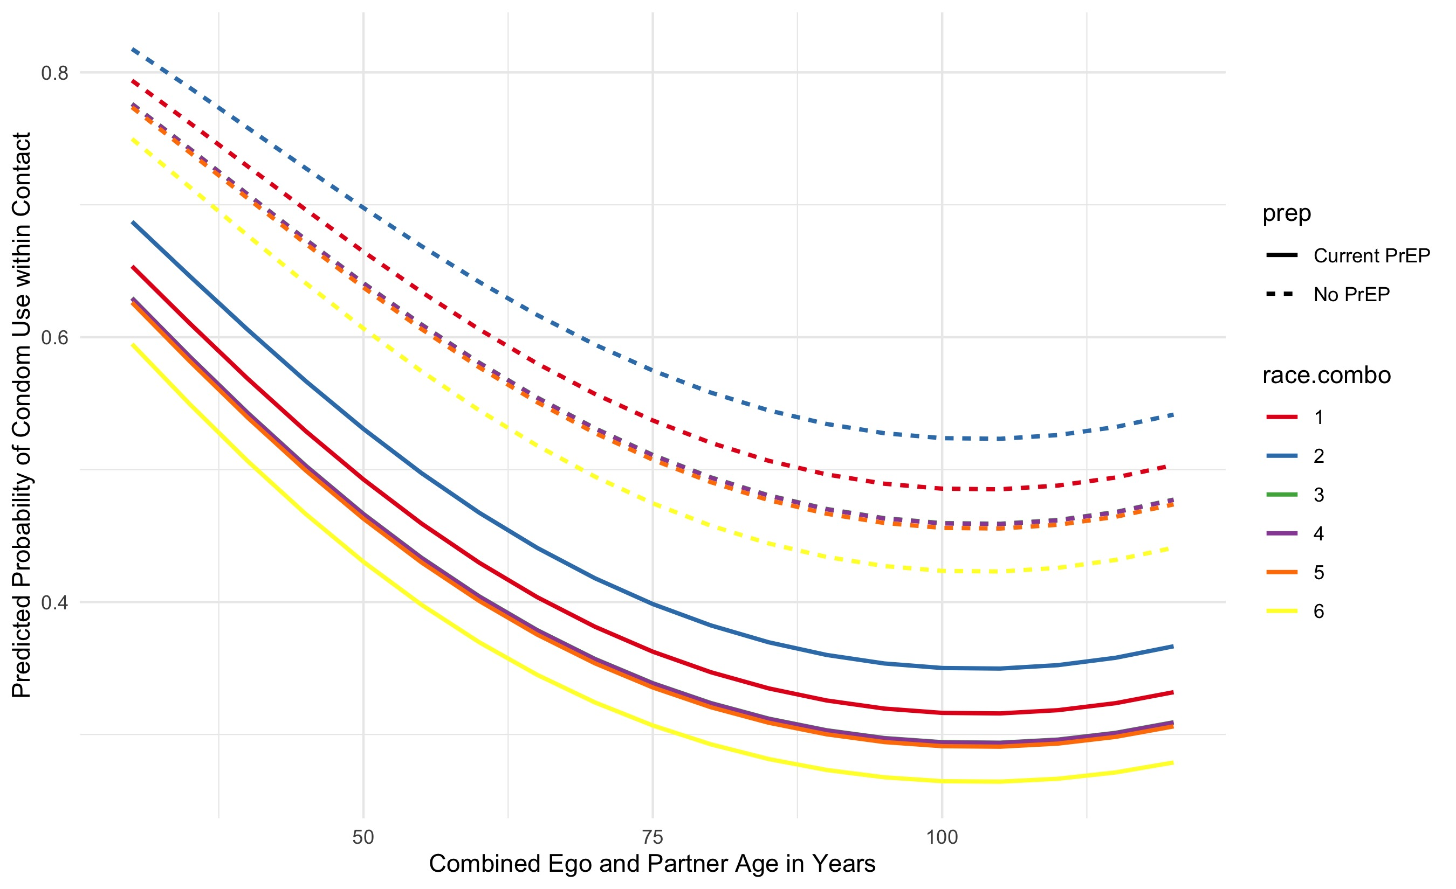
Men were assigned an individual sexual role preference (exclusively insertive, exclusively receptive, or versatile) as described in Section 3.1.9. Relationships between two exclusively insertive or two exclusively receptive men are prohibited via the TERGM models. Versatile men were further assigned a preference for being the insertive partner drawn from a uniform distribution between 0 and 1 upon entry into the population; we refer to this proportion as the ‘insertivity quotient’. When two versatile men are simulated to have an anal intercourse act, their sexual positions during that act must be determined (all other allowed combinations have only one direction). One option is for men to engage in intra-event versatility (IEV; i.e. both men engage in insertive and receptive anal intercourse during the act). The probability of this was derived from the partner-specific role data described in Section 3.1.9. If IEV does not occur, then each man’s probability of being the insertive partner equals his insertivity quotient divided by the sum of the two men’s insertivity quotients.

5 DEMOGRAPHY AND INITIAL CONDITIONS
In this model, there are three demographic processes: entries, exits, and aging. Entries and exits are conceptualized as flows into and out of the sexually active population of interest: MSM aged 15 to 64 years old. Entry into this population represents the time at which persons become at risk of infection via male-to-male sexual intercourse, and we model these flows as starting at an age associated with sexual debut and ending at an age potentially before exiting the network when reaching age 65. This age range also mapped directly on to the eligibility criteria of the ARTnet study.⁸

5.1 Arrivals at Sexual Onset
All persons enter the network at age 15, which was the lower age boundary of ARTnet. The number of new entries at each time step was based on a fixed rate (0.052 per 100 person-weeks) that kept the overall network size in a relatively stable state. The model parameter governing this rate was tuned iteratively in order to generate simulations with a population size at equilibrium, given the inherent variability in population flows related to background mortality, sexual cessation (i.e., reaching the upper age limit of 65), and disease-induced mortality. At each time step, the exact number of men entering the population was simulated by drawing from a Poisson distribution with the rate parameter.

5.2 Initialization of Attributes
Persons entering the population were assigned attributes in different categories. Some attributes remained fixed by definition (e.g., race/ethnicity), others were fixed by assumption (e.g., insertive versus receptive sexual role), and others were allowed to vary over time (e.g., age and disease status). Here we describe attributes initialized at the outset in the model and for arrivals into the population at each time step:
- Race/ethnicity. This model was based on a race/ethnic population composition categorized into three mutually exclusive groups: Black, Hispanic, and White. At the outset of the model simulations, individuals were randomly assigned into one of these three groups with a probability equal to the proportions each represented in the Atlanta metropolitan target population based on 2018 Census data estimates for men aged 15 to 65. Those probabilities were: 51.5% Black, 4.6% Hispanic, and 43.9% White. Incoming nodes during the dynamic simulation were also randomly assigned a race/ethnicity in these proportions.
- Age. In the dynamic simulation, as noted above, all incoming nodes were assigned an age of 15, which incrementally grew in weekly time steps. At the outset of the model simulations, we assigned nodes an age based on a uniform distribution, with ages from 15 to 64. This population-level age distribution was expected to converge to a more realistic distribution during model burn-in and calibration (explained in Section 9.2).
- HIV Status. In the dynamic simulation, all incoming nodes were assigned an HIV status of uninfected upon arrival into the population. This reflects the assumption that arrival corresponded with sexual debut, before which exposure to HIV would be very rare. At the outset of the model simulations, we randomly seeded the nodes with HIV infection by fitting and predicting from a logistic regression of diagnosed HIV status from the ARTnet data. This model incorporated city (residence in Atlanta), age, and race/ethnicity as the primary predictors based on the self-reported diagnosed HIV status reported by ARTnet respondents. These initial infections were all assumed to be diagnosed based on this outcome. We did not expect that this initial condition of diagnosed HIV prevalence at the outset of the burn-in model to match the calibrated disease prevalence prior to experimental intervention models; instead this statistical modeling approach allowed for a data-driven seeding of HIV infection in the population that was distributed according to known demographic and geographic heterogeneity. Further description of the transition from initial HIV conditions to calibrated levels are provided in Section 8.2.
- Circumcision Status. Circumcision status was randomly assigned to incoming nodes at arrival and for all nodes as initial conditions in the simulations. Based on empirical data from Atlanta MSM,¹⁹ 89.6% of men were circumcised before sexual onset. As described in Section 8, circumcision was associated with a 60% reduction in the per-act probability of infection for HIV- males for insertive anal intercourse only (i.e., circumcision did not lower the transmission probability if the HIV+ partner was insertive).^{2,20}

5.3 Departures from the Network
All persons exited the network by age 65, either from mortality or by reaching the upper age bound of the MSM target population of interest. This upper limit of 65 was modeled deterministically (probability = 1), but other exits due to mortality were modeled stochastically. Departures included both natural (non-HIV) and disease-induced mortality causes before age 65. Background mortality rates were based on US all-cause mortality rates specific to age and race/ethnicity from the National Vital Statistics life tables.²¹ Note that these rates include deaths due to HIV/AIDS; however, the relative fraction of those deaths to total deaths is small enough not to impact this background mortality process. Supplemental Table 8 shows the probability of mortality per year by age and race/ethnicity.
Supplemental Table 8. Age- and Race/Ethnicity-Specific Probabilities of Mortality among Men in the United States
Age | Black | Hispanic | White
15–19 | 0.00124 | 0.00062 | 0.00064
20–24 | 0.00213 | 0.00114 | 0.00128
25–29 | 0.00252 | 0.00127 | 0.00166
30–34 | 0.00286 | 0.00132 | 0.00199
35–39 | 0.00349 | 0.00154 | 0.00226
40–44 | 0.00422 | 0.00186 | 0.00272
45–49 | 0.00578 | 0.00271 | 0.00382
50–54 | 0.00870 | 0.00440 | 0.00591
55–59 | 0.01366 | 0.00643 | 0.00889
60–64 | 0.02052 | 0.00980 | 0.01266
These yearly probabilities were transformed into weekly risks. Natural mortality was then applied to persons within the population at each time step stochastically by drawing from a Bernoulli distribution for each eligible person with a probability parameter corresponding to their age- and race-specific risk of death. Disease-related mortality, in contrast, was modeled based on clinical disease progression, as described in Section 6.

5.4 Aging
The aging process in the population was linear by time step for all persons. The unit of time step in these simulations was one week, and therefore, persons were aged in weekly steps between the minimum and maximum ages allow (15 and 65 years old). Evolving age impacted background mortality, age-based mixing in forming new partnerships, and other features of the epidemic model described below. Persons who exited the network were no longer active and their attributes such as age were no longer updated.

6 INTRAHOST EPIDEMIOLOGY
Intrahost epidemiology includes features related to the natural disease progression within HIV+ persons in the absence of clinical intervention. The main component of progression that was explicitly modeled for this study was HIV viral load. In contrast to other modeling studies that model both CD4 and viral load, our study used viral load progression to control both interhost epidemiology (HIV transmission rates) and disease progression eventually leading to mortality.
Following prior approaches,^{1,2,4,6,22} we modeled changes in HIV viral load to account for the heightened viremia during acute-stage infection, viral set point during the long chronic stage of infection, and subsequent rise of VL at clinical AIDS towards disease-related mortality. The HIV viral load has a direct impact on the rates of HIV transmission within serodiscordant pairs in the model, and this interaction is detailed in Section 8. A starting viral load of 0 is assigned to all persons upon infection. From there, the natural viral load curve is fit with the following parameters.
Supplemental Table 9. HIV Natural History Parameters
Parameter | Value | Reference
Time to peak viremia in acute stage | 45 days | Little²³
Level of peak viremia | 6.886 log₁₀ | Little²³
Time from peak viremia to viral set point | 45 days | Little,²³ Leynaert²⁴
Level of viral set point | 4.5 log₁₀ | Little²³
Duration of chronic stage infection (no ART) | 3550 days | Buchbinder,²⁵ Katz²⁶
Duration of AIDS stage | 728 days | Buchbinder²⁵
Peak viral load during AIDS | 7 log₁₀ | Estimated from average duration of AIDS
After infection, it takes 45 days to reach peak viremia, at a level of 6.886 log₁₀. From peak viremia, it takes another 45 days to reach viral set point, which is set at a level of 4.5 log₁₀. Changes occur linearly on the log scale. The total time of acute stage infection is therefore 3 months. The duration of chronic stage infection in the absence of clinical intervention is 3550 days, or 9.7 years. The total duration of pre-AIDS disease from infection is therefore approximately 10 years. At onset of AIDS, HIV viral load rises linearly on the log scale from 4.5 log₁₀ to 7 log₁₀. The time spent in the AIDS stage is 728 days, or 2 years. This viral load trajectory is for ART-naïve persons only, and the influence of ART on disease progression is detailed in Section 7. These transitions are deterministic for all ART-naïve persons. In the AIDS stage, disease-related mortality is imposed stochastically with a homogenous risk of 1/104, corresponding to average duration of the AIDS stage in weeks. This is accomplished by drawing from a binomial (Bernoulli) distribution for all eligible individuals in the AIDS stage.

7 CLINICAL EPIDEMIOLOGY
Clinical epidemiological processes in the model refer to all steps along the HIV care continuum after initial HIV infection: diagnosis, linkage to ART care, adherence to ART, and HIV viral load suppression. In this model, these clinical features have interactions with behavioral features detailed above, as well as impacts on the rates of HIV transmission, detailed in the next section. The features of our model’s clinical processes generally follow the steps of the HIV care continuum, in which persons transition across states from infection to diagnosis to ART initiation to HIV viral suppression.²⁷

7.1 HIV Diagnostic Screening
Both HIV-uninfected and HIV-infected persons in our model were exposed to regular interval-based HIV screening that served as a common entry point for HIV prevention and HIV treatment services, respectively. Individuals screened at routine intervals first based on whether they were currently using PrEP or not. For HIV screening outside of PrEP care, based on exploratory analyses of behavioral and clinical data, and the research questions of this study, we elected to stratify these screening rates by race/ethnicity.
Our approach to parameterization for HIV screening among PrEP non-users was first to start with priors based on ARTnet data for time since last HIV test for HIV-uninfected, and then use model calibration (the technical details of which are explained in Section 9) to fit these parameters to reproduce the race-stratified levels of the first step of the HIV care continuum (the fraction of HIV-infected persons who were diagnosed). For this and the following surveillance target statistics, we have used values specific to MSM. We used that approach because self-reported HIV screening data alone may be biased, and this calibration approach allows for triangulation of diagnostic history based on more objective laboratory data.
Supplemental Figure 4 shows the general results to this calibration. The model starts with all persons with HIV infection as undiagnosed, then the model is simulated for 120 years (x axis for plot time scale is in weeks) to establish stable equilibrium conditions for this and the other calibrated parameters. The target statistics are shown with dashed horizontal lines and the simulated statistics are shown with solid lines.
Each model calibration was simulated 1000 times, so the solid lines represent the median values across those simulations and the polygon bands are the interquartile ranges. The three model parameters for the weekly screening rates were calibrated to meet the target statistics, which were the fraction of HIV-infected MSM who were diagnosed. The numerical results from this parameterization are shown in Supplemental Table 10.
Supplemental Figure 4. Fraction of MSM with HIV Who Are Diagnosed, Simulations versus Target Statistics, Stratified by Race/Ethnicity (blue = Black MSM, red = Hispanic MSM, green = White MSM)
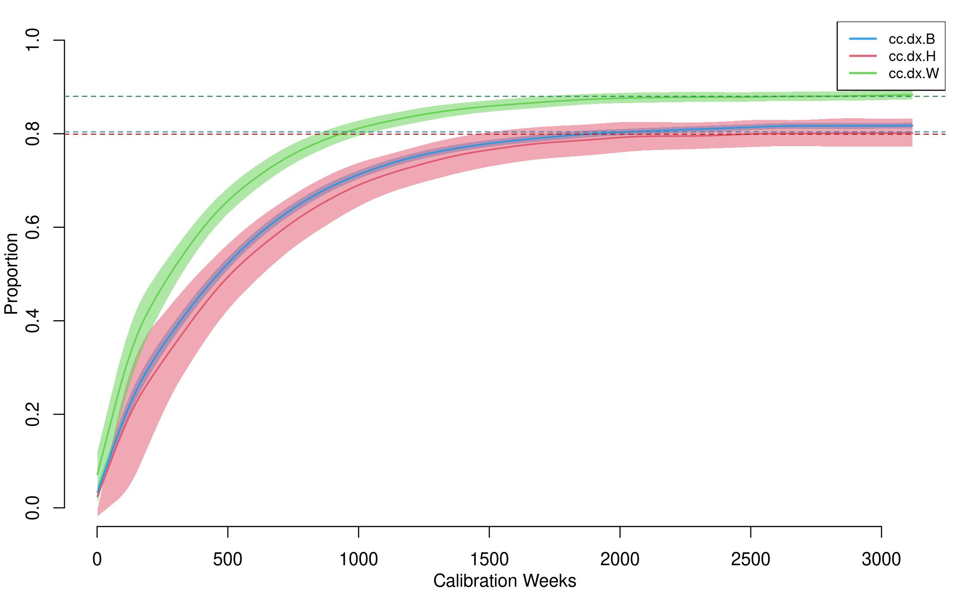
Supplemental Table 10. Model Parameterization for HIV Screening
 | Black MSM | Hispanic MSM | White MSM
Target Statistic: Diagnosed Fraction²⁸ | 80.4% | 79.9% | 88.0%
Simulations: Diagnosed Fractions | 80.1% | 81.7% | 88.3%
Calibrated Rates (per Week) | 0.00385 | 0.00380 | 0.00690
Mean Inter-Test Interval (Years) | 5.00 | 5.06 | 2.79
Median Diagnostic Delay (Years) | 2.50 | 2.52 | 1.70
Abbreviation: MSM, men who have sex with men.
The target statistics for the diagnosed fraction were drawn from a Georgia Department of Public Health surveillance report based on laboratory data for MSM in 2017, the most recent year for which the data were available. The diagnosed fraction was higher for White MSM compared to Black and Hispanic MSM. After calibration, the simulated diagnosed fractions were nearly identical to those targets. The calibrated screening rates per week were higher among White MSM, and lower among Black and Hispanic MSM, consistent with producing the differentials in the diagnosed fractions across the groups. These weekly rates were consistent with average inter-test intervals, or the average time between HIV negative screening events, of 2.8 to 5.1 years. Note that these intervals represent marginal averages across the target population; some MSM may screen more frequently while others screen very rarely.
We also calculated the diagnostic delay as a validation of this calibration process. Whereas the inter-test interval is calculated for HIV-negative MSM in the model, the diagnostic delay is calculated for HIV-infected MSM who are eventually diagnosed positive. This delay is the median number of years between HIV infection and HIV diagnosis. As shown in Supplemental Figure 5, this time starts out high in the early part of the burn-in model, but converges to a stable equilibrium value by the end of the burn-in. The simulated median values were 2.5 years for Black and Hispanic MSM, and 1.7 years for White MSM. This is what would be expected given the differences in the calibrated screening rates. This is also consistent with forward projections of two external studies of national surveillance data. Hall et al. estimate race-stratified median times between infection and diagnosis for 2003 and 2011,²⁹ and Dailey et al. update these estimates for 2015.³⁰ The median delays declined substantially over this period, from 5.4 years in 2003 to 3.0 years in 2015. To compare against our other target statistics, we fit a log-linear model to estimate the relative yearly declines in median delay times, with a prediction for 2017. The 2017 projections from this model were 2.44 years overall, 2.47 years for Black MSM, 2.51 years for Hispanic MSM, and 2.09 years for White MSM. The corresponding estimates from our simulation model calibrated to the Georgia Department of Public Health HIV care continuum statistics resulted in median times of 2.32 years overall, 2.50 years for Black MSM, 2.56 years for Hispanic MSM, and 1.71 years for White MSM. So overall our simulations slightly (by 5%) underestimate the projected 2017 median time to diagnosis, but this gap was small (but larger for White MSM), and it captured the racial/ethnic differences.
Supplemental Figure 5. Median Years Delay Between Infection and Diagnosis, Stratified by Race/Ethnicity (blue = Black MSM, red = Hispanic MSM, green = White MSM)
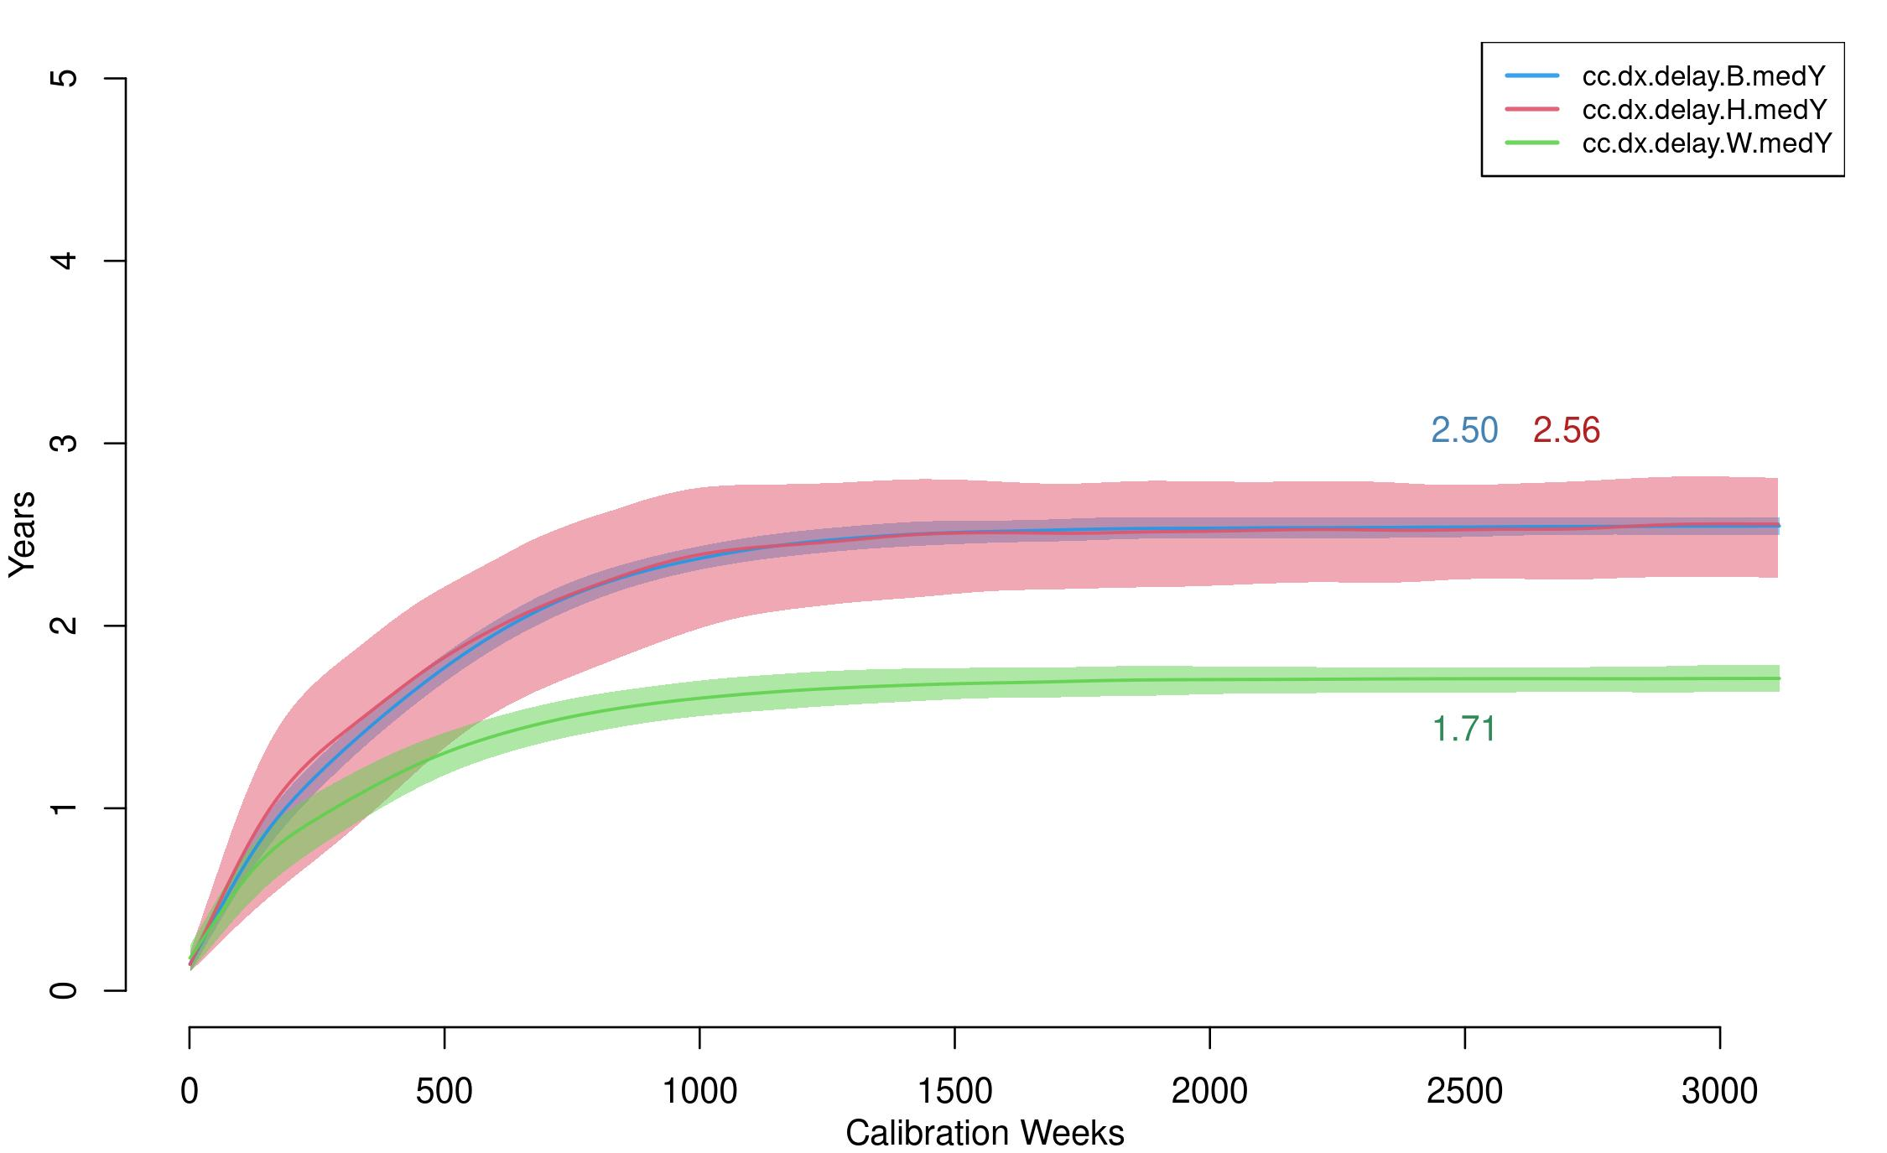
Diagnostic testing was simulated stochastically using draws from a binomial distribution with probability parameters equal to these stratified probabilities. This generated a population-level geometric distribution of times since last test. For PrEP users, we modeled HIV screening practice based on CDC clinical practice guidelines.³¹ The guidelines recommend ongoing screening at 3-month intervals for MSM actively using PrEP. This schedule was imposed for all PrEP users active in their PrEP use, regardless of PrEP adherence categories. We also assumed no racial/ethnic variation in HIV screening rates for PrEP users.
Finally, we also modeled a 21-day window period after infection during which the tests of the truly HIV+ persons would show as negative to account for the lack of antibody response immediately after infection.³² HIV+ persons who tested after this window period would be correctly diagnosed with 100% test sensitivity. MSM with recent but undetected infection were still eligible for PrEP initiation since PrEP eligibility was based diagnosed HIV status. This would have resulted in a period in which HIV-infected but undiagnosed persons were classified as on PrEP. We assumed PrEP use in MWM with HIV had no multiplier effect on the per-act probability of HIV transmission. This undetected infection would then be identified at the next quarterly PrEP clinical visit, at which point they would be transitioned off PrEP.

7.2 Antiretroviral Therapy (ART) Initiation
Following HIV diagnosis, individuals were linked to HIV care that provided ART. In the absence of quantitative data and based on current clinical practice guidelines for MSM in the U.S., we assumed no gap between treatment entry and ART initiation. Although the intermediate steps of the HIV care continuum are often characterized by any linkage to HIV care and/or ART, we selected a second HIV care continuum target of linkage to HIV care specifically within one month of diagnosis for two reasons. First, in the dynamic modeling context, the temporally defined threshold easily mapped on to the tracking implemented for simulated individuals in the model. Second, there were readily available surveillance estimates for this outcome. With respect to the latter, we used data from the Georgia Department of Public Health care continuum estimates for 2017, stratified by transmission risk level and race/ethnicity. We assume therefore that there is a statistical relationship between the proportion linked to care within one month and the average time to care entry following diagnosis: time-to-care entry is assumed to be exponentially distributed, where we use the data on proportion linked to care within one month to solve for the exponential rate parameter. This time-to-event estimate below is generally consistent with recent cohort data that suggest relatively rapid ART initiation following diagnosis.³³
Supplemental Figure 6 shows the general results to this calibration. The approach was similar to calibration for HIV screening rates. Over the 120-year burn-in simulation period, persons were linked to HIV care with ART with initiation rates that were specific to race/ethnicity. The specific metric used within the simulations to compare against the target statistics was the time period between diagnosis and first ART use, which were uniquely tracked for all individuals with HIV infection in the model. A group-specific proportion of persons whose difference between diagnosis and ART initiation was less than or equal to four weeks was calculated in the model. The target statistics are shown with dashed horizontal lines and the simulated statistics are shown with solid lines. Each model calibration was simulated 1000 times, so the solid lines represent the median values across those simulations and the polygon bands are the interquartile ranges.
Supplemental Figure 6. Proportion of Diagnosed HIV-Infected MSM Linked to ART Care within One Month of Diagnosis, Stratified by Race/Ethnicity (blue = Black MSM, red = Hispanic MSM, green = White MSM)
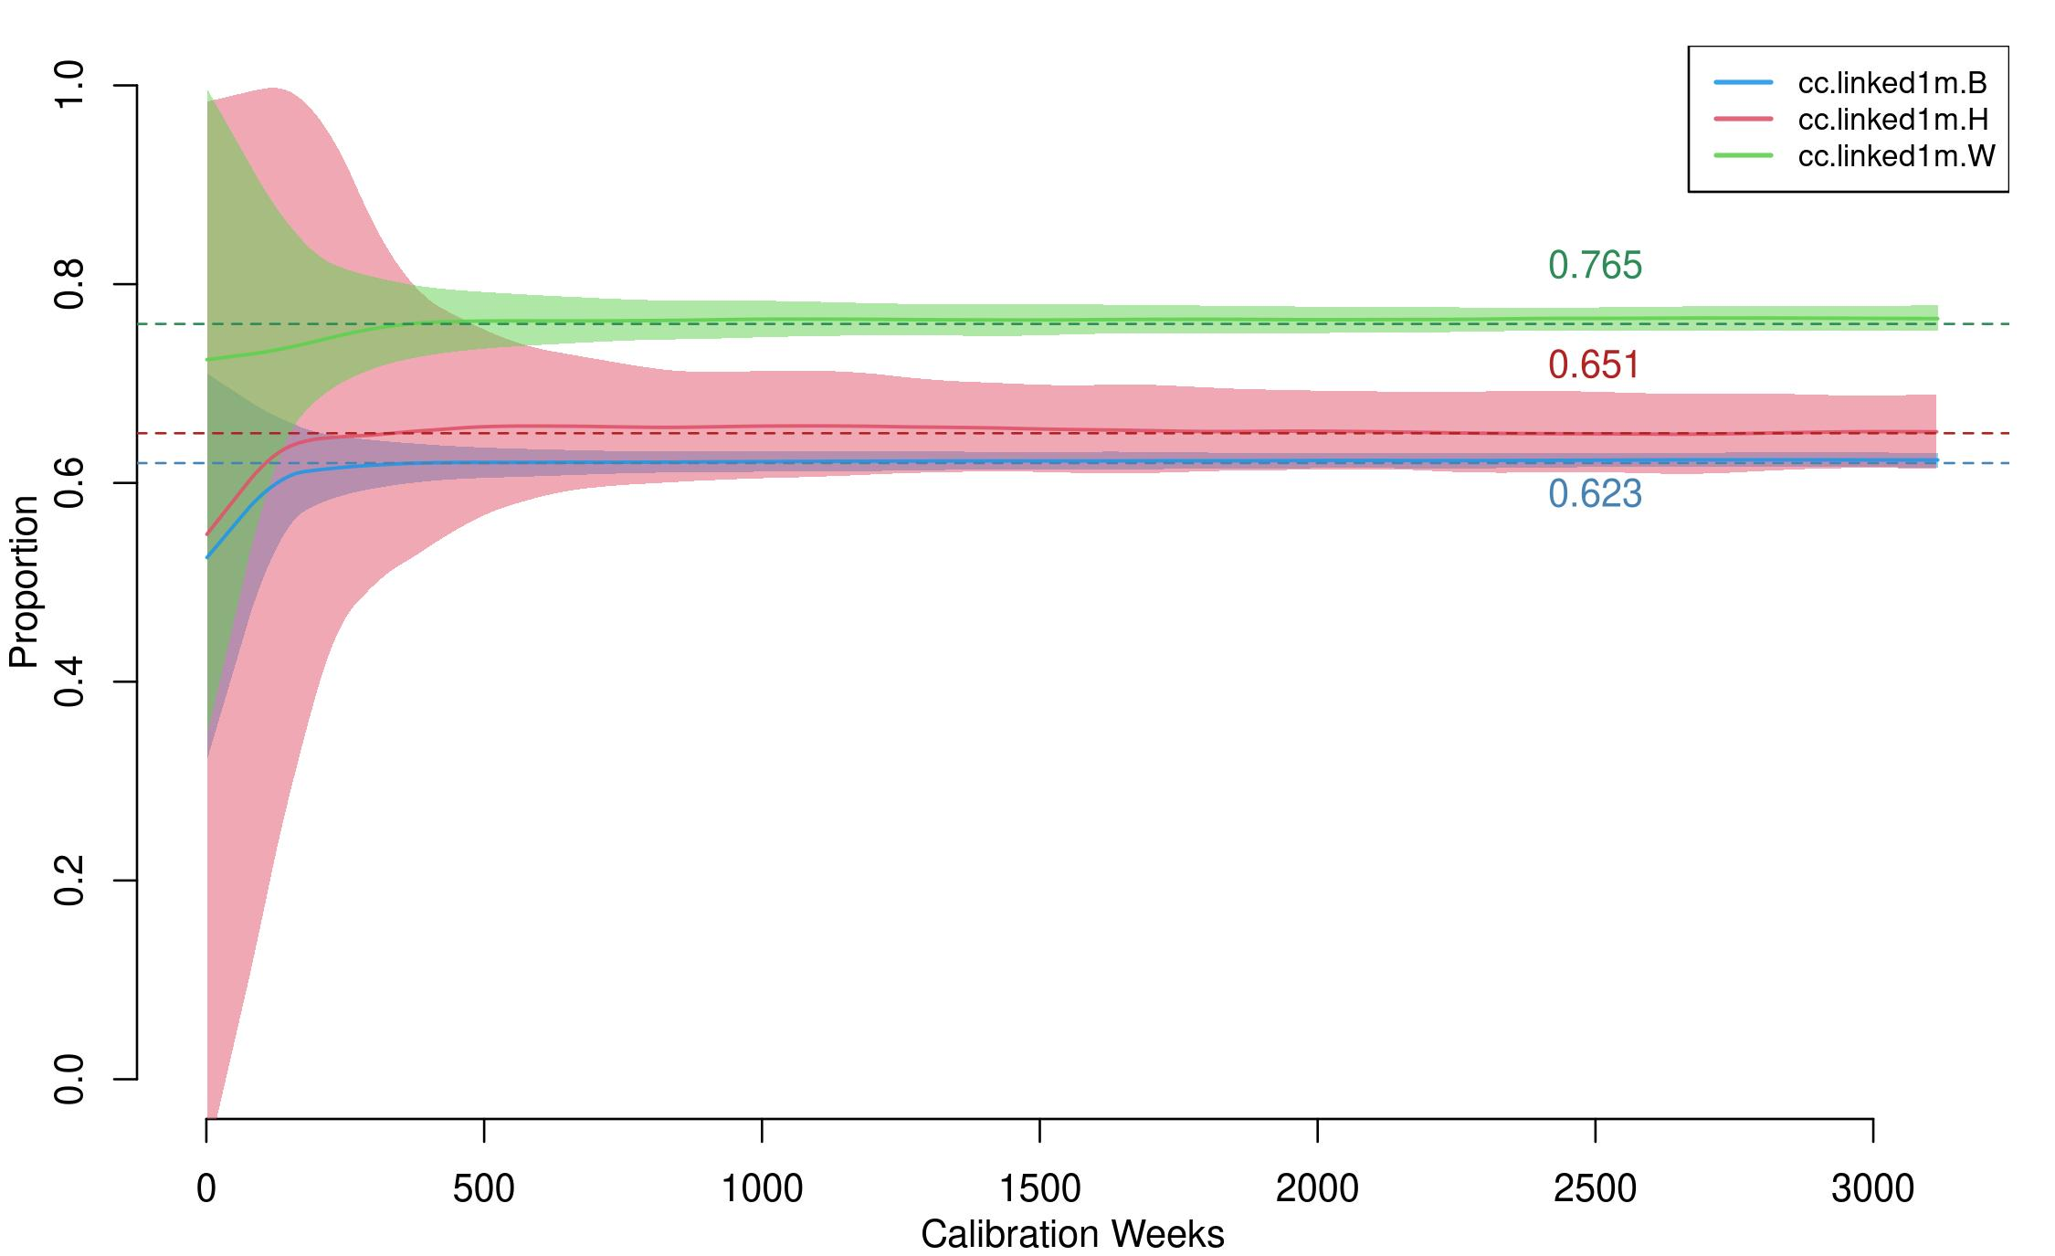
Supplemental Table 11 shows the numerical results of the calibration. The rate of care establishment was highest for White MSM, and lower for Black and Hispanic MSM. With the calibrated rates, the model simulations matched these target statistics. The inverse of these rates implied that the average time to ART initiation after HIV diagnosis was between 4 to 6 weeks on average.

Supplemental Table 11. Model Parameterization for ART Linkage After Diagnosis
 | Black MSM | Hispanic MSM | White MSM
Target Statistic: Fraction Linked within 1m²⁸ | 62% | 65% | 76%
Simulations: Fraction Linked | 62.3% | 65.1% | 76.5%
Calibrated Rates (per Week) | 0.1775 | 0.1900 | 0.2521
Mean Time to ART (in Weeks) | 5.6 | 5.3 | 4.0
Abbreviations: ART, antiretroviral therapy; m, month; MSM, men who have sex with men.

7.3 ART Adherence and HIV Viral Load Suppression
MSM who initiated ART could cycle on and off treatment, where cycling off treatment resulted in an increase in the VL back up to the assumed set point of 4.5 log₁₀. The slope of changes to VL were calculated such that it took a total of 3 months to transition between the set point and the on-treatment viral loads.³⁴ Individuals on ART could reach full suppression with sustained ART use. The nadir HIV viral load level was assumed to be 1.5 log₁₀ among those at full suppression levels.³⁴ The latter corresponds to a rounded value (on the log₁₀) scale of an absolute viral load of 30 which is below the standard levels of detection.³⁵ Viral load was tracked and updated continuously over time based on the natural history of HIV disease by stage, and current use of ART.
The patterns of ART adherence (cycling on and off ART) leading to full HIV viral suppression were estimated based on an analysis of HIV care patterns among MSM in the United States³⁶ and model calibration similar to the first two HIV care continuum steps. The rates of cycling off ART after initially starting (the “halting rate”) and the rates of cycling back on after a period of stopping (the “reinitiation rate”) controlled overall levels of HIV viral suppression. Within the intervention component of the model, improvement to HIV care retention corresponded to reductions in the halting rate by relative amounts compared to the base calibrates rates.
Because of the negative collinearity of the halting and reinitiation rates that would result in non-identifiability issues with both were simultaneously estimated, we elected to keep the reinitiation rates fixed and fit the halting rates. We started with halting and reinitiation rates and their uncertainty intervals based on an earlier model of the HIV care continuum in the U.S.³⁷ These reinitiation rates were 0.1326 per year, corresponding to an average time spent off ART before reengagement of 7.5 years. With the reinitiation rates fixed there, we then allowed the halting rates to vary by race/ethnicity and fit them to generate simulations matching the race/ethnicity-specific proportions of diagnosed MSM with a suppressed VL in the cross-section. We did not model a distinct clinical typology of ART users with a lower propensity for ART discontinuation, above and beyond the differences by race/ethnicity, for two reasons. First, the empirical data to support a distinct typology at the population-level are insufficient. Second, the retention interventions currently in the scenarios are designed to shift the overall population averages rather than focus on a subgroup who would be at higher-risk of ART dropout.
Supplemental Figure 7 shows the general results of this calibration. The general approach was the same as for calibration of HIV screening rates and ART linkage rates. The specific metric used within the simulations to compare against the target statistics was the proportion of individuals who had a HIV VL below the detectable limit of 200 copies/mL. A group-specific proportion of persons was calculated at each time step in the model. The target statistics are shown with dashed horizontal lines and the simulated statistics are shown with solid lines. Each model calibration was simulated 1000 times, so the solid lines represent the median values across those simulations and the polygon bands are the interquartile ranges.
Supplemental Figure 7. Proportion of Diagnosed HIV-Infected MSM with HIV Viral Load Suppression, Stratified by Race/Ethnicity (blue = Black MSM, red = Hispanic MSM, green = White MSM)
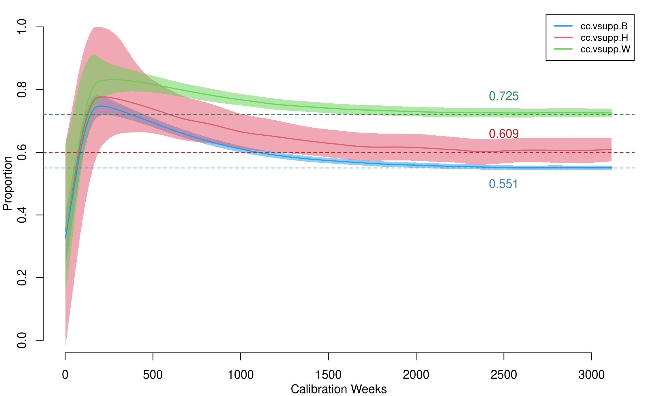
Supplemental Table 12 shows the numerical results of the calibration. Georgia Department of Public Health data for MSM in 2017 were our target statistics for the proportion of diagnosed MSM with a suppressed viral load in the cross-section. This mapped directly onto to our model simulations.

Supplemental Table 12. Model Parameterization for ART Retention Rates After Linkage
 | Black MSM | Hispanic MSM | White MSM
Target Statistic: Fraction VL Suppressed²⁸ | 55% | 60% | 72%
Simulations: Fraction VL Suppressed | 55.1% | 609% | 72.5%
Calibrated Halting Rates (per Week) | 0.0058 | 0.00475 | 0.0028
Mean Time to First ART Stoppage (in Weeks) | 171.4 | 209.5 | 356.1
Mean Time to First ART Stoppage (in Years) | 3.3 | 4.0 | 6.8
Abbreviations: ART, antiretroviral therapy; MSM, men who have sex with men; VL, viral load.
The corresponding halting rates were therefore lowest in White MSM and highest in Black MSM. The inverse of these rates implied a time to first stopping ART after initiation of 161 to 323 weeks.

7.4 AIDS Disease Progression and AIDS-Related Mortality
Progression to AIDS after ART initiation was modeled based on the cumulative time on and off ART for individuals who had been linked to treatment (persons never linked to ART progressed according to the rates in Section 6). The maximum untreated time between infection and the start of AIDS for those who never initiate treatment was 10 years.²⁵ For those with some treatment history, we assumed a slower progression time, with individuals who had ever initiated ART spending a maximum of 15 years off of ART over the life course before progression to AIDS, similar to previous models.¹ Persons who had ever initiated ART progressed to AIDS at a similar rate as those who were ART-naïve, but ART use during the AIDS stage was associated with the same declines in HIV viral load as in pre-AIDS stages. However, to account for treatment failure during the AIDS stage, the same mortality rate was applied to persons on active ART and those not on active ART within the AIDS stage. Therefore, we assumed that the probability of disease-induced mortality given AIDS was 1/104 per week consistent with approximately 2 years on average spent in the AIDS stage during untreated infection.

7.5 PrEP Initiation and Adherence
In our models, we consider that PrEP initiation can only occur after a negative HIV test. This makes the PrEP initiation rate linked to the test rate. PrEP start and stop rate are thus calibrated after the other parameters (the technical details of which are explained in Section 13.2).

8 INTERHOST EPIDEMIOLOGY
Interhost epidemiological processes represent the HIV-1 disease transmission within the model. Disease transmission occurs between sexual partners who are active on a given time step. This section will describe how the overall rate is calculated as a function of the intrahost epidemiological profile of each member of a partnership, and behavioral features within the dyad.

8.1 HIV-Discordant Dyads
At each time step in the simulation, a list of active dyads was selected based on the current composition of the network. This was called an “edgelist.” Given the three types of partnerships detailed above, the full edgelist was a concatenation of the type-specific sublists. The complete edgelist reflects the work of the STERGM- and ERGM-based network simulations, wherein partnerships formed on the basis of nodal attributes and degree distributions (see Section 3). From the full edgelist, a disease-discordant subset was created by removing those dyads in which both members were HIV- or both were HIV+. This left dyads that were discordant with respect to HIV status, which was the set of potential partnerships over which infection may be transmitted at that time step.

8.2 HIV Transmission Rates
Within HIV-discordant dyads, transmission was simulated stochastically across separate sexual acts at each timestep. The per-act probabilities were a combined function of attributes of the HIV-negative and HIV-positive partner, these probabilities were calibrated to reach the empirical diagnosed HIV prevalence. The final per-partnership transmission rates per time step were then a function of one minus these per-act transmission probabilities raised to the number of acts within the partnership during that time step.

8.2.1 Per-Act Transmission Probabilities
Within disease-discordant dyads, HIV transmission was modeled based on a sexual act-by-act basis, in which multiple acts of varying infectiousness could occur within one partnership within a weekly time step. Determination of the number of acts within each discordant dyad for the time step, as well as condom use and role for each of those acts, was described in Section 4. Transmission by act was then modeled as a stochastic process for each discordant sex act following a Bernoulli distribution with a probability parameter that is a multiplicative function of the following predictors of the HIV- and HIV+ partners within the dyad, as shown in Supplemental Table 13 below.
For each act, the overall transmission probability was determined first based on sexual position and HIV viral suppression status of the infected partner. If the infected partner was virally suppressed and on ART, then the base probability was 2.2/100,000, which was derived from a model-based estimate of Supervie.³⁸ This study estimated upper bound of the transmission probability of 4.4/100,000 for MSM; we used the mean between the observed number (zero) and this upper bound as our base per-act transmission probability (so 2.2 transmissions per 100,000 exposures) in our model.
If the infected partner was not virally suppressed (at conditions of 200 copies/mL or higher) or not currently on ART, the base probability was a function of whether the HIV positive partner was in the receptive or insertive role, with an infection risk 2.6 times higher for in the case of an insertive infected partner compared to receptive. Then, following the parametric function of Wilson,³⁹ the HIV+ partner’s viral load modifies this base probability in a non-linear formulation, upwards if the VL was above the VL set point during chronic stage infection in the absence of ART, and downwards if it was below the set point.
Following others, we modeled an excess transmission risk in the acute stage of infection above that predicted by the heightened VL during that period.⁴⁰ Three covariates could reduce the risk of infection: condom use within the act by either the HIV- or HIV+ partner, circumcision status of the HIV- partner (only if the HIV- partner was insertive in that act), and PrEP use at the time of the act by the HIV- partner.

Supplemental Table 13. Per-Act Transmission Probabilities and Modifiers
Predictor | Partner | Parameters | References
Sexual role (insertive or receptive) | HIV- | Receptive: 0.008938 base probability when HIV+ partner has 4.5 log₁₀ viral load | Vittinghoff⁴¹
 |  | Insertive: 0.003379 base probability when HIV+ partner has 4.5 log₁₀ viral load | Vittinghoff⁴¹
HIV viral load (VL) | HIV+ (Not virally suppressed or not on ART) | Multiplier of 2.45^{(VL - 4.5)} on sexual-role specific base probabilities above | Wilson³⁹
 | HIV+ (Virally suppressed and on ART) | 0.000022 base probability, regardless of sexual role | Supervie³⁸
Acute stage | HIV+ | Multiplier of 6 | Leynaert,²⁴ Bellan⁴⁰
Condom use | Both | Multiplier of 0.05 times (1 – 0.25) | Varghese,⁴² Weller,⁴³ Smith⁴⁴
Circumcision status | HIV-, insertive | Multiplier of 0.40 | Gray²⁰
Preexposure Prophylaxis (PrEP) | HIV- | High adherence: Multiplier of 0.01  Medium adherence: Multiplier of 0.19  Low adherence: Multiplier of 0.69 | Grant⁴⁵
Current STI | Urethral | Multiplier of 1.73 for HIV acquisition  Multiplier of 1.30 for HIV transmission | Fitted values (see Section 9.2 below) for acquisition; Wall⁴⁶ for transmission
 | Rectal | Multiplier of 2.78 for HIV acquisition  Multiplier of 1.30 for HIV transmission
For condom use, we updated our previous approach to explicitly represent condom failure that would result in a transmission event. Our previous models used estimates of HIV incidence comparing consistent condom users to occasional or non-condom users, resulting in a condom “efficacy” of 75–80%. However, this efficacy gap of 20–25% is the function of both the biological/physiological gaps in protection given perfect and consistent condom use during anal intercourse as well as the human error resulting in impact use. Such error could represent condom breakage, misapplication, incomplete use during sexual activity, and other related causes.⁴⁴ For this model, we assumed a 95% efficacy for the former, and a 25% absolute reduction in that efficacy as a function of condom failure to arrive at the previous range of 71% total effectiveness.

8.2.2 Calibration of Transmission Probabilities
In addition to the calibration of the HIV care continuum parameters described in Section 7, we also calibrated the per-act transmission probabilities so that the diagnosed HIV prevalence was consistent with empirical data on HIV burden in this target population. Our target statistic for this calibration step was diagnosed HIV prevalence by race/ethnicity, which was estimated in Rosenberg.⁴⁷ The target statistics of diagnosed HIV prevalence for MSM in the Atlanta area were 33.3% for Black MSM, 12.7% for Hispanic MSM, and 8.4% for White MSM. We took this approach to calibration because there are no external data on the baseline estimated HIV incidence by race/ethnicity for our target population of MSM aged 15 to 65 of all race/ethnicities. There is some historical cohort data for younger (18 to 39 years old) Black and White MSM in Atlanta;¹³ these were used to calibrate our earlier modeling studies.⁴ But we are concerned that the cohort members may be higher risk than all demographically similar MSM in Atlanta due to selection biases. This was a main motivation to moving towards calibrating the model primarily based on population-level surveillance targets for the care continuum and disease prevalence.
The per-act transmission probabilities defined above were then multiplied by a factor unique to each race/ethnic group of the uninfected partner. The final factor levels were 2.53 for Black MSM, 0.4 for Hispanic MSM, and 0.275 for White MSM. These calibration factors represent the additional sources of potential error in the transmission parameters that would generate the current HIV epidemic. The upweighting of the transmission probabilities for Black MSM and down-weighting for White and Hispanic MSM is due to the long-standing finding that race-stratified behavioral and network data do not, by themselves, explain the excess burden of HIV among Black MSM.^{48,49}
Supplemental Figure 8. Diagnosed HIV Prevalence, Stratified by Race/Ethnicity (blue = Black MSM, red = Hispanic MSM, green = White MSM)
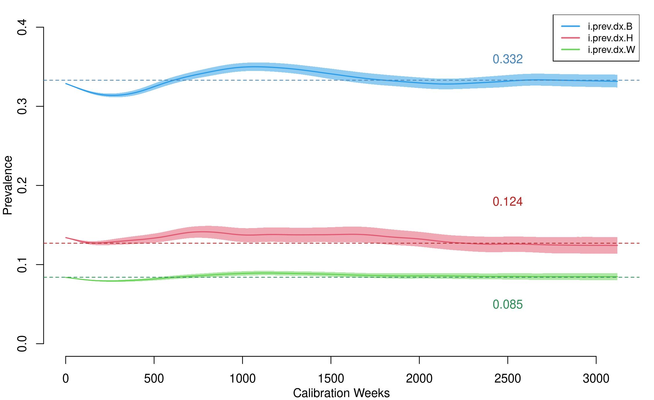
The results of the calibration are visualized in Supplemental Figure 8. The HIV prevalence was initialized based on the statistical model of diagnosed HIV prevalence with ARTnet data, but allowed to change over the 120-year burn-in period to reach the specified target statistics. In the calibrated model, the median diagnosed HIV prevalence during the final year of the calibration period was 33.2% for Black MSM, 12.4% for Hispanic MSM, and 8.5% for White MSM.

8.2.3 Final Per-Partnership-Week Transmission Rates
The final transmission rate per partnership per weekly time step was a function of the per-act probability of transmission in each act and the number of acts per time step. The per-act transmission probability could be heterogeneous within a partnership due to various types of acts in each interval: for example, a HIV- man who is versatile in role may have both insertive and receptive intercourse within a single partnership; some acts within a partnership may be protected by condom use while others are condomless. Transmission was simulated for each act within each serodiscordant dyad, based on draws from a Bernouli distribution with the probability parameter equal to the per-act transmission probabilities detailed above.

9 STI TRANSMISSION

9.1 Overview of Model Structure
Directional transmission of NG and CT was modeled between sexual partners who were sexually active during a given time step. At each time step, a list of active dyads (the “edgelist”) was selected based on the current composition of the network. This edgelist concatenated the three types of partnerships included in the network simulations: main, casual, and one-off. Dyads were considered active at a particular time step if the terminus of that simulated edge was greater than or equal to the current time step.
We created a disease-discordant subset of the edgelist for both NG and CT at each time step by removing dyads in which both members had the disease of interest or neither had the disease of interest. This left dyads discordant with respect to both NG and CT infection status, which was the set of potential partnerships in which the infections could be transmitted at that time step.
Site-specific transmission of NG and CT was modeled on a sexual act-by-act basis, in which multiple acts of varying infectiousness could occur within a partnership within a weekly time step. The number of anal sex acts per week for each ongoing relationship was determined from a random draw from a Poisson distribution, with the lambda (event rate) parameter of the distribution specific to the partnership type.⁵⁰ For one-time contacts, the number was set deterministically to 1 for the time step in which it occurred.
For site-specific disease transmission to occur, the sexual position of partners within an MSM anal intercourse dyad was considered. For example, receptive AI with a partner infected with a urethral STI was necessary for an individual to become rectally infected. Dual-site and dual-disease infection was possible, such that a man could have had, for example, rectal NG and rectal CT infection, rectal NG and urethral CT, or rectal NG and urethral NG concurrently. We modeled disease transmission by act as a stochastic process for each discordant sex act, which followed a binomial distribution with a probability parameter that was a multiplicative function of the base transmission probability and condom use.

9.2 STI Co-Factor Effect on HIV Acquisition and Transmission Probability
We modeled an increased HIV acquisition risk from a current STI status. Chesson et al.⁵¹ described this effect for several STIs. Starting with a baseline HIV transmission probability per sex-act of 0.001 (95% CI: 0.0005–0.0015), they estimated a 10-fold (95% CI: 5–15) increase in per-act HIV transmission probability, to 0.014 (95% CI: 0.01–0.05), in the presence of NG infection. For CT infection, they estimated a 5-fold increase (95% CI: 3–15) in per-act HIV transmission probability to 0.0078 (95% CI: 0.003–0.01). Vaughan et al.⁵² found that the hazard ratio for existing rectal NG or CT infection on HIV seroconversion was 2.7 (95% CI:1.2–6.4), and Pathela et al.⁵³ estimated a similar risk ratio for the effect of rectal NG or CT infection on HIV acquisition, which was slightly elevated over estimates not taking site-specific infection into account.⁵⁴ Using these estimates, we established a Bayesian prior distribution of 2.00–3.00 for the relative increase in per-act HIV acquisition risk for rectal STI infections, and 1.00–2.00 for urethral STI infections. These estimates incorporate site-specific infection and assume an increased risk associated with rectal infection. After model fitting, the estimated posterior multiplier values for risk of HIV acquisition were 2.7807 for rectal NG and CT, and 1.7324 for urethral NG and CT.
Fewer data are available to estimate the effect of NG/CT on HIV transmission from HIV-infected to HIV-uninfected partners. We are unaware of any studies that explicitly estimate this quantity among MSM; however, an estimate is available based on heterosexual partnerships in an African cohort.⁴⁶ Based on these data, we selected a plausible multiplier of 1.3 for the effect of NG/CT on HIV transmission from rectal and urethral sites.

9.3 Chlamydia Transmission Probability
Estimated values of the per-sex-act CT transmission risk in previous STI-only and HIV/STI models have depended on whether the infection was symptomatic, the type of sex act, as well as the role and position of the infected partner. The baseline per-act CT transmission risk for heterosexual encounters has been estimated in multiple models, with the middle 50% of per-act probability estimates describing male-to-female transmission clustered between 0.09–0.20^{55–69} with a wider range of 0.025 to 0.6.^{70–77} Estimated per-act transmission risk was generally higher in non-main partnerships when models incorporated or characterized different risk estimates by partnership types.⁶⁰ Per-partnership transmission risk estimates ranged widely from 0.09 to 0.7,^{67,78–81} and per-day infection probabilities ranged from 0.001571 to 0.154, with higher estimates for casual partnerships relative to main partnerships.^{82–85} In models where the direction of transmission was reported, the estimated per-act female-to-male CT transmission probability varied, commonly estimated as 0.5–0.8 times the male-to-female CT transmission probability,^{56,57,64,69,70,72,83} although some models did estimate that the female-to-male transmission probability was greater.^{55,84}
For our model, we focus on the baseline male-to-male CT transmission risk through anal intercourse in STI and HIV/STI models. Fewer models and estimates of this probability exist for MSM than do for heterosexual populations. Estimates of the per-act transmission probability have included 0.1–0.24,⁸⁶ 0.4 for receptive AI,⁸⁷ 0.32 for insertive AI,⁸⁷ and 0.35 per-partner.⁸⁸ To avoid the underdetermination issues of having too many parameters for a single target, we defined the per-act transmission probability for receptive AI using the calibrated value for insertive AI with an Odds Ratio of 1.5. The estimated posterior means were 0.185 for per sex-act rectal CT transmission probability and 0.131 for per sex-act urethral CT transmission probability. We also include a multiplier of 0.30 for the effect of condom usage on CT transmission probability to reflect the decreased probability of transmission in protected sex acts, consistent with the literature.^{89,90}

9.4 Gonorrhea Transmission Probability
Estimates of the NG transmission risk per sex-act have been diverse in HIV/STI models and STI-only models, depending on the type of sex act as well as the role and position of the infected partner. This baseline per-act risk has been estimated in a number of models, with the middle 50% of estimates of the per-act risk from male-to-female transmission models located between 0.20 and 0.60,^{55–59,64,69–71,73,76,79,91–101} with an outer range of 0.1 to 1.^{98,102,103} Per-day infection probability estimates ranged from 0.011 to 0.6,^{83,93,104} with higher probabilities estimates for non-main partnerships. Per-partnership estimates differed widely, ranging from 0.10 to 0.80.^{72,105,106} When female-to-male transmission was distinguished, the per-act55–57,69,72,83,91,92,94,98–100,105 and per-partnership^{70,106} estimated risk tended to be decreased or halved, compared to the male-to-female risk, with some exceptions in which the female-to-male risk was estimated to be greater.^{64,94,101}
Compared to CT infection, the baseline transmission probability per sex-act for male-male anal intercourse in STI models has been better characterized for NG infection. Estimates of these risks have ranged widely from 0.02 and 0.8,^{87,88,107–110} with greater risks assumed for receptive anal intercourse compared to insertive anal intercourse. To avoid the underdetermination issues of having too many parameters for a single target, we defined the per-act transmission probability for receptive AI using the calibrated value for insertive AI with an Odds Ratio of 1.5. The estimated posterior means were 0.276 for per sex-act rectal NG transmission probability and 0.203 for per sex-act urethral NG transmission probability. Similar to CT, we also included a multiplier of 0.30 for the effect of condom usage on NG transmission probability to reflect the decreased probability of transmission in protected sex acts.

10 STI SYMPTOMS AND TREATMENT

10.1 Treatment
Testing and treatment for NG and CTs was a function of whether the infection was symptomatic or asymptomatic. Treatment status was assigned stochastically among those with either symptomatic or diagnosed asymptomatic NG or CT infection acquired prior to the current time step. We simulated that 80% of men with NG or CT who have symptomatic infection successfully sought and completed treatment each week following the infection. Symptoms-driven testing was correlated, in that a man presenting with rectal symptoms was tested for both NG and CT at a rectal site. We assumed that treatment entailed sufficient antibiotic dosage to fully treat the infection. Additionally, we assumed that, for men with concurrent infection by the same bacterial STI at both rectal and urethral sites, treatment for one anatomic site would result in effective treatment at the other anatomic site. There are some data suggesting that certain antibiotics may be less effective at treating the bacterial STI at some anatomic sites, which may be a potential limitation for those modeled individuals who have concurrent dual site infection.
The time on treatment/in recovery was 1 week for NG and CT.
The site of infection influenced the symptomatic status of a given infection, with rectal infections more likely to be asymptomatic and urethral infections more likely to be symptomatic.¹¹¹ The symptomatic status of an infection was assigned stochastically from a binomial distribution at the time of infection according to site-specific and infection-specific probability parameters for symptomatic status. The probability of starting treatment varied between symptomatic and asymptomatic infections. Between 30% and 40% of men with STI symptoms delay seeking care for > 1 week^{112,113}. Thus, the weekly rate of starting treatment was 70% for symptomatic NG and 70% for symptomatic CT, resulting in >99% treatment within 4 weeks to allow for delays in care-seeking. Fewer data are available on the probability of successful treatment following screening, so we relied on expert opinion. The weekly probability of treatment for NG and CT detected via screening (i.e., asymptomatic) was 80%, reflecting the high probability of treatment. This resulted in >99% of positive screening tests resulting in treatment within 3 weeks (see section 12 STI screening).

10.2 Chlamydia Symptoms
The asymptomatic nature of some CT infections can have an impact on the risk of transmission, as well as the dynamics of spread in a population. These estimates have varied widely for CT. For men, the middle 50% of estimates of the proportion of infections that are symptomatic from STI or HIV/STI models has ranged from 0.3–0.5,55,61,64,66,69,70,73,76,80,81,85,86,91 with an outer range of 0–0.75^{59,65,68,114,115} and a sizable cluster of estimates at 0.75.^{74,75,83,84,88} Beck et al.⁸⁷ differentiated between the probability of symptoms of urethral and rectal CT infections in MSM, estimating a 4-fold increase in the likelihood of symptoms (0.58 versus 0.14) at the urethral site. The proportion symptomatic in males tends to be increased 1.5–3 fold over the same proportion in women,55,61,64–66,69,70,80,81,83–85,91 with a few exceptions where women are estimated to be more symptomatic.^{68,76,115} Given the uncertainty surrounding this estimate, we established a prior distribution for calibration of 0.01–0.15 for the probability that a rectal CT infection would be symptomatic, and a distribution of 0.40–0.95 for the probability that a urethral CT infection would be symptomatic to incorporate site-specific infection. The estimated posterior values were 0.14 for the probability of symptomatic rectal CT, and a probability of 0.48 for symptomatic urethral CT.

10.3 Gonorrhea Symptoms
NG infections can also be present with or without symptoms, and estimates of the proportion of infections that are symptomatic have been varied. The middle 50% of estimates of this proportion from STI or HIV/STI models for men has ranged from 0.35–0.88,55,69,73,76,91,93,99,103,108,109 with a lower quartile of 0.11 to 0.25^{59,70,98,114} with a sizable group of estimates between 0.9 to 0.95.^{64,83,88,106,116} Beck et al.⁸⁷ differentiated between the probability of symptoms of urethral and rectal NG infections in MSM, estimating a nearly 6-fold increase in the likelihood of symptoms (0.90 versus 0.16) at the urethral site. The proportion symptomatic in males tends to be increased 1.5–3 fold over the same proportion in women for NG.55,64,69,70,83,91,98,99,103,106,116 With less certainty about these parameters, we established a prior distribution of 0.01–0.15 for the probability that a rectal NG infection would be symptomatic, and a distribution of 0.60–0.95 for the probability that a urethral NG infection. The resulting posterior values were 0.16 for the probability of symptomatic rectal NG, and 0.80 for the probability of symptomatic urethral NG. As with CT, these reflect an increased likelihood of symptomatic urethral infection, which could be due to easier detection at a urethral site.

11 STI RECOVERY
We modeled recovery from a NG or CT infection according to whether men were treated for their infection. Recovery from infection back to susceptibility can occur through natural clearance of each infection or through effective antibiotic treatment. Recovery from untreated and treated NG or CT infection was simulated as a deterministic process. An individual would recover from the infection in 45 weeks without treatment or in one week after the start of the treatment otherwise. Upon recovery, individuals were immediately susceptible to reinfection.

11.1 Duration of Chlamydia Infection
Estimates of the duration of CT infection have varied broadly depending on whether the infection was symptomatic. STI and HIV/STI models have generally estimated the duration of symptomatic CT infection in men primarily as 30–35 days,^{61,62,65–68,75,81,83,84} but some models have estimates closer to 13–14 days for treated men^{73,80,87} or at a higher range between 112–365 days.^{64,69,70,87} Models which have not specified whether the infection is symptomatic or asymptomatic have widely divergent estimates ranging from 60 days up to 370 days.^{60,63,77,82,88,117,118} Some models specify the length of an infectious stage ranging from 3 weeks in treated infection up to 457 days,^{58,91} while Welte et al. estimate the incubation time of CT as 12 days.⁶⁷
For models specifying the duration of an asymptomatic CT infection, estimates tend to cluster between 200–240 days^{61,64–67,73,83,84,86} and 433–497 days.^{62,75,85,119} Some models estimated 180 days,^{68,80} 365 days,⁸¹ or 622 days,^{55,69} reflecting a range of uncertainty. Beck et al.⁸⁷ have estimated 240 days for urethral infection and 497 days for rectal infection. Given this uncertainty, we established a prior distribution of 39–65 weeks for the duration of untreated asymptomatic rectal or urethral CT infection. These resulted in posterior values of 45 weeks for the duration of asymptomatic CT infection.⁷³

11.2 Duration of Gonorrhea Infection
Estimates of NG duration have also varied widely depending on whether the infection was symptomatic. STI and HIV/STI models have modeled the duration of symptomatic NG infection as bimodal, with some estimates as low as 12–13 days,^{73,83,87,94,106}, generally for treated or care-seeking persons, and others between 105–185 days, including for untreated symptomatic infection.^{55,64,69,87} Models which have not specified whether the infection is symptomatic or asymptomatic have widely divergent estimates of duration, ranging from 10–60 days^{88,96,97,100–102,120} to 330–365 days^{98,117} with estimates also observed at 30-day intervals between 60 days and 200 days.^{70,105,109,120} Estimates of the duration of the infectious stage of NG ranged from 14 days in treated individuals^{87,91} to 180–185 days in untreated individuals^{87,95,99} but varied widely between those extremes.^{58,91,92,116}
For models specifying the duration of an asymptomatic NG infection, estimates were also bimodal, with clusters at 105–135 days^{55,64,69,83} and 180–185 days.^{73,106} Beck et al.⁸⁷ have estimated 240 days for urethral infection and 300 days for rectal infection. Given this uncertainty, we established a prior distribution of 25–52 weeks for the duration of both asymptomatic rectal and asymptomatic urethral NG infection. The estimated posterior means were 45 weeks for the duration of untreated asymptomatic rectal and urethral NG infection.

12 STI SCREENING
In this model, STI screening and treatment was modeled in a single step for MSM not on PrEP with a symptomatic NG or CT infection as described in section 10.1. PrEP users are tested every 26 weeks (half a year) where the presence of an NG or CT asymptomatic infection can be detected and treated. In this case the treatment is systematic once the infection is detected.

Other MSM are eligible to 2 different testing regimens depending on their risk. MSM sexually active are eligible to be tested every year (52 weeks) and MSM with more than one partner during the past 20 weeks are eligible to be tested twice a year (26 weeks). In the reference scenario, the coverage for the yearly regimens is 44% for eligible HIV negative MSM and 61% for eligible HIV positive MSM. The coverage for the high-risk regimen is 0% in the reference scenario. When MSM lose their eligibility, other eligible MSM are randomly picked to maintain the required coverage.

Testing is urethral for all screened MSM and an additional rectal test is performed for 48% of the screened HIV negative MSM and 63% of the screened HIV positive MSM.¹²¹

12.1 STI Incidence Targets for Calibration
We estimated the incidence of gonorrhea and chlamydia to be 12.81 and 14.59 per 100 PYAR, respectively. These estimates were generated by updating pre-PrEP era estimates¹²² using publicly available CDC STI surveillance data.^{123,124} During the 2010–2018 period, the number of diagnosed gonorrhea and chlamydia infections among all US men increased by a factor of 2.27 and 1.64, respectively.¹²³ During 2010–2017, the number of diagnosed gonorrheal infections among MSM attending CDC’s STD Surveillance Network (SSuN) clinics increased by a factor of 3.83.^{123,124} Because the increase in STI incidence among all men is likely lower than among MSM only, and because SSuN represents only a select population that may have higher incidence of STIs,¹²⁵ we assumed that all US men represented the lower bound of the relative increase in STI incidence and SSuN MSM represented the upper bound of the relative increase in STI incidence. Data on the annual chlamydia prevalence of SSuN MSM were not available, however we expect that the range of the true increase in chlamydia incidence among MSM during this time is similar to that of gonorrhea. Therefore, we estimated the upper bound for the increase in chlamydia by multiplying the ratio of the gonorrhea bounds with the lower bound for chlamydia. We then averaged the lower/upper relative bounds for each STI, and multiplied these averages to the pre-PrEP estimates to determine the updated incidences of each STI.

13 MODEL CALIBRATION
This section describes the methods for executing the simulations and conducting the data analysis on the outcomes in further detail.

13.1 Calibration Methods
We used Bayesian approaches to define model parameters with uncertain values, construct prior distributions for those parameters, and fit the model to HIV/STI prevalence and incidence data to estimate the posterior distributions of those parameter values.
We used approximate Bayesian computation with sequential Monte Carlo sampling (ABC-SMC) methods^{40,126} to calibrate behavioral parameters in which there was measurement uncertainty in order to match the simulated HIV prevalence and STI incidence at the end of the burn-in simulations to the targeted HIV prevalence and STI incidence. The details of ABC depend on the specific algorithm used, but in this case, ABC-SMC proceeded as follows.
For each candidate parameter, $θ$, to be estimated, we:
- Sampled a candidate $θ^{i}$ from a prior distribution $π(θ)$
- Simulated the epidemic model with candidate value, $θ^{i}$.
- Tested if a distance statistic, $d$ (e.g., the difference between observed HIV prevalence and model simulated prevalence) was greater than a tolerance threshold, $ϵ$.
  - If $d> ϵ$ then discard
  - If $d< ϵ$ then add the candidate $θ^{i}$ to the posterior distribution of $θ$.
- Sample the next sequential candidate, $θ^{i+1}$, either independently from $π(θ)$ (if 3a) or from $θ^{i}$ plus a perturbation kernel with a weight based on the current posterior distribution (if 3b).

13.2 Calibration Steps
We took a two-step approach to implementing the model calibration. First, we calibrated the model to match the target statistics for the HIV care continuum (screening, linkage, and HIV viral load suppression), diagnosed HIV prevalence, and STI incidence. This involved simulating the model at least 500 times for 120 years (the first burn-in period) and evaluating the distance between the selected target statistics and the simulations at the final year of the period. Once that calibration was complete, we simulated 20,000 replicates of the fitted model and selected the single simulation with the values of the target statistics closest to the targets (with total absolute deviance).
Second, we then simulated the model for 5 more years to add entropy to the system then an additional 5 years (representing the period between 2014 and 2019) in which PrEP was initially scaled up. The goal of this second burn-in period was to have PrEP coverage (the fraction of eligible MSM who currently use PrEP) calibrated to be approximately 15%. We accomplished this calibration by iteratively adjusting the model parameters for the probability of starting PrEP conditional on eligibility such that the final median PrEP coverage matched this target statistic. The final calibrated probability for starting PrEP-after a negative HIV test was 30.2%. To reach the 15% target in less than 5 years, we doubled this value during the first year in which PrEP was initially introduced to the model. The value was brought back to 30.2% for the following 4 years.

14 REFERENCES
1 Goodreau SM, Carnegie NB, Vittinghoff E, et al. What drives the US and Peruvian HIV epidemics in men who have sex with men (MSM)? PLoS ONE 2012; 7: e50522.
2 Goodreau SM, Carnegie NB, Vittinghoff E, et al. Can male circumcision have an impact on the HIV epidemic in men who have sex with men? PLoS ONE 2014; 9: e102960.
3 Carnegie NB, Goodreau SM, Liu A, et al. Targeting pre-exposure prophylaxis among men who have sex with men in the United States and Peru: partnership types, contact rates, and sexual role. J Acquir Immune Defic Syndr 2015; 69: 119–25.
4 Jenness SM, Goodreau SM, Rosenberg E, et al. Impact of the Centers for Disease Control’s HIV preexposure prophylaxis guidelines for men who have sex with men in the United States. The Journal of infectious diseases 2016; 214: 1800–7.
5 Jenness SM, Sharma A, Goodreau SM, et al. Individual HIV Risk versus population impact of risk compensation after HIV preexposure prophylaxis initiation among men who have sex with men. PLoS ONE 2017; 12: e0169484.
6 Jenness SM, Weiss KM, Goodreau SM, et al. Incidence of gonorrhea and chlamydia following human immunodeficiency virus preexposure prophylaxis among men who have sex with men: A modeling study. Clin Infect Dis 2017; 65: 712–8.
7 Goodreau SM, Hamilton DT, Jenness SM, et al. Targeting Human Immunodeficiency Virus Pre-Exposure Prophylaxis to Adolescent Sexual Minority Males in Higher Prevalence Areas of the United States: A Modeling Study. J Adolesc Health 2018; 62: 311–9.
8 Weiss KM, Goodreau SM, Morris M, et al. Egocentric Sexual Networks of Men Who Have Sex with Men in the United States: Results from the ARTnet Study. medRxiv 2019; : 19010579.
9 Jenness SM, Goodreau SM, Morris M. EpiModel: An R Package for Mathematical Modeling of Infectious Disease over Networks. J Stat Softw 2018; 84: 1–47.
10 Handcock MS, Hunter DR, Butts CT, Goodreau SM, Morris M. statnet: Software Tools for the Representation, Visualization, Analysis and Simulation of Network Data. J Stat Softw 2008; 24: 1548–7660.
11 Weiss KM, Goodreau SM, Morris M, et al. Egocentric sexual networks of men who have sex with men in the United States: Results from the ARTnet study. Epidemics 2020; 30: 100386.
12 Zlotorzynska M, Sullivan P, Sanchez T. The Annual American Men’s Internet Survey of Behaviors of Men Who Have Sex With Men in the United States: 2016 Key Indicators Report. JMIR Public Health Surveill 2019; 5: e11313.
13 Sullivan PS, Peterson J, Rosenberg ES, et al. Understanding racial HIV/STI disparities in black and white men who have sex with men: a multilevel approach. PLoS One 2014; 9: e90514.
14 Krivitsky PN, Handcock MS. A Separable Model for Dynamic Networks. J R Stat Soc Series B Stat Methodol 2014; 76: 29–46.
15 Hunter DR, Handcock MS, Butts CT, Goodreau SM, Morris M. ergm: A Package to Fit, Simulate and Diagnose Exponential-Family Models for Networks. J Stat Softw 2008; 24: nihpa54860.
16 Carnegie NB, Krivitsky PN, Hunter DR, Goodreau SM. An approximation method for improving dynamic network model fitting. J Comput Graph Stat; 24: 502–19.
17 Krivitsky PN, Handcock MS, Morris M. Adjusting for Network Size and Composition Effects in Exponential-Family Random Graph Models. Stat Methodol 2011; 8: 319–39.
18 Hollingsworth TD, Anderson RM, Fraser C. HIV-1 transmission, by stage of infection. J Inf Dis 2008; 198: 687–93.
19 Sullivan PS, Rosenberg ES, Sanchez TH, et al. Explaining racial disparities in HIV incidence in black and white men who have sex with men in Atlanta, GA: a prospective observational cohort study. Ann Epidemiol 2015; 25: 445–54.
20 Gray RH, Kigozi G, Serwadda D, et al. Male circumcision for HIV prevention in men in Rakai, Uganda: a randomised trial. Lancet 2007; 369: 657–66.
21 United States Census Bureau. Mortality Data. 2012.
22 Jenness SM, Maloney KM, Smith DK, et al. Addressing Gaps in HIV Preexposure Prophylaxis Care to Reduce Racial Disparities in HIV Incidence in the United States. Am J Epidemiol 2019; 188: 743–52.
23 Little SJ, McLean AR, Spina CA, Richman DD, Havlir D V. Viral dynamics of acute HIV-1 infection. J Exp Med 1999; 190: 841–50.
24 Leynaert B, Downs AM, de Vincenzi I. Heterosexual transmission of human immunodeficiency virus: variability of infectivity throughout the course of infection. European Study Group on Heterosexual Transmission of HIV. Am J Epidemiol 1998; 148: 88–96.
25 Buchbinder SP, Katz MH, Hessol NA, O’Malley PM, Holmberg SD. Long-term HIV-1 infection without immunologic progression. AIDS 1994; 8: 1123–8.
26 Katz MH, Hessol NA, Buchbinder SP, Hirozawa A, O’Malley P, Holmberg SD. Temporal trends of opportunistic infections and malignancies in homosexual men with AIDS. J Inf Dis 1994; 170: 198–202.
27 Mugavero MJ, Amico KR, Horn T, Thompson MA. The state of engagement in HIV care in the United States: from cascade to continuum to control. Clin Infect Dis 2013; 57: 1164–71.
28 HIV Epidemiology Section, Georgia Department of Public Health. Georgia HIV Care Continuum Update: Persons Living with HIV, and Persons DIagnosed with HIV, 2017. https://dph.georgia.gov/hiv-care-continuum.
29 Hall HI, Song R, Szwarcwald CL, Green T. Brief report: Time from infection with the human immunodeficiency virus to diagnosis, United States. J Acquir Immune Defic Syndr 2015; 69: 248–51.
30 Dailey AF, Hoots BE, Hall HI, et al. Vital Signs: Human immunodeficiency virus testing and diagnosis delays—United States. MMWR Morb Mortal Wkly Rep 2017; 66: 1300.
31 Centers for Disease Control and Prevention. Preexposure prophylaxis for the prevention of HIV infection in the United States–2017 Update: A Clinical Practice Guideline. 2017 https://www.cdc.gov/hiv/pdf/risk/prep/cdc-hiv-prep-guidelines-2017.pdf.
32 Fiebig EW, Wright DJ, Rawal BD, et al. Dynamics of HIV viremia and antibody seroconversion in plasma donors: implications for diagnosis and staging of primary HIV infection. AIDS 2003; 17: 1871–9.
33 Medland NA, Chow EPF, McMahon JH, Elliott JH, Hoy JF, Fairley CK. Time from HIV diagnosis to commencement of antiretroviral therapy as an indicator to supplement the HIV cascade: Dramatic fall from 2011 to 2015. PLoS ONE 2017; 12: e0177634.
34 Chu H, Gange SJ, Li X, et al. The effect of HAART on HIV RNA trajectory among treatment-naive men and women: a segmental Bernoulli/lognormal random effects model with left censoring. Epidemiology 2010; 21 Suppl 4: S25-34.
35 Chun T-W, Carruth L, Finzi D, et al. Quantification of latent tissue reservoirs and total body viral load in HIV-1 infection. Nature 1997; 387: 183–8.
36 Beer L, Oster AM, Mattson CL, Skarbinski J. Disparities in HIV transmission risk among HIV-infected black and white men who have sex with men, United States, 2009. AIDS 2014; 28: 105–14.
37 Shah M, Perry A, Risher K, et al. Effect of the US National HIV/AIDS Strategy targets for improved HIV care engagement: a modelling study. Lancet HIV 2016; 3: e140-146.
38 Supervie V, Breban R. Brief Report: Per Sex-Act Risk of HIV Transmission Under Antiretroviral Treatment: A Data-Driven Approach. J Acquir Immune Defic Syndr 2018; 79: 440–4.
39 Wilson DP, Law MG, Grulich AE, Cooper DA, Kaldor JM. Relation between HIV viral load and infectiousness: a model-based analysis. Lancet 2008; 372: 314–20.
40 Bellan SE, Dushoff J, Galvani AP, Meyers LA. Reassessment of HIV-1 acute phase infectivity: accounting for heterogeneity and study design with simulated cohorts. PLoS Med 2015; 12: e1001801.
41 Vittinghoff E, Douglas J, Judson F, McKirnan D, MacQueen K, Buchbinder SP. Per-contact risk of human immunodeficiency virus transmission between male sexual partners. Am J Epidemiol 1999; 150: 306–11.
42 Varghese B, Maher JE, Peterman TA, Branson BM, Steketee RW. Reducing the risk of sexual HIV transmission: quantifying the per-act risk for HIV on the basis of choice of partner, sex act, and condom use. Sex Transm Dis 2002; 29: 38–43.
43 Weller S, Davis K. Condom effectiveness in reducing heterosexual HIV transmission. Cochrane Database Syst Rev 2002; : CD003255.
44 Smith DDK, Herbst JHJ, Zhang X, Rose CE. Condom effectiveness for HIV prevention by consistency of use among men who have sex with men in the United States. J Acquir Immune Defic Syndr 2015; 68: 337–44.
45 Grant RM, Anderson PL, McMahan V, et al. Uptake of pre-exposure prophylaxis, sexual practices, and HIV incidence in men and transgender women who have sex with men: a cohort study. Lancet Infect Dis 2014; 14: 820–9.
46 Wall KM, Kilembe W, Vwalika B, et al. Risk of heterosexual HIV transmission attributable to sexually transmitted infections and non-specific genital inflammation in Zambian discordant couples, 1994–2012. International Journal of Epidemiology 2017; 46: 1593–606.
47 Rosenberg ES, Purcell DW, Grey JA, Hankin-Wei A, Hall E, Sullivan PS. Rates of prevalent and new HIV diagnoses by race and ethnicity among men who have sex with men, U.S. states, 2013-2014. Ann Epidemiol 2018; 28: 865–73.
48 Millett GA, Peterson JL, Wolitski RJ, Stall R. Greater risk for HIV infection of black men who have sex with men: a critical literature review. Am J Public Health 2006; 96: 1007–19.
49 Goodreau SM, Rosenberg ES, Jenness SM, et al. Sources of racial disparities in HIV prevalence in men who have sex with men in Atlanta, GA, USA: a modelling study. Lancet HIV 2017; 4: e311–20.
50 Jenness SM, Goodreau SM, Rosenberg E, et al. Impact of the Centers for Disease Control’s HIV preexposure prophylaxis guidelines for men who have sex with men in the United States. J Inf Dis 2016; 214: 1800–7.
51 Chesson HW, Pinkerton SD. Sexually transmitted diseases and the increased risk for HIV transmission: Implications for cost-effectiveness analyses of sexually transmitted disease prevention interventions. J Acquir Immune Defic Syndr 2000; 24: 48–56.
52 Vaughan AS, Kelley CF, Luisi N, et al. An application of propensity score weighting to quantify the causal effect of rectal sexually transmitted infections on incident HIV among men who have sex with men. BMC Medical Research Methodology 2015; 15: 25.
53 Pathela P, Braunstein SL, Blank S, Schillinger JA. HIV incidence among men with and those without sexually transmitted rectal infections: estimates from matching against an HIV case registry. Clinical infectious diseases : an official publication of the Infectious Diseases Society of America 2013; 57: 1203–9.
54 Chesson HW, Bernstein KT, Gift TL, Marcus JL, Pipkin S, Kent CK. The cost-effectiveness of screening men who have sex with men for rectal chlamydial and gonococcal infection to prevent HIV Infection. Sex Transm Dis 2013; 40: 366–71.
55 Johnson LF, Dorrington RE, Bradshaw D, Coetzee DJ. The role of sexually transmitted infections in the evolution of the South African HIV epidemic. Trop Med Int Health 2012; 17: 161–8.
56 Pinkerton SD, Layde PM, DiFranceisco W, Chesson HW, NIMH Multisite HIV Prevention Trial Group. All STDs are not created equal: An analysis of the differential effects of sexual behaviour changes on different STDs. Int J STD AIDS 2003; 14: 320–8.
57 Pinkerton SD, Chesson HW, Layde PM, National Institute of Mental Health Multisite HIV Prevention Trial Group. Utility of behavioral changes as markers of sexually transmitted disease risk reduction in sexually transmitted disease/HIV prevention trials. J Acquir Immune Defic Syndr 2002; 31: 71–9.
58 Stigum H, Magnus P, Veierod M, Bakketeig LS. Impact on Sexually Transmitted Disease Spread of Increased Condom Use by Young Females, 1987–1992. Int J Epidem 1995; 24: 813–20.
59 Vickerman P, Watts C, Peeling RW, Mabey D, Alary M. Modelling the cost effectiveness of rapid point of care diagnostic tests for the control of HIV and other sexually transmitted infections among female sex workers. Sex Transm Infect 2006; 82: 403–12.
60 Althaus CL, Heijne JCM, Herzog SA, Roellin A, Low N. Individual and population level effects of partner notification for Chlamydia trachomatis. PLoS ONE 2012; 7: e51438.
61 Andersen B, Gundgaard J, Kretzschmar M, Olsen J, Welte R, Oster-Gaard L. Prediction of costs, effectiveness, and disease control of a population-based program using home sampling for diagnosis of urogenital Chlamydia trachomatis infections. Sex Transm Dis 2006; 33: 407–15.
62 Davies B, Anderson S-J, Turner KME, Ward H. How robust are the natural history parameters used in chlamydia transmission dynamic models? A systematic review. Theor Biol Med Model 2014; 11: 8.
63 Heijne JCM, Herzog SA, Althaus CL, Tao G, Kent CK, Low N. Insights into the timing of repeated testing after treatment for Chlamydia trachomatis: data and modelling study. Sex Transm Infect 2013; 89: 57–62.
64 Hui BB, Gray RT, Wilson DP, et al. Population movement can sustain STI prevalence in remote Australian indigenous communities. BMC Infect Dis 2013; 13: 188.
65 Kretzschmar M, Satterwhite C, Leichliter J, Berman S. Effects of screening and partner notification on Chlamydia positivity in the United States: a modeling study. Sex Transm Dis 2012; 39: 325–31.
66 Kretzschmar M, Welte R, van den Hoek A, Postma MJ. Comparative model-based analysis of screening programs for Chlamydia trachomatis infections. Am J Epidemiol 2001; 153: 90–101.
67 Welte R, Postma M, Leidl R, Kretzschmar M. Costs and effects of chlamydial screening: dynamic versus static modeling. Sex Transm Dis 2005; 32: 474–83.
68 Turner KME, Adams EJ, Gay N, Ghani AC, Mercer C, Edmunds WJ. Developing a realistic sexual network model of chlamydia transmission in Britain. Theor Biol Med Model 2006; 3: 3.
69 Johnson LF, Alkema L, Dorrington RE. A Bayesian approach to uncertainty analysis of sexually transmitted infection models. Sex Transm Infect 2010; 86: 169–74.
70 Freeman EE, Orroth KK, White RG, et al. Proportion of new HIV infections attributable to herpes simplex 2 increases over time: simulations of the changing role of sexually transmitted infections in sub-Saharan African HIV epidemics. Sex Transm Infect 2007; 83 Suppl 1: i17-24.
71 Pinkerton SD, Chesson HW, Crosby RA, Layde PM. Linearity and nonlinearity in HIV/STI transmission: implications for the evaluation of sexual risk reduction interventions. Evaluation review 2011; 35: 550–65.
72 Swinton J, Garnett GP, Brunham RC, Anderson RM. Gonococcal infection, infertility, and population growth: I. Endemic states in behaviourally homogeneous growing populations. IMA J Math Appl Med Biol 1992; 9: 107–26.
73 Gopalappa C, Huang Y-LA, Gift TL, Owusu-Edusei K, Taylor M, Gales V. Cost-effectiveness of screening men in Maricopa County jails for chlamydia and gonorrhea to avert infections in women. Sex Transm Dis 2013; 40: 776–83.
74 Gray RT, Beagley KW, Timms P, Wilson DP. Modeling the impact of potential vaccines on epidemics of sexually transmitted Chlamydia trachomatis infection. J Inf Dis 2009; 199: 1680–8.
75 Schmid B V, Kretzschmar M. Determinants of sexual network structure and their impact on cumulative network measures. PLoS Comput Biol 2012; 8: e1002470.
76 Turner KME, Round J, Horner P, et al. An early evaluation of clinical and economic costs and benefits of implementing point of care NAAT tests for Chlamydia trachomatis and Neisseria gonorrhoea in genitourinary medicine clinics in England. Sex Transm Infect 2014; 90: 104–11.
77 Turner KME, Adams EJ, Lamontagne DS, Emmett L, Baster K, Edmunds WJ. Modelling the effectiveness of chlamydia screening in England. Sex Transm Infect 2006; 82: 496–502.
78 Althaus CL, Heijne JCM, Low N. Towards more robust estimates of the transmissibility of Chlamydia trachomatis. Sex Transm Dis 2012; 39: 402–4.
79 Pinkerton SD, Layde PM, NIMH multisite HIV prevention trial group. Using sexually transmitted disease incidence as a surrogate marker for HIV incidence in prevention trials: a modeling study. Sex Transm Dis 2002; 29: 298–307.
80 Owusu-Edusei K, Hoover KW, Gift TL. Cost-effectiveness of opt-out chlamydia testing for high-risk young women in the US. Am J Prev Med 2016; 51: 216–24.
81 de Vries R, van Bergen JEAM, de Jong-van den Berg LTW, Postma MJ, PILOT-CT Study Group. Systematic screening for Chlamydia trachomatis: estimating cost-effectiveness using dynamic modeling and Dutch data. Value Health 2006; 9: 1–11.
82 Clarke J, White KAJ, Turner K. Approximating optimal controls for networks when there are combinations of population-level and targeted measures available: chlamydia infection as a case-study. Bull Math Biol 2013; 75: 1747–77.
83 Kretzschmar M, van Duynhoven YT, Severijnen AJ. Modeling prevention strategies for gonorrhea and Chlamydia using stochastic network simulations. Am J Epidemiol 1996; 144: 306–17.
84 Roberts TE, Robinson S, Barton PM, et al. Cost effectiveness of home based population screening for Chlamydia trachomatis in the UK: economic evaluation of chlamydia screening studies (ClaSS) project. BMJ 2007; 335: 291.
85 Schmid B V, Over EAB, van den Broek IVF, et al. Effects of population based screening for Chlamydia infections in the Netherlands limited by declining participation rates. PloS One 2013; 8: e58674.
86 Xiridou M, Vriend HJ, Lugner AK, et al. Modelling the impact of chlamydia screening on the transmission of HIV among men who have sex with men. BMC Infect Dis 2013; 13: 436.
87 Beck EC, Birkett M, Armbruster B, Mustanski B. A data-driven simulation of HIV spread among young men who have sex with men: Role of age and race mixing and STIs. J Acquir Immune Defic Syndr 2015; 70: 186–94.
88 Tuli K, Kerndt PR. Preventing sexually transmitted infections among incarcerated men who have sex with men: a cost-effectiveness analysis. Sex Transm Dis 2009; 36: S41-8.
89 Darrow WW. Condom use and use-effectiveness in high-risk populations. Sexually Transmitted Diseases 1989; 16: 157–60.
90 Joesoef MR, Linnan M, Barakbah Y, Idajadi A, Kambodji A, Schulz K. Patterns of sexually transmitted diseases in female sex workers in Surabaya, Indonesia. International Journal of STD & AIDS 1997; 8: 576–80.
91 Korenromp EL, Van Vliet C, Grosskurth H, et al. Model-based evaluation of single-round mass treatment of sexually transmitted diseases for HIV control in a rural African population. AIDS 2000; 14: 573–93.
92 Marseille E, Kahn JG, Billinghurst K, Saba J. Cost-effectiveness of the female condom in preventing HIV and STDs in commercial sex workers in rural South Africa. Soc Sci Med 2001; 52: 135–48.
93 Armbruster B, Brandeau ML. Contact tracing to control infectious disease: when enough is enough. Health Care Manag Sci 2007; 10: 341–55.
94 Chen MI, Ghani AC, Edmunds J. Mind the gap: the role of time between sex with two consecutive partners on the transmission dynamics of gonorrhea. Sex Transm Dis 2008; 35: 435–44.
95 Garnett GP, Swinton J, Brunham RC, Anderson RM. Gonococcal infection, infertility, and population growth: II. The influence of heterogeneity in sexual behaviour. IMA J Math Appl Med Biol 1992; 9: 127–44.
96 Ghani AC, Aral SO. Patterns of sex worker-client contacts and their implications for the persistence of sexually transmitted infections. J Inf Dis 2005; 191: S34–41.
97 Ghani AC, Swinton J, Garnett GP. The role of sexual partnership networks in the epidemiology of gonorrhea. Sex Transm Dis 1997; 24: 45–56.
98 Hazel A, Marino S, Simon C. An anthropologically based model of the impact of asymptomatic cases on the spread of Neisseria gonorrhoeae. J R Soc Interface 2015; 12: 20150067.
99 Hui BB, Ryder N, Su J-Y, et al. Exploring the benefits of molecular testing for gonorrhoea antibiotic resistance surveillance in remote settings. PLoS ONE 2015; 10: e0133202.
100 McCluskey CC, Roth E, van den Driessche P. Implication of Ariaal sexual mixing on gonorrhea. Am J Hum Biol 2005; 17: 293–301.
101 Turner KME, Garnett GP, Ghani AC, Sterne JAC, Low N. Investigating ethnic inequalities in the incidence of sexually transmitted infections: mathematical modelling study. Sex Transm Infect 2004; 80: 379–85.
102 Edwards R, Kim S, van den Driessche P. A multigroup model for a heterosexually transmitted disease. Math Biosci 2010; 224: 87–94.
103 Craig AP, Gray RT, Edwards JL, et al. The potential impact of vaccination on the prevalence of gonorrhea. Vaccine 2015; 33: 4520–5.
104 Althouse BM, Hébert-Dufresne L. Epidemic cycles driven by host behaviour. J R Stat Soc Series B Stat Methodol 2014; 11: 20140575.
105 Boily MC, Anderson RM. Human immunodeficiency virus transmission and the role of other sexually transmitted diseases. Measures of association and study design. Sex Transm Dis 1996; 23: 312–32.
106 Garnett GP, Mertz KJ, Finelli L, Levine WC, St Louis ME. The transmission dynamics of gonorrhoea: modelling the reported behaviour of infected patients from Newark, New Jersey. Philos Trans R Soc Lond B Biol Sci 1999; 354: 787–97.
107 Xiridou M, Soetens LC, Koedijk FDH, VAN DER Sande MAB, Wallinga J. Public health measures to control the spread of antimicrobial resistance in Neisseria gonorrhoeae in men who have sex with men. Epidemiol Infect 2015; 143: 1575–84.
108 Morin BR, Medina-Rios L, Camacho ET, Castillo-Chavez C. Static behavioral effects on gonorrhea transmission dynamics in a MSM population. J Theor Biol 2010; 267: 35–40.
109 Xiridou M, Lugnér A, de Vries HJC, et al. Cost-effectiveness of dual antimicrobial therapy for gonococcal infections among men who have sex with men in the Netherlands. Sex Transm Dis 2016; 43: 542–8.
110 Hui B, Fairley CK, Chen M, et al. Oral and anal sex are key to sustaining gonorrhoea at endemic levels in MSM populations: a mathematical model. Sex Transm Infect 2015; 91: 365–9.
111 Kent CK, Chaw JK, Wong W, et al. Prevalence of rectal, urethral, and pharyngeal chlamydia and gonorrhea detected in 2 clinical settings among men who have sex with men: San Francisco, California, 2003. Clin Infect Dis 2005; 41: 67–74.
112 Malek AM, Chang C-CH, Clark DB, Cook RL. Delay in Seeking Care for Sexually Transmitted Diseases in Young Men and Women Attending a Public STD Clinic. Open AIDS J 2013; 7: 7–13.
113 Delay in Seeking Health Care Services After Onset of Urethritis Symptoms in Men - PubMed. https://pubmed.ncbi.nlm.nih.gov/30985634/ (accessed Dec 16, 2021).
114 Gift TL, Kissinger P, Mohammed H, Leichliter JS, Hogben M, Golden MR. The cost and cost-effectiveness of expedited partner therapy compared with standard partner referral for the treatment of chlamydia or gonorrhea. Sex Transm Dis 2011; 38: 1067–73.
115 Tuite AR, Jayaraman GC, Allen VG, Fisman DN. Estimation of the burden of disease and costs of genital Chlamydia trachomatis infection in Canada. Sex Transm Dis 2012; 39: 260–7.
116 White PJ, Ward H, Cassell JA, Mercer CH, Garnett GP. Vicious and virtuous circles in the dynamics of infectious disease and the provision of health care: gonorrhea in Britain as an example. J Inf Dis 2005; 192: 824–36.
117 Vickerman P, Ndowa F, O’Farrell N, Steen R, Alary M, Delany-Moretlwe S. Using mathematical modelling to estimate the impact of periodic presumptive treatment on the transmission of sexually transmitted infections and HIV among female sex workers. Sex Transm Infect 2010; 86: 163–8.
118 Brunham RC, Pourbohloul B, Mak S, White R, Rekart ML. The unexpected impact of a Chlamydia trachomatis infection control program on susceptibility to reinfection. J Inf Dis 2005; 192: 1836–44.
119 Althaus CL, Heijne JCM, Roellin A, Low N. Transmission dynamics of Chlamydia trachomatis affect the impact of screening programmes. Epidemics 2010; 2: 123–31.
120 Boily MC, Lowndes C, Alary M. The impact of HIV epidemic phases on the effectiveness of core group interventions: insights from mathematical models. Sex Transm Infect 2002; 78 Suppl 1: i78-90.
121 Hoots BE, Torrone EA, Bernstein KT, Paz-Bailey G, NHBS Study Group. Self-Reported Chlamydia and Gonorrhea Testing and Diagnosis Among Men Who Have Sex With Men-20 US Cities, 2011 and 2014. Sex Transm Dis 2018; 45: 469–75.
122 Kojima N, Davey DJ, Klausner JD. Pre-exposure prophylaxis for HIV infection and new sexually transmitted infections among men who have sex with men: AIDS 2016; 30: 2251–2.
123 Centers for Disease Control and PreventionDivision of STD Prevention, National Center for HIV/AIDS, VIral Hepatitis, STD, and TB Prevention. Tables - 2018 Sexually Transmitted Diseases Surveillance. 2019; published online July 30. https://www.cdc.gov/std/stats18/tables.htm (accessed April 20, 2020).
124 Stenger MR, Pathela P, Anschuetz G, et al. Increases in the Rate of Neisseria gonorrhoeae Among Gay, Bisexual and Other Men Who Have Sex With Men-Findings From the Sexually Transmitted Disease Surveillance Network 2010-2015. Sex Transm Dis 2017; 44: 393–7.
125 Celum CL, Bolan G, Krone M, et al. Patients attending STD clinics in an evolving health care environment. Demographics, insurance coverage, preferences for STD services, and STD morbidity. Sex Transm Dis 1997; 24: 599–605.
126 Toni T, Welch D, Strelkowa N, Ipsen A, Stumpf MPH. Approximate Bayesian computation scheme for parameter inference and model selection in dynamical systems. J R Soc Interface 2009; 6: 187–202.

