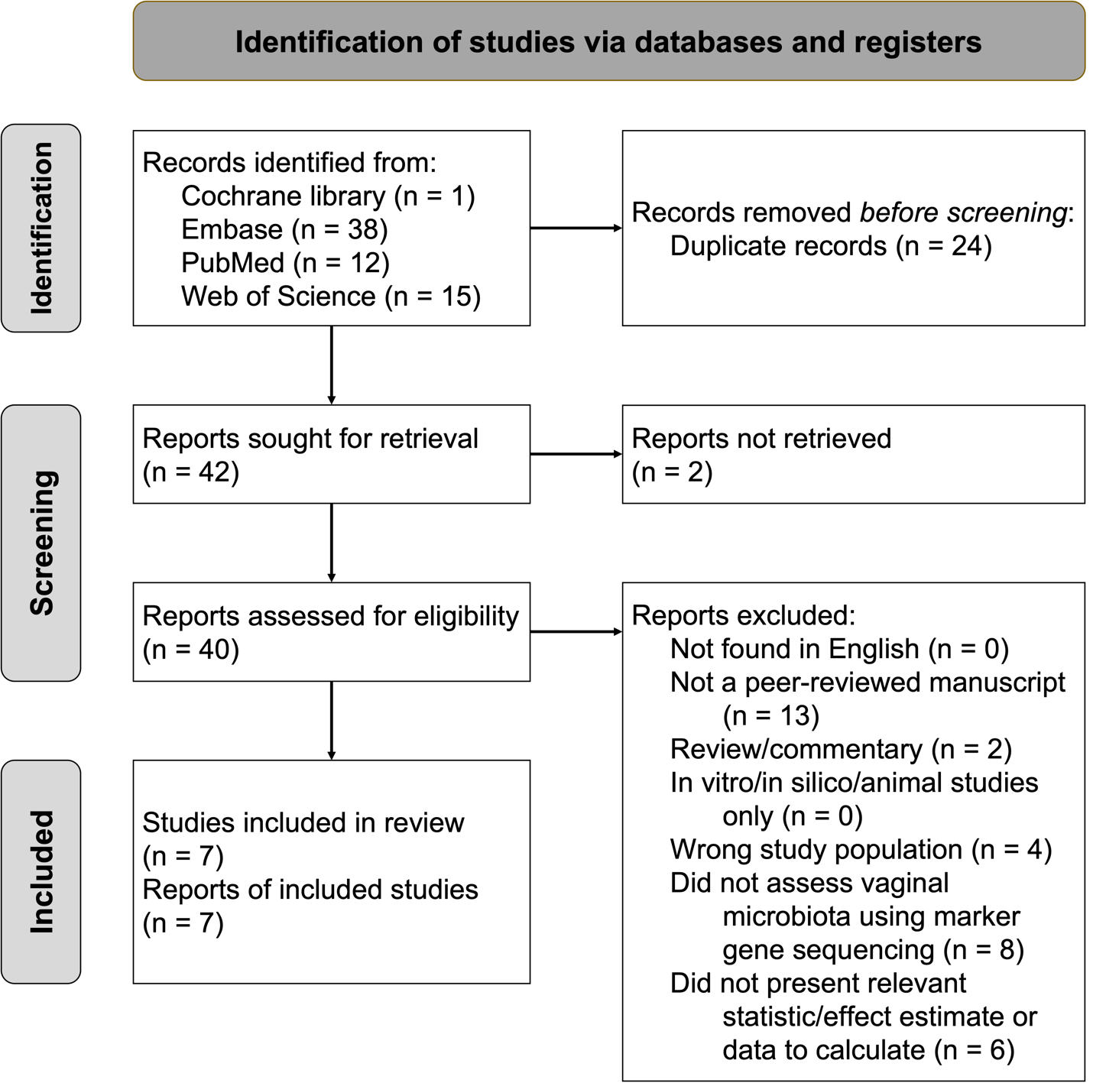
Supplemental Figure 1: Chlamydia trachomatis systematic review PRISMA diagram.
Diagram adapted from Page et al. BMJ Brit Med J. 2021;372:n71.
PRISMA; Preferred reporting items for systematic reviews and meta-analyses.

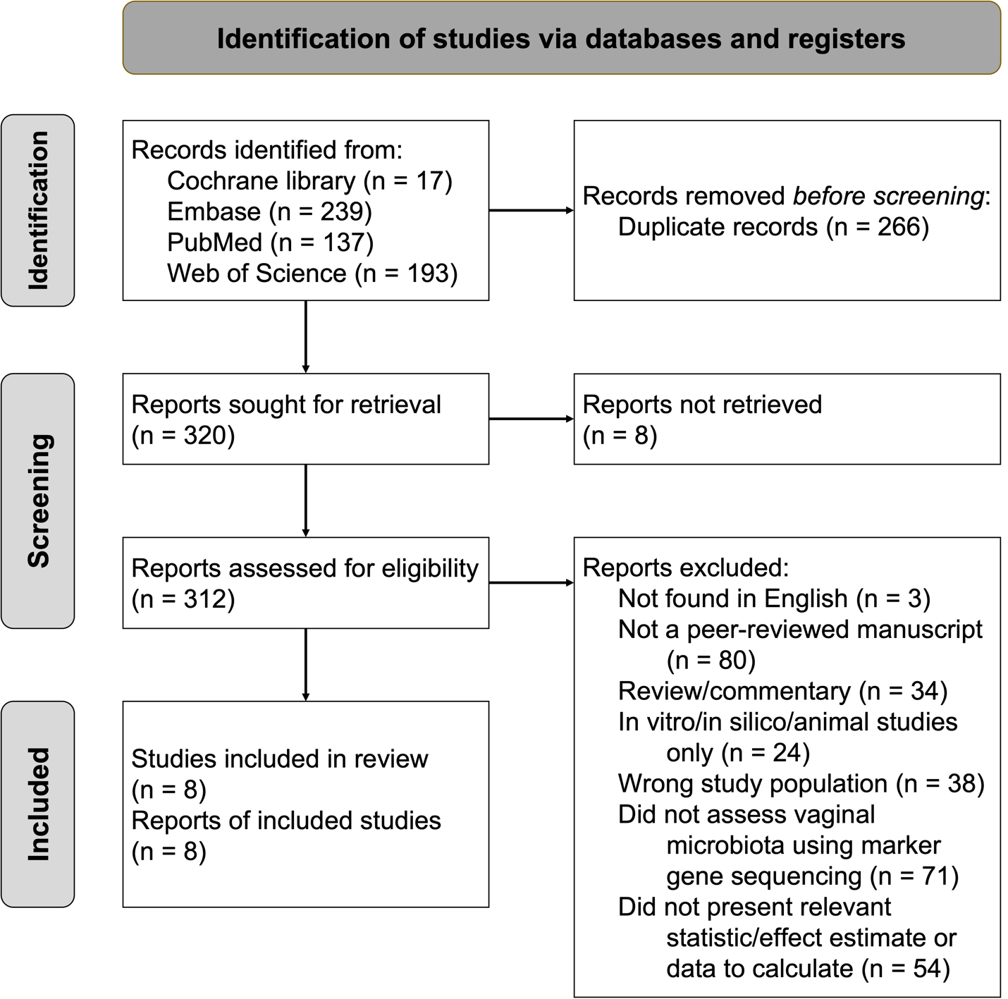
Supplemental Figure 2: BV systematic review PRISMA diagram.
Diagram adapted from Page et al. BMJ Brit Med J. 2021;372:n71.
PRISMA; Preferred reporting items for systematic reviews and meta-analyses; BV, bacterial vaginosis.

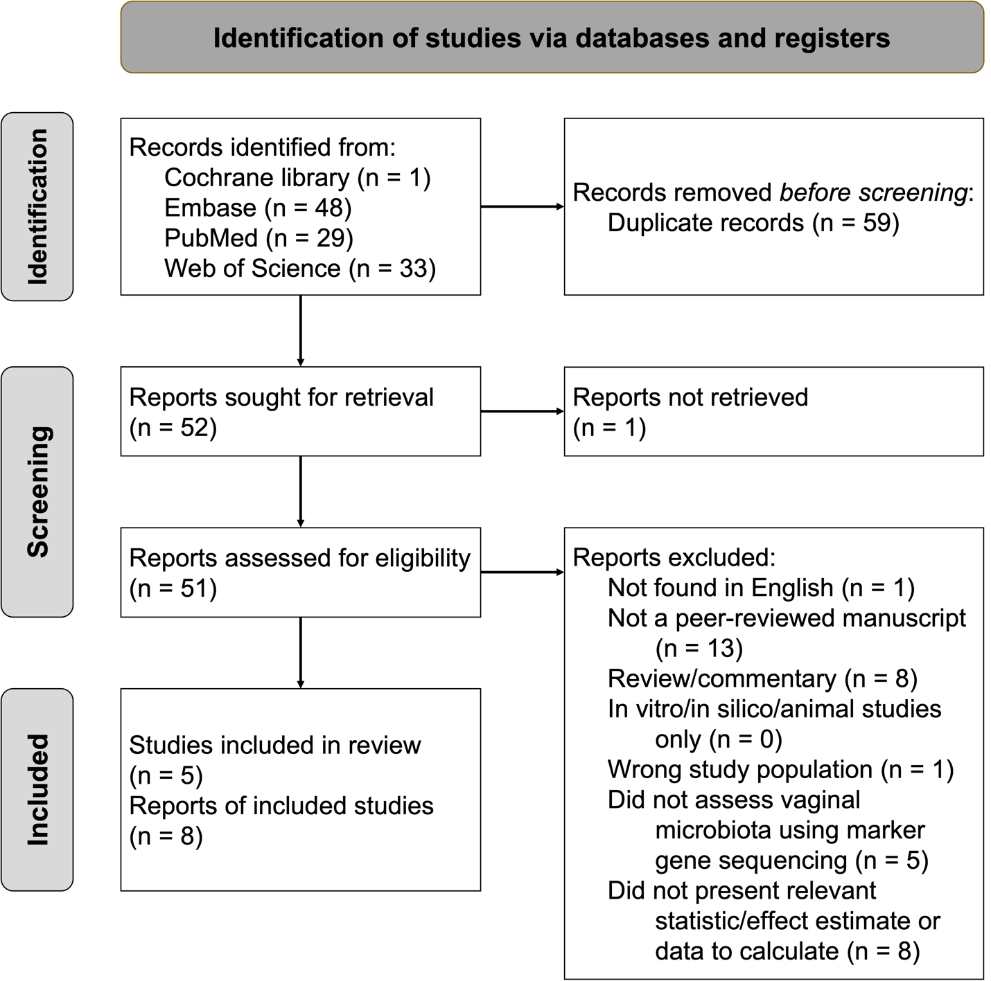
Supplemental Figure 3: HPV systematic review PRISMA diagram.
Diagram adapted from Page et al. BMJ Brit Med J. 2021;372:n71.
PRISMA; Preferred reporting items for systematic reviews and meta-analyses; HPV, human papillomavirus.

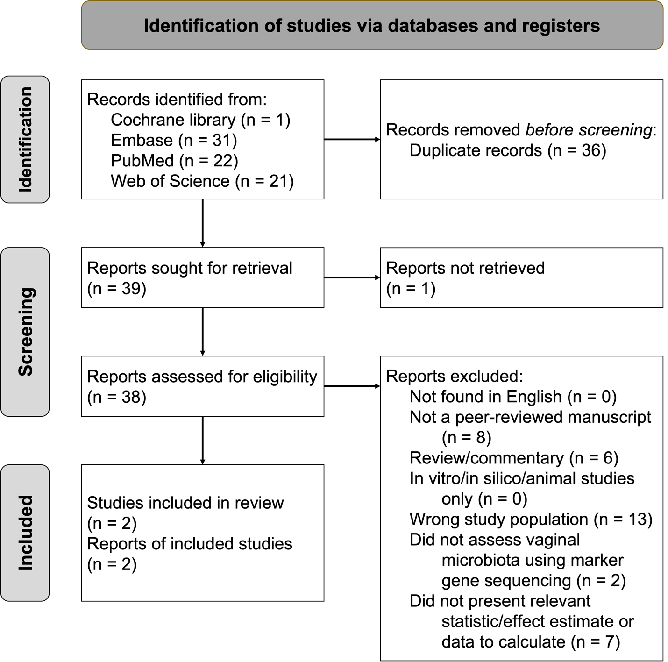

Supplemental Figure 4: Cervical dysplasia systematic review PRISMA diagram.
Diagram adapted from Page et al. BMJ Brit Med J. 2021;372:n71.
PRISMA; Preferred reporting items for systematic reviews and meta-analyses.

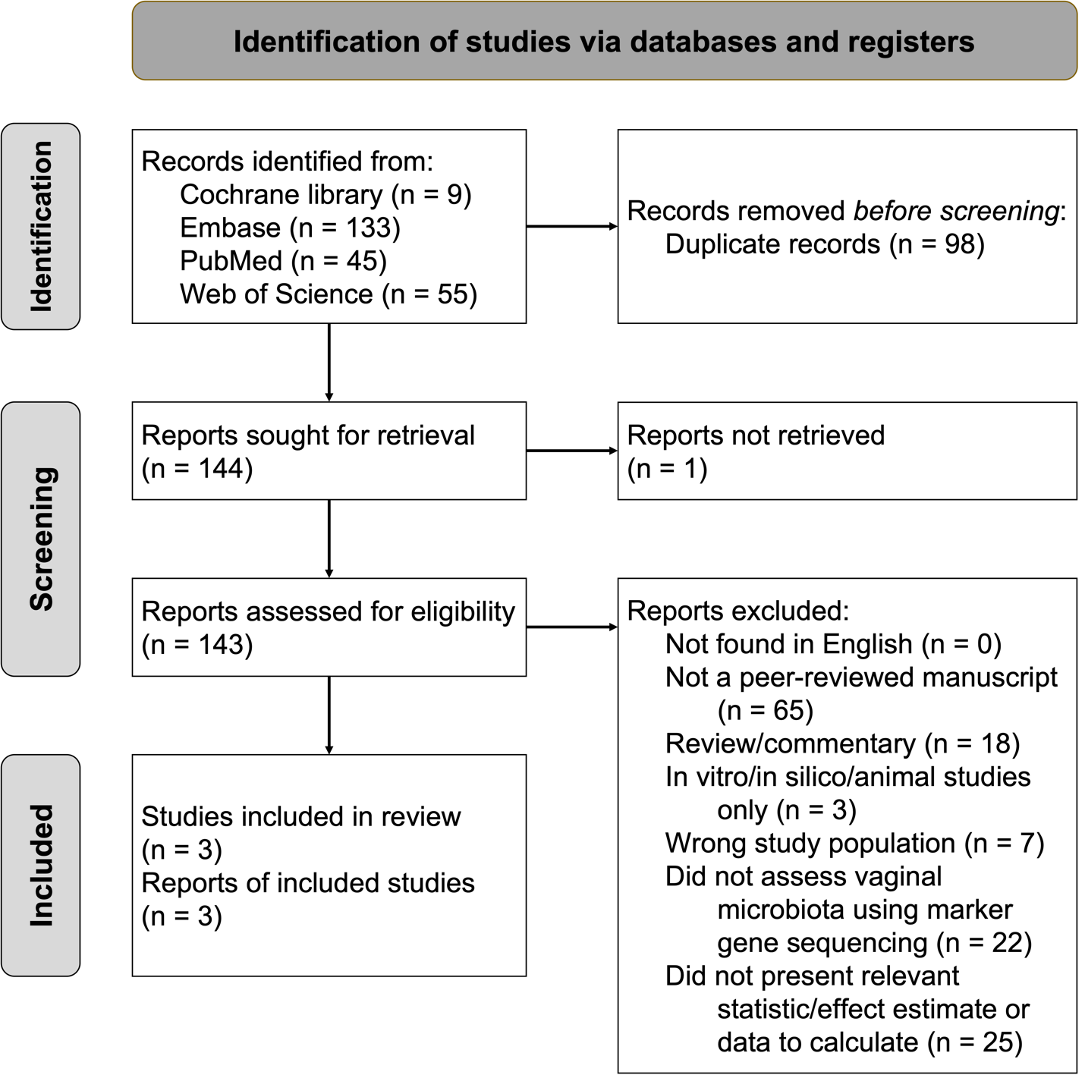

Supplemental Figure 5: HIV systematic review PRISMA diagram.
Diagram adapted from Page et al. BMJ Brit Med J. 2021;372:n71.
PRISMA; Preferred reporting items for systematic reviews and meta-analyses; HIV, human immunodeficiency virus.

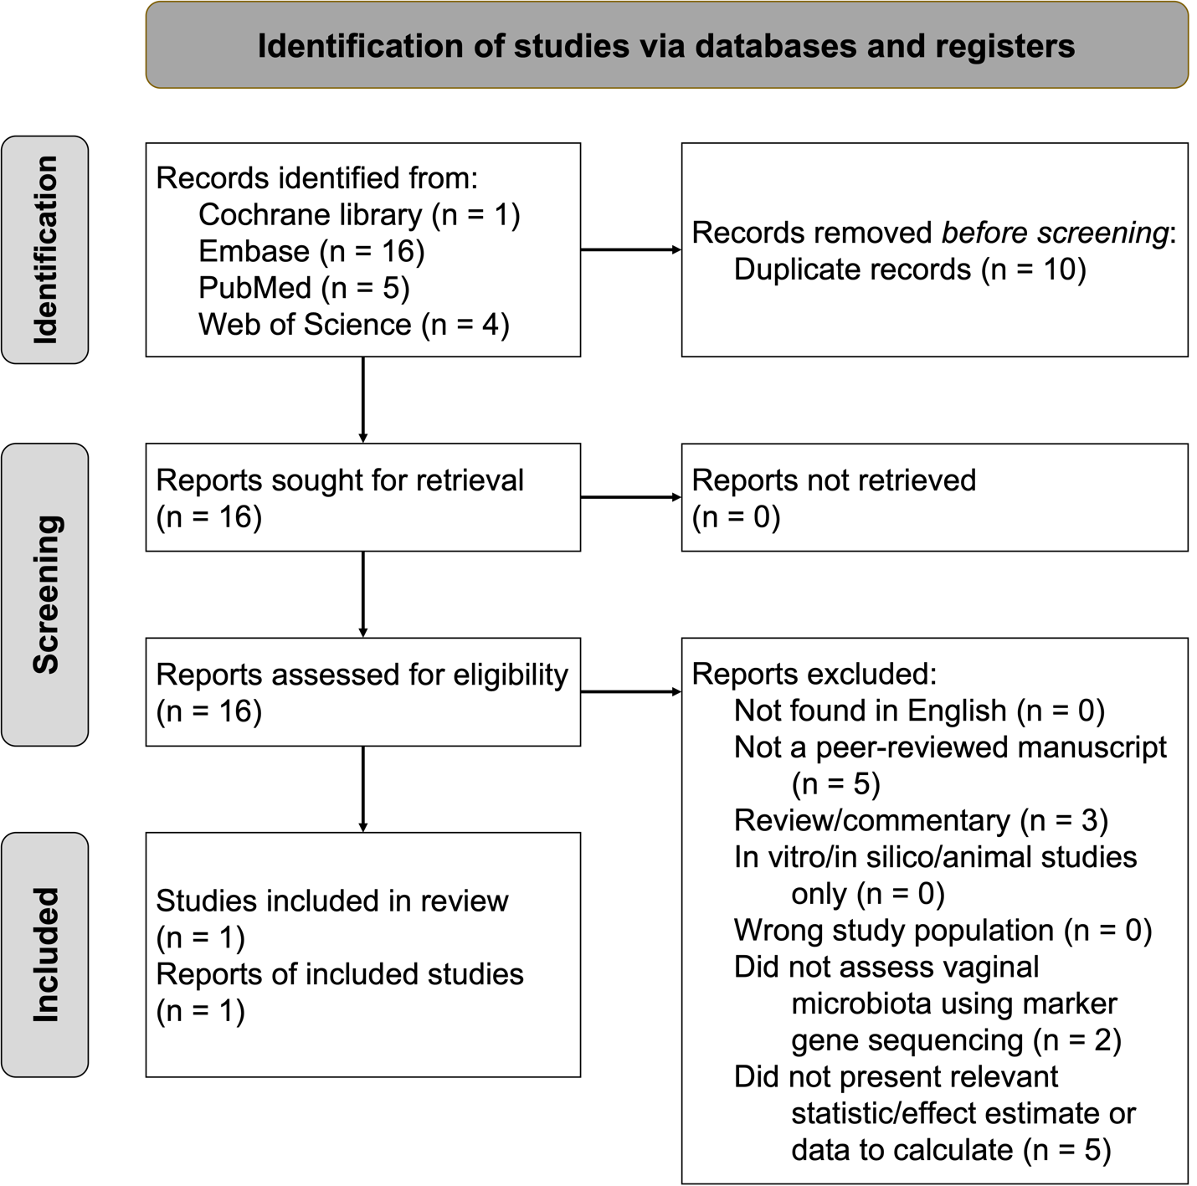

Supplemental Figure 6: Genital HSV-2 systematic review PRISMA diagram.
Diagram adapted from Page et al. BMJ Brit Med J. 2021;372:n71.
PRISMA; Preferred reporting items for systematic reviews and meta-analyses; HSV-2, herpes simplex virus type-2.

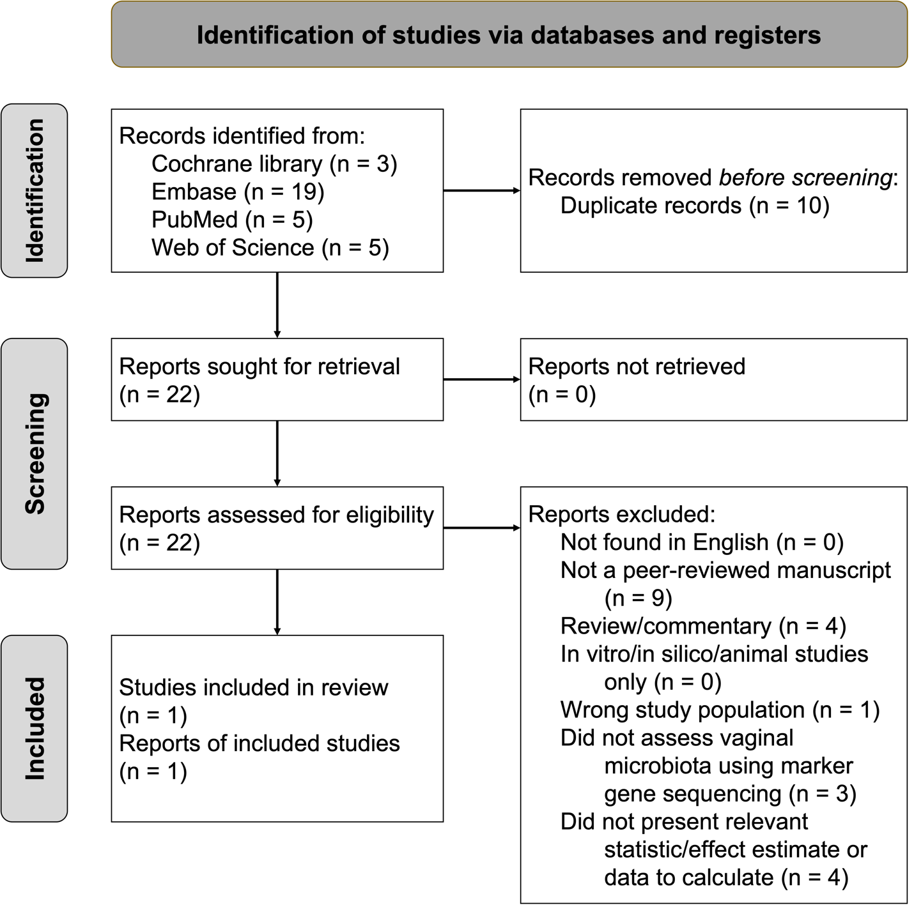

Supplemental Figure 7: Trichomonas vaginalis systematic review PRISMA diagram.
Diagram adapted from Page et al. BMJ Brit Med J. 2021;372:n71.
PRISMA; Preferred reporting items for systematic reviews and meta-analyses.

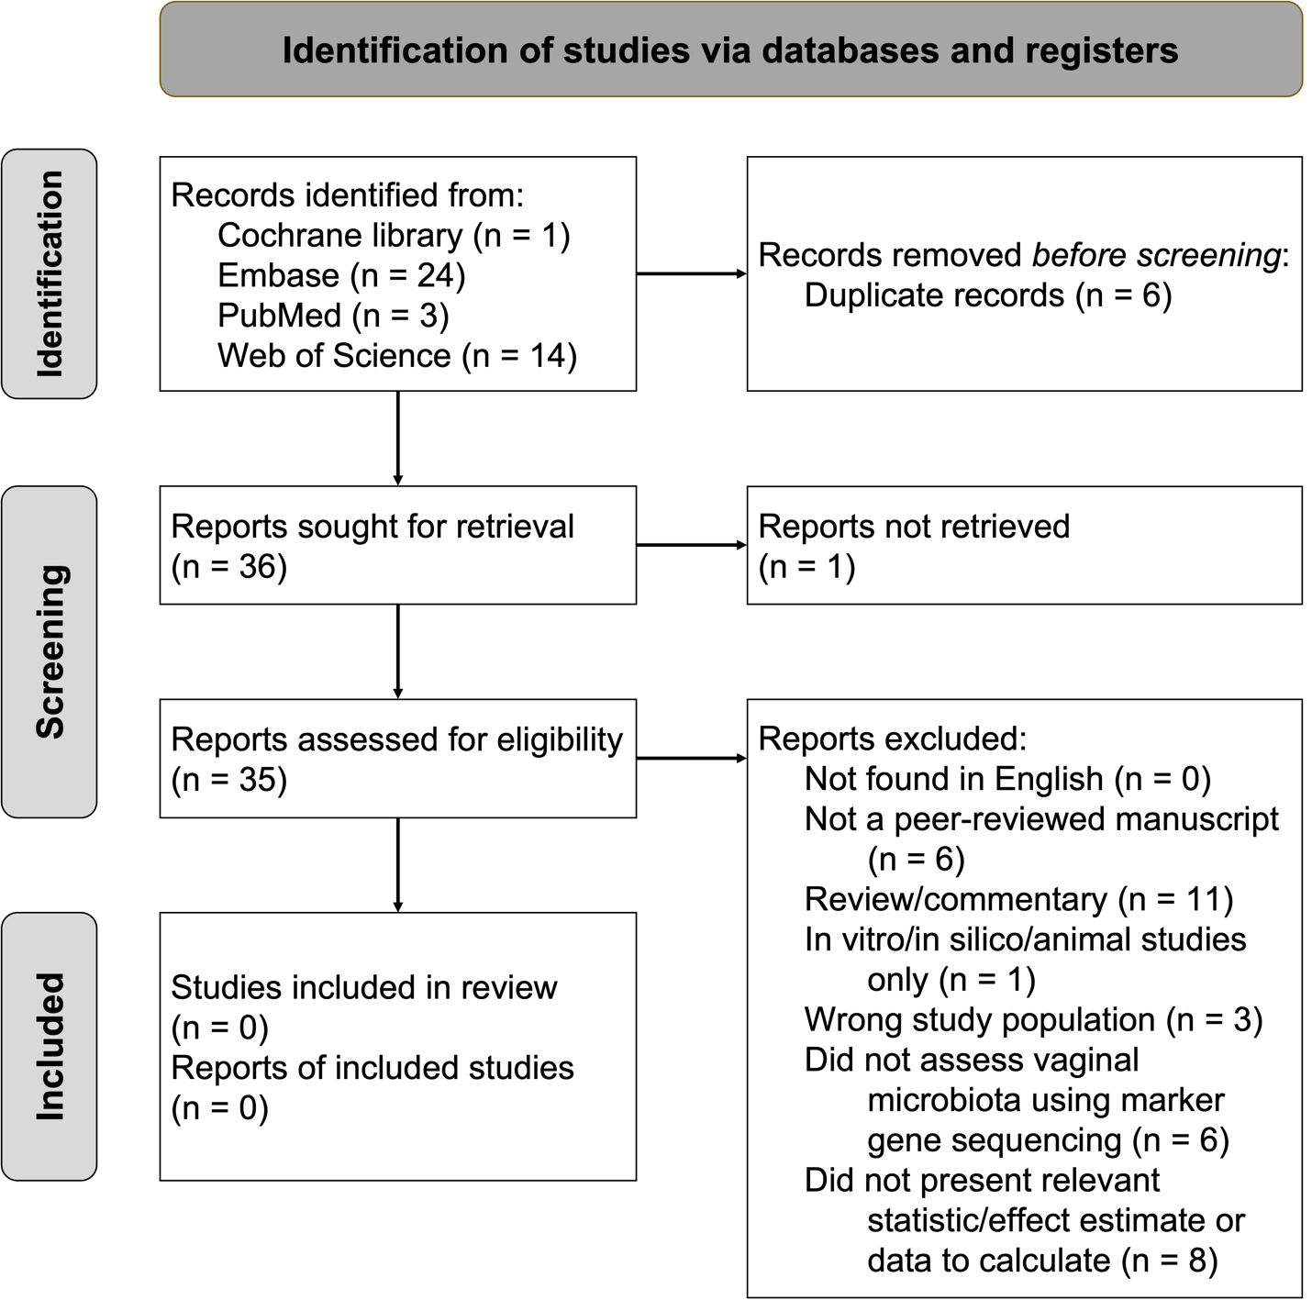
Supplemental Figure 8: Neisseria gonorrhoeae systematic review PRISMA diagram.
Diagram adapted from Page et al. BMJ Brit Med J. 2021;372:n71.
PRISMA; Preferred reporting items for systematic reviews and meta-analyses.

