Supplemental Material for

Costs, health benefits, and cost-effectiveness of chlamydia screening and partner notification in the United States, 2000–2019: a mathematical modeling analysis

Authors: Minttu M Rönn*, Yunfei Li, Thomas L Gift, Harrell W Chesson, Nicolas A Menzies, Katherine Hsu, Joshua A Salomon

Corresponding author
Minttu Rönn
Email: mronn@hsph.harvard.edu

The findings and conclusions in this report are those of the authors and do not necessarily represent the official position of the Centers for Disease Control and Prevention (CDC).

Table S1. Description of the calibration scenarios investigated as part of the sensitivity analysis in calibration of the transmission model (described in Rönn et al, 2019).¹ We examined the impact of prior assumptions on changes in screening coverage and completeness of chlamydia case reporting, which were implemented as time-varying parameters.

Calibration Scenario Name | Prior Assumptions on Reportingª of Cases | Prior Assumptions on Screening^{b}
Scenario 1: More Constrained Priors on Reporting and Screening | Percentage of infections reported assumed to be at least 50% in 2000, and it was constrained to increase over time from 2000 to 2015 | Screening coverage was allowed to remain stable or to increase from one year to the next from 2000 to 2015
Scenario 2: Less Constrained Priors on Reporting, More Constrained Priors on Screening | Reporting was not constrained as in Scenario 1, but it was only allowed to increase over time from 2000 to 2015 | Same as Scenario 1
Scenario 3: More Constrained Priors on Reporting, Less Constrained Priors on Screening | Same as Scenario 1 | Screening was allowed to decrease, remain stable or increase from 2000 to 2015
Scenario 4: Less Constrained Priors on Reporting and Screening | Same as Scenario 2 | Same as Scenario 3

a) Reporting completeness (i.e., the percentage of diagnosed infections reported as cases to the national surveillance) is modeled as a logistic function. Prior parameter for reporting in 2000 was estimated as (Beta(7,3)/2+0.5) with a median reporting 86% (IQR 80-90%) in Scenarios 1 and 3, and estimated as Beta(7,3) with a median of 71% (IQR 61-80%) in Scenarios 2 and 4. The beta distribution is defined by shape parameters (α,β), IQR: interquartile range.
b) Screening is modeled as a Bezier function with 4 control points to allow for more flexible time trends (in Web Appendix 1.8 in Rönn et al. 2019 ¹). Changes implemented in the screening priors in the calibration scenarios apply to ages 15–18 years and 19–24 years.

Figure S1. Proportion of chlamydial tests which were NAATs among women ages 15-54 years. Data from the Infertility Prevention Project

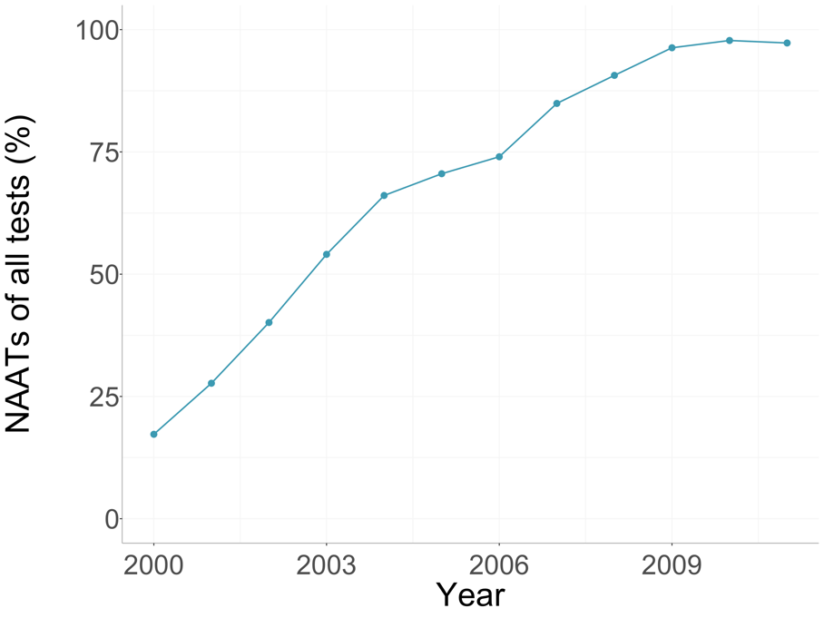

Utility values

Estimation of overall disutility using age-specific background utilities incorporated multiplicatively: disutility (d) was calculated as $d=a-au$, where a is the age specific background utility and u the sequelae specific utility. We adopted age-specific background utility using the EQ-5D index scores to account for age-related co-morbidity.²

Table S2. Utilities from the Global Burden of Disease (GBD) study³ used in the sensitivity analyses

Outcome | Mean | 95% uncertainty Interval | Distribution and parameters | Reference
Symptomatic infection (women) | 0.994 | 0.988-0.998 | Beta (886.74, 5.35) | ³
Symptomatic urethral infection (men) | 0.961 | 0.946-0.974 | Beta (740.36, 30.15) | ³
PID utility | 0.864 | 0.816-0.905 | See below | ^{3,4}
PID severity (proportion)
Moderate PID | 0.895 | 0.888-0.902 | 1-severe PID | ⁴
Severe PID | 0.105 | 0.098-0.112 | Beta (696.96, 5962.39) | ⁴
PID severity (utility)
Moderate PID | 0.886 | 0.844-0.924 | Beta (205.24, 26.41) | ³
Severe PID | 0.677 | 0.560-0.784 | Beta (44.97, 21.55) | ³
CPP | 0.923 | 0.897-0.945 | See below | ^{3,4}
CPP severity (proportion)
Mild CPP | 0.472 | 0.470-0.474 | 0.5*(1-severe CPP) | ⁴
Moderate CPP | 0.472 | 0.470-0.474 | 0.5*(1-severe CPP) | ⁴
Severe CPP | 0.056 | 0.053-0.060 | Beta (924.87, 15534.36) | ⁴
CPP severity (utility)
Mild CPP | 0.989 | 0.979-0.996 | Beta (600.65, 6.68) | ³
Moderate CPP | 0.886 | 0.844-0.924 | Beta (205.24, 26.41) | ³
Severe CPP | 0.677 | 0.560-0.784 | Beta (44.97, 21.55) | ³
TFI | 0.993 | 0.988-0.997 | See below | ^{3,5}
Sequelae severity (proportion)
Primary infertility | 0.659 | 0.464-0.850 | 1-secondary infertility | ⁵
Secondary infertility | 0.341 | 0.150-0.536 | Uniform(0.140, 0.546) | ⁵
Sequelae severity (utility)
Primary infertility | 0.992 | 0.985-0.997 | Beta (828.67, 6.68) | ³
Secondary infertility | 0.995 | 0.989-0.999 | Beta (829.49, 4.17) | ³
EP | 0.886 | 0.843-0.924 | Beta (205.24, 26.41) | ³
EDS | 0.872 | 0.822-0.916 | Beta (165.78, 24.33) | ³
Duration estimates used in the sensitivity analysisª
TFI | NA | NA | Uniform(5,10) | Assumption
CPP | NA | NA | Uniform(5,10) | Assumption

- Same as in the main analyses
PID: pelvic inflammatory disease; TFI: tubal factor infertility; CPP: chronic pelvic pain; EP: ectopic pregnancy; EDS: epididymitis.

Table S3. Utilities from the Institute of Medicine (IOM) study⁶ used in the sensitivity analyses

Outcome | Mean | 95% uncertainty Interval | Distribution and parameters | Reference
Utility estimates
Symptomatic chlamydia (women) | 0.751 | 0.621- 0.864 | Beta (34.32, 11.44) | ⁶
Symptomatic urethral infection (men) | 0.839 | 0.754-0.911 | Beta (68.85, 13.11) | ⁶
Asymptomatic infection | 1 | Fixed | NA
PID | 0.651 | 0.472-0.811 | Beta (18.93, 10.19) | ⁶
CPP | 0.602 | 0.405-0.785 | Beta (14.53, 9.68) | ⁶
TFI | 0.820 | 0.726-0.900 | Beta (58.04, 12.74) | ⁶
EP | 0.580 | 0.375-0.777 | Beta (12.86, 9.32) | ⁶
EDS | 0.460 | 0.206-0.729 | Beta (5.80, 6.80) | ⁶
Duration estimates used in the sensitivity analysisª
TFI | NA | NA | Uniform(5,lifetime) | ⁶
CPP | NA | NA | Uniform(5,lifetime) | ⁶

- Longer than in the main analyses

PID: pelvic inflammatory disease; TFI: tubal factor infertility; CPP: chronic pelvic pain; EP: ectopic pregnancy; EDS: epididymitis.

Supplemental results

- Results using GBD utilities

Table S4. Incremental costs and benefits and cost-effectiveness ratio for the current policy compared to no screening and no partner notification (PN). Costs are in 2020 US dollars. All results are shown to 5 significant digits.

Scenario | Cumulative costs in ‘000s  (discounted)($) | Cumulative QALYs lost in ‘000s  (discounted) | Incremental Costs, in ‘000s ($) | Incremental QALYs gained, in ‘000s | ICER ($/ QALY gained)
1. 2000-2015
No screening and no PN | 15,969,000 | 1,528.00 | NA | NA | NA
Current Policy | 21,157,000 | 1,098.90 | 5,188,000 | 429.10 | 12,090
95% Uncertainty | NA | NA | -270,670; 11,369,000 | 113.28; 1,002.6 | Cost-saving; 67,630
2.1 2016-2019
Current Policy | 6,919,100 | 279.74 | NA | NA | NA
Guidelines | 8,042,900 | 249.26 | 1,123,800 | 30.480 | 36,870
95% Uncertainty | NA | NA | 416,440; 1,938,200 | 8.1948; 69.736 | 9,420.9; 161,320
2.2 2016-2019 + 5 years
Current Policy | 14,541,000 | 590.21 | NA | NA | NA
Guidelines | 15,494,000 | 544.53 | 953,000 | 45.680 | 20,863
95% Uncertainty | NA | NA | 202,170; 1,785,400 | 12.112; 106.35 | 3,102.2; 101,790

- Results using IOM utilities

Table S5. Incremental costs and benefits and cost-effectiveness ratio for the current policy compared to no screening and no partner notification (PN). Costs are in 2020 US dollars. All results are shown to 5 significant digits.

Scenario | Cumulative costs in ‘000s  (discounted)($) | Cumulative QALYs lost in ‘000s  (discounted) | Incremental Costs, in ‘000s ($) | Incremental QALYs gained, in ‘000s | ICER ($/ QALY gained)
1. 2000-2015
No screening and no PN | 15,969,000 | 6,828.00 | NA | NA | NA
Current Policy | 21,157,000 | 4,909.20 | 5,188,000 | 1,918.8 | 2,703.8
95% Uncertainty | NA | NA | -270,670; 11,369,000 | 541.56; 4,162.7 | Cost-saving; 14,318
2.1 2016-2019
Current Policy | 6,919,100 | 1,251.40 | NA | NA | NA
Guidelines | 8,042,900 | 1,112.70 | 1,123,800 | 138.70 | 8,102.4
95% Uncertainty | NA | NA | 416,440; 1,938,200 | 39.412; 294.20 | 2,166.8; 33,932
2.2 2016-2019 + 5 years
Current Policy | 14,541,000 | 2,640.20 | NA | NA | NA
Guidelines | 15,494,000 | 2,433.90 | 953,000 | 206.30 | 4,619.5
95% Uncertainty | NA | NA | 202,170; 1,785,400 | 57.967; 446.97 | 695.70; 21,426

- Results discounting to the year of infection

Table S6. Incremental costs and benefits and cost-effectiveness ratio for the current policy compared to no screening and no partner notification (PN). Costs are in 2020 US dollars. All results are shown to 5 significant digits.

Scenario | Cumulative costs in ‘000s  (discounted)($) | Cumulative QALYs lost in ‘000s  (discounted) | Incremental Costs, in ‘000s ($) | Incremental QALYs gained, in ‘000s | ICER ($/ QALY gained)
1. 2000-2015
No screening and no PN | 19,818,000 | 2,367.10 | NA | NA | NA
Current Policy | 26,580,000 | 1,671.60 | 6,762,000 | 695.50 | 9,722.5
95% Uncertainty | NA | NA | -351,390; 14,658,000 | 205.12; 1,524.8 | Cost-saving; 49,511
2.1. 2016-2019
Current Policy | 7,229,700 | 365.73 | NA | NA | NA
Guidelines | 8,399,300 | 325.58 | 1,169,600 | 40.150 | 29,131
95% Uncertainty | NA | NA | 430,360; 2,021,200 | 12.013; 86.736 | 7,669.6; 115,790
2.2. 2016-2019 + 5 years
Current Policy | 16,323,000 | 829.09 | NA | NA | NA
Guidelines | 17,294,000 | 766.94 | 971,000 | 62.150 | 15,623
95% Uncertainty | NA | NA | 180,490; 1,845,800 | 18.357; 135.92 | 2,047.6; 70,317

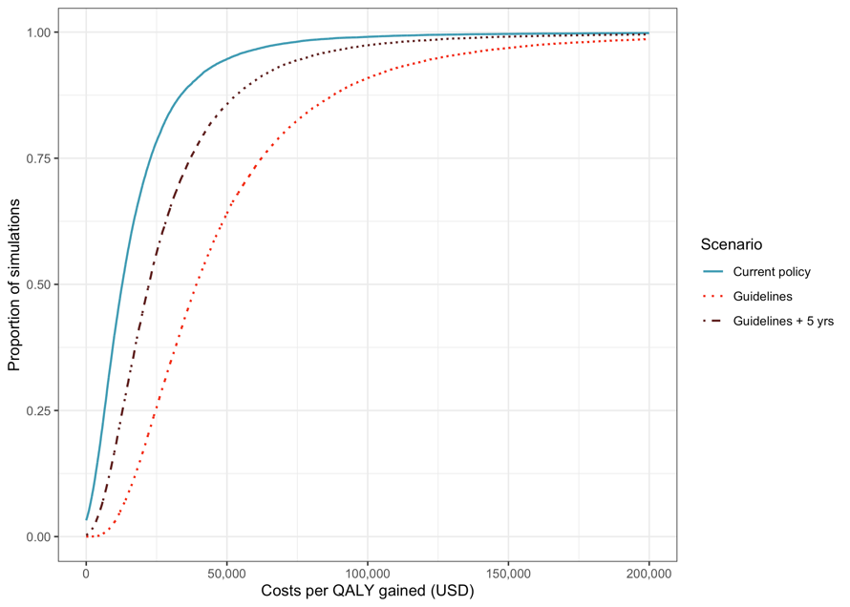
Figure S2. Cost-effectiveness acceptability curves for the three scenarios performed. Results using the GBD utilities.

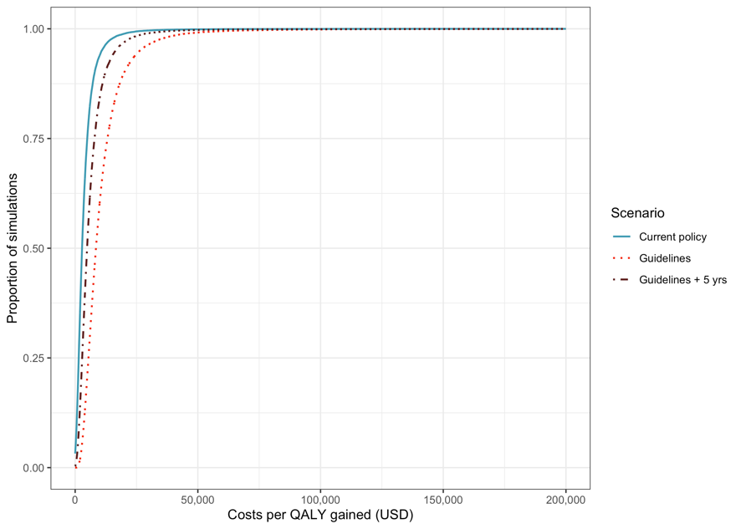
Figure S3. Cost-effectiveness acceptability curves for the three scenarios performed. Results using the IOM utilities.

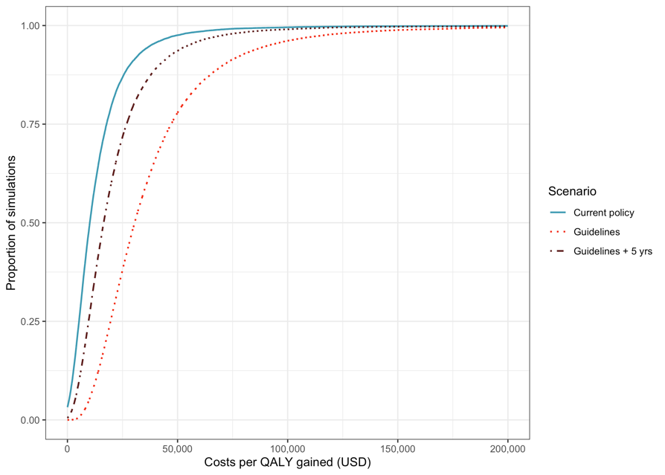

Figure S4. Cost-effectiveness acceptability curves for the three scenarios performed. Results discounted to the year of incident infection.

Footnote: Figures show the percentage of simulations in which the cost per QALY gained was less than the given threshold. Lines present the three main scenarios: CEAC for 2000-2015 current policy compared to no screening & no PN; CEAC for screening at guidelines level compared to current policy (2016-2019); CEAC for screening at guidelines level compared to current policy with additional 5 years of follow-up (2016-2019 + 5 years)

Table S7A. Scenario: Current policy 2000-2015. Yearly mean number of select outcomes. QALYs lost and costs discounted. All outputs in ‘000s. Testing and PN costs include both screening and testing of symptomatic infections (with a NAAT or non-NAAT), and costs associated with PN services.

Year | Incident infection | PID | CPP | TFI | EP | EPID | QALYs lost | All costs ($) | Testing and PN costs ($)
2000 | 3,458 | 251 | 82 | 57 | 30 | 47 | 133 | 1,292,802 | 212,376
2001 | 3,412 | 241 | 79 | 55 | 29 | 45 | 124 | 1,320,345 | 305,429
2002 | 3,342 | 229 | 75 | 52 | 28 | 43 | 114 | 1,334,822 | 392,326
2003 | 3,271 | 219 | 71 | 50 | 27 | 42 | 106 | 1,349,120 | 473,000
2004 | 3,208 | 210 | 68 | 48 | 25 | 40 | 99 | 1,356,890 | 537,135
2005 | 3,157 | 203 | 66 | 46 | 25 | 39 | 93 | 1,346,943 | 573,920
2006 | 3,116 | 197 | 64 | 45 | 24 | 39 | 87 | 1,344,710 | 614,754
2007 | 3,082 | 191 | 62 | 43 | 23 | 38 | 82 | 1,367,443 | 677,269
2008 | 3,055 | 186 | 61 | 42 | 23 | 37 | 78 | 1,370,110 | 715,133
2009 | 3,035 | 182 | 59 | 41 | 22 | 37 | 74 | 1,370,988 | 746,535
2010 | 3,020 | 179 | 58 | 41 | 22 | 37 | 71 | 1,353,719 | 755,750
2011 | 3,008 | 177 | 58 | 40 | 21 | 36 | 68 | 1,325,912 | 751,348
2012 | 2,996 | 175 | 57 | 40 | 21 | 36 | 65 | 1,308,021 | 754,797
2013 | 2,982 | 174 | 57 | 39 | 21 | 36 | 63 | 1,275,846 | 742,837
2014 | 2,962 | 172 | 56 | 39 | 21 | 35 | 60 | 1,240,026 | 726,864
2015 | 2,935 | 171 | 56 | 39 | 21 | 36 | 58 | 1,198,872 | 706,475
Total | 50,036 | 3,158 | 1,030 | 715 | 383 | 624 | 1,374 | 21,156,569 | 9,685,950

Table S7B. Scenario: No screening and no PN 2000-2015. Yearly mean number of select outcomes. QALYs lost and costs discounted. All outputs in ‘000s. Testing and PN costs include both screening and testing of symptomatic infections (with a NAAT or non-NAAT), and costs associated with PN services.

Year | Incident infection | PID | CPP | TFI | EP | EPID | QALYs lost | All costs ($) | Testing and PN costs ($)
2000 | 3,523 | 260 | 85 | 59 | 31 | 51 | 137 | 1,135,811 | 33,790
2001 | 3,587 | 268 | 87 | 61 | 33 | 52 | 138 | 1,140,741 | 36,921
2002 | 3,624 | 274 | 89 | 62 | 33 | 53 | 137 | 1,133,000 | 40,319
2003 | 3,646 | 277 | 90 | 63 | 34 | 53 | 134 | 1,117,763 | 43,886
2004 | 3,659 | 279 | 91 | 63 | 34 | 53 | 131 | 1,097,172 | 46,560
2005 | 3,668 | 281 | 92 | 64 | 34 | 53 | 128 | 1,071,647 | 46,672
2006 | 3,673 | 282 | 92 | 64 | 34 | 53 | 125 | 1,044,659 | 46,415
2007 | 3,677 | 282 | 92 | 64 | 34 | 53 | 122 | 1,019,449 | 48,264
2008 | 3,679 | 283 | 92 | 64 | 34 | 53 | 118 | 992,747 | 48,501
2009 | 3,680 | 283 | 92 | 64 | 34 | 53 | 115 | 966,337 | 48,651
2010 | 3,681 | 283 | 92 | 64 | 34 | 53 | 112 | 939,295 | 47,642
2011 | 3,682 | 284 | 93 | 64 | 34 | 53 | 108 | 912,359 | 46,133
2012 | 3,683 | 284 | 93 | 64 | 34 | 53 | 105 | 886,924 | 45,479
2013 | 3,683 | 284 | 93 | 64 | 34 | 53 | 102 | 861,484 | 44,160
2014 | 3,683 | 284 | 93 | 64 | 34 | 53 | 99 | 836,744 | 42,878
2015 | 3,684 | 284 | 93 | 64 | 34 | 53 | 97 | 812,634 | 41,633
Total | 58,512 | 4,472 | 1,459 | 1,013 | 542 | 850 | 1,909 | 15,968,762 | 707,903

Table S7C. Scenario: Current policy 2016-2024. Yearly mean number of select outcomes. QALYs lost and costs discounted. All outputs in ‘000s. Testing and PN costs include both screening and testing of symptomatic infections (with a NAAT or non-NAAT), and costs associated with PN services. Years 2020-2024 included only in the analysis where 5 additional years of follow-up were included.
Year | Incident infection | PID | CPP | TFI | EP | EPID | QALYs lost | All costs ($) | Testing and PN costs ($)
2016 | 2,939 | 170 | 56 | 39 | 21 | 36 | 90 | 1,797,823 | 1,030,864
2017 | 2,961 | 172 | 56 | 39 | 21 | 36 | 89 | 1,753,223 | 1,001,658
2018 | 2,973 | 173 | 57 | 39 | 21 | 36 | 87 | 1,706,654 | 972,276
2019 | 2,979 | 174 | 57 | 39 | 21 | 36 | 84 | 1,661,374 | 945,652
2020 | 2,983 | 175 | 57 | 40 | 21 | 36 | 82 | 1,614,302 | 917,856
2021 | 2,985 | 175 | 57 | 40 | 21 | 36 | 80 | 1,568,125 | 891,060
2022 | 2,986 | 175 | 57 | 40 | 21 | 36 | 78 | 1,522,746 | 864,878
2023 | 2,987 | 175 | 57 | 40 | 21 | 36 | 75 | 1,480,230 | 841,219
2024 | 2,987 | 175 | 57 | 40 | 21 | 36 | 73 | 1,436,374 | 815,792
Total | 26,779 | 1,565 | 510 | 354 | 190 | 323 | 738 | 14,540,851 | 8,281,256

Table S7D. Scenario: Guidelines 2016-2024. Yearly mean number of select outcomes. QALYs lost and costs discounted. All outputs in ‘000s. Testing and PN costs include both screening and testing of symptomatic infections (with a NAAT or non-NAAT), and costs associated with PN services. Years 2020-2024 included only in the analysis where 5 additional years of follow-up were included.
Year | Incident infection | PID | CPP | TFI | EP | EPID | QALYs lost | All costs ($) | Testing and PN costs ($)
2016 | 2,879 | 161 | 53 | 36 | 20 | 33 | 85 | 2,139,736 | 1,404,718
2017 | 2,816 | 154 | 50 | 35 | 19 | 32 | 79 | 2,044,489 | 1,359,480
2018 | 2,781 | 151 | 49 | 34 | 18 | 32 | 75 | 1,968,748 | 1,316,568
2019 | 2,760 | 149 | 49 | 34 | 18 | 32 | 72 | 1,889,880 | 1,272,269
2020 | 2,807 | 156 | 51 | 35 | 19 | 33 | 73 | 1,536,345 | 908,412
2021 | 2,885 | 164 | 54 | 37 | 20 | 35 | 75 | 1,524,224 | 885,398
2022 | 2,929 | 169 | 55 | 38 | 20 | 35 | 75 | 1,497,312 | 861,542
2023 | 2,954 | 171 | 56 | 39 | 21 | 36 | 74 | 1,465,475 | 839,263
2024 | 2,968 | 173 | 56 | 39 | 21 | 36 | 72 | 1,427,808 | 814,649
Total | 25,778 | 1,448 | 472 | 328 | 176 | 304 | 681 | 15,494,017 | 9,662,299

References

1 Rönn MM, Tuite AR, Menzies NA, et al. The Impact of Screening and Partner Notification on Chlamydia Prevalence and Numbers of Infections Averted in the United States, 2000–2015: Evaluation of Epidemiologic Trends Using a Pair-Formation Transmission Model. Am J Epidemiol 2019:188(3):545–54.
2 Sullivan PW, Ghushchyan V. Preference-based EQ-5D index scores for chronic conditions in the United States. Med Decis Mak 2006:26(4):410–20.
3 Global Burden of Disease Collaborative Network. Global Burden of Disease Study 2019 (GBD 2019) Disability Weights. 2019.Available from:http://ghdx.healthdata.org/record/ihme-data/gbd-2019-disability-weights Accessed October 8,2021.
4 Rein DB, Kassler WJ, Irwin KL, et al. Direct medical cost of pelvic inflammatory disease and its sequelae: decreasing, but still substantial. Obstet Gynecol 2000:95(3):397–402.
5 Price MJ, Ades AE, Soldan K, et al. The natural history of Chlamydia trachomatis infection in women: a multi-parameter evidence synthesis. Health Technol Assess 2016:20(22):1–250.
6 Stratton K, Durch J, Lawrence R. Vaccines for the 21st Century. National Academies Press 2000.

