Supplemental Table 1. Search strings.
Sr.no | Search string | Database | Results
1 | (("Hip Fractures/surgery"[MAJR]) AND "Anesthesia, General/adverse effects"[MAJR]) OR "Anesthesia, General/mortality" [MAJR] | PubMed | 213
 |  | Embase | 3
 |  | Cochrane | 1
2 | "Hip Fractures" AND "surgery" AND "spinal anesthesia" | PubMed | 195
 |  | Embase | 104
 |  | Cochrane | 85
3 | (("Hip Fractures/surgery"[MAJR]) AND ("Anesthesia, General"[MAJR] OR "Anesthesia, Spinal"[MAJR])) | PubMed | 168
 |  | Embase | 2
 |  | Cochrane | 2
4 | ("Hip Fractures/surgery" [MAJR]) AND "spinal anesthesia" | PubMed | 153
 |  | Embase | 2
 |  | Cochrane | 5
5 | ("Hip Fractures/surgery"[MAJR]) AND "Anesthesia, Conduction/adverse effects"[MAJR]) OR "Anesthesia. Conduction/mortality"[MAJR] | PubMed | 144
 |  | Embase | 1
 |  | Cochrane | 1
6 | ("Anesthesia/methods"[MAJR]) AND "Hip Fractures/surgery"[MAJR] | PubMed | 141
 |  | Embase | 0
 |  | Cochrane | 0
7 | "Hip Fractures" AND "surgery" AND "Anesthesia, General" | PubMed | 125
 |  | Embase | 3
 |  | Cochrane | 21
8 | Intertrochanteric femur fractures AND "hip fractures" AND "anesthesia"] | PubMed | 109
 |  | Embase | 0
 |  | Cochrane | 0
9 | ("Hip Fractures/surgery"[MAJR]) AND "Anesthesia, Spinal"[MAJR] | PubMed | 107
 |  | Embase | 2
 |  | Cochrane | 1
10 | ("Hip Fractures/surgery"[MAJR]) AND ("Nerve Block/methods"[MeSH] OR "Nerve Block/adverse effects"[MeSH])) | PubMed | 79
 |  | Embase | 0
 |  | Cochrane | 3
11 | "Hip Fractures" AND "surgery" AND "Anesthesia, General" AND "Mortality" | PubMed | 70
 |  | Embase | 2
 |  | Cochrane | 14
12 | "Anesthesia, Spinal"[MAJR] AND femoral neck fractures | PubMed | 69
 |  | Embase | 38
 |  | Cochrane | 29
13 | femoral neck fractures AND "hip fractures" AND "anesthesia" | PubMed | 60
 |  | Embase | 146
 |  | Cochrane | 43
14 | "Hip Fractures" AND "surgery" AND "Anesthesia, General" AND "Postoperative Complications" | PubMed | 55
 |  | Embase | 0
 |  | Cochrane | 14
15 | ("Hip Fractures/surgery"[MAJR]) AND "Length of Stay"[MeSH] AND "Anesthesia" | PubMed | 44
 |  | Embase | 1
 |  | Cochrane | 6
16 | "Hip Fractures" AND "surgery" AND "Anesthesia, Epidural" | PubMed | 41
 |  | Embase | 0
 |  | Cochrane | 6
17 | "Hip Fractures" AND "surgery" AND "Anesthesia, General" AND "Pain" | PubMed | 27
 |  | Embase | 0
 |  | Cochrane | 9
18 | "Hip Fractures" AND "surgery" AND "Anesthesia, General" AND "Treatment Outcome" | PubMed | 25
 |  | Embase | 1
 |  | Cochrane | 4
19 | "Hip Fractures" AND "surgery" AND "Anesthesia, Epidural" AND "Mortality" | PubMed | 24
 |  | Embase | 0
 |  | Cochrane | 5
20 | "Hip Fractures" AND "surgery" AND "Anesthesia, General" AND "Morbidity" | PubMed | 22
 |  | Embase | 0
 |  | Cochrane | 7
21 | "Hip Fractures/surgery" AND "Anesthesia, Epidural" AND "Pain" | PubMed | 18
 |  | Embase | 0
 |  | Cochrane | 2
22 | "Hip Fractures" AND "surgery" AND "Anesthesia, Epidural" AND "Treatment Outcome" | PubMed | 8
 |  | Embase | 0
 |  | Cochrane | 1
23 | "Hip Fractures" AND "surgery" AND "Anesthesia, Epidural" AND "Postoperative Complications" | PubMed | 8
 |  | Embase | 0
 |  | Cochrane | 2
24 | "Anesthesia, Spinal"[MAJR] AND intertrochanteric femur fractures | PubMed | 3
 |  | Embase | 0
 |  | Cochrane | 0
 |  | Total | 2474

Table 1. Search strings used for systematic review in all three databases.

Supplemental Figure 2. General anesthesia vs. spinal/regional mean differences in age. CI, confidence interval; GA, general anesthesia; MD, mean difference; SD, standard deviation; S/R, spinal/regional anesthesia.
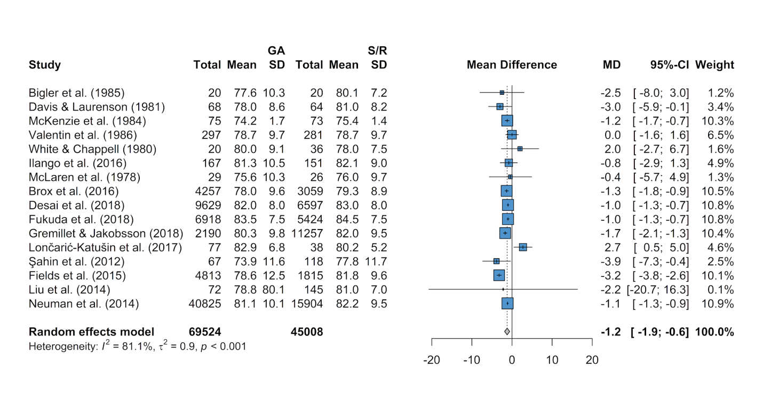

Supplemental Figure 3. General anesthesia vs. spinal/regional mean differences in body mass index. CI, confidence interval; GA, general anesthesia; MD, mean difference; SD, standard deviation; S/R, spinal/regional anesthesia.

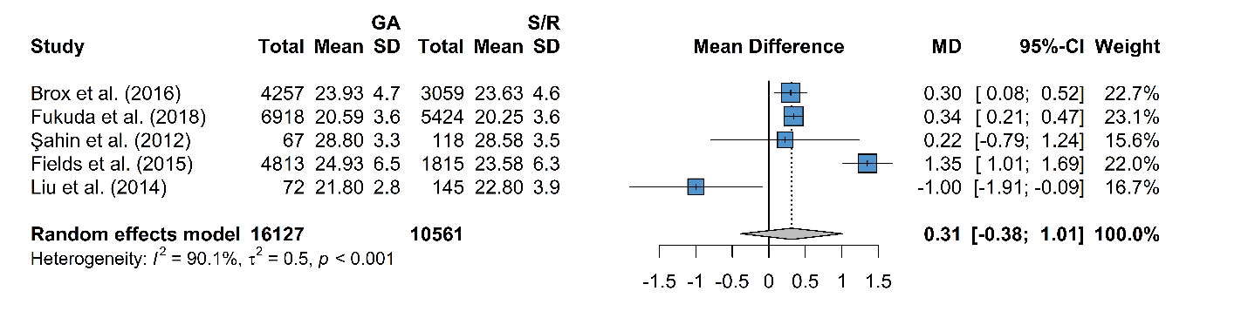

Supplemental Figure 4. General anesthesia vs. spinal/regional odds ratios of female sex. CI, confidence interval; GA, general anesthesia; OR, odds ratio; S/R, spinal/regional anesthesia.

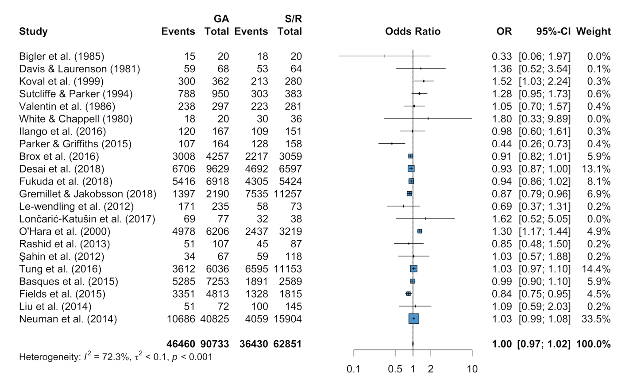

Supplemental Figure 5. General anesthesia vs. spinal/regional odds ratios of hypertension. CI, confidence interval; GA, general anesthesia; OR, odds ratio; S/R, spinal/regional anesthesia.

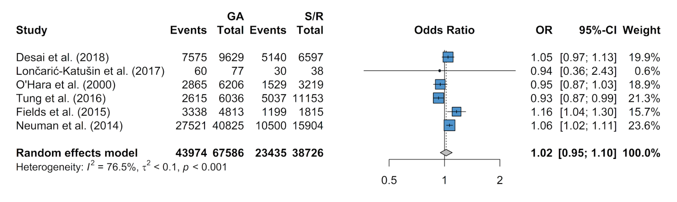

Supplemental Figure 6. General anesthesia vs. spinal/regional odds ratios of cardiovascular disease. CI, confidence interval; GA, general anesthesia; OR, odds ratio; S/R, spinal/regional anesthesia.

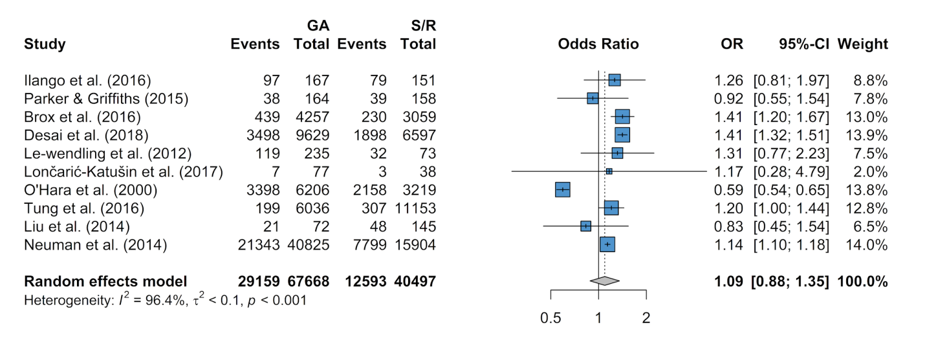

Supplemental Figure 7. General anesthesia vs. spinal/regional odds ratios of myocardial infarction. CI, confidence interval; GA, general anesthesia; OR, odds ratio; S/R, spinal/regional anesthesia.

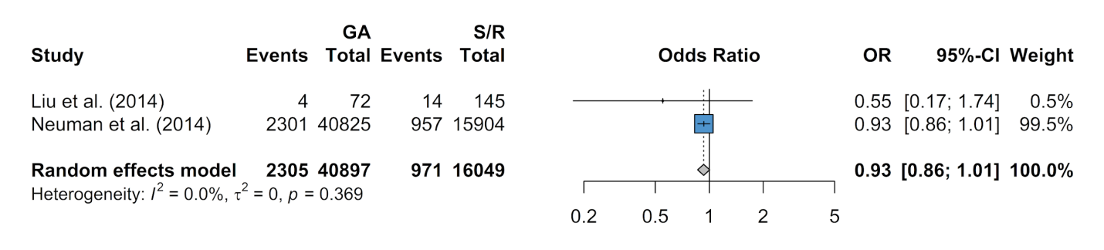

Supplemental Figure 8. General anesthesia vs. spinal/regional odds ratios of stroke. CI, confidence interval; GA, general anesthesia; OR, odds ratio; S/R, spinal/regional anesthesia.

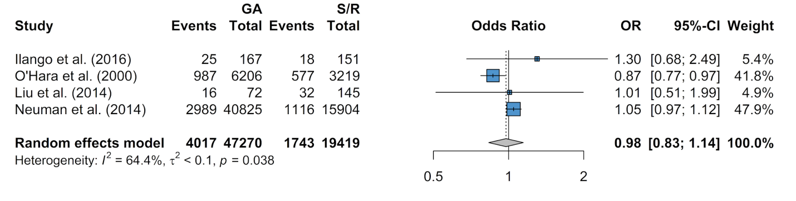

Supplemental Figure 9. General anesthesia vs. spinal/regional odds ratios of diabetes mellitus. CI, confidence interval; GA, general anesthesia; OR, odds ratio; S/R, spinal/regional anesthesia.
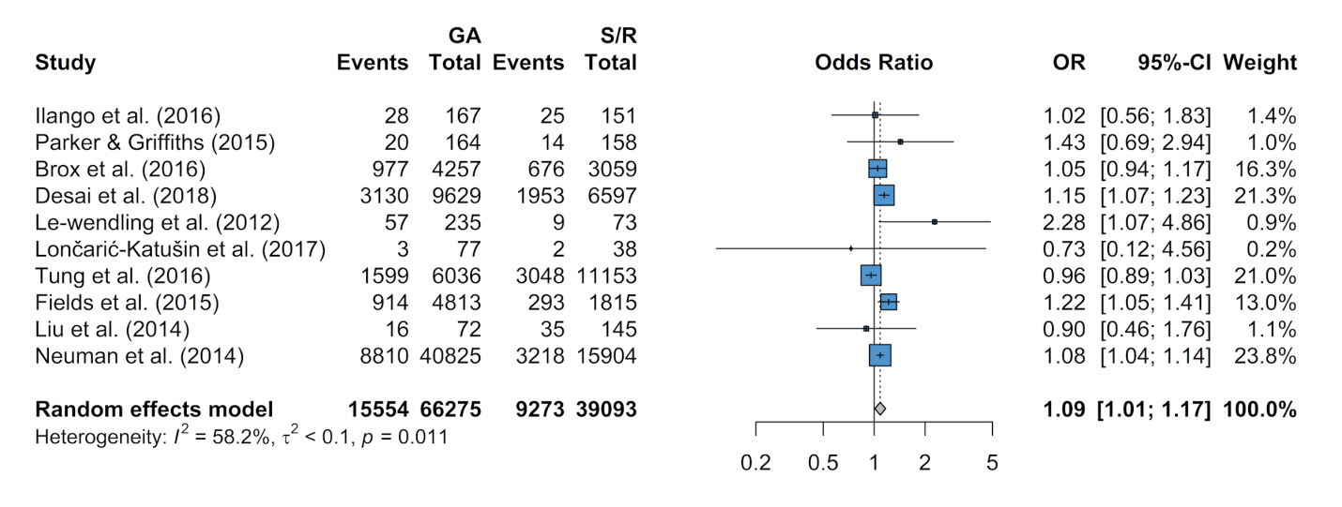

Supplemental Figure 10. General anesthesia vs. spinal/regional odds ratios of respiratory disease. CI, confidence interval; GA, general anesthesia; OR, odds ratio; S/R, spinal/regional anesthesia.

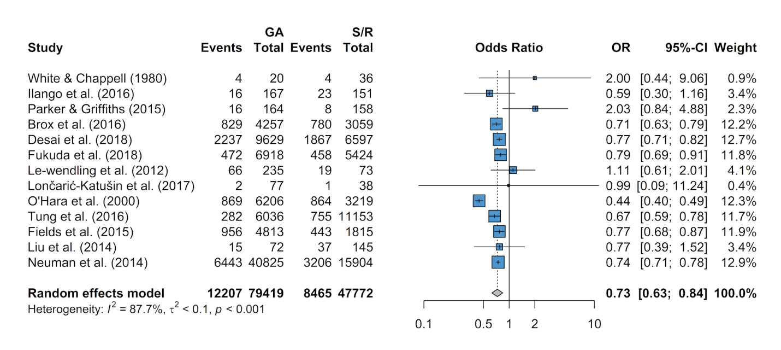

Supplemental Figure 11. General anesthesia vs. spinal/regional odds ratios of delirium. CI, confidence interval; GA, general anesthesia; OR, odds ratio; S/R, spinal/regional anesthesia.

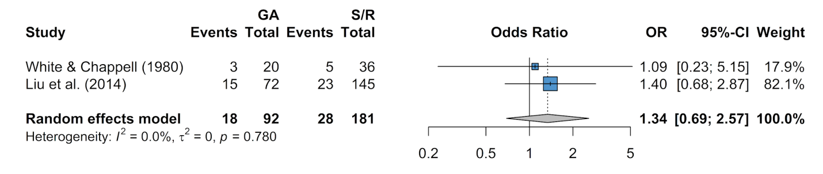

Supplemental Figure 12. General anesthesia vs. spinal/regional odds ratios of dementia. CI, confidence interval; GA, general anesthesia; OR, odds ratio; S/R, spinal/regional anesthesia.
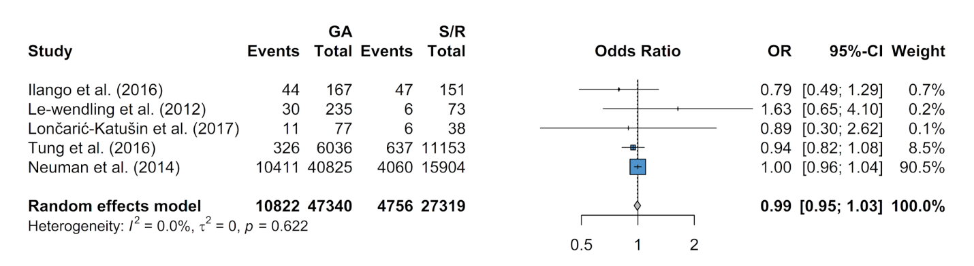

Supplemental Figure 13. General anesthesia vs. spinal/regional odds ratios of renal disease. CI, confidence interval; GA, general anesthesia; OR, odds ratio; S/R, spinal/regional anesthesia.
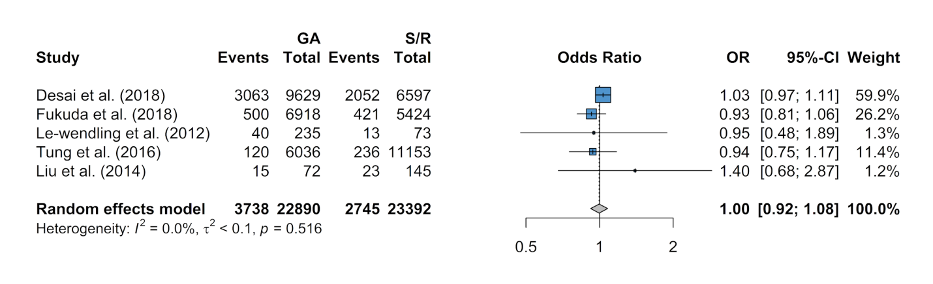

Supplemental Figure 14. General anesthesia vs. spinal/regional odds ratios of stroke. CI, confidence interval; GA, general anesthesia; OR, odds ratio; S/R, spinal/regional anesthesia.
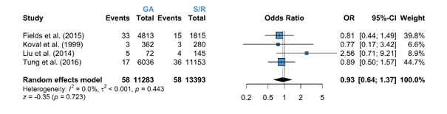

Supplemental Figure 15. General anesthesia vs. spinal/regional odds ratios of delirium. CI, confidence interval; GA, general anesthesia; OR, odds ratio; S/R, spinal/regional anesthesia.
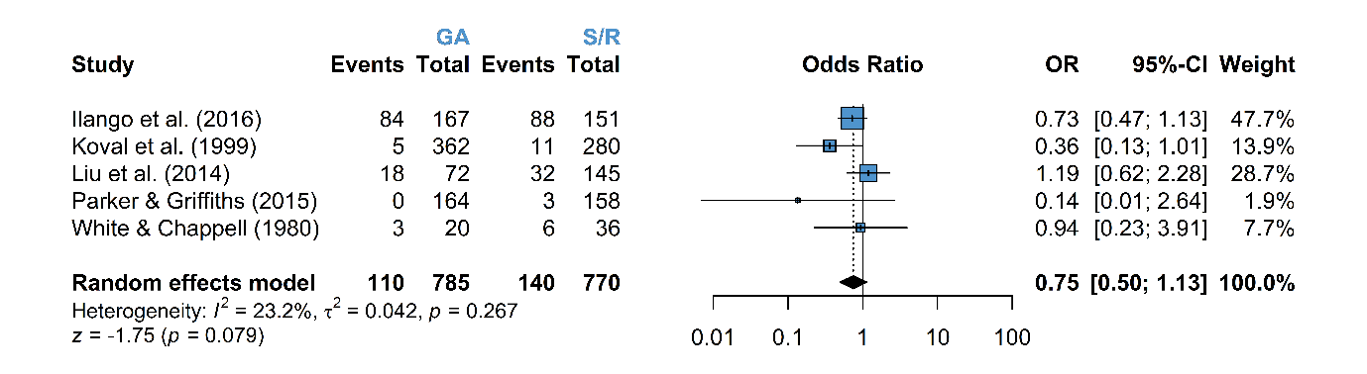

Supplemental Figure 16. General anesthesia vs. spinal/regional odds ratios of respiratory events. CI, confidence interval; GA, general anesthesia; OR, odds ratio; S/R, spinal/regional anesthesia.
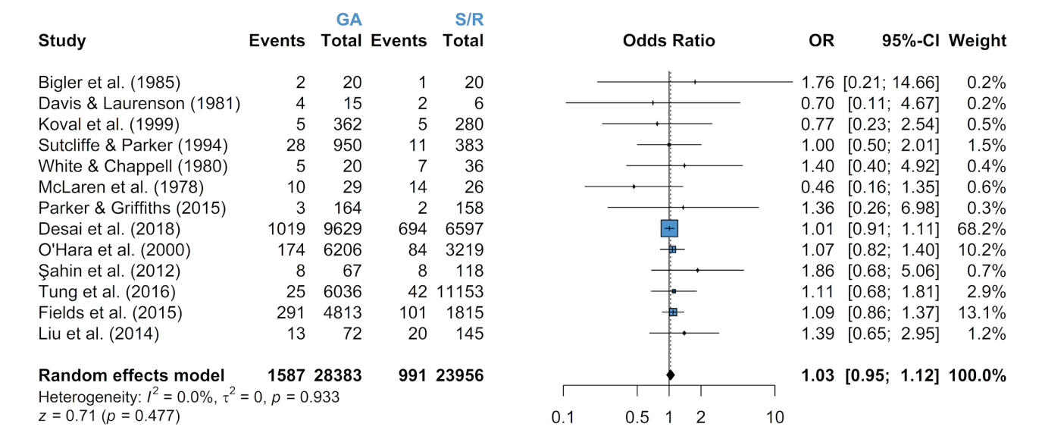

Supplemental Figure 17. General anesthesia vs. spinal/regional odds ratios of myocardial infarction. CI, confidence interval; GA, general anesthesia; OR, odds ratio; S/R, spinal/regional anesthesia.
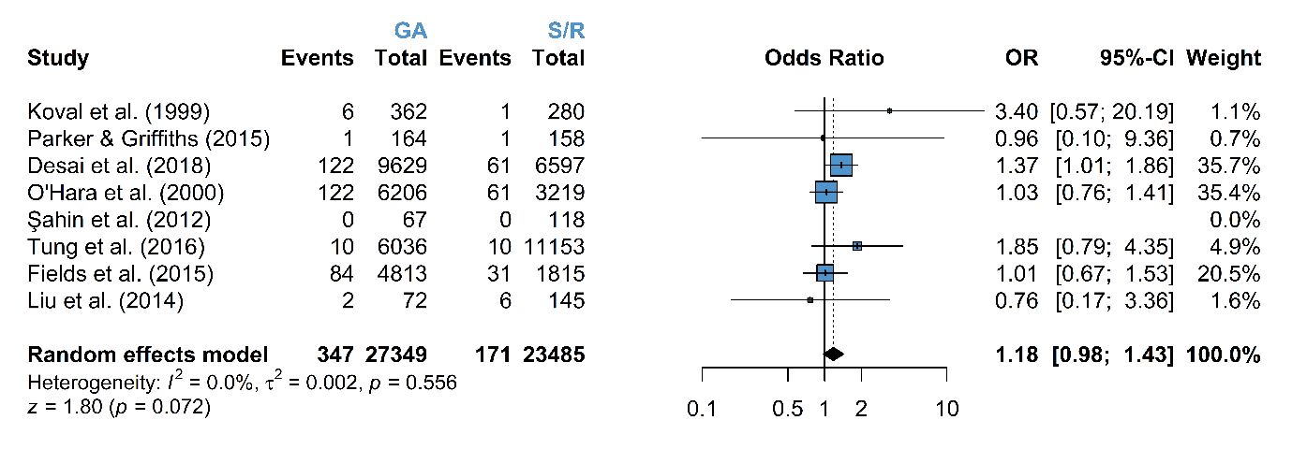

Supplemental Figure 18. General anesthesia vs. spinal/regional odds ratios of renal events. CI, confidence interval; GA, general anesthesia; OR, odds ratio; S/R, spinal/regional anesthesia.
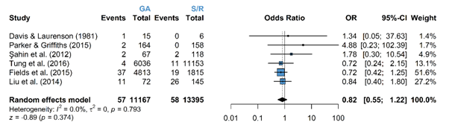

Supplemental Figure 19. General anesthesia vs. spinal/regional odds ratios of wound/surgery site infections. CI, confidence interval; GA, general anesthesia; OR, odds ratio; S/R, spinal/regional anesthesia.
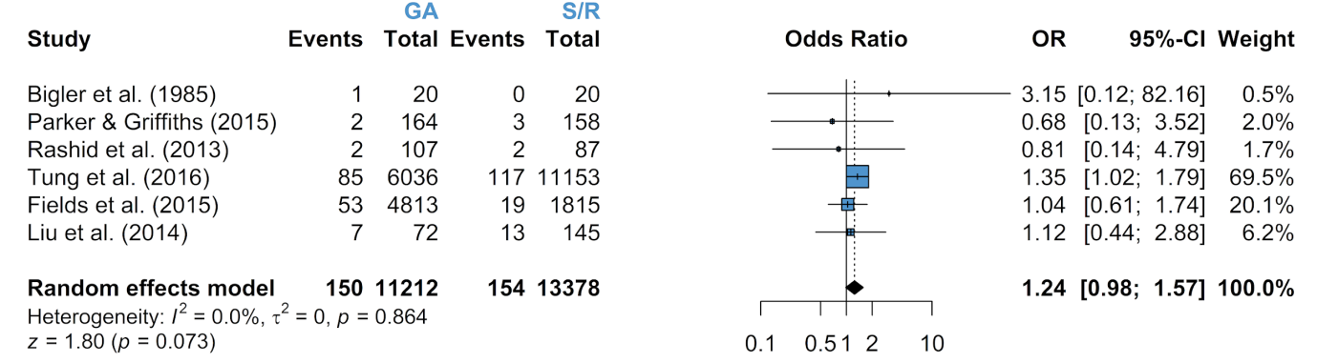

Supplemental Figure 20. General anesthesia vs. spinal/regional odds ratios of general infections. CI, confidence interval; GA, general anesthesia; OR, odds ratio; S/R, spinal/regional anesthesia.
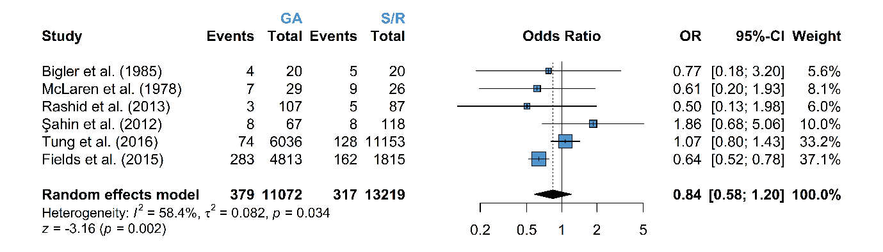

Supplemental Figure 21. General anesthesia vs. spinal/regional odds ratios of sepsis. CI, confidence interval; GA, general anesthesia; OR, odds ratio; S/R, spinal/regional anesthesia.

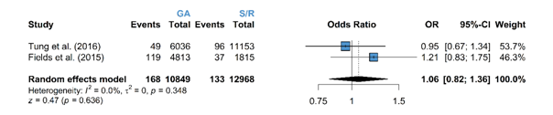

Supplemental Figure 22. General anesthesia vs. spinal/regional odds ratios of deep vein thrombosis. CI, confidence interval; GA, general anesthesia; OR, odds ratio; S/R, spinal/regional anesthesia.
