Wang et al., Supplemental Materials

Figures

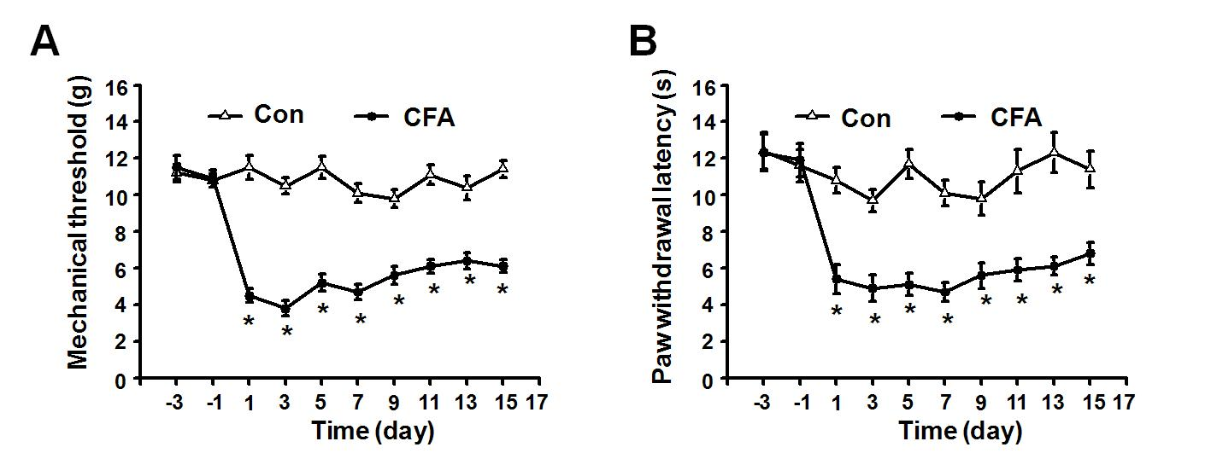
SFig. 1. Time courses of tactile allodynia and thermal hyperalgesia in control and CFA-injected rats. (A) Mechanical allodynia was quantitatively measured using the von Frey method. Each data point represents the mean mechanical threshold of 8–10 rats. (B) Hyperalgesia was quantitatively evaluated by measuring paw withdrawal latencies to a thermal stimulus. Each data point represents the mean withdrawal latency of 8–10 rats. * indicates P < 0.05 vs. the control group.

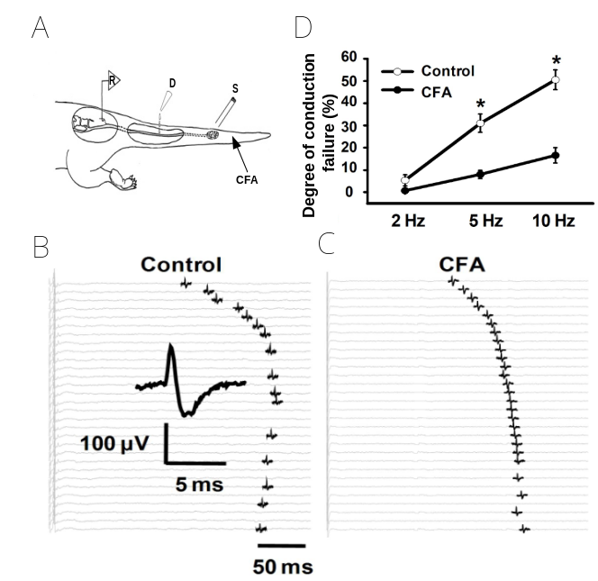
SFig. 2. Conduction failure of polymodal nociceptive C fibers in control and CFA-injected rats. (A) The experimental setup for single fiber recording, indicating the regions for recording (R), drug application (D), and stimulation (S), as well as the site of CFA injection. (B) Original consecutive recordings of single C fibers from control rats in response to 10 Hz electrical stimulation (60 s duration, 120% threshold). The inset shows a representative action potential. Every 20th sweep is shown (consecutive sweeps were at 2 s intervals) and is displayed top-to-bottom. (C) Recordings of single C fibers from CFA-injected rats in response to the same stimulation as in B. (D) Quantitative analysis of conduction failure in C-fibers from control and CFA-injected rats.
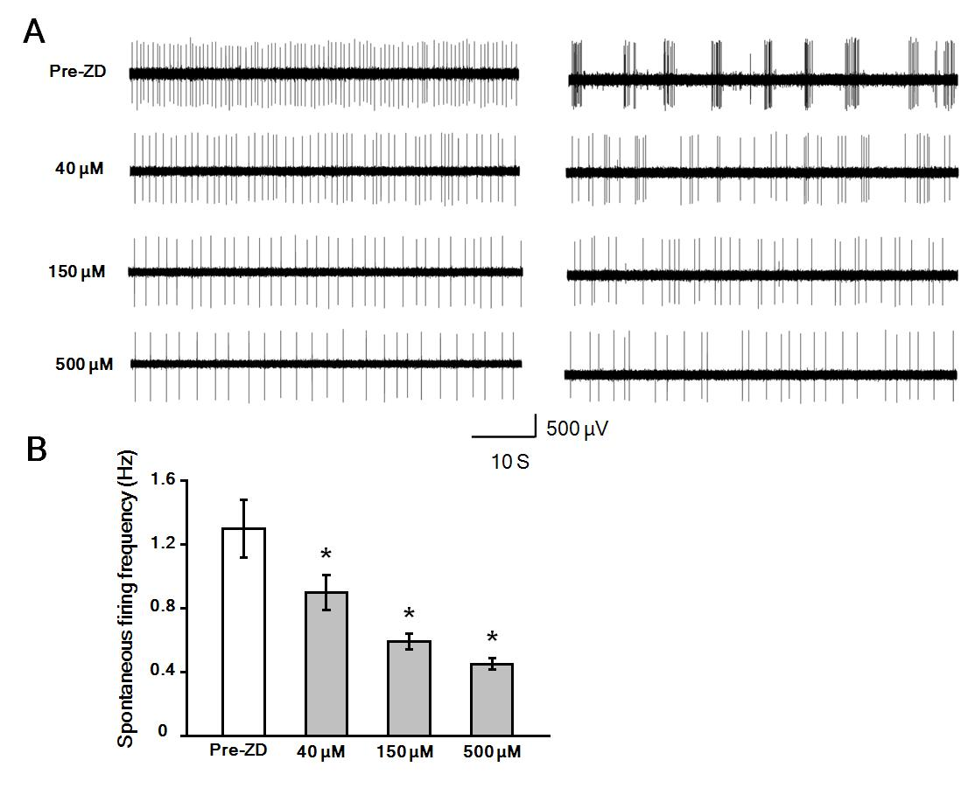
SFig. 3. (A) Left: Representative recording of spontaneous discharges (non-period firing) from a single C-fiber from a CFA-injected rats 60 s before treatment (indicated as Pre-ZD) and in the presence of varying concentrations of ZD7288. Right: Bursting firing changed to non-period firing after exposure to different concentrations of ZD7288. (B): Dose-response histograms for the effect of ZD7288 on spontaneous discharges. Each bar represents the mean of 10 recordings. * indicates P < 0.05 vs. the Pre-ZD group.

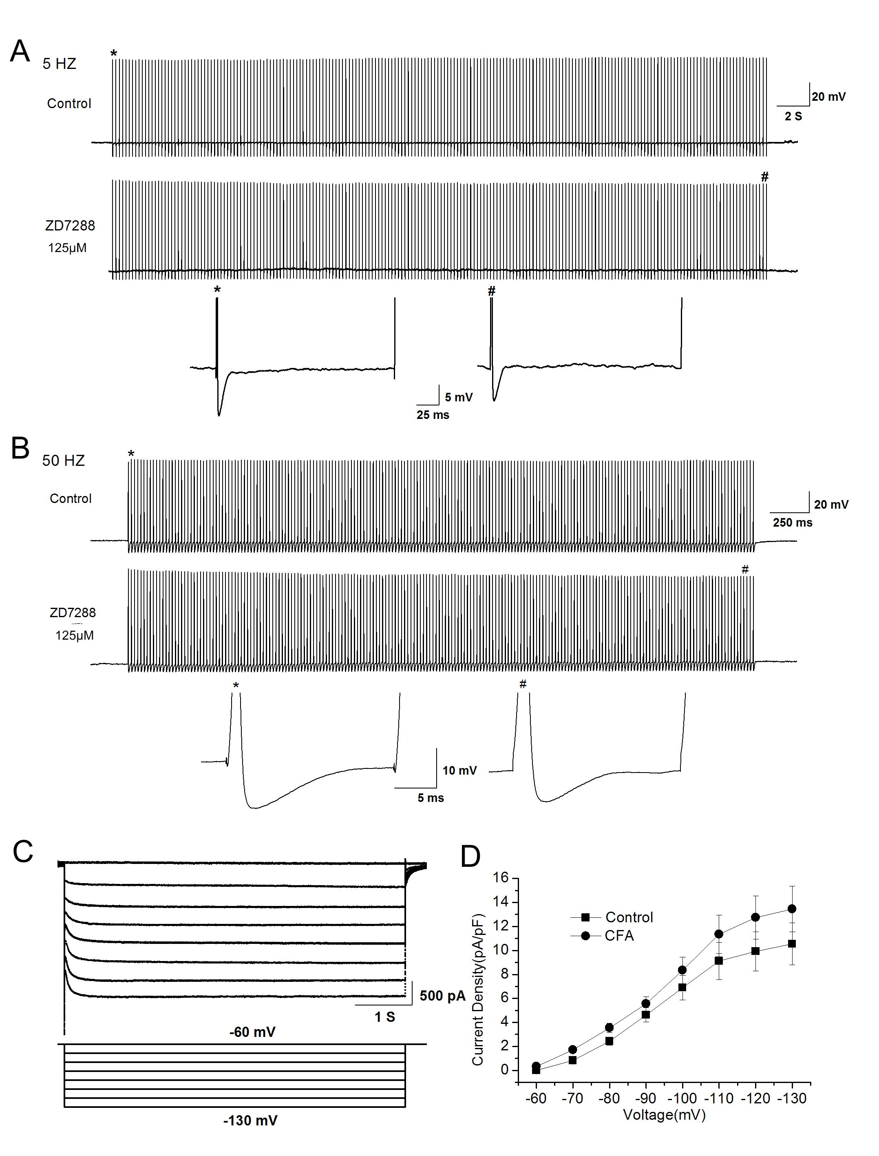
SFig. 4. Characteristics of AHP and I_{h} current in large-diameter DRG neurons. (A) The absence of AHP piling up and summation in response to 5 Hz intracellular stimulation (200 pulses, 40 s duration, upper trace), thus no conduction failure occurred. Application of ZD7288 (middle trace) had no effect on AHP piling up characteristics. Extended plots of the two spikes marked by * and # in the upper and middle traces displayed only a decrease of AHP amplitude in response to ZD7288 application. (lower trace). (B) Similarly, no spike failure was observed in response to 50 Hz stimulation (200 pulses, 4 s duration, upper trace). ZD7288 application (middle trace) had no effect on AHP piling up characteristics. Extended plots of the two spikes marked by * and # in the upper and middle traces are also shown (lower trace). (C) Representative I_{h} traces evoked by a series of hyperpolarizing voltage steps (bottom panel) from a holding potential of -60 mV to -130 mV for 6 s in 10 mV increments. (D) The mean current density of I_{h} in large-diameter DRG neurons from control and CFA-injected rats (n = 8).

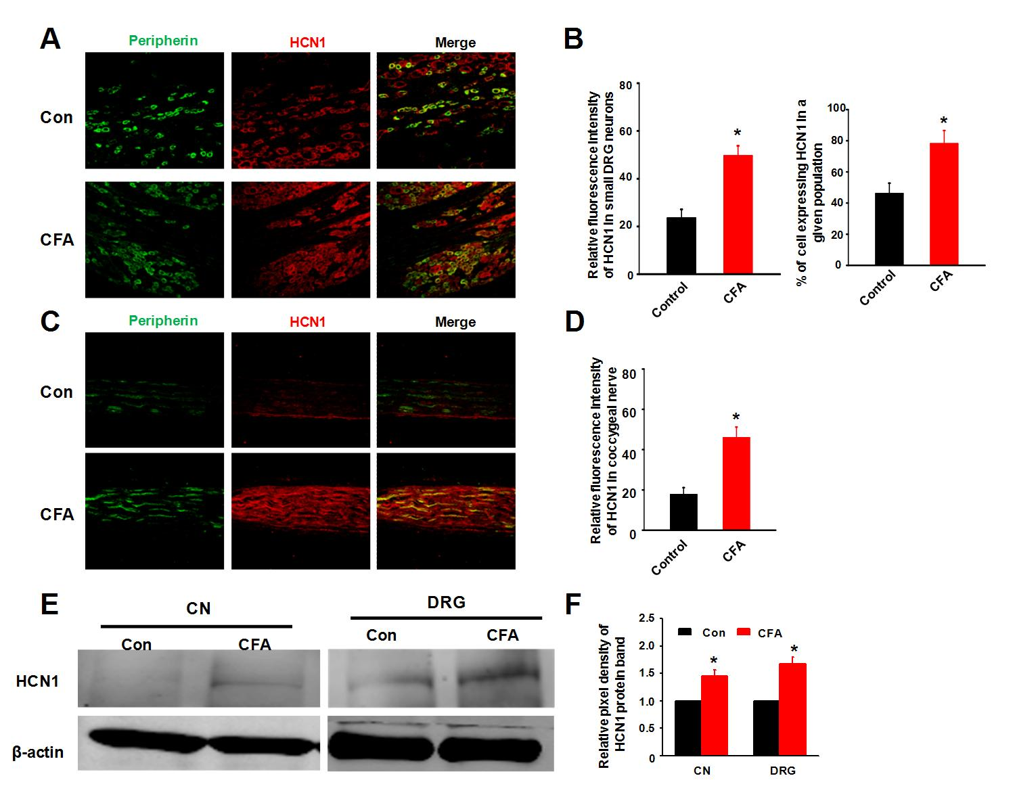
SFig. 5. HCN1 expression in DRGs and coccygeal nerves from control and CFA-injected rats. (A) Representative images of DRG neurons double-labeled for HCN1 (red) and peripherin (green), the latter of which is a marker of small-diameter DRG neurons. (B) Left: Quantitative analysis of HCN1 fluorescence intensity in small-diameter DRG neurons from control (n = 6) and CFA-injected rats (n = 5). Right: Percentages of HCN1-positive cells in DRG tissues from control and CFA-injected rats. (C) Representative images of coccygeal nerve tissues double-labeled for HCN1 (red) and peripherin (green). (D) Quantitative analysis of HCN1 fluorescence intensity in coccygeal nerve tissues from control and CFA-injected rats (n = 6). (E) HCN1 expression in DRGs and coccygeal nerves from control and CFA-injected rats. (F) Quantitative analysis of the Western blotting data represented in panel E. All data are represented as the mean ± S.E.M. * indicates P < 0.05 vs. the control group. Con: control; CN: coccygeal nerve; DRG: dorsal root ganglion.

