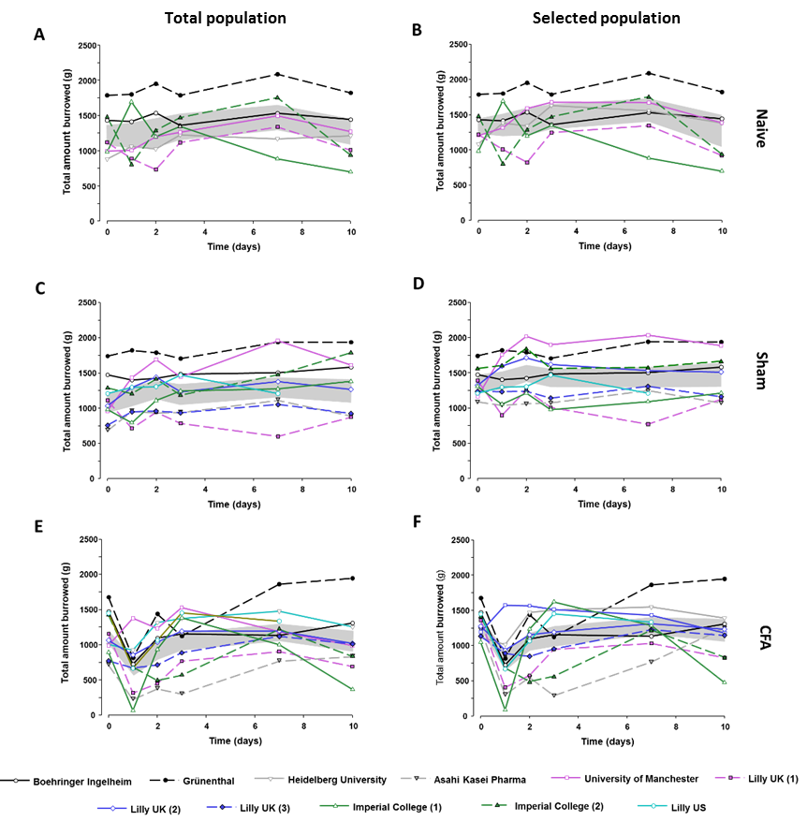

Suppl. 2: Burrowing behavior in individual studies – total amount burrowed
A, C, E) Total population: Burrowing behavior in individual studies in naïve (A), sham (C) and CFA (E) groups. Grey area represents the mean with 95% CI
B, D, F) Selected population: Burrowing behavior in individual studies in naïve (A), sham (C) and CFA (E) groups. Grey area represents the mean with 95% CI

