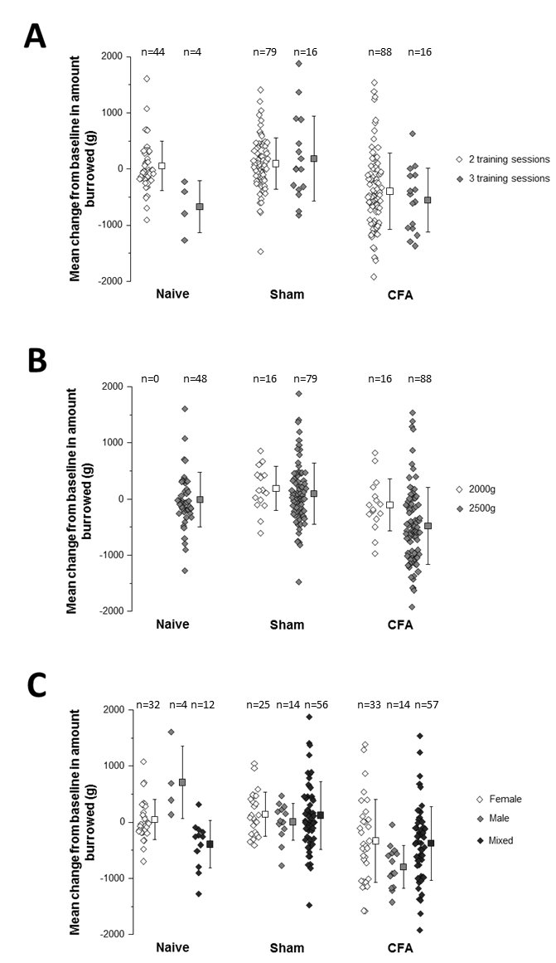

Suppl. 4: Burrowing performance 24 hrs following CFA injections in subgroups factoring in protocol variations (total population)
- Burrowing dependent on number of training sessions
- Burrowing dependent on substrate provided
- Burrowing dependent on gender of experimenter
Data shown as single values (diamonds) and mean (square) with 95% CI (whiskers).

