Supplemental Content to:
The Local and Systemic Exposure to Oxygen in Children With Severe Bronchiolitis on Invasive Mechanical Ventilation: a Retrospective Cohort Study
Thijs A. Lilien¹ MD, Eleonore S.V. de Sonnaville¹ MD, Job B.M. van Woensel¹ MD PhD, Reinout A. Bem¹ MD PhD
1. Amsterdam UMC location University of Amsterdam, Emma Children’s Hospital, Pediatric Intensive Care Unit, Meibergdreef 9, Amsterdam, The Netherlands;

Index
Content | Page number
eMethods and statistical analysis | 2-3
eTable 1. Admission diagnosis codes used for record selection from the electronic patient database | 4
eTable 2. Descriptive statistics of included patients | 5
eTable 3. Exploratory analysis of the association of oxygen exposure with outcome using quantile regression of the median | 6
eFigure 1. Flow diagram of the selection process of included records | 7
eFigure 2. Prevalence and proportion of arterial line use categorized by admission year | 8
eFigure 3. Repeated measures correlation plot | 9
eFigure 4. Healthcare worker’s response on fraction of inspired oxygen setting | 10
eReferences | 11

eMethods
This study is reported in accordance with the Reporting of Studies Conducted Using Observational Routinely Collected Health Data (RECORD) guideline.
Admission codes for patient record retrieval were based on the International Classification of Diseases 10th Revision (eTable 1). Extracted data included: (baseline) patient characteristics; presence of bacterial superinfection defined as a positive sputum culture and treatment with antibiotics; outcome data, including duration of invasive mechanical ventilation (IMV) and length of stay in the pediatric intensive care unit (PICU) in days (derived from total hours); ventilator data, including fraction of inspired oxygen (FiO₂), and peripheral oxygen saturation (SpO₂) at every hour up to the 10th day of IMV, and any partial pressure of arterial oxygen (PaO₂) from arterial blood gas analyses. The PaO₂ was only extracted at times patients had an intra-arterial line. In our center, routinely collected health data are validated every hour by the attending nurse. In case of a reintubation due to bronchiolitis-related respiratory insufficiency the additional days of IMV were extracted up to the 10th cumulative day of IMV.
According to local guidelines, oxygen therapy is started in our PICU at SpO₂ levels of ≤92% and dosed in accordance with protective ventilation principles. In addition to the attending physicians, PICU nurses titrate oxygen in our unit. No ventilator integrated automated feedback on oxygen titration was available.
The used cumulative excessive oxygen exposure score (CEE) was adapted from a prior study (1). Based on normative data of SpO₂ of healthy children at sea-level and the pediatric acute respiratory distress syndrome (ARDS) guideline which advises to maintain SpO₂ at 92-97% (2, 3), the threshold of 97% was chosen to score excessive oxygen use. Given the arbitrary definition of oxygen overuse, a sensitivity analysis was included with SpO₂ ≥95% based on the prior study from which the score was adapted and to analyze a less conservative definition of oxygen overuse. To exemplify the calculation of CEE: if a patient is treated with a FiO₂ of 0.50 when SpO₂ is 99%, the score is 0.29 (i.e. 29 percentage point of excessively administered oxygen). If SpO₂ is below 97% (or 95% in the sensitivity analysis), the CEE is always 0, regardless of the oxygen administered.

Statistical analysis
Descriptive statistics were reported as mean and standard deviation (SD) when normally distributed or otherwise as median with interquartile range (IQR). To address the longitudinal nature of the data, the cumulative exposure over a certain period of time was calculated by the area under the curve (AUC) of each variable using a trapezoid model. Subsequently, this cumulative dose was divided by the observed time period to acquire a time-weighted average (TWA). For calculation of the TWA of each consecutive day on IMV (i.e. per 24h window; TWA_{24h}) a minimum of 16h of IMV were required to calculate a TWA. TWA_{24h}-PaO₂ was only calculated if patients had at least 3 measurements over a period of 12h or more. Missing ventilator-related data were not imputed since the AUC approach interpolates between missing time points. However, individual cases with substantial missing data (i.e. >30% of observed time points) were omitted from the analysis. In the mixed-effects model used to assess changes over time in ventilator-related data, each subject was used as a random effect. In the first exploratory analysis on the prevalence of arterial line use over the past years, each two consecutive calendar years were grouped as a categorical variable. We used Fisher’s exact test for bivariate analysis and logistic regression to assess differences between grouped years. Secondly, in the second exploratory analysis on outcome, we assessed if oxygen exposure on the first day of IMV, defined as local exposure (TWA_{24h}-FiO₂) and excessive exposure (TWA_{24h}-CEE), was associated with a change in median duration of IMV and length of stay in the PICU. In this analysis TWA_{24h}-CEE was defined using both the primary threshold (97%) and that of the sensitivity analysis (95%). We used univariate quantile regression of the median (4), as the outcome variable was not normally distributed and data transformation did not sufficiently solve this issue.

eTable 1. Admission diagnosis codes used for records selection from the electronic patient database
International Classification of Diseases 10th Revision-codes used for patient identification:
Acute bronchiolitis, unspecified (code J21.9);
Acute bronchiolitis due to respiratory syncytial virus (code J21.0);
Respiratory syncytial virus pneumonia (code J12.1);
Unspecified acute lower respiratory infection (code J22).

eTable 2. Descriptive statistics of included patients
Variable | Included patients (N=176)

Baseline
Age (mo), median [IQR] | 1.0 [1.0-2.25]
Weight (kg), median [IQR] | 4.6 [3.7-5.6]
Sex (female), N (%) | 75 (42.6)
Comorbidity, N (%) | 56 (31.8)
Premature, N (%) | 43 (24.4)
BPD, N (%) | 6 (3.4)
Down syndrome, N (%) | 2 (1.1)
Congenital heart disease, N (%) | 9 (5.1)
Hemoglobin (mmol/l), mean (SD) | 7.0 (1.5)

Ventilator-related parameters
RSV positive, N (%) | 135 (76.7)
Bacterial superinfection, N (%) | 92 (52.3)
Arterial line at any time during IMV, N (%) | 140 (79.5)
Duration of IMV (days), median [IQR] | 5.5 [4.5-7.5]
Reintubation, N (%) | 6 (3.4)

Outcome
Mortality, N (%) | 1 (0.6)
Use of NO, N (%) | 5 (2.8)
Need for ECMO, N (%) | 1 (0.6)
Need for CVVH, N (%) | 0
Readmission, N (%) | 8 (4.5)
Legend eTable 2. Descriptive statistics of patients included in the analysis. IQR, Interquartile range; BPD, Bronchopulmonary dysplasia; SD, Standard deviation; RSV, Respiratory syncytial virus; IMV, Invasive mechanical ventilation; NO, Nitric oxide; ECMO, Extracorporeal membrane oxygenation; CVVH, Continuous veno-venous hemofiltration.
eTable 3. Exploratory analysis of the association of oxygen exposure with outcome using quantile regression of the median
Outcome | β | 95% confidence interval

Duration of IMV (days)
TWA_{24h}-FiO₂ª (%) | 0.080 | 0.037 – 0.123
TWA_{24h}-CEE (≥97% SpO₂)^{b} (%) | 0.032 | -0.043 – 0.106
TWA_{24h}-CEE (≥95% SpO₂)^{c} (%) | 0.044 | -0.014 – 0.103

Length of stay PICU (days)
TWA_{24h}-FiO₂ª (%) | 0.070 | 0.021 – 0.118
TWA_{24h}-CEE (≥97% SpO₂)^{b} (%) | 0.067 | -0.025 – 0.158
TWA_{24h}-CEE (≥95% SpO₂)^{c} (%) | 0.082 | 0.009 – 0.156
Legend eTable 3. Univariate quantile regression of the median using the time-weighted average over the first 24 hours of IMV as the predictor variable. ªIntercept was set to FiO₂ = 21% for a more interpretable result; ^{b}Primary threshold used to define overuse of oxygen; ^{c}Threshold of sensitivity analysis to define overuse of oxygen. β, regression coefficient; IMV, invasive mechanical ventilation; TWA_{24h}, time-weighted average over 24 hours; FiO₂, fraction of inspired oxygen; CEE, cumulative oxygen exposure score; SpO₂, peripheral oxygen saturation; PICU, pediatric intensive care unit.

eFigure 1. Flow diagram of the selection process of included records
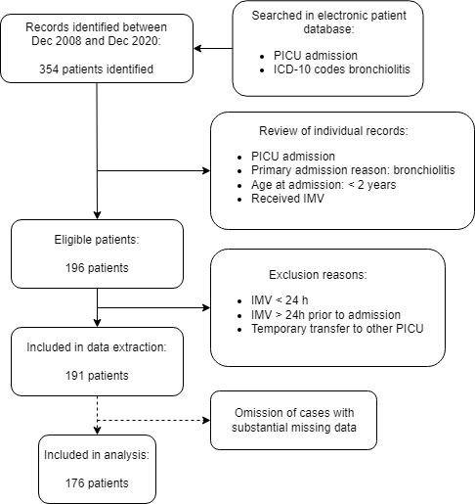
eFigure 2. Prevalence and proportion of arterial line use categorized by admission year
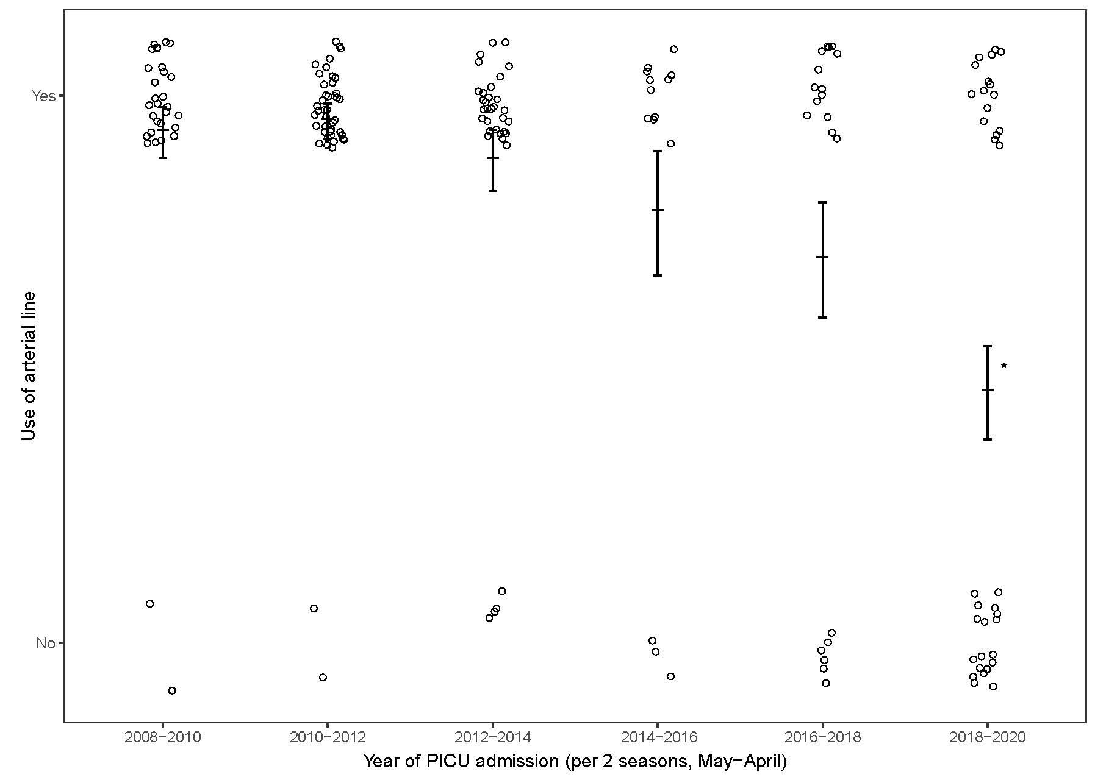
Legend eFigure 2. Proportion of arterial line use per admission year, categorized per two consecutive years, is shown. Dash and whiskers represent the observed proportion with its 95% CI respectively. *, P-value < 0.05 vs. admission years May 2008 – April 2010, using univariate logistic regression.
eFigure 3. Repeated measures correlation plot
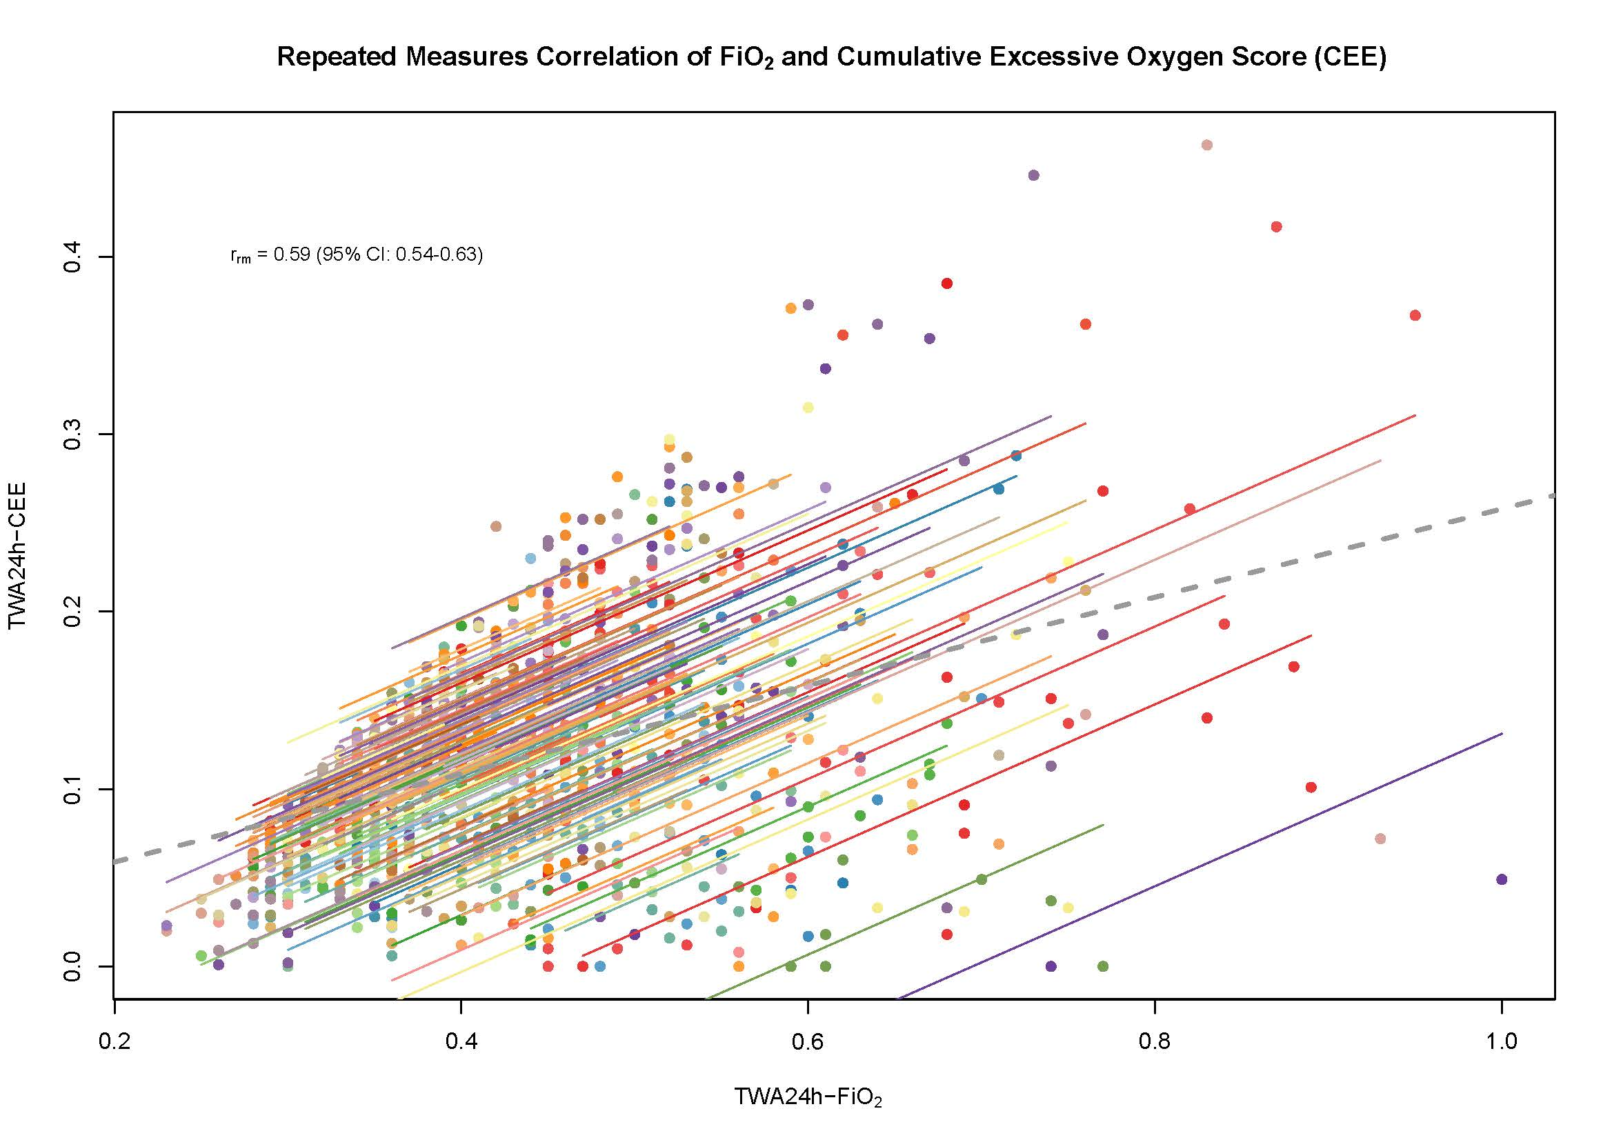
Legend eFigure 3. Repeated measures correlation plot of the time-weighted average per 24 hours of the fraction of inspired oxygen and the cumulative excessive oxygen score. Colored lines represent intra-individual correlation between repeated measures. Dashed grey line represent the overall inter-individual correlation if data were to be defined as independent identically distributed data. The correlation value (r_{rm}) is calculated based on intra-individual correlation.

eFigure 4. Healthcare worker’s response on fraction of inspired oxygen setting
Legend eFigure 4. Healthcare worker’s response on fraction of inspired oxygen setting during the next hour of invasive mechanical ventilation when oxygenation was sufficient, i.e. peripheral oxygen saturation ≥97%. Percentages of the total observations (N) during the next hour of invasive ventilation are shown per category of the fraction of inspired oxygen. Number of observations per category of change in fraction of inspired oxygen are shown left of every bar. FiO₂, fraction of inspired oxygen; SpO₂, peripheral oxygen saturation.
eReferences
1. Balcarcel DR, Coates BM, Chong G, et al.: Excessive Oxygen Supplementation in the First Day of Mechanical Ventilation Is Associated With Multiple Organ Dysfunction and Death in Critically Ill Children. Pediatr Crit Care Med 2022; 23:89-98
2. Balasubramanian S, Suresh N, Ravichandran C, et al.: Reference values for oxygen saturation by pulse oximetry in healthy children at sea level in Chennai. Ann Trop Paediatr 2006; 26:95-99
3. Pediatric Acute Lung Injury Consensus Conference G: Pediatric acute respiratory distress syndrome: consensus recommendations from the Pediatric Acute Lung Injury Consensus Conference. Pediatr Crit Care Med 2015; 16:428-439
4. Koenker RB, G.: Regression Quantiles. Econometrica 1978; 46:33-50

