Supplemental Digital Content

PALICC-2 Section 10 – Leveraging Clinical Informatics and Data Science to Improve Care and Facilitate Research in Pediatric Acute Respiratory Distress Syndrome: From the Second Pediatric Acute Lung Injury Consensus Conference

Supplemental Table 1: Search Strategies 2
Supplemental Figure 1. Study flow diagram according to the Preferred Reporting Items for 8
Systematic Review and Meta-Analysis (PRISMA) protocol recommendations. 8
Supplemental Figure 2: Pooled sensitivity and specificity for automated detection algorithms in identifying ARDS. 9
Supplemental Table 2: Evidence to Decision Framework for Recommendation 10.1 10
Supplemental Table 3: Evidence to Decision Framework for Recommendation 10.2 13
APPENDIX 1. Second Pediatric Acute Lung Injury Consensus Conference (PALICC-2) Group 17

Supplemental Table 1: Search Strategies
PALICC-2 Group 10: Machine Learning, Clinical Decision Support Tools

PubMed: 11/23/2020  Medline (Ovid) and Epub Ahead of Print, In-Process, In-Data-Review & Other Non-Indexed Citations and Daily 1946 to February 8, 2022: Results 11/20/2020  EBM Reviews (Ovid) (EBM Reviews - Cochrane Database of Systematic Reviews 2005 to January 20, 2022, EBM Reviews - ACP Journal Club 1991 to December 2021, EBM Reviews - Database of Abstracts of Reviews of Effects 1st Quarter 2016, EBM Reviews - Cochrane Clinical Answers December 2021, EBM Reviews - Cochrane Central Register of Controlled Trials December 2021, EBM Reviews - Cochrane Methodology Register 3rd Quarter 2012, EBM Reviews - Health Technology Assessment 4th Quarter 2016, EBM Reviews - NHS Economic Evaluation Database 1st Quarter 2016): Results 11/23/2020  Web of Science: Results 11/23/2020  Scopus: Results 11/20/2020 | Pubmed: 11/20/2020-2/9/2022  Medline (Ovid) and Epub Ahead of Print, In-Process, In-Data-Review & Other Non-Indexed Citations and Daily 1946 to February 8, 2022: Results 11/20/2020-2/9/2022  EBM Reviews (Ovid) (EBM Reviews - Cochrane Database of Systematic Reviews 2005 to January 20, 2022, EBM Reviews - ACP Journal Club 1991 to December 2021, EBM Reviews - Database of Abstracts of Reviews of Effects 1st Quarter 2016, EBM Reviews - Cochrane Clinical Answers December 2021, EBM Reviews - Cochrane Central Register of Controlled Trials December 2021, EBM Reviews - Cochrane Methodology Register 3rd Quarter 2012, EBM Reviews - Health Technology Assessment 4th Quarter 2016, EBM Reviews - NHS Economic Evaluation Database 1st Quarter 2016): Results 11/20/2020-2/9/2022  Web of Science:  Results Publication year 2020-2021-2022  (searched on 1/26/2022)  Scopus: Results 2020-2022 (searched on 2/8/2022):
PubMed:
#1. ARDS/Pediatric critical care
"ARDS"[all] OR "respiratory distress syndrome"[Mesh] OR "respiratory distress syndrome, adult"[all] OR "adult respiratory distress syndrome"[all] OR "adult respiratory distress syndromes"[all] OR "acute respiratory distress syndrome"[all] OR "acute respiratory distress syndromes"[all] OR "shock lung"[all] OR "shock lungs"[all] OR "acute lung injury"[mesh] OR "acute lung injury"[all] OR "acute lung injuries"[all] OR "acute hypoxemic respiratory failure"[all] OR "acute hypoxemic respiratory failures"[all] OR "AHRF"[all] OR "idiopathic respiratory distress syndrome"[all] OR "idiopathic respiratory distress syndromes"[all] OR "PARDS"[all] OR "pediatric respiratory distress syndrome"[all] OR "pediatric respiratory distress syndromes"[all] OR "paediatric respiratory distress syndrome"[all] OR "paediatric respiratory distress syndromes"[all]
OR "Pediatric critical care"[all] OR "Paediatric critical care"[all] OR "intensive care units, pediatric"[mesh:noexp] OR "pediatric intensive care"[all] OR "paediatric intensive care"[all]
OR "PICU"[all]

#2. EHR/ data
"data standard"[all] OR "data standards"[all] OR "data ontology"[all] OR "data ontologies"[all] OR "data terminology"[all] OR "data terminologies"[all] OR "thesaurus"[all] OR "thesauri"[all] OR "metadata"[mesh] OR "metadata"[all] OR "meta data"[all] OR
"Common data elements"[mesh] OR "Common data elements"[all] OR "Common data element"[all] OR "data mapping"[all] OR "Semantic Web"[mesh] OR "semantic web"[all] OR "semantic webs"[all] OR "linked data"[all] OR "linked datas"[all] OR "semantic network"[all] OR "semantic networks"[all] OR "data curation"[all] OR
"Integrated advanced information management systems"[mesh] OR "Integrated advanced information management systems"[all] OR "Integrated advanced information management system"[all] OR "Common data models"[all] OR "Common data model"[all] OR "centralized database"[all] OR "centralized databases"[all] OR "centralised database"[all] OR "centralised databases"[all] OR "federated network"[all] OR "federated networks"[all] OR
"Image-recognition"[all] OR "Image classification"[all] OR "image classifications"[all] OR "image processing"[all] OR "Electronic data processing"[mesh] OR "data processing"[all] OR "Automatic"[all] OR "Automated"[all] OR "pattern recognition, automated"[mesh] OR "pattern recognition"[all] OR "information processing"[all] OR "feature detection"[all]

#3. CDS tools
"Decision support systems, clinical"[mesh] OR "Clinical decision support"[all] OR "Clinical decision supports"[all] OR "dashboards"[all] OR "dashboard"[all] OR
"Decision making, computer-assisted"[mesh:noexp] OR "Diagnosis, computer-assisted"[mesh] OR "Therapy, computer-assisted"[mesh:noexp] OR "Drug Therapy, Computer-Assisted"[mesh] OR "computer-assisted"[all] OR "computer-aided"[all] OR "Computerized"[All] OR "computerised"[all] OR
"Clinical alarms"[mesh] OR "alert"[all] OR "alerts"[all] OR "sniffer"[all] OR "alarm"[All] OR "alarms"[All] OR
"machine learning"[mesh] OR "machine learning"[all] OR "deep learning"[all] OR "smart system"[all] OR "feature learning"[all] OR "representation learning"[all] OR "hierarchical learning"[all] OR "neural networks, computer"[mesh] OR "network learning"[all] OR "neural network"[all] OR "neural networks"[all] OR "connectionist model"[all] OR "connectionist models"[all] OR "connectionist system"[all] OR "connectionist systems"[all] OR "connectionist network"[all] OR "connectionist networks"[all] OR "perceptron"[all] OR "perceptrons"[all] OR "artificial intelligence"[mesh:noexp] OR "artificial intelligence"[all]

#4. Limits
("animals"[mesh] NOT ("animals"[mesh] AND "humans"[mesh]))

#5. Combination
((1 and (2 or 3)) not 4)

AND Since 1980 AND English[LA]

#6. Rerun
#6 2020/11/20 :2022/02/09[dp]
#5 and #6

Medline (Ovid) and Epub Ahead of Print, In-Process, In-Data-Review & Other Non-Indexed Citations and Daily 1946 to February 8, 2022:
#1. ARDS/Pediatric critical care
"respiratory distress syndrome"/ OR Exp "acute lung injury"/ OR ("ARDS" OR "respiratory distress syndrome, adult" OR "adult respiratory distress syndrome" OR "adult respiratory distress syndromes" OR "acute respiratory distress syndrome" OR "acute respiratory distress syndromes" OR "shock lung" OR "shock lungs" OR "acute lung injury" OR "acute lung injuries" OR "acute hypoxemic respiratory failure" OR "acute hypoxemic respiratory failures" OR "AHRF" OR "idiopathic respiratory distress syndrome" OR "idiopathic respiratory distress syndromes" OR "PARDS" OR "pediatric respiratory distress syndrome" OR "pediatric respiratory distress syndromes" OR "paediatric respiratory distress syndrome" OR "paediatric respiratory distress syndromes").af
OR "intensive care units, pediatric"/ OR ("Pediatric critical care" OR "Paediatric critical care" OR "pediatric intensive care" OR "paediatric intensive care" OR "PICU").af

#2. EHR/ data
"metadata"/ OR "Common data elements"/ OR "Semantic Web"/ OR
"Integrated advanced information management systems"/ OR "Electronic data processing"/ OR "pattern recognition, automated"/ OR
("data standard" OR "data standards" OR "data ontology" OR "data ontologies" OR "data terminology" OR "data terminologies" OR "thesaurus" OR "thesauri" OR "metadata" OR "meta data" OR "Common data elements" OR "Common data element" OR "data mapping" OR "semantic web" OR "semantic webs" OR "linked data" OR "linked datas" OR "semantic network" OR "semantic networks" OR "data curation" OR "Integrated advanced information management systems" OR "Integrated advanced information management system" OR "Common data models" OR "Common data model" OR "centralized database" OR "centralized databases" OR "centralised database" OR "centralised databases" OR "federated network" OR "federated networks" OR "Image-recognition" OR "Image classification" OR "image classifications" OR "image processing" OR "data processing" OR "Automatic" OR "pattern recognition" OR "information processing" OR "feature detection").af OR "Automated".mp

#3. CDS tools
"Decision support systems, clinical"/ OR "Decision making, computer-assisted"/ OR Exp "Diagnosis, computer-assisted"/ OR "Therapy, computer-assisted"/ OR "Drug Therapy, Computer-Assisted"/ OR "Clinical alarms"/ OR Exp "machine learning"/ OR Exp "neural networks, computer"/ OR "artificial intelligence"/ OR
("Clinical decision support" OR "Clinical decision supports" OR "dashboards" OR "dashboard" OR "computer-assisted" OR "computer-aided" OR "Computerized" OR "computerised" OR "alert" OR "alerts" OR "sniffer" OR "alarm" OR "alarms" OR "machine learning" OR "deep learning" OR "smart system" OR "feature learning" OR "representation learning" OR "hierarchical learning" OR "network learning" OR "neural network" OR "neural networks" OR "connectionist model" OR "connectionist models" OR "connectionist system" OR "connectionist systems" OR "connectionist network" OR "connectionist networks" OR "perceptron" OR "perceptrons" OR "artificial intelligence").af

#4. Limits
("animals"/ NOT ("animals"/ AND "humans"/))

#5. Combination
((1 and (2 or 3)) not 4)

AND Since 1980 AND English.lg

#6. Rerun
Limit 5 to rd=20201120-20220209

EBM Reviews (Ovid) (EBM Reviews - Cochrane Database of Systematic Reviews 2005 to January 20, 2022, EBM Reviews - ACP Journal Club 1991 to December 2021, EBM Reviews - Database of Abstracts of Reviews of Effects 1st Quarter 2016, EBM Reviews - Cochrane Clinical Answers December 2021, EBM Reviews - Cochrane Central Register of Controlled Trials December 2021, EBM Reviews - Cochrane Methodology Register 3rd Quarter 2012, EBM Reviews - Health Technology Assessment 4th Quarter 2016, EBM Reviews - NHS Economic Evaluation Database 1st Quarter 2016):

#1. ARDS/Pediatric critical care
"adult respiratory distress syndrome"/ OR Exp "acute lung injury"/ OR ("ARDS" OR "respiratory distress syndrome, adult" OR "adult respiratory distress syndrome" OR "adult respiratory distress syndromes" OR "acute respiratory distress syndrome" OR "acute respiratory distress syndromes" OR "shock lung" OR "shock lungs" OR "acute lung injury" OR "acute lung injuries" OR "acute hypoxemic respiratory failure" OR "acute hypoxemic respiratory failures" OR "AHRF" OR "idiopathic respiratory distress syndrome" OR "idiopathic respiratory distress syndromes" OR "PARDS" OR "pediatric respiratory distress syndrome" OR "pediatric respiratory distress syndromes" OR "paediatric respiratory distress syndrome" OR "paediatric respiratory distress syndromes").ti,ab,kw
OR " pediatric intensive care units"/ OR ("Pediatric critical care" OR "Paediatric critical care" OR "pediatric intensive care" OR "paediatric intensive care" OR "PICU").ti,ab,kw

#2. EHR/ data
"metadata"/ OR "Common data elements"/ OR "Semantic Web"/ OR
"information systems"/ OR "Information processing"/ OR "automated pattern recognition"/ OR
("data standard" OR "data standards" OR "data ontology" OR "data ontologies" OR "data terminology" OR "data terminologies" OR "thesaurus" OR "thesauri" OR "metadata" OR "meta data" OR "Common data elements" OR "Common data element" OR "data mapping" OR "semantic web" OR "semantic webs" OR "linked data" OR "linked datas" OR "semantic network" OR "semantic networks" OR "data curation" OR "Integrated advanced information management systems" OR "Integrated advanced information management system" OR "Common data models" OR "Common data model" OR "centralized database" OR "centralized databases" OR "centralised database" OR "centralised databases" OR "federated network" OR "federated networks" OR "Image-recognition" OR "Image classification" OR "image classifications" OR "image processing" OR "data processing" OR "Automatic" OR "Automated" OR "pattern recognition" OR "information processing" OR "feature detection").ti,ab,kw

#3. CDS tools
"clinical decision support systems"/ OR "decision support systems"/ OR "computer assisted diagnosis"/ OR "computer assisted therapy"/ OR "Computer Assisted Drug Therapy"/ OR "alarm monitor"/ OR "machine learning"/ OR "artificial neural network"/ OR "deep learning"/ OR "semi supervised machine learning"/ OR "supervised machine learning"/ OR "support vector machine"/ OR "unsupervised machine learning"/ OR "artificial intelligence"/ OR
("Clinical decision support" OR "Clinical decision supports" OR "dashboards" OR "dashboard" OR "computer-aided" OR "Computerized" OR "computerised" OR "computer-assisted" OR "alert" OR "alerts" OR "sniffer" OR "alarm" OR "alarms" OR "machine learning" OR "deep learning" OR "smart system" OR "feature learning" OR "representation learning" OR "hierarchical learning" OR "network learning" OR "neural network" OR "neural networks" OR "connectionist model" OR "connectionist models" OR "connectionist system" OR "connectionist systems" OR "connectionist network" OR "connectionist networks" OR "perceptron" OR "perceptrons" OR "artificial intelligence").ti,ab,kw

#4. Limits
("animal"/ NOT ("animal"/ AND "human"/))

#5. Combinations
((1 and (2 or 3)) not 4)

AND Since 1980 AND English.lg

#6. Rerun
Limit 5 to dc=20201120-20220209

Web of Science:
#1. ARDS/Pediatric critical care
TS=("ARDS" OR "respiratory distress syndrome, adult" OR "adult respiratory distress syndrome" OR "adult respiratory distress syndromes" OR "acute respiratory distress syndrome" OR "acute respiratory distress syndromes" OR "shock lung" OR "shock lungs" OR "acute lung injury" OR "acute lung injuries" OR "acute hypoxemic respiratory failure" OR "acute hypoxemic respiratory failures" OR "AHRF" OR "idiopathic respiratory distress syndrome" OR "idiopathic respiratory distress syndromes" OR "PARDS" OR "pediatric respiratory distress syndrome" OR "pediatric respiratory distress syndromes" OR "paediatric respiratory distress syndrome" OR "paediatric respiratory distress syndromes" OR "Pediatric critical care" OR "Paediatric critical care" OR "pediatric intensive care" OR "paediatric intensive care" OR "PICU")

#2. EHR/ data
TS=("data standard" OR "data standards" OR "data ontology" OR "data ontologies" OR "data terminology" OR "data terminologies" OR "thesaurus" OR "thesauri" OR "metadata" OR "meta data" OR "Common data elements" OR "Common data element" OR "data mapping" OR "semantic web" OR "semantic webs" OR "linked data" OR "linked datas" OR "semantic network" OR "semantic networks" OR "data curation" OR "Integrated advanced information management systems" OR "Integrated advanced information management system" OR "Common data models" OR "Common data model" OR "centralized database" OR "centralized databases" OR "centralised database" OR "centralised databases" OR "federated network" OR "federated networks" OR "Image-recognition" OR "Image classification" OR "image classifications" OR "image processing" OR "data processing" OR "Automatic" OR "Automated" OR "pattern recognition" OR "information processing" OR "feature detection")

#3. CDS tools
TS=("Clinical decision support" OR "Clinical decision supports" OR "dashboards" OR "dashboard" OR "computer-assisted" OR "computer-aided" OR "Computerized" OR "computerised" OR "alert" OR "alerts" OR "sniffer" OR "alarm" OR "alarms" OR "machine learning" OR "deep learning" OR "smart system" OR "feature learning" OR "representation learning" OR "hierarchical learning" OR "network learning" OR "neural network" OR "neural networks" OR "connectionist model" OR "connectionist models" OR "connectionist system" OR "connectionist systems" OR "connectionist network" OR "connectionist networks" OR "perceptron" OR "perceptrons" OR "artificial intelligence")

#4. Combinations
(1 and (2 or 3))

Since 1980 – English in post-search filters

#5. Rerun
Publication year 2020-2021-2022

Scopus:
#1. ARDS/Pediatric critical care
TITLE-ABS-KEY({ARDS} OR {respiratory distress syndrome, adult} OR {adult respiratory distress syndrome} OR {adult respiratory distress syndromes} OR {acute respiratory distress syndrome} OR {acute respiratory distress syndromes} OR {shock lung} OR {shock lungs} OR {acute lung injury} OR {acute lung injuries} OR {acute hypoxemic respiratory failure} OR {acute hypoxemic respiratory failures} OR {AHRF} OR {idiopathic respiratory distress syndrome} OR {idiopathic respiratory distress syndromes} OR {PARDS} OR {pediatric respiratory distress syndrome} OR {pediatric respiratory distress syndromes} OR {paediatric respiratory distress syndrome} OR {paediatric respiratory distress syndromes} OR {Pediatric critical care} OR {Paediatric critical care} OR {pediatric intensive care} OR {paediatric intensive care} OR {PICU})

#2. EHR/ data
TITLE-ABS-KEY({data standard} OR {data standards} OR {data ontology} OR {data ontologies} OR {data terminology} OR {data terminologies} OR {thesaurus} OR {thesauri} OR {metadata} OR {meta data} OR {Common data elements} OR {Common data element} OR {data mapping} OR {semantic web} OR {semantic webs} OR {linked data} OR {linked datas} OR {semantic network} OR {semantic networks} OR {data curation} OR {Integrated advanced information management systems} OR {Integrated advanced information management system} OR {Common data models} OR {Common data model} OR {centralized database} OR {centralized databases} OR {centralised database} OR {centralised databases} OR {federated network} OR {federated networks} OR
{Image-recognition} OR {Image classification} OR {image classifications} OR {image processing} OR {data processing} OR {Automatic} OR {Automated} OR {pattern recognition} OR {information processing} OR {feature detection})

#3. CDS tools
TITLE-ABS-KEY({Clinical decision support} OR {Clinical decision supports} OR {dashboards} OR {dashboard} OR {computer-assisted} OR {computer-aided} OR {Computerized} OR {computerised} OR {alert} OR {alerts} OR {sniffer} OR {alarm} OR {alarms} OR {machine learning} OR {deep learning} OR {smart system} OR {feature learning} OR {representation learning} OR {hierarchical learning} OR {network learning} OR {neural network} OR {neural networks} OR {connectionist model} OR {connectionist models} OR {connectionist system} OR {connectionist systems} OR {connectionist network} OR {connectionist networks} OR {perceptron} OR {perceptrons} OR {artificial intelligence})

#4. Limits
1980-2021, English in post-search filters. No controlled vocabulary in Scopus, so cannot limit to human.

#5. Combinations
(1 and (2 or 3))
#6. Rerun
2020-2022, English in post-search filters. No controlled vocabulary in Scopus, so cannot limit to human.

Supplemental Figure 1. Study flow diagram according to the Preferred Reporting Items for

Systematic Review and Meta-Analysis (PRISMA) protocol recommendations.

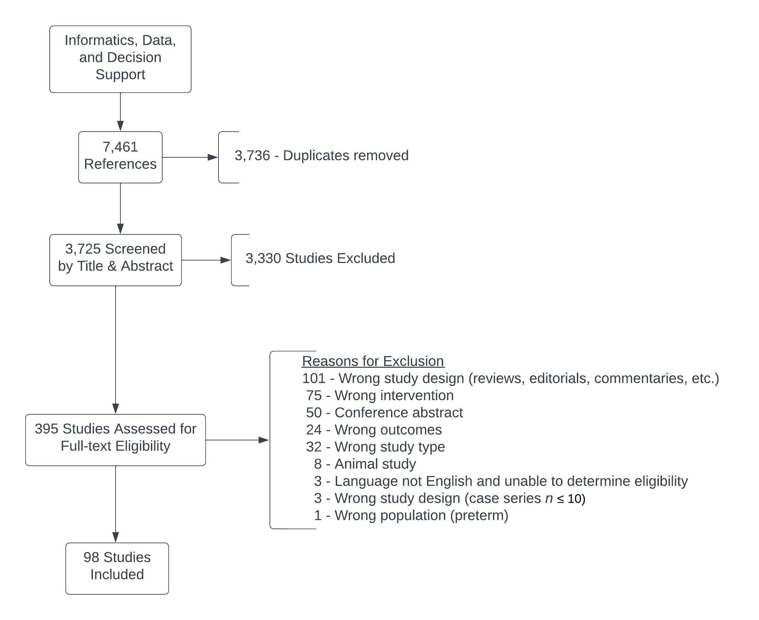

Supplemental Figure 2: Pooled sensitivity and specificity for automated detection algorithms in identifying ARDS.

- Pooled sensitivity for ARDS automated detection:
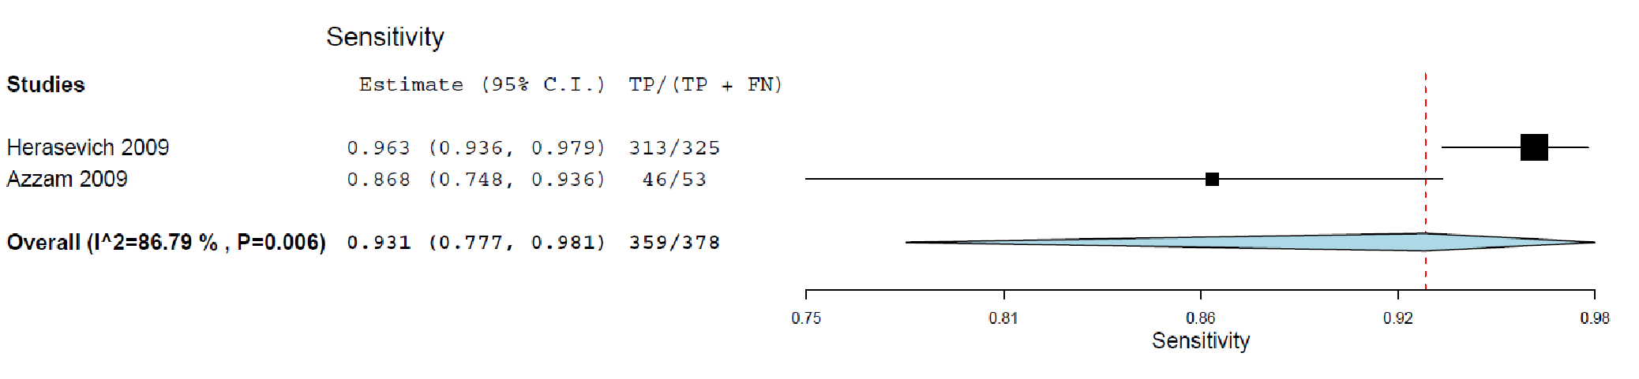
- Pooled specificity for ARDS automated detection:
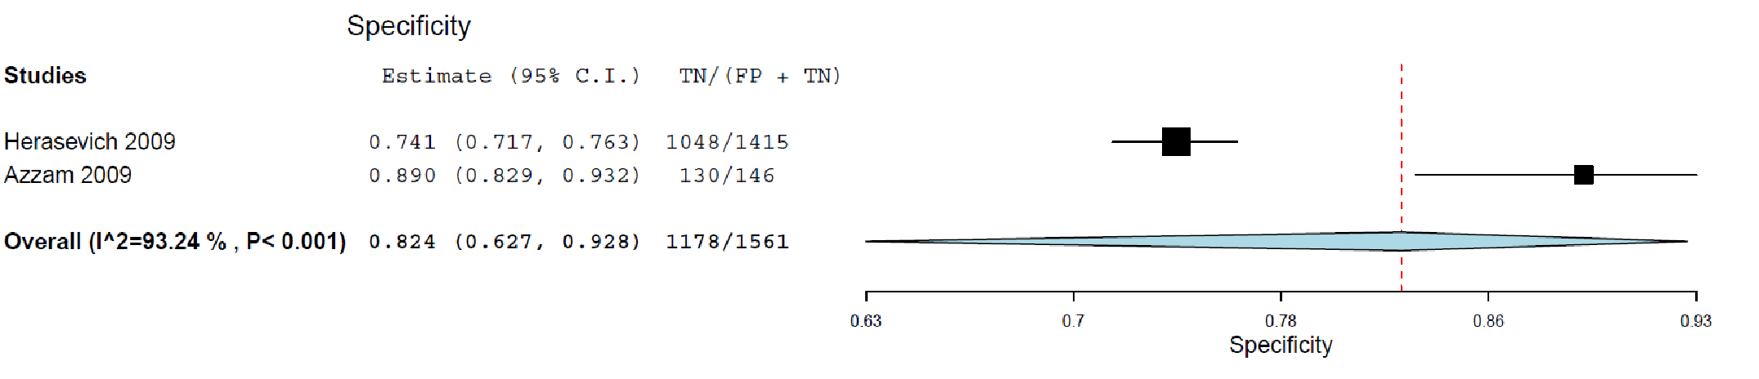

Supplemental Table 2: Evidence to Decision Framework for Recommendation 10.1

POPULATION: |  | Critically ill pediatric patients
INTERVENTION: |  | Automatic screening for PARDS or risk of developing PARDS using electronic tools
COMPARISON: |  | Bedside clinician identification or manual review
MAIN OUTCOMES: |  | Sensitivity and specificity for identifying patients with PARDS or at significant risk of developing PARDS

Recommendation
10.1 We suggest that clinicians implement electronic tools to automatically screen critically ill children to help identify those with PARDS or at significant risk of developing PARDS as compared to non-electronic screening or no standardized screening. (Conditional recommendation, very low certainty of evidence, 96% agreement).

Desirable Effects
How substantial are the desirable anticipated effects?
 | JUDGEMENT |  | RESEARCH EVIDENCE | ADDITIONAL CONSIDERATIONS
 | Moderate |  | Evidence suggests that correct and earlier identification of patients with ARDS is associated with higher adherence to clinical best practices. Evidence also suggests that automatic screening algorithms perform better than humans at identifying patients with ARDS earlier and correctly.

Undesirable Effects
How substantial are the undesirable anticipated effects?
 | JUDGEMENT |  | RESEARCH EVIDENCE | ADDITIONAL CONSIDERATIONS
 | Small |  | Implementation of electronic tools may be costly and requires a team of trained professionals with expertise in clinical informatics, health information technology, and tool implementation. Misclassification of patients could lead to alert fatigue and wasted resources in unnecessary diagnostic testing. However, there is no evidence comparing the potential risk and benefits of automatic ARDS screening tools. Evidence suggest that implementation of automatic screening tools for other conditions (e.g. acute kidney injury) may have positive effects.

Certainty of evidence
What is the overall certainty of the evidence of effects?
 | JUDGEMENT |  | RESEARCH EVIDENCE | ADDITIONAL CONSIDERATIONS
 | Low |  | Existing evidence for the effectiveness of automatic ALI/ARDS screening tools comes from prospective implementation studies in critically ill adults. These screening tools generally use information from arterial blood gases and chest X-ray reports and rule-based algorithms. Two large studies in adult ICUs with a total of 409 patients with ALI and 4,656 controls found that automatic screening tools had a sensitivity of 96 to 98% to detect ALI, compared to bedside clinician documentation (26.5% sensitivity) and a manual chart review by trained research coordinator (57.1% sensitivity).^{1,2} A smaller study in adult trauma patients requiring mechanical ventilation, including 53 patients with ALI and 146 controls, found that an automatic screening tool had an 87% sensitivity and 89% specificity when compared to the expert review by two clinicians.³  - Herasevich et al., Validation of an electronic surveillance system for acute lung injury. Intensive Care Medicine (2009)  - Azzam et al., Validation Study of an Automated Electronic Acute Lung Injury Screening Tool. Journal of the American Medical Informatics Association (2009)  - Koenig et al., Performance of an automated electronic acute lung injury screening system in intensive care unit patients. Critical Care Medicine (2011) | The “target” population for the information provided by automatic screening algorithms and clinical decision support tools are usually the bedside clinicians, thus evidence from adult studies could be considered highly relevant in pediatric settings given that bedside clinicians are likely to have comparable behaviors across adult and pediatric settings.
 | Values  Is there important uncertainty about or variability in how much people value the main outcomes? |  |  |  |  |  | ADDITIONAL CONSIDERATIONS
 | JUDGEMENT |  | RESEARCH EVIDENCE | ADDITIONAL CONSIDERATIONS
 | Possibly important uncertainty or variability |  | Despite evidence to the contrary, many bedside clinicians believe that they do not require help in identifying patients with or at high-risk for developing ARDS. For automatic screening tools to be of value, their implementation must consider the human factors involved in decision making in the clinical setting and maximize the human-algorithm interaction to accurately identify patients that will benefit from specific management.

Balance of Effects
Does the Balance between desirable and undesirable effects favor the recommendation?
 | JUDGEMENT |  | RESEARCH EVIDENCE | ADDITIONAL CONSIDERATIONS
 | Probably favors the comparison |  | Evidence suggest that early and correct identification of patients with ARDS is associated with improved adherence to clinical best practices. Evidence also suggests that bedside clinicians have inadequate sensitivity in identifying patients with ARDS when compared to automatic screening algorithms.

Resources required
How large are the resource requirements (costs)?
 | JUDGEMENT |  | RESEARCH EVIDENCE | ADDITIONAL CONSIDERATIONS
 | Moderate costs |  | Implementation of electronic tools may be costly and requires a team of trained professionals with expertise in clinical informatics, health information technology, and tool implementation. Misclassification of patients could lead to alert fatigue and wasted resources in unnecessary diagnostic testing.

Equity
What would be the impact on health equity?
 | JUDGEMENT |  | RESEARCH EVIDENCE | ADDITIONAL CONSIDERATIONS
 | Probably increased |  | Because automatic screening algorithms will likely be implemented sooner in high-resourced settings, there is a risk that health equity will be impacted.

Implementation
Is the intervention feasible to implement?
 | JUDGEMENT |  | RESEARCH EVIDENCE | ADDITIONAL CONSIDERATIONS
 | Yes |  | There are many examples of successful automatic screening tool implementation in adult and pediatric settings.

Supplemental Table 3: Evidence to Decision Framework for Recommendation 10.2

POPULATION: |  | Pediatric patients with PARDS
INTERVENTION: |  | Compliance with PALICC best practice guidelines is automatically monitored and real-time feedback is provided to clinicians
COMPARISON: |  | Usual care based on clinician judgment
MAIN OUTCOMES: |  | Adherence to PALICC best practice guidelines

Recommendation
10.2 We suggest automatic monitoring of compliance with PALICC clinical practice guidelines for lung protective strategies, as compared to no monitoring of compliance (Conditional recommendation, low certainty of evidence, 96% agreement).
Remarks: Automatic monitoring should incorporate measures of gas exchange and mechanical ventilation and provide feedback to clinicians in real-time with user-friendly interfaces.

Desirable Effects
How substantial are the desirable anticipated effects?
 | JUDGEMENT | RESEARCH EVIDENCE | ADDITIONAL CONSIDERATIONS
 | Moderate | Evidence suggest that adherence to best practice guidelines and protocols in patients with PARDS is associated with improved clinical outcomes. Evidence also suggests that automatic compliance monitoring and feedback is associated with greater adherence to best practice guidelines when compared to usual care.

Undesirable Effects
How substantial are the undesirable anticipated effects?
 | JUDGEMENT | RESEARCH EVIDENCE | ADDITIONAL CONSIDERATIONS
 | Small | Implementation of electronic tools may be costly and requires a team of trained professionals with expertise in clinical informatics, health information technology, and tool implementation. Providing frequent or excessive feedback to clinicians may lead to alert fatigue. However, there is evidence that improved adherence to best practice guidelines facilitated by electronic tools is associated with improved clinical outcomes in children with PARDS.

Certainty of evidence
What is the overall certainty of the evidence of effects?
 | JUDGEMENT | RESEARCH EVIDENCE | ADDITIONAL CONSIDERATIONS
 | Low | Evidence for automatic compliance of ARDS/PARDS best practice guidelines can be divided into two groups: those focused on adherence to tidal volume recommendations and those studying compliance with other lung protective strategies or bundles. Evidence for adherence to tidal volume recommendations comes mainly from adult ICU studies. Five quasi-experimental studies and one RCT (including 2,618 patients receiving the intervention and 6703 controls) show that automatic tidal volume compliance monitoring and feedback to clinicians resulted in greater time adhering to recommended best practices and/or lower mean tidal volume in the intervention patients when compared to controls.¹⁻⁶ Evidence for adherence to other lung protective strategies or bundles recommendations comes from both adult and pediatric ICU studies. The adult studies include one quasi-experimental study and one RCT (with 337 patients receiving the intervention and 220 controls). The pediatric studies include three quasi-experimental studies (with 143 patients receiving the intervention and 258 controls). In both the adult and pediatric studies, evidence show that automatic compliance monitoring and feedback to clinicians resulted in greater time adhering to recommended best practices in the intervention patients when compared to controls.⁷⁻¹¹ One pediatric study also associated this improved adherence to best practices with improved clinical outcomes when compared to historic controls.  - Eslami et al., Evaluation of consulting and critiquing decision support systems: Effect on adherence to a lower tidal volume mechanical ventilation strategy. Journal of Critical Care (2012)  - Bourdeaux et al., Increasing compliance with low tidal volume ventilation in the ICU with two nudge-based interventions: evaluation through intervention time-series analyses. BMJ Open (2016)  - Eslami et al., Effect of a clinical decision support system on adherence to a lower tidal volume mechanical ventilation strategy. Journal of Critical Care (2009)  - Castellanos et al., Effects of staff training and electronic event monitoring on long-term adherence to lung-protective ventilation recommendations. Journal of Critical Care (2018)  - Bagga et al., Better Ventilator Settings Using a Computerized Clinical Tool Clinical decision support systems (CDSS) for ARDS patients. Respiratory Care (2014)  - Blum et al., Automated alerting and recommendations for the management of patients with pre-existing hypoxemia and potential lung injury. Anesthesiology (2013)  - Herasevich et al., Limiting ventilator-induced lung injury through individual electronic medical record surveillance. Critical Care Medicine (2011)  - McKinley et al., Computerized Decision Support for Mechanical Ventilation of Trauma Induced ARDS: Results of a Randomized Clinical Trial. Journal of Trauma (2001)  - Walsh et al., Daily Goals Formulation and Enhanced Visualization of Mechanical Ventilation Variance Improves Mechanical Ventilation Score. Respiratory Care (2017)  - Hotz et al., Real-Time Effort Driven Ventilator Management: A Pilot Study. Pediatric Critical Care Medicine (2020)  - Rajapreyar et al., Development of a Standardized Clinical Assessment and Management Plan for Pediatric Acute Respiratory Distress Syndrome. Journal of Pediatric Intensive Care (2021) | The “target” population for the information provided by automatic monitoring algorithms and clinical decision support tools are usually the bedside clinicians, thus evidence from adult studies could be considered highly relevant in pediatric settings given that bedside clinicians are likely to have comparable behaviors across adult and pediatric settings.
 | Values  Is there important uncertainty about or variability in how much people value the main outcomes? |  |  |  |  | ADDITIONAL CONSIDERATIONS
 | JUDGEMENT | RESEARCH EVIDENCE | ADDITIONAL CONSIDERATIONS
 | Possibly important uncertainty or variability | Despite evidence to the contrary, many bedside clinicians believe that they do not require help to maintain high adherence to best practice guidelines. For clinical decision support tools to be of value, their implementation must consider the human factors involved in decision making in the clinical setting and maximize the human-algorithm interaction to improve adherence to best practices.

Balance of Effects
Does the Balance between desirable and undesirable effects favor the recommendation?
 | JUDGEMENT | RESEARCH EVIDENCE | ADDITIONAL CONSIDERATIONS
 | Probably favors the comparison | Evidence suggests that automatic compliance monitoring and feedback is associated with greater adherence to best practice guidelines when compared to usual care. Evidence also suggest that adherence to best practice guidelines in patients with PARDS is associated with improved clinical outcomes.

Resources required
How large are the resource requirements (costs)?
 | JUDGEMENT | RESEARCH EVIDENCE | ADDITIONAL CONSIDERATIONS
 | Moderate costs | Implementation of electronic tools may be costly and requires a team of trained professionals with expertise in clinical informatics, health information technology, and tool implementation. Providing frequent or excessive feedback to clinicians may lead to alert fatigue.

Equity
What would be the impact on health equity?
 | JUDGEMENT | RESEARCH EVIDENCE | ADDITIONAL CONSIDERATIONS
 | Probably increased | Because electronic tools will likely be implemented sooner in high-resourced settings, there is a risk that health equity will be impacted.

Implementation
Is the intervention feasible to implement?
 | JUDGEMENT | RESEARCH EVIDENCE | ADDITIONAL CONSIDERATIONS
 | Yes | There are many examples of successful implementation of automatic compliance monitoring and associated clinical decision support tools in adult and pediatric settings.

APPENDIX 1. Second Pediatric Acute Lung Injury Consensus Conference (PALICC-2) Group

Co-Chairs – Guillaume Emeriaud, Yolanda M López-Fernández, Robinder G Khemani
Methodologists: Narayan Prabhu Iyer, Melania Bembea, Steven Kwasi Korang, Katherine M. Steffen
Experts
Section 1 (Definition, Incidence and Epidemiology) Nadir Yehya, Lincoln Smith, Neal J. Thomas, Jerry J. Zimmerman, Simon J. Erickson, Steven L. Shein
Section 2 (Pathobiology, Severity, and Risk Stratification) Jocelyn R. Grunwell, Mary K. Dahmer, Anil Sapru, Michael W. Quasney, Heidi R Flori.
Section 3 (Ventilatory Support) Analia Fernandez, Vicent Modesto i Alapont, Peter Rimensberger, Ira Cheifetz.
Section 4 (Pulmonary Specific Ancillary Treatment) Courtney Rowan, Adrienne G. Randolph, Martin Kneyber.
Section 5 (Non pulmonary treatment) Stacey Valentine, Sapna Kudchadkar, Shan Ward, Vinay Nadkarni, Martha A.Q. Curley.
Section 6 (Monitoring) Anoopindar Bhalla, Florent Baudin, Muneyuki Takeuchi, Pablo Cruces.
Section 7 (Noninvasive support) Christopher L Carroll, Natalie Napolitano, Marti Pons-Odena, Sandrine Essouri.
Section 8 (Extracorporeal Support) Jérome Rambaud, Ryan Barbaro, Duncan Macrae, Heidi Dalton.
Section 9 (Morbidity and Long-Term Outcomes) Elizabeth Killien, Aline Maddux, Sze Man Tse, Scott Watson.
Section 10 (Clinical Informatics and Data Science) L. Nelson Sanchez-Pinto, Michaël Sauthier, Prakadeshwari Rajapreyar, Philippe Jouvet, Christopher Newth.
Section 11 (Resource-Limited Settings) Brenda Morrow, Asya Agulnik, Werther Brunow de Carvalho, Mohamod Chisti, Jan Hau Lee.
Librarians: Katie Lobner, Lynn Kysh, Alix Pincivy, Philippe Dodin

