SUPPLEMENTAL DIGITAL CONTENT

"Physical, emotional/behavioural and neurocognitive developmental outcomes from 2- to 4-years after PICU admission: a secondary analysis of the early versus late parenteral nutrition randomised controlled trial cohort"

Ines Verlinden, M.D.¹, Fabian Güiza, Ph.D.¹, Karolijn Dulfer, Ph.D.², Hanna Van Cleemput, M.Sc.¹, Pieter J Wouters, M.Sc.¹, Gonzalo Garcia Guerra M.D.³, Koen F. Joosten, M.D², Sascha C. Verbruggen, M.D.², Ilse Vanhorebeek, Ph.D.^{1*}, Greet Van den Berghe, M.D.^{1*}

¹ Clinical Division and Laboratory of Intensive Care Medicine, Department of Cellular and Molecular Medicine, KU Leuven, Leuven, Belgium; ² Intensive Care Unit, Department of Paediatrics and Paediatric Surgery, Erasmus Medical Centre, Sophia Children’s Hospital, Rotterdam, The Netherlands; ³ Department of Paediatrics, Intensive Care Unit, University of Alberta, Stollery Children's Hospital, Edmonton, Canada.
* Contributed equally
Address correspondence to: Greet Van den Berghe, Clinical Division and Laboratory of Intensive Care Medicine, KU Leuven, Herestraat 49, B-3000 Leuven, Belgium. Phone: 32-16-34-40-21; Fax: 32-16-34-40-15; Email: greet.vandenberghe@kuleuven.be; ORCID: 0000-0002-5320-1362

TABLE OF CONTENTS

SUPPLEMENTAL DIGITAL CONTENT METHODS

Methods_S1. Participants, informed consent and institutional review board approval
Methods_S2. Detailed description of outcome measures
Methods_S3. Definition of “Syndrome”
Methods_S4. Definition of educational and occupational level of parents

SUPPLEMENTAL DIGITAL CONTENT FIGURES

Figure_S1. Macronutrient doses during the first week in PICU administered to the tested population
Figure_S2. Univariable analyses of the evolution of physical, emotional/behavioural and neurocognitive functions of former PICU patients versus healthy control children over time from 2- to 4-year follow-up: anthropometrics, clinical neurological examination and executive functioning and emotional/behavioural problems as reported by parents or caregivers and clinically tested neurocognitive functions
Figure_S3. Univariable analyses of the evolution of VMI, alertness and verbal memory for word pair recognition of former early-PN versus late-PN PICU patients over time from 2- to 4-year follow-up

SUPPLEMENTAL DIGITAL CONTENT TABLES

Table_S1. Demographics and medical characteristics of former early-PN and late-PN PICU patients tested at 2- and 4-year follow-up
Table_S2. Number of available data per outcome prior to imputation at 2- and 4-year follow-up
Table_S3. Multivariable analyses of the evolution of physical, emotional/behavioural and neurocognitive functions of former early-PN versus late-PN PICU patients over time from 2- to 4-year follow-up

SUPPLEMENTAL DIGITAL CONTENT METHODS

Methods S1. Participants, informed consent and institutional review board approval
Apart from unrelated children recruited from the same geographic region as the patients, patients’ siblings and relatives also were included as controls, to match, as closely as possible, for genetic and socio-economic/environmental background. Healthy control children could only participate if they had never been admitted to a neonatal ICU or PICU or to a hospital for 7 days or longer with need of an intravenous line.
Parents or legal guardians, and when applicable participants themselves (when 18 years or older), gave written informed consent according to local regulations. The institutional review boards at each centre approved this longitudinal follow-up study (Ethische Commissie Onderzoek UZ Leuven/KU Leuven: ML8052; Medisch Ethische Toetsings Commissie Erasmus MC: NL49708.078; John Dossetor Health Ethics Centre: Pro00038098), which was performed in accordance with the 1964 Declaration of Helsinki and its amendments.

Methods S2. Detailed description of outcome measures

Medical assessment

Anthropometric data
At the beginning of the follow-up visit, height (in cm), body weight (in kg) and head circumference (in cm) were measured.

Clinical neurological examination
In order to assess whether there were gross neurological abnormalities, during a structured clinical neurological examination, signs of major neurologic dysfunction were detected in the following domains: interaction/language skills, gross motor function, involuntary movements, reflexes, coordination and balance, fine motor function, cranial nerves, and special senses (sensory, visual, and auditory function). These were all scored normal or abnormal. An abnormal result for each of these domains was given 1 point and the sum was made of all the abnormal results, with a range of 0-8.

Neurocognitive testing

Parent-reported outcomes (PROs) on executive functioning and emotional behavioural problems
Executive functioning was assessed with the Behavior Rating Inventory of Executive Function in children aged 2.5 - 5 years with BRIEF-P, and in children 6 - 18 years with BRIEF, filled out by the parents/caregivers of the child (1,2). Overlapping scales and indices of both questionnaires (Inhibition, Flexibility, Emotional Control, Working Memory, Planning and Organisation, Meta-cognition) and a Total Score were analysed (T-scores, with mean 50 and SD 10). Higher scores indicate worse performance.
Emotional and behavioural problems were assessed by the parent/caregiver with the Child behavior Checklist (CBCL 1.5 -5 years or CBCL 6 - 18 years) (3,4). Internalising, externalising, and total problems were analysed (T-scores, with mean 50 and SD 10). Higher scores indicate more problems.

Intelligence
General intellectual ability was assessed with use of age-appropriate versions of the Wechsler Intelligence Quotient (IQ) tests. The Wechsler Preschool and Primary Scale of Intelligence (WPPSI-III-NL) (5) was used for children aged 2.5 - 5 years (one version for age range 2.5 - 3 years, and another version for age range 4 - 5 years), the Wechsler Intelligence Scale for Children (WISC-III-NL) (6) was used for children aged 6 - 16 years, and the Wechsler Adult Intelligence Scale (WAIS-IV-NL) (7) for adolescents who were 17 years or older. For all these tests, Total IQ, Verbal IQ, and Performance IQ scores (Standard scores, with mean 100, SD 15) were computed.

Visual-motor integration
We used the Beery Developmental Test of Visual-Motor Integration, 6th Edition (VMI) to assess the ability to integrate their visual and motor functions (Scaled score, with mean 10, SD 3). This involves eye-hand coordination (8).

Alertness and motor-coordination
To measure alertness and motor-coordination, the validated Amsterdam Neuropsychological Tasks (ANT) program was used (9). The ANT is a computerised assessment battery of reaction time (RT) tasks that allows for the systematic evaluation of information processing capacities. Children aged 4 years and older performed the ANT-Baseline Speed (BS) and ANT-Tapping (TP) tasks. The ANT-BS evaluated alertness by measuring simple RT to visual stimuli (Z-scores of mean RT were obtained for the right and left hand separately). Higher scores reflect slower reaction times or more inconsistent responses. The ANT-TP assessed motor coordination for the right hand, left hand, bimanual alternating, and bimanual synchronous (number of taps in 10 seconds).

Memory
Auditory/verbal memory and visual-spatial/non-verbal memory were assessed with use of four tests from the Children’s Memory Scale (CMS) for children aged between 5 - 16 years (10).
As to verbal memory, CMS-Numbers assessed short-term verbal memory span (forward digit recall) and verbal working memory load (backward digit recall). The CMS-Word Pairs (recall a list of word pairs) assessed short-term and long-term verbal memory, and recognition.
As to non-verbal memory, CMS-Picture Locations (remembering and recall of pictures in various locations) assessed short-term visual memory. CMS-Dot Locations (remembering and recall of the location of dots) assessed short-term and long-term visual memory.
For CMS-Numbers (for verbal memory span, CMS-numbers forward, and verbal working memory load, CMS-numbers backward), scaled scores (with mean 10, SD 3) were reported. For CMS-Word Pairs, CMS-Picture Locations, and CMS-Dot Locations, proportional scores were analysed (proportion of correct responses ranging from 0 to 1, with higher scores reflecting better performance).
The CMS-Learning index is a standardised score of the sum of the three learning trials of the CMS-Word Pairs and the learning trial of the CMS-Dot Locations subtests. The range of the score is 50-150, with a higher score representing a better learning ability.
Methods S3. Definition of “Syndrome”

A syndrome or illness a priori defined as affecting or possibly affecting neurocognitive development, and which is subdivided in the following categories:

  - Genetically confirmed syndrome or pathogenic chromosomal abnormality
  - Clearly defined syndrome, association or malformation without (identified) genetic aberration
  - Polymalformative syndrome of unknown aetiology
  - Clear auditory or visual impairment without specified syndrome
  - Congenital hypothyroidism due to thyroid agenesis
  - Brain tumour or tumour with intracranial metastatic disease
  - Paediatric psychiatric disorder (e.g. autism spectrum disorder, (treatment for) attention deficit hyperactivity disorder)

  - Severe medical disorder, not primarily neurologic, but suspected to alter psychomotor and/or mental performance
  - Severe neonatal problem (e.g. severe asphyxia)
  - Severe craniocerebral trauma or near-drowning
  - Severe infectious encephalitis or drug-induced encephalopathy
  - Infectious meningitis, encephalitis or Guillain-Barré
  - Resuscitation and/or need for extracorporeal membrane oxygenation prior to randomisation
  - Severe convulsions or stroke prior to randomisation

Methods S4. Definition of educational and occupational level of parents

Educational level of parents
The educational level is calculated based upon the 3-point scale subdivision as made by the Algemene Directie Statistiek (Belgium; statbel.fgov.be/nl/) and the Centraal Bureau voor de Statistiek (The Netherlands; statline.cbs.nl): low (1), middle (2) and high (3) educational level. The average score of the paternal and maternal educational level was calculated and categorised as: average 1 or 1.5 = category 1, average 2 or 2.5 = category 2, average 3 = category 3.

Occupational level of parents
The occupational level is calculated based upon the international Isco System 4-point scale for professions (http://www.ilo.org/public/english/bureau/stat/isco/). In case one of the parents filled in two jobs in the questionnaire, the highest Isco code level was used. In case ‘unemployed’, ‘disabled’, ‘student’, or ‘housewife/houseman’ was filled in, an Isco code level of 1 was given to that parent. When the parents described their profession as ‘employee’, ‘worker’, ‘liberal profession’, or ‘retired’, they were given an Isco code level of 2. The average score of the paternal and maternal occupational level was calculated and categorised as: average 1 or 1.5 = category 1, average 2 or 2.5 = category 2, average 3 or 3.5 = category 3, average 4 = category 4.

SUPPLEMENTAL DIGITAL CONTENT FIGURES

Figure S1. Macronutrient doses during the first week in PICU administered to the tested patient population
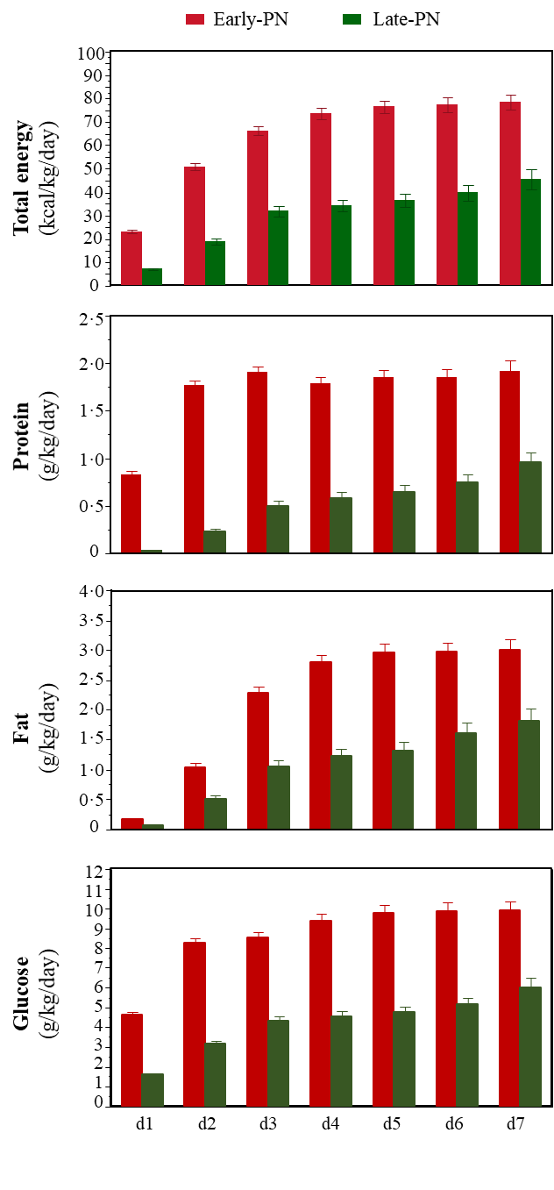
Daily amount of total energy in kcal/kg/day, and the daily amounts of total substrates in g/kg/day are shown for the first 7 days in the paediatric intensive care unit (PICU). Bars represent the mean and the whiskers represent the standard error of the mean (SEM). The red bars represent the early-PN group and the green bars represent the late-PN group.
Figure S2. Univariable analyses of the evolution of physical, emotional/behavioural and neurocognitive functions of former PICU patients versus healthy control children over time from 2- to 4-year follow-up

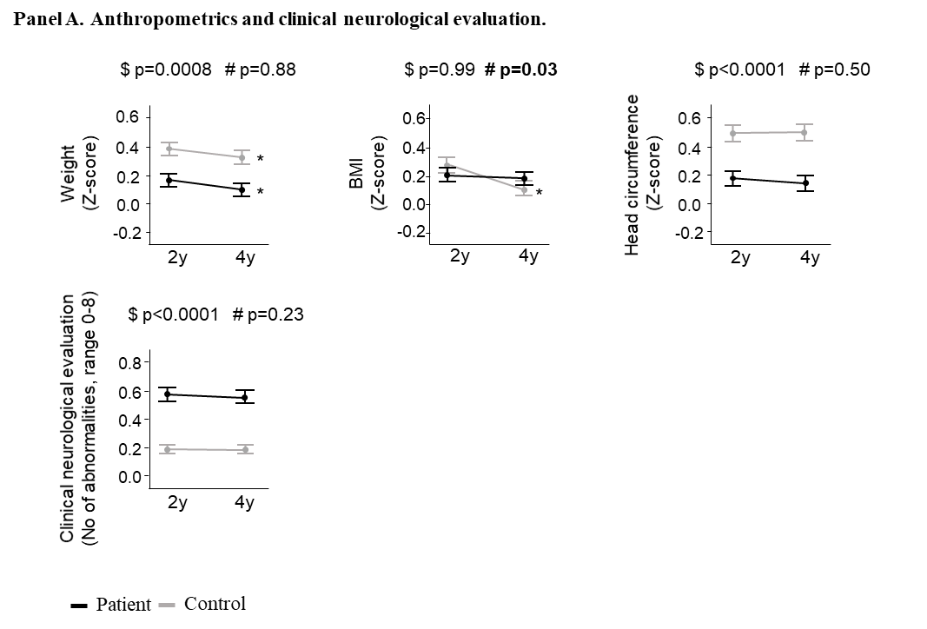

Results are presented as mean and standard error. For weight and head circumference, age- and gender-adjusted Z-scores were calculated with the use of reference data from the World Health Organisation Growth Charts.
For the clinical neurological evaluation score, higher scores reflect worse performance.
* p-value ≤0.05 for the univariable comparison of the evolution over time within former PICU patients or within healthy controls separately. $ group p-value for the univariable comparison between groups at both time points (former PICU patients and healthy children). # interaction p-value comparing the evolution over time between groups (former PICU patients versus healthy controls).
Abbreviations: BMI, body mass index; EF, executive functioning; emo/behav, emotional and behavioural.

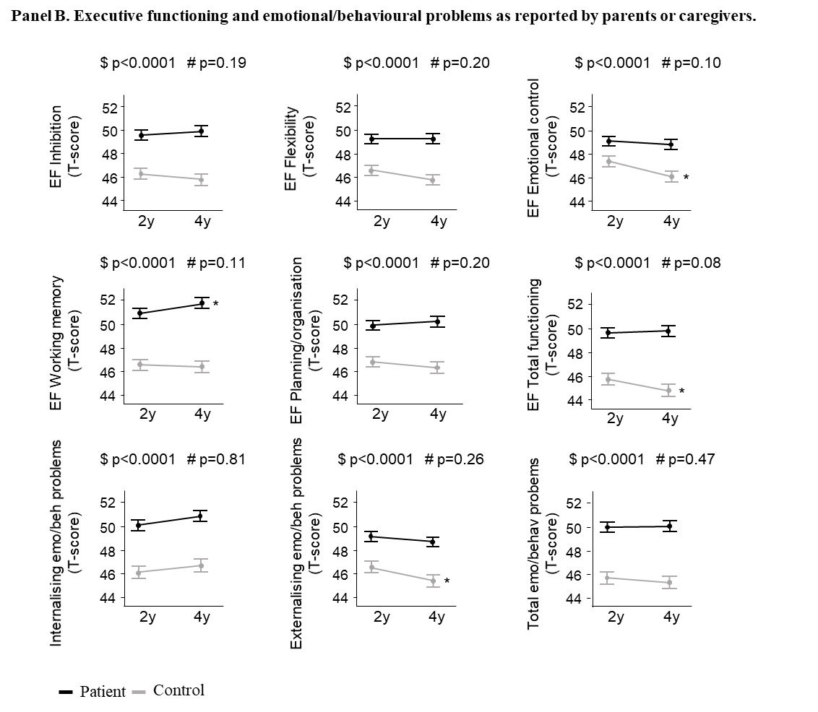

Results are presented as mean and standard error. For the parent- or caregiver-reported executive functioning and emotional/behavioural problems, higher scores reflect worse performance.
* p-value ≤0.05 for the univariable comparison of the evolution over time within former PICU patients or within healthy controls separately. $ group p-value for the univariable comparison between groups at both time points (former PICU patients and healthy children). # interaction p-value comparing the evolution over time between groups (former PICU patients versus healthy controls).
Abbreviations: EF, executive functioning; emo/behav, emotional and behavioural.

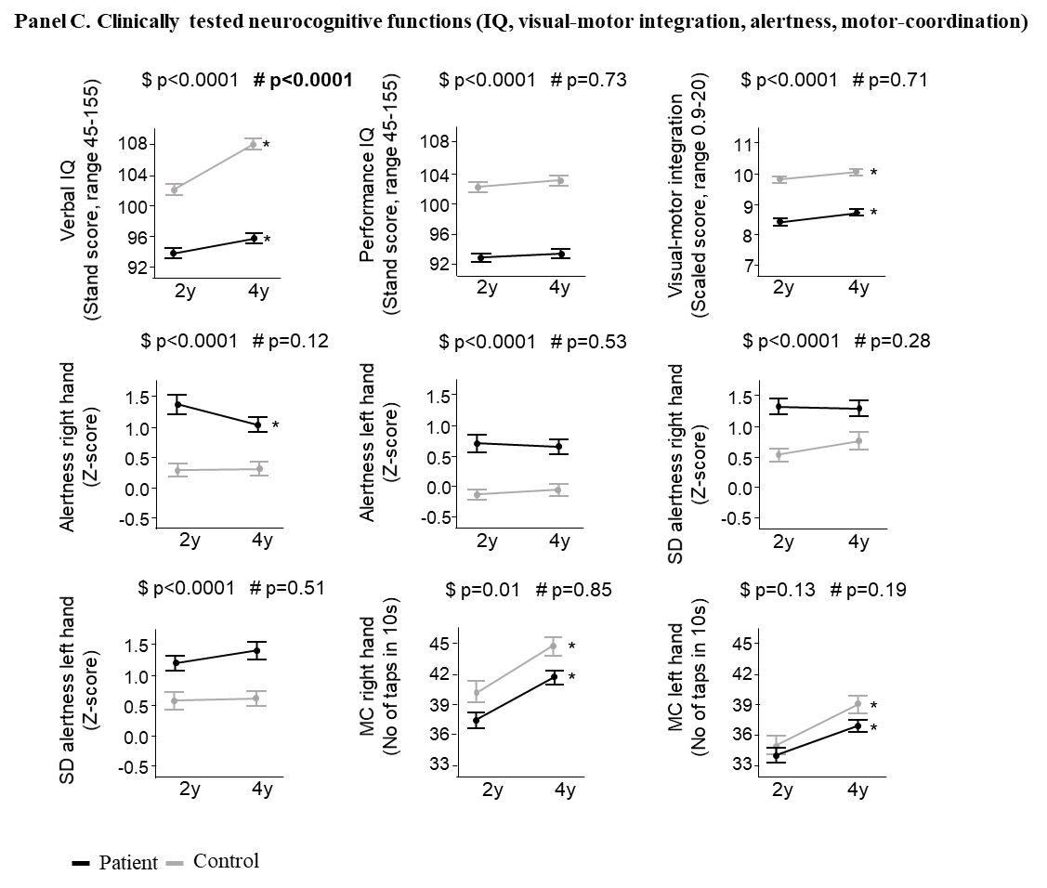

Results are presented as mean and standard error. For alertness and within-subject SD of repeated tests, higher scores reflect worse performance. For intelligence, visual-motor integration, motor-coordination and memory tests, higher scores reflect better performance.
* p-value ≤0.05 for the univariable comparison of the evolution over time within former PICU patients or within healthy controls separately. $ group p-value for the univariable comparison between groups at both time points (former PICU patients and healthy children). # interaction p-value comparing the evolution over time between groups (former PICU patients versus healthy controls).
Abbreviations: IQ, intelligence quotient; MC, motor-coordination; No, number; SD, standard deviation.

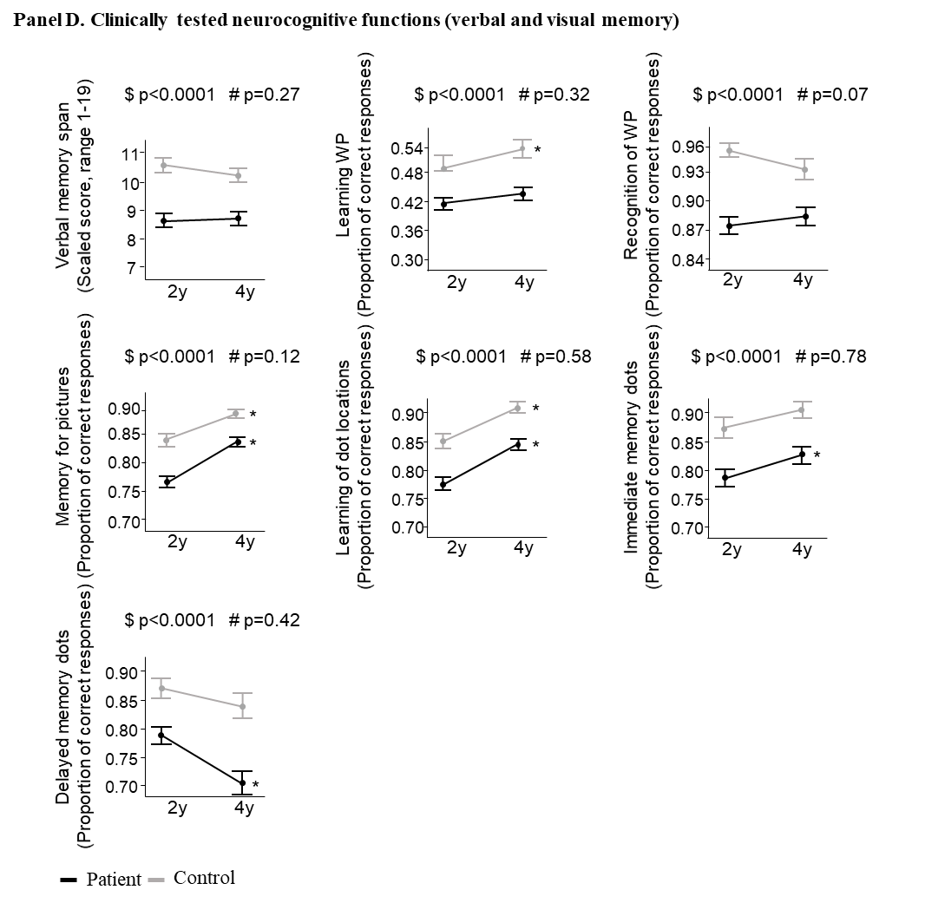

Results are presented as mean and standard error. For memory tests, higher scores reflect better performance.
* p-value ≤0.05 for the univariable comparison of the evolution over time within former PICU patients or within healthy controls separately. $ group p-value for the univariable comparison between groups at both time points (former PICU patients and healthy children). # interaction p-value comparing the evolution over time between groups (former PICU patients versus healthy controls).
Abbreviations: WP, word pairs.

Figure S3. Univariable analyses of the evolution of VMI, alertness and verbal memory for word pair recognition of former early-PN versus late-PN PICU patients over time from 2- to 4-year follow-up

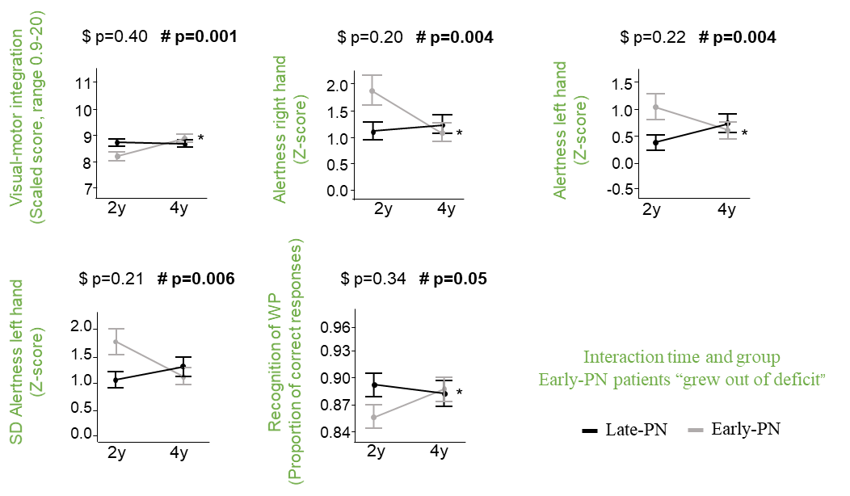
Results are presented as mean and standard error. Outcomes are shown for which an interaction between time (from 2- to 4-year follow-up) and group (former early-PN PICU patients versus former late-PN PICU patients) was documented.
For alertness and within-subject SD of repeated tests, higher scores reflect worse performance. For visual-motor integration, motor-coordination and the memory test recognition of word pairs, higher scores reflect better performance.
* p-value ≤0.05 for the univariable comparison of the evolution over time within former early-PN or late-PN PICU patients separately. $ group p-value for the univariable comparison between groups at both time points (former early-PN PICU patients and former late-PN PICU patients). # interaction p-value comparing the evolution over time between groups (former early-PN PICU patients versus former late-PN PICU patients).
Abbreviations: SD, standard deviation; WP, word pairs

SUPPLEMENTAL DIGITAL CONTENT TABLES

Table S1. Demographics and medical characteristics of former early-PN and late-PN PICU patients tested at 2- and 4-year follow-up
Demographics of participants and medical characteristics of patients | Former Early-PN  PICU patients  N=297 | Former Late-PN  PICU patients  N=317 | p-value
Demographics
Age at 2-year follow-up - median (IQR) - years | 3.3 (2.6-6.7) | 3.1 (2.6-6.5) | 0.72
- mean (SD) - years | 5.5 (4.3) | 5.3 (4.1)
Age at 4-year follow-up - median (IQR) - years | 5.2 (4.4-8.4) | 5.0 (4.4-8.5) | 0.61
- mean (SD) - years | 7.4 (4.3) | 7.2 (4.2)
Sex  Male - no (%) | 171 (57.6) | 182 (57.4) | 0.96
Female - no (%) | 126 (42.4) | 135 (42.6)
Known non-Caucasian raceª - no (%) | 30 (10.1) | 18 (5.7) | 0.04
Known non-European originª - no (%) | 64 (21.6) | 47 (14.8) | 0.03
Known not exclusive Dutch or English language - no (%) | 69 (23.2) | 69 (21.8) | 0.66
Socioeconomic status
Educational level parents^{b} |  |  | 0.94
Educational level 1 - no (%) | 37 (12.5) | 40 (12.6)
Educational level 2 - no (%) | 124 (41.8) | 137 (43.2)
Educational level 3 - no (%) | 85 (28.6) | 91 (28.7)
Educational level unknown - no (%) | 51 (17.2) | 49 (15.5)
Occupational level parents^{c} |  |  | 0.17
Occupational level 1 - no (%) | 24 (8.1) | 42 (13.3)
Occupational level 2 - no (%) | 85 (28.6) | 80 (25.2)
Occupational level 3 - no (%) | 80 (26.9) | 84 (26.5)
Occupational level 4 - no (%) | 42 (14.1) | 53 (16.7)
Occupational level unknown - no (%) | 66 (22.2) | 58 (18.3)
Patient characteristics upon PICU admission
Infant (age<1y) at randomisation - no (%) | 139 (46.8) | 155 (48.9) | 0.60
STRONGkids risk level^{d} |  |  | 0.68
Medium - no (%) | 265 (89.2) | 286 (90.2)
High - no (%) | 32 (10.8) | 31 (9.8)
PeLOD score, first 24h in PICU^{e} - mean (SD) | 19.8 (11.6) | 20.3 (11.4) | 0.77
PIM3 score^{f} – mean (SD) | -3.5 (1.4) | -3.5 (1.3) | 0.85
PIM3 probability of death^{g} (%) - mean (SD) | 6.7 (11.6) | 6.4 (11.6) | 0.85
Diagnostic category |  |  | 0.86
Surgical
Abdominal - no (%) | 28 (9.4) | 29 (9.2)
Burns - no (%) | 1 (0.3) | 1 (0.3)
Cardiac - no (%) | 126 (42.4) | 138 (43.5)
Neurosurgery-Traumatic brain injury - no (%) | 28 (9.4) | 23 (7.3)
Thoracic - no (%) | 20 (6.7) | 15 (4.7)
Transplantation - no (%) | 3 (1.0) | 7 (2.2)
Orthopaedic surgery-Trauma - no (%) | 12 (4.0) | 7 (2.2)
Other - no (%) | 8 (2.7) | 13 (4.1)
Medical
Cardiac - no (%) | 8 (2.7) | 14 (4.4)
Gastrointestinal-Hepatic - no (%) | 1 (0.3) | 1 (0.3)
Oncologic-Haematologic - no (%) | 2 (0.7) | 3 (1.0)
Neurologic - no (%) | 16 (5.4) | 19 (6.0)
Renal - no (%) | 0 (0.0) | 0 (0.0)
Respiratory - no (%) | 30 (10.1) | 34 (10.7)
Other - no (%) | 14 (4.7) | 13 (4.1)
Malignancy - no (%) | 21 (7.1) | 15 (4.7) | 0.21
Diabetes - no (%) | 0 (0.0) | 0 (0.0) | >0.99
Syndrome^{h} - no (%) | 24 (8.1) | 34 (10.7) | 0.26

ª Participants were classified according to race and geographical origin by the investigators. These classifications were performed to capture ethnical and regional differences in the frequency of consanguinity, which may adversely affect cognitive performance.
^{b} The educational level is the average of the paternal and maternal educational level, which were calculated based upon the 3-point scale subdivisions as made by the Algemene Directie Statistiek (Belgium; statbel.fgov.be/nl/) and the Centraal Bureau voor de Statistiek (The Netherlands; statline.cbs.nl): Low (=1), middle (=2) and high (=3) educational level (Supplemental Digital Content Methods S3).
^{c} The occupational level is the average of the paternal and maternal occupational level, which is calculated based upon the International Isco System 4-point scale for professions (Supplemental Digital Content Methods S3).
^{d} Scores on the Screening Tool for Risk on Nutritional Status and Growth (STRONGkids) range from 0 to 5, with a score of 0 indicating a low risk of malnutrition, a score of 1 to 3 indicating medium risk, and a score of 4 to 5 indicating high risk.
^{e} Paediatric Logistic Organ Dysfunction (PeLOD) scores range from 0 to 71, with higher scores indicating more severe illness.
^{f} Paediatric Index of Mortality 3 (PIM3) scores, with higher scores indicating a higher risk of mortality.
^{g} Paediatric Index of Mortality 3 (PIM3) probability of death.
^{h} A pre-randomisation syndrome or illness a priori defined as affecting or possibly affecting neurocognitive development (Supplemental Digital content Methods S2).
Abbreviations: IQR, interquartile range; NA, not applicable; no, number; PeLOD, paediatric logistic organ dysfunction score; PICU, paediatric intensive care unit; PIM3, paediatric index of mortality 3 score; PN, parenteral nutrition; SD, standard deviation.

Table S2. Number of available data per outcome prior to imputation at 2- and 4-year follow-up

Outcomes assessed at 2- and 4-year follow-up | No available data per outcome | No (%) available data per outcome prior to imputation at 2-year follow-up | No (%) available data per outcome prior to imputation at 4-year follow-up
Anthropometrics and physical examination
Height | 941 | 893 (94.9%) | 909 (96.6%)
Weight | 941 | 900 (95.6%) | 903 (96.0%)
BMI | 941 | 892 (94.8%) | 902 (95.9%)
Head circumference | 971 | 855 (88.1%) | 907 (93.4%)
Clinical neurological evaluation (range, 0-8) | 971 | 923 (95.1%) | 900 (92.7%)
Executive functioning as reported by parents or caregivers (T-score)
Inhibition | 941 | 708 (75.2%) | 822 (87.4%)
Flexibility | 941 | 709 (75.3%) | 822 (87.4%)
Emotional control | 941 | 708 (75.2%) | 822 (87.4%)
Working memory | 941 | 704 (74.8%) | 822 (87.4%)
Planning and organisation | 941 | 706 (75.0%) | 821 (87.2%)
Meta-cognition | 941 | 702 (74.6%) | 820 (87.1%)
Total score | 941 | 701 (74.5%) | 820 (87.1%)
Emotional/behavioural problems as reported by parents or caregivers (T-score)
Internalising problems | 941 | 839 (89.2%) | 838 (89.1%)
Externalising problems | 941 | 839 (89.2%) | 838 (89.1%)
Total problems | 941 | 839 (89.2%) | 838 (89.1%)
Clinical neurocognitive tests
Intelligence (range, 45-155)
Total IQ | 971 | 898 (92.5%) | 872 (89.8%)
Verbal IQ | 971 | 892 (91.2%) | 862 (91.6%)
Performance IQ | 971 | 898 (92.5%) | 874 (90.0%)
Visual-motor integration (range, 0.9-20) | 971 | 907 (93.4%) | 944 (97.2%)
Alertness and motor coordination
Alertness (Z-score)
Reaction time right hand | 418 | 340 (81.3%) | 330 (78.9%)
Within subject SD of repeated tests | 418 | 340 (81.3%) | 330 (78.9%)
Reaction time left hand | 418 | 343 (82.1%) | 331 (79.2%)
Within subject SD of repeated tests | 418 | 343 (82.1%) | 331 (79.2%)
Motor coordination (No of taps in 10s)
No of unimanual taps
Right hand | 418 | 353 (84.4%) | 337 (80.6%)
Left hand | 418 | 353 (84.4%) | 337 (80.6%)
No of valid alternating taps | 418 | 320 (76.6%) | 316 (75.6%)
No of valid synchronous taps | 418 | 341 (81.6%) | 334 (79.9%)
Memory
Verbal-auditory
Numbers (range, 1-19)
Memory span (forward) | 286 | 248 (86.7%) | 240 (83.9%)
Working memory (backward) | 286 | 236 (82.5%) | 239 (83.6%)
Word pairs (proportion of correct responses)
Learning | 286 | 219 (76.6%) | 237 (82.9%)
Immediate memory | 286 | 217 (75.9%) | 207 (72.4%)
Delayed memory | 286 | 215 (75.2%) | 204 (71.3%)
Recognition | 286 | 213 (74.5%) | 204 (71.3%)
Non-verbal, visual-spatial
Pictures (proportion of correct responses) | 286 | 242 (84.6%) | 234 (81.8%)
Dots (proportion of correct responses)
Learning | 286 | 235 (82.2%) | 220 (76.9%)
Immediate memory | 286 | 335 (82.2%) | 220 (76.9%)
Delayed memory | 286 | 231 (80.8%) | 214 (74.8%)
Learning index (range, 50-150) | 286 | 214 (74.8%) | 203 (71.0%)

Inability to fully complete the neurocognitive test battery may indicate poor neurocognitive function and introduce bias. Therefore, as previously described (11,12), multiple-data-imputation-by-chained-equations was performed to correctly address partial responses (13). To avoid bias and instability in this imputation model, the percentage of missing data per variable could not exceed 30% and thus the number of iterative imputations was set at 31 (13). The following table indicates the number of available data prior to imputation.
Abbreviations: BMI, body mass index; IQ, intelligence quotient; No, number.

Table S3. Multivariable analyses of the evolution of physical, emotional/behavioural and neurocognitive functions of former early-PN versus late-PN PICU patients over time from 2- to 4-year follow-up

Outcomes assessed at 2- and 4-year follow-upª | No available data per outcome | β-estimate (95% CI) - difference in scores “delta” adjusted for risk factors | p-value
Anthropometrics^{b} and physical examination
Height (Z-score) | 941 | -0.02 (-0.08 to 0.04) | 0.44
Weight (Z-score) | 941 | -0.06 (-0.11 to 0.00) | 0.05
BMI (Z-score) | 941 | -0.04 (-0.12 to 0.04) | 0.29
Head circumference (Z-score) | 971 | -0.05 (-0.12 to 0.02) | 0.17
Clinical neurological evaluation (range, 0-8) | 971 | -0.01 (-0.03 to 0.01) | 0.47
Executive functioning as reported by parents or caregivers (T-score)
Inhibition | 941 | -0.64 (-1.45 to 0.16) | 0.11
Flexibility | 941 | 0.39 (-0.43 to 1.21) | 0.34
Emotional control | 941 | 0.48 (-0.34 to 1.29) | 0.25
Working memory | 941 | -0.17 (-1.00 to 0.66) | 0.68
Planning and organisation | 941 | -0.10 (-0.93 to 0.74) | 0.81
Meta-cognition | 941 | -0.42 (-1.26 to 0.41) | 0.31
Total score | 941 | -0.17 (-0.99 to 0.64) | 0.67
Emotional/behavioural problems as reported by parents or caregivers (T-score)
Internalising problems | 941 | 0.54 (-0.31 to 1.39) | 0.22
Externalising problems | 941 | 0.15 (-0.62 to 0.93) | 0.69
Total problems | 941 | 0.64 (-0.17 to 1.44) | 0.11
Clinical neurocognitive tests
Intelligence (range, 45-155)
Total IQ | 971 | 0.29 (-0.62 to 1.19) | 0.53
Verbal IQ | 971 | 0.09 (-0.95 to 1.13) | 0.86
Performance IQ | 971 | 0.39 (-0.61 to 1.39) | 0.44
Visual-motor integration (range, 0.9-20) | 971 | 0.31 (0.10 to 0.52) | 0.004
Alertness and motor coordination
Alertness (Z-score)^{c}
Reaction time right hand | 418 | -0.40 (-0.72 to -0.08) | 0.01
Within subject SD of repeated tests | 418 | -0.21 (-0.54 to 0.11) | 0.20
Reaction time left hand | 418 | -0.37 (-0.67 to -0.07) | 0.01
Within subject SD of repeated tests | 418 | -0.44 (-0.78 to -0.10) | 0.01
Motor coordination (No of taps in 10s)
No of unimanual taps
Right hand | 418 | 0.50 (-0.61 to 1.61) | 0.37
Left hand | 418 | 0.98 (-0.13 to 2.09) | 0.08
No of valid alternating taps | 418 | 1.03 (-1.34 to 3.39) | 0.39
No of valid synchronous taps | 418 | 0.56 (-0.78 to 1.89) | 0.41
Memory
Verbal-auditory
Numbers (range, 1-19)
Memory span (forward) | 286 | 0.33 (-0.17 to 0.83) | 0.19
Working memory (backward) | 286 | 0.02 (-0.47 to 0.51) | 0.94
Word pairs (proportion correct responses)
Learning | 286 | 0.01 (-0.02 to 0.05) | 0.35
Immediate memory | 286 | 0.02 (-0.01 to 0.06) | 0.14
Delayed memory | 286 | 0.01 (-0.01 to 0.04) | 0.41
Recognition | 286 | 0.01 (-0.01 to 0.03) | 0.21
Non-verbal, visual-spatial
Pictures (proportion of correct responses) | 286 | -0.01 (-0.04 to 0.01) | 0.20
Dots (proportion of correct responses)
Learning | 286 | -0.01 (-0.04 to 0.01) | 0.23
Immediate memory | 286 | -0.00 (-0.04 to 0.04) | 0.97
Delayed memory | 286 | -0.00 (-0.05 to 0.05) | 0.96
Learning index (range, 50-150) | 286 | 0.69 (-2.33 to 3.71) | 0.65

The “delta” of scores for the different tests was calculated as the score at 4-year follow-up minus the score at 2-year follow-up. Outcomes with p-values in green represent an improvement in patients as compared with healthy controls or in early-PN patients as compared with late-PN PICU patients over time, outcomes with p-values in red represent a worsening in patients as compared with healthy controls or in early-PN patients as compared with late-PN PICU patients over time.
ª For the clinical neurological evaluation score, higher scores reflect worse performance. For parent-reported executive functioning and emotional and behavioural problems, higher scores reflect worse performance. For intelligence and visual-motor integration, higher scores reflect better performance. For alertness and within-subject SD of repeated tests, higher scores reflect worse performance. For motor coordination, higher scores reflect better performance. For memory tests, higher scores reflect better performance.
^{b} Age- and gender-adjusted Z-scores were calculated with the use of reference data from the World Health Organisation Growth Charts.
^{c} Age-adjusted Z-scores were calculated.
Abbreviations: BMI, body mass index; CI, confidence interval; IQ, intelligence quotient; No, number; PICU, paediatric intensive care unit; PN, parenteral nutrition, SD, standard deviation.

References
1 Van der Heijden KB, Suurland J, De Sonneville LM, et al: BRIEF-P Vragenlijst voor executieve functies voor 2- tot 5-jarigen: Handleiding. Amsterdam: Hogrefe, 2013
2 Huizinga M, Smidts D: BRIEF Vragenlijst executieve functies voor 5- tot 18-jarigen: Handleiding. Amsterdam: Hogrefe, 2012
3 Achenbach TM, Rescorla LA: Manual for the ASEBA Preschool Forms and Profiles. Burlington: University of Vermond, Research Center for Children, Youth and Families, 2000
4 Verhulst FC, Van der Ende J: Handleiding ASEBA. Vragenlijsten voor leeftijd van 6 tot en met 18 years [ASEBA Manual Questionnaires for ages 6 to 18 years]. Rotterdam: ASEBA Nederland, 2013
5 Hendriksen J, Hurks P: WPPSI-III-NL Wechsler Preschool and Primary Scale of Intelligence: Handleiding. Amsterdam: Pearson, 2010
6 Wechsler D: WISC-III Nederlandstalige bewerking. Handleiding. Amsterdam: Pearson, 2005
7 Wechsler D: WAIS-III Nederlandstalige bewerking. Afname en Scoringshandleiding. Amsterdam: Pearson, 2012
8 Beery KE, Buktenica NA, Beery NA: The Beery-Buktenica Developmental Test of Visual-Motor Integration, 6th edition (BEERYTM VMI). Amsterdam: Pearson, 2010
9 De Sonneville L: Handboek Amsterdamse Neuropsychologische Taken. Amsterdam: Boom test uitgevers, 2014
10 Cohen MJ: Children's Memory Scale Manual. Bloomington, MN: Pearson, 1997
11 Verstraete S, Verbruggen SC, Hordijk JA, et al: Long-term developmental effects of withholding parenteral nutrition for 1 week in the paediatric intensive care unit: a 2-year follow-up of the PEPaNIC international. randomised. controlled trial. Lancet Respir Med 2019; 7:141-153
12 Jacobs A, Dulfer K, Eveleens R, et al: Long-term developmental impact of withholding parenteral nutrition in paediatric-ICU: a 4-year follow-up of the PEPaNIC randomised controlled trial. Lancet Child Adolesc Health 2020; 7:503-514
13 Wulff J JL: Multiple imputation by chained equations in praxis: guidelines and review. Electron J Bus Res Methods 2017; 15:41-56

