Supplemental Materials
Pharmacogenomic Testing
The GeneSight Psychotropic test included evaluation of genotypes for 58 alleles and variants across 8 genes (CYP1A2: 3497G>A, 2499A>T, 558C>A, 5166G>A, -2467T>delT, 5347C>T, 2473G>A, 5090C>T, -163C>A, 125C>G, 3533G>A, 2116G>A, -739T>G, 729C>T, -3860G>A,; CYP2C9: *1, *2, *3, *4, *5, *6; CYP2C19: *1, *2, *3, *4, *5, *6, *7, *8, *17; CYP3A4: *1, *13, *15A, *22; CYP2B6: *1, *4, *6, *9; CYP2D6: *1, *2, *2A, *3, *4, *5, *6, *7, *8, *9, *10, *11, *12, *14, *15, *17, *41, gene duplication; HTR2A: rs7997012 (-1438 G >A); SLC6A4: 44 bp promoter indel (5-HTTLPR). Psychotropic medications included antidepressants, and antipsychotics. The GeneSight ADHD test included evaluation of the genotypes of 20 alleles and variants across 3 genes (ADRA2A: -1291C>G; COMT: Val158Met; CYP2D6: *1, *2, *2A, *3, *4, *5, *6, *7, *8, *9, *10, *11, *12, *14, *15, *17, *41, gene duplication. As a laboratory developed test, it has not been approved by the U.S. Food and Drug Administration.

Supplemental Figure 1. Demographics and drug concentration/dose for each medication type.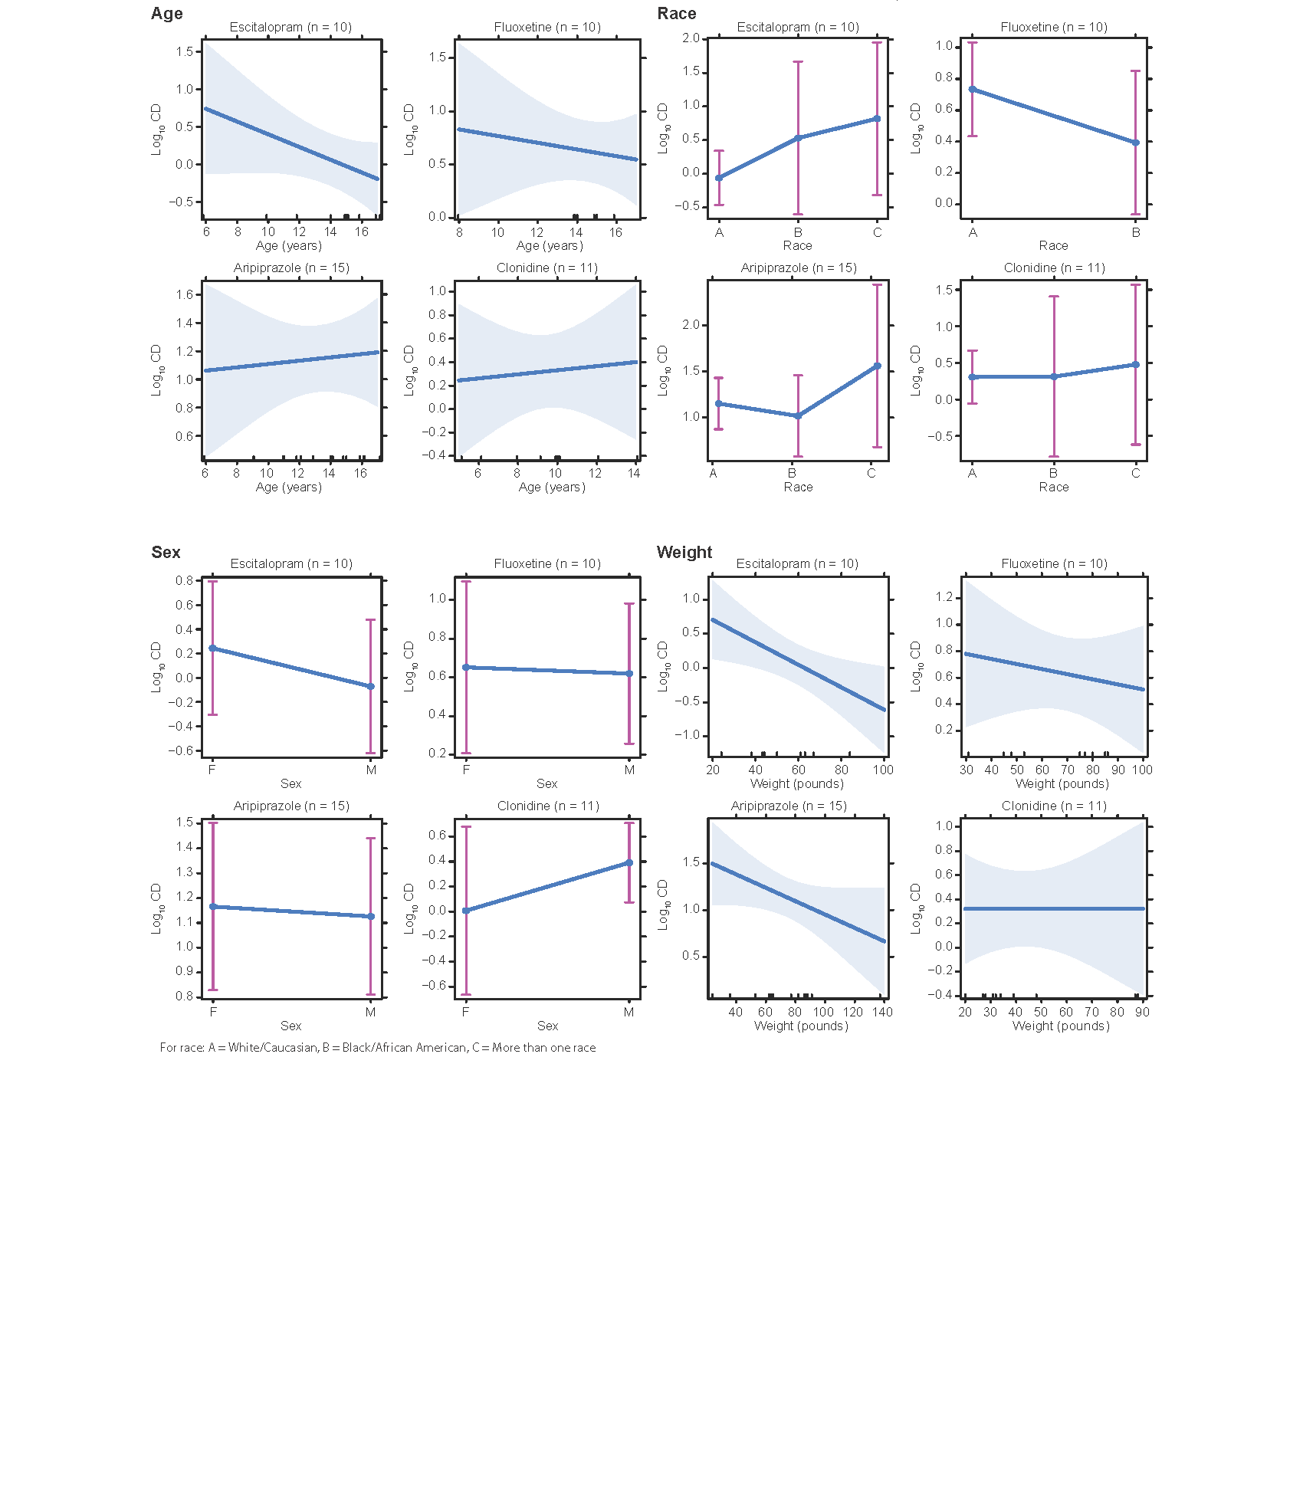

Supplemental Table 1. Prescription and blood-drug measurement frequency by medication
Medication | Panel | Prescription Frequency (N†, %) | Blood-Drug Measurements  (N)
Amitriptyline | Psychotropic | 2 (1%) | 0
Aripiprazole | Psychotropic | 23 (11.3%) | 15
Atomoxetine | ADHD | 2 (1%) | 1
Bupropion | Psychotropic | 6 (2.9%) | 0
Citalopram | Psychotropic | 3 (1.5%) | 1
Clonidine | ADHD | 19 (9.3%) | 11
Dexmethylphenidate | ADHD | 6 (2.9%) | 0
Duloxetine | Psychotropic | 5 (2.5%) | 2
Escitalopram | Psychotropic | 19 (9.3%) | 10
Fluoxetine | Psychotropic | 18 (8.8%) | 10
Guanfacine | ADHD | 10 (4.9%) | 3
Haloperidol | Psychotropic | 1 (0.5%) | 1
Lisdexamphetamine | ADHD | 9 (4.4%) | 0
Lurasidone | Psychotropic | 1 (0.5%) | 0
Methylphenidate | ADHD | 21 (10.3%) | 0
Mirtazapine | Psychotropic | 1 (0.5%) | 0
Olanzapine | Psychotropic | 3 (1.5%) | 2
Paliperidone | Psychotropic | 1 (0.5%) | 0
Quetiapine | Psychotropic | 4 (2%) | 1
Risperidone | Psychotropic | 10 (4.9%) | 1
Sertraline | Psychotropic | 21 (10.3%) | 6
Thioridazine | Psychotropic | 1 (0.5%) | 0
Thiothixene | Psychotropic | 1 (0.5%) | 0
Trazodone | Psychotropic | 11 (5.4%) | 2
Venlafaxine | Psychotropic | 4 (2%) | 2
Vortioxetine | Psychotropic | 1 (0.5%) | 0
†N indicates the number of patients taking a given medication, patients could be taking more than 1 medication.

