Supplemental Digital Content 2. Home training program V1* (weekly training of the quadriceps and hamstrings & evaluation methods)
D1: Training session | Isometric FES training of quadriceps and hamstrings  Intensity is increased until a muscle contraction of 4/5 MRC  5 sets of 12 to 15 contractions 5s ON, 5s OFF with a 2 min rest between sets  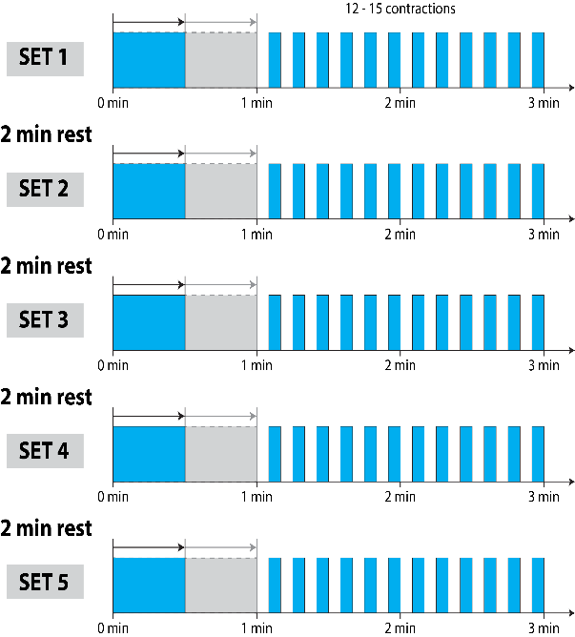 | 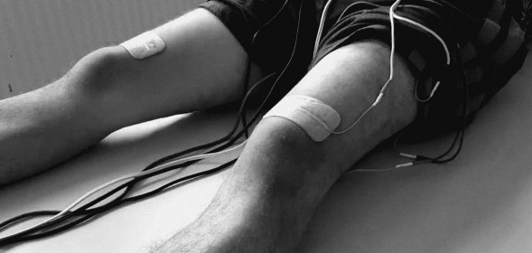  Patient’s positioning: supine position  Each contraction = 1 s: Intensity increases (0 mA –>I_{max}) 3 s: Stimulation at I_{max} 1 s: Intensity decreases (I_{max} -> 0 mA) 5 s: Rest  After each set, XX was allowed to increase the stimulation intensity to counteract fatigue and maintain a strong contraction.  As a precaution, it was recommended that the intensity not be increased by more than 40 mA during a single session.
D2: Rest
D3: Training session
D4: Rest
D5: Training session
D6: Rest
D7: Evaluation session | Evaluation session of both quadriceps  Intensity is increased until a muscle contraction of 4/5 MRC  5 sets of 10 contractions /2min rest between sets  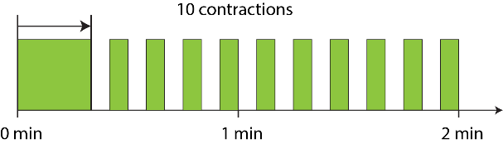 | 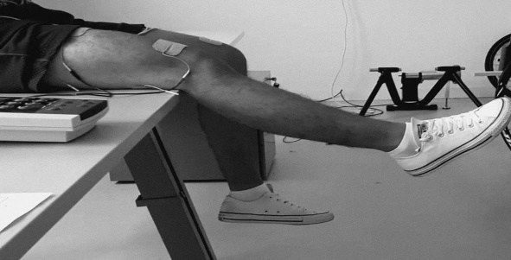  Patient’s positioning: sitting position  The minimum intensity required to produce muscle strength of 4/5 MRC in each quadriceps is noted by the subject on a dedicated sheet  This stimulation intensity served as an initial intensity for the training of the following week.
D 1: …D7: …
Devices and parameters used
- Portable stimulator CEFAR Physio 4®
- 4 cables and electrodes (left Q, right Q, left H and right H)
Parameters of stimulation: Rectangular biphasic current pulses, 1 sec rising and 1 sec descending ramp, frequency 30Hz, pulse duration: 450µs, stimulation trains: 5 sec, rest time: 5 sec.
W, Week; HR, Q, Quadriceps; H, Hamstrings; mA, milliAmperes; MRC, Medical Research Council. *Phase V1: Three 20 to 30-minute resistance training sessions per week with a 48h rest between sessions and one evaluation session per week

