Supplemental Digital Content 3. Home training program V2*-V3** (weekly resistance training on the ergocycle & evaluation methods)
D 1: Training session | 10’ Warm-up (30 Hz) | FES-cycling training (60 Hz)  - The participant starts arm-cranking to initiate movement with a resistance set to the level determined during the evaluation test  - The participant gradually increases intensity until autonomous cycling (without arms) is achieved.  - Initial stimulation intensity should be similar to the initial intensity of the previous session  - Intensity can be increased to obtain efficient contractions for an active cycling. Intensity is adjusted as required (i.e. if muscular fatigue occurs) up to the maximum. | - If this is not enough to sustain cycling for 20-30min, cycling should be supported by the arms, just enough to maintain movement. The main load should be performed by the legs.  - If after 30min of cycling, it is still possible to cycle, increasing the resistance by one level every 5 minutes is recommended.
D 2: Rest
D 3: Training session | 10’ Warm-up (30 Hz)
D 4: Rest
D 5: Training session | 10’ Warm-up (30 Hz)
D 6: Rest
D 7: Evaluation session | 5’ Warm-up (30 Hz) | Evaluation test (60Hz)  - The participant starts arm-cranking to initiate movement with a resistance set up at level 1.  - The participant increases intensity until cycling without arms is achieved. | After each minute of active cycling,  - Resistance is increased by one level.  - Stimulation intensity is adjusted as required (i.e. if muscular fatigue occurs) up to the maximum.  The test stops when active cycling (without arms) is no longer possible.
D 1: …D7 :…
Warm-up modalities |  | Devices and parameters used | Patient’s positioning: sitting position on a wheelchair attached to the ergocycle)
- The participant starts arm-crank training on the ergocycle.  - The stimulation intensity that triggers a 1/5 MRC muscular contraction is set up. Legs are moved passively during this time, helped by the upper limbs.  - Resistance and cycling speed are adjusted to meet the targeted HR of 60 to 70% of the HR max (aerobic zone) |  | - Ergocycle Berkelbike Fitness®  - Portable stimulator BERKELBIKE FES Box® with 8 cables and electrodes (left Q, right Q, left H and right H)  - BerkelBike cycling software -Berkelbike BV The Netherlands-.  Parameters of stimulation: Biphasic rectangular current pulses, frequency 30Hz (warm-up) or 60Hz (evaluation test and training), pulse duration: 450µs, Maximal intensity: 120mA. Stimulation steps (button click) = 3mA. Resistance levels: 8,7, 6, 5, 4, 3, 2, 1 (8 = the strongest resistance) Pattern: Original Berkelbike pattern | 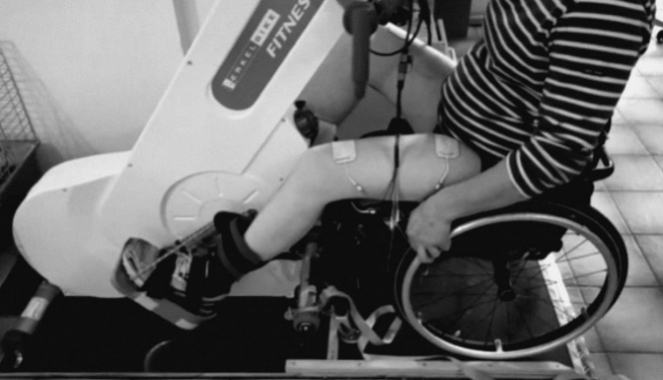
D, Day; W, Week; HR, Heart Rate; Q, Quadriceps; H, Hamstrings; mA, milliAmperes; MRC, Medical Research Council. *Phase V2: Three 30-minute resistance training sessions per week with a 48h rest between sessions; **Phase V3: Two to four resistance training sessions per week with a 24 to 48h rest between sessions

