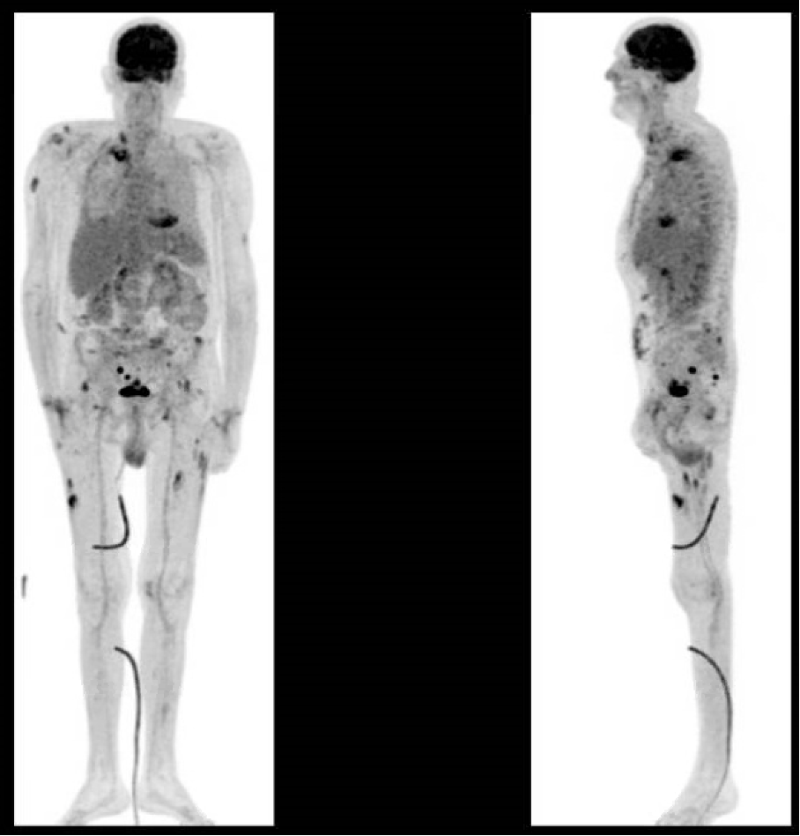

Supplementary Digital Content 2: FDG PET-scanner found cutaneous and sub-cutaneous calcium deposit moderately hypermetabolic, and focal hypermetabolic rectal lesion

