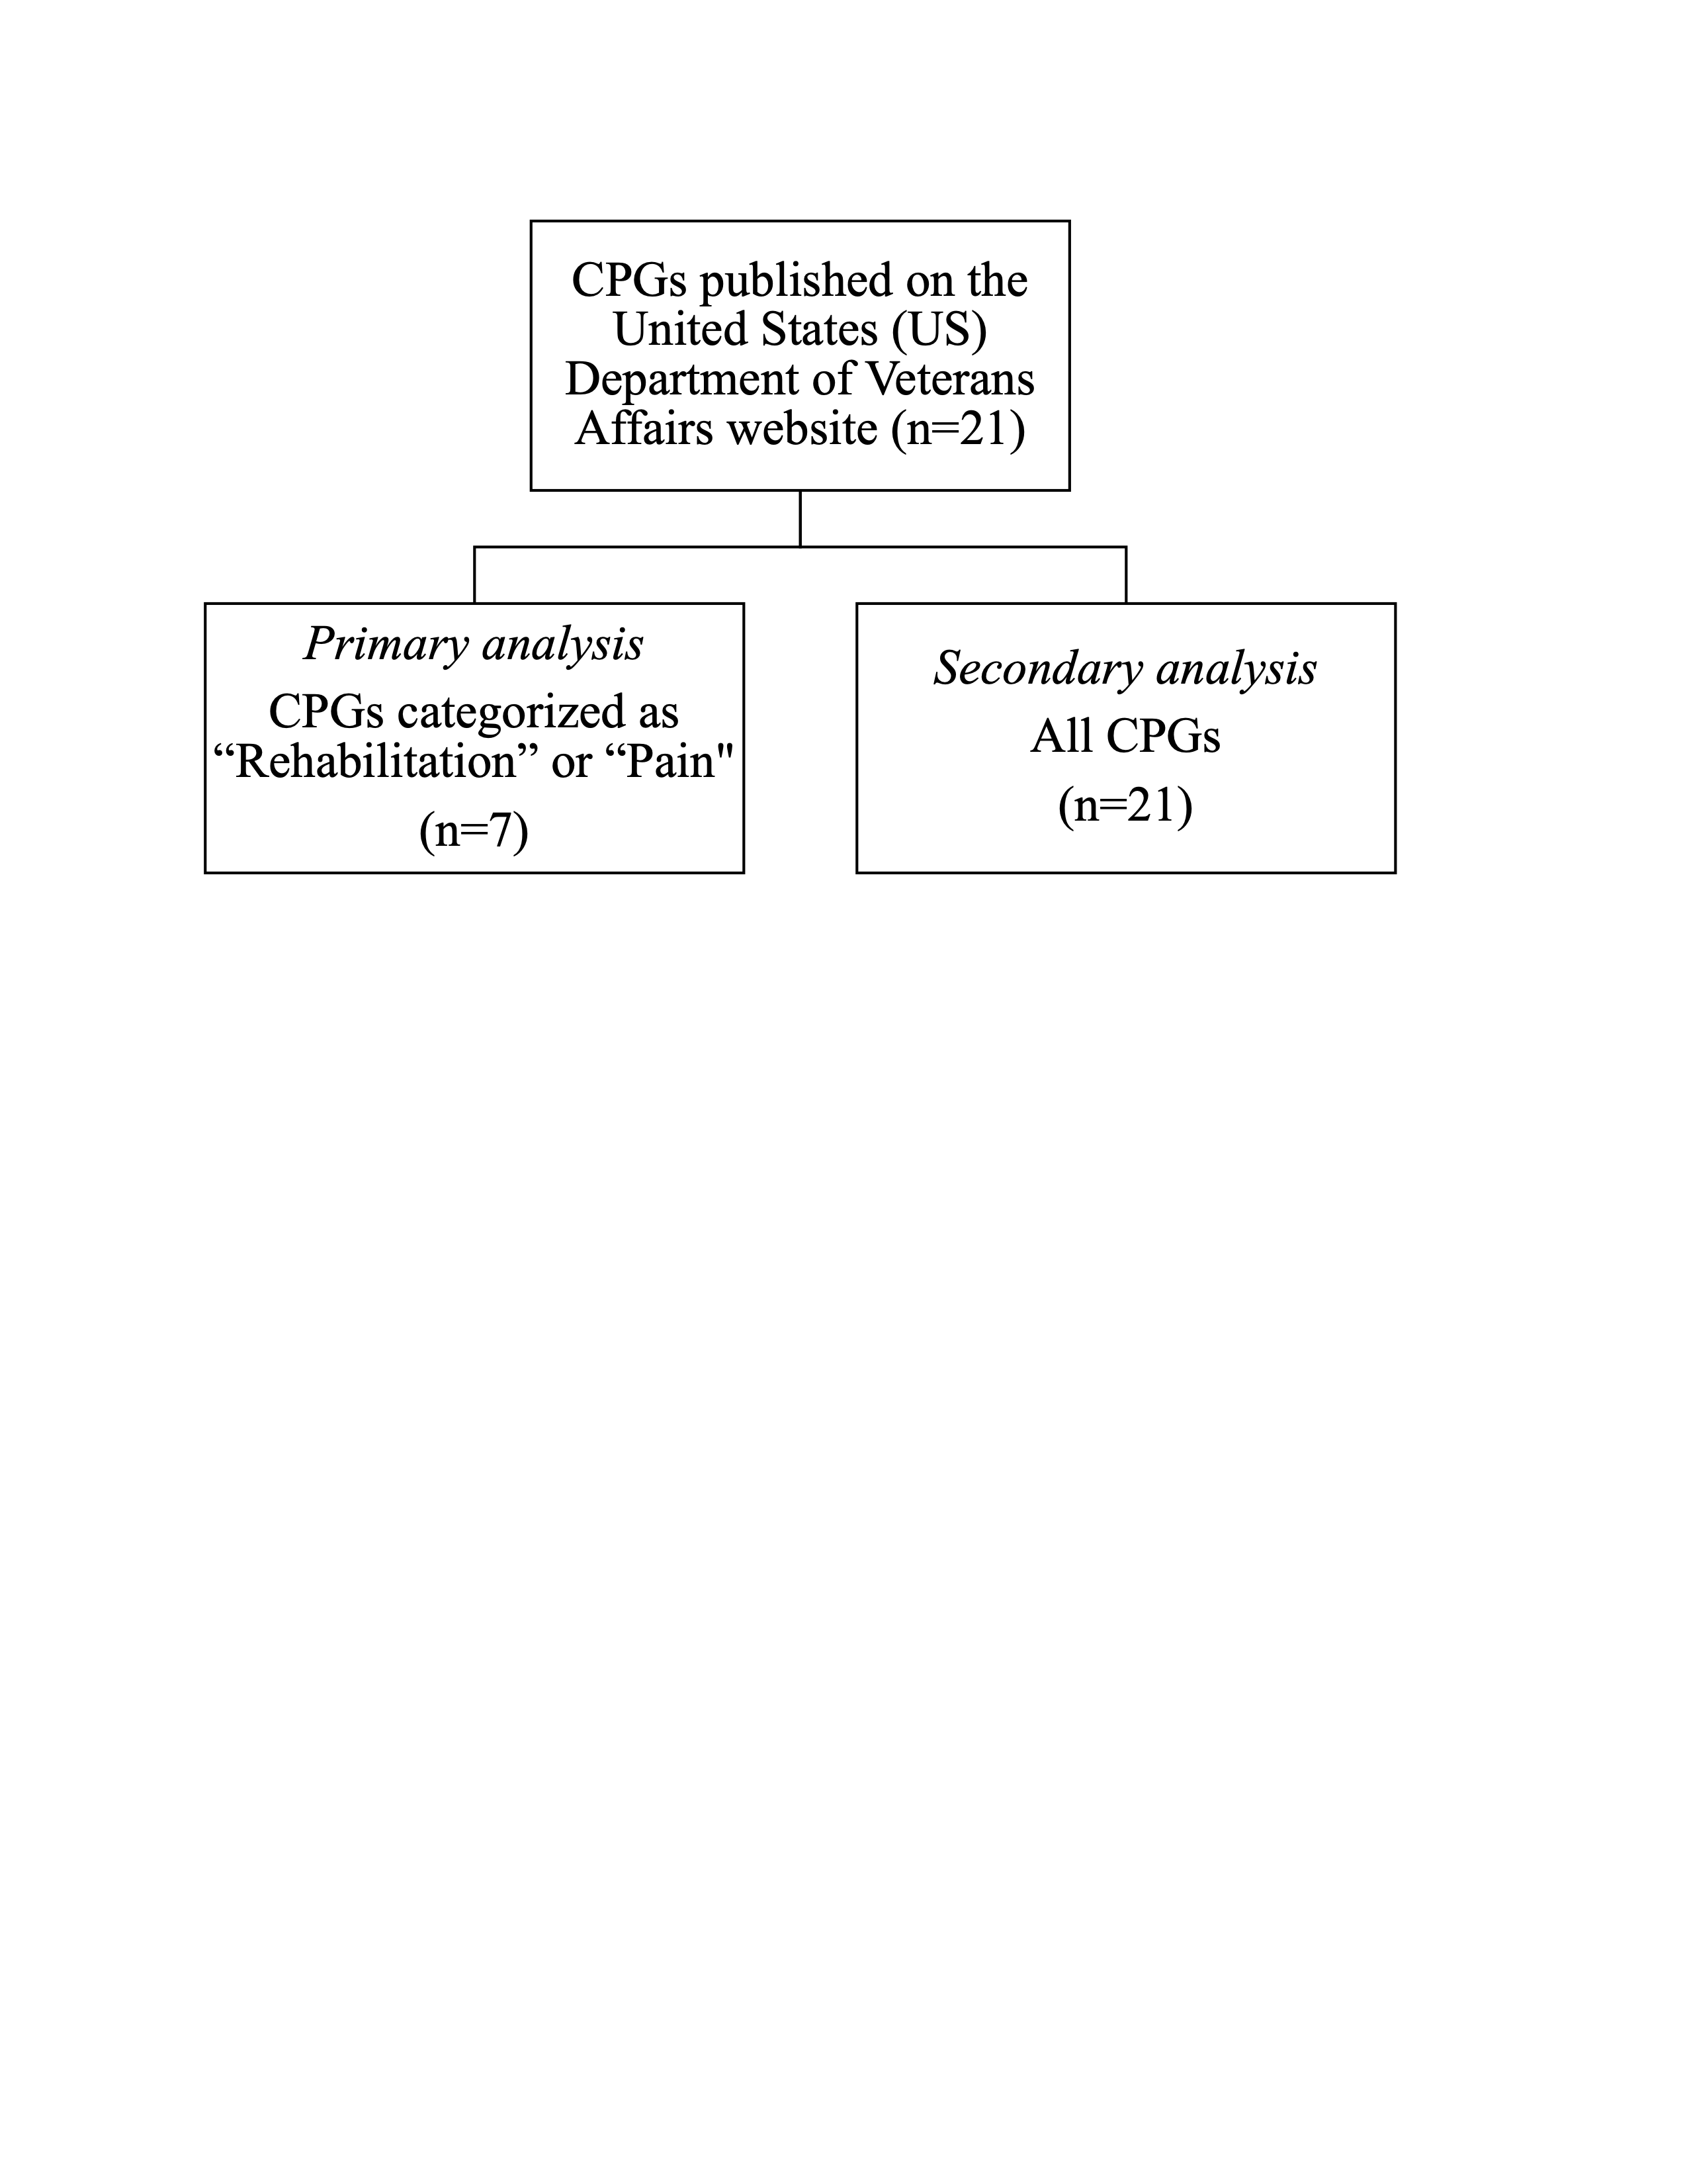
Appendix Figure A. Veterans Affairs Clinical Practice Guidelines by Analysis Type. Legend:
Clinical Practice Guidelines (CPGs) selected for the primary and secondary analysis on the Department of Veterans Affairs website accessed March 2021: https://www.healthquality.va.gov/.

