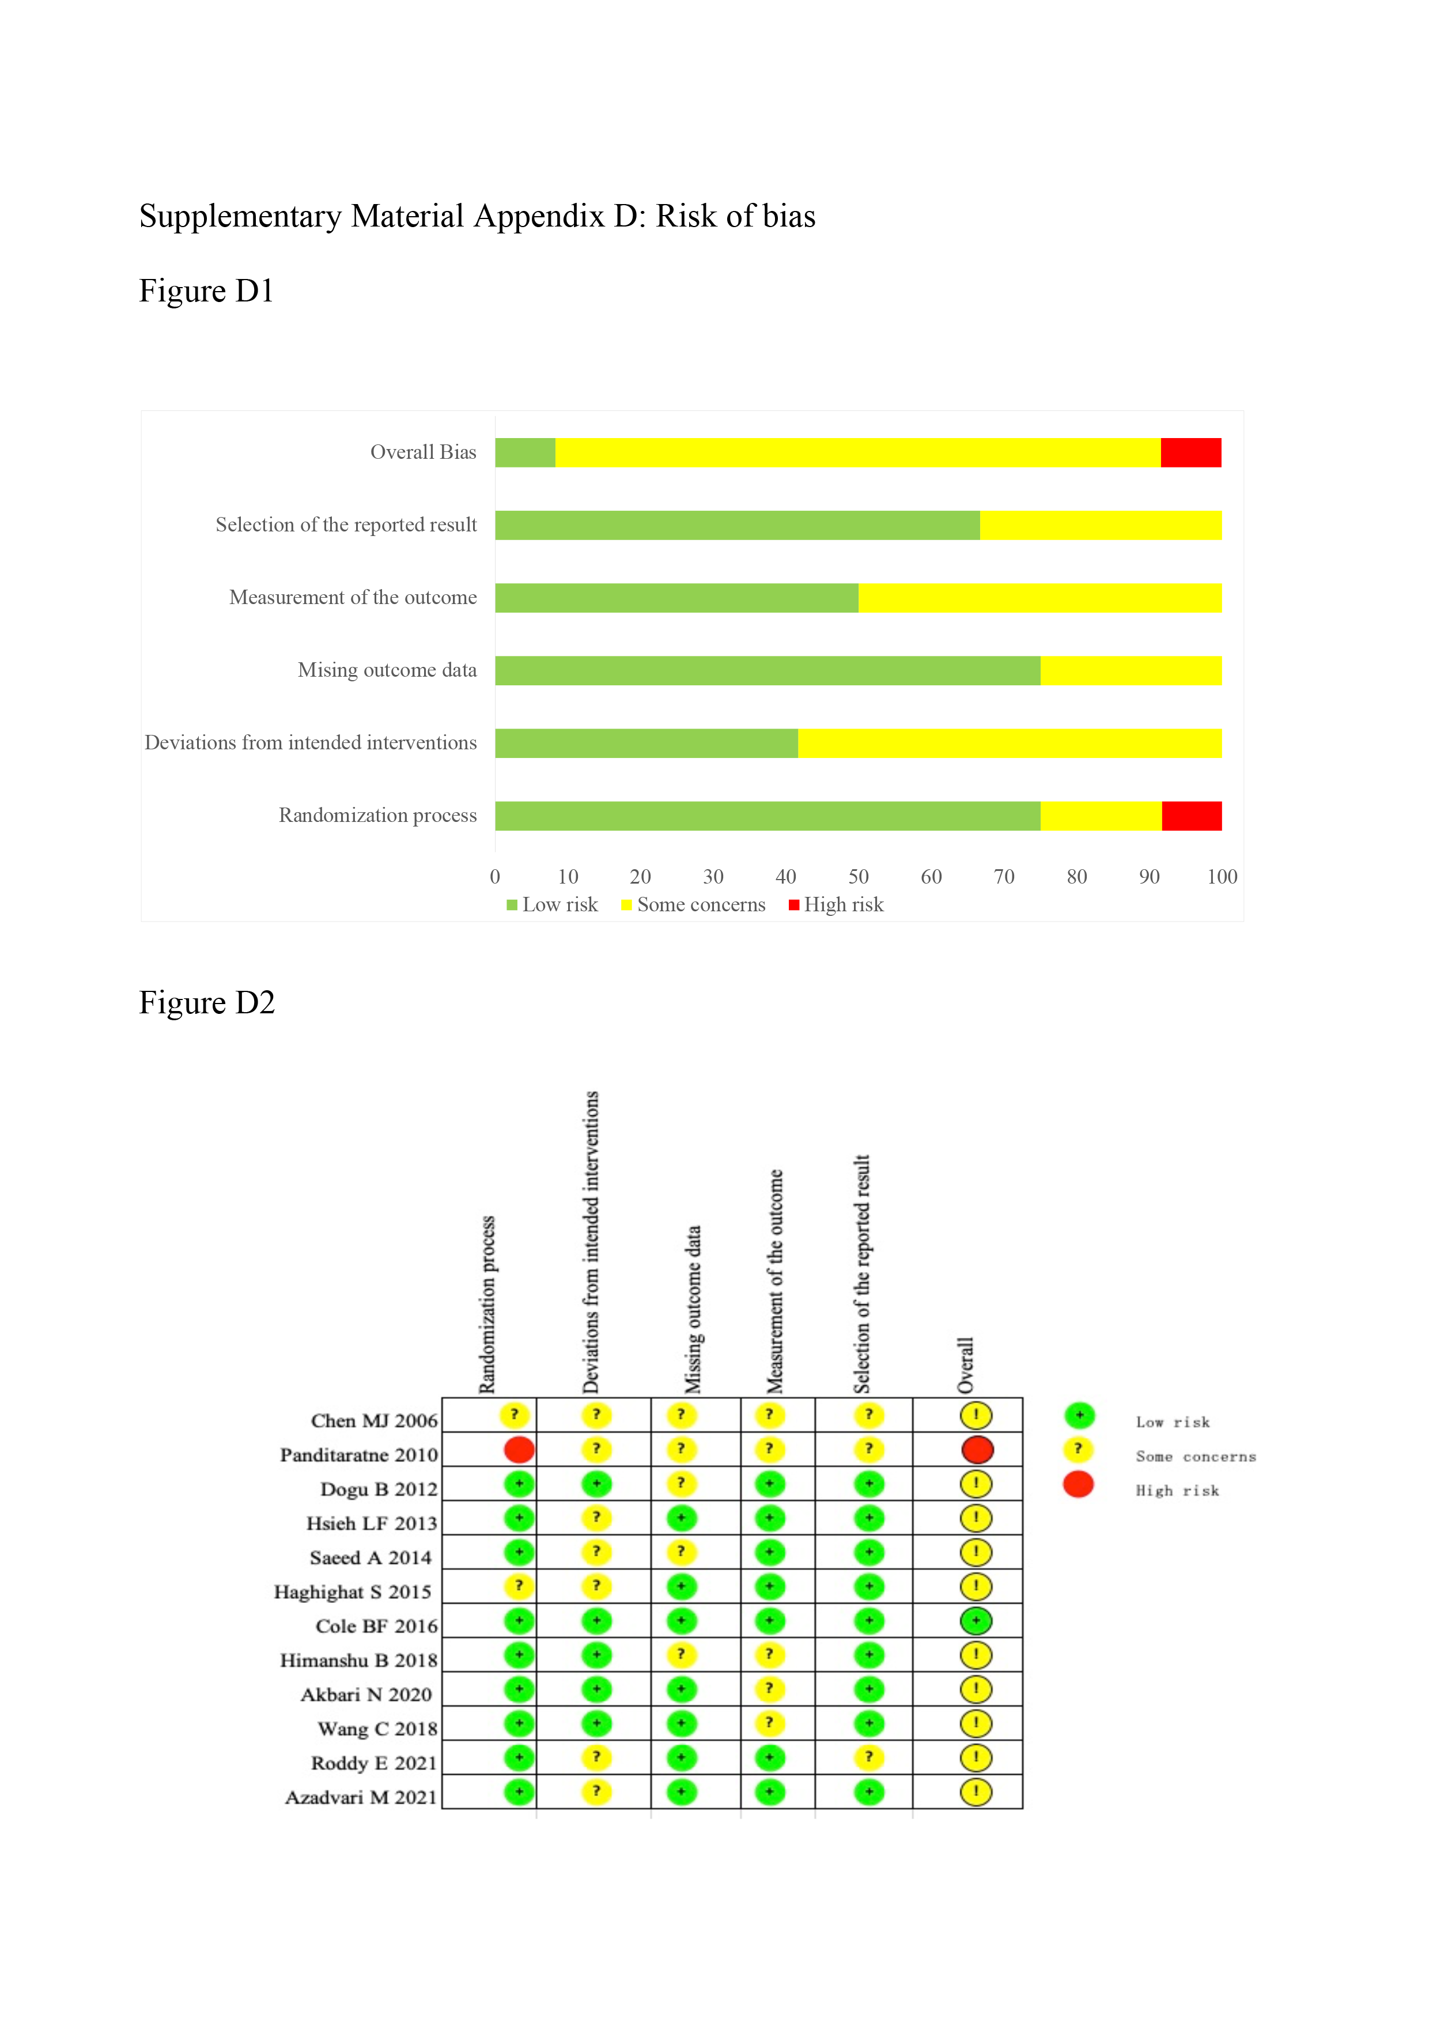Supplementary Material Appendix D: Risk of bias
Figure D1 Risk of bias graph for included studies.
Figure D2 Risk of bias summary for included studies.

