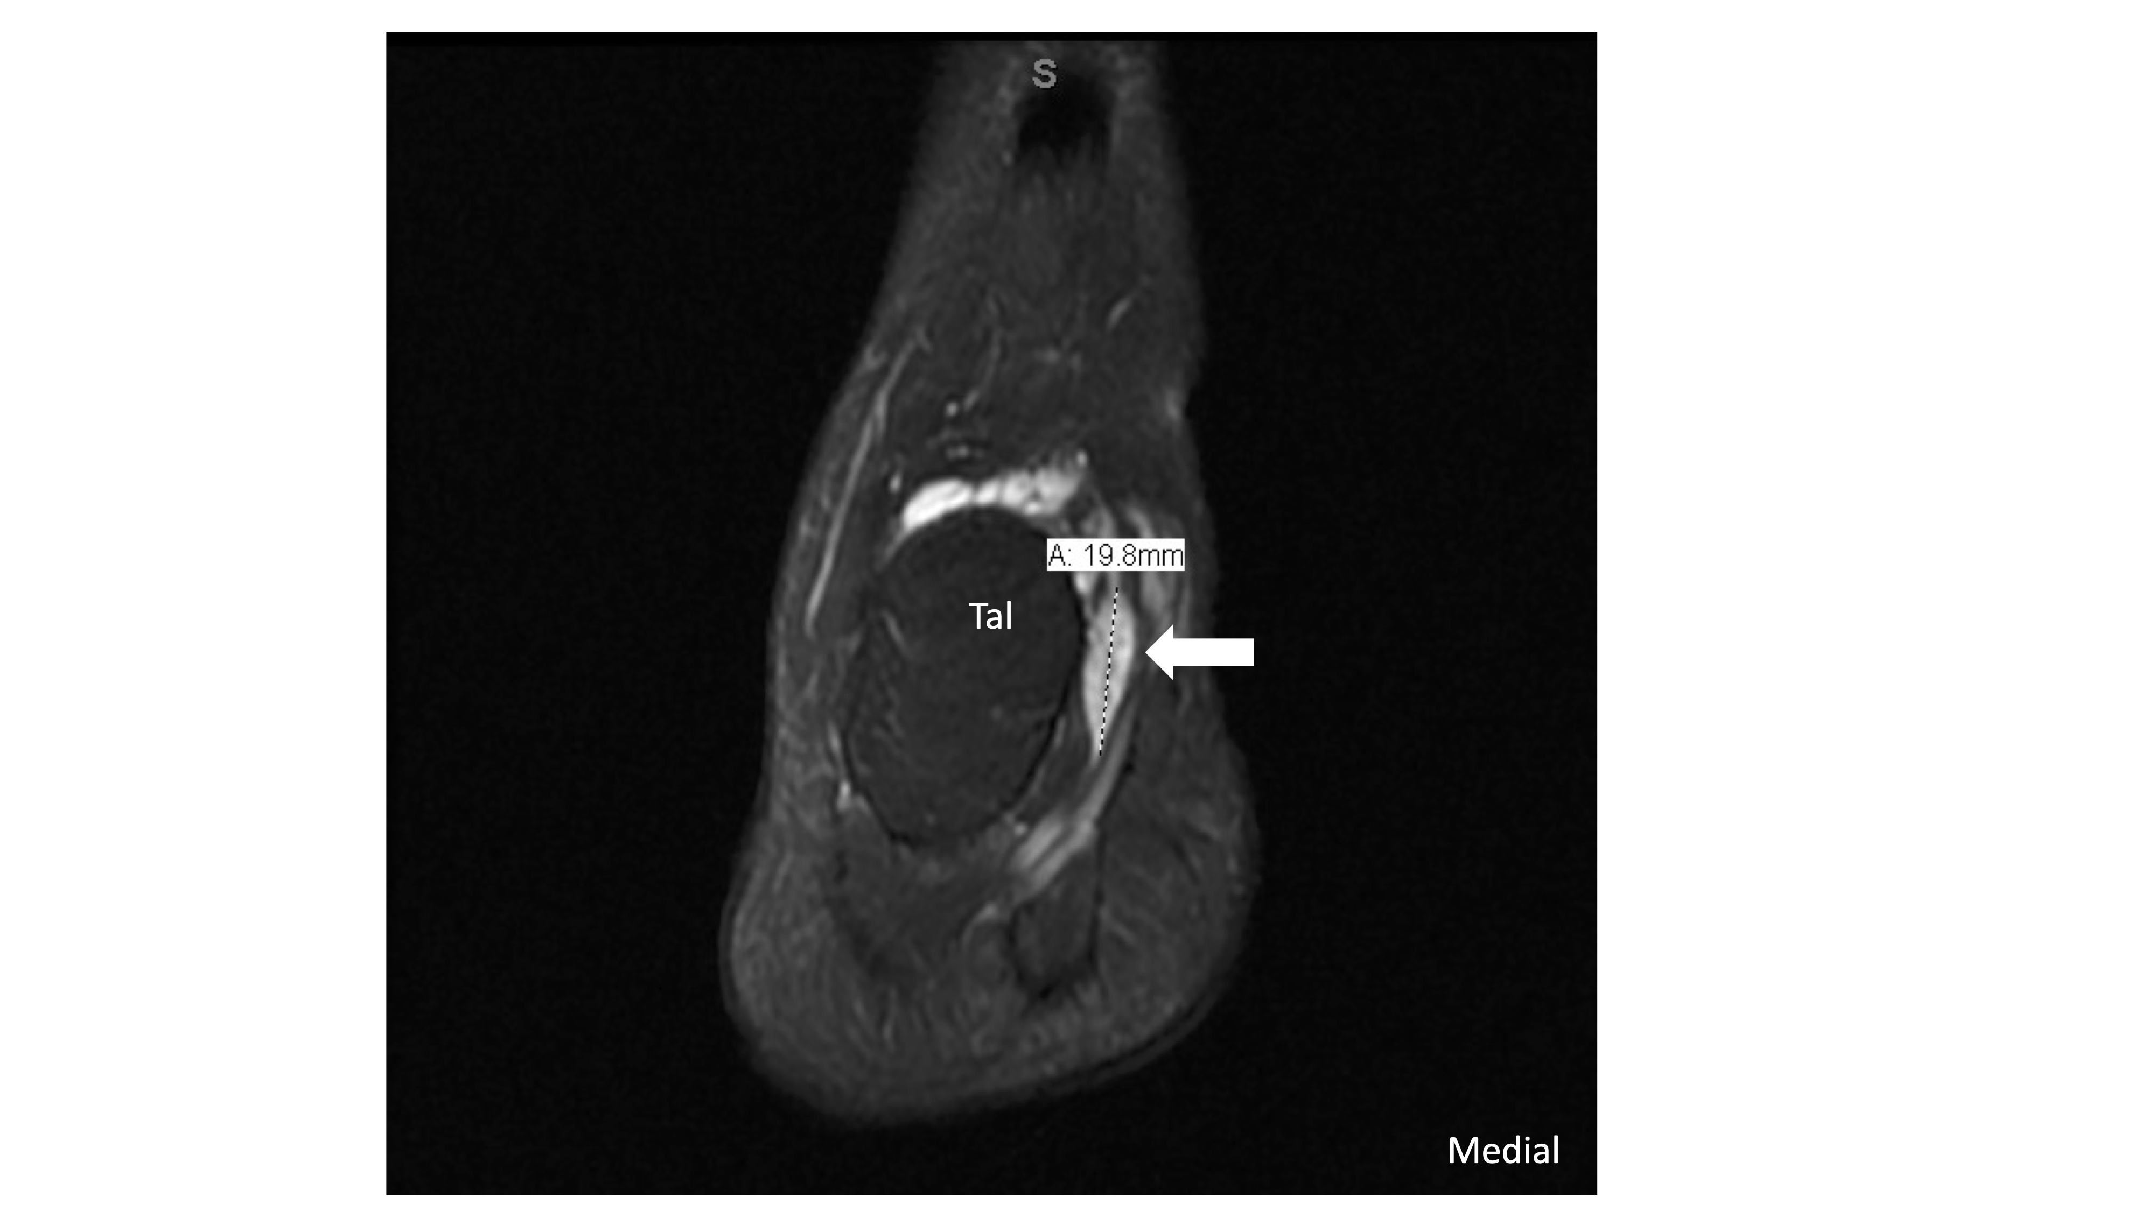

Supplemental Figure 1: Coronal T2 fat-suppressed MRI demonstrates an area of focally increased intrasubstance signal within the anterior tibialis tendon at the level of the talus. Additionally, the distal most portion of the tendon is mildly increased in signal intensity as well and is irregular/attenuated in appearance at the insertion site, concerning for insertional tendinopathy with partial-thickness tear.

