Appendix I – Scoring
Variable | Behavior/modifier | How to score?/ Specific feature
Neuromotor actions | Sensory experience state event vs. point event | - Modifier: ‘aim of sensory experience’  Affective sensory experience – to cuddle or to pet the infants head/tummy  Mixed affective and body awareness – not clear to differentiate, it is a combination of a therapeutic aim and to pet the infant  With the aim of body awareness – is related to a therapeutic aim e.g. to touch or tickle the dorsal part of a fist with the aim to open it, or to redirect the hand’s movement direction.  Moving in a sling with suspension point on the ceiling, moving on the knee (“horse riding”) or ”flying” in the air are also examples of sensory stimulation of body awareness  - A point event only last for a few seconds and other activity are not being changed.  - A state event is used when a whole sequence of ‘sensory experience’ is observed.  - If you observe multiple point events with very short intervals, this series of point events is scored as a single point event.
 | CSPMB, infant is allowed to continue activity by him/herself | - Modifier ‘variation’:  ‘little’ – is challenged to explore one or two strategies to reach and grasp, to control posture, to roll, etc. This may also imply that the PT or caregiver presents objects in various directions, but does not provide the infant with ample opportunity to deal with the challenge  ‘large’ – is challenged to explore multiple strategies to reach and grasp, to control posture, to roll, etc. This implies that the infant is offered ample time to deal with the various challenges, and that some challenges are offered multiple times.  - Note that the neuromotor action CSPMB changes into ‘Self-produced motor behavior’ if PT/CG has not renewed the challenge within an interval of 20 seconds.
 | Self-produced motor behavior in combination with constraint of one upper limb, interference of caregiver | - The less affected arm is restrained by the PT/CG or constrained by means of e.g. towel, sling or mitten] in order to force the use of the more affected arm  - This can be a point event or a state event (see prescription in “neuromotor actions)
 | CSPMB, infant is allowed to continue activity by him/herself | - Modifier: ‘extent of challenge’:  ‘minimal’ challenge’ – it is obvious that the child can fulfil the task applying relatively little effort (e.g. toy is placed into the child’s hand)  ‘just’ at the verge of the infant’s ability’ – the child has to put some effort to succeed or it may imply that occasionally the infant fails to accomplish the task (shows an error in the trial & error behavior)  - Within one challenge a toy may be offered several times or a new toy is offered but the challenge remains identical. This may be indicated by ‘interference by PT/CG during treatment session’ – ‘PT/CG interrupts activities of infant’
 | CSPMB, activity flows over into or is combined with facilitation, sensory, passive | - Scoring of the challenge see above  - While or after the challenge a ‘facilitation technique’ may occur.  - Modifier ‘type of facilitation techniques, sensory, passive motor experience’  - To indicate that a ‘facilitation technique’ starts while the challenge continues an ‘interference by PT/CG during treatment session’ is scored as ‘PT/CG corrects when infant fails’
Educational actions | Coaching | - PT observing the CG/infant interaction is part of coaching therefore a whole intervention session can be scored as ‘coaching’
 | Training | - PT shows/trains CG in facilitation techniques or Vojta techniques  - Training may be verbally only, it does not imply that the CG has to be active with the infant
 | PT/CG corrects when infant fails | - The PT/CG corrects the infant’s movement to a more ‘efficient’ way in the sense of optimizing the movement. (e.g. the infant is doing side steps and the PT/CG poses the food in a certain position), PT corrects head position by returning the head in the midline position
Position/ locomotion | Rolling | - If the infant actively rolls, you need to score starting and end position (e.g., supine to side, or supine to prone) (caution: infant being turned by PT/CG, it is scored as transition with handling)  - Rolling as locomotion: The infant rolls over several times as means of locomotion e.g. in order to reach a toy further away. In addition to the change of position the category ‘locomotion’ has to be scored in ‘other’
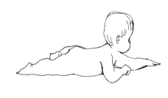1 | Creeping | - ‘prone’  - Modifier: depending on the level of postural support  - At the same time ‘locomotion’ has to be scored in ‘creeping’
 | Crawling | - ‘prone’  - Modifier: depending on the level of postural support  - At the same time category ‘locomotion’ has to be scored in ‘crawling’
 | 4-point-kneeling | - ‘prone’  - Modifier: depending on the level of postural support
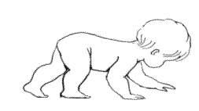 |  | - ‘prone’  - Modifier: depending on the level of postural support  - At the same time category ‘locomotion’ has to be scored in ‘crawling’
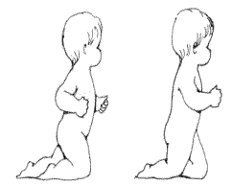 | Knee-walking | - ‘walking’  - Modifier: depending on the level of postural support  - At the same time category ‘locomotion’ has to be scored in ‘other’
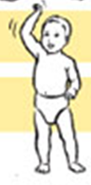 | Walking | - ‘walking’  - Modifier: depending on the level of postural support  - At the same time category ‘locomotion’ has to be scored in ‘walking’
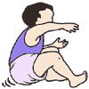 2 | Bottom shuffling | - ‘sitting’  - Modifier: depending on the level of postural support  - At the same time category ‘locomotion’ has to be scored in ‘bottom shuffling’
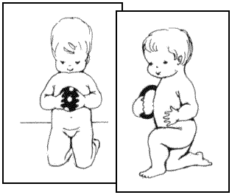 | Kneeling/  Half kneeling | - ‘standing’  - Modifier: depending on the level of postural support (caution: when the infant is sitting on his knees, ‘sitting – on flat surface’ is scored.)
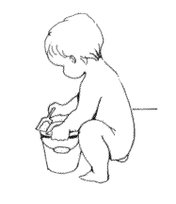 | Squat | - ‘standing’  - Modifier: depending on the level of postural support
 | Side | - Side is scored a) when almost the entire side of the body is supported by a support surface, or b) when - in a semi-sideward sitting position - the lateral part of the thorax is supported. Examples of support surfaces are the matrass, the PT/CG, a pillow or another support device or adaptive equipment.
 | Transition | - Is done by PT/CG. It is not scored if the child actively changes the position. Then you only score the end position of the child.  - ‘with a handling technique’  - Category ‘neuromotor actions’ has to be set as ‘facilitation technique’; modifier ‘handling’  - ‘without a handling technique’  - Category ‘neuromotor actions’ has to be set as ‘not specified neuromotor action’
Situation | Carrying | - During carrying of the child the position is depending on main support of child’s centre of gravity (e.g. stomach is facing PT/CG upper body ⇒ ‘prone’; back is facing PT/CG upper body ⇒ ‘supine’)  - Modifier: ‘against upper part of caregiver’s/ PT’s body’  - If CG/PT is walking the situation has to be changed into ‘carrying’. Maintains the CG/PT for example in a sitting position, the current situation continues.
 | Motor activity and play | - most of the treatment situation
 | Feeding  Bathing  Dressing/Undressing  Changing diapers | - If ‘neuromotor action’ can be observed you have to score them as such. In general this means that SPMB is scored, unless a specific therapeutic technique is used. Besides that ‘position’ of the child and aspects of ‘communication’ or ‘education’ need to be scored as well.

1 http://bidok.uibk.ac.at/library/ammann-respekt.html [11.11.2012]
2 http://www.novita.org.au/Content.aspx?p=70 [11.11.2012]

