Figure 2. 2018 Classification of Severity and Management of Congenital Muscular Torticollis (CMT)
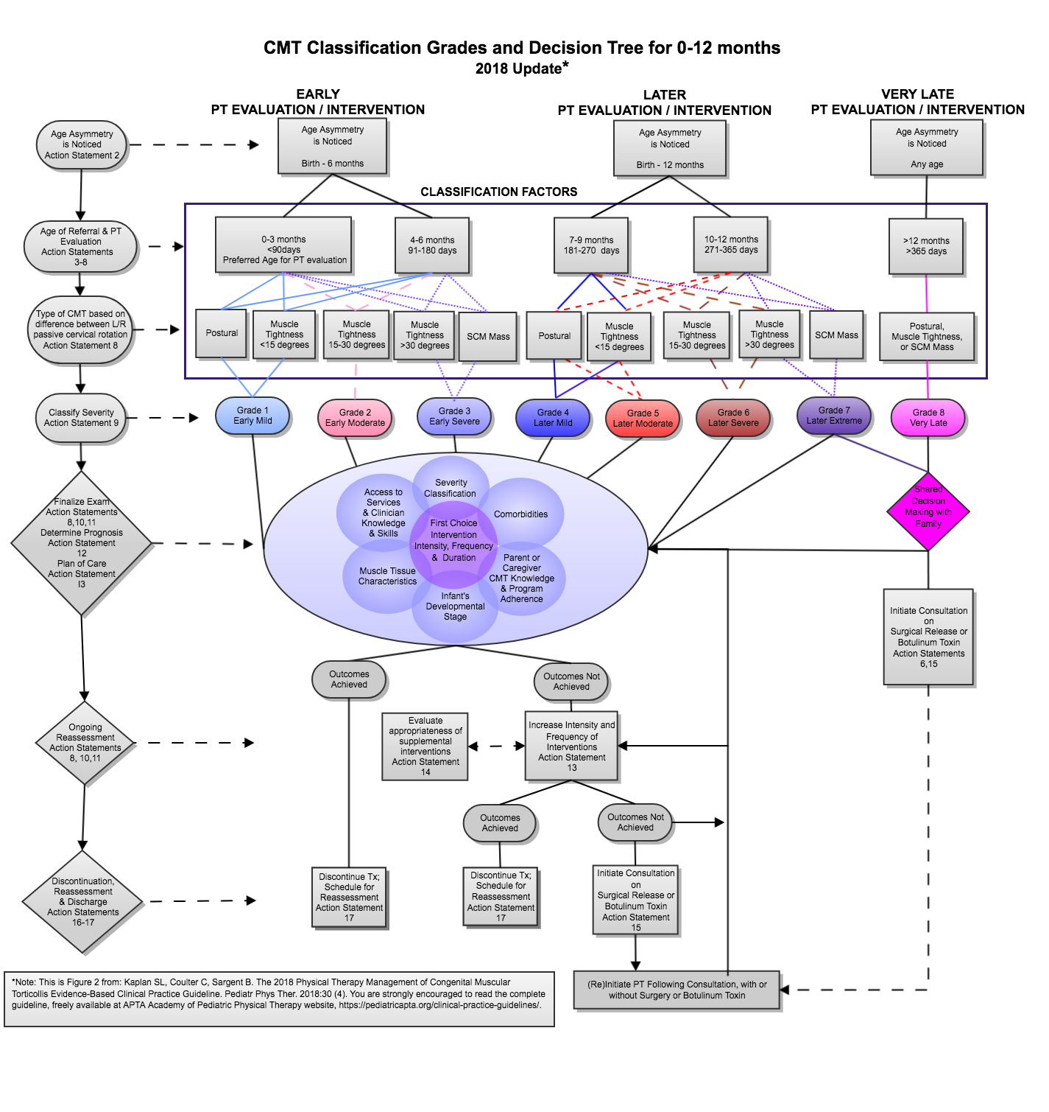
To use this chart: The vertically aligned ovals on the left, list the factors that are most relevant to the classification process (age asymmetry noted, age of referral and PT evaluation, type of CMT); the diamonds below describe the cycle of PT examination, intervention and reassessment. Begin in the larger rectangle with age at evaluation and type of CMT to choose a grade in the ovals below. Abbreviations: PT, physical therapy; TX, treatment; SCM, sternocleidomastoid; L/R, left/right.

