Supplemental Digital Content 1
CP Treatment Flowsheet ©2019 Epic Systems Corporation. Used with permission.
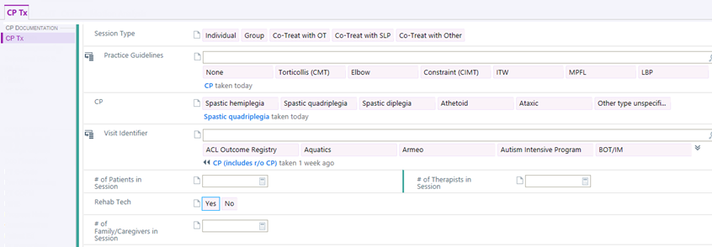

CP Treatment Flowsheet ©2019 Epic Systems Corporation. Used with permission.
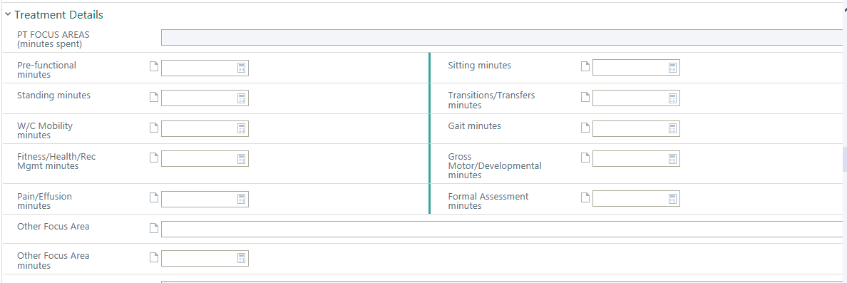
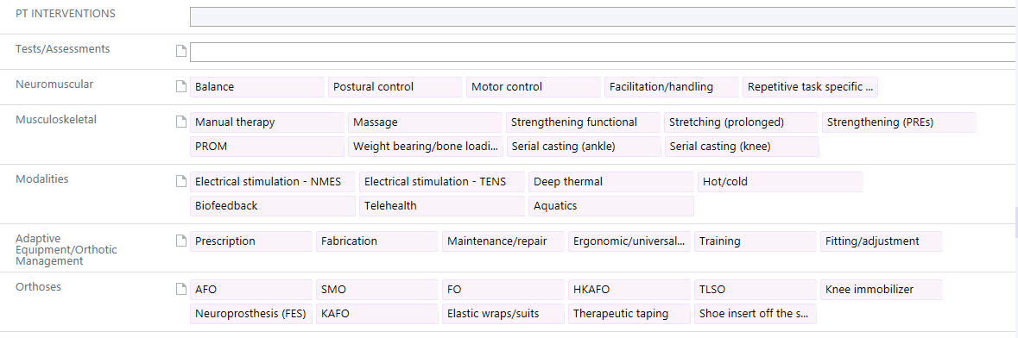

CP Treatment Flowsheet ©2019 Epic Systems Corporation. Used with permission.
