Supplemental Digital Content 1
Methods
The Cultivation of Open Presence meditation prompt was as follows:
Generate a state of total openness, in which the mind is vast like the sky. Maintain a clear awareness and presence open to the surrounding space. The mind is calm and relaxed, not focused on something particular, yet totally present, clear, vivid and transparent. When thoughts arise, simply let them pass through your mind without leaving any trace in it. When you perceive noises, images, tastes, or other sensations, let them be as they are, without engaging into them or rejecting them. Consider that they can’t affect the serene equanimity of your mind (5).
Results
Low Pain Level
Mean pain intensity and pain unpleasantness scores were subjected to separate repeated-measures analyses of variance having two levels of condition (baseline, meditation), and two levels of drug (saline, Naloxone). There was a significant main effect of condition for both pain intensity and pain unpleasantness (Pain Intensity: F(1,31) = 50.27, p < 0.001, $η_{ρ}^{2}$= 0.62; Pain Unpleasantness: F(1,31) = 33.86, p < 0.001, $η_{ρ}^{2}$= 0.52), indicating that pain intensity and pain unpleasantness during meditation were significantly different than at baseline, qualified by the interaction between drug and condition. Paired sample t-tests confirmed the presence of meditation analgesia under Saline and Naloxone for pain intensity and pain unpleasantness (Supplemental Table 1, Supplemental Figure 1). The main effect of drug was not significant for pain intensity (F(1,31)= 1.52, p = 0.23, $η_{ρ}^{2}$= 0.05) or pain unpleasantness (F(1,31) = 1.23, p = 0.28, $η_{ρ}^{2}$= 0.04), indicating that Naloxone did not have a significant effect across conditions for pain intensity or pain unpleasantness, qualified by the interaction between drug and condition.
The interaction between drug and condition was significant for both pain intensity (F(1,31) = 5.22, p = 0.029, $η_{ρ}^{2}$= 0.14) and pain unpleasantness (F(1,31) = 4.93 , p = 0.034, $η_{ρ}^{2}$= 0.14), indicating that the effect of Naloxone on pain was different during meditation than at baseline for both pain intensity and pain unpleasantness. Paired samples t-tests (Supplemental Table 1, Supplemental Figure 1) comparing between Saline and Naloxone revealed no significant differences at baseline (Pain Intensity: t(31) = 0.03, p = 0.97 d = 0.006; Pain Unpleasantness: t(31) = 0.07, p = 0.95, d = 0.01), but significantly lower pain intensity (t(31) =2.49, p = 0.018 , d = 0.54) and pain unpleasantness (t(31) = 2.28, p = 0.029, d = 0.42) during meditation under Naloxone than under Saline. These effects persisted when controlling for session order, age, and gender, with the exception of the drug by condition interaction for Pain Unpleasantness (F(1,30) = 3.80, p= 0.061.

Supplemental Table 1. The Effect of Naloxone on Meditation Analgesia, Low Pain Level
Pain Intensity
Drug | Baseline M (SD) | Meditation M (SD) | Effect Size (Cohen’s d)
Saline | 3.72(1.22)ª | 3.22(1.42)^{b} | 0.56
Naloxone | 3.73(1.57)ª | 2.66(1.22)^{c} | 1.16
Pain Unpleasantness
Saline | 2.43(1.52)ª | 1.75(1.64)^{b} | 0.60
Naloxone | 2.45(1.81)ª | 1.21(1.22)^{c} | 1.16
Note. N = 32. Different superscript letters indicate a significance pairwise difference at p < .05 within a rating type (pain intensity or pain unpleasantness).

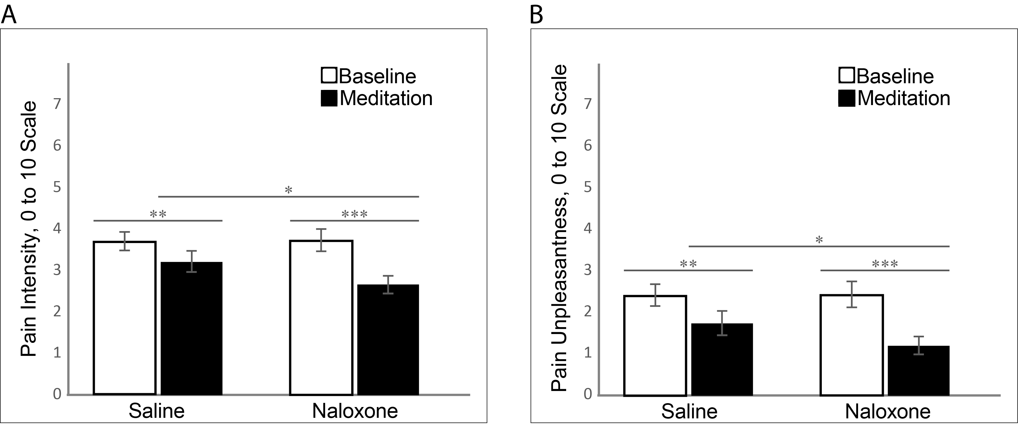
Supplemental Figure 1. Mean (a) pain intensity and (b) pain unpleasantness for baseline and meditation conditions in the saline and Naloxone sessions. N = 32. Error bars represent standard error. All statistical comparisons are within-subject. * p < .05, ** p < .01, *** p < .001.

