**Supplemental Digital Content**

The Effects of Dietary Improvement on Symptoms of Depression and Anxiety: A Meta-Analysis of Randomized Controlled Trials: Second erratum.

*Psychosomatic Medicine* previously published an erratum to a meta-analysis by Firth et al (1) to correct an estimated effect size for one of the 16 studies included in the meta-analysis. The erratum corrected the effect size for the included study by Wardle et al. (2) and provided updated effect sizes of the meta-analysis.

After publication of this erratum, it was noticed that a mislabelling of subgroup information had resulted in slight imprecision of the main effect estimates used for three other studies (3-5; k = 3; n= 583 out of k = 16, n= 45,826), and various changes to subgroup analyses were required. After correcting these oversights, meta-analyses were rerun, figures reproduced, and the tables were remade (see supplementary materials). The overall findings of the meta-analyses as published in 2019 remain unchanged (1), but details related to the trim and fill analyses and subgroup analyses require correction. These corrections are provided in the tables and figures below.

The following tables and figures correct the results of Firth et al. (2019). In addition to the below regarding the main paper, the analyses used for the previous correspondence (6) about the original article have also been rerun using the revised data.

The supplemental materials below present the following:

* Corrections of the materials presented in the original article (Firth et al. 2019).
  + Table 2 from Firth et al. Effects of dietary interventions on symptoms of depression. (Corrected, see Notes column)
  + Table 3 from Firth et al. Effects of dietary interventions on symptoms of anxiety. (Corrected, see Notes column)
  + Figure 1 from Firth et al. Meta-analysis of the effects of dietary interventions on symptoms of depression. (Box size represents the corrected data for study weighting. Diamond represents overall effect size and 95% CIs.)
  + Figure 2 from Firth et al. Meta-analysis showing differential effects of dietary interventions in male versus female samples, on (A) a symptoms of depression and (B) symptoms of anxiety. Box size represents the corrected data for study weighting. Diamond represents overall effect size and 95% CIs.
  + Figure 3 from Firth et al. Meta-analysis of the effects of dietary interventions on symptoms of anxiety. Box size represents the corrected data for study weighting. Diamond represents overall effect size and 95% CIs.
* Revised supplementary materials for initial Firth et al. (2019) article regarding the Funnel Plot of Standard Error by Hedge’s g, and meta-regressions of effect size for depressive symptoms (Hedge’s G) by study length, mean age, and study quality.

Results of the new sensitivity analyses with Scheier et al. (7) removed (g=0.157, 95% C.I.=0.04 to 0.27, p=0.006, I2=66.5), Endevelt et al. (8) removed (g=0.140, 95% C.I.=0.04 to 0.24, p=0.007, I2=61.4), or both studies removed (g=0.132, 95% C.I.=0.03 to 0.24, p=0.015, I2=62.1) show only minor changes from original presented values.

**References**

1. Firth J, Marx W, Dash S, Carney R, Teasdale SB, Solmi M, Stubbs B, Schuch FB, Carvalho AF, Jacka F, Sarris J. The Effects of Dietary Improvement on Symptoms of Depression and Anxiety: A Meta-Analysis of Randomized Controlled Trials. Psychosom Med. 2019;81(3):265-80.

2. Wardle J, Rogers P, Judd P, Taylor MA, Rapoport L, Green M, Perry KN. Randomized trial of the effects of cholesterol-lowering dietary treatment on psychological function. The American Journal of Medicine. 2000 May 1;108(7):547-53.

3. Kiernan M, King AC, Stefanick ML, Killen JD. Men gain additional psychological benefits by adding exercise to a weight-loss program. Obesity 2001;9:770–7.

4. Scheier MF, Helgeson VS, Schulz R, Colvin S, Berga S, Bridges MW, Knapp J, Gerszten K, Pappert WS. Interventions to enhance physical and psychological functioning among younger women who are ending nonhormonal adjuvant treat- ment for early-stage breast cancer. J Clin Oncol 2005;23:4298.

5. Forster SE, Powers HJ, Foulds GA, Flower DJ, Hopkinson K, Parker SG, Young TA, Saxton J, Pockley AG, Williams EA. Improvement in nutritional status reduces the clinical impact of infections in older adults. J Am Geriatr Soc 2012; 60:1645–54.

6. Firth J, Marx W, Carney R, Teasdale SB, Solmi M, Stubbs B, Schuch FB, Carvalho AF, Jacka F, Sarris J. Author’s Response. Psychosom Medicine. 2020 82(5):534-5.

7. Scheier MF, Helgeson VS, Schulz R, Colvin S, Berga S, Bridges MW, Knapp J, Gerszten K, Pappert WS. Interventions to enhance physical and psychological functioning among younger women who are ending nonhormonal adjuvant treatment for early-stage breast cancer. J Clin Oncol 2005;23:4298.

8. Endevelt R, Lemberger J, Bregman J, Kowen G, Berger-Fecht I, Lander H, Karpati T, Shahar D. Intensive dietary intervention by a dietitian as a case manager among community dwelling older adults: the EDIT study. J Nutr Health Aging 2011;15:624–30.

| Table 2 from Firth et al. (*Corrected, see Notes column*). Effects of dietary interventions on symptoms of depression. | | | | | | | | | | | | | | |
| --- | --- | --- | --- | --- | --- | --- | --- | --- | --- | --- | --- | --- | --- | --- |
|  | Sample |  | | | **Meta-analysis** | | | | | Heterogeneity | | | **Notes** | |
|  | Studies | Diet / Ctrl / Total | | | **Hedge’s *g*** | | **95% CI** | | **P value** | Q-value | P value | I2 |  | |
| *Main* | 16 | 18746 | 27080 | 45826 | 0.162 | 0.055 | | 0.269 | 0.003 | 43.76 | <0.1 | 65.72 | 1 | |
| *High Quality Studies* | 11 | 18567 | 26902 | 45469 | 0.171 | 0.057 | | 0.286 | 0.003 | 32.72 | <0.1 | 69.44 | * | |
| *Diet vs. Active Control* | 9 | 774 | 531 | 1305 | 0.224 | 0.052 | | 0.397 | 0.011 | 15.48 | 0.05 | 48.31 | | 2 |
| *Diet vs. Inactive Control* | 11 | 18266 | 26549 | 44815 | 0.114 | 0.008 | | 0.219 | 0.035 | 20.14 | 0.03 | 50.36 | 2 | |
| *Non-clinical depression* | 15 | 18715 | 27055 | 45770 | 0.138 | 0.038 | | 0.238 | 0.007 | 34.91 | <0.1 | 59.90 | * | |
| *Diet + Exercise vs Exercise alone* | 2 | 139 | 137 | 276 | 0.265 | 0.030 | | 0.501 | 0.027 | 0.01 | 0.93 | 0.00 | = | |
| ***Comparative Subgroup Analyses for Depression Outcomes*** | | | | | | | |  |  |  |  |  |  | |
| *Aim: Improving Nutrition* | 9 | 560 | 610 | 1170 | 0.182 | -0.043 | | 0.406 | 0.113 | 22.19 | <0.1 | 63.95 | - | |
| *Aim: Reducing % Fat Intake* | 4 | 17601 | 26037 | 43638 | 0.182 | -0.013 | | 0.376 | 0.067 | 10.38 | 0.02 | 71.09 | 3 | |
| *Aim: Inducing Weight Loss* | 4 | 585 | 483 | 1068 | 0.169 | 0.013 | | 0.324 | 0.034 | 4.45 | 0.22 | 32.56 | * | |
| *Nutrition Professional* | 12 | 18618 | 26890 | 45508 | 0.174 | 0.055 | | 0.294 | 0.004 | 39.67 | <0.1 | 72.27 | * | |
| *No nutrition professional* | 4 | 128 | 190 | 318 | 0.115 | -0.141 | | 0.371 | 0.378 | 3.37 | 0.34 | 11.04 | - | |
| *>75% female sample* | 8 | 17906 | 26314 | 44220 | 0.194 | 0.052 | | 0.337 | 0.007 | 17.98 | 0.01 | 61.07 | * | |
| *>75% male sample* | 4 | 366 | 362 | 728 | -0.208 | -0.449 | | 0.033 | 0.091 | 5.17 | 0.16 | 41.93 | = | |
| *100% female sample* | 6 | 17739 | 26141 | 43880 | 0.160 | 0.015 | | 0.306 | 0.031 | 10.73 | 0.06 | 53.41 | 4 | |
| *100% male sample* | 3 | 353 | 352 | 705 | -0.176 | -0.427 | | 0.074 | 0.168 | 3.94 | 0.14 | 49.23 | = | |

**Table 2 Legend:** The Notes column annotates:

**\*** the effect estimate is reduced, but results remain statistically significant (as in original article)

**-** the effect estimate is altered but remain non-significant (as in original article)

**=** the effect estimate is unchanged by corrections, findings remain same as original article

1 The main effect regarding depressive symptoms were reduced from the originally published estimate (g = 0.275, 95% CI = 0.10 - 0.45, p = .002) to a lower estimate (g = 0.162, 95% CI = 0.055 – 0.269, p = 0.003), but the effect remained statistically significant (Fig 1). While indication for publication bias remained (Egger's regression intercept = 0.99, p =.018), the random effects trim-and-fill analysis now found no missing studies, producing the same results as the new main analysis. Recalculated meta-regressions still show no relations for study effect sizes with weeks duration (B=-.0016, S.E.=.0012, p=0.191), sample age (B=.0003, S.E.=.0044, p=0.951) or ADA scores (B=.0183, S.E.=0.0431, p=0.671).

2 Pooled effects in the “inactive control” subgroup remain statistically significant, but smaller than original estimates (revised g=0.114, 95% C.I.=0.01 to 0.22, p=0.035, vs. original g=0.308, 0.02 to 0.60, p=0.038), and the effect estimate for the “active control” subgroup is now slightly larger than the “inactive control” subgroup (although with large overlap in confidence intervals for both, as before). There remained no evidence of publication bias significantly altering the findings for the “active control” subgroup, although further adjusting the “inactive control” subgroup with trim-and-fill analyses produced null effects for this subgroup (g=0.017, 95% C.I.=-0.085 to 0.119, p>0.05).

3Pooled effects on depressive symptoms in the ‘Reducing % fat intake’ subgroup are now smaller and fall short of significance (p=0.067).

4As in original article, significantly greater effects from dietary interventions on depression were observed in female sample studies than male sample studies (initially p = .021 between subgroups, revised p=.023).

| Table 3 from Firth et al. (*Corrected, see Notes column*). Effects of dietary interventions on symptoms of anxiety | | | | | | | | | | | | | | |
| --- | --- | --- | --- | --- | --- | --- | --- | --- | --- | --- | --- | --- | --- | --- |
|  | Sample |  | | | **Meta-analysis** | | | | | Heterogeneity | | **Notes** | | |
|  | Studies | Diet / Ctrl / Total | | | **Hedge’s *g*** | | **95% CI** | | **P value** | Q-value | P value | | I2 |  |
| *Main Analysis* | 11 | 1213 | 1057 | 2270 | 0.085 | -0.031 | | 0.202 | 0.151 | 16.61 | 0.08 | | 39.78 | 1 |
| *High Quality Studies* | 8 | 1082 | 922 | 2004 | 0.092 | -0.052 | | 0.236 | 0.209 | 15.67 | 0.03 | | 55.33 | - |
| *Diet vs. Active Control* | 5 | 576 | 349 | 925 | 0.089 | -0.100 | | 0.278 | 0.356 | 6.31 | 0.18 | | 36.57 | - |
| *Diet vs. Inactive Control* | 8 | 781 | 708 | 1489 | 0.077 | -0.069 | | 0.224 | 0.302 | 12.05 | 0.10 | | 41.90 | - |
| *Diet + Exercise vs Exercise alone* | 2 | 139 | 137 | 276 | 0.050 | -0.185 | | 0.285 | 0.676 | 0.04 | 0.83 | | 0.00 | = |
| ***Comparative Subgroup Analyses for Anxiety Outcomes*** | | | | | | | |  |  |  |  | |  | |
| *Aim: Improving Nutrition* | 6 | 440 | 429 | 869 | 0.097 | -0.139 | | 0.333 | 0.421 | 10.65 | 0.06 | | 53.07 | - |
| *Aim: Reducing % Fat Intake* | 2 | 188 | 195 | 383 | 0.237 | 0.017 | | 0.457 | 0.035 | 1.14 | 0.29 | | 12.04 | * |
| *Aim: Inducing Weight Loss* | 4 | 585 | 483 | 1068 | 0.049 | -0.072 | | 0.170 | 0.424 | 1.83 | 0.61 | | 0.00 | - |
| *Nutrition Professional* | 9 | 1170 | 1015 | 2185 | 0.076 | -0.051 | | 0.203 | 0.242 | 15.76 | 0.05 | | 49.24 | 2 |
| *No nutrition professional* | 2 | 43 | 42 | 85 | 0.248 | -0.171 | | 0.667 | 0.247 | 0.12 | 0.73 | | 0.00 | = |
| *>75% female* | 6 | 493 | 472 | 965 | 0.211 | 0.085 | | 0.337 | 0.001 | 2.64 | 0.75 | | 0.00 | = |
| *>75% male* | 3 | 353 | 352 | 705 | -0.190 | -0.420 | | 0.041 | 0.107 | 3.43 | 0.18 | | 41.7 | = |
| *100% female* | 4 | 326 | 298 | 624 | 0.158 | 0.001 | | 0.315 | 0.048 | 1.41 | 0.70 | | 0.00 | = |
| *100% male* | 3 | 353 | 352 | 705 | -0.190 | -0.420 | | 0.041 | 0.107 | 3.43 | 0.18 | | 41.7 | = |

**Table 3** **Legend:** The Notes column annotates:

**\*** the effect estimate is reduced, but results remain statistically significant (as in original article)

**-** the effect estimate is altered, but results remain non-significant (as in original article)

**=** the effect estimate is unchanged by corrections, findings remain same as original article

1Pooled effects on anxiety remained non-significant as in the original analyses (Fig 2). Slight indication of publication bias remained (Egger’s regression intercept=1.036, p=0.160) and results remained non-significant in trim-and-fill analyses.

2 Pooled effects on anxiety symptoms among the ‘nutritional professional’ subgroup are now smaller not statistically significant (p=0.242).

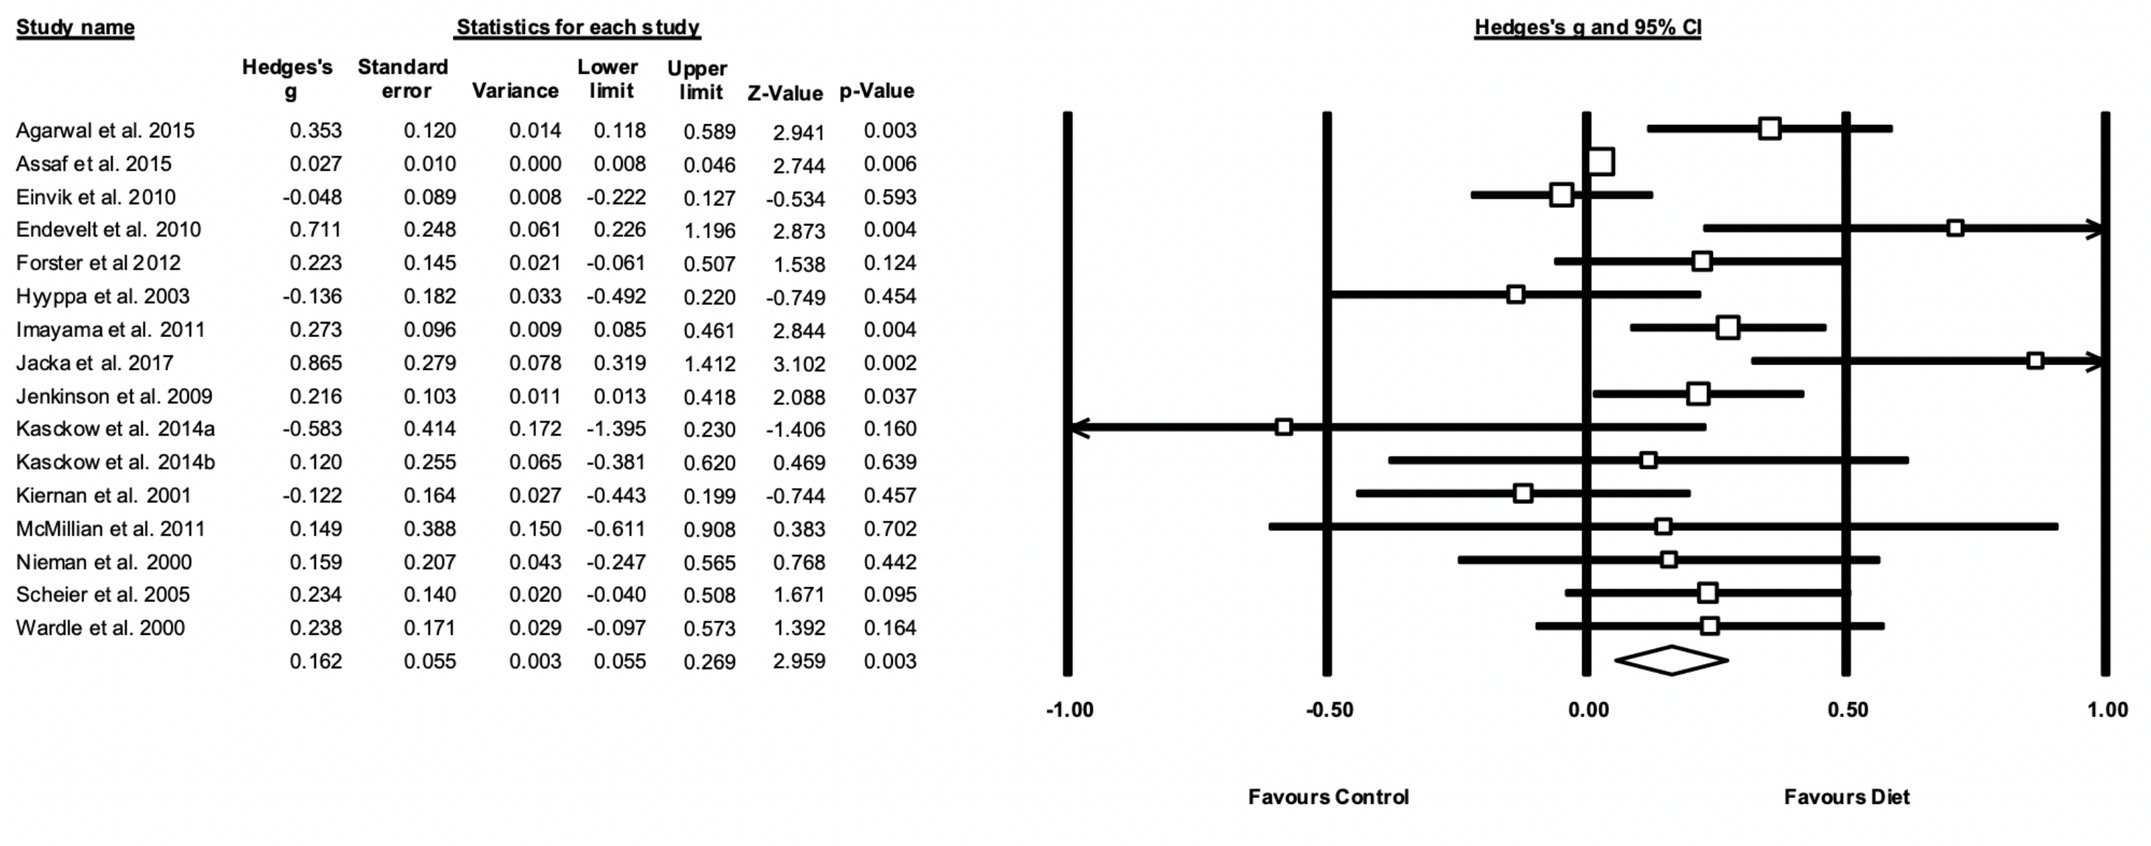

**FIGURE 1** from Firth et al. Meta-analysis of the effects of dietary interventions on symptoms of depression. Box size represents study weighting. Diamond represents overall effect size and 95% CIs.

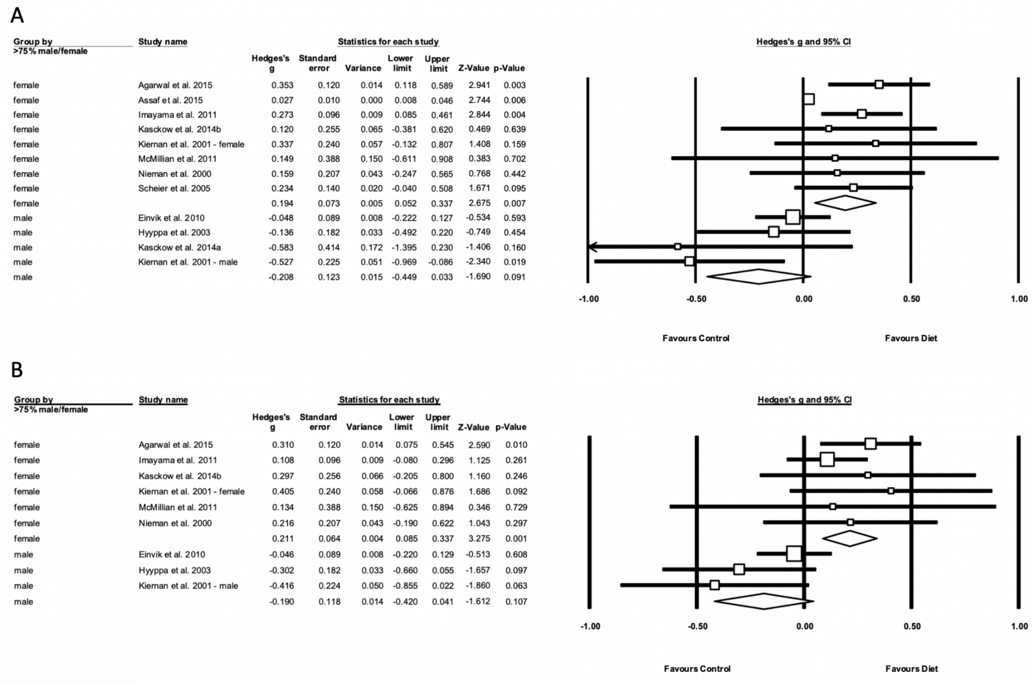

**FIGURE 2** from Firth et al.Meta-analysis showing differential effects of dietary interventions in male versus female samples, on (A) a symptoms of depression and (B) symptoms of anxiety. Box size represents study weighting. Diamond represents overall effect size and 95% CIs.

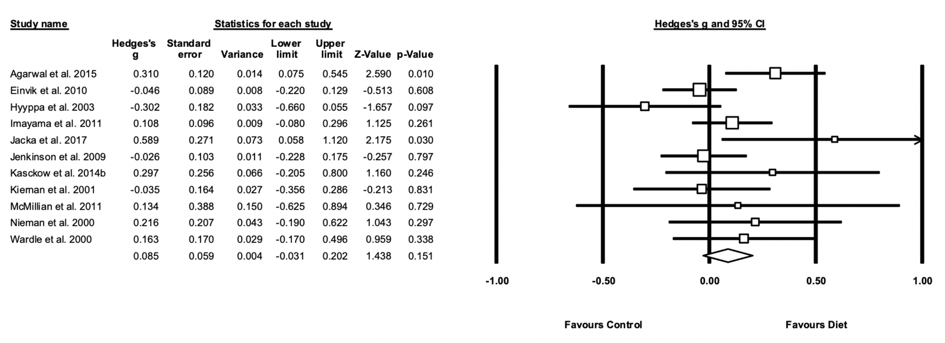

**FIGURE 3** from Firth et al. Meta-analysis of the effects of dietary interventions on symptoms of anxiety. Box size represents study weighting. Diamond represents overall effect size and 95% CIs.

.

*Revised supplementary materials for initial Firth et al. (2019) article.*



**Supplement 3.** Funnel Plot demonstrating the significant risk of publication bias for effect sizes of dietary interventions on symptoms of depression. Findings remained significant after Duval and Tweedie ‘trim-and-fill’ correction.

**Note:** In the original article, this supplementary figure was plotted around fixed effects. The funnel plot is now plotted around the random effects models used for trim-and-fill analyses (as described in Methods).



S4a. Meta-regression of effect size for depressive symptoms (Hedge’s G) by study length (weeks)

Coeff=-0.0016, S.E.=.0012, p=0.191



S4b. Meta-regression of effect size for depressive symptoms (Hedge’s G) by mean age (years)

Coeff =0.0003, S.E.=.0044, p=0.951



S4c. Meta-regression of effect size for depressive symptoms (Hedge’s G) by study quality (ADA Score)

Coeff=0.0183, S.E.=0.0431, p=0.671