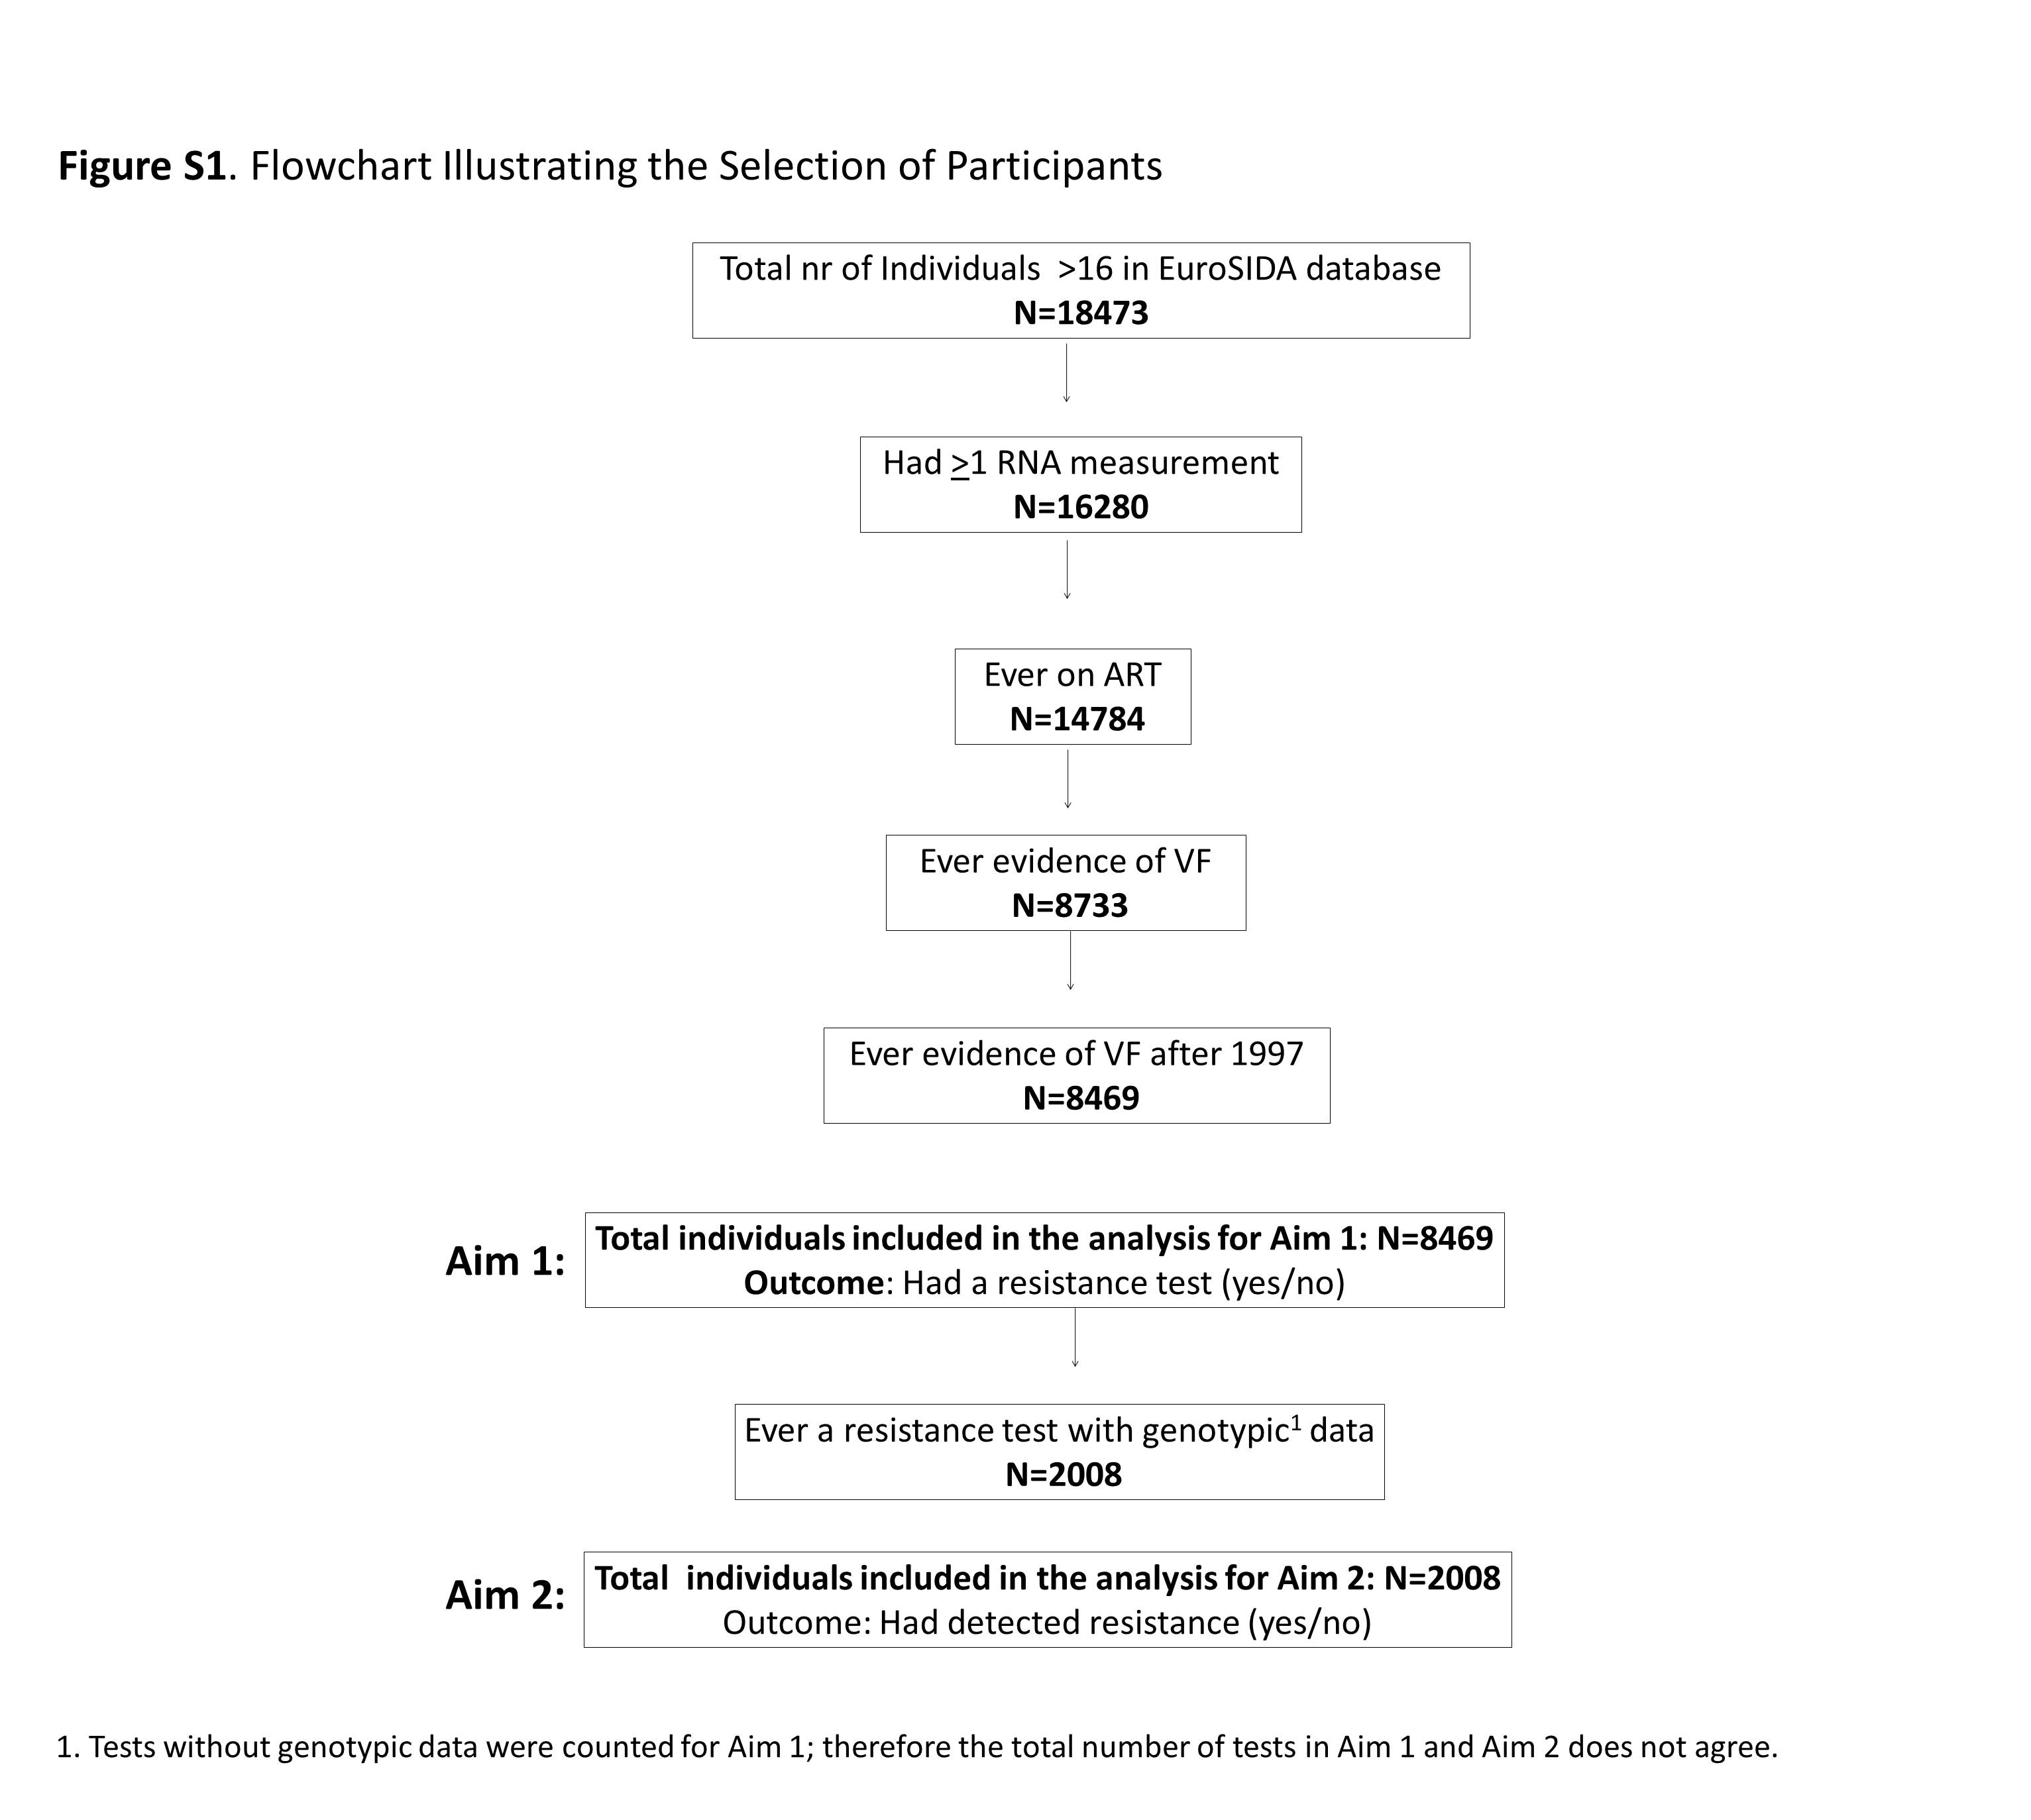
Supplementary Digital Content 2. Countries included in each region in EuroSIDA
Southern Europe | Central Western Europe | Northern Europe | Central Eastern Europe | Eastern Europe | Argentina
Spain | France | United Kingdom | Poland | Estonia | Argentina
Portugal | Belgium | Ireland | the Czech Republic | Latvia
Italy | South Germany | the Netherlands | Slovakia | Lithuania
Greece | Luxembourg | North Germany | Hungary | Belarus
Israel | Switzerland | Denmark | Romania | Ukraine
 | Austria | Sweden | Serbia | the Russian Federation
 |  | Norway | Bulgaria
 |  | Finland | Croatia
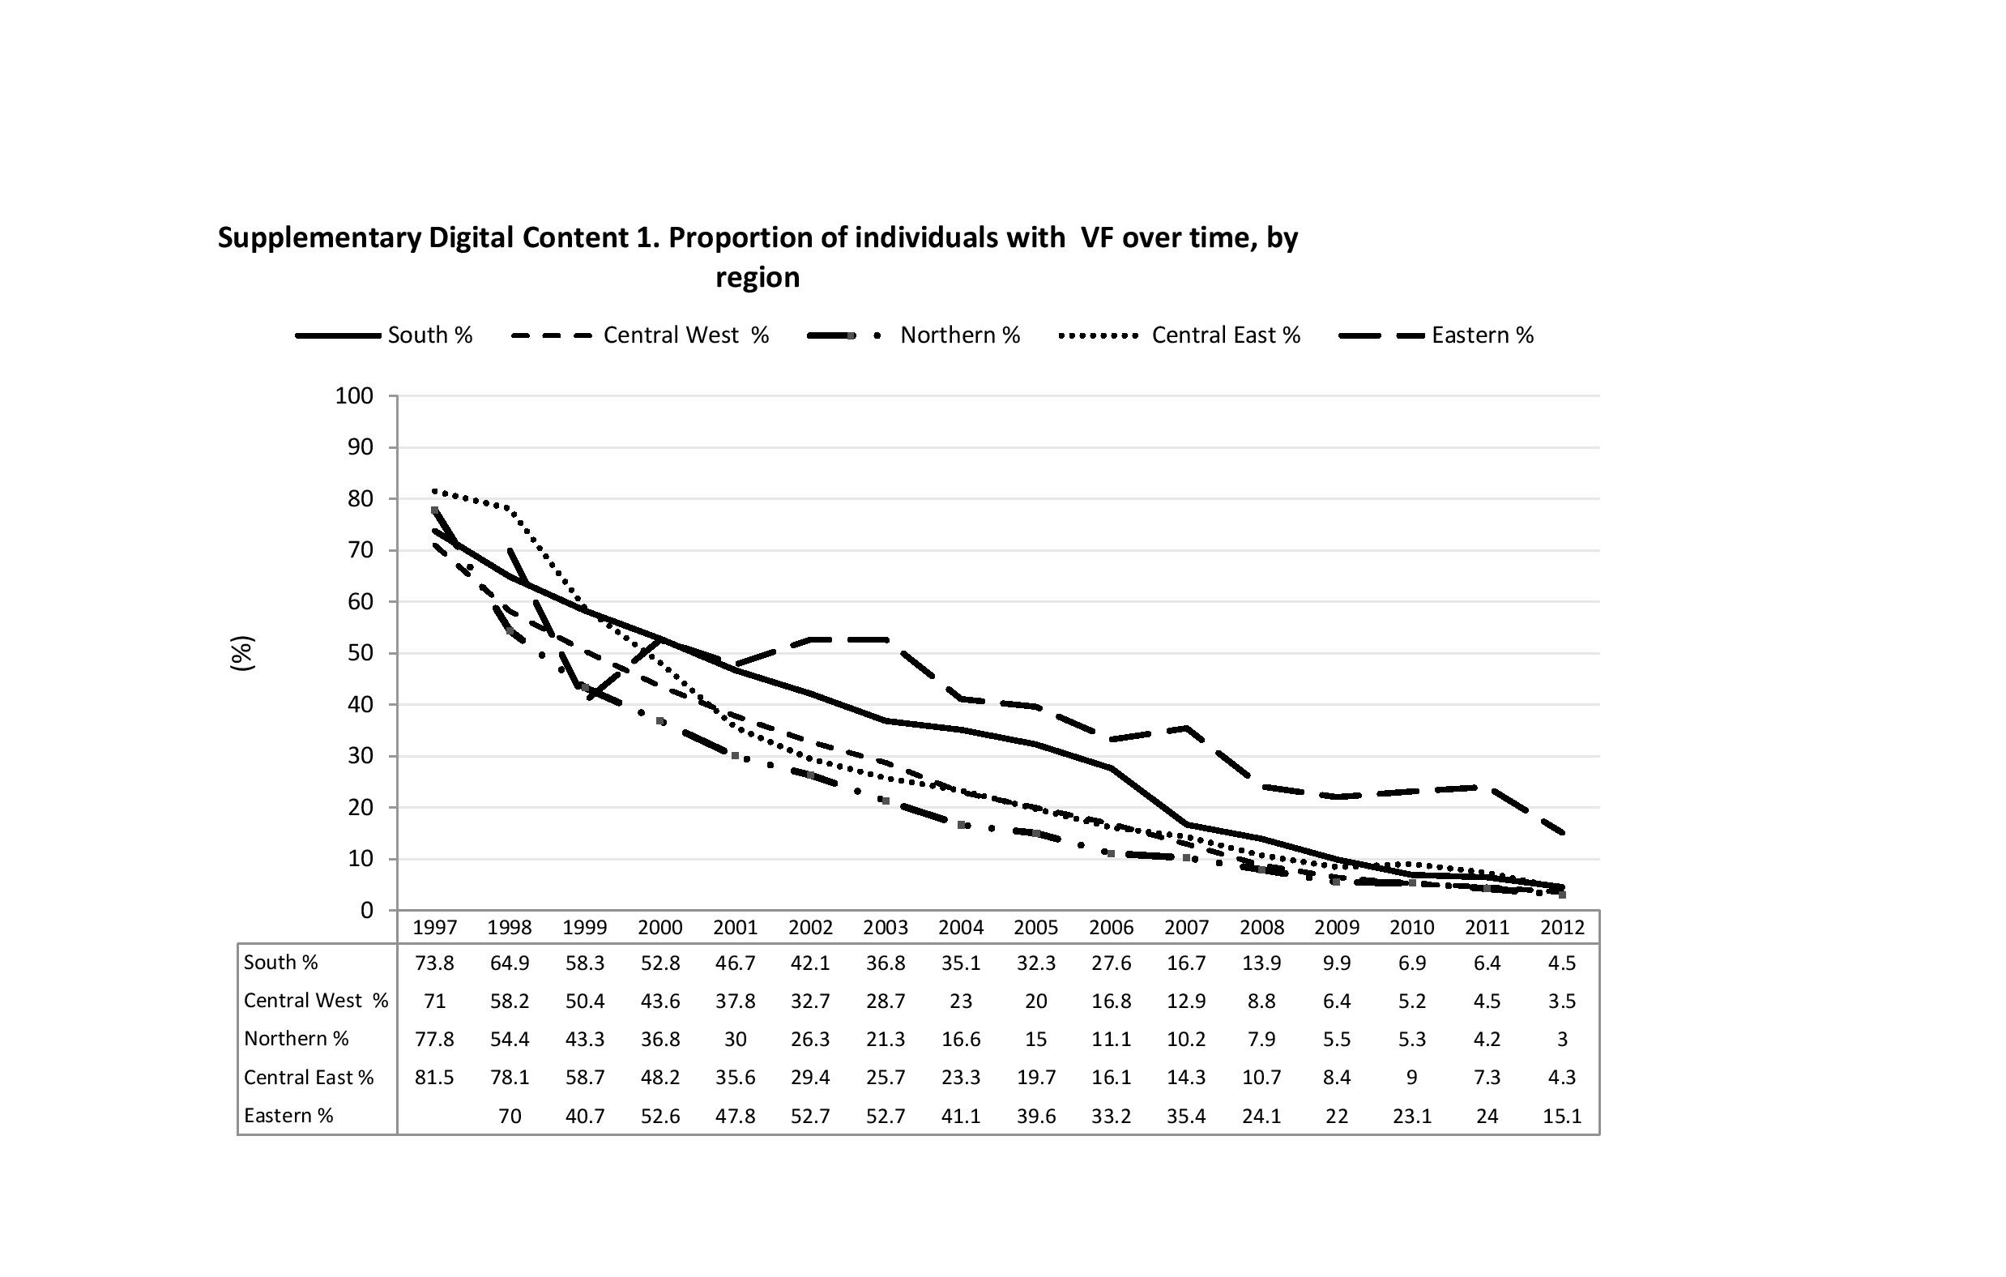

Supplementary Digital Content 4. Factors associated with having a resistance test after VF
 |  | Unadjusted |  | Adjusted^{1,2}
 |  | OR (95% CI) | P-value | OR (95% CI) | P-value | Global P-value
Age (per 10 year increase |  | 1.26 (1.22 - 1.31) | <.001 | 1.03 (0.99 - 1.08) | 0.10 | 0.12
CD4 at failure, per 100 increase² |  | 0.99 (0.97 - 1.00) | 0.09 | 1.01 (1.00 - 1.03) | 0.07 | 0.08
Gender | Male |  |  |  |  | 0.75
 | Female | 0.86 (0.79 - 0.95) | 0.002 | 0.98 (0.89 - 1.08) | 0.75
Ethnic Group | White
 | Non-white | 1.16 (1.04 - 1.30) | 0.01 | 0.83 (0.75 - 0.92) | <.001 | <.001
Risk Group | MSM
 | IDU | 0.68 (0.61 - 0.75) | <.001 | 0.91 (0.82 - 1.00) | 0.05 | 0.03
 | Heterosexual | 0.88 (0.80 - 0.97) | 0.01 | 1.03 (0.93 - 1.14) | 0.54
 | Other | 1.03 (0.89 - 1.20) | 0.68 | 1.10 (0.96 - 1.26) | 0.19
Region | South |  |  |  |  | <.001
 | Central West | 1.56 (1.40 - 1.72) | <.001 | 1.66 (1.51 - 1.82) | <.001
 | North | 2.03 (1.84 - 2.24) | <.001 | 2.15 (1.96 - 2.36) | <.001
 | Central East | 0.98 (0.84 - 1.15) | 0.82 | 0.94 (0.81 - 1.09) | 0.41
 | East | 0.55 (0.42 - 0.71) | <.001 | 0.72 (0.55 - 0.94) | 0.02
ARVs used at failure | PI (boosted) |  |  |  |  | 0.01
 | PI (unboosted) | 0.67 (0.58 - 0.76) | <.001 | 0.92 (0.80 - 1.05) | 0.202
 | NNRTI | 1.08 (0.91 - 1.29) | 0.36 | 1.11 (0.93 - 1.33) | 0.24
 | PI and NNRTI | 1.76 (1.58 - 1.96) | <.001 | 0.96 (0.86 - 1.07) | 0.49
 | Neither PI or NNRTI | 0.50 (0.60 - 0.42) | <.001 | 0.77 (0.65 - 0.91) | 0.003
History of mono/dual therapy | No |  |  |  |  | 0.48
 | Yes | 1.27 (1.15 - 1.40) | <.001 | 0.96 (0.86 - 1.07) | 0.47
RNA at failure | <1000 |  |  |  |  | <.001
 | 1000-10000 | 1.91 (1.71 - 2.14) | <.001 | 2.10 (1.86 - 2.37) | <.001
 | 10000-50000 | 2.38 (2.12 - 2.67) | <.001 | 2.74 (2.43 - 3.10) | <.001
 | >50000 | 2.48 (2.18 - 2.82) | <.001 | 2.68 (2.34 - 3.07) | <.001
Previous Resistance Test | None |  |  |  |  | <.001
 | 1 | 10.32 (9.26 - 11.51) | <.001 | 6.26 (5.51 - 7.12) | <.001
 | 2-4 | 11.19 (9.72 - 12.89) | <.001 | 6.76 (5.75 - 7.93) | <.001
 | >4 | 14.85 (9.59 - 22.99) | <.001 | 11.23 (7.04 - 17.92) | <.001
Previous Virological failure | No |  |  |  |  | 0.002
 | Yes | 3.16 (2.88 - 3.46) | <.001 | 1.19 (1.06 - 1.33) | 0.003
Calendar Year | 97-98 | 0.08 (0.07 - 0.10) | <.001 | 0.11 (0.09 - 0.14) | <.001 | <.001
 | 99-00 | 0.39 (0.36 - 0.44) | <.001 | 0.49 (0.43 - 0.55) | <.001
 | 01-02 | 0.75 (0.68 - 0.82) | <.001 | 0.85 (0.76 - 0.95) | 0.003
 | 03-04
 | 05-06 | 0.84 (0.75 - 0.94) | 0.002 | 0.77 (0.68 - 0.89) | <.001
 | 07-08 | 0.52 (0.45 - 0.60) | <.001 | 0.46 (0.39 - 0.54) | <.001
 | 09-10 | 0.32 (0.26 - 0.39) | <.001 | 0.33 (0.27 - 0.41) | <.001
 | 11-12 | 0.22 (0.17 - 0.28) | <.001 | 0.25 (0.19 - 0.32) | <.001
1. The multivariable model is adjusted for all the variables listed in the table.
2. 26 individuals were excluded from the model with CD4 count as an exposure as well as the multivariable model due to missing CD4 counts.

Supplementary Digital Content 5. Prevalence of testing and resistance using different inclusion criteria
 | Definition A¹ | Definition B² | Definition C³ | Definition D⁴ | Definition E⁵ | Definition F⁶ | Definition G⁷
 | N (%) | N (%) | N (%) | N (%) | N (%) | N (%) | N (%)
Failing | 8468 | 6017 | 9661 | 7828 | 1894 | 5748 | 3776
Resistance test/individual | 2676 (31.6) | 2204 (36.6) | 2210 (22.9) | 2547 (32.5) | 823 (43.5) | 1863 (32.4) | 1767 (46.8)
Detected resistance/test | 2431 (77.9) | 2078 (81.1) | 1886 (76.3) | 2299 (78.4) | 268 (84.8) | 1788 (76.5) | 638 (81.6)

- Primary definitions.
- Defining VF as at least 2 consecutive measures >500 instead of a single value, after at least 6 months on ART.
- Defining VF as a single value above the detection limit of the test used after at least 6 months on ART.
- Defining VF as a single VL >1000 (instead of >500) after at least 6 months on ART.
- Restricting the analysis to individuals with adherence data, and excluding individuals with poor adherence (“<75%”) in a given year as reported by the treating physician and using the primary definitions.
- Defining failure as a single viral load >500, requiring an individual to supress to <500 before a subsequent failure was included in the analysis.
- Defining VF as a single viral load >500 followed by a switch to a drug belonging to a class that was not included in the regimen started >6 months earlier.

