Supporting Information
Model Details
The model was implemented in the R programming language [1] and solved using the ode function of the deSolve package [2].
Table S1 lists the model variables. To allow us to keep track of the origin of TB cases and the status of the previously cured population several variables are split for “cure” status. Superscript C indicates individuals who were previously cured. Table S2 lists the parameter values. The model equations are shown below.
Variable | Symbol
Individuals cured of latent infection following IPT | C
Susceptible (i.e. never infected) individuals | S
Latently infected individuals (> 2 years since infection) | L
Recently infected individuals (in first or second year) | I_{i}, i=1,2
Recently reinfected individuals (in first or second year) | R_{i}, i=1,2
Primary TB disease occurring in first 2 years following infection | TB_{p}
Exogenous TB disease occurring in first 2 years following reinfection | TB_{x}
Endogenous (reactivation) TB disease | TB_{n}
Table S1 – Model variables
Parameter | Range | Reference
Annual risk of infection, ARI | 1-10% (uniform) | Estimated via fitting
Proportion of latent infections “cured” by INH, p | 0-1 (uniform) | Estimated via fitting
Annual risk of TB disease in first year following infection in HIV negative individuals, dp₁ | 8.5% [2,15] (normal) | [3]
CD4 in HIV negative individuals, CD4₋ | 1179 [1143, 1215] (lognormal) | [4]
Increase in risk of TB per 100 cells/μL decline in CD4 in PLWH, α | 0.36 [0.24,0.48] (normal) | [5]
Relative risk of TB in second year after infection (independent of HIV status), ν | 0.41 | [3, 6]
Relative risk of TB > 2 years post infection (independent of HIV status, γ | 0.13 | [3, 6]
Relative risk of disease following reinfection (independent of HIV status), ε | 0.6 [0.55,0.65] (normal) | [3]
Ratio of RR for reinfection to reactivation in HIV positives, ω | 3 [1,5] (beta) | [7]
Table S2 – Parameter ranges used in model calibration
Model Equations
$\frac{dC}{dt}=-λC-δ\left(t\right)C$
$\frac{dS}{dt}=-λS-δ\left(t\right)S$
$\frac{dI_{1}}{dt}=λS-rI_{1}-{RR}_{px}{dp}_{1}I_{1}-δ\left(t\right)I_{1}$
$\frac{dI_{2}}{dt}=rI_{1}-rI_{2}-{RR}_{px}{dp}_{2}I_{2}-δ\left(t\right)I_{2}$
$\frac{dR_{1}}{dt}=λL-rR_{1}-{RR}_{px}{dx}_{1}R_{1}-δ\left(t\right)R_{1}$
$\frac{dR_{2}}{dt}=rR_{1}-rR_{2}-{RR}_{px}{dx}_{2}R_{2}-δ\left(t\right)R_{2}$
$\frac{dR_{1}^{c}}{dt}=λ(C+L^{C})-rR_{1}^{c}-{RR}_{px}{dx}_{1}R_{1}-δ\left(t\right)R_{1}$
$\frac{dR_{2}^{c}}{dt}=rR_{1}^{c}-rR_{2}^{c}-{RR}_{px}{dx}_{2}R_{2}-δ\left(t\right)R_{2}$
$\frac{dL}{dt}=rI_{2}+rR_{2}-λL-{RR}_{n}dnL-δ\left(t\right)L$
$\frac{dL^{C}}{dt}=rR_{2}^{C}-λL^{C}-{RR}_{n}dnL^{C}-δ\left(t\right)L^{C}$
$\frac{d{TB}_{p}}{dt}={RR}_{px}{dp}_{1}I_{1}+{RR}_{px}{dp}_{2}I_{2}$
$\frac{d{TB}_{x}}{dt}={RR}_{px}{dx}_{1}R_{1}+{RR}_{px}{dx}_{2}R_{2}$
$\frac{d{TB}_{n}}{dt}={RR}_{n}dnL$
$\frac{d{TB}_{x}^{C}}{dt}={RR}_{px}{dx}_{1}R_{1}^{c}+{RR}_{px}{dx}_{2}R_{2}^{c}$
$\frac{d{TB}_{n}^{C}}{dt}={RR}_{n}dnL^{C}$

Where:
$λ=1-{(1-ARI)}^{(\frac{1}{52})}$ is the weekly force of infection
$δ(t)$ is the rate at which individuals drop out of each cohort at time t and is based on trial data.
The risk of TB disease in HIV negative individuals in the first year following infection is equal to dp₁. The risks of disease in subsequent years or following reinfection are:
${dp}_{2}=v{dp}_{1}$ (risk of disease in second year following infection)
${dx}_{1}=ε{dp}_{1}$ (risk of disease in first year following reinfection)
${dx}_{2}=ν{dx}_{1}$ (risk of disease in second year following reinfection)
$dn=γ{dp}_{1}$ (risk of disease more than 2 years following (re)infection)

The relative risks of TB in the HIV infected trial population are assumed to depend only on the distribution of CD4 counts observed in the trial. Following Williams et al. [5] we assume that the relative risk of TB increases exponentially with decreasing CD4 cell count at a rate α for each decline of 100 cells/μL. The relative risk of TB in a HIV infected person with CD4 count CD4(t) is given by:
${RR}_{HIV}=e^{α({CD4}_{neg}-CD4\left(t\right))}$
where CD4_{neg} is the average CD4 in HIV uninfected individuals

Data also suggest that HIV infection increases the risk of (re)infection disease more than reactivation disease [7-10]. This difference is described by the parameter ω. The relative risks of primary or exogenous (reinfection) disease (px) and endogenous (reactivation) disease (n) in PLWH are then given by:
$${RR}_{px}={RR}_{HIV}\frac{2ω}{(1+ω)}$$
$${RR}_{n}={RR}_{HIV}\frac{2}{(1+ω)}$$
This ensures that RR_{px} is equal to ωRR_{n} and that the average risk in PLWH is still equal to RR_{HIV}
Sensitivity analysis
In the sensitivity analysis we explored the impact of different assumptions about the level of resistance and the effectiveness of IPT against drug resistant strains of TB.
In the primary analysis we assumed drug resistance of 24% based on the occurrence of cases of drug resistant active TB during the trial. We also assumed that IPT was sufficient to suppress infection to the latent state in those recently infected with drug susceptible strains and to cure latent infection in some proportion p of individuals with susceptible infections.
In scenario 1 we assumed that drug resistance was 0%. This can be viewed as either an absence of drug resistance in the population or that INH is equally effective in resistant and susceptible strains. In scenario 2 we assumed resistance was 24% based on observed levels of drug resistance in the trial cohort.
In scenario 3 we assumed that drug resistance was 12.5% but that INH was sufficient to suppress recent infections with susceptible and resistant strains of TB.

These scenarios were modelled by varying the initial conditions in the intervention arm to reflect the assumptions about drug resistance and mechanism of action (see table S2).
State | Primary analysis, Scenarios 1 and 2 | Scenario 3
Cured | (1-(1-ARI)ª) p (1-δ) | (1-(1-ARI)ª) p (1-δ)
Never Infected | (1-ARI)ª | (1-ARI)ª
Recently infected | ((1-ARI)^{(a-i)})(1-(1-ARI))δ | 0
Recently reinfected | (1-(1-ARI^{)(a-i)})(1-(1-ARI))δ | 0
Latently infected | 1-C-S-I-R | 1-C-S-I-R
Primary TB | 0 | 0
Endogenous TB | 0 | 0
Exogenous TB | 0 | 0
Table S3 – Initial conditions in the placebo arm for the base-case and alternative scenarios. ARI=Annual risk of infection; p=proportion cured following IPT; a=average age of the cohort; δ=proportion of drug resistance in the population.
Table S4 compares the posterior estimates for p and the ARI under the different scenarios.
Output | Resistance=12.5%  (primary analysis) | Resistance=0% | Resistance= 24%, | Resistance=12.5%, INH suppresses recent infection with any strain
ARI, % | 4.0% (2.6-5.8) | 4.0 (2.7-5.9) | 4.0 (2.6-5.9). | 4.0 (2.6-5.9)
p, % | 35.4 (2.4-76.4). | 23.2 (1.0-61.5) | 39.8 (1.9-86.7). | 30.5 (2.1-6.8)
Table S4 – Sensitivity analysis. Posterior estimates for annual risk of infection (ARI) and proportion cured by IPT (p) for different assumptions about drug resistance

Supplementary figures
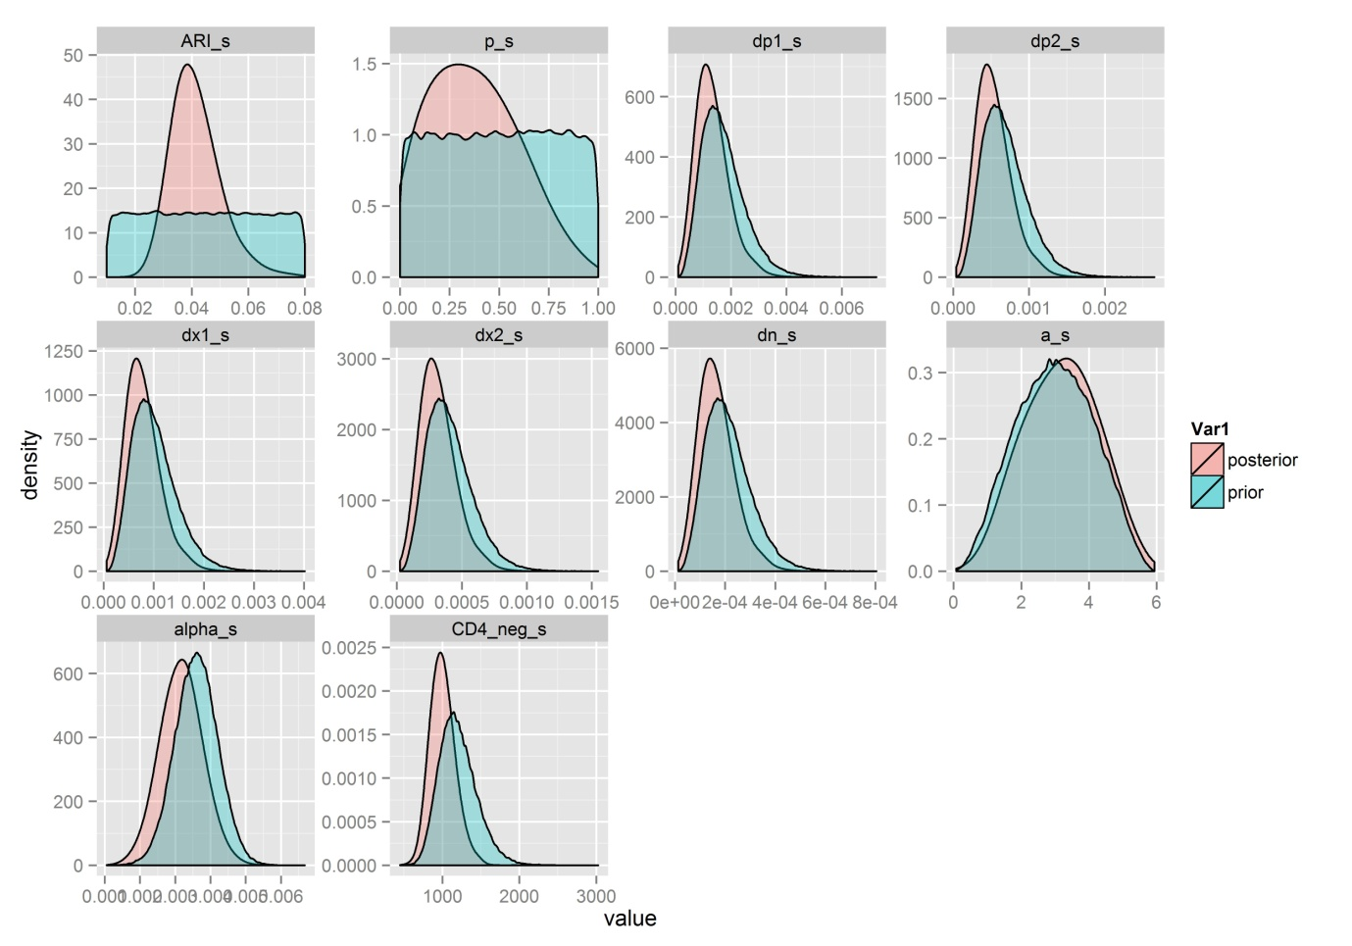
Figure S1 – Posterior distributions for the primary analysis (resistance=12.5%)
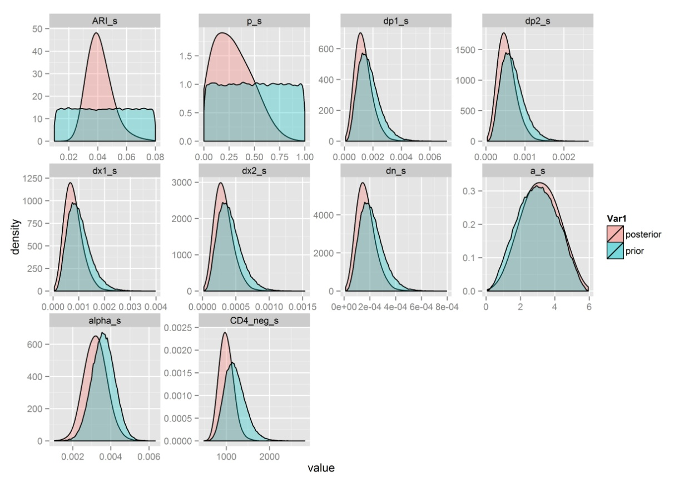
Figure S2 – Posterior distributions resistance=0%
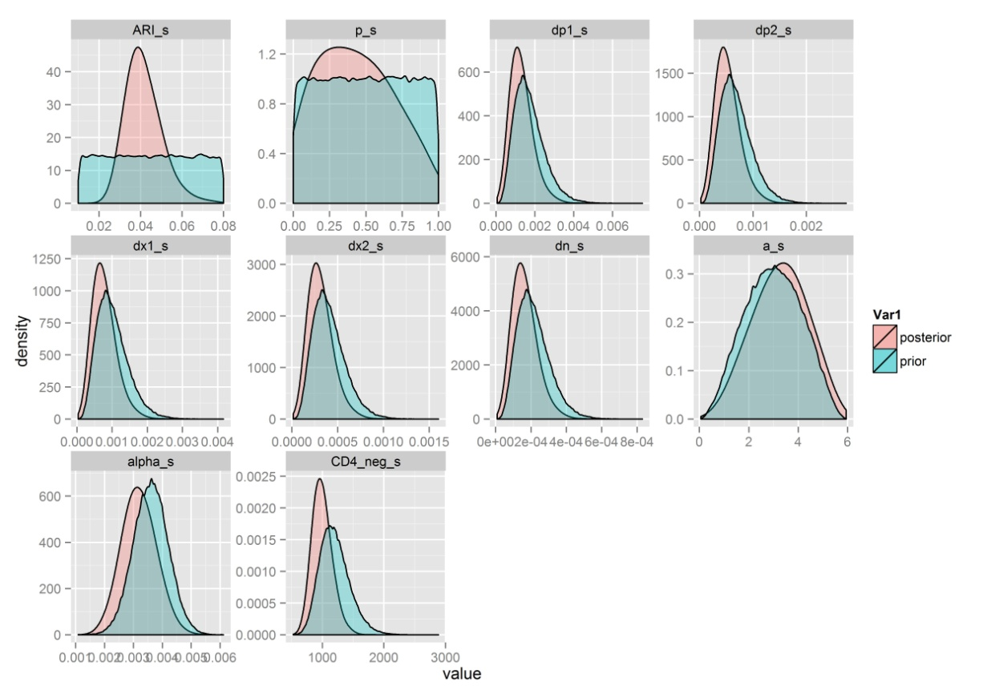
Figure S3 – Posterior distributions resistance=24%

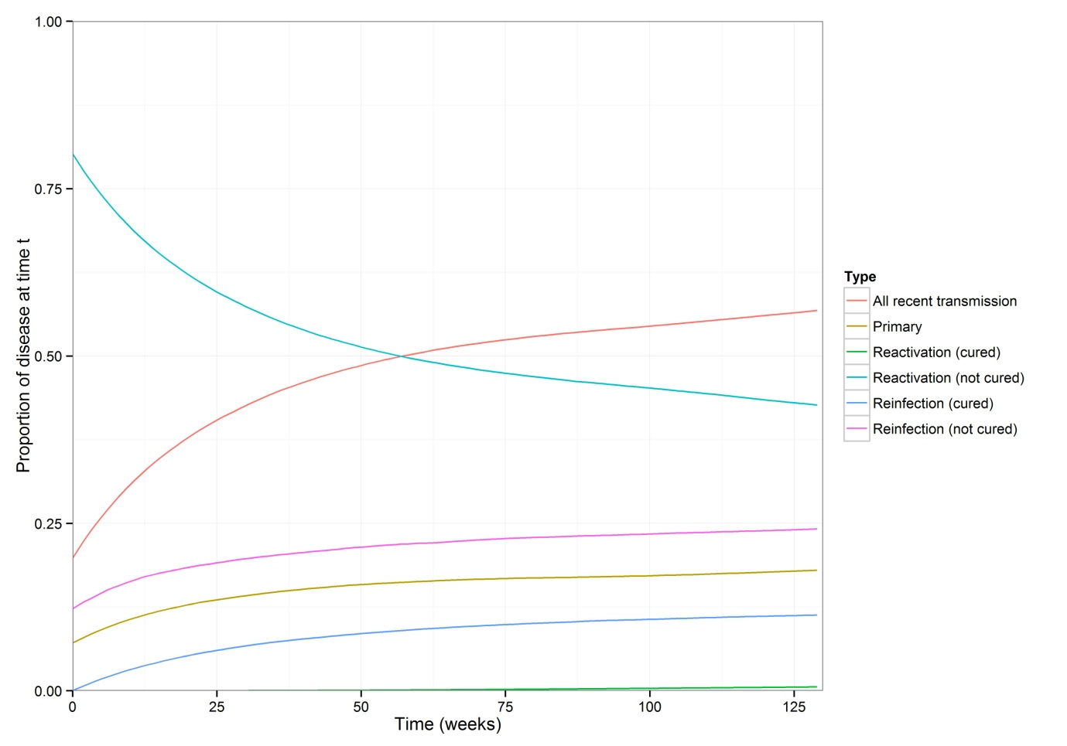
Figure S4 – Source of TB cases in the intervention arm. Median output from the 200,000 resampled model runs. “Primary” refers to disease occurring during the 2 years following first infection. “All recent transmission” includes primary TB and disease due to reinfection (within 2 years) in individuals who were cured and in those who remained latently infected following IPT. “Reactivation (cured)” refers to individuals who were cured, reinfected and developed disease (on average) 2 or more years after reinfection. “Reinfection (not cured)” refers to individuals who were not cured, reinfected and developed exogenous disease within 2 years of reinfection.

References
1. R Core Team, R: A language and environment for statistical computing, R Foundation for Statistical computing, Editor 2013: Vienna.
2. Soetaert, K., T. Petzoldt, and W. Setzer, Solving differential equations in R: Package deSolve. Journal of Statistical Software, 2010. 33(9): p. 1-25.
3. Vynnycky, E. and P.E.M. Fine, The natural history of tuberculosis: the implications of age-dependent risks of disease and the role of reinfection. Epidemiology and Infection, 1997. 119: p. 183-201.
4. Williams, B.G., et al., HIV infection, antiretroviral therapy, and CD4+ cell count distributions in African populations. J Infect Dis, 2006. 194(10): p. 1450-8.
5. Williams, B.G., et al., Antiretroviral therapy for tuberculosis control in nine African countries. Proceedings of the National Academy of Sciences of the United States of America 2010. 107(45): p. 19485-19489.
6. Sutherland, I., The ten-year incidence of clinical tuberculosis following "conversion" in 2550 individuals aged 14 to 19 years in TSRU Progress Report1968, KNCV: The Hague, The Netherlands.
7. Houben, R.M., et al., Human immunodeficiency virus increases the risk of tuberculosis due to recent re-infection in individuals with latent infection. Int J Tuberc Lung Dis, 2010. 14(7): p. 909-15.
8. Houben, R., et al., Human immunodeficiency virus associated tuberculosis more often due to recent infection than reactivation. International Journal of Tuberculosis and Lung Disease, 2011. 15(1): p. 24-31.
9. Crampin, A.C., et al., Recurrent TB: relapse or reinfection? The effect of HIV in a general population cohort in Malawi. AIDS, 2010. 24(3).
10. Sonnenberg, P., et al., HIV-1 and recurrence, relapse, and reinfection of tuberculosis after cure: a cohort study in South African mineworkers. The Lancet, 2001. 358(9294): p. 1687-1693.

