**Supplemental information**

**Animal studies.** Five juvenile pigtailed macaques (*Macaca nemestrina*) were inoculated i.v. with SIV/Delta B670 and SIV/17E-Fr, as previously described (see main text). At 12 days p.i., three animals started ART with a combination of tenofovir (30 mg/kg SID subq. for two weeks, then 10 mg/kg), darunavir (480 mg/kg BID p.o.), ritonavir (24 mg/kg BID p.o.), and the integrase inhibitor L000870812 (10 mg/kg BID p.o.).

At day 515 p.i. (503 days after ART initiation), one animal (Mn0) was mock-treated while two animals (Mn1, Mn2) were treated with ingenol-B (0.4 mg/kg/day for 30 days, then 0.6 mg/kg/day for 10 days). The concentration of ingenol-B was based on previous toxicology studies done in dogs and did not cause detectable side effects (Fig. S1). After a 15-day interruption, Mn1 and Mn2 were treated with ingenol-B (0.5 mg/kg/day) and vorinostat (6 mg/kg subq. infusion 4 times) for 10 days. ART was continued until the terminal time point. Macaques Mn0 and Mn2 remained asymptomatic throughout infection and were euthanized at days 627 and 628 p.i., respectively. Macaque Mn1 developed neurological symptoms and was euthanized at day 617 p.i.

Another group of two macaques (Mn3, Mn4) was part of a six-animal cohort used for viral rebound studies. Because the main goal was to use an ART regimen with higher penetrance in the CNS, atazanavir was used in the place of darunavir, as suggested by Dr. Scott Letendre (1). Animals started ART at 12 days p.i. with a combination of tenofovir (30 mg/kg SID subq. for two weeks, then 10 mg/kg), atazanavir (270 mg/kg BID p.o.), ritonavir (24 mg/kg BID p.o.), and L000870812 (10 mg/kg BID p.o.). At 120 p.i., several animals in the cohort showed signs of antiretroviral resistance. To maintain the cohort uniform, atazanavir was changed in all animals to darunavir (480 mg/kg BID p.o.). Once animals were virally suppressed, atazanavir treatment resumed and darunavir was stopped (189 days p.i.). However, animal Mn3 started showing signs of ART resistance and had to return to darunavir at 225 days p.i. to lower plasma VL. For animal Mn4, ART was withdrawn at day 232 p.i. and euthanasia performed four days later. For animal Mn3, ART was withdrawn at day 292 p.i. and euthanasia performed three days later.

**Table S1.** Description of human cohort from Johns Hopkins University.

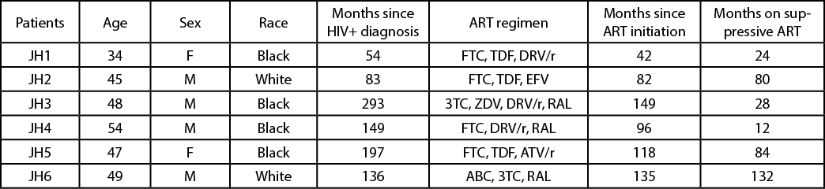

Abbreviations: ABC: abacavir; ATV: atazanavir; DRV: darunavir; EFV: efavirenz; FTC: emtricitabine; RAL: raltegravir; TDF: tenofovir; ZDV: zidovudine; /r: boosted with ritonavir.

**Table S2.** Description of human cohort from Université Libre de Bruxelles.

Abbreviations: ABC: abacavir; ATV: atazanavir; EFV: efavirenz; FTC: emtricitabine; NVP: nevirapine; TDF: tenofovir; ZDV: zidovudine; /r: boosted with ritonavir.



**Table S3.** Levels of darunavir (DRV), ritonavir (RTV), integrase inhibitor L-870812, and tenofovir (TFV) in tissues of Mn0, Pt1, and Pt2, measured by liquid chromatography–mass spectrometry (CFAR clinical pharmacology and analytical chemistry core - University of North Carolina).

|  |  |  |  |  |  |  |
| --- | --- | --- | --- | --- | --- | --- |
| **Sample ID** | | **Tissue Area (mm2)** | **DRV (ng/g)** | **RTV (ng/g)** | **L-870812 (ng/g)** | **TFV (ng/g)** |
| Mn0 | Brain - Basal Ganglia | 16 | 30 | BLQ | BLQ | 256 |
| Brain - Occipital Cortex | 114 | 2,047 | 40 | 32 | 39 |
| Brain - Parietal Cortex | 24 | 42 | BLQ | 433 | 190 |
| Liver | 12 | 4,958 | 221 | 154 | 1,072 |
| Spleen | 63 | 173 | 49 | 19 | 513 |
| Pt1 | Brain - Basal Ganglia | 26 | 346 | BLQ | 30,611 | 62 |
| Brain - Occipital Cortex | 35 | 1,031 | 93 | 52 | 91 |
| Brain - Parietal Cortex | 21 | 9,640 | BLQ | 2,077 | BLQ |
| Liver | 18 | 40,253 | 878 | 894 | 897 |
| Spleen | 17 | 2,002 | 243 | 1,021 | 1,581 |
| Pt2 | Brain - Basal Ganglia | 33 | 31 | BLQ | 28 | 292 |
| Brain - Occipital Cortex | 20 | 2,583 | 50 | 70 | 3,965 |
| Brain - Parietal Cortex | 56 | 44 | BLQ | 22 | 806 |
| Liver | 39 | 5,669 | 256 | 165 | 827 |
| Spleen | 36 | 518 | 55 | 33 | 471 |

**Table S4.** Density of SIV RNA+ cells per gram of brain tissue assessed by *in situ* hybridization.

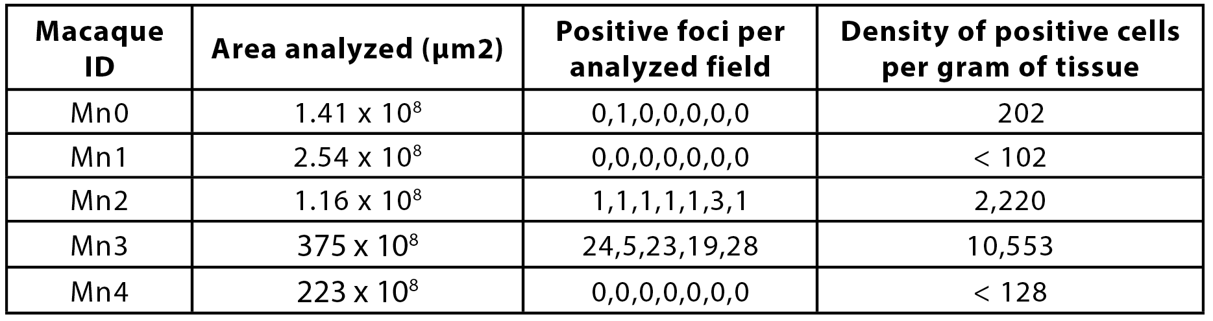

**Fig. S1.** Serum biochemistry panel of male dogs (beagle) treated for 14 days with 0.4, 1.25, or 4 mg/kg/day of orally delivered ingenol-B. Light blue denotes baseline values; dark blue denotes 14 days post treatment. ALT: Alanine aminotransferase; AST: Aspartate aminotransferase; ALP: Alkaline phosphatase; CREA: Creatinine. For mock and 4 mg/kg/day, n = 5; For 0.4 and 1.25 mg/kg/day, n = 3. Similar results were obtained in female dogs.

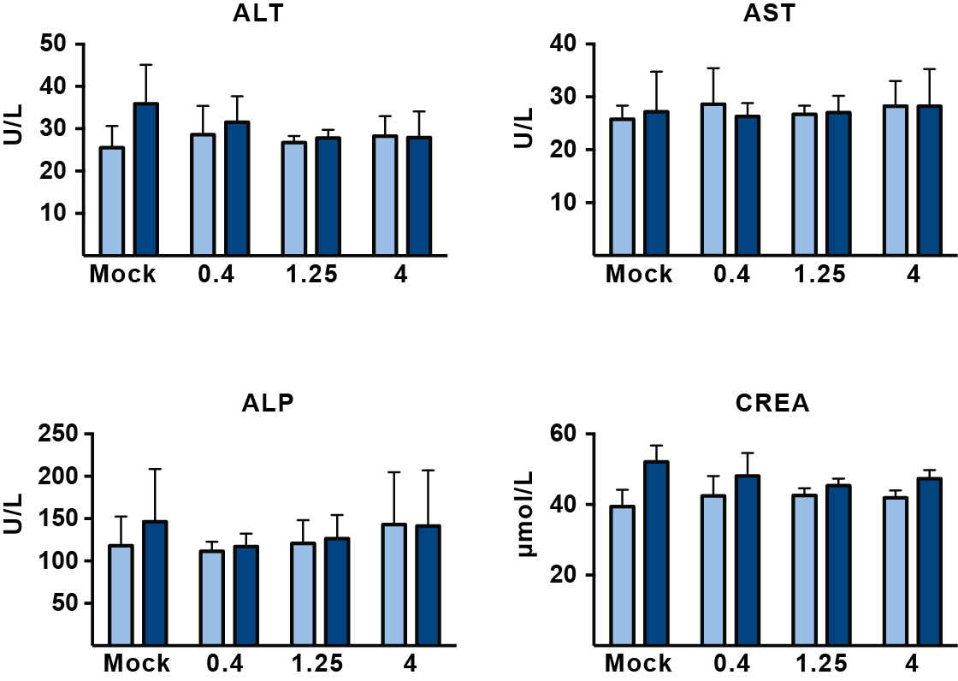

**Fig. S2.** Plasma viral load of two SIV-infected pigtailed macaques treated with ART starting at 12 days p.i. Each line color represents one animal. Full arrow marks when viral loads started being measured by ddPCR. Dashed arrows mark when ART was withdrawn for each animal (day 292 for Mn3 and 232 for Mn4). Virus rebound occurred 3-4 days after ART interruption, demonstrated by the detection of more than 100 SIV RNA copies/mL in plasma.

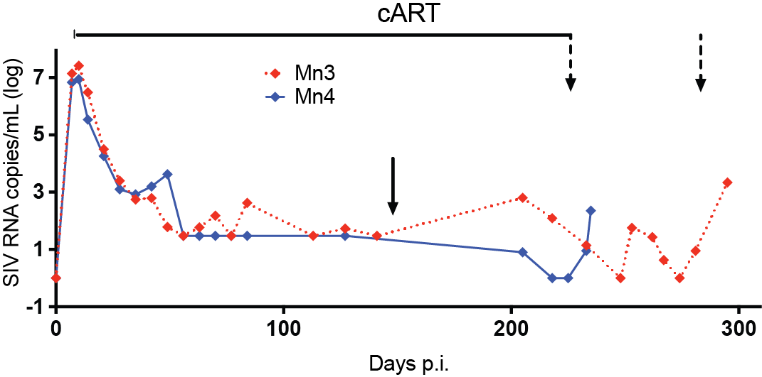

1. **Letendre S, Marquie-Beck J, Capparelli E, Best B, Clifford D, Collier AC, Gelman BB, McArthur JC, McCutchan JA, Morgello S, Simpson D, Grant I, Ellis RJ, Group C.** 2008. Validation of the CNS Penetration-Effectiveness rank for quantifying antiretroviral penetration into the central nervous system. Arch Neurol **65:**65-70.