Low abundance of colonic butyrate-producing bacteria in HIV infection is associated with microbial translocation and immune activation.

Stephanie M DILLON*¹, Jon KIBBIE*¹, Eric J LEE¹, Kejun GUO¹, Mario L. SANTIAGO¹, Gregory L. AUSTIN², Sara GIANELLA³, Alan L. LANDAY⁴, Andrew M. DONOVAN¹, Daniel N. FRANK^{1,5}, Martin D. McCARTER⁶ and Cara C. WILSON¹.
*Contributed equally.

¹Department of Medicine, University of Colorado Anschutz Medical Campus, Aurora, Colorado, USA. ²Department of Gastroenterology, University of Colorado Anschutz Medical Campus, Aurora, Colorado, USA. ³Division of Infectious Diseases, University of California, San Diego, La Jolla, California, USA. ⁴Department of Immunology-Microbiology, Rush University Medical Center, Chicago, Illinois, USA. ⁵University of Colorado Microbiome Research Consortium, Aurora, Colorado, USA. ⁶Department of Surgery, University of Colorado Anschutz Medical Campus, Aurora, Colorado, USA.

SUPPLEMENTARTY MATERIALS & METHODS:
Supplementary Table 1. Study Participant Characteristics
 | Uninfected study participants | HIV-1 infected study participants
Number of subjects | 14 | 18
Age (yrs) | 31 (23-54) | 32.5 (22-58)
Male/Female Ratio | 9/5 | 13/5
CD4 count (cells/μl) | 724 (468-1071) | 424.5 (238-782)*
Plasma Viral Load (HIV-1 RNA copies/ml) | - | 51350 (2880 – 207000)
Years since first HIV-1 seropositive test | - | 4.75 (0.25-15)
Body Mass Index (kg/m²) | 25.3 (18.5-32.3)# | 25.4 (17.4-34.7) ^{n/s}
Ethnicity: ^{n/s}
Non-Hispanic | 11 (78.6%) | 17 (94.4%)
Hispanic | 3 (21.4%) | 1 (5.6%)
Race: ^{n/s}
White/Caucasian | 10 (71.4%) | 12 (66.7%)
Black/African American | 2 (14.3%) | 5 (27.7%)
Asian | 2 (14.3%) | 1 (5.6%)
Values are shown as median (range) except for Ethnicity and Race which are shown as the number and percentage of each cohort. Statistical analysis was performed using Mann-Whitney test for comparisons between uninfected and HIV-1 infected subjects and the Fisher Exact test or Chi-square test for comparison of categorical data. n/s: not statistically different; *p<0.0001. #One subject had no weight or height values recorded at time of study therefore n=13.

Clinical study exclusion criteria.
Study exclusion criteria are extensively detailed elsewhere [1]. For HIV-1-infected subjects included 1) presence of AIDS-defining condition within 6 months and a CD4 count <200cells/μl within 3 months of clinic visit, 2) HIV-1 plasma viral load <2000 HIV-1 RNA copies/ml. Exclusion for all subjects included 1) medical history of a bleeding disorder, rectal bleeding or surgical history of left-sided colonic, rectal or anal resection or anastomosis, 2) medical history of inflammatory bowel disease or other intestinal inflammatory disorders, 3) chronic or acute medical conditions such as cancer, heart disease, diabetes, or hepatitis, 4) bacterial infection requiring antibiotic treatment in the 3 months prior to clinic visit and 5) continuous for more than 3 days within the past 60 days of immunosuppressives, immune modulators or probiotics.

SYBR-Green quantitative PCR for butyryl-CoA-CoA transferase transcripts
Primers (Forward primer 5’ CTKATCGTNGAYGAGATTCCRAACGG, Reverse primer 5’ CCGTTGATCTTTCCTGCYTTTGCRAT) were designed in the conserved regions of butyryl-CoA-CoA transferase genes of following commensal bacteria strains: Eubacterium rectale ATCC33656 (CP001107.1), E. hallii L2-7 AAZ23219 (DQ072258.2), Roseburia sp. A2-183 AAX19960 (AY796317.2), and Anaerostipes caccae L1-92 ABA39273 (DQ151450.2). Sample cDNA was reverse-transcribed from 1 µg of RNA using random hexamers in the Qiagen QuantiTect Reverse Transcription kit. cDNA was diluted 1:5 and 5 µl added to make a final concentration of 1x Quantitect SYBR green PCR reagent containing 5 pmol of each primer. Quantitative PCR was run on Biorad CFX96 real-time PCR machine under the following conditions: 95°C for 15 min followed by 40 cycles of 94°C 30s, 53°C 30s, 72°C 30s. Specificity was determined by melt curve analysis. qPCR data was analyzed with CFX Manager software (Biorad). Copy number was interpolated using a standard curve with 108–102 copies of butyryl-CoA-CoA transferase plasmid standard. 16S DNA copy numbers were generated in our samples following the methods outlined in Nadkarni et. al., 2002 [2]. In short, a Taqman based assay using pan-bacterial primers was used to detect 16S DNA in each sample. To infer 16S template counts we used a standard curve of a cloned Clostridial 16S gene[3].

Lamina propria mononuclear cell (LPMC) isolation and in vitro culture.
LPMC were isolated from macroscopically normal human jejunum tissue (n=9). Patients signed releases for the tissue prior to surgery and were screened and excluded for any recent chemotherapy, radiation treatments, inflammatory bowel disease and the use of immunosuppressives. Tissue samples were de-identified and the use of the samples for experimental purposes was granted exempt status by COMIRB. LPMC were isolated from tissue samples by a two-step digestion process as previously described [4-8]. HIV-1 and mock-infected LPMC were cultured in RPMI (Invitrogen, Carlsbad, CA) + 10% human AB serum (Gemini Bioproducts, West Sacramento, CA) + 1% penicillin/streptomycin/L-glutamine (Life Technologies, Grand Island, NY) + 500ug/ml Zosyn (Wyeth, Madison, NY) (cRPMI). For all assays, butyrate was added to LPMC cultures using a stock solution (20mM, pH of 7.5) of butyric acid diluted in cRPMI that was freshly prepared for each assay.

Supplementary Table S2. Antibodies and dyes used to determine lamina propria (LP) T cell activation and infection in the in vitro LPMC model.

Antibody | Clone | Company | Location
T cell identification
PE-Texas Red (ECD) CD3 | UCHT1 | Beckman Coulter | Brea, CA
APC CD8 | RPA-T8 | Tonbo Biosciences | San Diego, CA
T cell activation
AF700 CD38 | HIT2 | eBiosciences | San Diego, CA
AF700 mouse Ig1 isotype control |  | eBiosciences
APC-Cy7 HLA-DR | L243 | Biolegend | San Diego, CA
T cell infection
PE HIV-1 Core Antigen (p24) | KC57 | Beckman Coulter
Viability
Zombie aqua Live/Dead viability dye |  | Biolegend

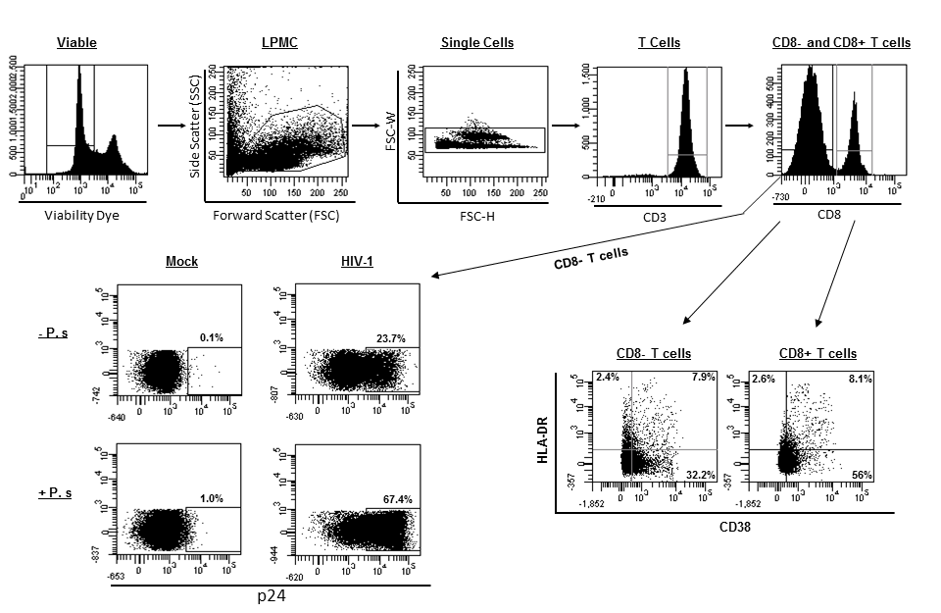
Supplementary Figure 1. Representative gating strategy to measure lamina propria (LP) T cell activation and productive HIV-1 infection levels in LP mononuclear cells (LPMC). Viable, leukocytes were identified using a viability dye and size (Forward Scatter, FSC) and Side scatter (SSC) properties. Single cells were identified using doublet exclusion gate (FSC-W vs FSC-H). T cells were identified as CD3+ and then CD8+ and CD8- T cell populations gated. CD4 T cells were identified as CD8- due reported decreases in CD4 expression during HIV-1 infection [5, 8]. T cell activation was enumerated as the percentage of T cells co-expressing HLA-DR and CD38. Activation marker expression was determined by FMO (HLA-DR) and isotype control (CD38). LP CD4 T cell infection was determined by first gating on CD8- T cells and then gating HIV-1 Core Antigen (p24) positive cells. Background p24 staining was established on matched mock-infected cells.

SUPPLEMENTARTY RESULTS:

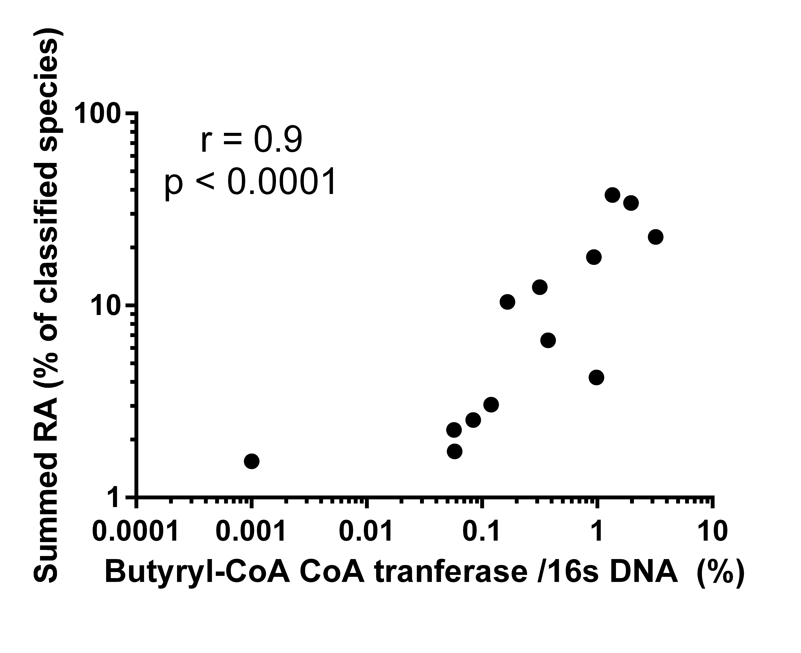
Supplementary Figure 2. Butyryl-CoA CoA transferase bacterial DNA expression correlates with the abundance of butyrate producing bacteria (BPB) species. The relative abundance (RA) of summed BPB species was determined in the stool of uninfected study participants (n=13). RA of each of the 15 detected BPB species were pooled together for each study participant. Butyryl-CoA CoA transferase copy number was determined in the stool by PCR reaction. PCR data was normalized to 16s DNA in each sample. The Spearman test was used to determine correlations between variables.

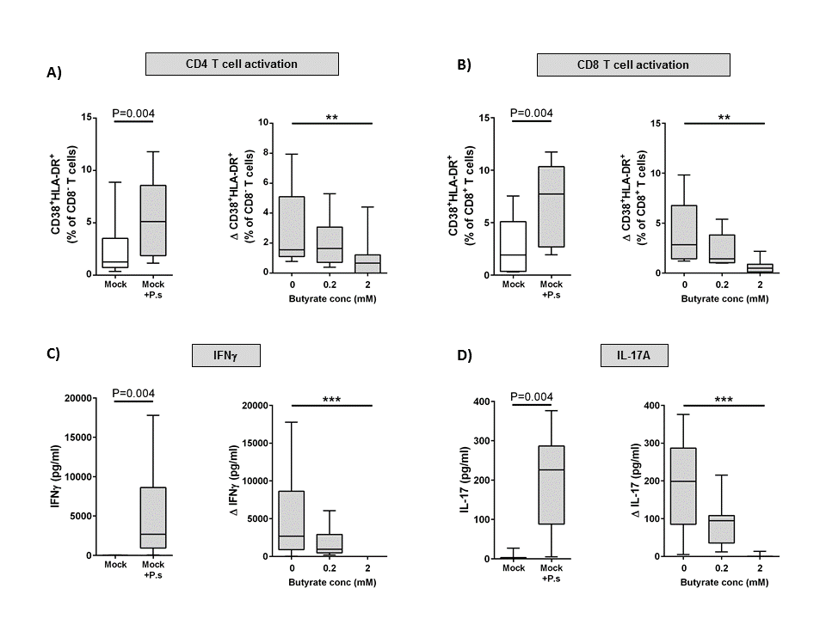
Supplementary Figure 3. Butyrate decreases P. stercorea driven lamina propria CD4 and CD8 T cell activation and cytokine production in the absence of HIV-1 infection in vitro. Lamina propria mononuclear cells (LPMC) were spinoculated with mock-infected culture supernatants and cultured with or without P. stercorea and butyrate (0.2mM, 2mM) for 4 days and levels of T cell activation and cytokine production determined (n=9). Percentages of LP CD4 (A) and CD8 (B) T cells co-expressing CD38 and HLA-DR were assessed using multi-color flow cytometry. FMO and isotype control values have been subtracted. Levels of IFNγ (C) and IL-17A (D) in culture supernatants at day 4 were evaluated by ELISA. P. stercorea-specific (Δ) values are shown as net values (P. stercorea/mock minus mock alone). Statistical significance was determined using the Wilcoxon matched pairs signed rank test and the Friedman’s test with comparisons to no butyrate controls. (**P<0.01, ***P<0.001). Data displayed as box and whiskers are represented with the box extending from the 25th to 75th percentile with the median value represented as the central line in the box and maximum and minimum values represented by the whiskers.

REFERENCES
1. Dillon SM, Lee EJ, Kotter CV, Austin GL, Dong Z, Hecht DK, et al. An altered intestinal mucosal microbiome in HIV-1 infection is associated with mucosal and systemic immune activation and endotoxemia. Mucosal Immunol 2014,7:983-994.
2. Nadkarni MA, Martin FE, Jacques NA, Hunter N. Determination of bacterial load by real-time PCR using a broad-range (universal) probe and primers set. Microbiology 2002,148:257-266.
3. Frank DN, St Amand AL, Feldman RA, Boedeker EC, Harpaz N, Pace NR. Molecular-phylogenetic characterization of microbial community imbalances in human inflammatory bowel diseases. Proc Natl Acad Sci U S A 2007,104:13780-13785.
4. Dillon SM, Lee EJ, Donovan AM, Guo K, Harper MS, Frank DN, et al. Enhancement of HIV-1 infection and intestinal CD4+ T cell depletion ex vivo by gut microbes altered during chronic HIV-1 infection. Retrovirology 2016,13:5.
5. Dillon SM, Manuzak JA, Leone AK, Lee EJ, Rogers LM, McCarter MD, et al. HIV-1 infection of human intestinal lamina propria CD4+ T cells in vitro is enhanced by exposure to commensal Escherichia coli. J Immunol 2012,189:885-896.
6. Dillon SM, Rogers LM, Howe R, Hostetler LA, Buhrman J, McCarter MD, et al. Human intestinal lamina propria CD1c+ dendritic cells display an activated phenotype at steady state and produce IL-23 in response to TLR7/8 stimulation. J Immunol 2010,184:6612-6621.
7. Howe R, Dillon S, Rogers L, McCarter M, Kelly C, Gonzalez R, et al. Evidence for dendritic cell-dependent CD4(+) T helper-1 type responses to commensal bacteria in normal human intestinal lamina propria. Clin Immunol 2009,131:317-332.
8. Steele AK, Lee EJ, Manuzak JA, Dillon SM, Beckham JD, McCarter MD, et al. Microbial exposure alters HIV-1-induced mucosal CD4+ T cell death pathways Ex vivo. Retrovirology 2014,11:14.

