Appendix

A1. Detailed Description of Simulation Approach
We created synthetic datasets to understand the impact of incorporating ANC-RT data in EPP. We use an R version of the EPP model (https://github.com/bsheng99/rt_paper_sim), and fit the EPP using both r-trend and r-spline with equilibrium prior. The simulation procedure is as follows:
- Fit the EPP r-spline model to the observed ANC-UAT and NPS data of some country. (We plot the observed HIV prevalence rates in Appendix Figure 1(b), and show the HIV prevalence ratio of pregnant women to adults in that country $φ_{t}$ in Appendix Figure 1(a).) Use one posterior sample (randomly chosen from 3000 total posterior samples) of the prevalence trajectory $ρ_{t}$ and other associated parameters ($α_{UAT}$, $δ_{SP}^{2}$, $b_{s}$, $τ^{2}$) to create the "true” fit. (We show the “true” population prevalence $ρ_{t}$ in Appendix Figure 1(b).)
- Replace observed ANC-UAT and NPS data points by simulated ones. (Appendix Figures 2(a), 2(c), 2(e), 2(g) show an example of simulated ANC-UAT and NPS prevalence.) Then, fit the EPP model to the simulated ANC-UAT and NPS data, and compute the median fit (of 3000 posterior samples).
  - For simulating NPS prevalence, use binomial draws for each year t. For the binomial sample size, use the observed sample size. For the binomial probability, use the “true” population prevalence $ρ_{t}$.
  - For simulating ANC-UAT prevalence, use binomial draws for each site s and year t. For the binomial sample size, use the observed sample size. For the binomial probability, sum the probit-scale pregnant women prevalence (${}^{-1}(ρ_{t}*φ_{t})$, where $ρ_{t}$ is the “true” population prevalence, and $φ_{t}$ is the ratio of pregnant women to adult prevalence), the “true” ANC-UAT calibration parameter $α_{UAT}$, the “true” site-effect $b_{s}$ for site s, and non-sampling error drawn from $N(0,δ_{SP}^{2})$ where $δ_{SP}^{2}$ is the “true” site-level non-sampling variance, and transform the probit-scale sum to probability scale.
- Generate the site-level ANC-RT data by using an arbitrary calibration parameter $β_{RT}=-0.1$, which comes from a preliminary comparison between ANC-RT data and ANC-UAT data. ANC-UAT data ends in 2010, and ANC-RT data begins in 2011.
  - Generate 11 ANC-RT site prevalences as a continuation of the 11 existing ANC-UAT sites. (Appendix Figure 2(c) shows an example of 11 simulated ANC-RT site prevalences.) Then, fit the EPP model to all the synthetic data (ANC-UAT, NPS, 11 ANC-RT sites), and compute the median fit (of 3000 posterior samples).
To simulate prevalence for these continuation ANC-RT sites, use binomial draws for each site s and year t. For the binomial sample size, use an arbitrary sample size of 1000. For the binomial probability, sum the probit-scale pregnant women prevalence (${}^{-1}(ρ_{t}*φ_{t})$, where $ρ_{t}$ is the “true” population prevalence, and $φ_{t}$ is the ratio of pregnant women to adult prevalence), the “true” ANC-UAT calibration parameter $α_{UAT}$, the “true” ANC-RT calibration parameter $β_{RT}$, the “true” site-effect $b_{s}$ for site s, and non-sampling error drawn from $N(0,δ_{SP}^{2})$ where $δ_{SP}^{2}$ is the “true” site-level non-sampling variance, and transform the probit-scale sum to probability scale.
  - Generate additional ANC-RT site prevalence rates that are not a continuation of the existing ANC-UAT sites. Simulate 50 total ANC-RT sites, and either include the 11 continuation ANC-RT sites (generate 39 non-continuation ANC-RT sites) or exclude them (generate 50 non-continuation ANC-RT sites). (Appendix Figure 2(e) shows an example of 50 simulated ANC-RT sites where 11 sites are a continuation of ANC-UAT.) Then, fit the EPP model to all the synthetic data (ANC-UAT, NPS, 50 ANC-RT sites), and compute the median fit.
To simulate prevalence for these non-continuation ANC-RT sites, use binomial draws for each site s and year t. For the binomial sample size, use an arbitrary sample size of 1000. For the binomial probability, sum the probit-scale pregnant women prevalence (${}^{-1}(ρ_{t}*φ_{t})$, where $ρ_{t}$ is the “true” population prevalence, and $φ_{t}$ is the ratio of pregnant women to adult prevalence), the “true” ANC-UAT calibration parameter $α_{UAT}$, the “true” ANC-RT calibration parameter $β_{RT}$, the site-effect drawn from $N(0,τ^{2})$ where $τ^{2}$ is the “true” site-effect variance, and non-sampling error drawn from $N(0,δ_{SP}^{2})$ where $δ_{SP}^{2}$ is the “true” site-level non-sampling variance, and transform the probit-scale sum to probability scale.
  - Generate 450 additional ANC-RT site prevalences that are not a continuation of the existing ANC-UAT sites, and this gives 500 total simulated ANC-RT sites. Include the 11 continuation ANC-RT sites in this site total.
- Generate the census-level ANC-RT data by aggregating the site-level ANC-RT obtained from Step 3(c). (Appendix Figure 2(g) shows an example of aggregated census-level ANC-RT prevalence.) Perform aggregation on the probability scale, not the probit scale. Then, fit the EPP model to all the synthetic data (ANC-UAT, NPS, census-level ANC-RT), and compute the median fit.

In summary, the availability of ANC-RT data varies in four dimensions that are 1) census-level vs site-level; 2) the number of sites; 3) the overlap with ANC-UAT sites; 4) the number of data years. From the first three dimensions, we have five different scenarios for the availability of ANC-RT data based on realistic cases of ANC-RT usage. These scenarios include no ANC-RT data, ANC-RT sites solely as a continuation of existing ANC-UAT sites, additional ANC-RT sites with continuation of existing ANC-UAT sites, entirely new ANC-RT sites chosen to be more geographically representative, and census-level ANC-RT data.
- “No ANC-RT” – No ANC-RT (ANC-UAT and NPS only)
- “11 Original” – 11 ANC-RT sites as a continuation of ANC-UAT sites,
- “50 with Continuity” – 50 ANC-RT sites with 11 sites as a continuation of ANC-UAT sites,
- “50 Resampled” – 50 ANC-RT sites with no continuation of ANC-UAT sites,
- “Census” – 500 ANC-RT sites aggregated to census-level.

For each scenario except “no ANC-RT”, we vary the number of years of simulated ANC-RT data at 1, 3, and 5 years. For each setting of scenario and year, we perform 50 replications under different seeds.

After simulating ANC-RT, ANC-UAT, and NPS data, we fit the EPP r-spline and r-trend models to the synthetic datasets, and estimate the HIV prevalence and additional parameters. During estimation, we used prior distributions including $α_{UAT}\sim N(0.15, 1.0)$ [14], $β_{RT}\sim N(0, 1.0)$, $α_{RT}\sim N(0, 1.0)$, $δ_{SP}^{2}\sim Exponential(mean=0.015)$, $δ_{C}^{2}\sim Exponential(mean=0.015)$.

After fitting the data, we compare the median fit (of 3000 posterior samples) of synthetic data with the “true” fit from Step 1. Specifically, we compute the error in prevalence estimation in 2011 (the first year of simulated ANC-RT data) and 2016 ($ρ_{2011}$, $ρ_{2016}$) and the year-on-year change in prevalence between 2010 to 2011 and 2015 to 2016 ($ρ_{2011}-ρ_{2010}$, $ρ_{2016}-ρ_{2015}$). (Appendix Figures 2(b), 2(d), 2(f), 2(h) show example comparisons of median prevalence and “true” prevalence.) We also compare estimation of the additional model parameters $α_{UAT}$, $β_{RT}$, and $δ_{SP}^{2}$. For each setting, we report mean absolute error (MAE) across the 50 seeds. (Appendix Figures 2(b), 2(d), 2(f), 2(h) show example fit evaluation under 5 ANC-RT data years and 1 ANC-RT data year.)

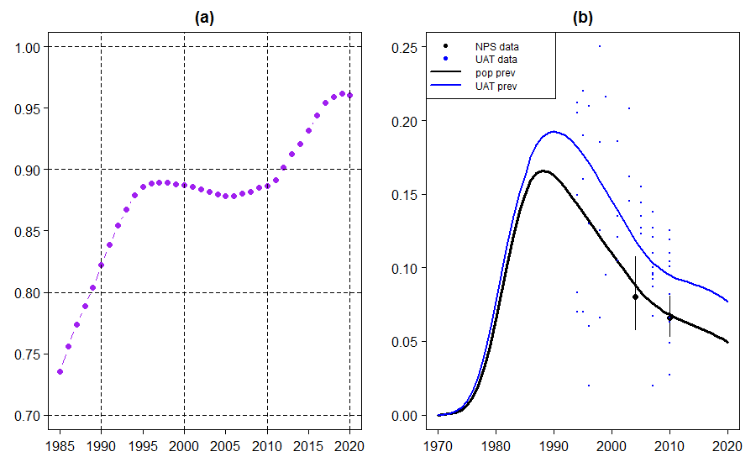

Appendix Figure 1. Observed Data and “True” Fit. (a) HIV prevalence ratio of pregnant women to adults. (b) observed HIV prevalence (NPS with 95% CI and ANC-UAT) and “true” fit (fitted population prevalence and fitted ANC-UAT prevalence) from one posterior sample.

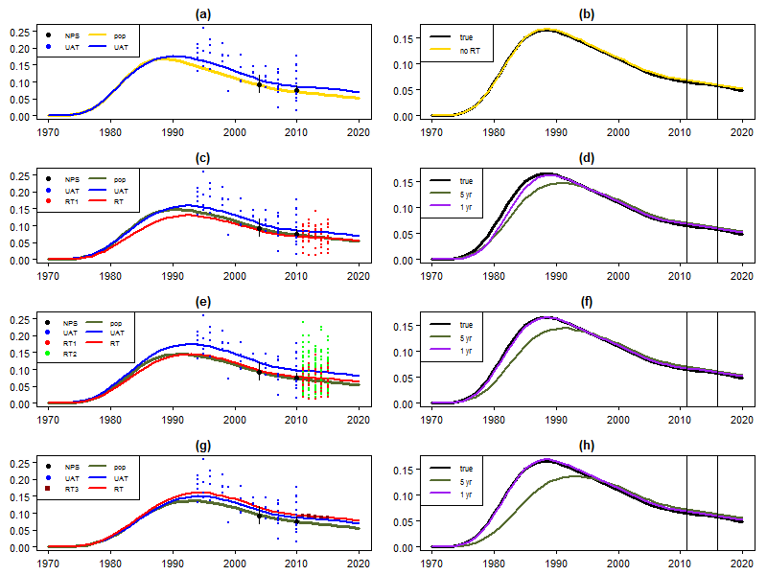
Appendix Figure 2. Fit of Simulated Data. (a) simulated data (NPS and ANC-UAT) and fitted prevalence (population and ANC-UAT). (b) population prevalence under “true” fit and “No ANC-RT” fit. (c) simulated data (NPS, ANC-UAT, and site-level ANC-RT as a continuation of existing ANC-UAT sites “RT1”) and fitted prevalence (population, ANC-UAT, ANC-RT). (d) population prevalence under “true” fit, and 11 continuation ANC-RT sites with 1 and 5 years of ANC-RT data. (e) simulated data (NPS, ANC-UAT, site-level ANC-RT as a continuation of existing ANC-UAT sites “RT1”, and site-level ANC-RT that is not a continuation of existing ANC-UAT sites “RT2”) and fitted prevalence (population, ANC-UAT, ANC-RT). (f) population prevalence under “true” fit, and 50 ANC-RT sites (with 11 as a continuation of ANC-UAT sites) with 1 and 5 years of ANC-RT data. (g) simulated data (NPS, ANC-UAT, and census-level ANC-RT “RT3”) and fitted prevalence (population, ANC-UAT, ANC-RT). (h) population prevalence under “true” fit, and census-level ANC-RT with 1 and 5 years of ANC-RT data.

A2. Results Using R-Trend

After simulating ANC-RT, ANC-UAT, and NPS data, we estimate the HIV prevalence and additional parameters. Under the various settings of the EPP model, ANC-RT scenario, and number of ANC-RT data years, we compare the estimated and “true” values of certain quantities. Here, we present the results for the r-trend model; that is, the data was still simulated under the r-spline model, but we now fit the synthetic data under the r-trend model. (In the main text, we present the results from fitting the synthetic data under the r-spline model)

For adults, the “true” values of HIV prevalence in 2011 ($ρ_{2011}$) and 2016 ($ρ_{2016}$) were 6.62% and 5.74%, respectively. For HIV prevalence change, the “true” value of the change from 2010 to 2011 was -0.193%, and the “true” value of the change from 2015 to 2016 was -0.179%.

  - Site-Level ANC-RT with Continuation from ANC-UAT Sites
Table 1 presents results for “No ANC-RT” and the two site-level ANC-RT scenarios (11 and 50 ANC-RT sites) with continuation from ANC-UAT sites.

With more years of ANC-RT data, for prevalence, prevalence change, and $δ_{SP}^{2}$, the MAE generally decreases, but the mean difference did not always improve. For example, for estimation of $ρ_{2016}$ with 11 ANC-RT sites, the MAE decreases from 0.772% for “No ANC-RT” and 0.740% for 1 ANC-RT data year to 0.676% for 5 ANC-RT data years; however, the mean difference (bias) increases from 0.275% for “No ANC-RT” and 0.305% for 1 ANC-RT data year to 0.360% for 5 ANC-RT data years. For $α_{UAT}$ and $β_{RT}$, the MAE does not show a clear pattern against the years of ANC-RT data.

Comparing the two site-level ANC-RT scenarios, the scenario with 50 ANC-RT sites has lower MAE and mean difference for $β_{RT}$. Increasing from 11 to 50 ANC-RT sites, the MAE decreases from 0.0490 to 0.0452 for 1 ANC-RT data year, from 0.0453 to 0.0428 for 3 ANC-RT data years, and from 0.0503 to 0.0454 for 5 ANC-RT data years; the mean difference decreases in magnitude from -0.0170 to -0.0102 for 1 ANC-RT data year, from -0.0196 to -0.0160 for 3 ANC-RT data years, and from -0.0242 to -0.0141 for 5 ANC-RT data years. The scenario with 50 ANC-RT sites has generally higher MAE for $α_{UAT}$ (except for 3 ANC-RT data years), and generally lower MAE for $δ_{SP}^{2}$ (except for 1 ANC-RT data year). For prevalence and prevalence change, with more ANC-RT sites, the MAE decreases for 5 ANC-RT data years, but generally does not change much for 1 and 3 ANC-RT data years.

  - Census-Level ANC-RT
Table 2 presents results for the “No ANC-RT” scenario and the census-level ANC-RT scenario.

With more years of ANC-RT data, for HIV prevalence and prevalence change, the MAE generally decreases, but the mean difference did not always improve. For example, for estimation of $ρ_{2016}$, the MAE decreases from 0.772% for “No ANC-RT” and 0.771% for 1 ANC-RT data year to 0.575% for 5 ANC-RT data years; however, the mean difference increases from 0.275% for “No ANC-RT” and 0.233% for 1 ANC-RT data year to 0.323% for 5 ANC-RT data years. With more years, the MAE decreases for $α_{UAT}$, but does not show a clear pattern for $δ_{SP}^{2}$.

  - Comparing Site-Level ANC-RT with and without Continuation from ANC-UAT Sites
Table 3 presents results for the two site-level ANC-RT scenarios with 50 ANC-RT sites.

With more years of ANC-RT data, for HIV prevalence, prevalence change, and $δ_{SP}^{2}$, the MAE generally decreases, but the mean difference did not always improve. For example, for estimation of $δ_{SP}^{2}$ without continuation from ANC-UAT sites, the MAE decreases from 0.00393 for 1 ANC-RT data year to 0.00128 for 5 ANC-RT data years; however, the mean difference changes from 0.00036 for 1 ANC-RT data year to -0.00053 for 5 ANC-RT data years. For $α_{UAT}$ and $β_{RT}$, the MAE does not show a strong pattern against the years of ANC-RT data.

In general, having continuation from ANC-UAT sites does not significantly change MAE for prevalence and prevalence change. For $β_{RT}$, continuation improves the MAE and mean difference. The MAE decreases from 0.0651 to 0.0452 for 1 ANC-RT data year, from 0.0605 to 0.0428 for 3 ANC-RT data years, and from 0.0630 to 0.0454 for 5 ANC-RT data years; the mean difference decreases in magnitude from 0.0466 to -0.0102 for 1 ANC-RT data year, from 0.0388 to -0.0160 for 3 ANC-RT data years, and from 0.0408 to -0.0141 for 5 ANC-RT data years. Continuation generally increases the MAE for $α_{UAT}$ (except for 3 ANC-RT data years), and generally decreases the MAE for $δ_{SP}^{2}$ (except for 3 ANC-RT data years).

Quantity | “True” Value | ANC-RT Data Scenario | Mean Difference |  |  | MAE
 |  |  | Years of RT Data |  |  | Years of RT Data
 |  |  | 1 | 3 | 5 | 1 | 3 | 5
Prevalence in 2011 ($ρ_{2011}$) | 6.615% | No ANC-RT | 0.007% |  |  | 0.483%
 |  | 11 Original | 0.044% | 0.094% | 0.060% | 0.474% | 0.482% | 0.450%
 |  | 50 with Continuity | 0.071% | 0.103% | 0.025% | 0.467% | 0.468% | 0.425%
Prevalence Change 2010-2011 ($ρ_{2011}-ρ_{2010}$) | -0.193% | No ANC-RT | 0.026% |  |  | 0.107%
 |  | 11 Original | 0.031% | 0.047% | 0.046% | 0.102% | 0.104% | 0.091%
 |  | 50 with Continuity | 0.038% | 0.054% | 0.030% | 0.105% | 0.104% | 0.068%
Prevalence in 2016 ($ρ_{2016}$) | 5.738% | No ANC-RT | 0.275% |  |  | 0.772%
 |  | 11 Original | 0.305% | 0.390% | 0.360% | 0.740% | 0.774% | 0.676%
 |  | 50 with Continuity | 0.343% | 0.426% | 0.221% | 0.776% | 0.778% | 0.539%
Prevalence Change 2015-2016 ($ρ_{2016}-ρ_{2015}$) | -0.179% | No ANC-RT | 0.077% |  |  | 0.092%
 |  | 11 Original | 0.072% | 0.072% | 0.075% | 0.092% | 0.088% | 0.093%
 |  | 50 with Continuity | 0.072% | 0.078% | 0.049% | 0.090% | 0.095% | 0.069%
Calibration btw UAT and RT ($β_{RT}$) | -0.1000 | No ANC-RT | NA |  |  | NA
 |  | 11 Original | -0.0170 | -0.0196 | -0.0242 | 0.0490 | 0.0453 | 0.0503
 |  | 50 with Continuity | -0.0102 | -0.0160 | -0.0141 | 0.0452 | 0.0428 | 0.0454
Calibration btw UAT and pregnant women ($α_{UAT}$) | 0.2402 | No ANC-RT | -0.0328 |  |  | 0.0480
 |  | 11 Original | -0.0369 | -0.0409 | -0.0412 | 0.0504 | 0.0526 | 0.0532
 |  | 50 with Continuity | -0.0092 | -0.0067 | 0.0114 | 0.0657 | 0.0488 | 0.0634
Non-Sampling Variance of UAT ($δ_{SP}^{2}$) | 0.01301 | No ANC-RT | 0.00014 |  |  | 0.00398
Shared Non-Sampling Variance of UAT and RT ($δ_{SP}^{2}$) | 0.01301 | 11 Original | 0.00031 | -0.00004 | 0.00015 | 0.00332 | 0.00281 | 0.00204
 |  | 50 with Continuity | 0.00079 | -0.00075 | -0.00045 | 0.00360 | 0.00176 | 0.00117

Appendix Table 1. Site-Level ANC-RT with Continuation from ANC-UAT Sites. Mean difference and MAE (Mean Absolute Error) between estimated and “true” value of quantities. Results given for each data scenario at 1, 3, and 5 years of simulated ANC-RT data (except “No ANC-RT”). For “No ANC-RT”, the fit only uses simulated NPS and ANC-UAT data, and does not use simulated ANC-RT data. Each setting (of data scenario and year) uses 50 replicates under different seeds.

Quantity | “True” Value | ANC-RT Data Scenario | Mean Difference  (or Mean Estimate) |  |  | MAE
 |  |  | Years of RT Data |  |  | Years of RT Data
 |  |  | 1 | 3 | 5 | 1 | 3 | 5
Prevalence in 2011 ($ρ_{2011}$) | 6.615% | No ANC-RT | 0.007% |  |  | 0.483%
 |  | Census | 0.015% | 0.050% | 0.017% | 0.469% | 0.473% | 0.438%
Prevalence Change 2010-2011 ($ρ_{2011}-ρ_{2010}$) | -0.193% | No ANC-RT | 0.026% |  |  | 0.107%
 |  | Census | 0.023% | 0.044% | 0.041% | 0.111% | 0.098% | 0.077%
Prevalence in 2016 ($ρ_{2016}$) | 5.738% | No ANC-RT | 0.275% |  |  | 0.772%
 |  | Census | 0.233% | 0.371% | 0.323% | 0.771% | 0.740% | 0.575%
Prevalence Change 2015-2016 ($ρ_{2016}-ρ_{2015}$) | -0.179% | No ANC-RT | 0.077% |  |  | 0.092%
 |  | Census | 0.062% | 0.080% | 0.076% | 0.087% | 0.091% | 0.076%
Calibration btw UAT and pregnant women ($α_{UAT}$) | 0.2402 | No ANC-RT | -0.0328 |  |  | 0.0480
 |  | Census | -0.0323 | -0.0322 | -0.0310 | 0.0479 | 0.0470 | 0.0467
Non-Sampling Variance of UAT ($δ_{SP}^{2}$) | 0.01301 | No ANC-RT | 0.00014 |  |  | 0.00398
 |  | Census | 0.00005 | 0.00008 | 0.00005 | 0.00396 | 0.00398 | 0.00399
Calibration btw RT and pregnant women ($α_{RT}$) | NA | Census | 0.2202 | 0.2156 | 0.2168 | NA | NA | NA
Non-Sampling Variance of Census RT ($δ_{C}^{2}$) | NA | Census | 0.01171 | 0.00226 | 0.00045 | NA | NA | NA

Appendix Table 2. Census-Level ANC-RT. Mean difference (or mean estimate for $α_{RT}$ and $δ_{C}^{2}$) and MAE (Mean Absolute Error) between estimated and “true” value of quantities. Results given for each data scenario at 1, 3, and 5 years of simulated ANC-RT data (except “No ANC-RT”). For “No ANC-RT”, the fit only uses simulated NPS and ANC-UAT data, and does not use simulated ANC-RT data. Each setting (of data scenario and year) uses 50 replicates under different seeds.

Quantity | “True” Value | ANC-RT Data Scenario | Mean Difference |  |  | MAE
 |  |  | Years of RT Data |  |  | Years of RT Data
 |  |  | 1 | 3 | 5 | 1 | 3 | 5
Prevalence in 2011 ($ρ_{2011}$) | 6.615% | 50 Resampled | 0.049% | 0.076% | 0.011% | 0.494% | 0.456% | 0.417%
 |  | 50 with Continuity | 0.071% | 0.103% | 0.025% | 0.467% | 0.468% | 0.425%
Prevalence Change 2010-2011 ($ρ_{2011}-ρ_{2010}$) | -0.193% | 50 Resampled | 0.032% | 0.050% | 0.027% | 0.106% | 0.092% | 0.078%
 |  | 50 with Continuity | 0.038% | 0.054% | 0.030% | 0.105% | 0.104% | 0.068%
Prevalence in 2016 ($ρ_{2016}$) | 5.738% | 50 Resampled | 0.293% | 0.392% | 0.207% | 0.767% | 0.745% | 0.562%
 |  | 50 with Continuity | 0.343% | 0.426% | 0.221% | 0.776% | 0.778% | 0.539%
Prevalence Change 2015-2016 ($ρ_{2016}-ρ_{2015}$) | -0.179% | 50 Resampled | 0.070% | 0.078% | 0.051% | 0.091% | 0.099% | 0.067%
 |  | 50 with Continuity | 0.072% | 0.078% | 0.049% | 0.090% | 0.095% | 0.069%
Calibration btw UAT and RT ($β_{RT}$) | -0.1000 | 50 Resampled | 0.0466 | 0.0388 | 0.0408 | 0.0651 | 0.0605 | 0.0630
 |  | 50 with Continuity | -0.0102 | -0.0160 | -0.0141 | 0.0452 | 0.0428 | 0.0454
Calibration btw UAT and pregnant women ($α_{UAT}$) | 0.2402 | 50 Resampled | -0.0422 | -0.0403 | -0.0411 | 0.0532 | 0.0510 | 0.0522
 |  | 50 with Continuity | -0.0092 | -0.0067 | 0.0114 | 0.0657 | 0.0488 | 0.0634
Shared Non-Sampling Variance of UAT and RT ($δ_{SP}^{2}$) | 0.01301 | 50 Resampled | 0.00036 | 0.00028 | -0.00053 | 0.00393 | 0.00172 | 0.00128
 |  | 50 with Continuity | 0.00079 | -0.00075 | -0.00045 | 0.00360 | 0.00176 | 0.00117

Appendix Table 3. Comparing Site-Level ANC-RT with and without Continuation from ANC-UAT Sites. Mean difference and MAE (Mean Absolute Error) between estimated and “true” value of quantities. Results given for each data scenario at 1, 3, and 5 years of simulated ANC-RT data. Each setting (of data scenario and year) uses 50 replicates under different seeds.

A3. Sensitivity Analysis of Non-Sampling Variance Parameter
In the paper, we assumed that ANC-UAT and site-level ANC-RT share the same site-level non-sampling variance $δ_{SP}^{2}$. However, we could assume that site-level ANC-RT has a different site-level non-sampling variance $δ_{SR}^{2}$. We perform the simulation with the “true” ANC-RT site-level non-sampling variance being equal to the ANC-UAT non-sampling variance, 50% lower, and 50% higher. Appendix Table 4 presents the results when fitting a single variance, and Appendix Table 5 presents the results when fitting different variances.

In Table 4, with one year of ANC-RT data, the estimate of site-level non-sampling variance $δ_{SP}^{2}$ is similar to the “true” ANC-UAT value. However, with more years of ANC-RT data, the estimate becomes closer to the “true” ANC-RT value.

In Table 5, the estimate of site-level ANC-RT variance $δ_{SR}^{2}$ has very high mean absolute error for one year of ANC-RT data, but the estimate improves with more years of ANC-RT data. As expected, more years of ANC-RT data does not significantly impact estimates of the site-level ANC-UAT variance $δ_{SP}^{2}$.

Based on this analysis, fitting a different site-level non-sampling variance for ANC-RT is reasonable, if we have multiple years of ANC-RT data.

“True” ANC-UAT Value | “True” ANC-RT Value | Number of RT Sites | Estimate of $δ_{SP}^{2}$ |  |  | MAE of $δ_{SP}^{2}$ (Compared to “True” ANC-UAT Value)
 |  |  | Years of RT Data |  |  | Years of RT Data
 |  |  | 1 | 3 | 5 | 1 | 3 | 5
0.01301 | 0.01301 | 11 (All from UAT) | 0.01332 | 0.01297 | 0.01316 | 0.00332 | 0.00281 | 0.00204
 |  | 50 (None from UAT) | 0.01337 | 0.01329 | 0.01248 | 0.00393 | 0.00172 | 0.00128
 |  | 50 (11 from UAT) | 0.01380 | 0.01226 | 0.01256 | 0.00360 | 0.00176 | 0.00117
0.01301 | 0.00651 | 11 (All from UAT) | 0.01195 | 0.00974 | 0.00896 | 0.00308 | 0.00377 | 0.00420
 |  | 50 (None from UAT) | 0.01336 | 0.00781 | 0.00706 | 0.00399 | 0.00520 | 0.00595
 |  | 50 (11 from UAT) | 0.01233 | 0.00781 | 0.00716 | 0.00308 | 0.00520 | 0.00585
0.01301 | 0.01952 | 11 (All from UAT) | 0.01470 | 0.01589 | 0.01649 | 0.00399 | 0.00403 | 0.00392
 |  | 50 (None from UAT) | 0.01335 | 0.01769 | 0.01797 | 0.00401 | 0.00478 | 0.00496
 |  | 50 (11 from UAT) | 0.01507 | 0.01714 | 0.01841 | 0.00413 | 0.00418 | 0.00540

Appendix Table 4. R-Trend Estimates of Site-Level Non-Sampling Variance $δ_{SP}^{2}$ under Single Variance Model. Results given for each data scenario at 1, 3, and 5 years of simulated ANC-RT data. Each setting (of data scenario and year) uses 50 replicates under different seeds.

RT Variance Setting | Parameter | “True” Value | Number of RT Sites | Mean Difference |  |  | MAE
 |  |  |  | Years of RT Data |  |  | Years of RT Data
 |  |  |  | 1 | 3 | 5 | 1 | 3 | 5
Equal | $$δ_{SP}^{2}$$ | 0.01301 | 11 (All from UAT) | -0.00037 | -0.00066 | -0.00047 | 0.00380 | 0.00378 | 0.00372
 |  |  | 50 (None from UAT) | -0.00048 | -0.00041 | -0.00050 | 0.00389 | 0.00389 | 0.00376
 |  |  | 50 (11 from UAT) | -0.00050 | -0.00052 | -0.00041 | 0.00381 | 0.00392 | 0.00369
 | $$δ_{SR}^{2}$$ | 0.01301 | 11 (All from UAT) | 0.00221 | 0.00078 | 0.00043 | 0.00577 | 0.00373 | 0.00220
 |  |  | 50 (None from UAT) | 0.01779 | 0.00047 | -0.00055 | 0.01779 | 0.00190 | 0.00140
 |  |  | 50 (11 from UAT) | 0.00557 | -0.00043 | -0.00031 | 0.00816 | 0.00186 | 0.00122
Low | $$δ_{SP}^{2}$$ | 0.01301 | 11 (All from UAT) | -0.00060 | -0.00069 | -0.00041 | 0.00375 | 0.00369 | 0.00365
 |  |  | 50 (None from UAT) | -0.00036 | -0.00028 | -0.00049 | 0.00384 | 0.00366 | 0.00371
 |  |  | 50 (11 from UAT) | -0.00070 | -0.00072 | -0.00038 | 0.00374 | 0.00372 | 0.00368
 | $$δ_{SR}^{2}$$ | 0.00651 | 11 (All from UAT) | 0.00395 | 0.00063 | 0.00025 | 0.00508 | 0.00227 | 0.00181
 |  |  | 50 (None from UAT) | 0.02356 | 0.00024 | -0.00007 | 0.02356 | 0.00114 | 0.00076
 |  |  | 50 (11 from UAT) | 0.00588 | -0.00017 | 0.00012 | 0.00649 | 0.00102 | 0.00082
High | $$δ_{SP}^{2}$$ | 0.01301 | 11 (All from UAT) | -0.00019 | -0.00048 | -0.00039 | 0.00390 | 0.00386 | 0.00378
 |  |  | 50 (None from UAT) | -0.00044 | -0.00039 | -0.00040 | 0.00377 | 0.00383 | 0.00381
 |  |  | 50 (11 from UAT) | -0.00050 | -0.00035 | -0.00026 | 0.00385 | 0.00387 | 0.00379
 | $$δ_{SR}^{2}$$ | 0.01952 | 11 (All from UAT) | 0.00018 | -0.00004 | -0.00050 | 0.00665 | 0.00524 | 0.00355
 |  |  | 50 (None from UAT) | 0.01220 | -0.00029 | -0.00077 | 0.01288 | 0.00238 | 0.00168
 |  |  | 50 (11 from UAT) | 0.00498 | 0.00012 | -0.00005 | 0.00902 | 0.00264 | 0.00175

Appendix Table 5. R-Trend Estimates of Site-Level Non-Sampling Variances under Different Variance Model. Results given for each data scenario at 1, 3, and 5 years of simulated ANC-RT data. Each setting (of data scenario and year) uses 50 replicates under different seeds.

A4. Results Using Observed Data from a Different Area
We run the simulation analysis using observed data (NPS and ANC-UAT) from a different area, and present the observed data in Appendix Figure 3. Since this new area has 25 ANC-UAT sites, we now simulate 100 ANC-RT sites for the site-level analysis and 1000 ANC-RT sites for the census-level analysis. (The other area had 11 ANC-UAT sites, and we simulated 50 ANC-RT sites for the site-level analysis and 500 ANC-RT sites for the census-level analysis.)

We present example fits in Appendix Figure 4 and the results in Appendix Tables 6-9.

As before, fitting HIV prevalence trends using synthetic data generally gives precise estimates (low mean absolute error (MAE)) of the underlying trend and other parameters. With more years of ANC-RT data, our estimates of prevalence, prevalence change, and site-level non-sampling variance (except the site-level variance in the census-level ANC-RT scenario) generally became more precise (lower MAE). Increasing the number of ANC-RT sites generally reduced the MAE for $β_{RT}$, but increased the MAE for $α_{UAT}$.

However, comparing the two scenarios with 100 ANC-RT sites, having ANC-RT continuation from ANC-UAT sites does not necessarily give a more precise estimate of the site-level ANC-RT calibration parameter $β_{RT}$.
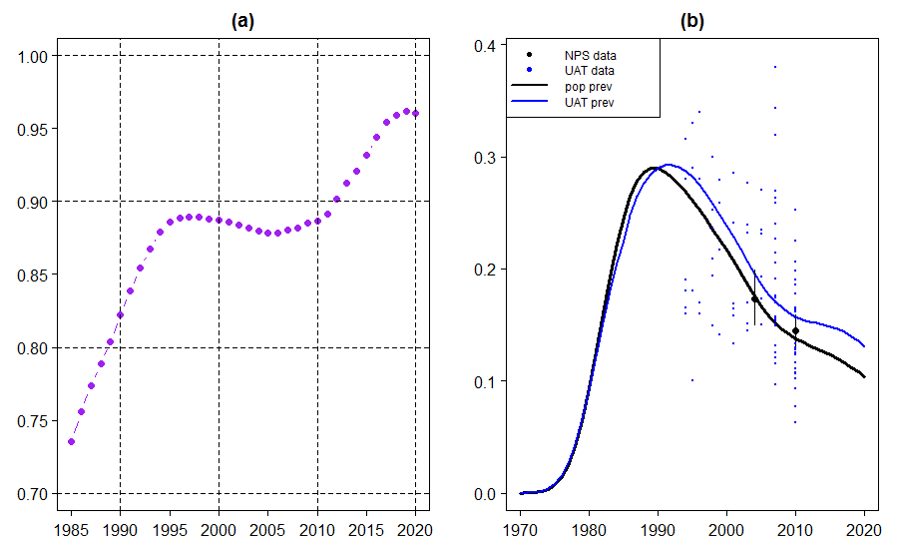

Appendix Figure 3. Observed Data and “True” Fit. (a) HIV prevalence ratio of pregnant women to adults. (b) observed HIV prevalence (NPS with 95% CI and ANC-UAT) and “true” fit (fitted population prevalence and fitted ANC-UAT prevalence) from one posterior sample.

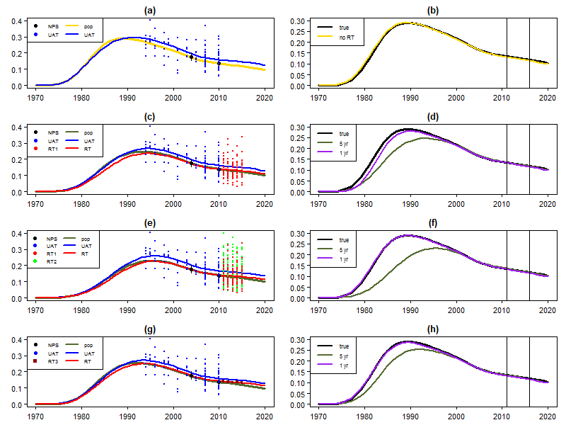

Appendix Figure 4. Fit of Simulated Data. (a) simulated data (NPS and ANC-UAT) and fitted prevalence (population and ANC-UAT). (b) population prevalence under “true” fit and “No ANC-RT” fit. (c) simulated data (NPS, ANC-UAT, and site-level ANC-RT as a continuation of existing ANC-UAT sites “RT1”) and fitted prevalence (population, ANC-UAT, ANC-RT). (d) population prevalence under “true” fit, and 11 continuation ANC-RT sites with 1 and 5 years of ANC-RT data. (e) simulated data (NPS, ANC-UAT, site-level ANC-RT as a continuation of existing ANC-UAT sites “RT1”, and site-level ANC-RT that is not a continuation of existing ANC-UAT sites “RT2”) and fitted prevalence (population, ANC-UAT, ANC-RT). (f) population prevalence under “true” fit, and 50 ANC-RT sites (with 11 as a continuation of ANC-UAT sites) with 1 and 5 years of ANC-RT data. (g) simulated data (NPS, ANC-UAT, and census-level ANC-RT “RT3”) and fitted prevalence (population, ANC-UAT, ANC-RT). (h) population prevalence under “true” fit, and census-level ANC-RT with 1 and 5 years of ANC-RT data.

Quantity | “True” Value | Number of  RT Sites | Mean Difference |  |  | MAE
 |  |  | Years of RT Data |  |  | Years of RT Data
 |  |  | 1 | 3 | 5 | 1 | 3 | 5
Prevalence in 2011 ($ρ_{2011}$) | 13.452% | 0 (No RT) | -0.136% |  |  | 0.278%
 |  | 25 (All from UAT) | -0.087% | -0.028% | 0.116% | 0.250% | 0.279% | 0.287%
 |  | 100 (25 from UAT) | -0.090% | -0.009% | 0.081% | 0.271% | 0.264% | 0.282%
Prevalence Change 2010-2011 ($ρ_{2011}-ρ_{2010}$) | -0.334% | 0 (No RT) | -0.010% |  |  | 0.015%
 |  | 25 (All from UAT) | -0.011% | -0.008% | -0.009% | 0.016% | 0.014% | 0.015%
 |  | 100 (25 from UAT) | -0.012% | -0.009% | -0.008% | 0.016% | 0.014% | 0.015%
Prevalence in 2016 ($ρ_{2016}$) | 11.950% | 0 (No RT) | -0.401% |  |  | 0.427%
 |  | 25 (All from UAT) | -0.348% | -0.289% | -0.157% | 0.369% | 0.348% | 0.278%
 |  | 100 (25 from UAT) | -0.359% | -0.266% | -0.191% | 0.394% | 0.319% | 0.285%
Prevalence Change 2015-2016 ($ρ_{2016}-ρ_{2015}$) | -0.349% | 0 (No RT) | -0.035% |  |  | 0.035%
 |  | 25 (All from UAT) | -0.034% | -0.033% | -0.036% | 0.034% | 0.033% | 0.036%
 |  | 100 (25 from UAT) | -0.037% | -0.032% | -0.036% | 0.037% | 0.032% | 0.036%
Calibration btw UAT and RT ($β_{RT}$) | -0.1000 | 0 (No RT) | NA |  |  | NA
 |  | 25 (All from UAT) | -0.0053 | -0.0093 | -0.0096 | 0.0264 | 0.0219 | 0.0220
 |  | 100 (25 from UAT) | -0.0037 | -0.0104 | -0.0080 | 0.0250 | 0.0226 | 0.0214
Calibration btw UAT and pregnant women ($α_{UAT}$) | 0.1589 | 0 (No RT) | 0.0070 |  |  | 0.0211
 |  | 25 (All from UAT) | 0.0078 | 0.0106 | 0.0082 | 0.0213 | 0.0212 | 0.0197
 |  | 100 (25 from UAT) | 0.0098 | 0.0130 | 0.0114 | 0.0234 | 0.0282 | 0.0290
Non-Sampling Variance of UAT ($δ_{SP}^{2}$) | 0.01879 | 0 (No RT) | 0.00030 |  |  | 0.00338
Shared Non-Sampling Variance of UAT and RT ($δ_{SP}^{2}$) | 0.01879 | 25 (All from UAT) | -0.00033 | -0.00046 | -0.00021 | 0.00260 | 0.00204 | 0.00163
 |  | 100 (25 from UAT) | -0.00021 | -0.00069 | 0.00003 | 0.00271 | 0.00160 | 0.00107

Appendix Table 6. R-Spline Site-Level ANC-RT with Continuation from ANC-UAT Sites. Mean difference and MAE (Mean Absolute Error) between estimated and “true” value of quantities. Results given for each data scenario at 1, 3, and 5 years of simulated ANC-RT data (except “No ANC-RT”). For “No ANC-RT”, the fit only uses simulated NPS and ANC-UAT data, and does not use simulated ANC-RT data. Each setting (of data scenario and year) uses 50 replicates under different seeds.

Quantity | “True” Value | Number of  RT Sites | Mean Difference |  |  | MAE
 |  |  | Years of RT Data |  |  | Years of RT Data
 |  |  | 1 | 3 | 5 | 1 | 3 | 5
Prevalence in 2011 ($ρ_{2011}$) | 13.452% | 0 (No RT) | 0.309% |  |  | 0.500%
 |  | 25 (All from UAT) | 0.319% | 0.289% | 0.198% | 0.490% | 0.458% | 0.403%
 |  | 100 (25 from UAT) | 0.335% | 0.251% | 0.180% | 0.502% | 0.471% | 0.391%
Prevalence Change 2010-2011 ($ρ_{2011}-ρ_{2010}$) | -0.334% | 0 (No RT) | 0.095% |  |  | 0.155%
 |  | 25 (All from UAT) | 0.094% | 0.077% | 0.056% | 0.147% | 0.154% | 0.138%
 |  | 100 (25 from UAT) | 0.103% | 0.068% | 0.047% | 0.152% | 0.138% | 0.082%
Prevalence in 2016 ($ρ_{2016}$) | 11.950% | 0 (No RT) | 0.710% |  |  | 1.125%
 |  | 25 (All from UAT) | 0.687% | 0.576% | 0.324% | 1.035% | 1.074% | 0.883%
 |  | 100 (25 from UAT) | 0.760% | 0.487% | 0.293% | 1.101% | 0.985% | 0.553%
Prevalence Change 2015-2016 ($ρ_{2016}-ρ_{2015}$) | -0.349% | 0 (No RT) | 0.127% |  |  | 0.156%
 |  | 25 (All from UAT) | 0.113% | 0.097% | 0.063% | 0.134% | 0.145% | 0.124%
 |  | 100 (25 from UAT) | 0.123% | 0.092% | 0.054% | 0.156% | 0.133% | 0.072%
Calibration btw UAT and RT ($β_{RT}$) | -0.1000 | 0 (No RT) | NA |  |  | NA
 |  | 25 (All from UAT) | -0.0194 | -0.0194 | -0.0147 | 0.0394 | 0.0391 | 0.0369
 |  | 100 (25 from UAT) | -0.0170 | -0.0165 | -0.0135 | 0.0340 | 0.0363 | 0.0275
Calibration btw UAT and pregnant women ($α_{UAT}$) | 0.1589 | 0 (No RT) | 0.0028 |  |  | 0.0203
 |  | 25 (All from UAT) | 0.0033 | 0.0018 | 0.0025 | 0.0198 | 0.0207 | 0.0200
 |  | 100 (25 from UAT) | 0.0076 | 0.0055 | 0.0059 | 0.0262 | 0.0246 | 0.0262
Non-Sampling Variance of UAT ($δ_{SP}^{2}$) | 0.01879 | 0 (No RT) | 0.00022 |  |  | 0.00338
Shared Non-Sampling Variance of UAT and RT ($δ_{SP}^{2}$) | 0.01879 | 25 (All from UAT) | 0.00015 | 0.00015 | -0.00029 | 0.00280 | 0.00249 | 0.00166
 |  | 100 (25 from UAT) | 0.00030 | 0.00011 | -0.00034 | 0.00272 | 0.00139 | 0.00105

Appendix Table 7. R-Trend Site-Level ANC-RT with Continuation from ANC-UAT Sites. Mean difference and MAE (Mean Absolute Error) between estimated and “true” value of quantities. Results given for each data scenario at 1, 3, and 5 years of simulated ANC-RT data (except “No ANC-RT”). For “No ANC-RT”, the fit only uses simulated NPS and ANC-UAT data, and does not use simulated ANC-RT data. Each setting (of data scenario and year) uses 50 replicates under different seeds.

Quantity | “True” Value | Model | Number of RT Sites | Mean Difference  (or Mean Estimate) |  |  | MAE
 |  |  |  | Years of RT Data |  |  | Years of RT Data
 |  |  |  | 1 | 3 | 5 | 1 | 3 | 5
Prevalence in 2011 ($ρ_{2011}$) | 13.452% | r-spline | 0 (No RT) | -0.136% |  |  | 0.278%
 |  |  | 1000 (Census) | -0.105% | -0.033% | 0.046% | 0.275% | 0.255% | 0.267%
 |  | r-trend | 0 (No RT) | 0.309% |  |  | 0.500%
 |  |  | 1000 (Census) | 0.357% | 0.332% | 0.275% | 0.523% | 0.502% | 0.427%
Prevalence Change 2010-2011 ($ρ_{2011}-ρ_{2010}$) | -0.334% | r-spline | 0 (No RT) | -0.010% |  |  | 0.015%
 |  |  | 1000 (Census) | -0.011% | -0.007% | -0.001% | 0.016% | 0.013% | 0.014%
 |  | r-trend | 0 (No RT) | 0.095% |  |  | 0.155%
 |  |  | 1000 (Census) | 0.098% | 0.095% | 0.083% | 0.152% | 0.133% | 0.096%
Prevalence in 2016 ($ρ_{2016}$) | 11.950% | r-spline | 0 (No RT) | -0.401% |  |  | 0.427%
 |  |  | 1000 (Census) | -0.374% | -0.293% | -0.196% | 0.399% | 0.342% | 0.282%
 |  | r-trend | 0 (No RT) | 0.710% |  |  | 1.125%
 |  |  | 1000 (Census) | 0.736% | 0.730% | 0.587% | 1.101% | 1.025% | 0.698%
Prevalence Change 2015-2016 ($ρ_{2016}-ρ_{2015}$) | -0.349% | r-spline | 0 (No RT) | -0.035% |  |  | 0.035%
 |  |  | 1000 (Census) | -0.035% | -0.033% | -0.031% | 0.036% | 0.033% | 0.031%
 |  | r-trend | 0 (No RT) | 0.127% |  |  | 0.156%
 |  |  | 1000 (Census) | 0.116% | 0.122% | 0.099% | 0.146% | 0.145% | 0.099%
Calibration btw UAT and pregnant women ($α_{UAT}$) | 0.1589 | r-spline | 0 (No RT) | 0.0070 |  |  | 0.0211
 |  |  | 1000 (Census) | 0.0066 | 0.0090 | 0.0100 | 0.0215 | 0.0208 | 0.0219
 |  | r-trend | 0 (No RT) | 0.0028 |  |  | 0.0203
 |  |  | 1000 (Census) | 0.0029 | 0.0030 | 0.0030 | 0.0205 | 0.0211 | 0.0205
Non-Sampling Variance of UAT ($δ_{SP}^{2}$) | 0.01879 | r-spline | 0 (No RT) | 0.00030 |  |  | 0.00338
 |  |  | 1000 (Census) | 0.00041 | 0.00076 | 0.00090 | 0.00324 | 0.00370 | 0.00376
 |  | r-trend | 0 (No RT) | 0.00022 |  |  | 0.00338
 |  |  | 1000 (Census) | 0.00021 | 0.00020 | 0.00012 | 0.00339 | 0.00341 | 0.00337
Calibration btw RT and pregnant women ($α_{RT}$) | NA | r-spline | 1000 (Census) | 0.0954 | 0.0938 | 0.0928 | NA | NA | NA
 |  | r-trend | 1000 (Census) | 0.0778 | 0.0730 | 0.0747 | NA | NA | NA
Non-Sampling Variance of Census RT ($δ_{C}^{2}$) | NA | r-spline | 1000 (Census) | 0.01257 | 0.00461 | 0.00049 | NA | NA | NA
 |  | r-trend | 1000 (Census) | 0.01179 | 0.00247 | 0.00033 | NA | NA | NA

Appendix Table 8. Census-Level ANC-RT. Mean difference (or mean estimate for $α_{RT}$ and $δ_{C}^{2}$) and MAE (Mean Absolute Error) between estimated and “true” value of quantities. Results given for each data scenario at 1, 3, and 5 years of simulated ANC-RT data (except “No ANC-RT”). For “No ANC-RT”, the fit only uses simulated NPS and ANC-UAT data, and does not use simulated ANC-RT data. Each setting (of data scenario and year) uses 50 replicates under different seeds.
Quantity | “True” Value | Model | Number of RT Sites (Number from UAT) | Mean Difference |  |  | MAE
 |  |  |  | Years of RT Data |  |  | Years of RT Data
 |  |  |  | 1 | 3 | 5 | 1 | 3 | 5
Prevalence in 2011 ($ρ_{2011}$) | 13.452% | r-spline | 100 (None) | -0.100% | -0.019% | 0.071% | 0.265% | 0.254% | 0.281%
 |  |  | 100 (25) | -0.090% | -0.009% | 0.081% | 0.271% | 0.264% | 0.282%
 |  | r-trend | 100 (None) | 0.330% | 0.283% | 0.238% | 0.489% | 0.495% | 0.426%
 |  |  | 100 (25) | 0.335% | 0.251% | 0.180% | 0.502% | 0.471% | 0.391%
Prevalence Change 2010-2011 ($ρ_{2011}-ρ_{2010}$) | -0.334% | r-spline | 100 (None) | -0.012% | -0.008% | -0.005% | 0.016% | 0.014% | 0.012%
 |  |  | 100 (25) | -0.012% | -0.009% | -0.008% | 0.016% | 0.014% | 0.015%
 |  | r-trend | 100 (None) | 0.089% | 0.080% | 0.071% | 0.139% | 0.139% | 0.099%
 |  |  | 100 (25) | 0.103% | 0.068% | 0.047% | 0.152% | 0.138% | 0.082%
Prevalence in 2016 ($ρ_{2016}$) | 11.950% | r-spline | 100 (None) | -0.366% | -0.276% | -0.186% | 0.396% | 0.327% | 0.283%
 |  |  | 100 (25) | -0.359% | -0.266% | -0.191% | 0.394% | 0.319% | 0.285%
 |  | r-trend | 100 (None) | 0.692% | 0.557% | 0.446% | 1.014% | 0.973% | 0.689%
 |  |  | 100 (25) | 0.760% | 0.487% | 0.293% | 1.101% | 0.985% | 0.553%
Prevalence Change 2015-2016 ($ρ_{2016}-ρ_{2015}$) | -0.349% | r-spline | 100 (None) | -0.035% | -0.032% | -0.033% | 0.035% | 0.032% | 0.033%
 |  |  | 100 (25) | -0.037% | -0.032% | -0.036% | 0.037% | 0.032% | 0.036%
 |  | r-trend | 100 (None) | 0.113% | 0.092% | 0.076% | 0.139% | 0.126% | 0.093%
 |  |  | 100 (25) | 0.123% | 0.092% | 0.054% | 0.156% | 0.133% | 0.072%
Calibration btw UAT and RT ($β_{RT}$) | -0.1000 | r-spline | 100 (None) | -0.0007 | -0.0090 | -0.0036 | 0.0243 | 0.0244 | 0.0234
 |  |  | 100 (25) | -0.0037 | -0.0104 | -0.0080 | 0.0250 | 0.0226 | 0.0214
 |  | r-trend | 100 (None) | -0.0181 | -0.0242 | -0.0144 | 0.0296 | 0.0382 | 0.0275
 |  |  | 100 (25) | -0.0170 | -0.0165 | -0.0135 | 0.0340 | 0.0363 | 0.0275
Calibration btw UAT and pregnant women ($α_{UAT}$) | 0.1589 | r-spline | 100 (None) | 0.0072 | 0.0085 | 0.0076 | 0.0216 | 0.0213 | 0.0215
 |  |  | 100 (25) | 0.0098 | 0.0130 | 0.0114 | 0.0234 | 0.0282 | 0.0290
 |  | r-trend | 100 (None) | 0.0021 | 0.0028 | 0.0026 | 0.0203 | 0.0207 | 0.0194
 |  |  | 100 (25) | 0.0076 | 0.0055 | 0.0059 | 0.0262 | 0.0246 | 0.0262
Shared Non-Sampling Variance of UAT and RT ($δ_{SP}^{2}$) | 0.01879 | r-spline | 100 (None) | 0.00070 | -0.00012 | -0.00032 | 0.00369 | 0.00134 | 0.00111
 |  |  | 100 (25) | -0.00021 | -0.00069 | 0.00003 | 0.00271 | 0.00160 | 0.00107
 |  | r-trend | 100 (None) | 0.00052 | -0.00016 | -0.00028 | 0.00363 | 0.00140 | 0.00103
 |  |  | 100 (25) | 0.00030 | 0.00011 | -0.00034 | 0.00272 | 0.00139 | 0.00105

Appendix Table 9. Comparing Site-Level ANC-RT with and without Continuation from ANC-UAT Sites. Mean difference and MAE (Mean Absolute Error) between estimated and “true” value of quantities. Results given for each data scenario at 1, 3, and 5 years of simulated ANC-RT data. Each setting (of data scenario and year) uses 50 replicates under different seeds.

