Appendix
Appendix 1: Continuum states over time by repeated cross-section, normal mortality scenario
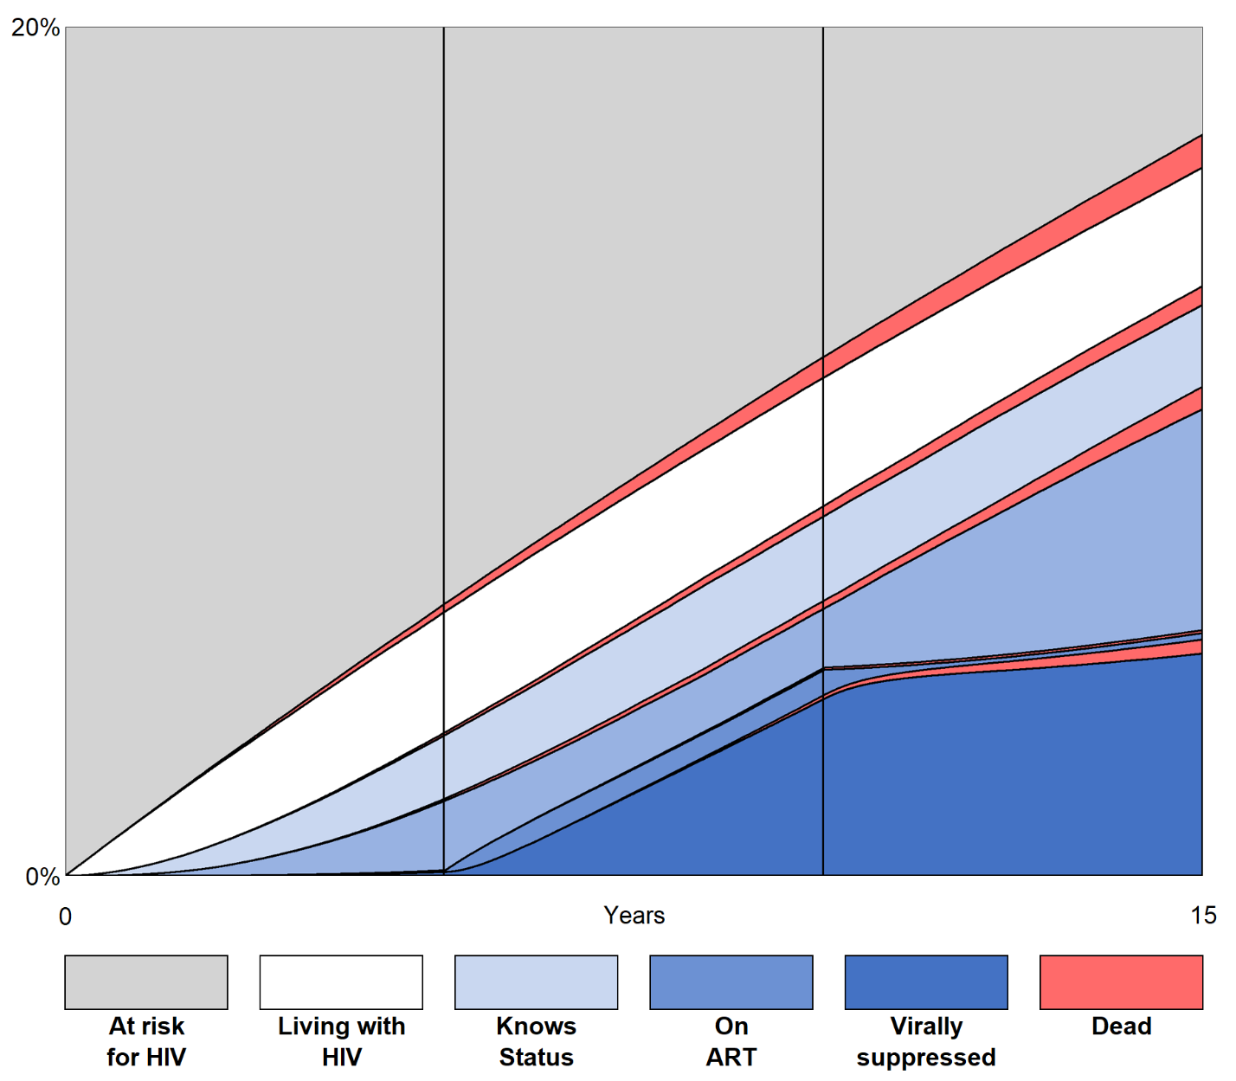
The stacked area represents the proportion of people in a given state on each day in the simulated scenario. All persons in a given state had passed through all prior states (e.g. persons who are in the “On ART” area had already passed through being at risk for HIV, living with HIV, and Knows status). The death state is shown in the state in which a person was when they died. The vertical bars represent the three simulated periods.

Appendix 2: Continuum states over time by repeated cross-section, high mortality scenario
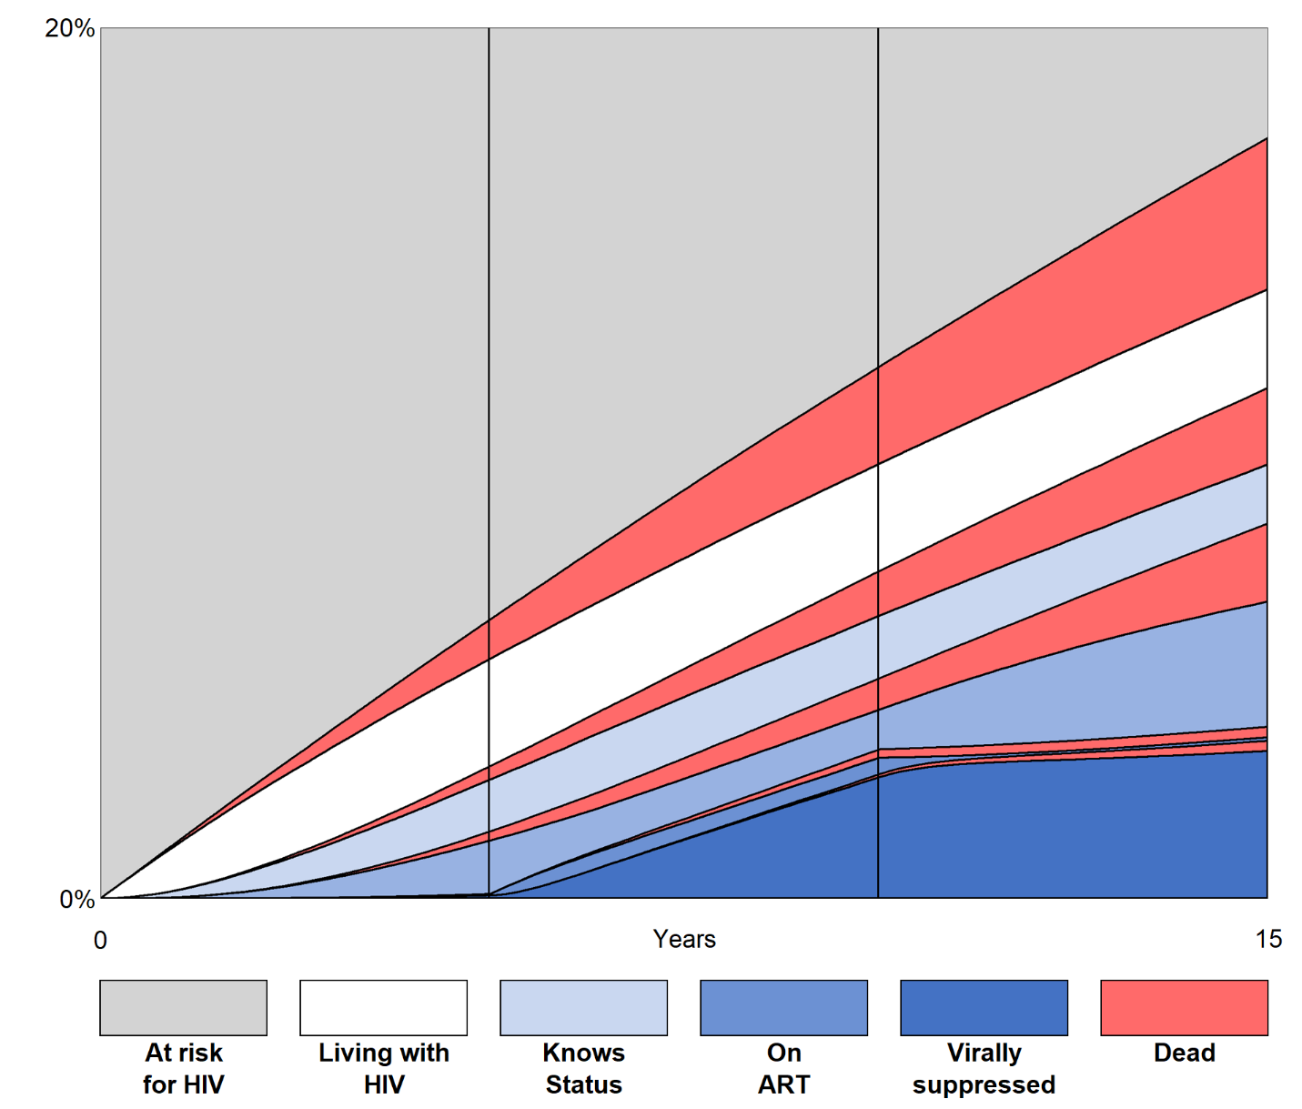
The stacked area represents the proportion of people in a given state on each day in the simulated scenario. All persons in a given state had passed through all prior states (e.g. persons who are in the “On ART” area had already passed through being at risk for HIV, living with HIV, and knows status). The death state is shown in the state in which a person was when they died. The vertical bars represent the three simulated periods.

Appendix 3: UNAIDS 90-90-90 metrics
 |  | Baseline mortality scenario |  |  | High mortality scenario
Years after simulation start |  | % Knows status  out of those who  are living with HIV | % On ART  out of those who  know their status | % Virally suppressed  out of those who  are on ART | % Knows status  out of those who  are living with HIV | % On ART  out of those who  know their status | % Virally suppressed  out of those who  are on ART
Low ART  (Period 1) | 1 | 16% | 0% | 33% | 16% | 0% | 33%
 | 2 | 29% | 1% | 44% | 29% | 1% | 44%
 | 3 | 39% | 2% | 49% | 39% | 2% | 49%
 | 4 | 47% | 3% | 61% | 47% | 3% | 61%
 | 5 | 53% | 4% | 69% | 53% | 4% | 69%
Normal ART  (Period 2) | 6 | 59% | 27% | 56% | 59% | 27% | 56%
 | 7 | 63% | 40% | 73% | 63% | 40% | 73%
 | 8 | 67% | 48% | 81% | 67% | 48% | 81%
 | 9 | 70% | 53% | 85% | 70% | 53% | 85%
 | 10 | 73% | 58% | 88% | 73% | 58% | 88%
Low ART  (Period 3) | 11 | 75% | 53% | 96% | 75% | 53% | 96%
 | 12 | 77% | 49% | 98% | 77% | 49% | 98%
 | 13 | 79% | 46% | 98% | 79% | 46% | 98%
 | 14 | 81% | 44% | 98% | 81% | 44% | 98%
 | 15 | 82% | 43% | 97% | 82% | 43% | 97%

