Supplementary Information
Supplementary table 1
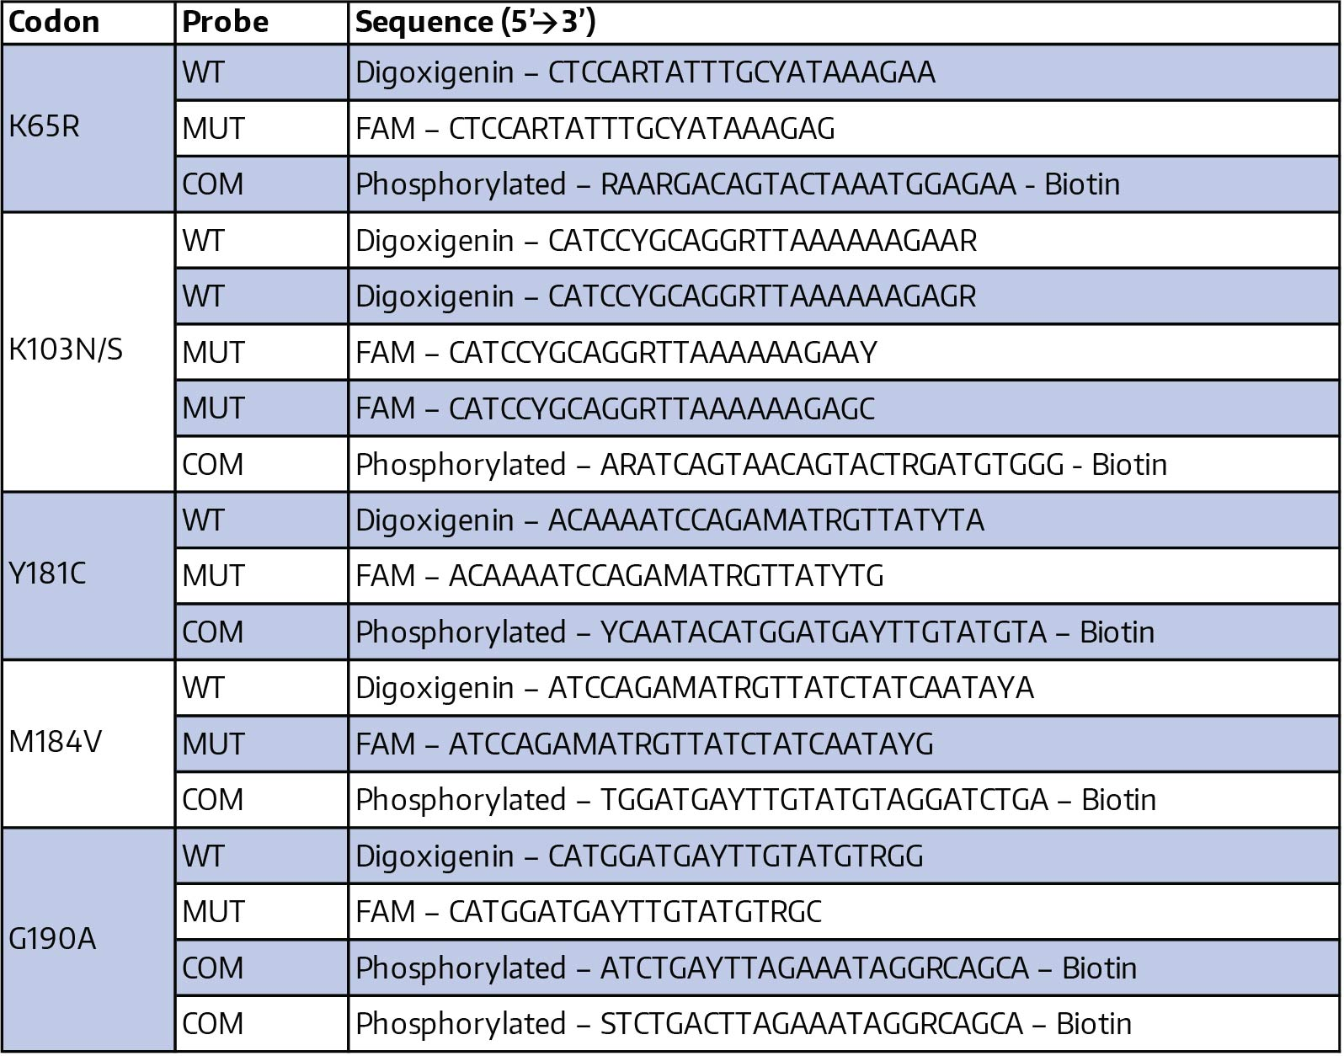

Supplementary table 2 Genotyping results by OLA-Simple and MiSeq
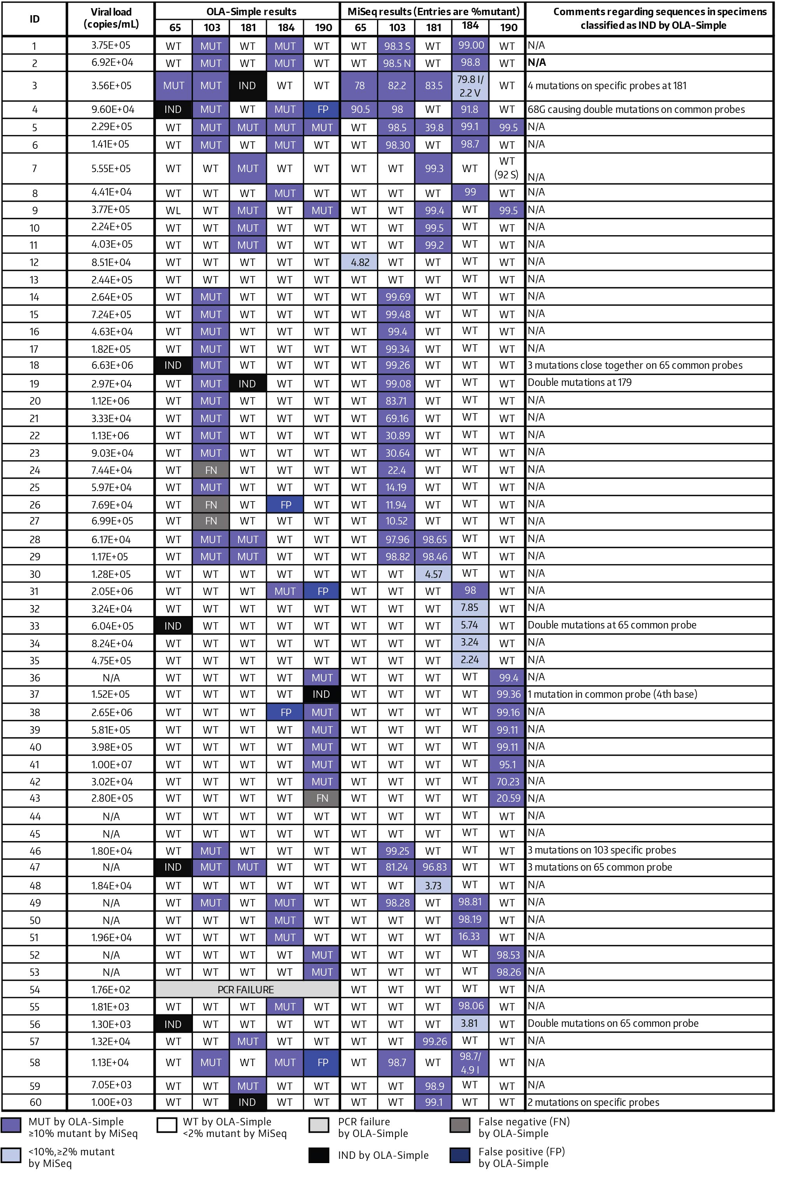

Supplementary table 3. Specificity and sensitivity of the updated OLA-Simple kit at different diagnostic thresholds.
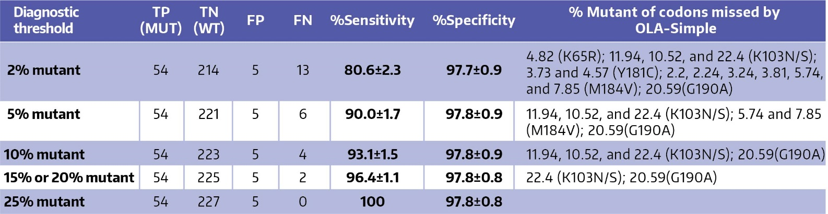
MiSeq results were used as the sensitive reference assay; ≥ diagnostic threshold and <diagnostic threshold results by MiSeq were classified as positive (mutant) or negative (wild-type), respectively, for the reference result. TP = True positive, TN = True negative, FP = False positive, FN = False negative. Percent sensitivity and specificity are reported with standard errors.
Supplementary table 4 Comparison of the workflows of OLA-Simple and MiSeq assays performed in this study
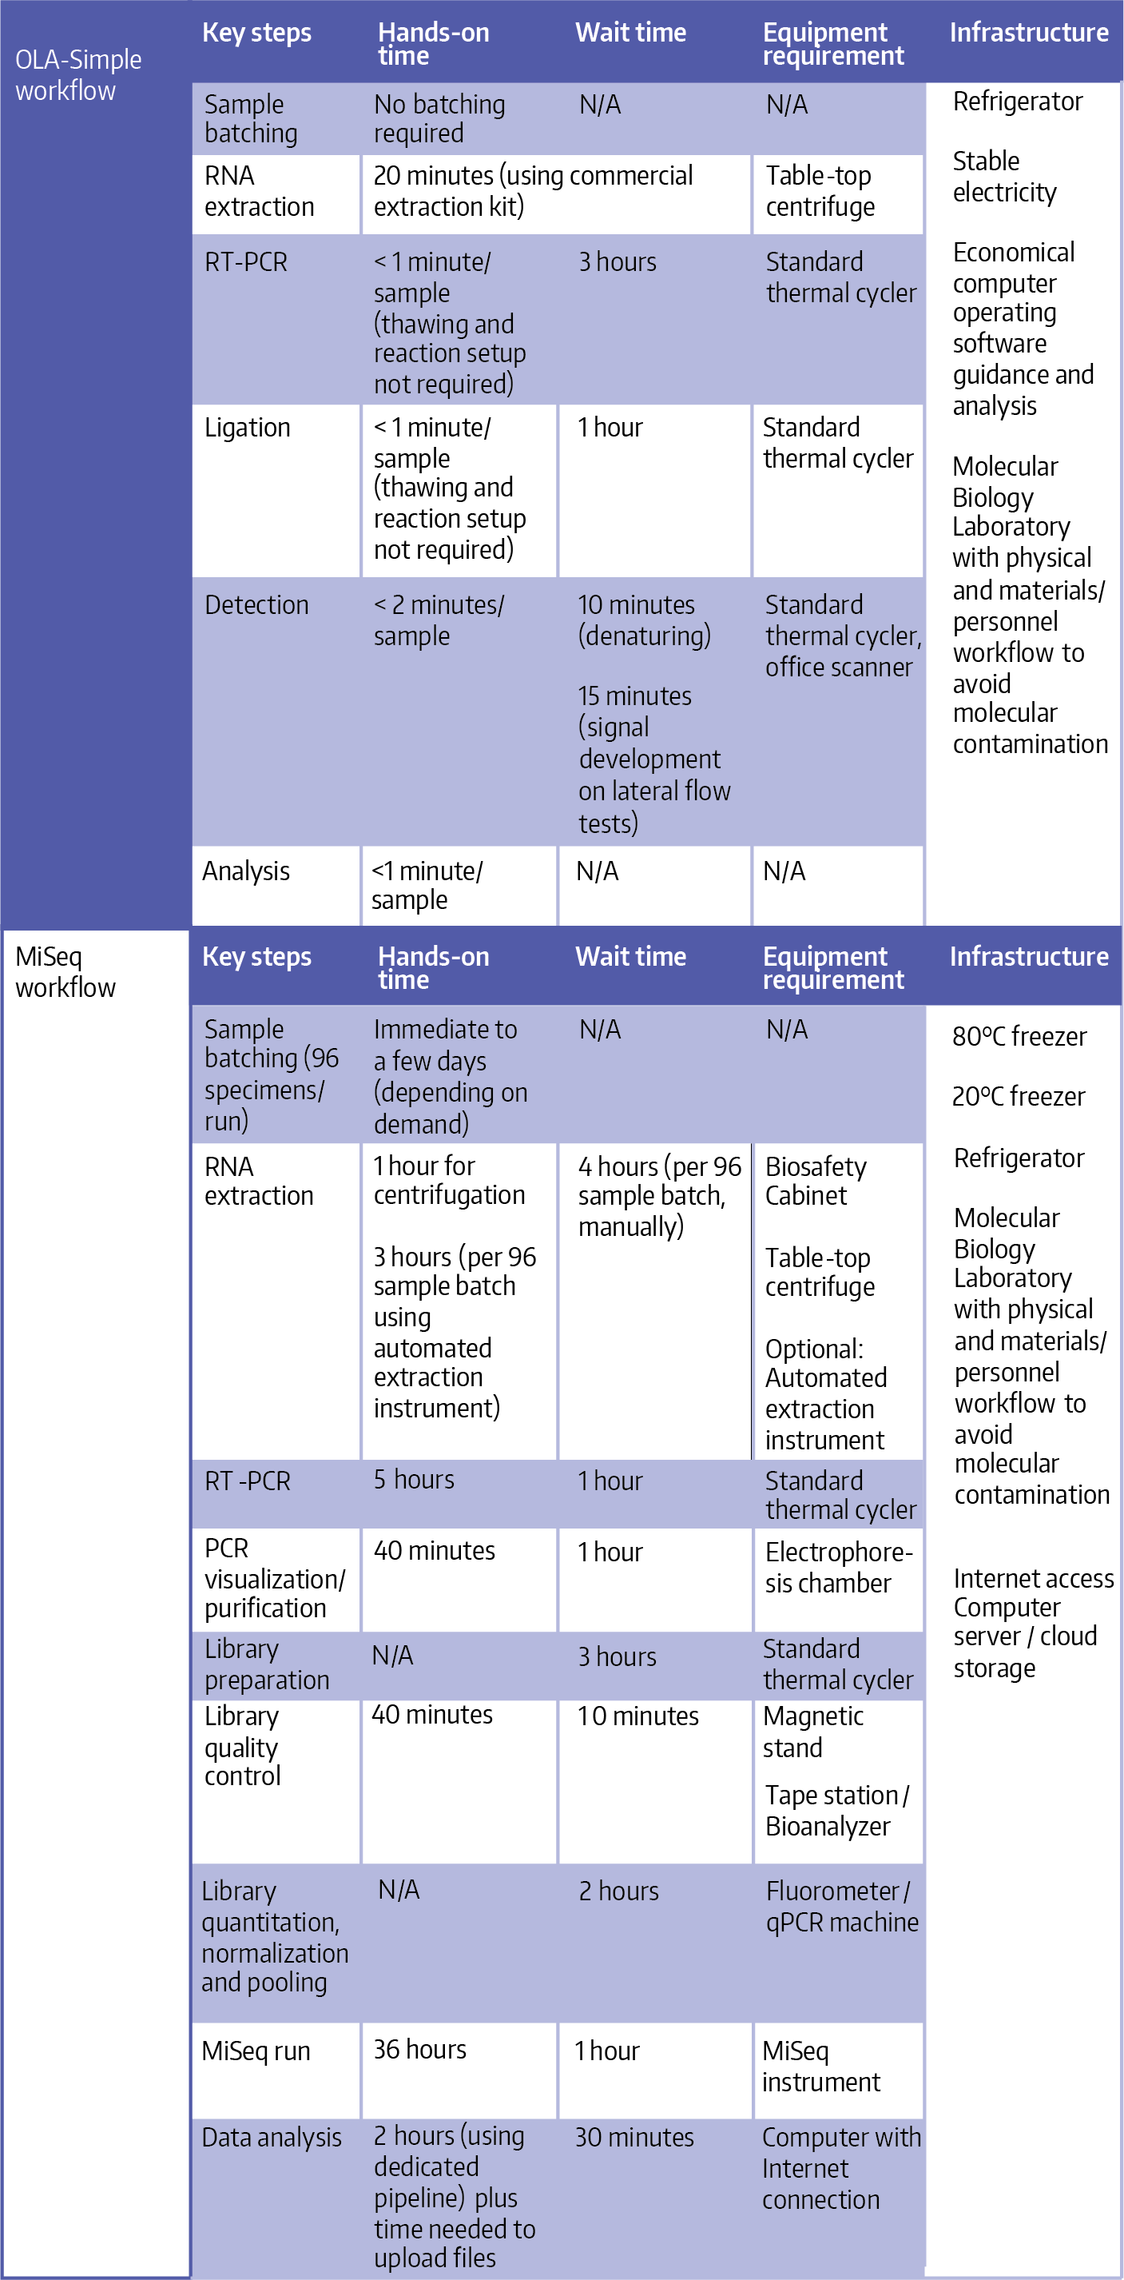

Supplementary table 5. Comparison of reagent costs, equipment costs, and assay times required in OLA-Simple and MiSeq
