Online Supplemental Material

eFigure 1. HIV-1 Antibody level distributions by PBMC-associated HIV-1 DNA level (<100 vs ≥100 copies per million PBMCs) – all participants
eFigure 2. HIV-1 Antibody level distributions by PBMC-associated HIV-1 DNA level (<100 vs ≥100 copies per million PBMCs) – participants with no viral load blips
eFigure 3. HIV-1 Antibody level distributions by PBMC-associated HIV-1 DNA level (<10 vs ≥10 copies per million PBMCs) – all participants
eFigure 4. HIV-1 Antibody level distributions by PBMC-associated HIV-1 DNA level (<10 vs ≥10 copies per million PBMCs) – participants with no viral load blips

eFigure Legends
eFigure 1. HIV-1 Antibody level distributions by PBMC-associated HIV-1 DNA level (<100 vs ≥100 copies per million PBMCs) for all participants. Closed and open circles represent participants who achieved VS at <1 year and 1 to 5 years of age, respectively. P-values based on GEE models, specifying HIV-1 antibody level as the dependent variable, dichotomized PBMC-associated HIV-1 DNA as the independent variable, and an exchangeable correlation matrix. Gp41, gp160, p24, and RT were log₁₀ transformed for the models.
eFigure 2. HIV-1 Antibody level distributions by PBMC-associated HIV-1 DNA level (<100 vs ≥100 copies per million PBMCs) restricted to those participants with no viral load blips. Closed and open circles represent participants who achieved VS at <1 year and 1 to 5 years of age, respectively. P-values based on GEE models, specifying HIV-1 antibody level as the dependent variable, dichotomized PBMC-associated HIV-1 DNA as the independent variable, and an exchangeable correlation matrix. Gp41, gp160, p24, and RT were log₁₀ transformed for the models.
eFigure 3. HIV-1 Antibody level distributions by PBMC-associated HIV-1 DNA level (<10 vs ≥10 copies per million PBMCs) for all participants. Closed and open circles represent participants who achieved VS at <1 year and 1 to 5 years of age, respectively. P-values based on GEE models, specifying HIV-1 antibody level as the dependent variable, dichotomized PBMC-associated HIV-1 DNA as the independent variable, and an exchangeable correlation matrix. Gp41, gp160, p24, and RT were log₁₀ transformed for the models.
eFigure 4. HIV-1 Antibody level distributions by PBMC-associated HIV-1 DNA level (<10 vs ≥10 copies per million PBMCs) restricted to those participants with no viral load blips. Closed and open circles represent participants who achieved VS at <1 year and 1 to 5 years of age, respectively. P-values based on GEE models, specifying HIV-1 antibody level as the dependent variable, dichotomized PBMC-associated HIV-1 DNA as the independent variable, and an exchangeable correlation matrix. Gp41, gp160, p24, and RT were log₁₀ transformed for the models.

eFigure 1
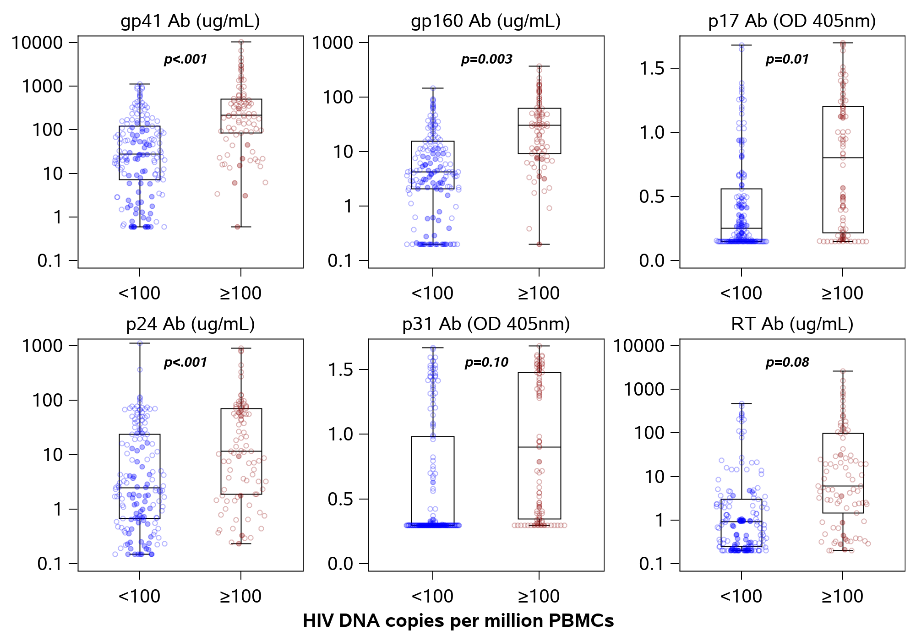

eFigure 2
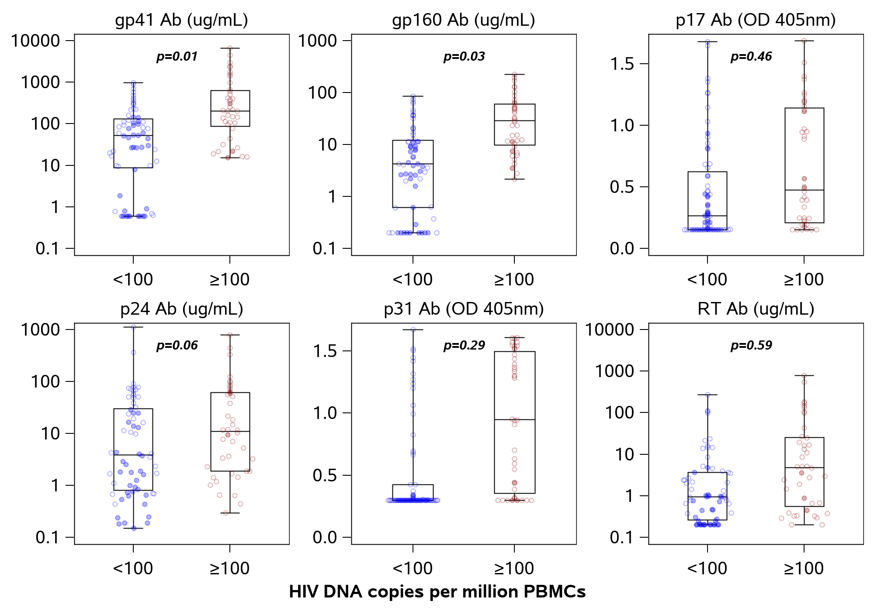
eFigure 3
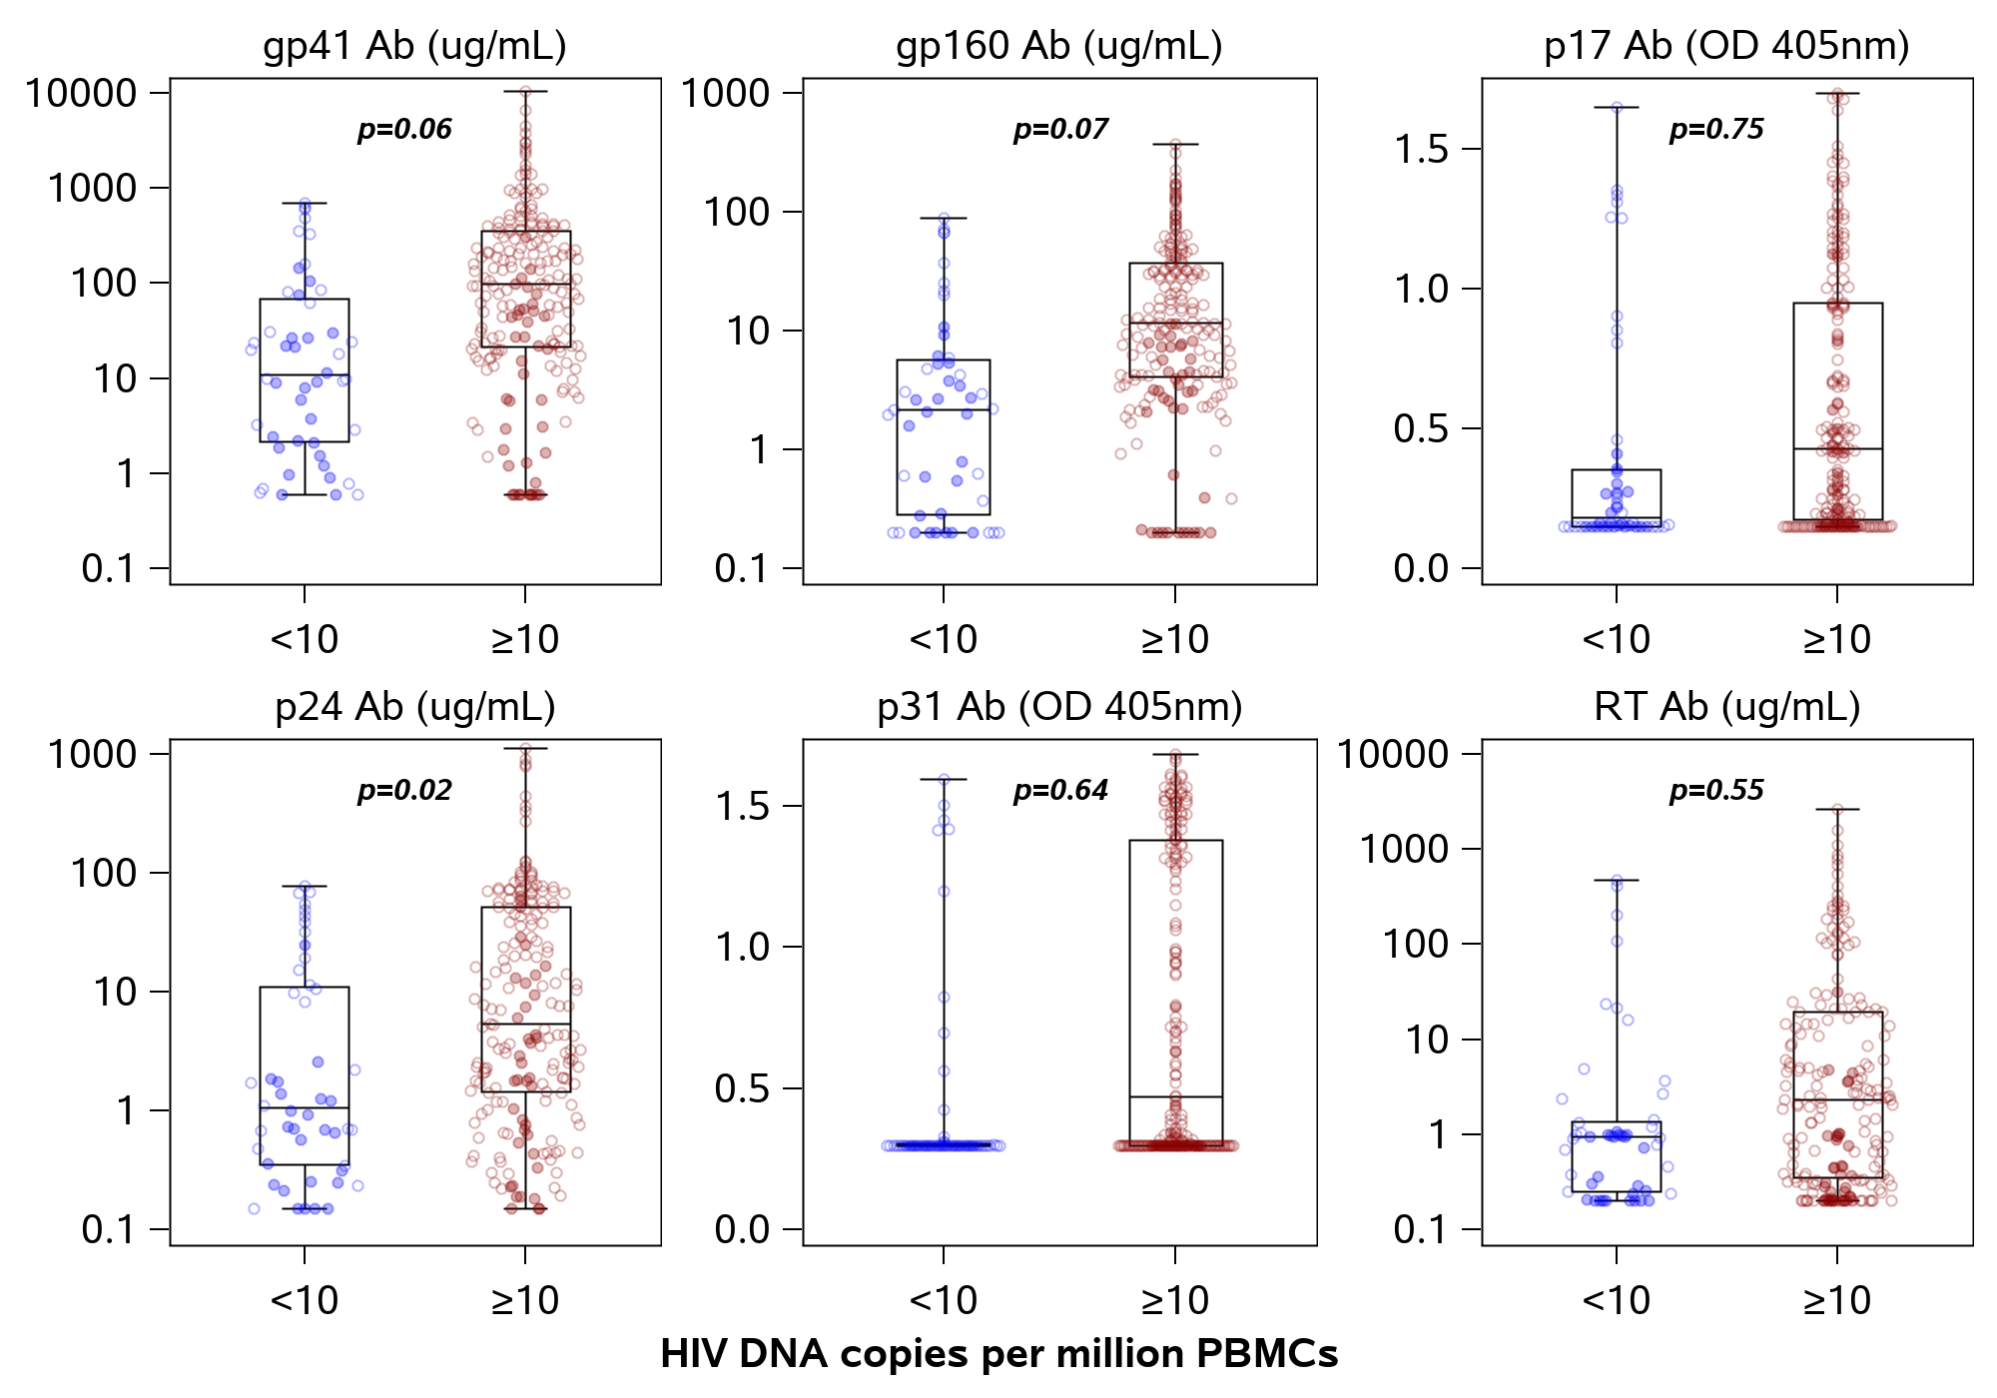

eFigure 4
