Figure S1

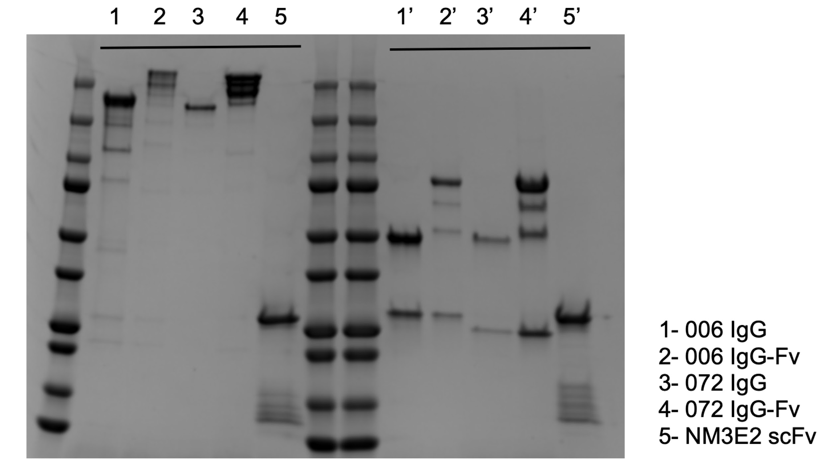

Figure S1. SDS-PAGE of bsAbs, mAbs and scFv post-expression under non-reducing and reducing (‘) conditions

Figure S2

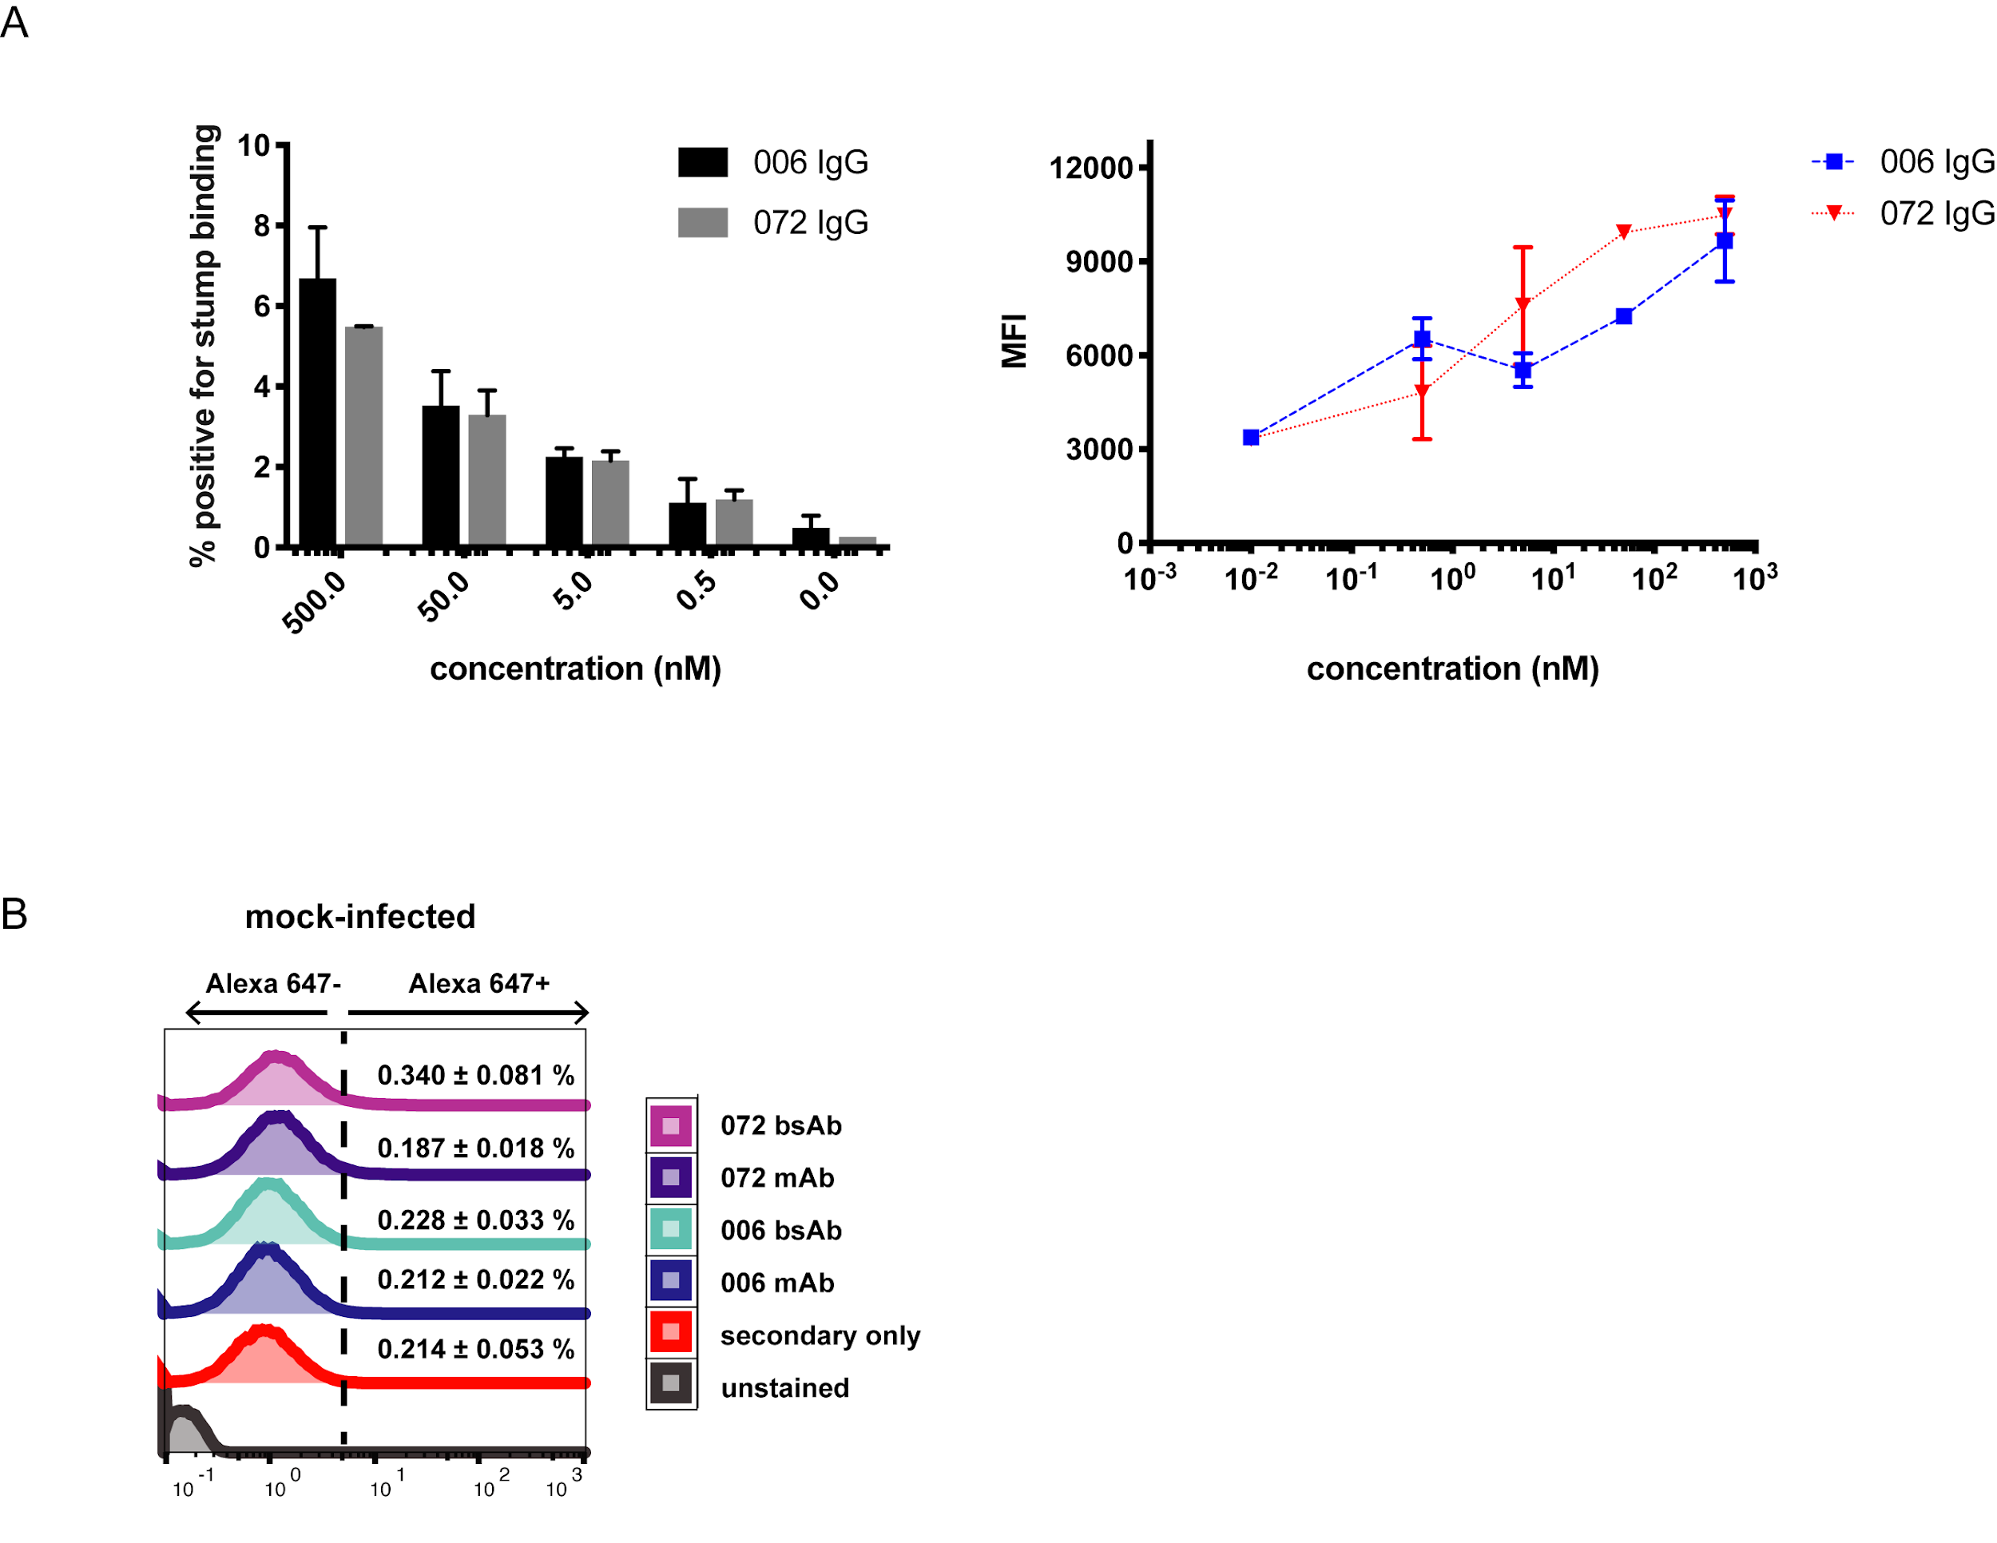

Figure S2 A. Dose-dependence of the binding of the 006 and 072 mAbs to CHO cells overexpressing Env, calculated as percent positive for stump binding (left) and by MFI (right).
B. No binding of either 072 or 006 bsAbs or mAbs to mock-infected primary CD4 T cells.

Figure S3

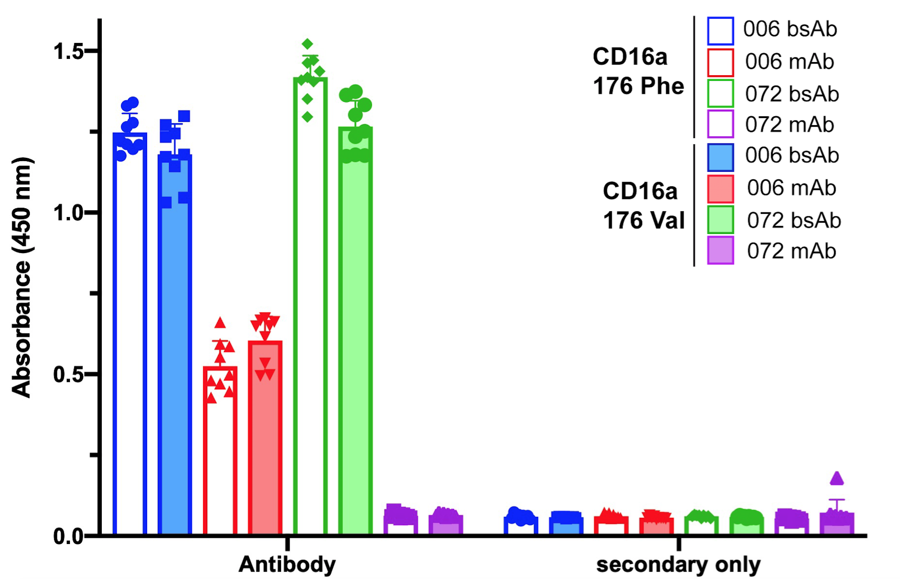

Figure S3. ELISA showing superior binding of bsAbs over mAbs at 0.5 μg/mL to two CD16 variants - CD16a 176 Phe (unshaded bars) and CD16a 176 Val (shaded bars). Secondary only was used as the control. Binding to the two CD16 variants remains unchanged.

