### **Supplementary materials**

**Title: Direct maternal deaths attributable to HIV in the era of ART: evidence from three population based HIV cohorts with verbal autopsy**

# Section 1: Additional methods

## Partner Sites

## Karonga

Karonga is a predominately rural area located in the north of Malawi. Government services in the region comprise one 200 bed district hospital, two rural hospitals and 15 rural health centres. In 2007-08, HIV prevalence was estimated at approximately 8.5% amongst women[1], with a total fertility rate (TFR) of 5.2 estimated for 2005-2014[2].

Demographic surveillance is undertaken in the area surrounding the port village of Chilumba, covering a population of over 35,000 individuals[3]. Data are collected through a network of key informants who continuously record vital events, including births and deaths, and report these at monthly meetings. VA interviews are conducted after a minimum two-week mourning period, using a tool that is very similar to the 2012 WHO VA questionnaire. Population based HIV sero-surveys were conducted annually between 2007 and 2011, and consequently data for this study are only included from 2007 until the end of 2012.

## Kisesa

Kisesa is a rural area located 20km from Mwanza, the capital city of the north-west region of Tanzania. Within the DSS, which covers a population of approximately 35,000[4], there is one health centre and three dispensaries which are run by the Government and three private dispensaries. Both health centres and dispensaries are required, according to national guidelines, to offer antenatal and delivery care. The TFR was estimated to be 4.7 births per woman in 2009-2013[4], and HIV prevalence 6% amongst women in 2011[5].

Demographic data are collected approximately every six months via an interview with an adult household representative, and population-based HIV testing has been conducted approximately every three years. VA data have been collected in Kisesa from the start of the DSS, initially using its own VA questionnaire (1994-2002) followed by the INDEPTH tool, before finally switching to an adapted version of the World Health Organization (WHO) recommended standard VA in 2007. A minimum of six weeks is given between the date of death and approaching the family for a VA interview. Data for this study are available from 1994 until 2014.

## uMkhanyakude

The DSS in uMkhanyakude is run by the Africa Health Research Institute. It was established in 2000 near Mtubatuba, a small market town in KwaZulu-Natal. The TFR in this area was nearly three children per woman in 2005[6], with HIV prevalence ranging from 26.5% amongst women 20-24 up to 50% amongst women aged 45-49 in 2011[7]. Within the DSS area, there are six Department of Health primary healthcare clinics, with a seventh clinic situated just outside of the DSS area. All these facilities offer delivery care[8].

The data available for this study include people under observation between 2004 and 2014. During this period, the DSS included over 85,000 people. Data are collected approximately every six months, and HIV sero-surveys have been conducted approximately annually since 2004. A sample of non-residents are included in the surveys; these were excluded from this analysis. VAs are conducted one to 12 months following the date of death. These VAs were all conducted using a tool that closely resembles the 2007 WHO standard VA tool.

## References

1. Wringe A, Floyd S, Kazooba P, Mushati P, Baisley K, Urassa M, et al. **Antiretroviral therapy uptake and coverage in four HIV community cohort studies in sub-Saharan Africa**. *Tropical medicine & international health : TM & IH* 2012; 17(8):e38-48.

2. McLean E, Price A, Chihana M, Kayuni N, Marston M, Koole O, et al. **Changes in Fertility at the Population Level in the Era of ART in Rural Malawi**. *J Acquir Immune Defic Syndr* 2017; 75(4):391-398.

3. Crampin AC, Dube A, Mboma S, Price A, Chihana M, Jahn A, et al. **Profile: the Karonga Health and Demographic Surveillance System**. *International journal of epidemiology* 2012; 41(3):676-685.

4. Kishamawe C, Isingo R, Mtenga B, Zaba B, Todd J, Clark B, et al. **Health & Demographic Surveillance System Profile: The Magu Health and Demographic Surveillance System (Magu HDSS)**. *International journal of epidemiology* 2015; 44(6):1851-1861.

5. Zaba B, Calvert C, Marston M, Isingo R, Nakiyingi-Miiro J, Lutalo T, et al. **Effect of HIV infection on pregnancy-related mortality in sub-Saharan Africa: secondary analyses of pooled community-based data from the network for Analysing Longitudinal Population-based HIV/AIDS data on Africa (ALPHA)**. *Lancet (London, England)* 2013; 381(9879):1763-1771.

6. Moultrie TA, Hosegood V, McGrath N, Hill C, Herbst K, Newell ML. **Refining the criteria for stalled fertility declines: an application to rural KwaZulu-Natal, South Africa, 1990-2005**. *Studies in family planning* 2008; 39(1):39-48.

7. Zaidi J, Grapsa E, Tanser F, Newell ML, Barnighausen T. **Dramatic increase in HIV prevalence after scale-up of antiretroviral treatment**. *Aids* 2013; 27(14):2301-2305.

8. Chetty T, Yapa HMN, Herbst C, Geldsetzer P, Naidu KK, De Neve JW, et al. **The MONARCH intervention to enhance the quality of antenatal and postnatal primary health services in rural South Africa: protocol for a stepped-wedge cluster-randomised controlled trial**. *BMC health services research* 2018; 18(1):625.

**Supplementary Table 1: Dates of transition for categories of “ART availability”**

|  |  |  |  |
| --- | --- | --- | --- |
|  | **Dates covered by following categories of ART availability** | | |
| No ART | Early ART | Widely Available ART |
| **Karonga** | Up to 1st July 2005 | 1st July 2005-30th September 2006 | From 1st October 2006 |
| **Kisesa** | Up to 1st March 2005 | 1st March 2005-31st August 2008 | From 1st September 2008 |
| **uMkhanyakude** | Up to 1st November 2004 | 1st November 2004-31st December 2006 | From 1st January 2007 |

## Supplementary Table 2: Cause of death categories (adapted from the InterVA-4 user guide available at: <https://www.tandfonline.com/doi/suppl/10.3402/gha.v5i0.19281/suppl_file/zgha_a_11817797_sm0001.pdf>, accessed on 17th December 2018)

|  |  |
| --- | --- |
| **InSilicoVA cause of death** | **ICD-10 equivalent codes** |
| Ectopic pregnancy | O00 Ectopic pregnancy |
| Abortion-related death | O03 Spontaneous abortion  O04 Medical abortion  O05 Other abortion  O06 Unspecified abortion  O07 Failed attempted abortion  O08 Complications following abortion and ectopic and molar pregnancy |
| Pregnancy-induced hypertension | O10 Pre-existing hypertension complicating pregnancy, childbirth and the puerperium  O11 Pre-existing hypertensive disorder with superimposed proteinuria  O12 Gestational [pregnancy-induced] oedema and proteinuria without hypertension  O13 Gestational [pregnancy-induced] hypertension without significant proteinuria  O14 Gestational [pregnancy-induced] hypertension with significant proteinuria  O15 Eclampsia  O16 Unspecified maternal hypertension |
| Obstetric haemorrhage  Ruptured uterus | O46 Antepartum haemorrhage, not elsewhere classified  O67 Labour and delivery complicated by intrapartum haemorrhage, not elsewhere classified  O71 Other obstetric trauma  O72 Postpartum haemorrhage |
| Obstructed labour | O63 Long labour  O64 Obstructed labour due to malposition and malpresentation of fetus  O65 Obstructed labour due to maternal pelvic abnormality  O66 Other obstructed labour |
| Pregnancy-related sepsis | O85 Puerperal sepsis  O75.3 Other infection during labour |
| Anaemia of pregnancy | O99.0 Anaemia complicating pregnancy, childbirth and the puerperium |

# Section 2: Additional results

**Supplementary Figure 1: Percentage of deaths attributable to direct maternal causes, by HIV status, study site, and ART availability in women aged 20-49 years. Cause of death assigned using InSilicoVA tool.**

## 

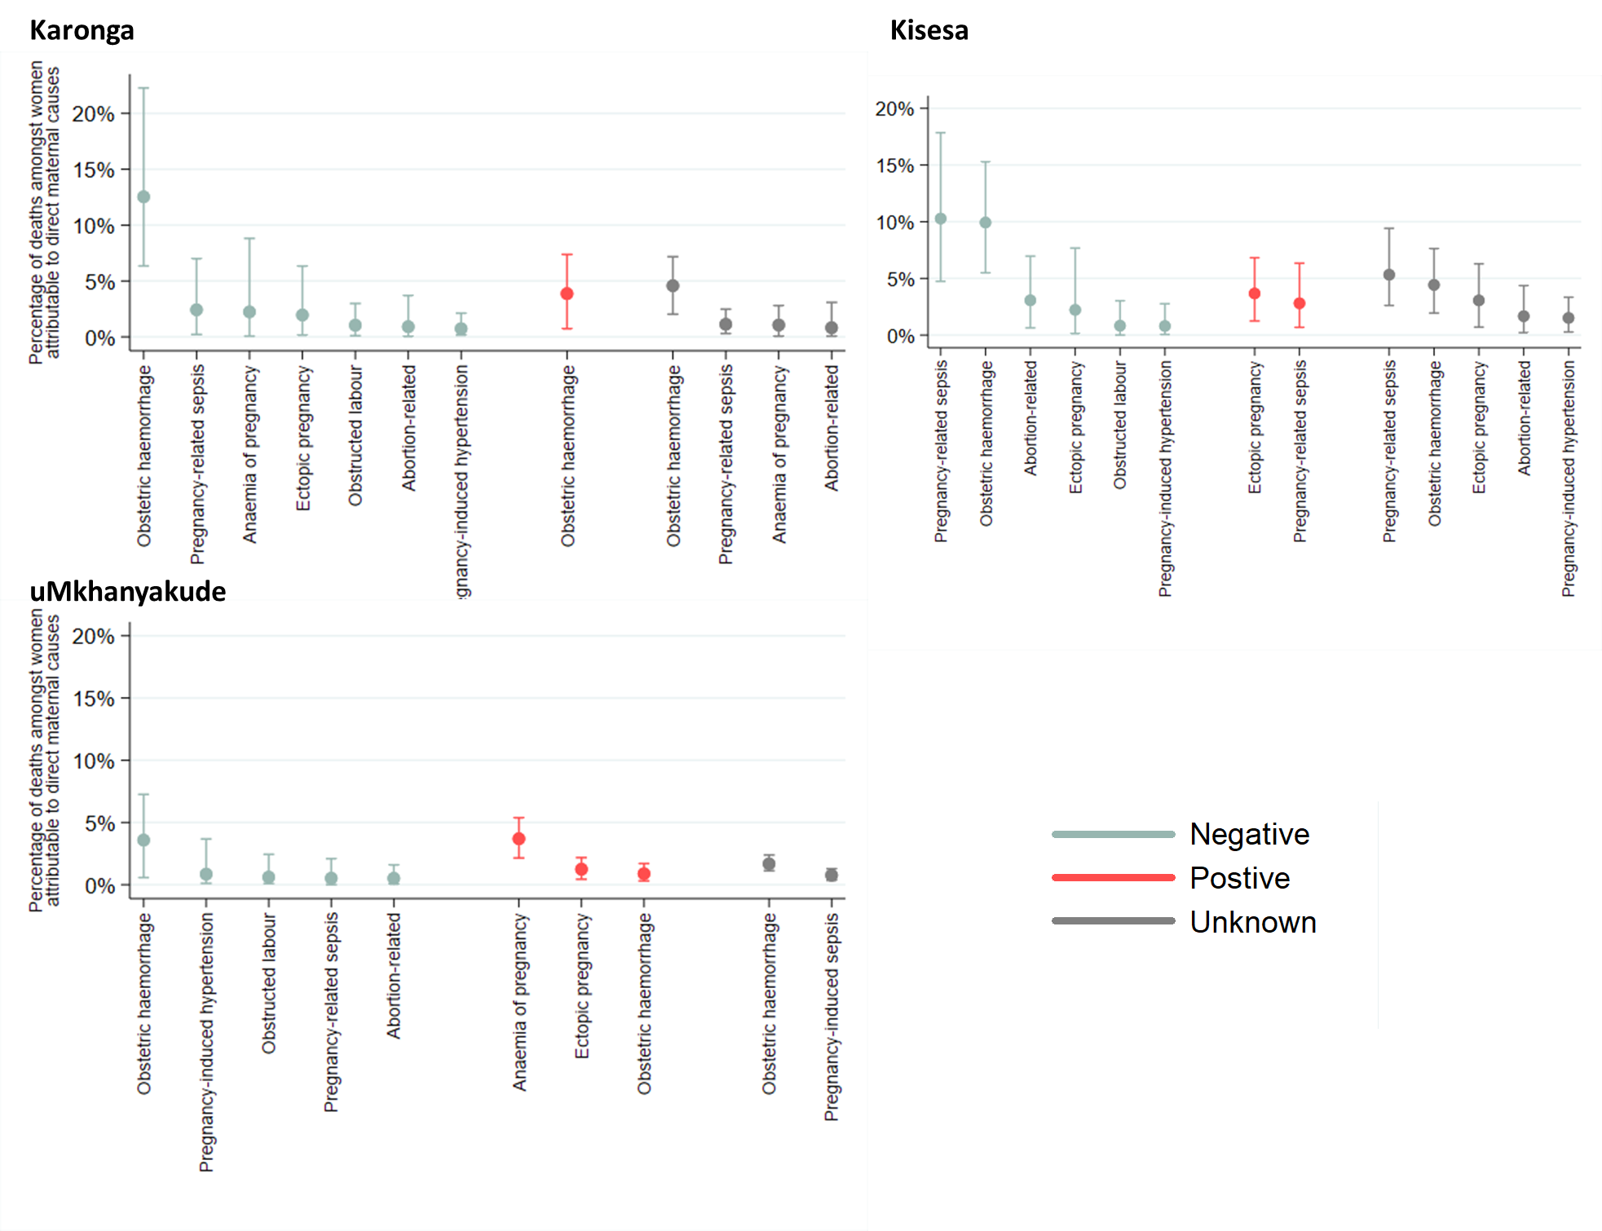

## Supplementary Figure 2: Percentage of deaths attributable to specific direct maternal causes with 95% confidence intervals, by HIV status and study site. Note: due to small numbers, data was combined across all ART time periods. Causes of death which occurred for <0.5% of deaths were excluded.

**Supplementary Table 3: Direct maternal mortality rates per 100,000 person years, by study site, HIV status and age group**

|  |  |  |  |
| --- | --- | --- | --- |
| **Study site and age group** | **Direct maternal mortality rates per 100,000 person years (95% CI)** | | |
| **HIV negative** | **HIV positive** | **HIV status unknown** |
| **Karonga** |  |  |  |
| 20-29 | 99.19 (53.37-184.35) | - | 102.39 (46.00-227.90) |
| 30-39 | - | 328.64 (136.79-789.56) | 115.63 (43.40-308.09) |
| 40-49 | 25.20 (3.55-178.88) | 103.86 (14.63-737.34) | 48.83 (6.88-346.62) |
| **Kisesa** |  |  |  |
| 20-29 | 20.10 (2.83-142.72) | 314.91 (44.36-2235.53) | 64.17 (26.71-154.17) |
| 30-39 | 78.55 (29.48-209.29) | 470.51 (176.59-1253.64) | 124.19 (55.79-276.43) |
| 40-49 | 70.48 (22.73-218.53) | - | 39.21 (5.52-278.34) |
| **uMkhanyakude** |  |  |  |
| 20-29 | 7.79 (1.10-55.27) | 73.83 (38.42-141.90) | 29.47 (12.27-70.81) |
| 30-39 | 17.44 (2.46-123.83) | 152.39 (97.20-238.91) | 43.31 (18.03-104.05) |
| 40-49 | 35.49 (11.45-110.03) | 142.03 (78.66-256.47) | 34.47 (11.12-106.86) |

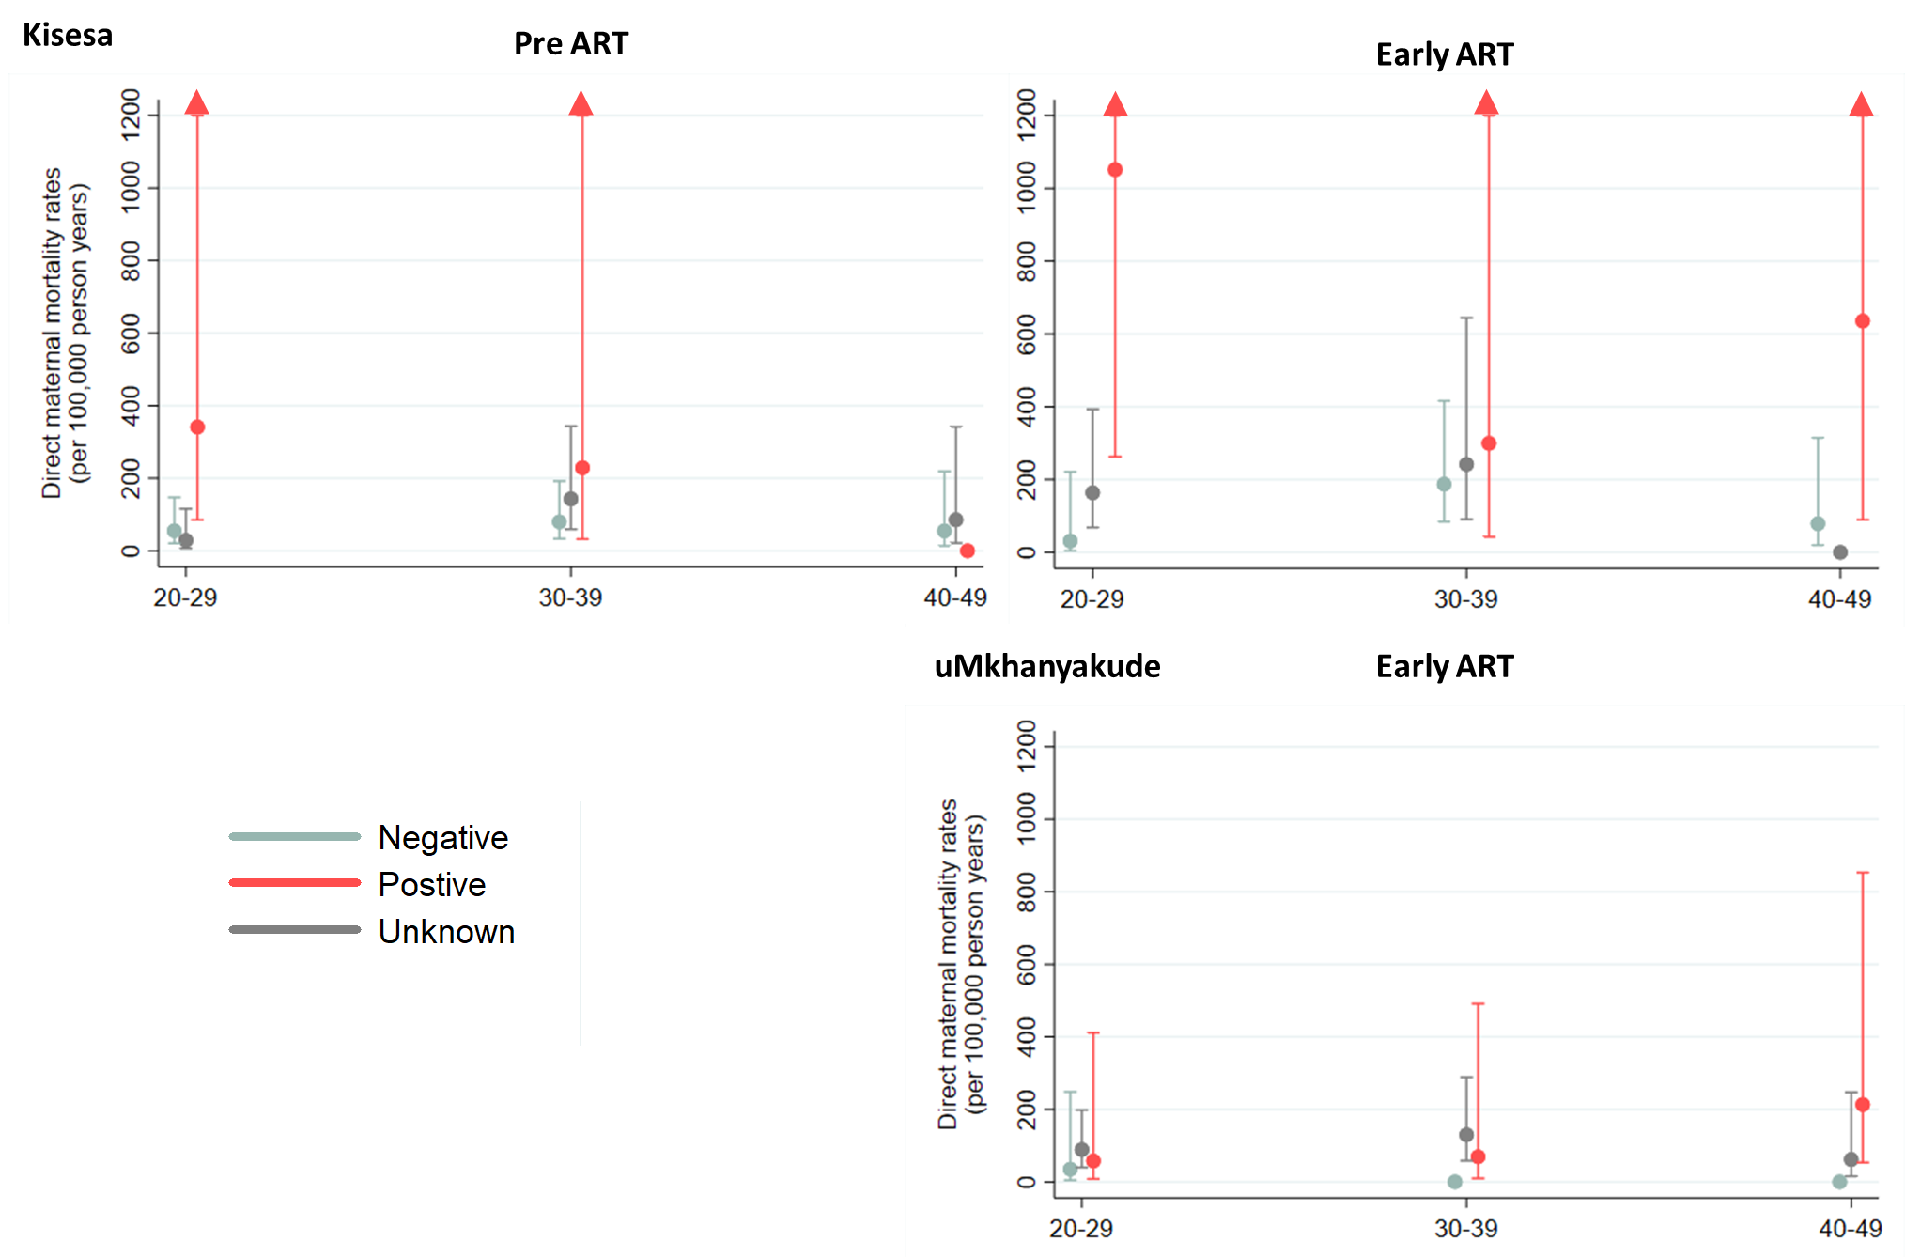

## Supplementary Figure 3: Direct maternal mortality rates per 100,000 person years by HIV status and age group, and by ART availability and study site

## Supplementary Table 4: Direct maternal mortality rates excluding anaemia of pregnancy, and rates ratios for these direct maternal deaths by HIV status and study, in women age 20-49 when ART was widely available.

|  |  |  |  |  |  |  |  |  |  |
| --- | --- | --- | --- | --- | --- | --- | --- | --- | --- |
|  | **No. of direct maternal deaths** | **Person years** | **Rate per 100000** | **Crude Rate Ratio** | **Crude p-value** | **Age-adjusted Rate Ratio** | **Age-adjusted p-value** | **Adjusted Rate Ratio**† | **Adjusted p-value**† |
| **Karonga** |  |  |  |  |  |  |  |  |  |
| Negative | 11 | 20829 | 53 (29-95) | 1 |  | 1 |  | 1 |  |
| Positive | 6 | 3229 | 186 (83-414) | 3.52 (1.30-9.52) |  | 4.04 (1.46-11.18) |  | 4.44 (1.59-12.43) |  |
| Unknown | 10 | 11367 | 88 (47-163) | 1.67 (0.71-3.92) | 0.06 | 1.64 (0.70-3.87) | 0.04 | 1.73 (0.66-4.49) | 0.03 |
| **Kisesa** |  |  |  |  |  |  |  |  |  |
| Negative | 8 | 14321 | 56 (28-112) | 1 |  | 1 |  | 1 |  |
| Positive | 5 | 1615 | 310 (129-744) | 5.54 (1.81-16.94) |  | 4.85 (1.57-14.93) |  | 5.21 (1.68-16.12) |  |
| Unknown | 12 | 15175 | 79 (45-139) | 1.42 (0.58-3.46) | 0.03 | 1.46 (0.59-3.61) | 0.04 | 1.67 (0.67-4.17) | 0.03 |
| **uMkhanyakude** |  |  |  |  |  |  |  |  |  |
| Negative | 5 | 27031 | 18 (8-44) | 1 |  | 1 |  | 1 |  |
| Positive | 8 | 32402 | 25 (12-49) | 1.33 (0.44-4.08) |  | 1.26 (0.41-3.89) |  | 1.39 (0.44-4.34) |  |
| Unknown | 13 | 37214 | 35 (20-60) | 1.89 (0.67-5.30) | 0.43 | 1.83 (0.65-5.16) | 0.46 | 1.98 (0.69-5.66) | 0.40 |

†Adjusted for age group, calendar period, residence and education level in Karonga and uMkhanyakude. In Kisesa, estimates are adjusted for age group, calendar period and residence.

## Supplementary Table 5: Sensitivity analyses, assuming that all HIV negative deaths without a cause assigned through verbal autopsy were direct maternal and none of the HIV positive deaths without a cause of death were direct maternal (in the period when ART was widely available)

|  |  |  |  |  |  |  |  |  |  |
| --- | --- | --- | --- | --- | --- | --- | --- | --- | --- |
|  | **No. of direct maternal deaths** | **Person years** | **Rate per 100000** | **Crude Rate Ratio** | **Crude p-value** | **Age-adjusted Rate Ratio** | **Age-adjusted p-value** | **Adjusted Rate Ratio**† | **Adjusted p-value**† |
| **Kisesa** |  |  |  |  |  |  |  |  |  |
| Negative | 10 | 14326 | 70 (38-130) | 1 |  | 1 |  | 1 |  |
| Positive | 5 | 1619 | 309 (129-742) | 4.43 (1.51-12.95) |  | 3.97 (1.35-11.71) |  | 4.23 (1.43-12.52) |  |
| Unknown | 12 | 15198 | 79 (45-139) | 1.13 (0.49-2.62) | 0.05 | 1.17 (0.50-2.73) | 0.07 | 1.32 (0.56-3.13) | 0.06 |
| **uMkhanyakude** |  |  |  |  |  |  |  |  |  |
| Negative | 8 | 27044 | 30 (15-59) | 1 |  | 1 |  | 1 |  |
| Positive | 39 | 32402 | 120 (88-165) | 4.07 (1.90-8.71) |  | 3.81 (1.77-8.22) |  | 3.63 (1.67-7.88) |  |
| Unknown | 13 | 37297 | 35 (20-60) | 1.18 (0.49-2.84) | <0.0001 | 1.16 (0.48-2.80) | <0.0001 | 1.17 (0.48-2.86) | 0.0001 |

†Adjusted for age group, calendar period, residence and education level in uMkhanyakude. In Kisesa, estimates are adjusted for age group, calendar period and residence.

## Supplementary Table 6: Sensitivity analysis using physician review, rather than InSilicoVA, to identify direct maternal deaths in Karonga

|  |  |  |  |  |  |  |  |  |  |
| --- | --- | --- | --- | --- | --- | --- | --- | --- | --- |
|  | **No. of direct maternal deaths** | **Person years** | **Rate per 100000** | **Crude Rate Ratio** | **Crude p-value** | **Age-adjusted Rate Ratio** | **Age-adjusted p-value** | **Adjusted Rate Ratio**† | **Adjusted p-value**† |
| **Physician Review** |  |  |  |  |  |  |  |  |  |
| Negative | 13 | 20829 | 62 (36-107) | 1 |  | 1 |  | 1 |  |
| Positive | 5 | 3229 | 155 (64-372) | 2.48 (0.88-6.96) |  | 2.93 (1.02-8.41) |  | 3.31 (1.14-9.58) |  |
| Unknown | 9 | 11367 | 79 (41-152) | 1.27 (0.54-2.97) | 0.28 | 1.24 (0.53-2.91) | 0.18 | 1.18 (0.46-3.05) | 0.13 |
| **InSilicoVA** |  |  |  |  |  |  |  |  |  |
| Negative | 11 | 20829 | 53 (29-95) | 1 |  | 1 |  | 1 |  |
| Positive | 6 | 3229 | 186 (83-414) | 3.52 (1.30-9.52) |  | 4.10 (1.48-11.35) |  | 4.52 (1.62-12.63) |  |
| Unknown | 11 | 11367 | 97 (54-175) | 1.83 (0.79-4.23) | 0.05 | 1.80 (0.78-4.16) | 0.03 | 2.02 (0.79-5.13) | 0.02 |

†Adjusted for age, calendar period, education and residence.

# Section 3: Mortality attributable to non-direct maternal causes of deaths

We identified deaths to be non-direct maternal if they were not classified to a direct maternal causes of death by InSilicoVA, but had evidence of pregnancy from the VA (i.e. were reported to be pregnant or within 6 weeks of pregnancy or had a positive response to another pregnancy-related symptom, or were classified by InSilicoVA as “other or unspecified maternal causes of death”). As with the direct maternal deaths, we calculated the total number of non-direct maternal deaths and the non-direct maternal mortality rates by HIV status. These results are presented in Supplementary Table 7.

After adjusting for key confounders, there was some evidence that women living with HIV in Karonga had over nine times the rate of non-direct maternal causes of death when compared with HIV negative women (RR=9.48, 95% CI: 1.50-59.76). In uMkhanyakude, the rate ratio was 4.43 (95% CI: 1.49-13.21). Only one non-direct maternal cause of death was identified amongst women who are HIV negative in Kisesa, limiting our ability to undertake adjusted analysis.

## Supplementary Table 7: Non direct maternal mortality rates and rates ratios for direct maternal mortality by HIV status and study, in women aged 20-49 in the period when ART was widely available

|  |  |  |  |  |  |  |  |  |  |
| --- | --- | --- | --- | --- | --- | --- | --- | --- | --- |
|  | **No. of non- direct maternal deaths** | **Person years** | **Rate per 100000** | **Crude Rate Ratio** | **Crude p-value** | **Age-adjusted Rate Ratio** | **Age-adjusted p-value** | **Adjusted Rate Ratio\*** | **Adjusted p-value\*** |
| **Karonga** |  |  |  |  |  |  |  |  |  |
| Negative | 2 | 20829 | 10 (2-38) | 1 |  | 1 |  | 1 |  |
| Positive | 3 | 3229 | 93 (30-288) | 9.68 (1.62-57.91) |  | 9.60 (1.55-59.45) |  | 9.48 (1.50-59.76) |  |
| Unknown | 3 | 11367 | 26 (9-82) | 2.75 (0.46-16.45) | 0.05 | 2.77 (0.46-16.56) | 0.05 | 2.28 (0.35-15.01) | 0.06 |
| **Kisesa** |  |  |  |  |  |  |  |  |  |
| Negative | 1 | 14323 | 7 (1-50) | 1 |  | - |  | - |  |
| Positive | 3 | 1615 | 186 (60-576) | 26.60 (2.77-255.70) |  | - |  | - |  |
| Unknown | 2 | 15174 | 13 (3-53) | 1.89 (0.17-20.82) | 0.01 | - | - | - | - |
| **uMkhanyakude** |  |  |  |  |  |  |  |  |  |
| Negative | 4 | 27031 | 15 (6-39) | 1 |  | 1 |  | 1 |  |
| Positive | 19 | 32402 | 59 (37-92) | 3.96 (1.35-11.65) |  | 4.09 (1.38-12.11) |  | 4.43 (1.49-13.21) |  |
| Unknown | 10 | 37214 | 27 (14-50) | 1.82 (0.57-5.79) | 0.01 | 1.87 (0.58-5.97) | 0.01 | 2.10 (0.65-6.76) | 0.008 |

**\***Adjusted for age, calendar period, education and residence