**Supplement Figure 1a. Examples of Differences between Definitions**

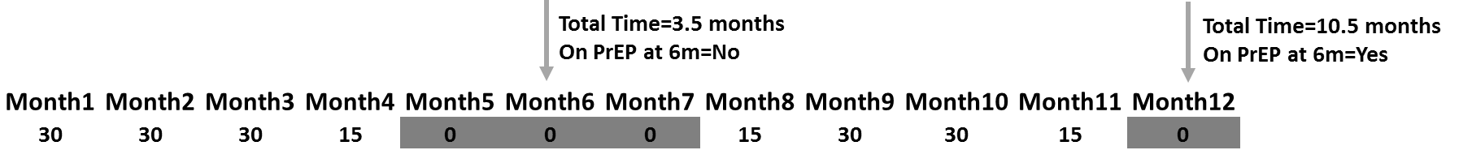

**Supplement Figure 1b. Examples of Differences between Definitions**



1. Gaps in PrEP use can be masked by Total Time on PrEP and can lead to changes in the On PrEP measure over time. For instance, Total Time on PrEP measured at the first arrow is 3.5 months and the patient would be considered not on PrEP at 6 months (3.5<6). However for the same patient, Total Time on PrEP measured at the latter arrow is 10.5 months and therefore the patient would be considered to be on PrEP at 6 months (10.5>6). Shaded months indicate gaps in PrEP use.
2. The intervals used to calculate PDC can alter interpretations. The three examples shown would be ≥85% PDC if calculated over the full 6-months (180 day) period. However, if calculated as ≥85% for each of the first 6 months, none would meet the criteria (gaps are shaded).

**Supplemental Table 1. Sensitivity and Specificity of PDC compared to TFV-DP, Among a Subsample of Patients**

|  |  |  |  |  |
| --- | --- | --- | --- | --- |
|  | **TFVDP >=700 fmol/punch** | **TFVDP <700 fmol/punch** | **Sens** | **Spec** |
| **PDC ≥57% (in prior month)** | 187 | 28 | 97.4% | 12.5% |
| **PDC<57% (in prior month)** | 5 | 4 |
|  | **TFVDP >=1050 fmol/punch** | **TFVDP <1050 fmol/punch** | **Sens** | **Spec** |
| **PDC ≥85% (in prior month)** | 152 | 63 | 97.4% | 7.4% |
| **PDC<85% (in prior month)** | 4 | 5 |

Over 1st 6 month only (n=224)