Appendix

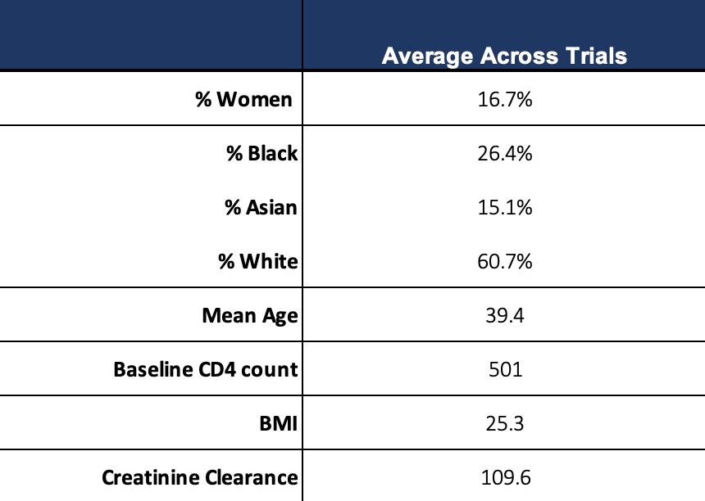
Appendix 1 – Average baseline demographics across all trials, and split into those trials done using boosted and unboosted TDF regimens

Appendix 2 – Meta-analysis of efficacy

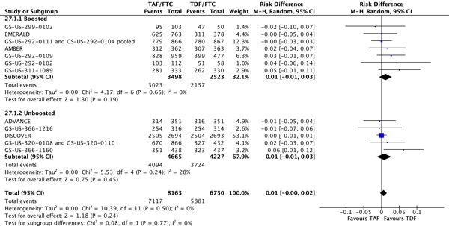
Appendix 3 – all grade 1-4 adverse events meta analysis
- including events/people expect advance = people/people

Appendix 4 – meta-analysis of grade 3/4 adverse events

Appendix 5 – Grade 3-4 laboratory adverse events

Appendix 6 – meta-analysis of serious adverse events

Appendix 7 – meta-analysis of discontinuations due to adverse events (D/CAE)

Appendix 8 – meta-analysis of number of deaths from any cause

Appendix 9 – discontinuations due to bone adverse events

Appendix 10 - Forest plot showing details of bone fractures - again divided by boosted and unboosted

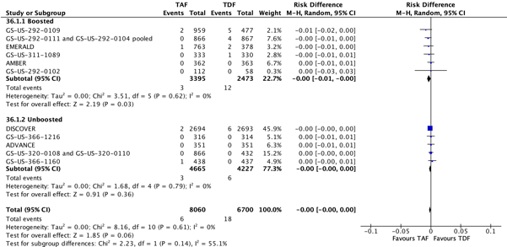

Appendix 11. Forest plot showing details of meta-analysis for discontinuations for renal adverse events, divided by boosted and unboosted.

Appendix 11 – renal tubular adverse events

