Table S1 Population-based HIV Impact Assessment (PHIA) survey questions used to determine HIV testing history and knowledge of HIV status ^{[1-4]}. Each unanswered question was marked as NA.

Questions | Ever tested and received results | Awareness of HIV-positive status
Question for all participants
What was the result of your last HIV test? | Participants who responded “positive”, “unknown/indeterminate” or “negative” were defined as self-reported ever tested and received results, while participants who responded “did not receive results”, were defined as self-reported never tested and received results. | Participants who responded “positive”, were defined as self-reported aware of HIV-positive status. Participants who responded “negative”, “unknown/indeterminate”, “don’t know” or “did not receive results”, were defined as self-reported unaware of HIV-positive status.
Questions for women who ever visited a health facility during pregnancy
Did you test positive for HIV before your pregnancy with [NAME]? | Participants who responded “yes” or “no”, were defined as self-reported ever tested and received results. Participants who responded “did not receive results”, were defined as self-reported never tested and received results. | Participants who responded “yes”, were defined as self-reported aware of HIV-positive status, while participants who responded “no” or “don’t know”, were defined as self-reported unaware of HIV-positive status.
What was the result of your last HIV test during your pregnancy with [NAME]? | Participants who responded “positive”, “unknown/indeterminate” or “negative” were defined as self-reported ever tested and received results, while participants who responded “did not receive results”, were defined as self-reported never tested and received results. | Participants who responded “positive”, were defined as self-reported aware of HIV-positive status, while participants who responded “negative”, “unknown/indeterminate”, “don’t know” or “did not receive results” were defined as self-reported unaware of HIV-positive status.
What was the result of the HIV test during labor? | Participants who responded “positive”, “unknown/indeterminate” or “negative”, were defined as self-reported ever tested and received results, while participants who responded “did not receive results”, were defined as self-reported never tested and received results. | Participants who responded “positive”, were defined as self-reported aware of HIV-positive status, while participants who responded “negative”, “unknown/indeterminate”, “don’t know” or “did not receive results” were defined as self-reported unaware of HIV-positive status.
Table S2 Prior distributions and interpretation of the unknown parameters used in the Bayesian latent class model.
Symbol | Description | Prior distribution | Reference
$$π$$ | True proportion of PLHIV ever tested / aware of HIV-positive status | ~Uniform(0%, 100%) | NA
$$Se_{SR_{pos}}$$ | Sensitivity of self-reports among PLHIV with detectable antiretroviral (ARV) metabolites | ~Uniform(0%, 100%) | NA
$$Se_{SR_{neg}}$$ | Sensitivity of self-reports among PLHIV without detectable ARV metabolites | ~Uniform(0%, 100%) | NA
$$Sp_{SR}$$ | Specificity of self-reports | 100% | Assumed
$${Cov}_{ARV}$$ | Proportion of PLHIV with detectable ARV | ~Uniform(0%, 100%) | NA
$$Sp_{ARV}$$ | Specificity of ARV metabolite status | 100% | Assumed
Ratio | Prevalence ratio of non-disclosure for the outcome of interest (ever tested or awareness) among PLHIV with detectable ARV metabolites compared to those without detectable ARV metabolites | exp (  $N$ (log (1.48), 4.0)) | ^{[5]}

Text S1. Likelihood equations of the latent data
$$Y_{1}=A+B; Y_{2}=C+D; Y_{3}=E+F; Y_{4}=G+H$$
$Y_{1}, Y_{2}, Y_{3}, Y_{4} \sim Multi (p_{1},p_{2}, p_{3}, p_{4};N)$ (1)
$p_{1}= π*Se_{SR_{pos}}* {Cov}_{ARV}+\left(1-π\right)*\left(1-Sp_{SR}\right)*(1-Sp_{ARV})$ (2)
$p_{2}= π*Se_{SR_{neg}}*(1-{Cov}_{ARV})+\left(1-π\right)*\left(1-Sp_{SR}\right)*Sp_{ARV}$ (3)
$p_{3}=π*(1-Se_{SR_{pos}})* {Cov}_{ARV}+\left(1-π\right)*Sp_{SR}*(1-Sp_{ARV})$ (4)
$p_{4}=π*(1-Se_{SR_{neg}})*\left(1-{Cov}_{ARV}\right)+\left(1-π\right)*Sp_{SR}*Sp_{ARV}$ (5)
$Se_{SR_{neg}}=1-Ratio*(1-Se_{SR_{pos}})$ (6)

Text S2. Description of the Population-based HIV Impact Assessment (PHIA) surveys and antiretroviral (ARV) metabolites testing algorithm.

The PHIA Project was designed to collect standardized data across countries to measure the reach and impact of HIV programs in PEPFAR-support countries through national household surveys ^{[6]}. PHIA surveys are being conducted in 14 countries and this study includes the four surveys that have publicly accessible data and available microdata on PLHIV aged 15+ years: Swaziland (Eswatini) HIV Incidence Measurement Survey 2 (SHIMS2, 2015-2016), Malawi PHIA (MPHIA, 2015-2016), Tanzania HIV Impact Survey (THIS, 2016-2017), and Zambia PHIA (ZAMPHIA, 2016). Final reports with analyzed survey data are produced after the data collection and can be found on the PHIA website (https://phia.icap.columbia.edu).
Biomarkers of ARV metabolites were tested at the University of Cape Town, (Cape Town, South Africa; SHIMS2 and ZAMPHIA), COM-JHP ( Blantyre, Malawi ; MPHIA) and NHLQATC (Dar es Salaam, Tanzania THIS). Selected biomarkers of ARV metabolites were detected using high-resolution liquid chromatography coupled with tandem mass spectrometry to detect ARVs from dry blood spot (DBS) specimens in all four countries. Based on national treatment guidelines for each country, the Atazanavir, Efavirenz, Lopinavir and Nevirapine biomarkers were examined for participants of MPHIA, THIS and ZAMPHIA, whereas SHIMS2 only tested for the latter three. ^{[7-10]}.

Table S3 Self-reported HIV testing history and awareness of HIV-positive status among people living with HIV (PLHIV) with (ARV+) and without detectable antiretrovirals (ARV-).

Self-reported ever tested for HIV and received results among PLHIV
 | Eswatini |  | Malawi |  | Tanzania |  | Zambia
 | ARV+ | ARV- | ARV+ | ARV- | ARV+ | ARV- | ARV+ | ARV-
Ever | 2266 | 634 | 1466 | 557 | 947 | 589 | 1458 | 738
Never | 10 | 79 | 26 | 141 | 33 | 240 | 38 | 194
Self-reported awareness of HIV-positive status among PLHIV
 | Eswatini |  | Malawi |  | Tanzania |  | Zambia
 | ARV+ | ARV- | ARV+ | ARV- | ARV+ | ARV- | ARV+ | ARV-
Aware | 2219 | 374 | 1409 | 211 | 905 | 161 | 1372 | 285
Unaware | 59 | 345 | 85 | 491 | 75 | 675 | 125 | 655

Table S4 Marginal posterior medians and 95% credible intervals (CrI). (A) Sensitivity of self-reported ever tested and received results and (B) Sensitivity of self-reported awareness of HIV-positive status among people living with HIV with ARV (ARV+) and without detectable ARV (ARV-).

(A) Sensitivity of self-reported ever tested and received results
 |  | Eswatini |  |  | Malawi |  | Tanzania |  |  | Zambia
 | ARV status | Median | 95% CrI | Median |  | 95% CrI |  | Median | 95% CrI | Median | 95% CrI
Overall | ARV+ | 99.5% | (99.2%, 99.8%) | 98.2% |  | (97.5%, 98.8%) |  | 96.6% | (95.3%, 97.6%) | 97.4% | (96.5%, 98.1%)
 | ARV- | 99.2% | (97.7%, 99.7%) | 96.9% |  | (92.1%, 98.4%) |  | 94.1% | (84.8%, 96.9%) | 95.6% | (88.7%, 97.6%)
ARV+ compare to ARV- |  | 0.3% | (0.0%, 1.6%) | 1.2% |  | (0.1%, 5.9%) |  | 2.4% | (0.1%, 11.4%) | 1.8% | (0.1%, 8.4%)
Female | ARV+ | 99.8% | (99.4%, 99.9%) | 98.4% |  | (97.5%, 99.1%) |  | 96.8% | (95.3%, 97.9%) | 98.1% | (97.2%, 98.8%)
 | ARV- | 99.6% | (98.6%, 99.9%) | 97.3% |  | (92.6%, 98.7%) |  | 94.4% | (85.4%, 97.2%) | 96.7% | (91.6%, 98.4%)
Male | ARV+ | 98.9% | (98.0%, 99.5%) | 97.5% |  | (95.8%, 98.7%) |  | 95.8% | (92.8%, 97.8%) | 95.7% | (93.6%, 97.3%)
 | ARV- | 98.1% | (94.5%, 99.3%) | 95.8% |  | (87.9%, 98.2%) |  | 92.6% | (79.5%, 96.9%) | 92.6% | (80.7%, 96.4%)
Female compare to male (ARV+) |  | 0.8% | (0.2%, 1.8%) | 0.9% |  | (-0.6%, 2.7%) |  | 1.0% | (-1.5%, 4.2%) | 2.4% | (0.6%, 4.7%)
Age 15-24 years | ARV+ | 97.1% | (94.3%, 98.8%) | 97.2% |  | (92.9%, 99.4%) |  | 96.2% | (90.3%, 99.1%) | 94.7% | (89.6%, 97.9%)
 | ARV- | 95.1% | (88.7%, 98.3%) | 95.1% |  | (84.1%, 99.0%) |  | 93.3% | (78.8%, 98.6%) | 90.9% | (78.5%, 96.9%)
Age 25-34 years | ARV+ | 99.4% | (98.7%, 99.8%) | 98.8% |  | (97.4%, 99.6%) |  | 97.8% | (95.2%, 99.2%) | 97.3% | (95.3%, 98.6%)
 | ARV- | 99.1% | (97.0%, 99.8%) | 97.9% |  | (93.5%, 99.4%) |  | 96.1% | (88.7%, 98.8%) | 95.4% | (88.9%, 98.1%)
Age 35-49 years | ARV+ | 99.7% | (99.2%, 99.9%) | 98.0% |  | (96.9%, 98.9%) |  | 96.2% | (94.3%, 97.7%) | 98.1% | (97.1%, 98.9%)
 | ARV- | 99.5% | (98.3%, 99.9%) | 96.6% |  | (91.0%, 98.5%) |  | 93.5% | (83.5%, 96.9%) | 96.9% | (92.4%, 98.6%)
Age 50+ years | ARV+ | 99.9% | (99.3%, 100.0%) | 97.5% |  | (95.1%, 98.9%) |  | 95.4% | (92.3%, 97.6%) | 95.7% | (92.7%, 97.8%)
 | ARV- | 99.8% | (98.6%, 100.0%) | 95.6% |  | (87.0%, 98.4%) |  | 92.2% | (78.7%, 96.7%) | 92.8% | (82.0%, 96.9%)
Urban | ARV+ | 99.3% | (98.3%, 99.8%) | 97.7% |  | (96.4%, 98.7%) |  | 96.4% | (94.3%, 97.9%) | 97.7% | (96.6%, 98.6%)
 | ARV- | 98.8% | (95.7%, 99.7%) | 96.0% |  | (89.1%, 98.2%) |  | 93.7% | (84.0%, 97.1%) | 96.1% | (89.6%, 98.1%)
Rural | ARV+ | 99.6% | (99.2%, 99.8%) | 98.6% |  | (97.6%, 99.2%) |  | 96.6% | (94.9%, 97.9%) | 96.8% | (95.2%, 98.1%)
 | ARV- | 99.2% | (97.8%, 99.7%) | 97.5% |  | (93.1%, 98.9%) |  | 94.2% | (85.0%, 97.2%) | 94.5% | (85.5%, 97.4%)
Table S4 (Cont.)
(A) Sensitivity of self-reported ever tested and received results (Cont.)
 |  | Eswatini |  | Malawi |  | Tanzania |  | Zambia
 | ARV status | Median | 95% CrI | Median | 95% CrI | Median | 95% CrI | Median | 95% CrI
SES (Lowest) | ARV+ | 99.7% | (99.0%, 100.0%) | 98.4% | (95.8%, 99.6%) | 92.1% | (87.0%, 95.7%) | 96.3% | (92.1%, 98.7%)
 | ARV- | 99.5% | (97.8%, 99.9%) | 97.2% | (90.0%, 99.4%) | 86.6% | (68.8%, 94.0%) | 93.4% | (80.5%, 98.0%)
SES (Second) | ARV+ | 99.1% | (98.0%, 99.7%) | 98.5% | (96.1%, 99.7%) | 98.0% | (95.3%, 99.4%) | 96.7% | (93.3%, 98.7%)
 | ARV- | 98.4% | (95.0%, 99.5%) | 97.4% | (90.7%, 99.5%) | 96.6% | (89.7%, 99.1%) | 94.2% | (83.3%, 98.1%)
SES (Middle) | ARV+ | 99.2% | (98.2%, 99.8%) | 98.2% | (95.8%, 99.5%) | 98.4% | (96.4%, 99.4%) | 96.6% | (94.2%, 98.2%)
 | ARV- | 98.7% | (95.6%, 99.7%) | 96.9% | (89.6%, 99.2%) | 97.3% | (92.1%, 99.2%) | 94.0% | (84.4%, 97.5%)
SES (Fourth) | ARV+ | 99.3% | (98.2%, 99.8%) | 97.2% | (95.0%, 98.7%) | 95.1% | (91.8%, 97.4%) | 97.1% | (95.1%, 98.4%)
 | ARV- | 98.8% | (95.7%, 99.8%) | 95.1% | (87.4%, 98.1%) | 91.6% | (82.2%, 96.4%) | 94.9% | (87.4%, 97.8%)
SES (Highest) | ARV+ | 99.8% | (98.8%, 100%) | 98.2% | (96.9%, 99.0%) | 96.2% | (92.6%, 98.5%) | 98.2% | (96.7%, 99.1%)
 | ARV- | 99.6% | (97.3%, 100%) | 96.8% | (91.4%, 98.6%) | 93.6% | (83.6%, 97.8%) | 96.9% | (91.5%, 98.8%)

(B) Sensitivity of self-reported awareness of HIV-positive status
 |  | Eswatini |  |  | Malawi |  | Tanzania |  |  | Zambia
 | ARV status | Median | 95% CrI | Median |  | 95% CrI |  | Median | 95% CrI | Median | 95% CrI
Overall | ARV+ | 97.4% | (96.7%, 98.0%) | 94.3% |  | (93.0%, 95.4%) |  | 92.3% | (90.5%, 93.8%) | 91.6% | (90.1%, 92.9%)
 | ARV- | 95.5% | (88.7%, 97.5%) | 90.1% |  | (74.5%, 94.4%) |  | 86.6% | (65.2%, 92.5%) | 85.4% | (62.4%, 91.6%)
ARV+ compare to ARV- |  | 1.8% | (0.1%, 8.5%) | 4.2% |  | (0.2%, 19.6%) |  | 5.7% | (0.3%, 26.7%) | 6.2% | (0.3%, 29.0%)
Female | ARV+ | 97.6% | (96.8%, 98.3%) | 94.6% |  | (93.1%, 95.8%) |  | 92.1% | (90.0%, 93.9%) | 92.9% | (91.2%, 94.4%)
 | ARV- | 95.9% | (89.2%, 97.8%) | 90.4% |  | (74.8%, 94.8%) |  | 85.7% | (60.2%, 92.4%) | 87.0% | (65.9%, 93.1%)
Male | ARV+ | 96.8% | (95.3%, 97.9%) | 93.4% |  | (90.8%, 95.5%) |  | 92.5% | (88.9%, 95.4%) | 88.4% | (85.3%, 91.1%)
 | ARV- | 94.5% | (85.0%, 97.3%) | 88.3% |  | (68.4%, 94.1%) |  | 86.5% | (60.6%, 93.7%) | 79.0% | (44.1%, 88.9%)
Female compare to male (ARV+) |  | 0.8% | (-0.5%, 2.4%) | 1.2% |  | (-1.4%, 4.0%) |  | -0.4% | (-4.0%, 3.6%) | 4.5% | (1.3%, 7.9%)

Table S4 (Cont.)
(B) Sensitivity of self-reported awareness of HIV-positive status (Cont.)
 |  | Eswatini |  |  | Malawi |  | Tanzania |  |  | Zambia
 | ARV status | Median | 95% CrI | Median |  | 95% CrI |  | Median | 95% CrI | Median | 95% CrI
Age 15-24 years | ARV+ | 90.1% | (85.4%, 93.8%) | 91.9% |  | (85.3%, 96.3%) |  | 87.2% | (77.9%, 93.7%) | 83.9% | (76.1%, 90.0%)
 | ARV- | 82.5% | (54.9%, 91.7%) | 85.0% |  | (51.7%, 94.5%) |  | 75.0% | (26.5%, 90.7%) | 68.5% | (25.4%, 86.0%)
Age 25-34 years | ARV+ | 96.8% | (95.3%, 98.0%) | 93.0% |  | (90.2%, 95.2%) |  | 91.0% | (86.6%, 94.4%) | 91.0% | (87.7%, 93.7%)
 | ARV- | 94.4% | (85.5%, 97.3%) | 87.0% |  | (63.8%, 93.7%) |  | 82.5% | (49.9%, 92.2%) | 82.4% | (55.5%, 91.6%)
Age 35-49 years | ARV+ | 98.4% | (97.5%, 99.1%) | 94.8% |  | (93.1%, 96.2%) |  | 92.0% | (89.3%, 94.2%) | 92.2% | (90.2%, 93.9%)
 | ARV- | 97.2% | (92.4%, 98.7%) | 90.4% |  | (73.3%, 95.2%) |  | 84.3% | (56.8%, 92.4%) | 84.9% | (62.8%, 92.4%)
Age 50+ years | ARV+ | 98.5% | (97.1%, 99.3%) | 94.8% |  | (91.6%, 97.0%) |  | 94.6% | (91.2%, 97.0%) | 92.9% | (89.2%, 95.7%)
 | ARV- | 97.3% | (92.0%, 99.0%) | 90.3% |  | (71.1%, 95.8%) |  | 89.4% | (68.5%, 95.7%) | 86.2% | (62.7%, 93.9%)
Urban | ARV+ | 95.4% | (93.4%, 97.0%) | 93.2% |  | (91.2%, 95.0%) |  | 93.1% | (90.4%, 95.2%) | 92.1% | (90.2%, 93.7%)
 | ARV- | 92.0% | (78.6%, 96.0%) | 88.1% |  | (67.9%, 93.7%) |  | 87.6% | (64.8%, 93.7%) | 85.8% | (61.8%, 92.3%)
Rural | ARV+ | 97.9% | (97.2%, 98.5%) | 95.0% |  | (93.4%, 96.4%) |  | 91.5% | (89.0%, 93.7%) | 90.7% | (88.2%, 92.9%)
 | ARV- | 96.4% | (90.6%, 98.1%) | 91.2% |  | (76.4%, 95.4%) |  | 84.9% | (57.5%, 92.0%) | 83.4% | (54.9%, 91.1%)
SES (Lowest) | ARV+ | 98.9% | (97.8%, 99.5%) | 93.0% |  | (88.4%, 96.2%) |  | 87.9% | (81.9%, 92.5%) | 88.2% | (81.9%, 93.0%)
 | ARV- | 98.0% | (93.5%, 99.3%) | 86.7% |  | (58.4%, 94.5%) |  | 75.6% | (29.9%, 89.4%) | 76.5% | (40.1%, 90.1%)
SES (Second) | ARV+ | 97.0% | (95.3%, 98.2%) | 94.7% |  | (90.8%, 97.3%) |  | 93.1% | (88.8%, 96.2%) | 92.0% | (87.3%, 95.4%)
 | ARV- | 94.6% | (84.7%, 97.5%) | 89.9% |  | (67.1%, 96.1%) |  | 86.1% | (57.7%, 94.4%) | 84.2% | (55.5%, 93.5%)
SES (Middle) | ARV+ | 97.4% | (95.8%, 98.6%) | 95.3% |  | (91.8%, 97.6%) |  | 94.2% | (91.1%, 96.5%) | 92.0% | (88.7%, 94.7%)
 | ARV- | 95.4% | (86.7%, 98.0%) | 91.0% |  | (71.1%, 96.5%) |  | 88.3% | (65.3%, 95.0%) | 84.2% | (58.4%, 92.8%)
SES (Fourth) | ARV+ | 95.9% | (93.7%, 97.6%) | 95.2% |  | (92.4%, 97.3%) |  | 90.3% | (85.8%, 93.8%) | 89.3% | (86.0%, 92.0%)
 | ARV- | 92.7% | (79.4%, 96.7%) | 90.9% |  | (72.3%, 96.1%) |  | 80.4% | (43.2%, 91.3%) | 78.7% | (45.7%, 89.7%)
SES (Highest) | ARV+ | 96.0% | (93.4%, 97.9%) | 93.2% |  | (91.1%, 95.0%) |  | 92.8% | (87.9%, 96.2%) | 93.4% | (91.0%, 95.4%)
 | ARV- | 92.9% | (79.5%, 97.0%) | 87.2% |  | (63.2%, 93.6%) |  | 85.5% | (54.2%, 94.4%) | 86.9% | (66.0%, 93.8%)

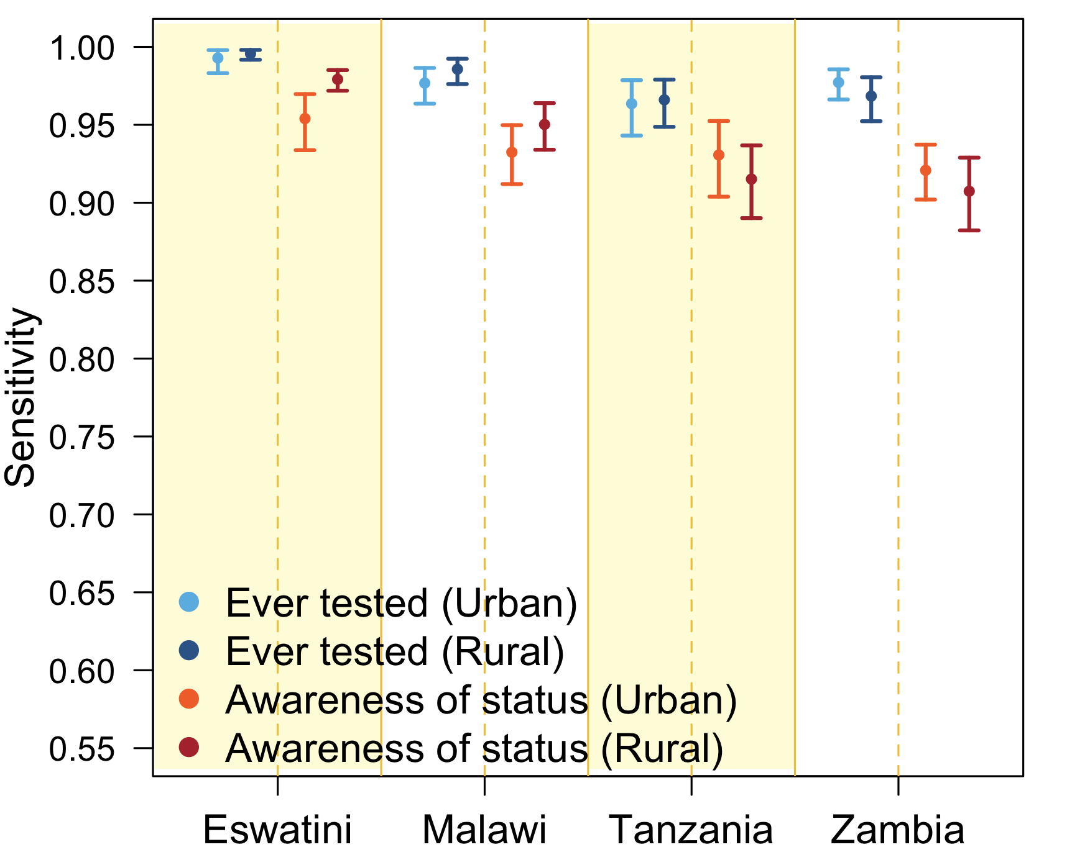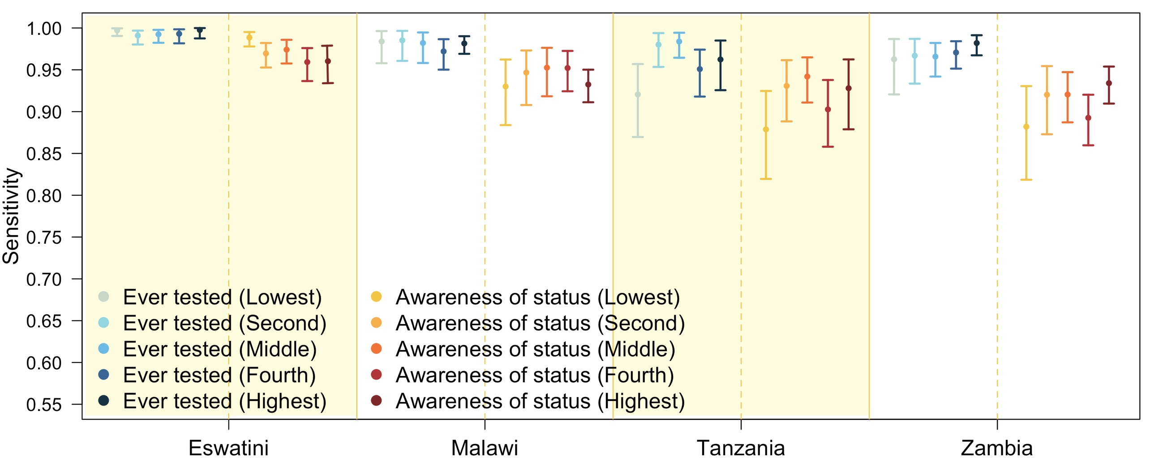
A
B

Figure S1 Marginal posterior medians and 95% credible intervals. Sensitivity of self-reported ever tested and received results and awareness of HIV-positive status among people living with HIV (PLHIV) with detectable ARV metabolites by: (A) household location (Urban / Rural) and (B) socioeconomic status.

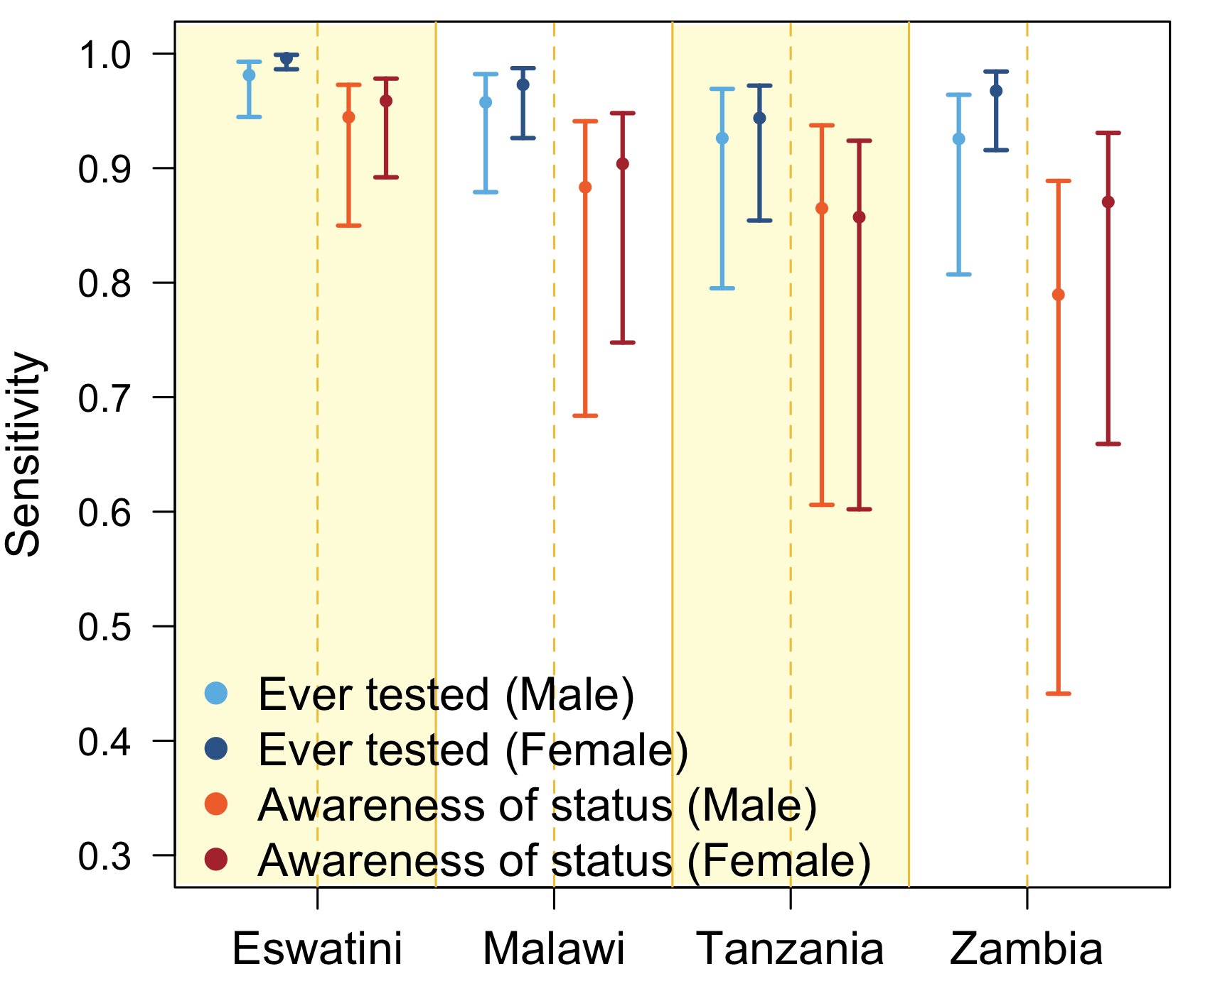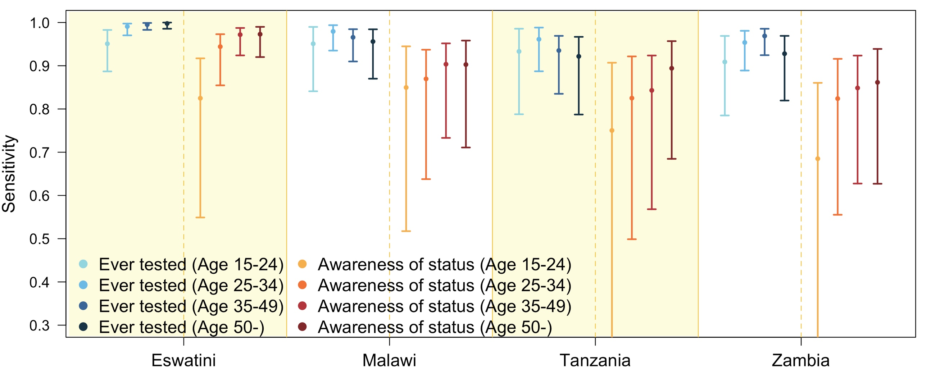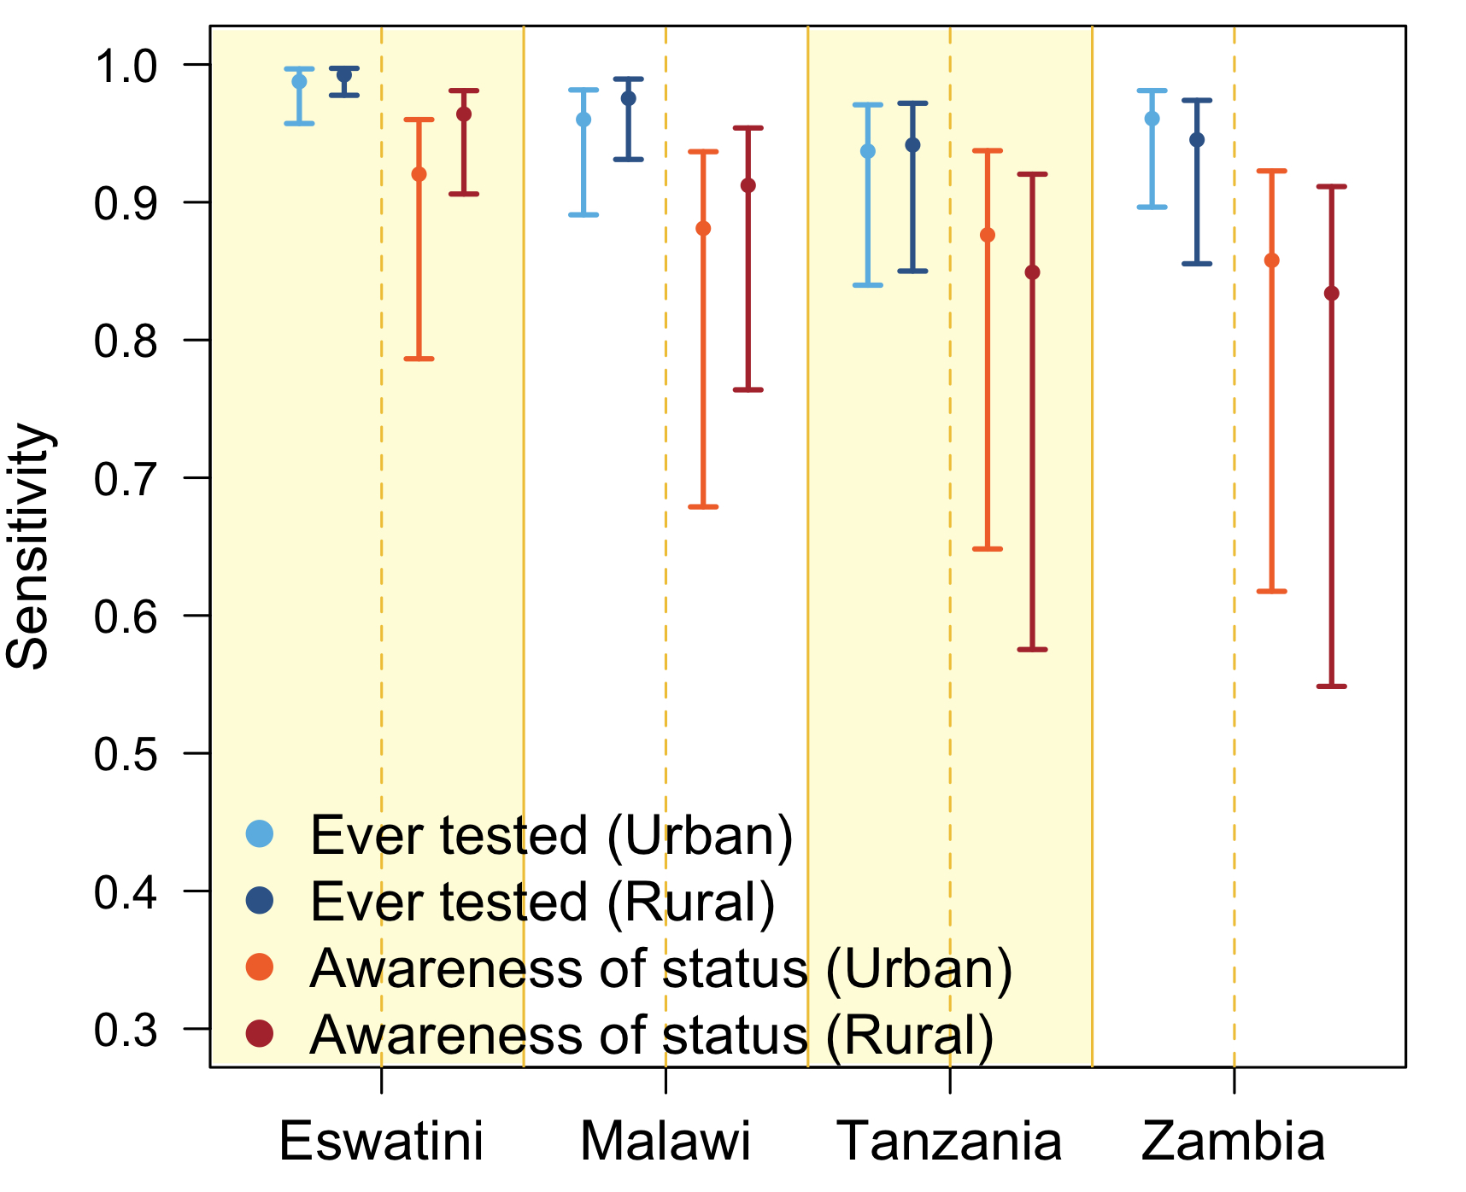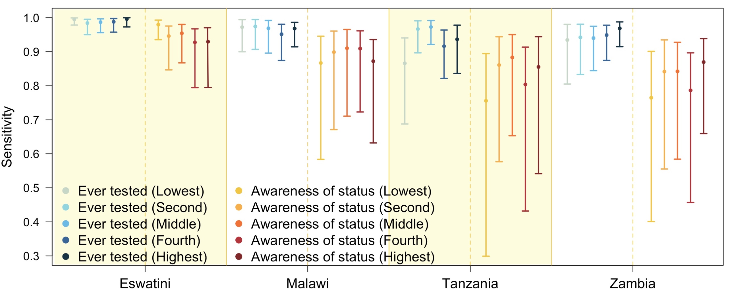\
C
D
A
B
Figure S2 Marginal posterior medians and 95% credible intervals. Sensitivity of self-reported ever tested and received results and awareness of HIV-positive status among people living with HIV (PLHIV) without detectable ARV by: (A) gender, (B) age groups, (C) urban/rural and (D) socioeconomic status.
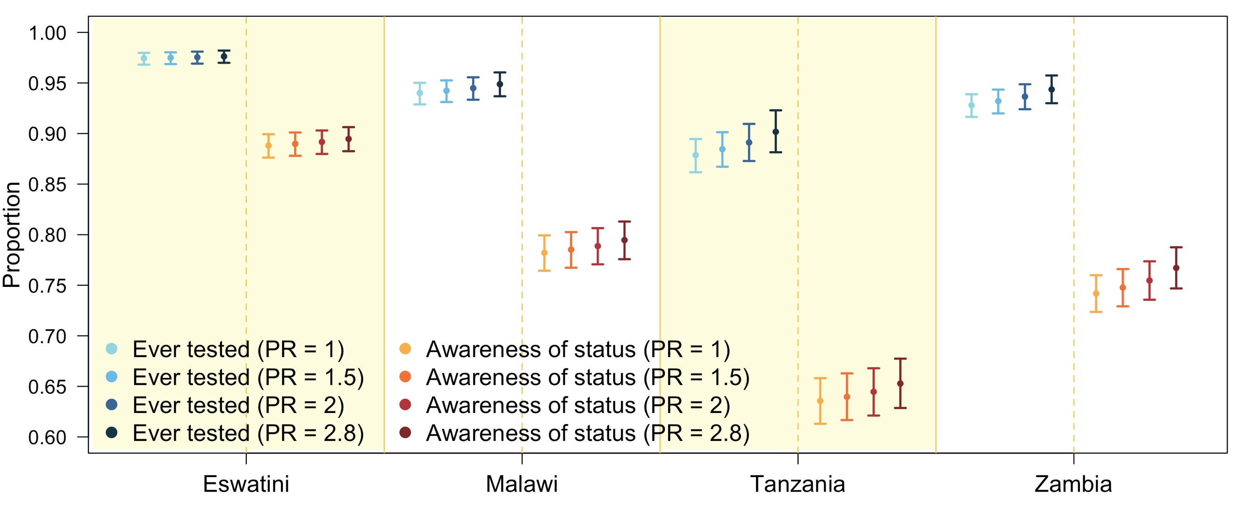
Figure S3 Marginal posterior medians and 95% credible intervals. Proportion ever tested and received results and awareness of HIV-positive status among people living with HIV (PLHIV) with varying prevalence ratio (PR) of non-disclosure priors comparing PLHIV without detectable ARV metabolites to PLHIV with detectable ARV metabolites.

References
1. Swaziland HIV incidence measurement survey 2 (SHIMS2) 2016-2017 adult survey quetionnaire. In. New York, NY; April 2019.
2. Tanzania HIV impact survey (THIS) 2016-2017 adult survey questionnaire. In. New York, NY; December 2018.
3. Malawi population-based HIV impact assessment (MPHIA) 2015-2016 adult survey questionnaire. In. New York, NY; December 2018.
4. Zambia population-based HIV impact assessment (ZAMPHIA) 2016-2017 adult survey questionnaire. In. New York, NY; February 2019.
5. Fuente-Soro L, Lopez-Varela E, Augusto O, Sacoor C, Nhacolo A, Honwana N, et al. Monitoring progress towards the first UNAIDS target: understanding the impact of people living with HIV who re-test during HIV-testing campaigns in rural Mozambique. J Int AIDS Soc 2018; 21(4):e25095.
6. Population-based HIV impact assessment (PHIA) data use manual. In. New York, NY; July 2019.
7. Eswatini GotKo. Swaziland HIV incidence measurement survey 2 (SHIMS2) 2016-2017. Final report. In. Mbabane: Government of the Kingdom of Eswatini; April 2019.
8. Ministry of Health M. Malawi population-based HIV impact assessment (MPHIA) 2015-2016: Final report. In. Lilongwe: Ministry of Health; October 2018.
9. Tanzania Commission for AIDS (TACAIDS), (ZAC) ZAC. Tanzania HIV impact survey (THIS) 2016-2017: Final report. In. Dar es Salaam: Tanzania; December 2018.
10. Ministry of Health Z. Zambia population-based HIV impact assessment (ZAMPHIA) 2016: Final report. In. Lusaka: Ministry of Health; February 2019.

