Supplementary material
This appendix is a supplement to: Keene et al. Virologic efficacy of tenofovir, lamivudine and dolutegravir as second-line in adults failing a tenofovir-based first-line regimen: a prospective cohort study

Table 1a. Frequency of specific major nucleoside reverse-transcriptase inhibitor (NRTI) and non-nucleoside reverse-transcriptase inhibitor (NNRTI) mutations at baseline
Table 1b. Listing of major and minor nucleoside reverse-transcriptase inhibitor (NRTI) and non-nucleoside reverse-transcriptase inhibitor (NNRTI) mutations at baseline by participant
Table 2. Outcomes for participants not suppressed (viral load [VL] <50 copies/mL) using the modified intention-to-treat analysis at week 24
Table 3. Aggregated HIV viral load outcomes by study visit

Table 4. HIV viral load data by participant
Figure 1. Time to virologic suppression <50 copies/mL by modified intention-to-treat analysis
Table 5. Characteristics by primary outcome (viral load <50 copies/mL) at week 24 (modified intention-to-treat analysis, n=60)
Table 6. Characteristics by viral load <400 copies/mL at week 24 (modified intention-to-treat analysis, n=60)
Figure 2. Subgroup analysis of primary endpoint stratified by baseline characteristics and adherence (tenofovir diphosphate [TFV-DP] concentration) at week 24 (VL < 50 copies/mL at week 24, modified intention-to-treat analysis)
Figure 3. Subgroup analysis of participants with viral load <400 copies/mL at week 24 stratified by baseline characteristics and adherence (tenofovir diphosphate concentration) at week 24 (modified intention-to-treat analysis)
Table 7. Categorised tenofovir diphosphate (TFV-DP) concentrations at baseline, week 12, and week 24, stratified by sex
Table 8. Summary of adverse events from baseline to week 24
Figure 4. Proportion of individuals with specific Modified Mini Screen (MMS) score over time (continuous score ranging from 0 to 22)
Figure 5. Proportion of individuals with insomnia severity index (ISI) score at each timepoint (continuous measure ranging from 0 to 28)
Table 9. Concomitant medications with potential for dolutegravir interaction taken at any point from baseline to week 24

Table 1a. Frequency of specific major nucleoside reverse-transcriptase inhibitor (NRTI) and non-nucleoside reverse-transcriptase inhibitor (NNRTI) mutations at baseline
Major NRTI mutations (n/%) | N=54 | Major NNRTI mutations (n/%) | N=54
M41L | 2 (4) | L100I | 2 (4)
K65R | 20 (37) | K101E | 5 (9)
K65N | 0 (0) | K101P | 0 (0)
K65E | 0 (0) | K103H | 0 (0)
D67N | 10 (19) | K103N | 31 (57)
T69Ins | 0 (0) | K103S | 1 (2)
T69Deletion | 1 (2) | K103T | 0 (0)
K70E | 4 (7) | V106A | 0 (0)
K70G | 0 (0) | V106M | 17 (31)
K70N | 0 (0) | E138K | 0 (0)
K70Q | 2 (4) | Y181C | 6 (11)
K70R | 7 (13) | Y181F | 0 (0)
K70S | 0 (0) | Y181G | 0 (0)
K70T | 2 (4) | Y181I | 0 (0)
L74I | 2 (4) | Y181S | 0 (0)
Y115F | 3 (6) | Y181V | 0 (0)
Q151L | 0 (0) | Y188C | 1 (2)
Q151M | 0 (0) | Y188F | 0 (0)
M184V | 45 (83) | Y188H | 0 (0)
M184I | 0 (0) | Y188L | 8 (15)
L210W | 0 (0) | G190A | 6 (11)
T215F | 0 (0) | G190C | 0 (0)
T215Y | 0 (0) | G190E | 1 (2)
 |  | G190Q | 0 (0)
 |  | G190S | 1 (2)
 |  | G190T | 0 (0)
 |  | G190V | 0 (0)
 |  | P225H | 16 (30)
 |  | F227C | 0 (0)
 |  | M230L | 1 (2)
Major mutations as defined by the Stanford university resistance database (last updated 2019-07-31)³

Table 1b. Listing of major and minor nucleoside reverse-transcriptase inhibitor (NRTI) and non-nucleoside reverse-transcriptase inhibitor (NNRTI) mutations at baseline by participant
No | NRTI, major | NRTI, minor | NNRTI, major | NNRTI, minor
1 | Y115F,M184V,K65R |  | Y181C | V108I
2 | D67N,K70R,M184V | K219E | V106M | F227L
3 |  |  | K103N
4 | M184V,L74I | K219Q | P225H,K103N | A98G
5 | K65R,M184V | V75I | K103N,L100I
6 | M184V,K65R |  | K103N,Y188L
7 | M184V,K65R | A62V,F77L,K219E | K103N,Y181C,G190A
8 | D67N,K70E,M184V |  | K103N,Y188L | H221Y
9 | K70R,D67N,M184V | K219E,T215I | K103N | V108I,K238T
10 | K70E,D67DN,M184V | K219KR | K103N,P225H
11 | M184V,K70Q |  | V106M,G190A,K101E
12 | K70T,M41L,K65R,M184V |  | V106M,Y188L | E138A
13 | M184V,M41L,K65R,K70T |  | V106M,Y188L | E138A
14 | M184V |  | K103N | V108I
15 | K65R,M184V,Y115F,L74LI,D67N | K219E | V106M,K103N
16 | M184V | L74V | P225H,L100I,K103N | K238T
17 | M184V,K70KR | K219E | V106M | V108I,F227FL
18 | M184V,K70R,D67N | T215IV,K219E | Y188L | A98G
19 | K70EQ,M184V |  | V106M | F227FL,E138A,V179D
20 |  |  | K103N
21 | M184V |  |  | E138A
22 | M184V,K70R,D67N | K219Q | V106M | F227L,E138Q
23 | M184V,K65R | A62V | V106M,K103S | F227L
24 | M184V |  | P225H,K103N
25 | D67N,M184V,K70E | K219R | K103N,P225H | H221Y,E138EG,F227FL,V108VI
26 | M184V |  | Y188L,P225H | E138Q
27 | K65R,M184V |  | K101E,Y181C,G190S
28 | M184V | V75VM | K103N,P225H
29 | D67N,K70R,M184V | K219E,T215I | G190E
30 | M41ML,M184V,K65R,L74L |  | K103N | E138EG,V108I
31 | K65R | A62AV | Y181C,V106M | H221Y,F227L
32 | M184V | A62AV | G190GA,P225H,K103N | K238KT
33 | K65R,M184V | A62AV | V106M | V179D
34 | M184V,Y115F,K65R |  | V106M,K103N | F227L
35 | M184V,K65R |  | P225H,K103N
36 | K65R,M184V |  | V106M,M230L | V179D
37 | K65R,M184V | A62V,K219E | K103N,G190A
38 |  |  | K103N,P225H
39 |  |  | K103N
40 | K65R,D67DN |  | Y181C,K101E,G190A,V106VM
41 |  |  | P225H,K103N
42 | M184V,K70KT,K65R | V75M,A62AV | Y188C,V106M
43 | M184V |  | P225H,K103N | V108I
44 | M184V,K65R | A62V | Y188L,K103N
45 | D67N,K70R,M184V | K219Q | G190A,V106M,K101E | F227L
46 | M184V,K70KE |  | K101KE,Y188L,P225PH | V106VI
47 | M184V |  | Y181C,K101E,V106M,G190A
48 | L74I,M184V |  | K103N,P225H | A98G,H221Y,V108I
49 | M184V |  | P225H,K103N
50 | K65R, T69Deletion | K219R,A62V | K103N,V106M
51 | M184V,K70Q |  | K103N | V108I,E138Q,L234LI
52 | D67N,M184V,K70R | K219E | P225H,K103N
53
54 | L74LI,M184V,K65KR,K70KN |  | K103N,P225H
Major and minor mutations as defined by the Stanford university resistance database (last updated 2019-07-31)³

Table 2. Outcomes for participants not suppressed (viral load [VL] <50 copies/mL) using the modified intention-to-treat analysis at week 24

Outcome | N(%) | Details
VL >1000 copies/ml | 0/60 (0%)
VL 50-1000 copies/ml | 7/60 (12%) | Six had a VL 50-99 copies/mL and one had a VL 100-999 copies/mL
Discontinued study drug (failure) | 0/60 (0%)
Discontinued study drug (other) | 1/60 (1.7%) | Participant discontinued the study drug due to a tenofovir-related adverse event
Missing data but still on study | 1/60 (1.7%) | Missed the study visit within the ±2 week VL window

Table 3. Aggregated HIV viral load outcomes by study visit
 | Participants analysed (n) |  | Percentage suppressed (95% confidence interval)
Week | mITT* | Sensitivity analysis** | <50cp/mL (mITT) | <50cp/mL (sensitivity) | <400cp/mL (mITT) | <400cp/mL (sensitivity)
0 | 60 | 60 | 0.0 (0.0-6.0)† | 0.0 (0.0-6.0)† | 0.0 (0.0-6.0)† | 0.0 (0.0-6.0)†
4 | 60 | 54 | 68.3 (55.0-79.7) | 75.9 (62.4-86.5) | 88.3 (77.4-95.2) | 98.1 (90.1-100.0)
8 | 60 | 51 | 73.3 (60.3-83.9) | 86.3 (73.7-94.3) | 80.0 (67.7-89.2) | 94.1 (83.8-98.8)
12 | 60 | 54 | 75.0 (62.1-85.3) | 83.3 (70.7-92.1) | 86.7 (75.4-94.1) | 96.3 (87.3-99.5)
16 | 60 | 52 | 76.7 (64.0-86.6) | 88.5 (76.6-95.6) | 86.7 (75.4-94.1) | 100.0 (93.2-100.0)†
20 | 60 | 48 | 63.3 (49.9-75.4) | 79.2 (65.0-89.5) | 80.0 (67.7-89.2) | 100.0 (92.6-100.0)†
24 | 60 | 57 | 85.0 (73.4-92.9) | 89.5 (78.5-96.0) | 95.0 (86.1-99.0) | 100.0 (93.7-100.0)†
* Modified intention-to-treat analysis (mITT) excludes those switching study drug for reasons of stopping contraception or wish to become pregnant, or becoming pregnant, transfer out for non-clinical reasons and death from non-HIV and non-drug causes
** Sensitivity analysis excludes those excluded from mITT analysis, as well as lost to follow up, those missing a VL within the window, participants who stopped or were changed from the study drug for reasons other than failure of the regimen and those who had evidence of poor adherence (tenofovir diphosphate [TFV-DP] <350 fmol/punch). As TFV-DP was measured at weeks 12 and 24 only, it was assumed that individuals that were adherent/nonadherent at those visits were adherent/nonadherent respectively at the preceding visits (ie, weeks 4-12 for the week 12 adherence measure and weeks 16-24 for the week 24 adherence measure). Using this assumption, only one additional visit (at week 16) was excluded from the sensitivity population.
† One sided 97.5% confidence interval (CI) when 0 or 100% were successful

Table 4. HIV viral load (VL) data by participant
Participant | VL result by week
 | Screening VL | Week 4 |  | Week 8 |  | Week 12 | Week 16 |  | Week 20 |  | Week 24
1 | 77425 | 314 |  | 215 |  | 69 | 102 |  | 58 |  | 49
2 | 4668 | <20 |  | LDL |  | 29 | LDL |  | 23 |  | LDL
3 | 2113 | LDL |  | LDL |  | LDL | LDL |  | <20 |  | <20
4 | 2608 | 33 |  | <20 |  | LDL | LDL |  | LDL |  | LDL
5 | 3097 | LDL |  | <20 |  | LDL | LDL |  | <100 |  | <20
6 | 1299 | 26 |  | 31 |  | 80 | 39 |  | 50 |  | <20
7 | 11178 | <20 |  | <20 |  | 70 | 22 |  | MV |  | LDL
8 | 8320 | <20 |  | <20 |  | LDL | 24 |  | <100 |  | <20
9 | 17356 | 319 |  | 22467 |  | <20 | 107 |  | LDL |  | <20
10 | 61758 | 45 |  | <20 |  | <20 | LDL |  | 32 |  | 27
11 | 48765 | 73 |  | <20 |  | LDL | 39 |  | LDL |  | 75
12 | 22197 | 77 |  | <20 |  | 30 | <20 |  | 30 |  | 52
13 | 1040 | LDL |  | LDL |  | LDL | <20 |  | LDL |  | LDL
14 | 44742 | <100 |  | LDL |  | LDL | MV |  | LDL |  | LDL
15 | 2218 | <20 |  | 21 |  | <20 | LDL |  | 37 |  | 81
16 | 22794 | 34 |  | LDL |  | <20 | <20 |  | 83 |  | <100
17 | 79908 | 56 |  | <20 |  | 24 | 40 |  | <20 |  | 21
18 | 3323 | LDL |  | LDL |  | LDL | <20 |  | LDL |  | LDL
19 | 6104 | 89 |  | 62 |  | 193 | 112 |  | 109 |  | 53
20 | 37243 | LDL |  | 26 |  | <20 | LDL |  | LDL |  | LDL
21 | 6282 | <20 |  | <20 |  | <20 | LDL |  | LDL |  | LDL
22 | 3432 | LDL |  | 166 |  | <20 | LDL |  | LDL |  | <20
23 | 4662 | <20 |  | 33 |  | 31 | 30 |  | 21 |  | 25
24 | 86446 | 71 |  | <20 |  | 26 | LDL |  | 143 |  | 21
25 | 24971 | 1816 |  | 869 |  | 5300 | 67 |  | 97 |  | <20
26 | 12649 | 23 |  | <20 |  | LDL | LDL |  | LDL |  | <50
27 | 7429 | <20 |  | 21 |  | <20 | <20 |  | <100 |  | LDL
28 | 3163 | <20 |  | LDL |  | LDL | LDL |  | <20 |  | LDL
29 | 25127 | LDL |  | LDL |  | LDL | LDL |  | 162 |  | <20
30 | 18081 | LDL |  | LDL |  | LDL | 45 |  | LDL |  | <20
31 | 16123 | <20 |  | 20 |  | LDL | LDL |  | LDL |  | LDL
32 | 12661 | <20 |  | <20 |  | <20 | LDL |  | MV |  | LDL
33 | 2138 | 29 |  | 34 |  | <20 | MV |  | MV |  | LDL
34 | 64216 | 41 |  | 68 |  | 105 | 74038 |  | MV |  | 755
35 | 22809 | <20 |  | <20 |  | <20 | 38 |  | MV |  | <20
36 | 20846 | 32 |  | LDL |  | LDL | <20 |  | MV |  | LDL
37 | 11414 | <20 |  | 24 |  | 21 | LDL |  | MV |  | 27
38 | 1952 | 66 |  | LDL |  | 221 | LDL |  | MV |  | LDL
39 | 1147 | <20 |  | 34 |  | <20 | MV |  | MV |  | LDL
40 | 92677 | <20 |  | <20 |  | MV | MV |  | <50 |  | <20
41 | 7383 | <20 |  | <20 |  | MV | 132 |  | 22 |  | LDL
42 | 7027 | <20 |  | 34 |  | 1108 | MV |  | <50 |  | <50
43 | 39339 | 50 |  | <20 |  | MV | <20 |  | <50 |  | <20
44 | 18426 | 22 |  | <20 |  | MV | <20 |  | LDL |  | LDL
45 | 9981 | LDL |  | LDL |  | LDL | <20 |  | MV |  | LDL
46 | 2061 | LDL |  | MV |  | <20 | <20 |  | LDL |  | <20
47 | 9190 | LDL |  | MV |  | LDL | LDL |  | LDL |  | <20
48 | 57190 | LDL |  | MV |  | MV | <20 |  | LDL |  | LDL*
49 | 1834 | 21 |  | MV |  | <20 | LDL |  | LDL |  | LDL
50 | 44757 | <20 |  | MV |  | <20 | <20 |  | MV |  | <20
51 | 124717 | 195 |  | MV |  | 35 | 33 |  | <20 |  | 20
52 | 40761 | 68 |  | MV |  | 206 | 107 |  | MV |  | MV
53 | 1009 | LDL |  | MV |  | <20 | LDL |  | <20 |  | LDL
54 | 2827 | MV |  | LDL |  | LDL | LDL |  | <20 |  | 21
55 | 6697 | MV |  | MV |  | 46 | 39 |  | <20 |  | <20
56 | 1923 | MV |  | LDL |  | <50 | 27 |  | 44 |  | 26
57 | 54005 | MV |  | <20 |  | <50 | <20 |  | <20 |  | <20
58 | 56219 | MV |  | 48 |  | MV | LDL |  | 32 |  | 63
59 | 1495 | LDL |  | LDL |  | MV | LDL |  | LDL |  | LDL
60 | 2265 | MV |  | 3216 |  | 36 | MV |  | <20 |  | <50
Key | VL suppressed <50 copies/mL |  | VL 50-99 copies/mL |  | VL 100-999 copies/mL |  |  | VL ≥ 1000 copies/mL |  | MV: missed visit
Result considered suppressed if the value is <50 copies/mL, or noted in the report as “<50”, “<20” or “LDL” (lower than detectable limit)
VL “<100”: Based on the low sample volume, the linear range of this assay in dilution was 100 - 10,000,000 copies/mL.
* This participant was considered as a ‘virological failure’ in the modified intention-to-treat analysis as they were switched due to a tenofovir-related adverse event

Figure 1. Time to virologic suppression <50 copies/mL by modified intention-to-treat analysis
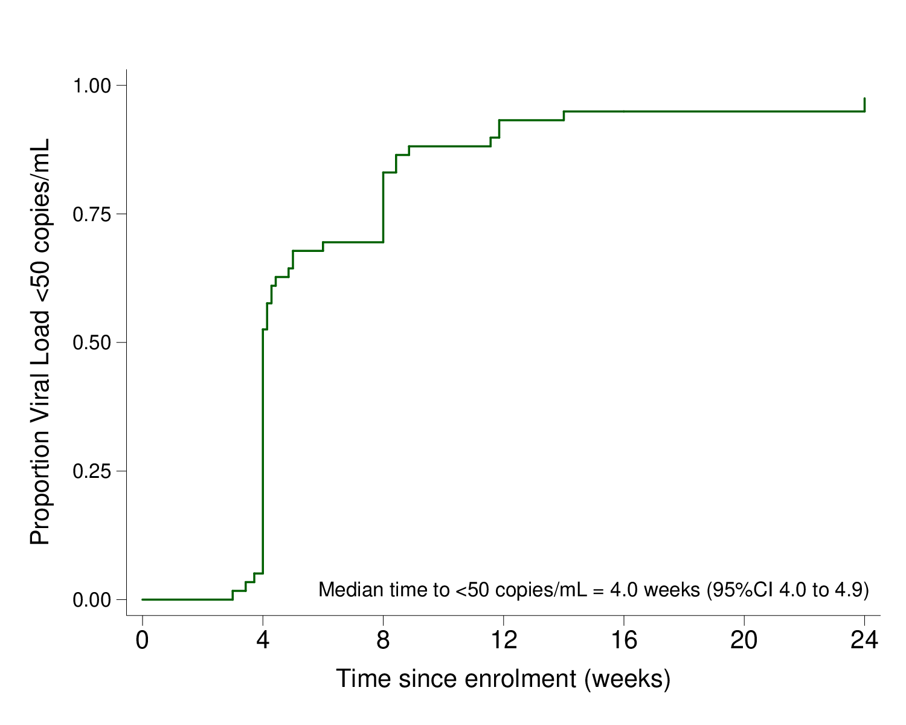

Table 5. Characteristics by primary outcome (viral load <50 copies/mL) at week 24 (modified intention-to-treat analysis, n=60)
 | Success at week 24  (VL<50 copies/mL)  (n=51) | Failure at week 24  (VL not <50 copies/mL)  (n=9)
Participant characteristics
Female, (n/%) | 37 (73%) | 5 (56%)
Age in years, (median/IQR) | 37 (31-46) | 36 (30-51)
Baseline HIV characteristics
CD4 count in cells/mm3 (median/IQR) | 294 (174-380) | 202 (175-236)
Viral load in copies/mL (median/IQR) | 8 320 (2 608-24 971) | 40 761 (22 197-56 219)
ART history
Previous ART duration in years (median/IQR) | 6.4 (3.0-8.5) | 3.4 (1.2-6.3)
Ever on zidovudine or stavudine (n/%) | 9/51 (18%) | 1/9 (11%)
Baseline resistance*, n(%)
Tenofovir/ XTC resistance
Both <15 | 6/46 (13%) | 0/8 (0%)
Only tenofovir ≥15 | 0/46 (0%) | 0/8 (0%)
Only XTC ≥15 | 11/46 (24%) | 2/8 (25%)
Both ≥15 | 29/46 (63%) | 6/8 (75%)
Efavirenz and/or nevirapine resistance | 44/46 (96%) | 8/8 (100%)
TFV-DP concentrations at week 24 (fmol/punch)**
<350, n (%) | 1/42 (2%) | 1/7 (14%)
350-700, n (%) | 1/42 (2%) | 0 /7 (0%)
701-1250, n (%) | 17/42 (41%) | 1/7 (14%)
>1250, n (%) | 23/42 (55%) | 5/7 (71%)
ART (antiretroviral therapy), VL (viral load), XTC (lamivudine or emtricitabine)
* Resistance classified using Stanford interpretation, where a score <15 indicates susceptible or potential low-level resistance to a drug, and ≥15 indicate low-level, intermediate, or high-level resistance to a drug³
** Tenofovir diphosphate (TFV-DP) concentration categorisation: <350 fmol/punch (equivalent of - men: <1.2 doses per week and women: <0.6 doses per week), 350-700 fmol/punch (men: 1.2 - 3.2 doses per week and women: 0.6 - 2.0 doses per week), 700-1250 fmol/punch (men: 3.2-6 doses per week and women: 2.0-5.3 doses per week) and > 1250 fmol/punch (men: >6 doses per week and women: >5.3 doses per week)⁴.

Table 6. Characteristics by viral load <400 copies/mL at week 24 (modified intention-to-treat analysis, n=60)
 | Success at week 24 (VL<400 copies/mL)  (n=57) | Failure at week 24  (VL not<400 copies/mL) (n=3)
Participant characteristics
Female, (n/%) | 39 (68) | 3 (100)
Age in years, (median/IQR) | 37 (31-46) | 34 (28-51)
Baseline HIV characteristics
CD4 count in cells/mm3 (median/IQR) | 263 (175-349) | 189 (110-241)
Viral load in copies/mL (median/IQR) | 9 190 (2 827-24 971) | 57 190 (40 761-64 216)
ART history
Previous ART duration in years (median/IQR) | 6.3 (3.0-8.3) | 2.7 (1.2-5.1)
Ever on zidovudine or stavudine (n/%) | 10 (18) | 0 (0)
Baseline resistance*, n(%) | (n=52) | (n=2)
Tenofovir/ XTC resistance
Both <15 | 6 (12) | 0 (0)
Only tenofovir ≥15 | 0 (0) | 0 (0)
Only XTC ≥15 | 12 (23) | 1 (50)
Both ≥15 | 34 (65) | 1 (50)
Efavirenz and/or nevirapine resistance | 50 (96) | 2 (100)
TFV-DP concentrations at week 24 (fmol/punch)**
<350, n (%) | 1/48 (4%) | 1/1 (100%)
350-700, n (%) | 1/48 (4%) | 0/1 (0%)
701-1250, n (%) | 18/48 (38%) | 0/1 (0%)
>1250, n (%) | 28/48 (58%) | 0/1 (0%)
ART (antiretroviral therapy), VL (viral load), XTC (lamivudine or emtricitabine)
* Resistance classified using Stanford interpretation, where a score <15 indicates susceptible or potential low-level resistance to a drug, and ≥15 indicate low-level, intermediate, or high-level resistance to a drug³
** Tenofovir diphosphate (TFV-DP) concentration categorisation: <350 fmol/punch (equivalent of - men: <1.2 doses per week and women: <0.6 doses per week), 350-700 fmol/punch (men: 1.2 - 3.2 doses per week and women: 0.6 - 2.0 doses per week), 700-1250 fmol/punch (men: 3.2-6 doses per week and women: 2.0-5.3 doses per week) and > 1250 fmol/punch (men: >6 doses per week and women: >5.3 doses per week)⁴.
Figure 2. Subgroup analysis of primary endpoint stratified by baseline characteristics and adherence (tenofovir diphosphate concentration) at week 24 (VL < 50 copies/mL at week 24, modified intention-to-treat analysis)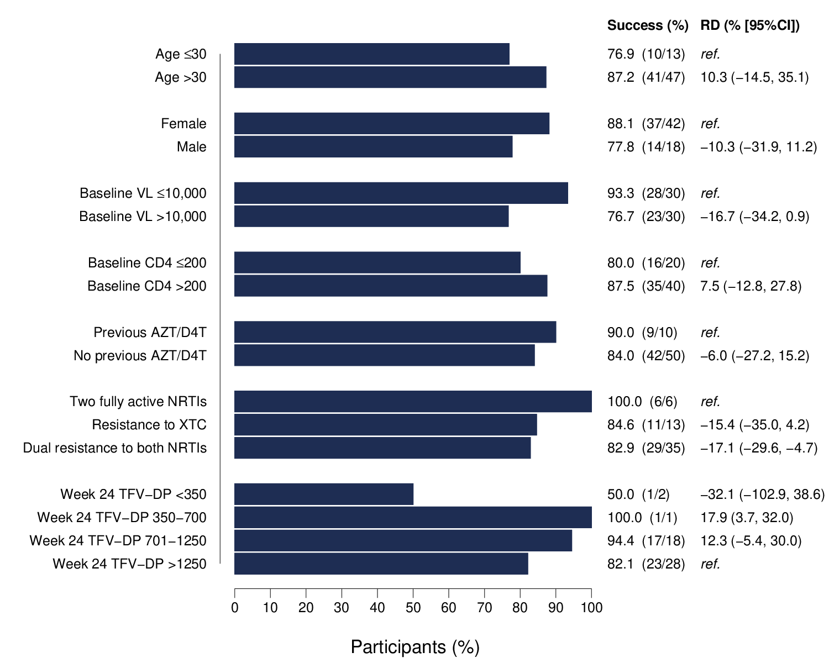
AZT (zidovudine), D4T (stavudine), NRTI (nucleoside reverse transcriptase inhibitor), TFV-DP (tenofovir diphosphate), VL (viral load), XTC (lamivudine or emtricitabine)

Figure 3. Subgroup analysis of participants with viral load <400 copies/mL at week 24 stratified by baseline characteristics and adherence (tenofovir diphosphate concentration) at week 24 (modified intention-to-treat analysis)
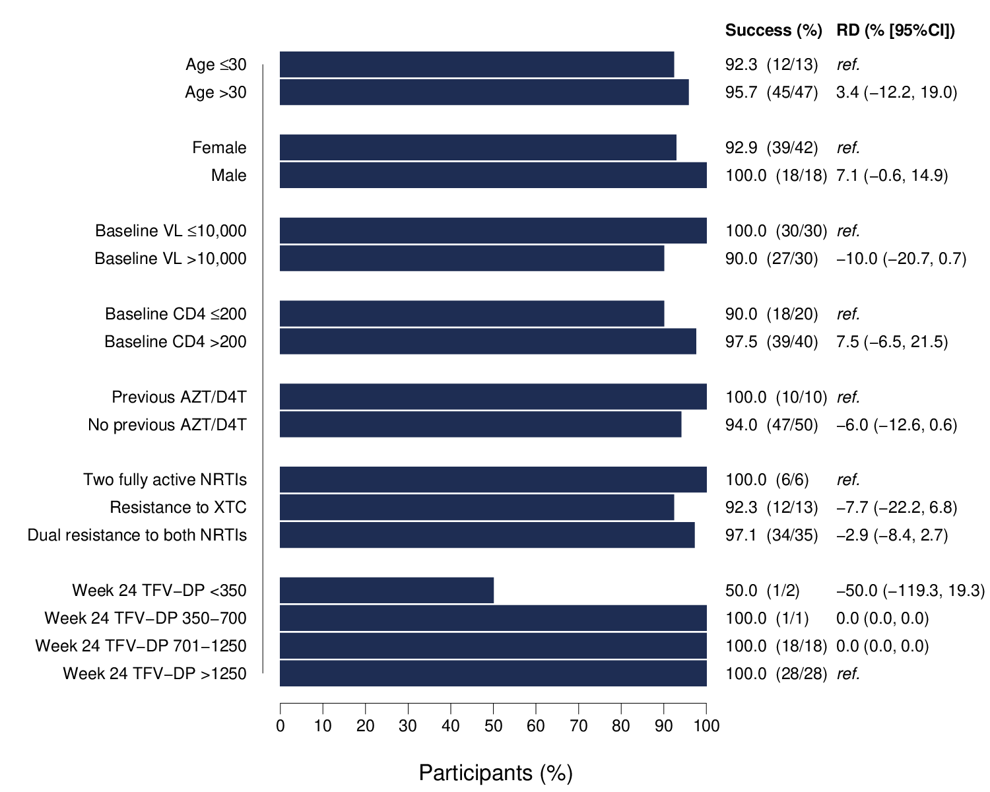
AZT (zidovudine), D4T (stavudine), NRTI (nucleoside reverse transcriptase inhibitor), TFV-DP (tenofovir diphosphate), VL (viral load), XTC (lamivudine or emtricitabine)

Table 7. Categorised tenofovir diphosphate (TFV-DP) concentrations at baseline, week 12, and week 24, stratified by sex
TFV-DP (fmol/punch)* | Baseline (N=60), n (%) |  | Week 12 (N=55), n (%) |  | Week 24 (N=49), n (%)
 | Women (N=42) | Men (N=18) | Women  (N=38) | Men  (N=17) | Women  (N=34) | Men (N=15)
<350, n (%) | 7 (16.7) | 1 (5.6) | 0 | 0 | 2 (5.9) | 0
350-700, n (%) | 0 | 2 (11.1) | 1 (2.6) | 0 | 1 (2.9) | 0
701-1250, n (%) | 18 (42.8) | 6 (33.3) | 11 (29) | 4 (23.5) | 14 (41.2) | 4 (26.7)
>1250, n (%) | 17 (40.5) | 9 (50) | 26 (68.4) | 13 (76.5) | 17 (50) | 11 (73.3)
* TFV-DP concentration categorisation: <350 fmol/punch (equivalent of - men: <1.2 doses per week and women: <0.6 doses per week), 350-700 fmol/punch (men: 1.2 - 3.2 doses per week and women: 0.6 - 2.0 doses per week), 700-1250 fmol/punch (men: 3.2-6 doses per week and women: 2.0-5.3 doses per week) and > 1250 fmol/punch (men: >6 doses per week and women: >5.3 doses per week)⁴.

Table 8. Summary of adverse events (AE) from baseline to week 24
 | Number of individuals (n/%) | Total number of events
Mortality (all-cause) | 0 (0%) | 0
Serious AEs* | 4 (7%) | 4
Grade 3 and 4 AEs | 7 (12%) | 11
Clinical | 5 (8%) | 7
Grade 3 | 5 (8%) | 7
Grade 4 | 0 (0%) | 0
Laboratory | 4 (7%) | 4
Grade 3 | 3 (5%) | 3
Grade 4 | 1 (2%) | 1
Adverse events requiring discontinuation of any ART medication* | 1 (2%) | 1
* Serious AEs are defined as adverse events that result in death, a life-threatening incident, hospitalisation, disability, congenital abnormality or requires medical or surgical intervention to prevent permanent damage.

Figure 4. Proportion of individuals with specific Modified Mini Screen (MMS) score over time (continuous score ranging from 0 to 22*)
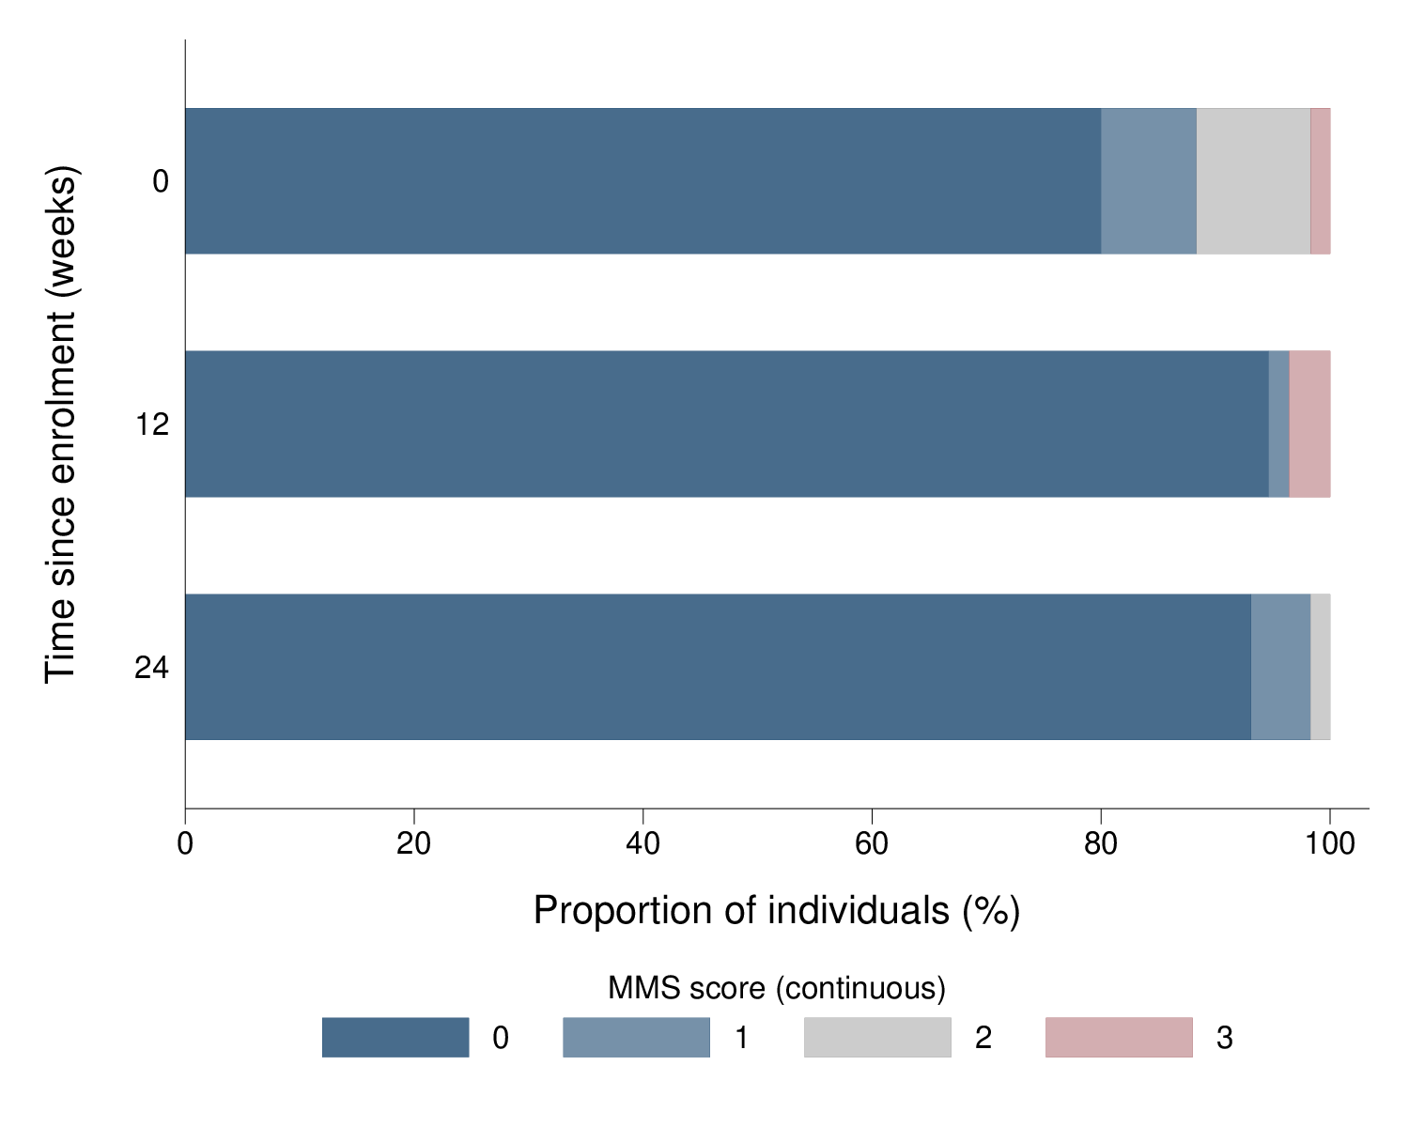
* A score of ≥9 on the MMS has been validated to identify a DSM diagnosis of anxiety, mood or psychotic disorder with 82% specificity and 63% sensitivity¹
Figure 5. Proportion of individuals with insomnia severity index (ISI) score at each timepoint (continuous measure ranging from 0 to 28*)
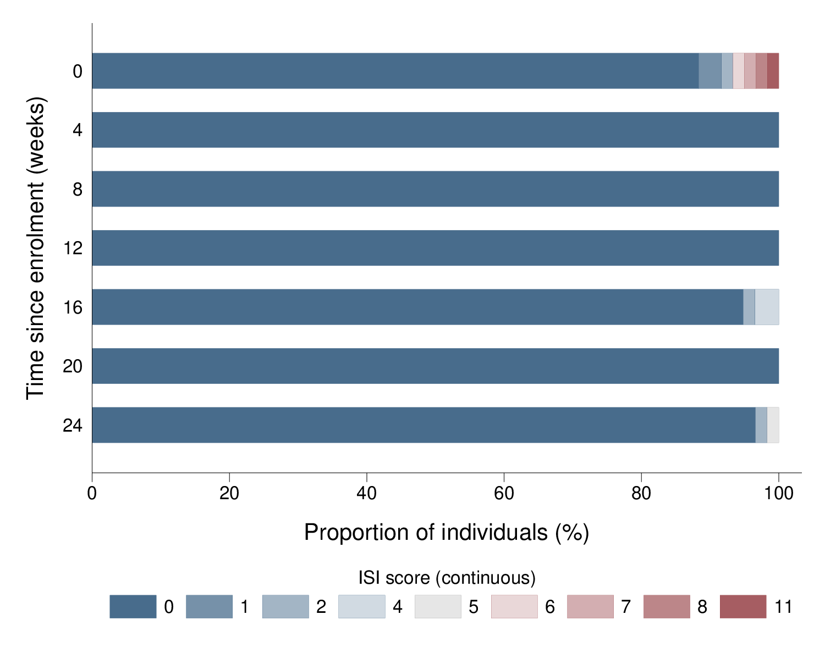
*A score of ≥11 on the ISI has been shown to detect severe insomnia with 97% sensitivity and 100% specificity².

Table 9. Concomitant medications with potential for dolutegravir interaction taken at any point from baseline to week 24
Concomitant medications | n=60
Key concomitant preventative medications, n(%)
Isoniazid* | 40 (67%)
Cotrimoxazole | 21 (35%)
Other concomitant medications with potential for dolutegravir interaction, n(%)
Ferrous sulphate | 5 (2%)
Metformin | 1 (0%)
Rifampicin | 1 (0%)
Zinc Sulfate Monohydrate | 1 (0%)
*Participants received isoniazid as tuberculosis preventative therapy

References
1. Alexander MJ, Haugland G, Lin SP, Bertollo DN, McCorry FA. Mental health screening in addiction, corrections and social service settings: Validating the MMS. Int J Ment Health Addict. 2008;6(1):105-119. doi:10.1007/s11469-007-9100-x
2. Morin CM, Belleville G, Bélanger L, Ivers H. The insomnia severity index: Psychometric indicators to detect insomnia cases and evaluate treatment response. Sleep. 2011;34(5):601-608. doi:10.1093/sleep/34.5.601
3. Stanford University. DRM penalty scores and resistance interpretation. HIV Drug Resistance Database. Published 2020. Accessed September 4, 2020. https://hivdb.stanford.edu/page/release-notes/
4. Anderson PL, Liu AY, Castillo-mancilla JR, et al. Intracellular Tenofovir-Diphosphate and Emtricitabine-Triphosphate in Dried Blood Spots following Directly Observed Therapy. Antimicrob Agents Chemother. 2018;62(1):1-13.

