Supplemental Information
Methods

MSM Rates
Grey et al.[1] combined data from the American Community Survey (ACS), National Health and Nutrition Examination Survey (NHANES), and National Health and Social Life Survey (NHSLS) to indirectly estimate the MSM population sizes at the county level. The estimation results showed that over one-half of the total U.S. MSM population resided in 51 counties, and the largest number of MSM lived in Los Angeles County, California, which comprised about 5.6% of U.S. MSM. We used the estimates reported by Grey et al.[1] and the total number of adult men to calculate the rates of MSM in each county:
$Rates of MSM= \frac{MSM Estimates}{(\frac{Total Adult Men}{1000})}$.
We then used the median of the MSM rates (i.e., 40.87) to split the dataset into two subgroups: (a) counties with higher MSM rates and (b) counties with lower MSM rates.
Twitter Data

Human Annotations and A HIV Support Vector Classifier for Tweets
We first selected relevant tweets about HIV by applying a Support Vector Machine model[2] to determine whether a tweet was about HIV (precision = .87, recall = .89, accuracy = .89). Two trained research assistants annotated 1,145 tweets using a binary code (1 = yes and 0 = no) for the presence of HIV, presented as “Is the tweet about HIV or AIDS? Not just as joke or insult (e.g., ‘food here so bad it gave me AIDS’ would not count).” For example, the tweet “What are the #globalgoals? The full list is here. #action2015 http://ow.ly/Qupsz” scored a 1 for HIV because the content is about HIV to be one of the global goals. The tweet “What was your experience with LGBT health awareness week? http://bit.ly/GLBTSurvey #LGBTHealthWeek,” also received a 1 for HIV because HIV/STI prevention is one of the LGBT health topics. We used 245 annotated tweets to establish the reliability of human annotations (Cohen’s Kappa = .86) and the remaining 900 annotated tweets to develop the SVM classifier included in the scikit-learn library using a 10-fold cross-validation method and thus derive the term-frequencies weighted by the inverse document frequency (tf-idf) as the feature set[3].
Topic Modeling
We modeled the topics of our corpus of HIV tweets in U.S. counties, so that county constituted the unit of analysis. Before analysis, we removed unnecessary words and items from the text corpus, including numbers, punctuation, and stop words, in addition to forming uni-grams (i.e., one-word phrases). Messages in each county were analyzed as a single document, and the words from all tweets from each county were combined into one single word-by-frequency matrix (see Fig. 2). We used the Python package scikit-learn to convert a collection of documents (i.e., tweets in each county) into a frequency matrix of token counts. The matrix of token counts was then analyzed using a well-established algorithm in computer science, namely Latent Dirichlet Allocation[4]. LDA is a Bayesian mixture model, P (word | topic) and P (topic | document), that groups words that often appear together to create topics (see Fig. 2). We conducted over ten experiments (i.e., ks = 25, 50, 75, 100, 125, 150, 175, 200 300, 400, and 500) to determine the optimal number of topics. The results showed that a model with 100 topics had the highest log perplexity score. Hence, we used this model for analysis.
Survey Data
Design and Methods. A complete description of the 2014-2016 respondents was previously provided by Sanchez et al.[5,6] and Zlotorzynska, Sullivan, and Sanchez[7]. ﻿The AMIS surveys included 30,675 participants across 1,959 U.S. counties. On average, 72% of respondents were non-Hispanic white, about 7% of respondents were non-Hispanic black or African American, and 13% of respondents were Hispanic. Across all years, the average age ranged from 38–40 years; over half of respondents had more than 3 sex partners in the past 12 months; more than 30% of respondents had some college or an associate’s or technical degree; and 54% of respondents completed a 4-year college degree.
Statistical Analyses

We combined county-level MSM rates, tweet rates, and Twitter topic probabilities with the AMIS individual-level data and calculated intra-class correlations (ICCs) to determine whether respondents should be nested within counties or whether the variance in AMIS variables could be assumed to vary as a function of participants. Values of ICC can range from 0 to 1, and a value close to zero indicates that the observations within clusters are no more similar than observations from different clusters[8]. Typically, values of ICC > .20 support the need to use multi-level modeling, which in our case would imply analyzing respondents and counties as separate levels. We used the performance package in R to calculate ICCs with PrEP use, HIV testing, hearing about PrEP, discussing PrEP use, and discussing HIV testing as the outcomes.
Measures of PrEP and HIV testing. We used answers (i.e., “Yes” or “No”) to the questions, “In the past 12 months, have you taken PrEP to reduce the risk of getting HIV?” and “Have you had an HIV test in the past 12 months?” to indicate respondents’ PrEP use status and HIV testing behavior in the past 12 months. Answers were provided as “Yes” or “No.”
Measures of Hearing about PrEP, Discussing PrEP use, and Discussing HIV testing. We used answers (i.e., “Yes” or “No”) to three questions to indicate whether respondents heard about PrEP, “Before today, have you ever heard of people who do not have HIV taking PrEP, the antiretroviral medicine taken every day for months or years to reduce the risk of getting HIV?” discussed PrEP use, “In the past 12 months, have you had a discussion with a healthcare provider about taking PrEP?” and discussed HIV testing, “In the past 12 months, have you had a one-on-one conversation with an outreach worker, counselor, or prevention program worker about ways to prevent HIV?”
Bayesian correlation. We first performed Bayesian correlational analyses involving all variables of interest (i.e., PrEP use, HIV testing, hear about PrEP, discuss PrEP use and discuss HIV testing) across counties with higher and lower rates of MSM using JASP[9]. We used the default uniform prior (i.e., 1) in which the possible correlation between -1 and +1 is equally plausible[10]. A Bayes factor of 10 or more indicates that the data support the alternative hypothesis of a relation between two variables at least ten times more than the null hypothesis of the absence of association. We examined the relations of the tweet rates and topic probabilities with (a) HIV prevention and testing (i.e., PrEP use and HIV testing) and (b) reported communication about PrEP and HIV (i.e., hear about PrEP, discuss PrEP, and discuss HIV). When the correlations suggested both an association between tweets and reported communications and an association between reported communication and HIV prevention and testing, they met the condition for mediation analyses, and we proceeded to analyze mediation.
Bayesian mediation analyses. We next used the BayesMed package in R to conduct Bayesian mediational models[11]. Specifically, we tested models with a path from tweet measures to a reported communication as a mediator (i.e., path a), a path from the mediator to HIV prevention and testing behaviors (i.e., HIV testing or PrEP use; path b), and a direct path from tweeting about HIV to HIV prevention and testing, while taking the communication mediator into account (i.e., path c’). The analyses examined the mediation effect (i.e., path ab) and the direct effect (i.e., path c’). Results of both path ab and path c’ are used to assess the presence of a full or partial mediation. In particular, the presence of evidence of path ab (BF₁₀ >10) but not path c’ (BF₁₀ <10) indicates a full mediation, whereas the presence of evidence of both path ab and path c’ suggests a partial mediation. After examining the first proposed model (see top panel of Fig. 1), we assessed the alternative model containing paths from reported communication to HIV prevention and testing to either tweet rates or Twitter topics (see bottom panel of Fig. 1).
Results
Association between MSM rates and Reported Communication about PrEP and Tweets
One reason why counties with higher MSM rates may have stronger associations between tweets, other communications, and HIV prevention and behavior is that a larger MSM community may actually lead to more tweets or more in person conversations about HIV relevant issues. That is, a certain threshold of communication about the issues may be necessary for tweets to influence behavior.
To examine this possibility, we correlated MSM rates with both the twitter variables and reported communications. County-level correlations between MSM rates and tweets, showed no associations for either tweet rates or topics (BF₁₀ < 10). In contrast, correlations between MSM rates and reported communication about PrEP (N = 30,675) showed a positive association between MSM rates with hearing about and discussing PrEP (rs = .13 – .18, BF₁₀ > 100). Hence, more MSM in the community may promote more in-person conversations and thus retransmit contents that may begin on social media.

References
1 Grey JA, Bernstein KT, Sullivan PS, Purcell DW, Chesson HW, Gift TL, et al. Estimating the population sizes of men who have sex with men in US states and counties using data from the American Community Survey. JMIR Public Heal Surveill 2016; 2:e14.
2 Lohmann S, White BX, Zuo Z, Chan MS, Morales A, Li B, et al. HIV messaging on Twitter: An analysis of current practice and data-driven recommendations. AIDS 2018; 32:2799–2805.
3 Baeza-Yates R, Ribeiro-Neto B. Modeling. In: Modern Information Retrieval.New York: Addison-Wesley Longman Publishing; 1999.
4 Blei DM, Ng AY, Jordan MI. Latent Dirichlet Allocation. J Mach Learn Res 2003; 3:993–1022.
5 Sanchez TH, Sineath RC, Kahle EM, Tregear SJ, Sullivan PS. The annual American Men’s Internet Survey of behaviors of men who have sex with men in the United States: Protocol and key indicators report 2013. 2015; 1:e3.
6 Sanchez T, Zlotorzynska M, Sineath C, Kahle E, Sullivan P. The annual American Men’s Internet Survey of behaviors of men who have sex with men in the United States: 2014 key indicators report. JMIR Public Heal Surveill 2016; 2:e23.
7 Zlotorzynska M, Sullivan P, Sanchez T. The annual American Men’s Internet Survey of behaviors of men who have sex with men in the United States: 2015 key indicators report. JMIR Public Heal Surveill 2017; 3:e13.
8 Hox JJ. Multilevel analysis: Techniques and applications, 2nd ed. New York, NY, US: Routledge/Taylor & Francis Group; 2010.
9 JASP Team. JASP (Version 0.8.6). 2018.
10 Marsman M, Wagenmakers E-J. Bayesian benefits with JASP. Eur J Dev Psychol 2017; 14:545–555.
11 Nuijten MB, Wetzels R, Matzke D, Dolan C V., Wagenmakers E-J. A default Bayesian hypothesis test for mediation. Behav Res Methods 2015; 47:85–97.

Table S1
Bayesian Correlational Results Among Tweets about HIV, Reported Communication about PrEP and HIV, and HIV Prevention and Testing in Counties with Higher Rates of MSM
Variable | HIV prevention and testing |  | Reported Communication about  PrEP and HIV |  |  | Any indication of mediating associations (yes/no) (If yes, number of mediation)
 | PrEP use | HIV testing | Hear about PrEP | Discuss PrEP use | Discuss HIV testing
Survey measures
HIV testing | 0.22*** | -
Hear about PrEP | 0.17*** | 0.16*** | -
Discuss PrEP use | 0.61ᵃ | 0.36*** | NA | -
Discuss HIV testing | 0.09*** | 0.16*** | 0.02 | 0.21*** | -
Measures of tweets
Tweet rates | 0.06*** | 0.06*** | 0.08*** | 0.08*** | 0.02 | Yes (2)
Twitter topics
Topic 0 | 0.04*** | 0.02 | 0.02 | 0.05* | -0.01 | Yes (1)
Topic 1 | -0.04*** | -0.02 | -0.02 | -0.05** | 0 | Yes (1)
Topic 2 | 0.04*** | 0.02 | 0.03 | 0.04 | 0 | No
Topic 3 | -0.02 | -0.02 | 0.01 | -0.03 | 0.01 | No
Topic 4 | -0.03 | 0 | -0.01 | -0.02 | 0 | No
Topic 5 | -0.02 | -0.01 | 0.01 | -0.01 | 0 | No
Topic 6 | -0.01 | -0.02 | -0.01 | -0.03 | -0.01 | No
Topic 7 | 0 | 0 | -0.02 | 0 | 0 | No
Topic 8 | -0.04*** | -0.02 | -0.02 | -0.06*** | 0.01 | Yes (1)
Topic 9 | -0.02 | -0.01 | -0.02 | -0.02 | 0 | No
Topic 10 | 0 | 0 | 0.03 | 0.01 | 0.01 | No
Topic 11 | 0 | -0.01 | 0 | 0 | 0 | No
Topic 12 | -0.04** | -0.03 | -0.04*** | -0.04 | -0.01 | Yes (1)
Topic 13 | -0.01 | 0.01 | -0.01 | -0.01 | 0 | No
Topic 14 | -0.02 | -0.01 | 0 | 0 | -0.01 | No
Topic 15 | 0.02 | 0 | 0.03 | 0.01 | -0.02 | No
Topic 16 | -0.01 | -0.02 | -0.01 | 0 | 0 | No
Topic 17 | 0.04*** | 0.02 | 0.02 | 0.05** | 0.01 | Yes (1)
Topic 18 | 0.01 | 0.01 | 0.02 | 0.03 | -0.01 | No
Topic 19 | 0.04*** | 0.03 | 0.03 | 0.04 | 0 | No
Topic 20 | -0.03 | -0.02 | -0.01 | -0.04 | 0 | No
Topic 21 | -0.02 | 0.02 | 0 | 0 | 0.02 | No
Topic 22 | 0.01 | 0.01 | -0.01 | -0.01 | 0.01 | No
Topic 23 | -0.01 | 0 | -0.01 | -0.01 | 0 | No
Topic 24 | -0.03 | -0.03 | -0.02 | -0.03 | -0.01 | No
Topic 25 | 0.02 | 0.01 | 0.03* | 0.03 | -0.01 | No
Topic 26 | -0.03 | -0.03 | -0.01 | -0.04 | -0.01 | No
Topic 27 | 0 | -0.02 | -0.01 | 0.01 | 0.01 | No
Topic 28 | -0.01 | -0.02 | -0.01 | -0.01 | 0.01 | No
Topic 29 | -0.01 | 0 | -0.01 | -0.03 | 0 | No
Topic 30 | -0.02 | -0.01 | -0.02 | -0.03 | 0 | No
Topic 31 | -0.01 | -0.02 | -0.01 | 0 | 0.01 | No
Topic 32 | -0.03 | -0.03 | -0.04*** | -0.03 | 0 | No
Topic 33 | 0.02 | 0.02 | 0.03 | 0.01 | 0.01 | No
Topic 34 | -0.02 | -0.02 | 0 | -0.01 | 0.01 | No
Topic 35 | -0.04*** | -0.04*** | -0.03 | -0.06*** | -0.03 | Yes (1)
Topic 36 | -0.01 | -0.01 | 0 | -0.03 | -0.01 | No
Topic 37 | -0.03 | 0 | -0.02 | -0.03 | 0.02 | No
Topic 38 | 0.01 | 0.01 | 0.02 | 0.02 | 0.01 | No
Topic 39 | -0.03 | -0.01 | -0.03 | -0.03 | 0.01 | No
Topic 40 | -0.01 | -0.01 | -0.01 | -0.02 | 0 | No
Topic 41 | -0.01 | 0 | 0.01 | -0.03 | 0 | No
Topic 42 | -0.04*** | -0.03* | -0.02 | -0.05* | 0 | Yes (1)
Topic 43 | 0.03 | 0.03* | 0.02 | 0.03 | -0.01 | No
Topic 44 | -0.03 | -0.02 | -0.01 | -0.02 | 0.01 | No
Topic 45 | -0.04*** | -0.03* | -0.03* | -0.04 | 0 | Yes (1)
Topic 46 | -0.01 | -0.02 | -0.01 | -0.02 | 0 | No
Topic 47 | -0.02 | -0.02 | -0.01 | -0.01 | -0.01 | No
Topic 48 | 0.04*** | 0.03 | 0.03 | 0.04 | 0 | No
Topic 49 | 0.05*** | 0.02 | 0.04*** | 0.05* | -0.01 | Yes (2)
Topic 50 | 0.04*** | 0.02 | 0.02 | 0.03 | -0.01 | No
Topic 51 | -0.01 | 0 | 0.01 | -0.01 | 0.01 | No
Topic 52 | -0.02 | 0.01 | -0.03 | -0.02 | 0.03 | No
Topic 53 | 0.01 | 0 | 0.01 | 0.03 | 0 | No
Topic 54 | -0.04*** | -0.02 | -0.02 | -0.05* | -0.02 | Yes (1)
Topic 55 | -0.01 | 0 | 0 | -0.03 | 0.01 | No
Topic 56 | 0 | 0.01 | 0 | 0.01 | 0.01 | No
Topic 57 | -0.04*** | -0.01 | -0.03 | -0.03 | 0.01 | No
Topic 58 | -0.01 | -0.02 | -0.02 | 0 | 0 | No
Topic 59 | -0.02 | -0.02 | -0.02 | -0.02 | 0.01 | No
Topic 60 | -0.01 | 0 | -0.01 | 0 | 0 | No
Topic 61 | 0.02 | 0.02 | 0.02 | 0.03 | -0.03 | No
Topic 62 | -0.04*** | -0.03 | -0.04** | -0.05** | 0 | Yes (2)
Topic 63 | 0.03 | 0 | 0.03 | 0 | -0.03 | No
Topic 64 | -0.02 | -0.01 | -0.01 | -0.02 | -0.01 | No
Topic 65 | -0.02 | -0.01 | 0 | -0.02 | 0 | No
Topic 66 | -0.05*** | -0.03 | -0.03 | -0.06*** | -0.02 | Yes (1)
Topic 67 | -0.01 | -0.01 | 0.01 | -0.02 | -0.01 | No
Topic 68 | -0.01 | -0.03 | -0.02 | 0.01 | 0.01 | No
Topic 69 | 0.07*** | 0.05*** | 0.06*** | 0.08*** | -0.01 | Yes (2)
Topic 70 | -0.01 | 0.02 | -0.02 | -0.02 | 0.03 | No
Topic 71 | -0.01 | -0.02 | 0 | -0.03 | -0.01 | No
Topic 72 | 0.01 | -0.01 | 0 | 0.03 | 0.01 | No
Topic 73 | 0 | 0 | 0 | -0.01 | -0.01 | No
Topic 74 | 0.04*** | 0.01 | 0.03 | 0.04 | 0.01 | No
Topic 75 | -0.02 | -0.03 | -0.03 | -0.01 | 0 | No
Topic 76 | 0.05*** | 0.03 | 0.04** | 0.04 | -0.01 | Yes (1)
Topic 77 | 0.03 | 0.01 | 0.02 | 0.02 | 0 | No
Topic 78 | 0.04** | 0.01 | 0.03 | 0.04 | 0 | No
Topic 79 | 0.03 | 0.02 | 0.03 | 0.02 | -0.01 | No
Topic 80 | -0.02 | -0.01 | -0.01 | -0.02 | 0 | No
Topic 81 | -0.02 | 0.01 | -0.02 | -0.01 | 0.01 | No
Topic 82 | -0.01 | -0.01 | -0.01 | -0.01 | 0 | No
Topic 83 | -0.06*** | -0.03** | -0.05*** | -0.06*** | 0.01 | Yes (2)
Topic 84 | -0.03 | -0.01 | -0.03 | -0.04 | 0.01 | No
Topic 85 | 0 | 0 | 0.02 | 0 | -0.01 | No
Topic 86 | 0 | 0.01 | -0.01 | 0.01 | -0.01 | No
Topic 87 | 0.01 | -0.02 | 0.01 | -0.03 | -0.04** | No
Topic 88 | 0.04*** | 0.02 | 0.02 | 0.04 | -0.01 | No
Topic 89 | 0 | 0 | 0.01 | -0.01 | -0.01 | No
Topic 90 | 0 | -0.03 | 0.01 | 0 | 0.01 | No
Topic 91 | 0.03 | 0.03* | 0.04*** | 0.04 | 0.01 | No
Topic 92 | -0.04*** | -0.02 | -0.04*** | -0.04 | 0 | Yes (1)
Topic 93 | 0 | -0.01 | 0.01 | -0.01 | -0.02 | No
Topic 94 | 0 | 0.01 | 0.01 | 0.01 | 0 | No
Topic 95 | 0.04*** | 0.03 | 0.03 | 0.04 | -0.01 | No
Topic 96 | 0.04** | 0.04*** | 0.04** | 0.04 | 0 | Yes (1)
Topic 97 | 0.02 | -0.01 | 0.01 | 0.02 | -0.01 | No
Topic 98 | -0.04*** | -0.05*** | -0.02 | -0.03 | -0.01 | No
Topic 99 | 0.04*** | 0.02 | 0.02 | 0.04 | -0.01 | No
Note. * BF₁₀ > 10, ** BF₁₀ > 30, *** BF₁₀ > 100, ∞ BF₁₀ infinite. Item in bold indicates the presence of possible mediating association(s).

Table S2
Bayesian Correlational Results Among Tweets about HIV, Reported Communication about PrEP and HIV, and HIV Prevention and Testing in Counties with Lower Rates of MSM
Variable | HIV Prevention and Testing |  | Reported Communication about  PrEP and HIV |  |  | Any indication of mediating associations (yes/no) (If yes, number of mediation)
 | PrEP use | HIV testing | Hear about  PrEP | Discuss  PrEP use | Discuss  HIV testing
Survey measures
HIV testing | 0.17*** | -
Hear about PrEP | 0.14*** | 0.15*** | -
Discuss PrEP use | 0.58ᵃ | 0.34*** | NA | -
Discuss HIV testing | 0.09*** | 0.18*** | 0.05*** | 0.24*** | -
Measures of tweets
Tweet rates | 0 | 0 | 0.01 | 0.01 | -0.01 | No
Twitter topics
Topic 0 | 0 | -0.02 | -0.02 | -0.02 | -0.01 | No
Topic 1 | 0 | 0.01 | 0 | -0.01 | 0 | No
Topic 2 | 0.01 | -0.01 | 0.01 | 0 | 0 | No
Topic 3 | 0 | -0.01 | -0.01 | 0.01 | 0 | No
Topic 4 | 0 | 0 | 0.01 | 0.02 | 0.01 | No
Topic 5 | 0.01 | 0 | 0.03 | -0.01 | 0 | No
Topic 6 | 0 | 0 | -0.01 | 0.02 | 0 | No
Topic 7 | -0.01 | 0.02 | 0 | 0 | -0.01 | No
Topic 8 | -0.01 | 0 | -0.02 | 0 | 0 | No
Topic 9 | -0.01 | -0.01 | -0.02 | -0.01 | 0 | No
Topic 10 | 0.02 | 0.01 | 0 | 0.01 | 0 | No
Topic 11 | 0.01 | 0 | 0.01 | 0.02 | -0.02 | No
Topic 12 | 0 | 0 | -0.02 | 0 | -0.01 | No
Topic 13 | 0.01 | 0.01 | 0.01 | 0.01 | 0 | No
Topic 14 | 0.01 | 0.02 | 0.02 | 0 | -0.01 | No
Topic 15 | 0 | 0.01 | -0.01 | 0 | -0.02 | No
Topic 16 | -0.01 | 0.01 | 0 | 0.02 | -0.01 | No
Topic 17 | -0.01 | 0 | 0 | 0.01 | 0.01 | No
Topic 18 | -0.01 | -0.01 | 0 | 0 | 0 | No
Topic 19 | 0.01 | 0.01 | 0.01 | 0.03 | 0.01 | No
Topic 20 | 0 | -0.01 | 0.01 | 0.01 | 0 | No
Topic 21 | 0.02 | 0.01 | 0.02 | 0.01 | 0 | No
Topic 22 | -0.01 | 0.01 | 0 | 0 | 0.01 | No
Topic 23 | 0 | 0 | 0.02 | 0 | 0.01 | No
Topic 24 | 0.01 | 0 | -0.02 | 0 | 0.02 | No
Topic 25 | 0 | 0 | -0.01 | -0.01 | -0.01 | No
Topic 26 | -0.01 | -0.02 | -0.01 | -0.01 | -0.02 | No
Topic 27 | 0.01 | 0.01 | 0.01 | 0.03 | 0.01 | No
Topic 28 | -0.01 | 0.01 | 0 | 0.02 | -0.01 | No
Topic 29 | -0.02 | -0.01 | -0.01 | -0.01 | -0.01 | No
Topic 30 | 0 | 0.01 | 0 | 0.01 | 0.02 | No
Topic 31 | 0 | 0.01 | 0.01 | 0 | 0 | No
Topic 32 | 0 | -0.01 | 0 | -0.01 | -0.01 | No
Topic 33 | 0 | -0.01 | 0.02 | 0.01 | 0 | No
Topic 34 | 0.01 | -0.01 | -0.01 | -0.01 | -0.01 | No
Topic 35 | 0 | 0 | 0.01 | -0.01 | 0.01 | No
Topic 36 | 0.01 | -0.02 | 0 | 0 | 0.01 | No
Topic 37 | -0.01 | 0 | 0.01 | -0.01 | -0.02 | No
Topic 38 | 0.02 | 0.02 | 0.02 | 0.02 | 0 | No
Topic 39 | 0 | -0.01 | -0.02 | 0.01 | -0.01 | No
Topic 40 | 0.01 | 0 | 0 | 0 | -0.02 | No
Topic 41 | 0 | -0.01 | 0 | 0 | -0.01 | No
Topic 42 | -0.01 | -0.02 | 0 | -0.02 | -0.02 | No
Topic 43 | 0 | -0.02 | -0.01 | 0 | 0.01 | No
Topic 44 | 0 | 0.01 | 0.01 | 0 | 0 | No
Topic 45 | -0.01 | 0 | 0 | -0.01 | 0.01 | No
Topic 46 | 0.03 | 0.02 | 0.02 | 0.02 | 0.01 | No
Topic 47 | 0 | 0 | -0.02 | -0.01 | 0 | No
Topic 48 | -0.01 | 0 | -0.01 | -0.02 | -0.01 | No
Topic 49 | 0 | 0 | 0 | -0.01 | -0.01 | No
Topic 50 | -0.01 | -0.02 | 0 | 0 | 0.01 | No
Topic 51 | 0 | 0.02 | 0.02 | -0.01 | 0.01 | No
Topic 52 | 0 | 0.01 | -0.01 | 0 | 0.01 | No
Topic 53 | 0 | 0.02 | 0 | 0 | 0.01 | No
Topic 54 | 0 | 0 | -0.01 | 0.01 | -0.01 | No
Topic 55 | 0 | 0 | 0 | 0 | -0.01 | No
Topic 56 | 0 | 0.01 | 0 | -0.01 | -0.01 | No
Topic 57 | -0.01 | 0.01 | 0.02 | -0.01 | 0.01 | No
Topic 58 | -0.01 | -0.02 | -0.02 | -0.02 | -0.01 | No
Topic 59 | 0 | 0.01 | 0 | -0.01 | 0 | No
Topic 60 | 0 | 0.01 | -0.01 | -0.01 | 0 | No
Topic 61 | -0.01 | -0.02 | -0.01 | -0.04 | -0.01 | No
Topic 62 | 0 | 0.01 | -0.02 | -0.01 | 0.01 | No
Topic 63 | 0.01 | -0.01 | 0.01 | 0 | 0 | No
Topic 64 | -0.01 | 0 | -0.01 | -0.03 | -0.01 | No
Topic 65 | 0.02 | 0.01 | 0 | 0.01 | 0.01 | No
Topic 66 | 0 | 0.01 | 0.01 | -0.01 | 0.01 | No
Topic 67 | 0 | 0 | 0 | -0.01 | 0 | No
Topic 68 | 0 | 0.02 | 0.02 | 0.01 | 0 | No
Topic 69 | 0 | 0.01 | 0.02 | 0.02 | 0.01 | No
Topic 70 | 0 | 0 | 0 | 0.01 | 0.01 | No
Topic 71 | 0 | 0.02 | -0.01 | -0.01 | 0.01 | No
Topic 72 | 0.01 | 0.02 | 0.02 | -0.01 | 0.01 | No
Topic 73 | -0.01 | -0.01 | -0.02 | -0.02 | 0 | No
Topic 74 | 0.01 | 0.01 | 0.02 | 0.01 | -0.01 | No
Topic 75 | -0.01 | -0.01 | 0 | -0.01 | 0.01 | No
Topic 76 | 0.01 | -0.01 | 0 | 0.01 | -0.02 | No
Topic 77 | 0.01 | 0 | 0 | 0.01 | 0 | No
Topic 78 | 0.01 | 0.01 | 0.01 | 0 | -0.01 | No
Topic 79 | 0 | 0 | 0.02 | 0.01 | 0.01 | No
Topic 80 | 0.01 | 0 | 0.01 | 0.01 | 0.01 | No
Topic 81 | 0 | 0.01 | 0 | -0.02 | 0 | No
Topic 82 | 0 | 0 | 0.01 | 0.02 | -0.01 | No
Topic 83 | -0.01 | 0 | -0.01 | -0.01 | 0 | No
Topic 84 | -0.01 | -0.02 | 0 | -0.02 | -0.01 | No
Topic 85 | 0 | 0.03 | 0.02 | -0.02 | 0 | No
Topic 86 | 0.02 | 0.02 | -0.01 | 0.03 | 0.02 | No
Topic 87 | 0 | 0 | -0.01 | -0.01 | 0.01 | No
Topic 88 | 0 | 0 | -0.02 | 0.01 | 0.01 | No
Topic 89 | -0.01 | 0 | -0.02 | 0 | -0.01 | No
Topic 90 | 0 | 0.02 | 0 | 0.01 | 0.01 | No
Topic 91 | 0.02 | 0 | 0.01 | 0 | -0.01 | No
Topic 92 | -0.01 | -0.01 | -0.02 | -0.02 | -0.01 | No
Topic 93 | -0.01 | 0.01 | 0 | 0.02 | -0.01 | No
Topic 94 | -0.01 | 0 | -0.01 | -0.01 | 0 | No
Topic 95 | 0 | -0.01 | 0.01 | 0.02 | -0.01 | No
Topic 96 | -0.01 | 0 | 0.01 | -0.01 | 0.01 | No
Topic 97 | 0.01 | 0 | 0.01 | 0 | 0.01 | No
Topic 98 | 0 | -0.02 | -0.01 | -0.02 | 0 | No
Topic 99 | 0 | 0 | 0 | -0.01 | 0.02 | No
Note. * BF₁₀ > 10, ** BF₁₀ > 30, *** BF₁₀ > 100, ∞ BF₁₀ infinite.

Table S3

Top Twenty Words of the LDA Topic Model with 100 Topics
Topic | Top twenty terms
0 | stop, thinking, rt, cant, share, nd, chicago, close, podcast, submit, visit, pm, lake, gain, im, nice, lives, story, world, journey
1 | living, rt, truly, names, friday, im, reminder, message, world, ex, huge, kickoff, art, thinking, looked, ignore, dan, grandma, jeff, eagles
2 | election, wednesday, rt, help, celebrate, espn, pm, season, weve, release, bar, pussy, nc, world, planned, remember, news, kim, hoes, winners
3 | jlo, late, rt, patients, line, rn, cute, world, thinking, summer, respect, exactly, freedom, donate, check, warcraft, cash, fbi, pm, bill
4 | rt, winter, positive, pm, world, washington, round, gameday, player, god, magic, lives, thinking, wireless, ugh, vs, saved, lineup, johnson, amp
5 | pm, ill, free, test, rt, tired, october, surprised, im, wire, thinking, valley, putin, practice, driving, bay, world, holding, fil, prince
6 | rt, future, story, world, bro, bc, sec, thinking, drunk, fantasy, trip, tonights, soccer, pm, depression, term, contest, prep, loves, mixtape
7 | didnt, worth, wild, leadership, tech, thank, rt, thinking, opportunities, vehicle, world, hard, moved, manager, android, confirm, watched, allow, comics, reveals
8 | start, rt, pm, thinking, win, enter, giveaway, temperature, schedule, pick, fb, comes, st, niyahsworld, sleeping, ice, lil, world, allmins, race
9 | rt, world, nodapl, nathanzed, scene, weekly, king, inspiring, story, cars, supposed, held, cats, drop, texts, gif, decided, surprise, calmly, thinking
10 | events, socialmedia, rt, decemberat, started, gone, writers, pm, dies, january, world, quilt, check, ensure, lights, wedding, news, route, sell, lives
11 | study, rt, progress, oct, idk, army, af, edition, broken, thinking, imagine, brain, fav, pm, sale, featuring, possibly, nbcnews, reading, novel
12 | lol, run, thinking, rt, check, runkeeper, mi, horror, american, story, completed, dating, set, world, remember, season, im, supply, shape, sitting
13 | biggest, rt, girlposts, accident, pm, official, world, art, war, basel, killed, saddest, trends, story, companies, icymi, farm, knowing, ih, germany
14 | time, pm, low, damn, rt, street, town, wall, half, host, tune, thu, representative, glenn, ad, art, thinking, focus, laws, season
15 | thats, thinking, rt, worst, fighting, wouldnt, care, world, due, im, stars, fri, nah, able, tried, piece, hits, tom, author, story
16 | rt, isnt, cause, world, amazon, story, art, swear, taste, character, wnw, cities, cleared, weed, thinking, cvsextra, lying, clintons, damncourtney, dates
17 | joined, rt, photo, yes, leave, blame, common, china, willing, fit, world, potus, set, starwars, abuse, drone, married, story, selfie, stigma
18 | pm, dec, weather, holiday, mst, rt, hi, tv, st, current, av, online, art, picture, amp, mb, ne, sky, nov, pt
19 | watch, john, service, customer, rt, voice, send, listen, youll, strategy, world, system, cup, pm, pizza, able, videos, theyve, cavs, story
20 | generation, rt, remember, days, fuck, snow, basketball, world, ahead, fucked, chance, couldnt, canada, thinking, season, lane, direction, talk, stock, pm
21 | lives, rt, squad, leader, world, dogs, inspired, form, wine, saving, art, sign, pm, waking, ga, protest, restaurant, omfg, blow, ca
22 | austin, rt, artfeeis, quote, omg, market, break, nba, tx, dick, boyfriend, risk, rob, pm, rohn, pr, heads, settle, days, jump
23 | rt, guy, using, google, world, lives, boys, modern, girls, iphone, wait, prep, anniversary, georgetakei, thinking, reason, spent, changed, avoid, cost
24 | ok, rd, pm, rt, walking, party, dinner, thinking, bae, lebron, ra, resume, touching, ian, dr, mtvstarsladygaga, movie, plus, pre, souls
25 | testing, resistance, date, rt, moment, alive, semester, building, onyeyichii, app, walmart, person, startup, change, anxiety, hiv, tested, planet, heavy, citibank
26 | christmas, found, rt, pm, story, wed, games, seeing, representation, play, world, months, thinking, im, boss, christian, spirit, iartg, rained, child
27 | pm, rt, vs, world, pst, dakota, cole, happen, enjoy, tuesday, available, island, tonight, amp, course, live, bpddispatch, est, tweet, doubt
28 | rt, letter, sat, space, hey, bleacherreport, world, sent, meal, prep, pm, india, art, league, knowledge, handle, children, soundcloud, check, cure
29 | reply, rt, cnn, art, police, information, vegas, creative, regarding, las, except, passion, eyez, tis, forgot, degas, yea, crash, defense, details
30 | heres, rt, world, wasnt, thinking, arent, tour, try, deep, simply, pleasantly, story, thread, soul, zone, trash, ms, considering, real, delete
31 | tips, rt, theyre, havent, pop, thursday, capricorn, sense, leads, engaged, check, simple, able, remember, beats, world, commit, cards, art, brilliant
32 | story, rt, ive, wanna, ufc, mom, thinking, world, fight, snap, meeting, account, im, pm, nap, ugly, floor, ronda, rousey, able
33 | rt, art, id, world, women, photography, traffic, understand, science, pure, learn, promise, story, credit, discover, finding, potential, faith, office, viral
34 | rt, read, love, world, favorite, thinking, week, review, snohio, story, revolves, buying, officially, finished, product, plan, wrong, forest, via, check
35 | download, mplusplaces, politics, happens, art, calling, etsy, discuss, created, rt, thou, unique, nation, paint, whatsapp, emotional, client, bull, flint, yr
36 | medium, soon, tickets, bpddispatch, pm, closed, dropping, rt, zero, missed, nights, cdt, theyll, hurt, regular, hollywood, mouth, teach, nearly, mode
37 | art, rt, fine, stage, artists, nature, drawing, world, flight, sold, noon, set, artist, pm, rose, arena, imagination, panthers, shadow, imma
38 | rt, college, pm, football, daily, morning, company, catch, prep, student, services, pass, david, beer, joining, section, throw, van, amp, season
39 | absolutely, rt, art, store, miami, eat, museum, world, expected, lucky, country, ride, dr, hype, rock, hang, kept, tag, wired, pm
40 | means, rt, original, process, world, art, treat, pm, accept, chat, lmfao, grateful, question, strong, hilarious, fuckin, craft, powerful, comedy, tweets
41 | rt, world, peace, thinking, management, difference, wishful, thurs, lanes, closing, gun, wide, weight, stress, lives, pm, fail, everyday, responsibility, built
42 | team, actually, makes, rt, wisdom, thinking, data, words, worse, dude, gold, world, classic, clinton, signed, quotes, performing, situation, la, smile
43 | yall, rt, inches, ny, pm, lead, dog, rest, please, gift, winner, lives, midnight, world, card, michael, announced, rural, drama, burn
44 | music, life, benefit, rt, pm, monday, takes, currently, thinking, decision, hands, art, world, tue, lives, bruh, private, industry, hr, born
45 | rt, month, little, world, forever, birthday, mad, til, happened, players, thinking, changes, lives, able, concerns, celebrating, im, source, story, pain
46 | realdonaldtrump, hour, rt, easy, pm, hotel, ago, putting, alabama, rich, shares, laugh, views, highlights, killing, running, tim, meaning, flash, story
47 | youre, december, pm, rt, thinking, fire, trump, nigga, world, hot, playoff, die, september, artwork, dry, ima, mens, art, stay, jack
48 | sales, song, concert, rt, appeared, sweet, speed, meant, pray, rogue, figure, pm, art, facebook, apparently, animal, wikileaks, fiction, co, movies
49 | cool, november, rt, loss, star, business, pm, story, mobile, security, world, words, wars, im, response, rogueone, version, kiss, apps, exercise
50 | pm, cst, watching, issued, nws, brother, rt, honored, advisory, severe, article, chill, finish, guest, storm, redbox, upcoming, whenever, joke, thinking
51 | midnight, rt, feels, mane, lost, addstarwarsimproveamovie, asvpxrocky, hear, charity, fresh, millennialmusicals, terror, pm, makeamoviecold, richard, onewordoffchristmas, portland, addasongruinamovie, hiphopfood, friendly
52 | amazing, rt, instagram, story, check, shift, vine, art, factory, world, lyrics, td, pewdiepie, paintmixtures, weeks, rapspotlights, buzzfeed, galaxy, sheet, transformation
53 | rt, saturday, thinking, webinar, bitch, self, moving, honestly, minute, im, blessed, register, disappointment, world, pm, slow, able, jessica, bunch, bullshit
54 | checked, video, impact, youtube, event, liked, entire, rt, world, county, pm, via, international, tree, alert, check, jan, airport, ft, np
55 | trust, wont, rt, shes, trumps, hillary, wake, able, dr, guide, womens, iconic, coming, health, edgar, speech, maybe, alarm, pm, sister
56 | rt, hours, pm, shouldnt, world, able, starbucks, sucks, ave, preview, harry, attention, premiere, suck, clown, customers, head, thinking, og, hack
57 | taking, rt, lmao, sounds, telling, story, pm, idea, ready, thinking, university, im, nye, vacation, worlds, world, random, yep, lives, speaks
58 | world, rt, feeling, radio, example, apple, eyes, losing, green, dj, community, kinda, food, products, dubai, pm, honest, syria, brothers, hacking
59 | world, rt, series, till, art, painting, oil, spring, disney, jesus, cubs, wtf, expect, florida, canvas, entry, win, coaches, abstract, station
60 | pm, rt, phone, et, sunday, short, church, results, straight, story, six, house, fashion, st, hell, louis, changing, brunch, hospital, world
61 | th, pm, rt, rihanna, cat, thinking, mistake, political, mind, ios, light, sunset, gym, forecast, cloudy, ben, math, mon, warriors, yeah
62 | death, sleep, rt, pm, able, school, night, lit, actions, gifts, words, world, scott, busy, im, bama, recount, golf, silver, childrens
63 | status, call, miss, album, research, rt, custom, christ, pm, sodamntrue, chase, st, package, shake, world, fancy, fireworks, albums, relative, atav
64 | hope, world, cold, rt, breakfast, united, okay, definitely, looking, partner, purpose, thinking, shut, past, attacks, able, baseball, gratitude, memories, model
65 | success, starting, rt, stories, sometimes, art, western, sportscenter, story, prove, ebay, via, auto, shook, forgotten, world, thinking, set, check, empire
66 | day, rt, gonna, game, pm, thinking, im, ass, world, guess, minutes, dumb, fed, andseconds, able, spending, edge, romance, raw, act
67 | rt, truth, world, pipeline, realize, art, son, femaletexts, scottish, story, girlfriend, fiesta, debate, htt, reveal, thinking, terrible, xmas, award, threat
68 | update, rt, hate, home, fucking, eve, news, im, lie, world, camera, money, purchase, report, windows, gotten, pm, overwatch, someday, intelligence
69 | rt, michigan, coverage, lives, peoples, ideas, feelings, government, world, broke, officials, dope, fixed, hitting, martin, deals, dr, downtime, screen, hm
70 | join, create, pretty, glad, mark, rt, communities, national, championship, pm, words, able, world, im, pro, story, insane, art, talk, bb
71 | pm, marketing, ep, tournament, final, none, rt, nl, holdem, issues, hoe, financial, universe, world, stuck, gon, south, heroes, check, southern
72 | fund, rt, hes, art, sun, fan, shop, thinking, raise, east, pm, awareness, fix, friend, songs, brand, near, pearl, world, repost
73 | rt, doesnt, snapchat, story, freddyamazin, walk, finals, world, culture, union, foxnews, drug, dr, pepper, indians, reply, pm, prayer, champions, update
74 | access, rt, san, humidity, cleveland, following, bit, francisco, world, holy, dead, dallas, pokemon, meme, barometer, gop, wrestling, uploaded, pm, innovation
75 | rt, drake, playing, fast, story, ig, dreams, eye, wad, toy, samsteinhp, pm, north, probably, matthew, receive, shared, caught, screenshot, thinking
76 | tell, rt, media, story, social, behavior, pm, nytimes, world, teams, career, em, plays, talk, bridge, protesters, dr, poor, thinking, screaming
77 | rt, thinking, local, fear, bout, worldwidewob, pm, visual, tbh, studio, usa, santa, uk, importantly, park, world, plane, kick, door, im
78 | white, hiv, rt, wins, vaccine, pictures, weird, story, flu, thinking, basically, dangerous, announces, playstation, world, info, hair, cia, tf, art
79 | look, people, rt, thinking, failure, lives, utc, lord, world, jim, wrote, art, talk, murder, annual, words, wisconsin, delivery, story, remember
80 | pm, gt, rt, est, block, starts, warning, russia, tonight, world, amp, write, saying, clouds, champion, lot, paul, live, injury, thunderstorm
81 | link, rt, check, save, boy, lives, dm, vacuum, energy, level, art, russian, follow, click, world, crying, updates, story, thinking, safe
82 | pm, rain, trying, wind, mph, temp, honeoye, doors, rt, todays, books, apart, dance, hum, baro, falling, sw, pics, brown, scenes
83 | fight, rt, guys, human, youve, added, win, ruin, im, lives, funnybrawls, penn, worldstar, indiana, talk, adults, jr, troyandretti, lunch, breath
84 | whats, theres, rt, art, happy, world, deal, hall, blue, air, mine, story, glass, vintage, pm, lately, track, deco, jewelry, hero
85 | rt, pm, outside, thanksgiving, bowl, limited, world, aquarius, box, dark, joe, thinking, streaming, ur, novemberat, lethargy, inne, art, stadium, extra
86 | feel, bio, pm, rt, stupid, donald, city, explore, touch, va, victims, tweetlikeagiri, barely, premium, prelim, world, linkedin, aqi, airnow, o\xe2\x82\x83
87 | thinking, rt, pm, reported, texas, xx, im, red, halloween, smith, hiring, location, wi, ofav, sir, theft, lines, st, car, agency
88 | related, shit, rt, sports, band, honor, pm, trade, explain, students, world, thinking, history, aleppo, application, whatever, involved, thx, lives, remember
89 | risk, rt, sorry, buy, single, haha, goes, world, selling, thinking, pm, actual, turkey, left, internet, im, netflix, entertainment, violation, adult
90 | twitter, rt, oh, fake, thinking, leading, world, beauty, nfl, news, sma, hillaryclinton, story, stand, view, voting, strange, bitches, weekend, cry
91 | falls, digital, black, jobs, rt, clemson, art, america, pm, couple, white, ct, lives, madison, lovely, library, advance, moon, cook, mm
92 | world, rt, travel, thanks, special, winning, democrats, talent, moral, max, articles, era, reduce, posting, story, thinking, art, voters, express, im
93 | beat, dont, literally, rt, thinking, epidemic, title, lives, mlb, user, dna, saves, world, diceworld, led, mattdpearce, rigged, slept, jason, crap
94 | wow, rt, world, move, thinking, post, woke, director, husband, story, arms, cloud, art, hiv, billion, quo, empathy, sex, youd, gay
95 | aids, rt, text, worldaidsday, reply, evidence, paper, [MASKED], statement, thinking, matter, type, advice, wish, emoji, art, software, world, thru, laughing
96 | rt, personal, design, art, whos, lives, dad, story, thinking, arrived, world, george, racist, concept, sc, sick, antonio, portrait, thick, pm
97 | service, getting, giving, rt, including, thinking, im, request, set, natural, cheap, trouble, driver, file, talk, praying, hosting, tl, license, pool
98 | ohio, rt, word, holidays, tomorrow, spread, bring, pm, program, support, defend, world, st, bad, tryna, win, usual, champagne, keeping, magazine
99 | pm, rt, bed, thankful, pressure, joy, thinking, family, double, world, wwe, front, happiness, steve, fun, im, abc, times, five, trial

Note. [MASKED] indicates a derogatory and stigmatizing term.

Fig. S1

Word Clouds of Twitter Topics Associating with Reported Communication about PrEP and PrEP Use
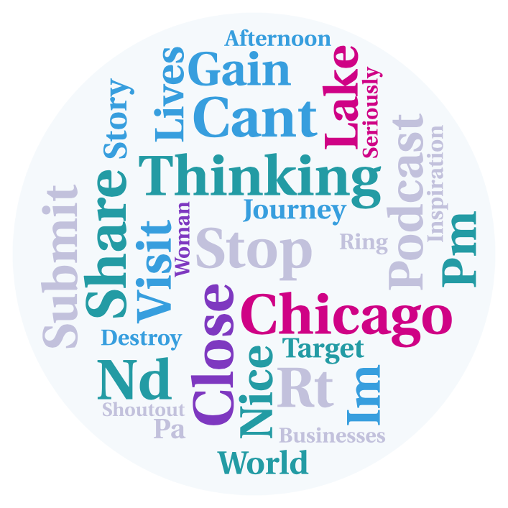  Topic 0^ | 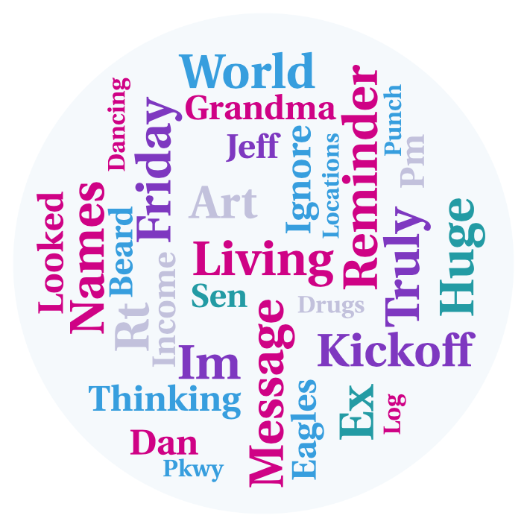  Topic 1 | 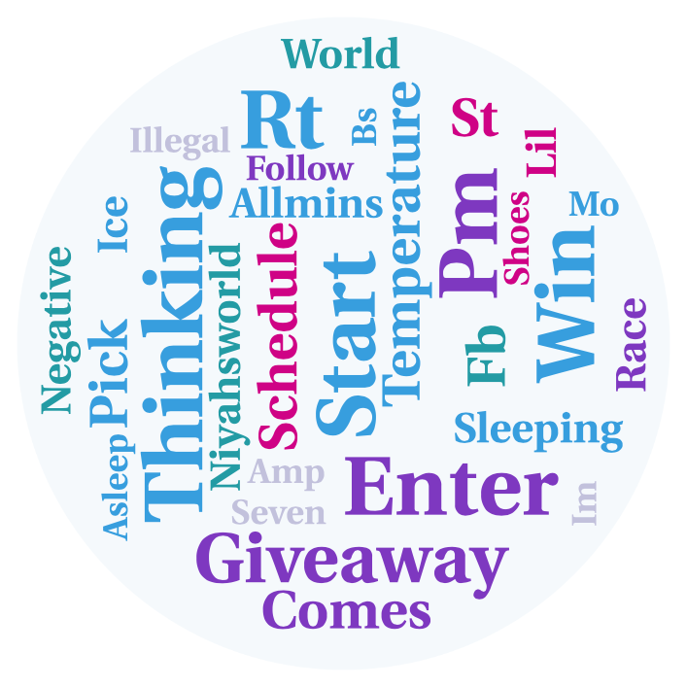  Topic 8 | 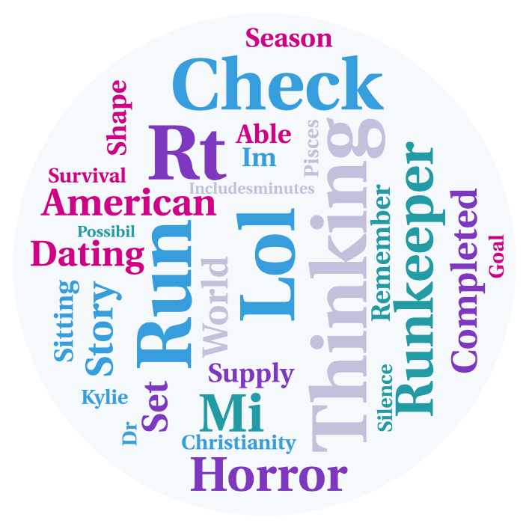  Topic 12 | 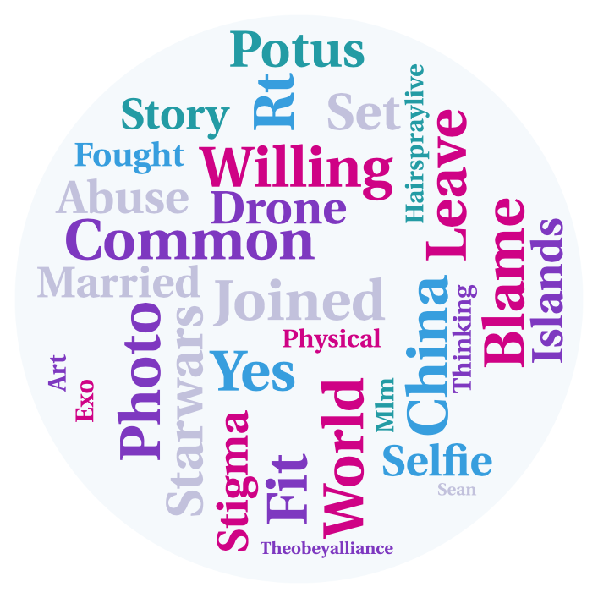  Topic 17^
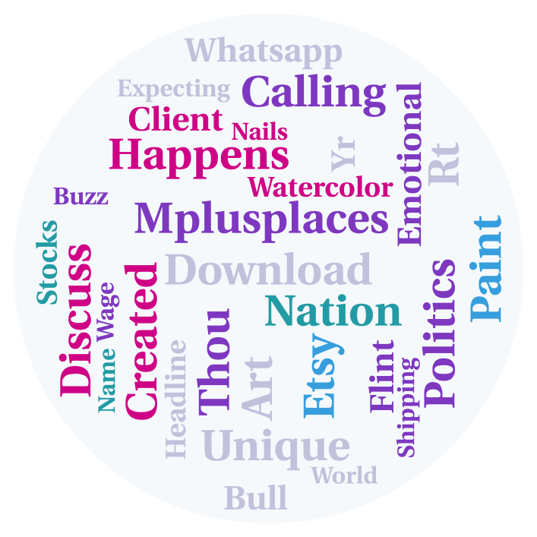  Topic 35 | 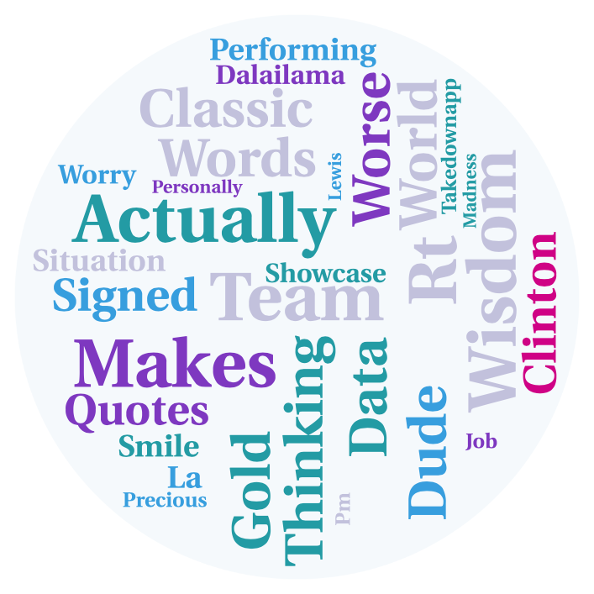  Topic 42 | 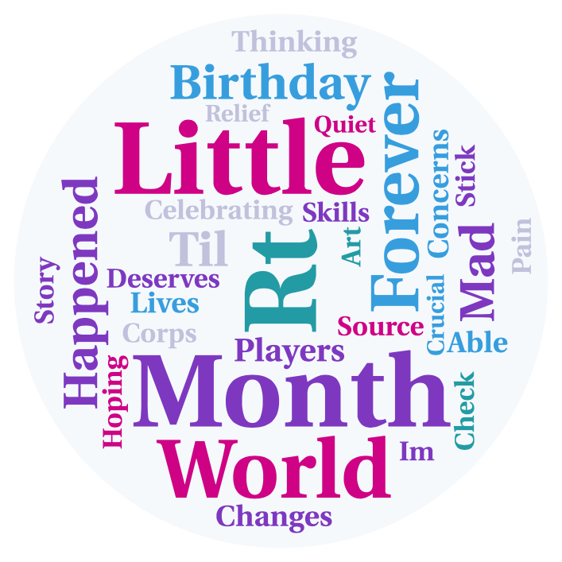  Topic 45 | 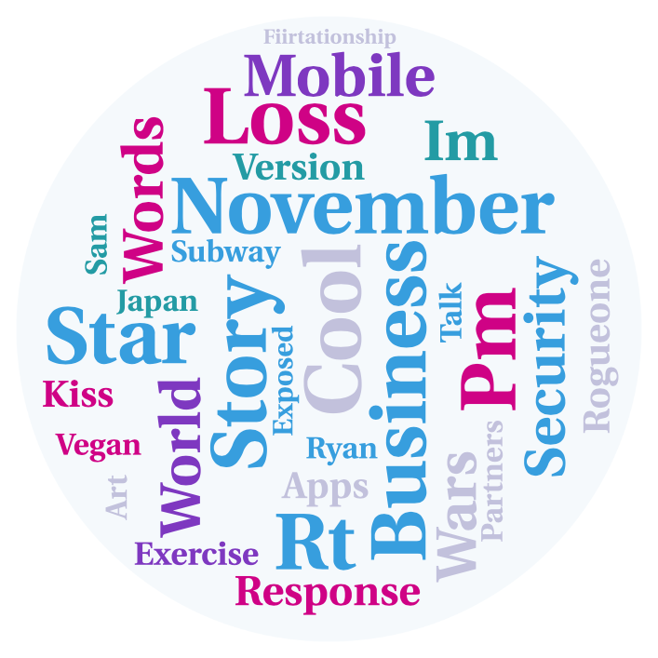  Topic 49^ | 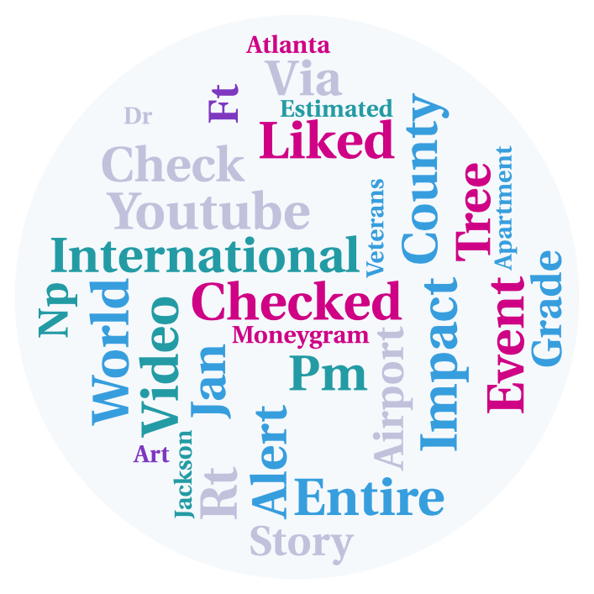  Topic 54
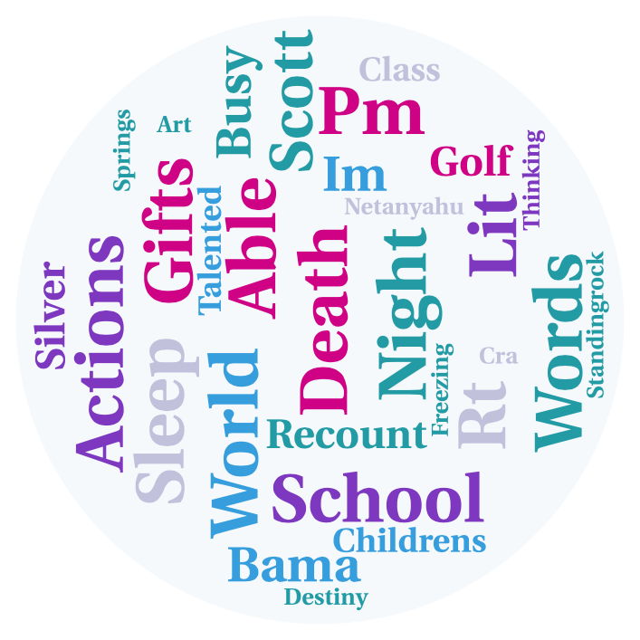  Topic 62 | 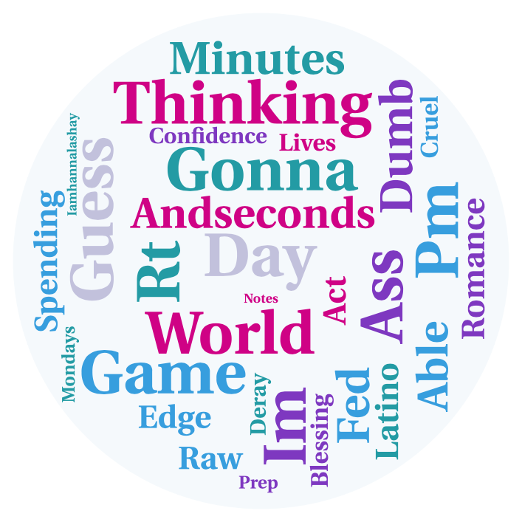  Topic 66 | 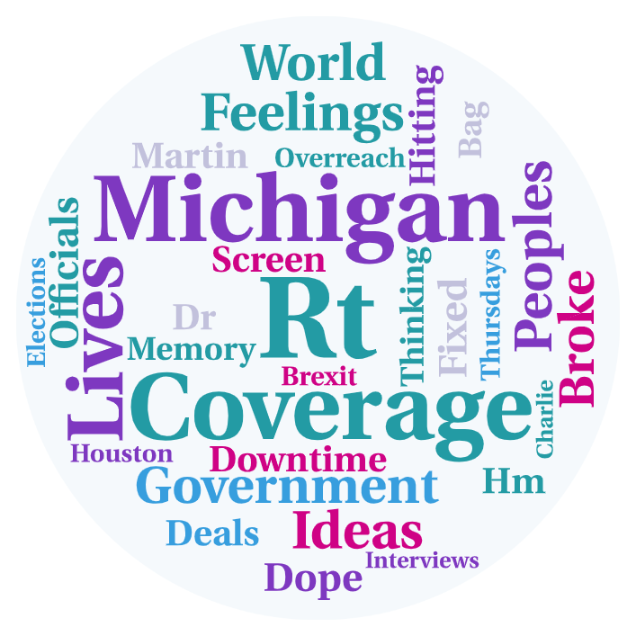  Topic 69^ | 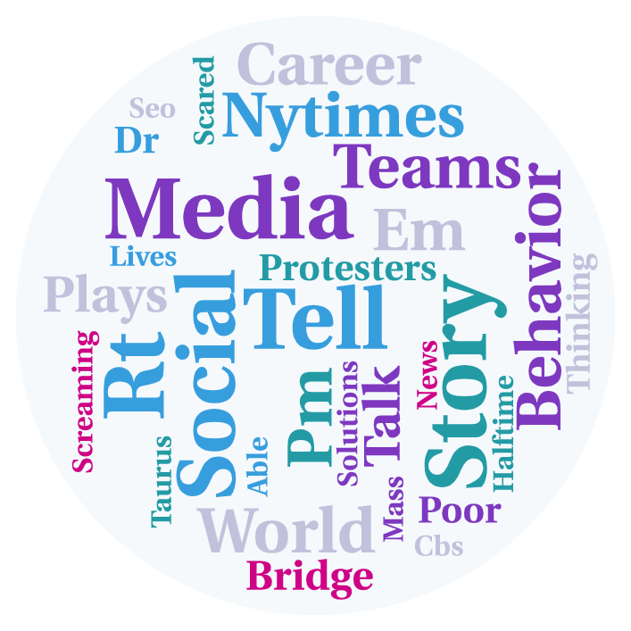  Topic 76^ | 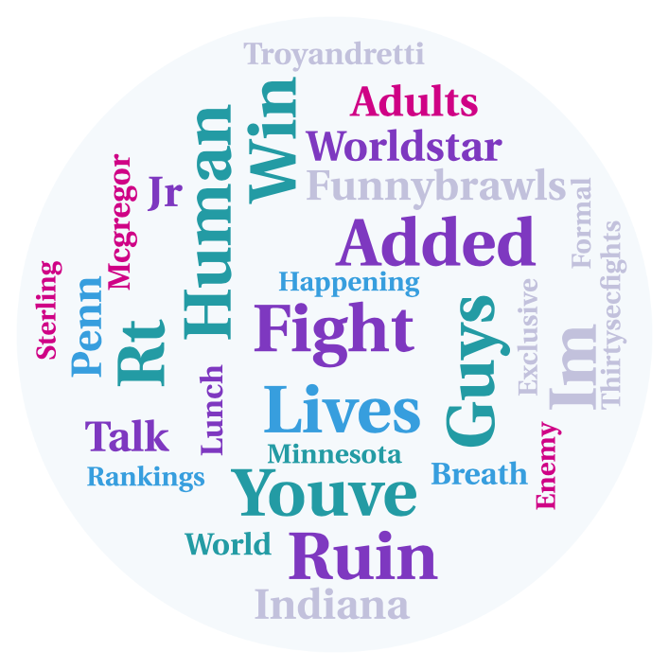  Topic 83
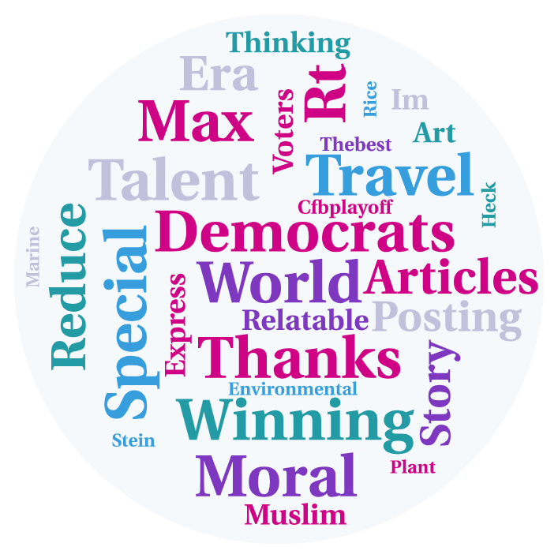  Topic 92 | 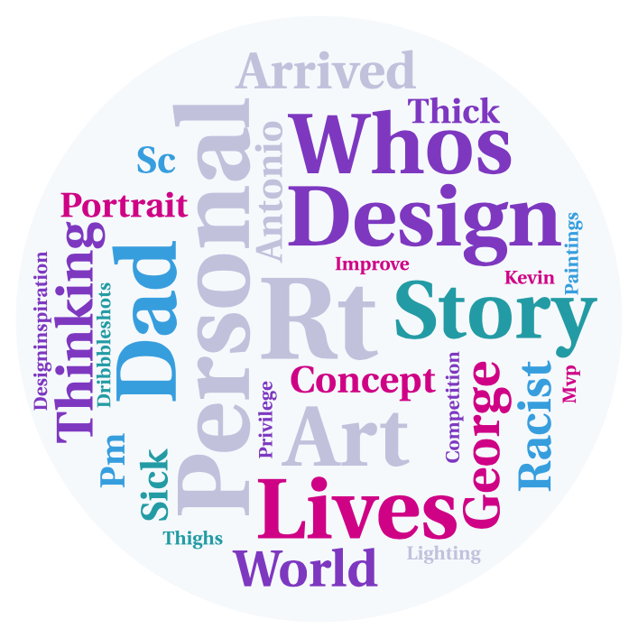  Topic 96^
Note. ^ denotes Twitter topics having positive correlations with reported communication about PrEP and PrEP use

Keywords used to collect relevant tweets include: Bacterial Vaginosis,STI,Chlamydia,Genital Herpes,Gonorrhea,Hepatitis B,Hepatitis C,Human Papillomavirus,HPV,Lymphogranuloma Venereum,LGV,Pubic Lice,Scabies,Syphilis,Trichomoniasis,Yeast Infections,Chancroid,venereal disease,Mucopurulent Cervcitis,MPC,genital wart,genital warts,Molluscum Conatagiosum,Cytomegalovirus,CMV,Hepatitis A,Herpes,Mononucleosis,Mycoplasma Genitalium,Nongonococcal Urethritis,Pelvic Inflammatory Disease,Trich,HIV,human immunodeficiency virus,AIDS,acquired immune deficiency syndrome,Truvada,NRTIs,NNRTIs,entry inhibitors,fusion inhibitors,integrase inhibitors,HIV-1,Seronegative,CD4 count,AIDS cocktail,HAART,Transmitted resistance,HIV-2,Western blot test,T-cell,serodiscordant,HIV neutral,AIDS Drugs Assistance Program,Aids Support Organization,Atripla,Sustiva,efavirenz,Viread,tenofovir,Emtriva,emtricitabine,Retrovir,zidovudine,Combivir,Trizivir,Epivir,lamivudine,Epzicom,Ziagen,abacavir,Gay Related Immune Disorder,Highly Active Anti-Retroviral Therapy,antiretroviral therapy,Intelence,Etravirine,TMC125,Isentress,Raltegravir,Kaletra,Lopinavir,Lexiva,Amprenavir,Agenerase,Ritonavir,Norvir,Prezista,Duranavir,Reyataz,Selzentry,Maraviroc,Okamoto,Caution Wear,Contempo,abstinence,fluid bonding,fluid bonded,PreP,PeP,pre-exposure prophylaxis,post-exposure prophylaxis,needle and syringe program,needle and syringe programs,needle exchange program,needle exchange programs,syringe exchange program,syringe exchange programs,clean needle program,clean needle programs,sharing needle,sharing needles,seroconcordant,azidothymidine

