Supplemental Figure. Local site and systemic adverse reactions in 14 PWH within the first week following D1 and D2 of SARS-CoV-2 mRNA vaccination.

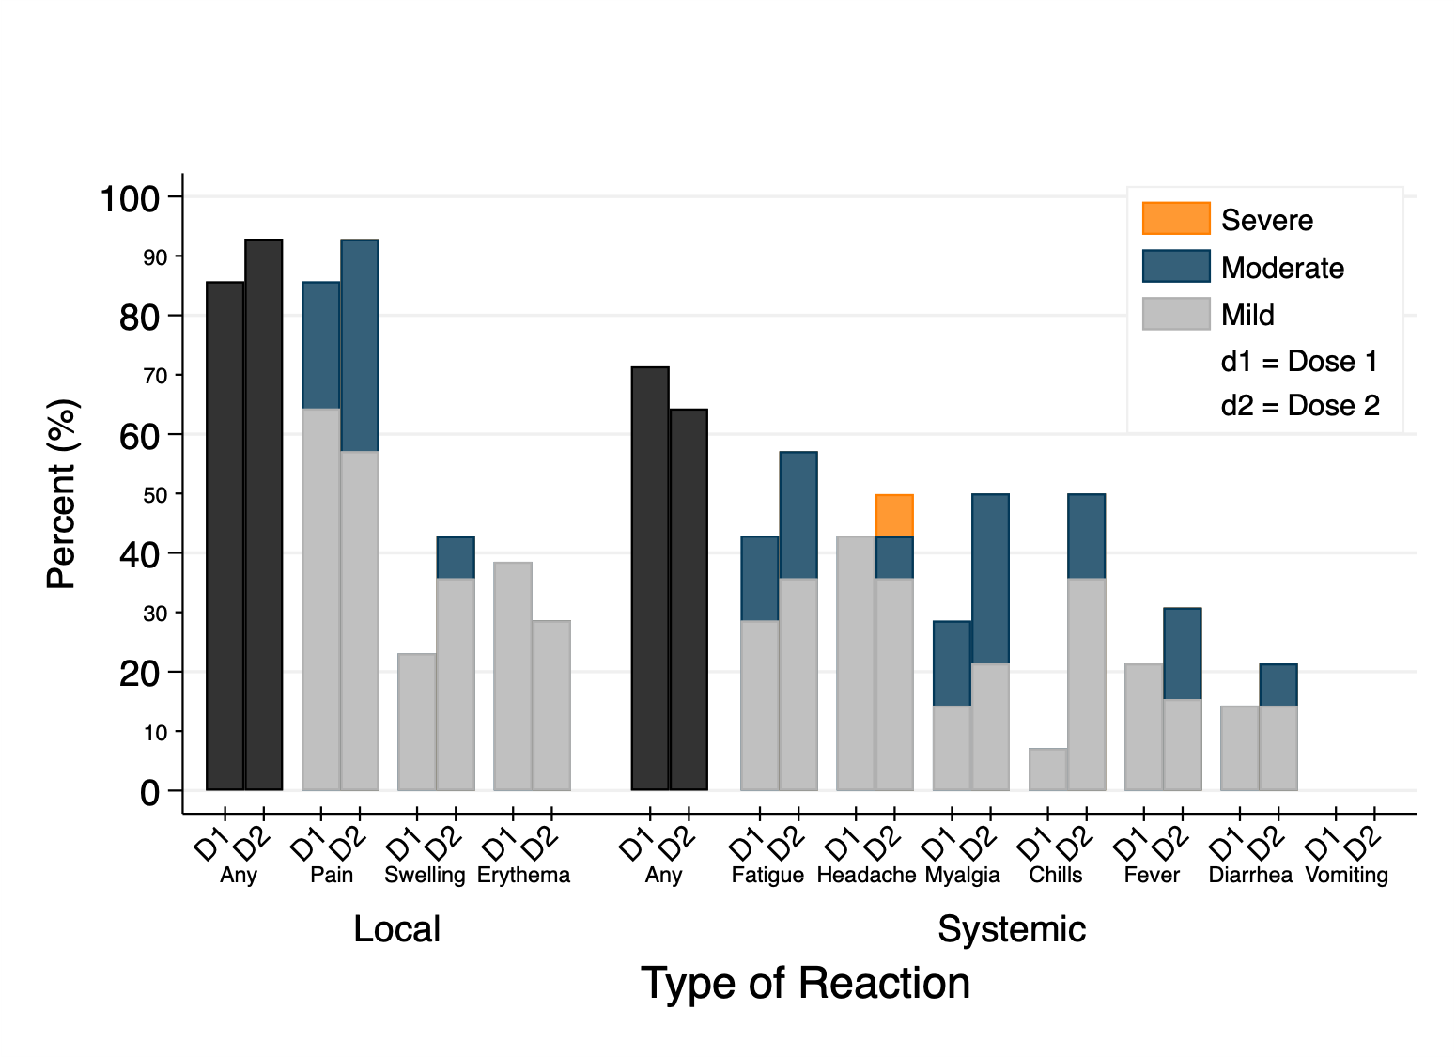
Legend:
Mild: does not interfere with activity, moderate: some interference with activity, severe: prevents daily activity. Rates of adverse reactions in BNT162b2 trial within 7 days of D1 and D2:^{[15]} pain D1 78% and D2 72.9%, swelling D1 6.4% and D2 6.4%, erythema D1 5.0% and D2 6.4%, fatigue D1 41.5% and D2 55.6%, headache D1 34.8% and D2 46.5%, myalgia D1 18.0% and D2 33.6%, chills D1 10.6% and D2 29.9%, fever D1 2.7% and D2 13.9%, diarrhea D1 9.7% and D2 9.1%, vomiting D1 0.6% and D2 1.6%. Rates of adverse reactions in mRNA-1273 trial within 7 days of D1 and D2:^{[16]} Pain D1 83.7% and D2 88.2%, swelling D1 6.1% and D2 12.2%, erythema D1 2.8% and D2 8.6%, fatigue D1 37.2% and D2 65.3%, headache D1 32.7% and D2 58.6%, myalgia D1 22.7% and D2 58.0%, chills D1 8.3% and D2 44.2%, and fever D1 0.8% and D2 15.5%. Rates of diarrhea and vomiting were not measured in the mRNA-1273 trial.

