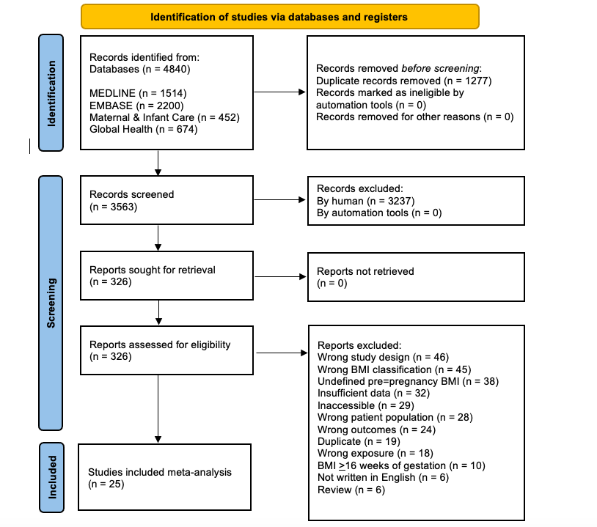
Supplementary 1: PRISMA Flow Chart

From: Page MJ, McKenzie JE, Bossuyt PM, Boutron I, Hoffmann TC, Mulrow CD, et al. The PRISMA 2020 statement: an updated guideline for reporting systematic reviews. BMJ 2021;372:n71. doi: 10.1136/bmj.n71

For more information, visit: http://www.prisma-statement.org/

BMI: body mass index

Supplementary 2: Search Terms

Database: MEDLINE (Search 1)
- maternal obes*.mp. [mp=title, abstract, original title, name of substance word, subject heading word, floating sub-heading word, keyword heading word, organism supplementary concept word, protocol supplementary concept word, rare disease supplementary concept word, unique identifier, synonyms]
- maternal weight gain.mp. [mp=title, abstract, original title, name of substance word, subject heading word, floating sub-heading word, keyword heading word, organism supplementary concept word, protocol supplementary concept word, rare disease supplementary concept word, unique identifier, synonyms]
- obese mother*.mp. [mp=title, abstract, original title, name of substance word, subject heading word, floating sub-heading word, keyword heading word, organism supplementary concept word, protocol supplementary concept word, rare disease supplementary concept word, unique identifier, synonyms]
- overweight mother*.mp. [mp=title, abstract, original title, name of substance word, subject heading word, floating sub-heading word, keyword heading word, organism supplementary concept word, protocol supplementary concept word, rare disease supplementary concept word, unique identifier, synonyms]
- maternal BMI.mp. [mp=title, abstract, original title, name of substance word, subject heading word, floating sub-heading word, keyword heading word, organism supplementary concept word, protocol supplementary concept word, rare disease supplementary concept word, unique identifier, synonyms]
- maternal body mass index.mp. [mp=title, abstract, original title, name of substance word, subject heading word, floating sub-heading word, keyword heading word, organism supplementary concept word, protocol supplementary concept word, rare disease supplementary concept word, unique identifier, synonyms]
- maternal overweight.mp. [mp=title, abstract, original title, name of substance word, subject heading word, floating sub-heading word, keyword heading word, organism supplementary concept word, protocol supplementary concept word, rare disease supplementary concept word, unique identifier, synonyms]
- Obesity, Maternal/
- prepregnancy BMI.mp. [mp=title, abstract, original title, name of substance word, subject heading word, floating sub-heading word, keyword heading word, organism supplementary concept word, protocol supplementary concept word, rare disease supplementary concept word, unique identifier, synonyms]
- prepregnancy body mass index.mp. [mp=title, abstract, original title, name of substance word, subject heading word, floating sub-heading word, keyword heading word, organism supplementary concept word, protocol supplementary concept word, rare disease supplementary concept word, unique identifier, synonyms]
- (maternal adj1 body mass index).mp. [mp=title, abstract, original title, name of substance word, subject heading word, floating sub-heading word, keyword heading word, organism supplementary concept word, protocol supplementary concept word, rare disease supplementary concept word, unique identifier, synonyms]
- exp Pregnancy Complications/
- Pregnancy Outcome/
- adverse birth outcome*.mp. [mp=title, abstract, original title, name of substance word, subject heading word, floating sub-heading word, keyword heading word, organism supplementary concept word, protocol supplementary concept word, rare disease supplementary concept word, unique identifier, synonyms]
- adverse maternal outcome*.mp. [mp=title, abstract, original title, name of substance word, subject heading word, floating sub-heading word, keyword heading word, organism supplementary concept word, protocol supplementary concept word, rare disease supplementary concept word, unique identifier, synonyms]
- 12 or 13 or 14 or 15
- 1 or 2 or 3 or 4 or 5 or 6 or 7 or 8 or 9 or 10 or 11
- normal BMI.mp. [mp=title, abstract, original title, name of substance word, subject heading word, floating sub-heading word, keyword heading word, organism supplementary concept word, protocol supplementary concept word, rare disease supplementary concept word, unique identifier, synonyms]
- normal weight.mp. [mp=title, abstract, original title, name of substance word, subject heading word, floating sub-heading word, keyword heading word, organism supplementary concept word, protocol supplementary concept word, rare disease supplementary concept word, unique identifier, synonyms]
- healthy BMI.mp. [mp=title, abstract, original title, name of substance word, subject heading word, floating sub-heading word, keyword heading word, organism supplementary concept word, protocol supplementary concept word, rare disease supplementary concept word, unique identifier, synonyms]
- healthy body mass index.mp. [mp=title, abstract, original title, name of substance word, subject heading word, floating sub-heading word, keyword heading word, organism supplementary concept word, protocol supplementary concept word, rare disease supplementary concept word, unique identifier, synonyms]
- normal body mass index.mp. [mp=title, abstract, original title, name of substance word, subject heading word, floating sub-heading word, keyword heading word, organism supplementary concept word, protocol supplementary concept word, rare disease supplementary concept word, unique identifier, synonyms]
- healthy weight.mp. [mp=title, abstract, original title, name of substance word, subject heading word, floating sub-heading word, keyword heading word, organism supplementary concept word, protocol supplementary concept word, rare disease supplementary concept word, unique identifier, synonyms]
- ideal body weight.mp. [mp=title, abstract, original title, name of substance word, subject heading word, floating sub-heading word, keyword heading word, organism supplementary concept word, protocol supplementary concept word, rare disease supplementary concept word, unique identifier, synonyms]
- Ideal Body Weight/
- normal body weight.mp.
- 18 or 19 or 20 or 21 or 22 or 23 or 24 or 25 or 26
- 16 and 17 and 27
- exp animals/ not humans.mp. [mp=title, abstract, original title, name of substance word, subject heading word, floating sub-heading word, keyword heading word, organism supplementary concept word, protocol supplementary concept word, rare disease supplementary concept word, unique identifier, synonyms]
- 28 not 29

Database: MEDLINE (Search 2) (Neural Tube Defect):
- maternal obes*.mp. [mp=title, abstract, original title, name of substance word, subject heading word, floating sub-heading word, keyword heading word, organism supplementary concept word, protocol supplementary concept word, rare disease supplementary concept word, unique identifier, synonyms]
- maternal weight gain.mp. [mp=title, abstract, original title, name of substance word, subject heading word, floating sub-heading word, keyword heading word, organism supplementary concept word, protocol supplementary concept word, rare disease supplementary concept word, unique identifier, synonyms]
- obese mother*.mp. [mp=title, abstract, original title, name of substance word, subject heading word, floating sub-heading word, keyword heading word, organism supplementary concept word, protocol supplementary concept word, rare disease supplementary concept word, unique identifier, synonyms]
- overweight mother*.mp. [mp=title, abstract, original title, name of substance word, subject heading word, floating sub-heading word, keyword heading word, organism supplementary concept word, protocol supplementary concept word, rare disease supplementary concept word, unique identifier, synonyms]
- maternal BMI.mp. [mp=title, abstract, original title, name of substance word, subject heading word, floating sub-heading word, keyword heading word, organism supplementary concept word, protocol supplementary concept word, rare disease supplementary concept word, unique identifier, synonyms]
- maternal body mass index.mp. [mp=title, abstract, original title, name of substance word, subject heading word, floating sub-heading word, keyword heading word, organism supplementary concept word, protocol supplementary concept word, rare disease supplementary concept word, unique identifier, synonyms]
- maternal overweight.mp. [mp=title, abstract, original title, name of substance word, subject heading word, floating sub-heading word, keyword heading word, organism supplementary concept word, protocol supplementary concept word, rare disease supplementary concept word, unique identifier, synonyms]
- Obesity, Maternal/
- prepregnancy BMI.mp. [mp=title, abstract, original title, name of substance word, subject heading word, floating sub-heading word, keyword heading word, organism supplementary concept word, protocol supplementary concept word, rare disease supplementary concept word, unique identifier, synonyms]
- prepregnancy body mass index.mp. [mp=title, abstract, original title, name of substance word, subject heading word, floating sub-heading word, keyword heading word, organism supplementary concept word, protocol supplementary concept word, rare disease supplementary concept word, unique identifier, synonyms]
- (maternal adj1 body mass index).mp. [mp=title, abstract, original title, name of substance word, subject heading word, floating sub-heading word, keyword heading word, organism supplementary concept word, protocol supplementary concept word, rare disease supplementary concept word, unique identifier, synonyms]
- 1 or 2 or 3 or 4 or 5 or 6 or 7 or 8 or 9 or 10 or 11
- exp Congenital Abnormalities/
- exp Neural Tube Defects/
- congenital defect*.mp. [mp=title, abstract, original title, name of substance word, subject heading word, floating sub-heading word, keyword heading word, organism supplementary concept word, protocol supplementary concept word, rare disease supplementary concept word, unique identifier, synonyms]
- birth defect*.mp. [mp=title, abstract, original title, name of substance word, subject heading word, floating sub-heading word, keyword heading word, organism supplementary concept word, protocol supplementary concept word, rare disease supplementary concept word, unique identifier, synonyms]
- congenital malformation*.mp. [mp=title, abstract, original title, name of substance word, subject heading word, floating sub-heading word, keyword heading word, organism supplementary concept word, protocol supplementary concept word, rare disease supplementary concept word, unique identifier, synonyms]
- congenital abnormalit*.mp. [mp=title, abstract, original title, name of substance word, subject heading word, floating sub-heading word, keyword heading word, organism supplementary concept word, protocol supplementary concept word, rare disease supplementary concept word, unique identifier, synonyms]
- birth abnormalit*.mp. [mp=title, abstract, original title, name of substance word, subject heading word, floating sub-heading word, keyword heading word, organism supplementary concept word, protocol supplementary concept word, rare disease supplementary concept word, unique identifier, synonyms]
- NTD*.mp. [mp=title, abstract, original title, name of substance word, subject heading word, floating sub-heading word, keyword heading word, organism supplementary concept word, protocol supplementary concept word, rare disease supplementary concept word, unique identifier, synonyms]
- neural tube defect*.mp. [mp=title, abstract, original title, name of substance word, subject heading word, floating sub-heading word, keyword heading word, organism supplementary concept word, protocol supplementary concept word, rare disease supplementary concept word, unique identifier, synonyms]
- 13 or 14 or 15 or 16 or 17 or 18 or 19 or 20 or 21
- 12 and 22

Database: EMBASE (Search 1)
- maternal obes*.mp. [mp=title, abstract, heading word, drug trade name, original title, device manufacturer, drug manufacturer, device trade name, keyword, floating subheading word, candidate term word]
- maternal weight gain.mp. [mp=title, abstract, heading word, drug trade name, original title, device manufacturer, drug manufacturer, device trade name, keyword, floating subheading word, candidate term word]
- obese mother*.mp. [mp=title, abstract, heading word, drug trade name, original title, device manufacturer, drug manufacturer, device trade name, keyword, floating subheading word, candidate term word]
- overweight mother*.mp. [mp=title, abstract, heading word, drug trade name, original title, device manufacturer, drug manufacturer, device trade name, keyword, floating subheading word, candidate term word]
- maternal BMI.mp. [mp=title, abstract, heading word, drug trade name, original title, device manufacturer, drug manufacturer, device trade name, keyword, floating subheading word, candidate term word]
- maternal body mass index.mp. [mp=title, abstract, heading word, drug trade name, original title, device manufacturer, drug manufacturer, device trade name, keyword, floating subheading word, candidate term word]
- maternal overweight.mp. [mp=title, abstract, heading word, drug trade name, original title, device manufacturer, drug manufacturer, device trade name, keyword, floating subheading word, candidate term word]
- prepregnancy BMI.mp. [mp=title, abstract, heading word, drug trade name, original title, device manufacturer, drug manufacturer, device trade name, keyword, floating subheading word, candidate term word]
- prepregnancy body mass index.mp. [mp=title, abstract, heading word, drug trade name, original title, device manufacturer, drug manufacturer, device trade name, keyword, floating subheading word, candidate term word]
- (maternal adj1 body mass index).mp. [mp=title, abstract, heading word, drug trade name, original title, device manufacturer, drug manufacturer, device trade name, keyword, floating subheading word, candidate term word]
- exp Pregnancy Complications/
- Pregnancy Outcome/
- adverse birth outcome*.mp. [mp=title, abstract, heading word, drug trade name, original title, device manufacturer, drug manufacturer, device trade name, keyword, floating subheading word, candidate term word]
- adverse maternal outcome*.mp. [mp=title, abstract, heading word, drug trade name, original title, device manufacturer, drug manufacturer, device trade name, keyword, floating subheading word, candidate term word]
- 11 or 12 or 13 or 14
- maternal obesity/
- normal BMI.mp. [mp=title, abstract, heading word, drug trade name, original title, device manufacturer, drug manufacturer, device trade name, keyword, floating subheading word, candidate term word]
- normal weight.mp. [mp=title, abstract, heading word, drug trade name, original title, device manufacturer, drug manufacturer, device trade name, keyword, floating subheading word, candidate term word]
- healthy BMI.mp. [mp=title, abstract, heading word, drug trade name, original title, device manufacturer, drug manufacturer, device trade name, keyword, floating subheading word, candidate term word]
- healthy body mass index.mp. [mp=title, abstract, heading word, drug trade name, original title, device manufacturer, drug manufacturer, device trade name, keyword, floating subheading word, candidate term word]
- normal body mass index.mp. [mp=title, abstract, heading word, drug trade name, original title, device manufacturer, drug manufacturer, device trade name, keyword, floating subheading word, candidate term word]
- healthy weight.mp. [mp=title, abstract, heading word, drug trade name, original title, device manufacturer, drug manufacturer, device trade name, keyword, floating subheading word, candidate term word]
- ideal body weight.mp. [mp=title, abstract, heading word, drug trade name, original title, device manufacturer, drug manufacturer, device trade name, keyword, floating subheading word, candidate term word]
- Ideal Body Weight/
- normal body weight.mp.
- 17 or 18 or 19 or 20 or 21 or 22 or 23 or 24 or 25
- (exp animal/ or nonhuman/) not exp human/
- obes*.mp. [mp=title, abstract, heading word, drug trade name, original title, device manufacturer, drug manufacturer, device trade name, keyword, floating subheading word, candidate term word]
- obesity/
- 1 or 2 or 3 or 4 or 5 or 6 or 7 or 8 or 9 or 10 or 16 or 28 or 29
- 15 and 26 and 30
- 31 not 27

Database: MEDLINE (Search 2) (Neural Tube Defect):
- maternal obes*.mp. [mp=title, abstract, heading word, drug trade name, original title, device manufacturer, drug manufacturer, device trade name, keyword, floating subheading word, candidate term word]
- maternal weight gain.mp. [mp=title, abstract, heading word, drug trade name, original title, device manufacturer, drug manufacturer, device trade name, keyword, floating subheading word, candidate term word]
- obese mother*.mp. [mp=title, abstract, heading word, drug trade name, original title, device manufacturer, drug manufacturer, device trade name, keyword, floating subheading word, candidate term word]
- overweight mother*.mp. [mp=title, abstract, heading word, drug trade name, original title, device manufacturer, drug manufacturer, device trade name, keyword, floating subheading word, candidate term word]
- maternal BMI.mp. [mp=title, abstract, heading word, drug trade name, original title, device manufacturer, drug manufacturer, device trade name, keyword, floating subheading word, candidate term word]
- maternal body mass index.mp. [mp=title, abstract, heading word, drug trade name, original title, device manufacturer, drug manufacturer, device trade name, keyword, floating subheading word, candidate term word]
- maternal overweight.mp. [mp=title, abstract, heading word, drug trade name, original title, device manufacturer, drug manufacturer, device trade name, keyword, floating subheading word, candidate term word]
- prepregnancy BMI.mp. [mp=title, abstract, heading word, drug trade name, original title, device manufacturer, drug manufacturer, device trade name, keyword, floating subheading word, candidate term word]
- prepregnancy body mass index.mp. [mp=title, abstract, heading word, drug trade name, original title, device manufacturer, drug manufacturer, device trade name, keyword, floating subheading word, candidate term word]
- (maternal adj1 body mass index).mp. [mp=title, abstract, heading word, drug trade name, original title, device manufacturer, drug manufacturer, device trade name, keyword, floating subheading word, candidate term word]
- maternal obesity/
- 1 or 2 or 3 or 4 or 5 or 6 or 7 or 8 or 9 or 10 or 11
- exp neural tube defect/
- exp congenital malformation/
- neural tube defect*.mp. [mp=title, abstract, heading word, drug trade name, original title, device manufacturer, drug manufacturer, device trade name, keyword, floating subheading word, candidate term word]
- NTD*.mp. [mp=title, abstract, heading word, drug trade name, original title, device manufacturer, drug manufacturer, device trade name, keyword, floating subheading word, candidate term word]
- birth defect*.mp. [mp=title, abstract, heading word, drug trade name, original title, device manufacturer, drug manufacturer, device trade name, keyword, floating subheading word, candidate term word]
- congenital malformation*.mp. [mp=title, abstract, heading word, drug trade name, original title, device manufacturer, drug manufacturer, device trade name, keyword, floating subheading word, candidate term word]
- congenital defect*.mp. [mp=title, abstract, heading word, drug trade name, original title, device manufacturer, drug manufacturer, device trade name, keyword, floating subheading word, candidate term word]
- 13 or 14 or 15 or 16 or 17 or 18 or 19
- 12 and 20
- (exp animal/ or nonhuman/) not exp human/
- 21 not 22

Database: Global Health (Search 1):
- maternal obes*.mp. [mp=abstract, title, original title, broad terms, heading words, identifiers, cabicodes]
- maternal weight gain.mp. [mp=abstract, title, original title, broad terms, heading words, identifiers, cabicodes]
- obese mother*.mp. [mp=abstract, title, original title, broad terms, heading words, identifiers, cabicodes]
- overweight mother*.mp. [mp=abstract, title, original title, broad terms, heading words, identifiers, cabicodes]
- maternal BMI.mp. [mp=abstract, title, original title, broad terms, heading words, identifiers, cabicodes]
- maternal body mass index.mp. [mp=abstract, title, original title, broad terms, heading words, identifiers, cabicodes]
- maternal overweight.mp. [mp=abstract, title, original title, broad terms, heading words, identifiers, cabicodes]
- prepregnancy BMI.mp. [mp=abstract, title, original title, broad terms, heading words, identifiers, cabicodes]
- prepregnancy body mass index.mp. [mp=abstract, title, original title, broad terms, heading words, identifiers, cabicodes]
- (maternal adj1 body mass index).mp. [mp=abstract, title, original title, broad terms, heading words, identifiers, cabicodes]
- adverse birth outcome.mp. [mp=abstract, title, original title, broad terms, heading words, identifiers, cabicodes]
- adverse maternal outcome.mp. [mp=abstract, title, original title, broad terms, heading words, identifiers, cabicodes]
- exp pregnancy complications/
- 1 or 2 or 3 or 4 or 5 or 6 or 7 or 8 or 9 or 10
- 11 or 12 or 13
- 14 and 15

Database: Global Health (Search 2) (Neural Tube Defect):
- maternal obes*.mp. [mp=abstract, title, original title, broad terms, heading words, identifiers, cabicodes]
- maternal weight gain.mp. [mp=abstract, title, original title, broad terms, heading words, identifiers, cabicodes]
- obese mother*.mp. [mp=abstract, title, original title, broad terms, heading words, identifiers, cabicodes]
- overweight mother*.mp. [mp=abstract, title, original title, broad terms, heading words, identifiers, cabicodes]
- maternal BMI.mp. [mp=abstract, title, original title, broad terms, heading words, identifiers, cabicodes]
- maternal body mass index.mp. [mp=abstract, title, original title, broad terms, heading words, identifiers, cabicodes]
- maternal overweight.mp. [mp=abstract, title, original title, broad terms, heading words, identifiers, cabicodes]
- prepregnancy BMI.mp. [mp=abstract, title, original title, broad terms, heading words, identifiers, cabicodes]
- prepregnancy body mass index.mp. [mp=abstract, title, original title, broad terms, heading words, identifiers, cabicodes]
- (maternal adj1 body mass index).mp. [mp=abstract, title, original title, broad terms, heading words, identifiers, cabicodes]
- 1 or 2 or 3 or 4 or 5 or 6 or 7 or 8 or 9 or 10
- congenital malformation*.mp. [mp=abstract, title, original title, broad terms, heading words, identifiers, cabicodes]
- congenital defect*.mp. [mp=abstract, title, original title, broad terms, heading words, identifiers, cabicodes]
- birth defect*.mp. [mp=abstract, title, original title, broad terms, heading words, identifiers, cabicodes]
- exp congenital abnormalities/
- neural tube defect*.mp. [mp=abstract, title, original title, broad terms, heading words, identifiers, cabicodes]
- NTD*.mp. [mp=abstract, title, original title, broad terms, heading words, identifiers, cabicodes]
- 12 or 13 or 14 or 15 or 16 or 17
- 11 and 18

Database: Maternity & Infant Care (Search 1):

- maternal obes*.mp. [mp=abstract, heading word, title]
- maternal weight gain.mp. [mp=abstract, heading word, title]
- obese mother*.mp. [mp=abstract, heading word, title]
- overweight mother*.mp. [mp=abstract, heading word, title]
- maternal BMI.mp. [mp=abstract, heading word, title]
- maternal body mass index.mp. [mp=abstract, heading word, title]
- maternal overweight.mp. [mp=abstract, heading word, title]
- prepregnancy BMI.mp. [mp=abstract, heading word, title] (370)
- prepregnancy body mass index.mp. [mp=abstract, heading word, title]
- (maternal adj1 body mass index).mp. [mp=abstract, heading word, title]
- Pregnancy complications.de.
- Pregnancy outcome.de.
- adverse birth outcome.mp. [mp=abstract, heading word, title]
- adverse maternal outcome.mp. [mp=abstract, heading word, title]
- 11 or 12 or 13 or 14
- ("Weight gain (maternal)" or Prepregnancy weight).de.
- 1 or 2 or 3 or 4 or 5 or 6 or 7 or 8 or 9 or 10 or 16
- 15 and 17

Database: Maternity & Infant Care (Search 2) (Neural Tube Defects):
- maternal obes*.mp. [mp=abstract, heading word, title]
- maternal weight gain.mp. [mp=abstract, heading word, title]
- obese mother*.mp. [mp=abstract, heading word, title]
- overweight mother*.mp. [mp=abstract, heading word, title]
- maternal BMI.mp. [mp=abstract, heading word, title]
- maternal body mass index.mp. [mp=abstract, heading word, title]
- maternal overweight.mp. [mp=abstract, heading word, title]
- prepregnancy BMI.mp. [mp=abstract, heading word, title] (370)
- prepregnancy body mass index.mp. [mp=abstract, heading word, title]
- (maternal adj1 body mass index).mp. [mp=abstract, heading word, title]
- 1 or 2 or 3 or 4 or 5 or 6 or 7 or 8 or 9 or 10
- neural tube defect*.mp. [mp=abstract, heading word, title]
- NTD*.mp. [mp=abstract, heading word, title]
- Neural tube defects.de.
- congenital defect*.mp. [mp=abstract, heading word, title]
- birth defect*.mp. [mp=abstract, heading word, title]
- (Abnormalities or Birth defects).de.
- congenital malformation*.mp. [mp=abstract, heading word, title]
- 12 or 13 or 14 or 15 or 16 or 17 or 18
- 11 and 19

Supplementary 3: Inclusion and Exclusion Criteria for Meta-Analysis

Table 1: Inclusion and Exclusion Criteria for Meta-Analysis
Inclusion Criteria | Exclusion Criteria
Pre-pregnancy BMI | BMI is measured at ≥16 weeks of gestation/ Studies do not explicitly define the timing of when maternal BMI was measured
Studies assessing ≥1 of the following maternal outcomes:  - Preterm delivery  - Gestational hypertension  - Gestational diabetes  - Caesarean Section  - Pre-eclampsia | Studies including pregnancies using assisted reproductive technology (e.g. IVF)
Studies assessing ≥1 of the following infant outcomes:  - Small-for-gestational-age  - Large-for-gestational-age  - Low birthweight  - Macrosomia  - Stillbirths | Pregnant populations with specific co-morbidities
Studies assessing neural tube defects | Adolescent pregnancies
Cohort Studies | Reviews/Meta-analysis/Cross-Sectional/Case-Control studies
Studies using International WHO BMI classification* | Studies that did not provide raw values for the outcome
Written in English/Translation available | Studies evaluating mothers with multiple gestations
Any year of publication
Any country of origin

BMI: body mass index; IVF: in-vitro fertilization, WHO: World Health Organization
*Studies assessing neural tube defects were exempt from this inclusion criterion
Supplementary 4: Studies included in the Meta-Analysis of Maternal Obesity and Adverse Pregnancy Outcomes

Study ID | Study type | Location | Sample Size |  | Participant age | BMI measurement | Gestational age | Newcastle-Ottawa Assessment Score (/9)
 |  |  | Normal BMI | Obese BMI
Al-Hakmani 2016 | Prospective cohort | Oman | 245 | 238 | Normal-27.2  Obese-30.1 | ≤12 week of gestation | n/a | 6
Anzaku 2015 | Prospective cohort | Nigeria | 324 | 324 | 30 | ≤12 weeks of gestation | Normal-39.1  Obese-38.9 | 6
Avci 2015 | Retrospective cohort | Turkey | 542 | 103 | Normal-25.9  Obese-30.5 | Pre-pregnancy | n/a | 6
Blomberg 2009 | Retrospective cohort | Sweden | 660493 | 106612 | n/a | ≤12 weeks of gestation | n/a | 7
Denison 2013 | Retrospective cohort | Scotland | 61232 | 24354 | Normal-28.7  Obese-29.6 | ≤16 weeks of gestation | n/a | 8
Doi 2018 | Retrospective cohort | Scotland | 71538 | 25173 | n/a | ≤12 weeks of gestation | n/a | 8
Druil 2008 | Retrospective cohort | Italy | 533 | 51 | 31.2 | Pre-pregnancy | 38.4 | 8
El-Gillany 2010 | Prospective cohort | Saudi Arabia | 307 | 226 | Normal-25.9  Obese-30.7 | ≤12 weeks of gestation | n/a | 6
Enomoto 2016 | Retrospective cohort | Japan | 69126 | 2805 | Normal-32.0  Obese-32.0 | Pre-pregnancy | Normal-38.4  Obese-38.2 | 7
Hauger 2008 | Retrospective cohort | Argentina | 31286 | 3864 | n/a | Pre-pregnancy | n/a | 8
Hung 2016 | Retrospective cohort | Taiwan | 9021 | 267 | n/a | Pre-pregnancy | n/a | 6
Kallen 1998 | Retrospective cohort | Sweden | 511894 | 32678 | n/a | Pre-pregnancy | n/a | 7
Jensen 2003 | Retrospective cohort | Denmark | 1094 | 637 | Normal -31  Obese-39.6 | Pre-pregnancy | n/a | 6
Khashan 2009 | Retrospective cohort | United Kingdom | 50,448 | 17832 | Normal-27.4  Obese-28.8 | ≤16 weeks of gestation | n/a | 8
McIntyre 2012 | Retrospective cohort | Australia | 45918 | 8996 | Normal-30.5  Obese-30.5 | 12-16 weeks of gestation | n/a | 6
Melchor 2019 | Retrospective cohort | Spain | 9778 | 2207 | Normal-33.8  Obese-34.1 | 6-10 weeks of gestation | Normal-39.1  Obese-39.1 | 7
Moore  2000 | Retrospective cohort | United States of America | 20977 | 1974 | n/a | Pre-pregnancy | n/a | 6
Ovesen 2011 | Retrospective cohort | Denmark | 233,160 | 43161 | Normal-30.8  Obese-30.6 | Pre-pregnancy | n/a | 7
Simko 2019 | Retrospective cohort | Slovakia | 5400 | 358 | n/a | ≤12 weeks of gestation | n/a | 8
Soltani 2017 | Retrospective cohort | Indonesia | 344 | 6 | n/a | Pre-pregnancy | Normal-39.2  Obese-40.3 | 6
Toma 2017 | Retrospective cohort | Japan | 6801 | 207 | Normal-32.6  Obese-32.6 | Pre-pregnancy | n/a | 6
Vaswani 2013 | Retrospective cohort | UAE | 420 | 930 | Normal-32.6  Obese-32.6 | Early pregnancy | n/a | 6
Vinturache 2015 | Prospective cohort | Canada | 1313 | 211 | Normal-31  Obese-30.5 | Pre-pregnancy | n/a | 5
Zhang 2019 | Retrospective cohort | China | 152230 | 1027 | n/a | ≤12 weeks of gestation | n/a | 7
Zutshi 2018 | Retrospective cohort | Oman | 912 | 901 | n/a | ≤12 weeks of gestation | n/a | 5

n/a: not available

Supplementary 5: Forest Plots for each adverse pregnancy outcome from the meta-Analysis

Preterm Delivery

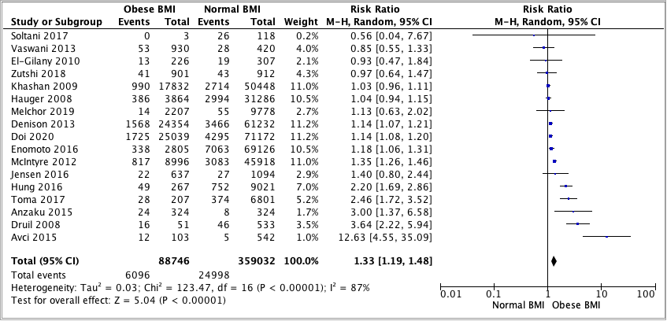

Gestational Hypertension

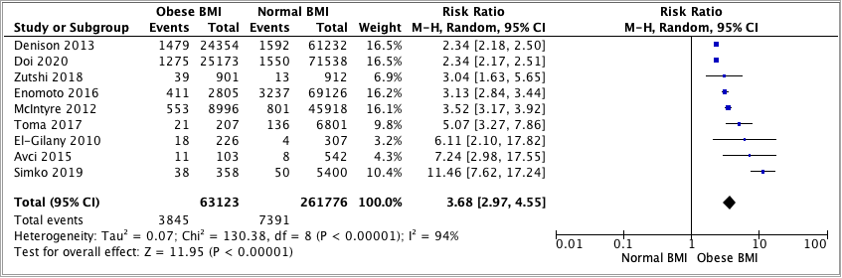

Gestational Diabetes Mellitus

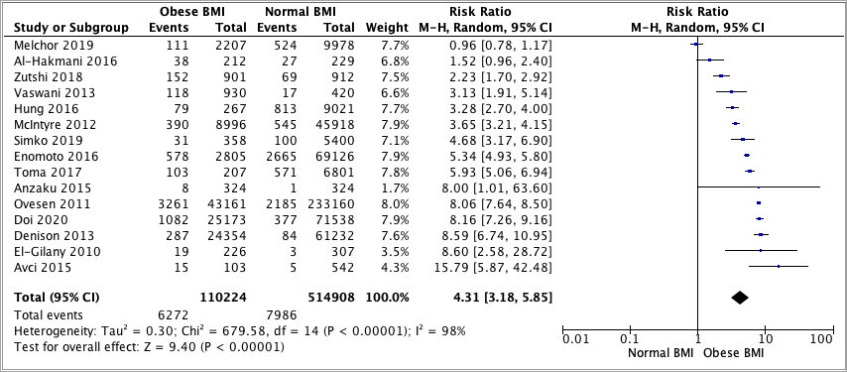

Pre-eclampsia

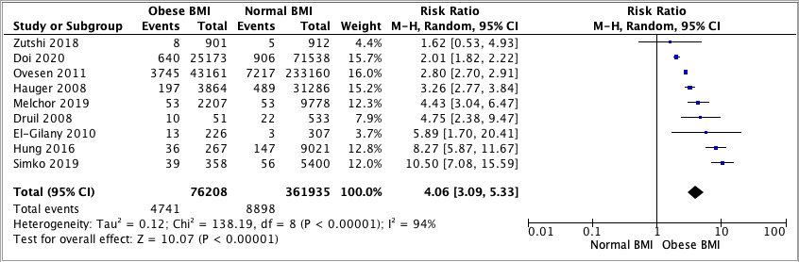

Caesarean Section

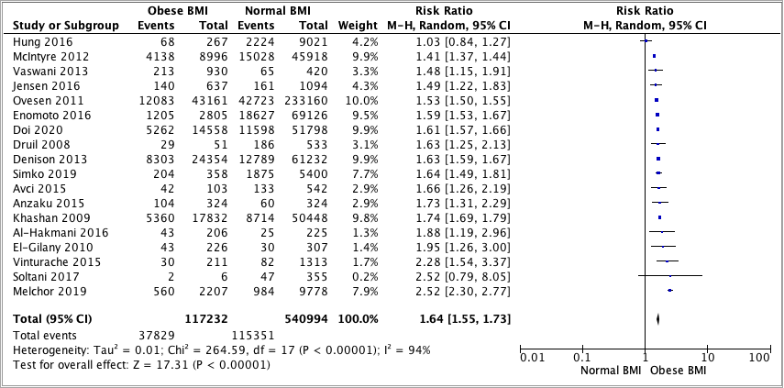

Post-Partum Haemorrhage

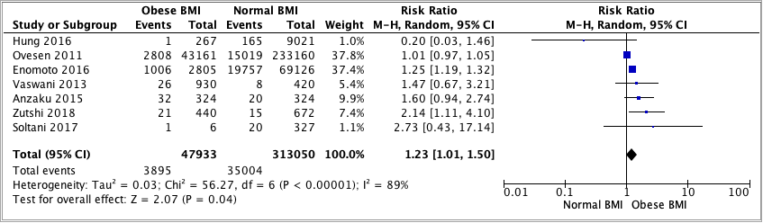

Small-for-gestational-age infants

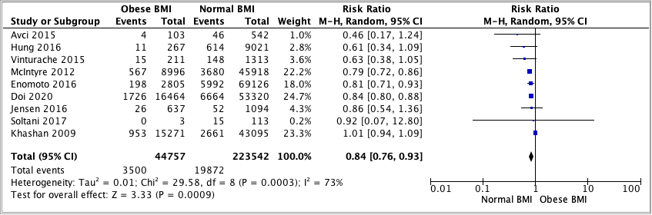

Large-for-gestational-age infants

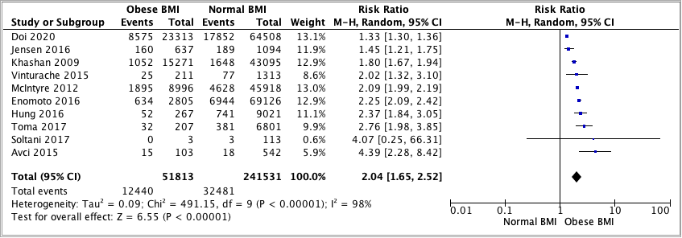

Stillbirths

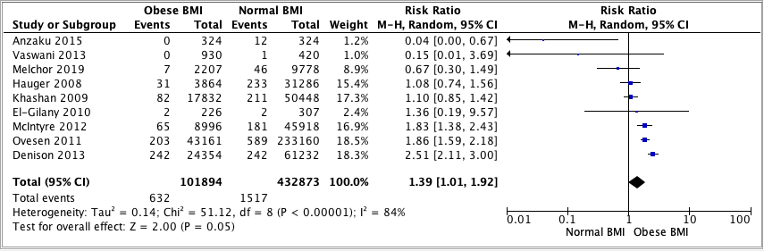

Low birthweight

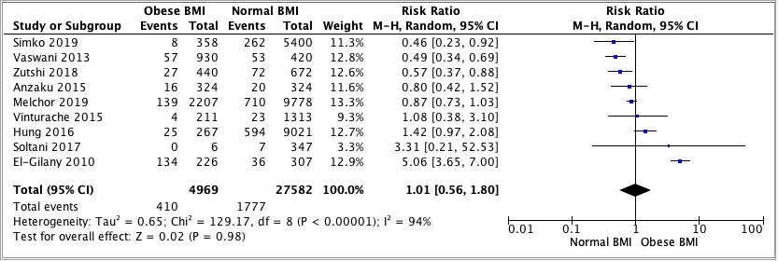

Macrosomia

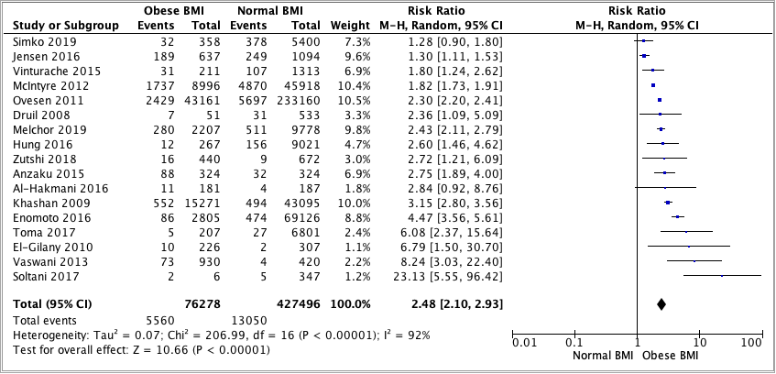

Neonatal Deaths

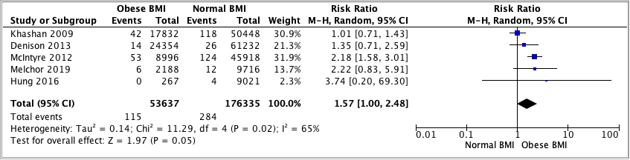

Neural tube defects

