Supplemental Digital Content

Figure S1. ATLAS plasma CAB and RPV trough concentrations over timeª
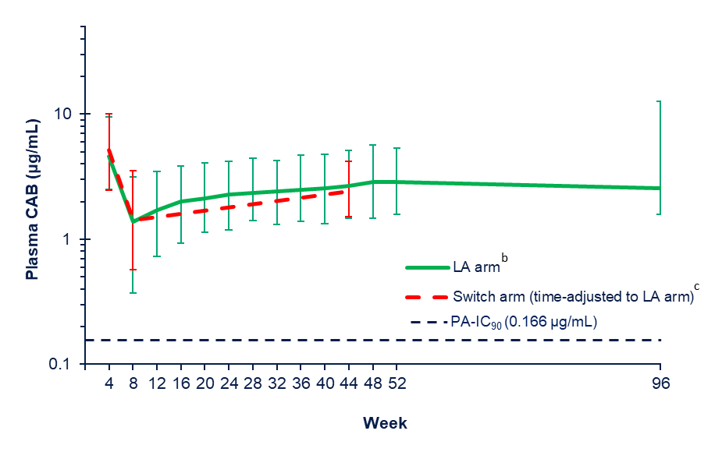
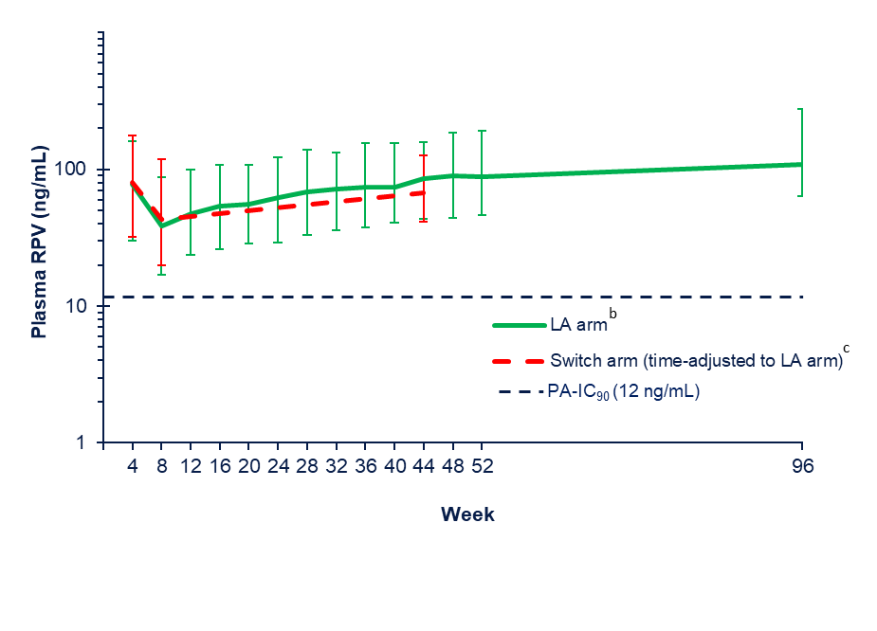

ªMedian (5th and 95th percentile) concentration–time data for CAB (top) and RPV (bottom) following Q4W LA administration. Values plotted at Week 4 represent steady-state oral dosing concentrations.
^{b}Timepoint, n (CAB/RPV): Week 4, n=259/258; Week 8, n=252/251; Week 12, n=261; Week 16, n=248/247; Week 20, n=233; Week 24, n=234/231; Week 28, n=232; Week 32, n=219/218; Week 36, n=209; Week 40, n=209/208; Week 44, n=221/223; Week 48, n=217/216; Week 52, n=215/214; Week 96, n=19.
^{c}Sparse pharmacokinetic sampling. Data for the Switch arm is time-adjusted to data from the LA arm (i.e. Week 56 values for the Switch arm are plotted to Week 4, Week 60 values are plotted to Week 8, and Week 96 values are plotted to Week 44). Timepoint, n (CAB/RPV): Week 56, n=149; Week 60, n=127; Week 96, n=24.
CAB, cabotegravir; LA, long-acting; PA-IC₉₀, protein binding–adjusted concentration required for 90% inhibition; Q4W, every 4 weeks; RPV, rilpivirine.

Table S1. Overview of common non-serious AEs
 | Maintenance Phase^{[1]} |  | Extension Phase
Commonª AEs excluding ISRs,  n (%) | LA arm  (Day 1 to  Week 52)  n=308 | CAR arm  (Day 1 to  Week 52)  n=308 | LA arm^{b}  (Week 52 to  Week 96)^{c} | Switch arm  (Week 52 to  Week 96)^{d}
Nasopharyngitis | 52 (17) | 42 (14) | 7 | 10
Headache | 34 (11) | 17 (6) | 1 | 4
Upper respiratory tract infection | 32 (10) | 25 (8) | 4 | 2
Diarrhea | 22 (7) | 15 (5) | 2 | 6
Fatigue | 22 (7) | 6 (2) | 1 | 5
Pyrexia | 21 (7) | 9 (3) | 0 | 6
Influenza | 17 (6) | 14 (5) | 1 | 8
Back pain | 20 (6) | 10 (3) | 2 | 2
Cough | 16 (5) | 14 (5) | 2 | 4
Insomnia | 15 (5) | 4 (1) | 1 | 0
Respiratory tract infection viral | 11 (4) | 17 (6) | 3 | 4

ªCommon is defined as a ≥5% incidence of event in either treatment group (148 and 174 are used as the denominator for the LA and Switch arms, respectively).
^{b}Values represent the number of new participants with AEs in the LA arm during the Extension Phase.
^{c}148 participants entered the Extension Phase; however, this number declined throughout the study, leaving 23 participants at the Week 96 analysis.
^{d}174 participants entered the Extension Phase; however, this number declined throughout the study, leaving 29 participants at the Week 96 analysis.

AE, adverse event; CAR, current antiretroviral therapy; ISR, injection site reaction; LA, long-acting.

Table S2. Summary of maximum emergent chemistry toxicities
 | Maintenance Phase |  | Extension Phase
Maximum emergent chemistry toxicities, n (%) | LA arm  (Day 1 to  Week 52)  n=308 | CAR arm  (Day 1 to  Week 52)  n=308 | LA armª  (Week 52 to  Week 96)^{b} | Switch arm  (Week 52 to  Week 96)^{c}
Grade ≥1 | 272 (88) | 271 (88) | 3 | 87
Grade ≥2 | 190 (62) | 197 (64) | 6 | 55
Grade ≥3 | 63 (20) | 57 (19) | 6 | 9

ªValues represent the number of new participants with new maximum emergent chemistry toxicities in the LA arm during the Extension Phase.
^{b}148 participants entered the Extension Phase; however, this number declined throughout the study, leaving 23 participants at the Week 96 analysis.
^{c}174 participants entered the Extension Phase; however, this number declined throughout the study, leaving 29 participants at the Week 96 analysis.

CAR, current antiretroviral therapy; LA, long-acting.

Bibliography

1. Swindells S, Andrade-Villanueva JF, Richmond GJ, Rizzardini G, Baumgarten A, Masiá M, et al. Long-acting cabotegravir and rilpivirine for maintenance of HIV-1 suppression. N Engl J Med 2020; 382:1112-1123.

