Appendix 1: EMR modifications (OOC List and HIV Follow-up tab)
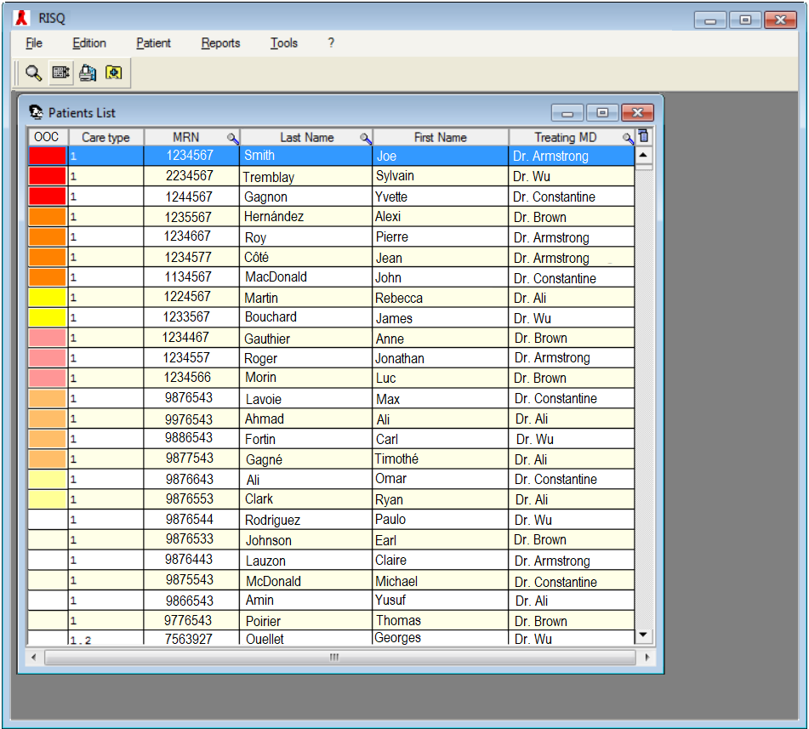
Presented in Figure A1 is the page of the clinical electronic medical records (EMR) system, called RISQ (Réseau d’Informations Scientifiques du Québec), displayed when nurses open the software.
Figure A1: Front page of the clinical EMR system (Fictional patients and physicians only)

Patients are organised by their OOC status (first column). Patients who are marked potentially OOC but have not yet been reviewed by nurses are marked in darker colours, organised according to their risk category (high risk in red, intermediate in orange, and low in yellow) and time since their last visit. Below them, in pale colours, are patients who have been recently validated by nurses, but not yet reengaged or in between contact attempts, also organised by risk category and time since last visit. These patients will be placed back into the top group of patients after the “Next attempt date” marked in their patient file (Figure 2; the “Validation and contact attempts” table at the bottom left) if they do not reengage. Below these patients (in white and beige) are patient who are not OOC (i.e. they are engaged in care). Not pictured here are patients who are marked as “Not followed” (i.e. no longer patients at the clinic), marked in grey below people engaged in care. All of these statuses are organised via each individual patient’s “HIV Follow-up” tab, which can be accessed by clicking any individual on the list.
Figure A2 shows the HIV Follow-up tab for a (fictional) patient, Joe Smith. In addition to viewing some potentially relevant HIV care information (viral loads, previous visits, phone numbers, etc.) this is where Mr. Smith’s OOC status can be controlled. First, a new contact attempt can be made and added to the “Validation and contact attempts” table at the bottom left. If the nurses successfully contact Mr. Smith and book an appointment for him, the “Next attempt date” will correspond to the date of his visit. If the nurses are unable to reach him, they can manually enter a “Next attempt date” or accept the one proposed by system (7 days for high risk patients, 14 days for intermediate risk, or 30 days for low risk). This patient will be placed among the pale colours in Figure 1 until the “Next attempt date,” after which he will be among the darker colours at the top of the list once more.
Second, nurses change the patients risk category in the “Risk category history” table on the right. Here, nurses can use information not included in the automated portion of the OOC-RPT to reclassify patients.
Third, nurses can enter information into the “Planned or unavoidable CVIS care interruptions” table regarding temporary care interruptions such as vacations, incarcerations, or temporary transfers of care due to pregnancy or other reasons. Patients with entries in this table will be placed among non-OOC patients on the front page of the EMR until the end date specified in this table.
Finally, nurses can add in information about patient follow up in the “Status” table at the bottom right. Here nurses can mark if a patient is no longer followed at the clinic, such as if the patient is deceased or permanently followed elsewhere. Unless the patient is deceased, if they come back to the clinic for a visit after have being marked as “Not followed” (i.e. removed from the list of active clinical patients), their status will be changed automatically to “Followed” (i.e. they will be added back into the pool of active clinical patients).
Our published protocol outlines additional information about integration of the OOC-RPT into the clinical EMR¹.

References

1. Cox J, Linthwaite B, Engler K, Lessard D, Lebouché B, Kronfli N. A type II implementation-effectiveness hybrid quasi-experimental pilot study of a clinical intervention to re-engage people living with HIV into care,‘Lost & Found’: an implementation science protocol. Pilot and feasibility studies. 2020;6(1):1-11.

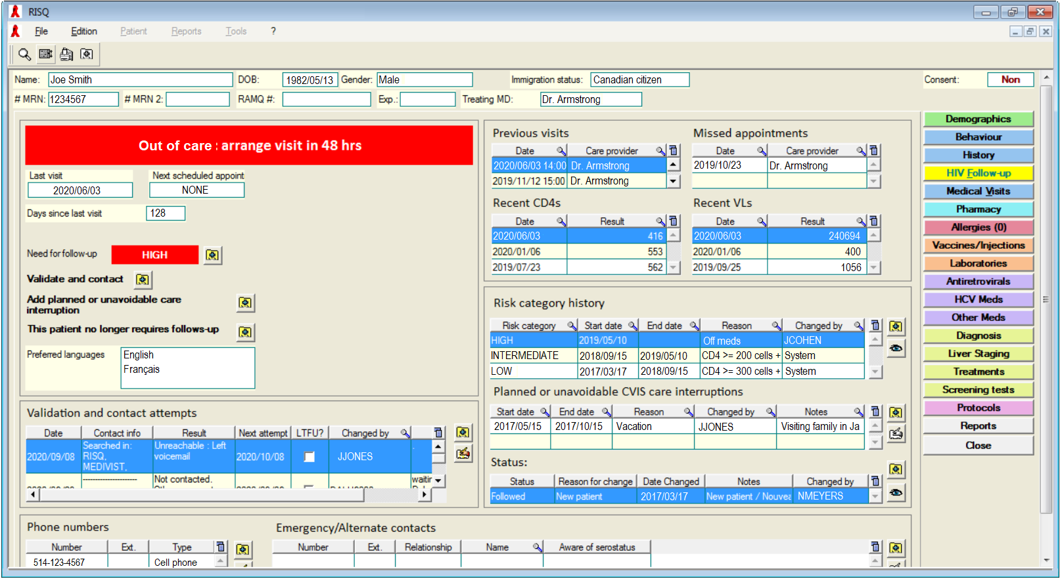
Figure A2: HIV follow-up tab in the clinical EMR (All fictional information)

